**DILAN’S TRAVEL GUIDE ANALYSIS MEGOLDÁS**

**(BORSI-NAGY GÁBOR)**

A feladatot több környezetben valósítottam meg. A kezdeti lépéseket bash-ben végeztem el. Az adatokat elsősorban SQL-ben elemeztem, Pythonban csak a prediction rész készült. A vizualizáció Power BI-ban és Looker Studio-ban készült, a prediction Pythonban. Ehhez Power BI-ban is fel kellett építenem a projektet, illetve megírni a megfelelő measure-okat hozzá.

**ELSŐ LÉPÉSEK BASH-BEN**

Letöltöttem az adatot egy külön könyvtárba wget-el.

Date és time különválasztása:

sed 's/ /;/1' dilans-data.csv > dilans—data.csv

Külön fájlokba szétválasztottam a tartalmakat event_type alapján:

grep 'read' dilans--data.csv > dilans-read.csv

grep 'buy' dilans--data.csv > dilans-buy.csv

grep 'subscribe' dilans--data.csv > dilans-subscribe.csv

Read file-ban ha egy oszloppal kevesebb van (visszatérő olvasó), akkor beszúr egy oszlopot:

#!/bin/bash

input_file="dilans-read.csv"

output_file="dilans--read.csv"

awk -F';' '

BEGIN { OFS=";" }

{

if (NF == 6) {

$6 = "Returning;" $6

}

print $1, $2, $3, $4, $5, $6, $7

}' "$input_file" > "$output_file"

Eltávolítja a végéről a ;-t, ha van:

sed 's/;$//' dilans--read.csv > dilans_read.csv

**SQL kódok**

Létrehoztam a 3 event_type táblázatot SQL-ben.

Bemásoltam az adatokat a szerverről:

COPY dilans_subscribe FROM '/home/pivotpanda/dilan/dilans__subscribe.csv' DELIMITER ';';

Összesítő adatok elkészítése:

SELECT EXTRACT(MONTH FROM r.my_date) AS month,

COUNT(DISTINCT r.user_id) AS reader,

COUNT(DISTINCT re_read.user_id) AS returning_reader,

COUNT(DISTINCT d.user_id) AS subscribe,

COUNT(DISTINCT b.user_id) AS buyer,

COUNT(DISTINCT re_buy.user_id) AS returning_buyer,

COUNT(DISTINCT r.user_id) - COUNT(DISTINCT re_read.user_id) AS churn_after_read,

COUNT(DISTINCT re_read.user_id) - COUNT(DISTINCT d.user_id) AS churn_after_re_read,

COUNT(DISTINCT d.user_id) - COUNT(DISTINCT b.user_id) AS churn_after_subscribe,

COUNT(DISTINCT b.user_id) - COUNT(DISTINCT re_buy.user_id) AS churn_after_buy

FROM dilans_read r

LEFT JOIN dilans_subscribe d ON r.user_id = d.user_id

LEFT JOIN dilans_buy b ON r.user_id = b.user_id

LEFT JOIN

(SELECT user_id

FROM dilans_read

GROUP BY user_id

HAVING COUNT(user_id)>1) AS re_read

ON r.user_id = re_read.user_id

LEFT JOIN

(SELECT user_id

FROM dilans_buy

GROUP BY user_id

HAVING COUNT(user_id)>1) AS re_buy

ON r.user_id = re_buy.user_id

GROUP BY EXTRACT(MONTH FROM r.my_date);

Ugyanez részletesebben (és ennek a különböző verziói, más-más lebontásokban, pl. napi, heti ):

SELECT r.my_date, EXTRACT(MONTH FROM r.my_date) AS month,

topic, country, source,

COUNT(DISTINCT r.user_id) AS reader,

COUNT(DISTINCT re_read.user_id) AS returning_reader,

COUNT(DISTINCT d.user_id) AS subscribe,

COUNT(DISTINCT b.user_id) AS buyer,

COUNT(DISTINCT re_buy.user_id) AS returning_buyer,

COUNT(DISTINCT r.user_id) - COUNT(DISTINCT re_read.user_id) AS churn_after_read,

COUNT(DISTINCT re_read.user_id) - COUNT(DISTINCT d.user_id) AS churn_after_re_read,

COUNT(DISTINCT d.user_id) - COUNT(DISTINCT b.user_id) AS churn_after_subscribe,

COUNT(DISTINCT b.user_id) - COUNT(DISTINCT re_buy.user_id) AS churn_after_buy,

SUM(b.price) AS revenue

FROM dilans_read r

LEFT JOIN dilans_subscribe d ON r.user_id = d.user_id

LEFT JOIN dilans_buy b ON r.user_id = b.user_id

LEFT JOIN

(SELECT user_id

FROM dilans_read

GROUP BY user_id

HAVING COUNT(user_id)>1) AS re_read

ON r.user_id = re_read.user_id

LEFT JOIN

(SELECT user_id

FROM dilans_buy

GROUP BY user_id

HAVING COUNT(user_id)>1) AS re_buy

ON r.user_id = re_buy.user_id

GROUP BY r.my_date, EXTRACT(MONTH FROM r.my_date), topic, country, source;

SELECT

COUNT(DISTINCT r.user_id) AS reader,

COUNT(DISTINCT re_read.user_id) AS returning_reader,

COUNT(DISTINCT d.user_id) AS subscribe,

COUNT(DISTINCT b.user_id) AS buyer,

COUNT(DISTINCT re_buy.user_id) AS returning_buyer,

COUNT(DISTINCT r.user_id) - COUNT(DISTINCT re_read.user_id) AS churn_after_read,

COUNT(DISTINCT re_read.user_id) - COUNT(DISTINCT d.user_id) AS churn_after_re_read,

COUNT(DISTINCT d.user_id) - COUNT(DISTINCT b.user_id) AS churn_after_subscribe,

COUNT(DISTINCT b.user_id) - COUNT(DISTINCT re_buy.user_id) AS churn_after_buy

FROM dilans_read r

LEFT JOIN dilans_subscribe d ON r.user_id = d.user_id

LEFT JOIN dilans_buy b ON r.user_id = b.user_id

LEFT JOIN

(SELECT user_id

FROM dilans_read

GROUP BY user_id

HAVING COUNT(user_id)>1) AS re_read

ON r.user_id = re_read.user_id

LEFT JOIN

(SELECT user_id

FROM dilans_buy

GROUP BY user_id

HAVING COUNT(user_id)>1) AS re_buy

ON r.user_id = re_buy.user_id;

Bevétel és profit számítások - havi (és ezek variációi, napit nem is írom):

WITH user_first_read AS (

SELECT

user_id,

country,

source,

MIN(my_date) AS first_read_date

FROM

dilans_read

WHERE source != 'Direct'

GROUP BY

user_id, country, source)

SELECT

EXTRACT(MONTH FROM b.my_date) AS month,

country,

source,

SUM(b.price) AS revenue

FROM

dilans_buy b

LEFT JOIN

UserFirstRead r ON b.user_id = r.user_id

GROUP BY

EXTRACT(MONTH FROM b.my_date), country, source

ORDER BY

EXTRACT(MONTH FROM b.my_date);

SELECT EXTRACT(MONTH FROM my_date) AS month,

SUM(price) AS revenue,

SUM(price) - 1000 AS profit

FROM

dilans_buy

GROUP BY EXTRACT(MONTH FROM my_date);

Heti bevétel:

WITH UserFirstRead AS (

SELECT

user_id, country, source,

MIN(my_date) AS first_read_date

FROM

dilans_read

WHERE source != 'Direct'

GROUP BY

user_id, country, source)

SELECT

EXTRACT(MONTH FROM b.my_date) AS month,

country, source,

SUM(b.price) AS revenue

FROM

dilans_buy b

LEFT JOIN

UserFirstRead r ON b.user_id = r.user_id

GROUP BY

EXTRACT(MONTH FROM b.my_date), country, source

ORDER BY EXTRACT(MONTH FROM b.my_date);

BIN-ek (különböző bontásokban készültek, egy mintát másolok ide):

|  |
| --- |
| WITH UserReadCounts AS ( |
| SELECT |
| user_id, country, |
| COUNT(*) AS read_count |
| FROM |
| dilans_read |
| GROUP BY |
| user_id, country |
| ), |
| BinnedData AS ( |
| SELECT |
| user_id, country, |
| read_count, |
| CASE |
| WHEN read_count = 1 THEN '01' |
| WHEN read_count = 2 THEN '02' |
| WHEN read_count = 3 THEN '03' |
| WHEN read_count = 4 THEN '04' |
| WHEN read_count BETWEEN 5 AND 10 THEN '05-10' |
| WHEN read_count BETWEEN 11 AND 20 THEN '11-20' |
| WHEN read_count BETWEEN 21 AND 30 THEN '21-30' |
| WHEN read_count BETWEEN 31 AND 40 THEN '31-40' |
| ELSE 'above 50' |
| END AS read_bin |
| FROM |
| UserReadCounts |
| ), |
| PurchaseData AS ( |
| SELECT |
| b.user_id, |
| SUM(b.price) AS total_purchase |
| FROM |
| dilans_buy b |
| GROUP BY |
| b.user_id |
| ), |
| CombinedData AS ( |
| SELECT |
| bd.read_bin, |
| bd.user_id, |
| bd.country, |
| COALESCE(pd.total_purchase, 0) AS total_purchase |
| FROM |
| BinnedData bd |
| LEFT JOIN |
| PurchaseData pd ON bd.user_id = pd.user_id |
| ) |
| SELECT |
| read_bin, country, |
| COUNT(DISTINCT user_id) AS user_count, |
| SUM(total_purchase) AS total_purchase |
| FROM |
| CombinedData |
| GROUP BY |
| read_bin, country |
| ORDER BY |
| read_bin, country |

Revenue megoszlás a termékek között:

|  |
| --- |
| WITH total_count AS ( |
| SELECT COUNT(*) AS total_count |
| FROM dilans_buy |
| ), |
| price_8_count AS ( |
| SELECT COUNT(*) AS price_8_count |
| FROM dilans_buy |
| WHERE price = 8 |
| ) |
| SELECT |
| (p.price_8_count * 1.0 / t.total_count) * 100 AS ratio |
| FROM |
| price_8_count p, |
| total_count t |

Funnel, rates, churn, group by country (ebből más variáció is lehetséges)

SELECT EXTRACT(MONTH FROM r.my_date) AS month,

country,

COUNT(DISTINCT r.user_id) AS reader,

COUNT(DISTINCT re_read.user_id) AS returning_reader,

COUNT(DISTINCT d.user_id) AS subscribe,

COUNT(DISTINCT b.user_id) AS buyer,

COUNT(DISTINCT re_buy.user_id) AS returning_buyer,

COUNT(DISTINCT r.user_id) - COUNT(DISTINCT re_read.user_id) AS churn_after_read,

COUNT(DISTINCT re_read.user_id) - COUNT(DISTINCT d.user_id) AS churn_after_re_read,

COUNT(DISTINCT d.user_id) - COUNT(DISTINCT b.user_id) AS churn_after_subscribe,

COUNT(DISTINCT b.user_id) - COUNT(DISTINCT re_buy.user_id) AS churn_after_buy,

(COUNT(DISTINCT r.user_id) - COUNT(DISTINCT re_read.user_id)) * 1.0 / COUNT(DISTINCT r.user_id) * 100 AS reader_churn_rate,

(COUNT(DISTINCT re_read.user_id) - COUNT(DISTINCT d.user_id)) * 1.0 / COUNT(DISTINCT re_read.user_id) * 100 AS returning_reader_churn_rate,

(COUNT(DISTINCT d.user_id) - COUNT(DISTINCT b.user_id)) * 1.0 / COUNT(DISTINCT d.user_id) * 100 AS subscriber_churn_rate,

(COUNT(DISTINCT b.user_id) - COUNT(DISTINCT re_buy.user_id)) * 1.0 / COUNT(DISTINCT b.user_id) * 100 AS buyer_churn_rate

FROM dilans_read r

LEFT JOIN dilans_subscribe d ON r.user_id = d.user_id

LEFT JOIN dilans_buy b ON r.user_id = b.user_id

LEFT JOIN

(SELECT user_id

FROM dilans_read

GROUP BY user_id

HAVING COUNT(user_id)>1) AS re_read

ON r.user_id = re_read.user_id

LEFT JOIN

(SELECT user_id

FROM dilans_buy

GROUP BY user_id

HAVING COUNT(user_id)>1) AS re_buy

ON r.user_id = re_buy.user_id

GROUP BY EXTRACT(MONTH FROM r.my_date), country;

**POWER BI kódok:**

Funnel analízis:

returning buyers =

 CALCULATE( COUNTROWS( FILTER( SUMMARIZE('dilans-buy', 'dilans-buy'[user_id], "BuyCount", COUNT('dilans-buy'[user_id]) ), [BuyCount] > 1 ) ) )

returning readers count =

CALCULATE(DISTINCTCOUNT('dilans-read'[user_id]),

'dilans-read'[source] = "Returning")

subscribers =

    CALCULATE(

        COUNT('dilans__subscribe'[user_id]),

        USERELATIONSHIP('dilans-read'[user_id], dilans__subscribe[user_id]))

buyers =

    CALCULATE(

        DISTINCTCOUNT('dilans-buy'[user_id]),

        USERELATIONSHIP('dilans-read'[user_id], 'dilans-buy'[user_id]))

ReturningBuyers2 =

CALCULATE(

    COUNTROWS(

        FILTER(

            SUMMARIZE(

                'dilans-buy',

                'dilans-buy'[user_id],

                "BuyCount", COUNT('dilans-buy'[user_id])),

            [BuyCount] > 1)),

    USERELATIONSHIP('dilans-read'[user_id], 'dilans-buy'[user_id]))

UserReadCount =

CALCULATE(

    COUNT('dilans-read'[user_id]),

    ALLEXCEPT('dilans-read', 'dilans-read'[user_id]))

Egyéb measure-ök:

revenue =

CALCULATE(

    SUM('dilans-buy'[price]),

    USERELATIONSHIP('dilans-read'[user_id], 'dilans-buy'[user_id]))

revenue per reader = DIVIDE([revenue],[readers count],0)

Model view:

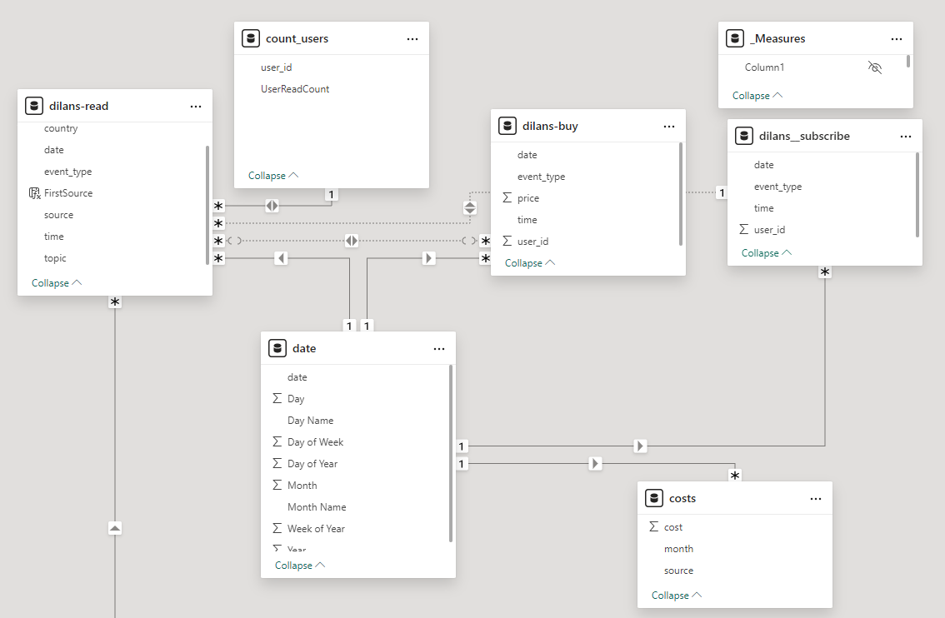

összes measure:

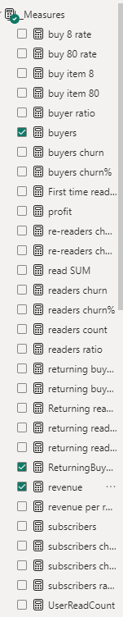

**PYTHON kódok:**

|  |
| --- |
| import numpy as np |
| import pandas as pd |
| import matplotlib |
| import matplotlib.pyplot as plt |
| %matplotlib inline |
|  |
| dilans_read = pd.read_csv('/home/pivotpanda/dilan/dilans--read.csv', delimiter = ';', names = ['my_date', 'my_time', 'event_type', 'country', 'user_id', 'source', 'topic']) |
| dilans_buy = pd.read_csv('/home/pivotpanda/dilan/dilans-buy.csv', delimiter = ';', names = ['my_date', 'my_time', 'event_type', 'user_id', 'price']) |
|  |
| dilans_read['my_date'] = pd.to_datetime(dilans_read['my_date']) |
| last_date = dilans_read['my_date'].max() |
| last_date_before = last_date - pd.Timedelta(days=1) |
| dilans_read_filtered = dilans_read[(dilans_read['my_date'] != last_date) & (dilans_read['my_date'] != last_date_before)] |
|  |
| dilans_read_date = dilans_read_filtered.groupby('my_date').count() |
| dilans_read_date = dilans_read_date.reset_index(drop=1) |
| dilans_read_date = dilans_read_date[['my_time']] |
| dilans_read_date = dilans_read_date.rename(columns={'my_time': 'total_read_count'}) |
|  |
| x = dilans_read_date.index |
| y = dilans_read_date.values |
| coefs = np.polyfit(x,y,2).reshape(-1) |
| predict = np.poly1d(coefs) |
|  |
| from sklearn.metrics import r2_score |
| r2_score(y, predict(x)) |
| 0.74364 |
|  |
| x_test = np.linspace(0, 136) |
| y_pred = predict(x_test[:, None]) |
| plt.scatter(x, y) |
| plt.plot(x_test, y_pred, c = 'r') |
| plt.show() |
|  |
| dilans_buy['my_date'] = pd.to_datetime(dilans_buy['my_date']) |
| last_date = dilans_buy['my_date'].max() |
| last_date_before = last_date - pd.Timedelta(days=1) |
| dilans_buy_filtered = dilans_buy[(dilans_buy['my_date'] != last_date)] |
|  |
| dilans_buy_date = dilans_buy_filtered.groupby('my_date').sum() |
| dilans_buy_date = dilans_buy_date.reset_index(drop=1) |
| dilans_buy_date = dilans_buy_date[['price']] |
| dilans_buy_date = dilans_buy_date.rename(columns={'price': 'total_revenue'}) |
|  |
| x = dilans_buy_date.index |
| y = dilans_buy_date.values |
| coefs = np.polyfit(x,y,3).reshape(-1) |
| predict = np.poly1d(coefs) |
|  |
| from sklearn.metrics import r2_score |
| r2_score(y, predict(x)) |
| 0.626434 |
|  |
| x_test = np.linspace(0, 136) |
| y_pred = predict(x_test[:, None]) |
| plt.scatter(x, y) |
| plt.plot(x_test, y_pred, c = 'r') |
| plt.show() |