**Lab 10**

**Suramya Chukka**

**Class Id : 11**

**1. News Service**

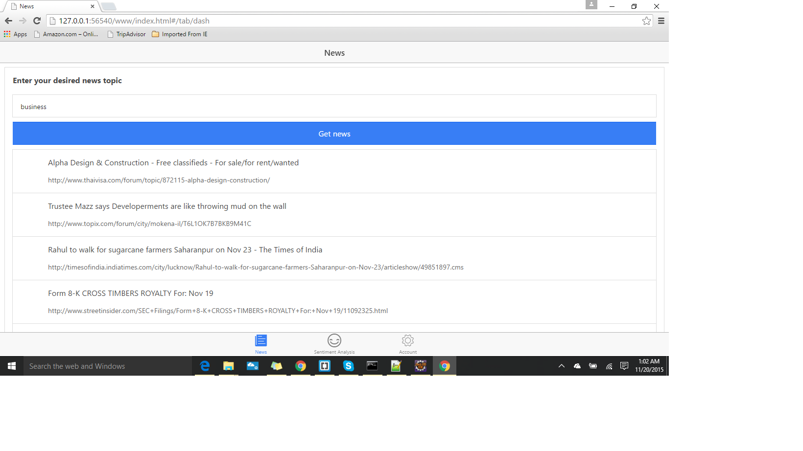

When the button is clicked ,A request is sent to the service through controller as follows:

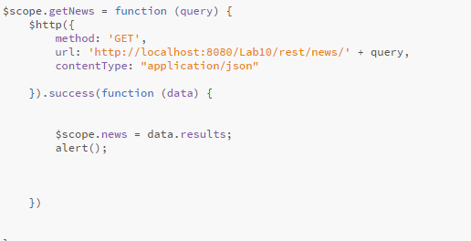

The service which is called is as follows:

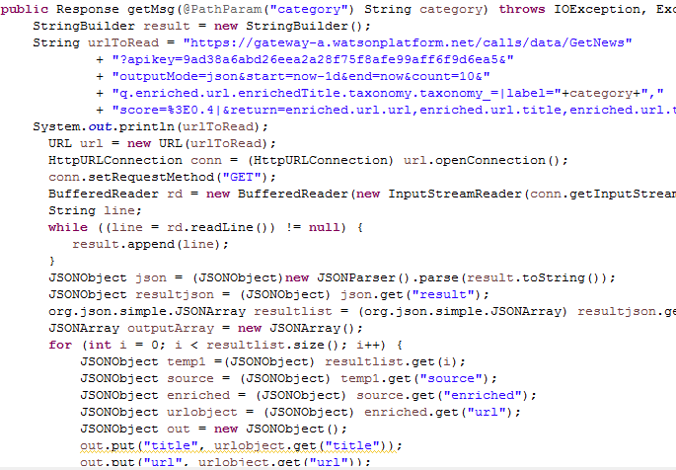

**2.Sentiment analysis**

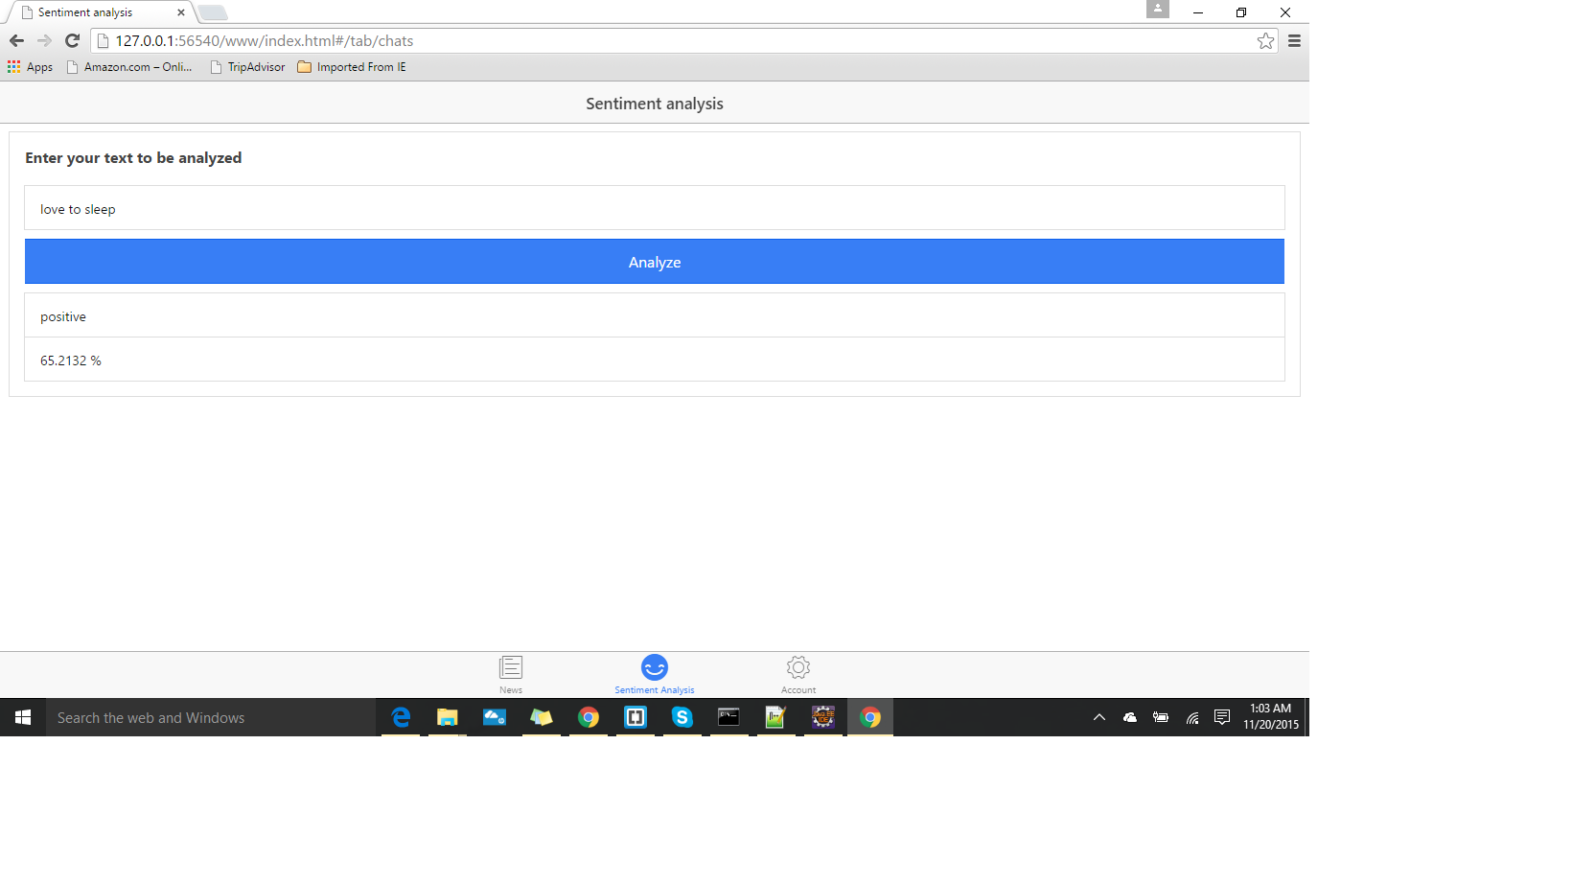

When the button is clicked ,A request is sent to the service through controller as follows:

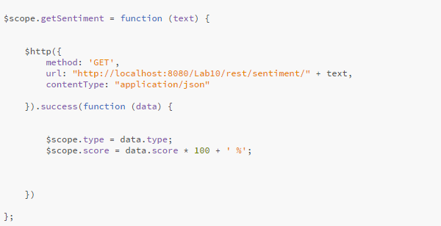

The service which is called is as follows:

