How to install, setup, and use Postman 

1. Download and extract our Postman Collections from the [DGConnect-ESRI](https://github.com/DigitalGlobe/DGConnect-ESRI/tree/master/Testing/Postman/Collections) (API for the ArcMap Addin) and [DGConnect](https://github.com/DigitalGlobe/DGConnect/tree/master/Testing/Postman/Collections) (API for the QGIS Plugin) GitHub repositories.
2. Download the Postman app [here](https://chrome.google.com/webstore/detail/postman/fhbjgbiflinjbdggehcddcbncdddomop?hl=en) or search “Postman” in the Google Chrome Web Store.
3. Launch Postman and continue to “go to the app”.

Postman at a glance

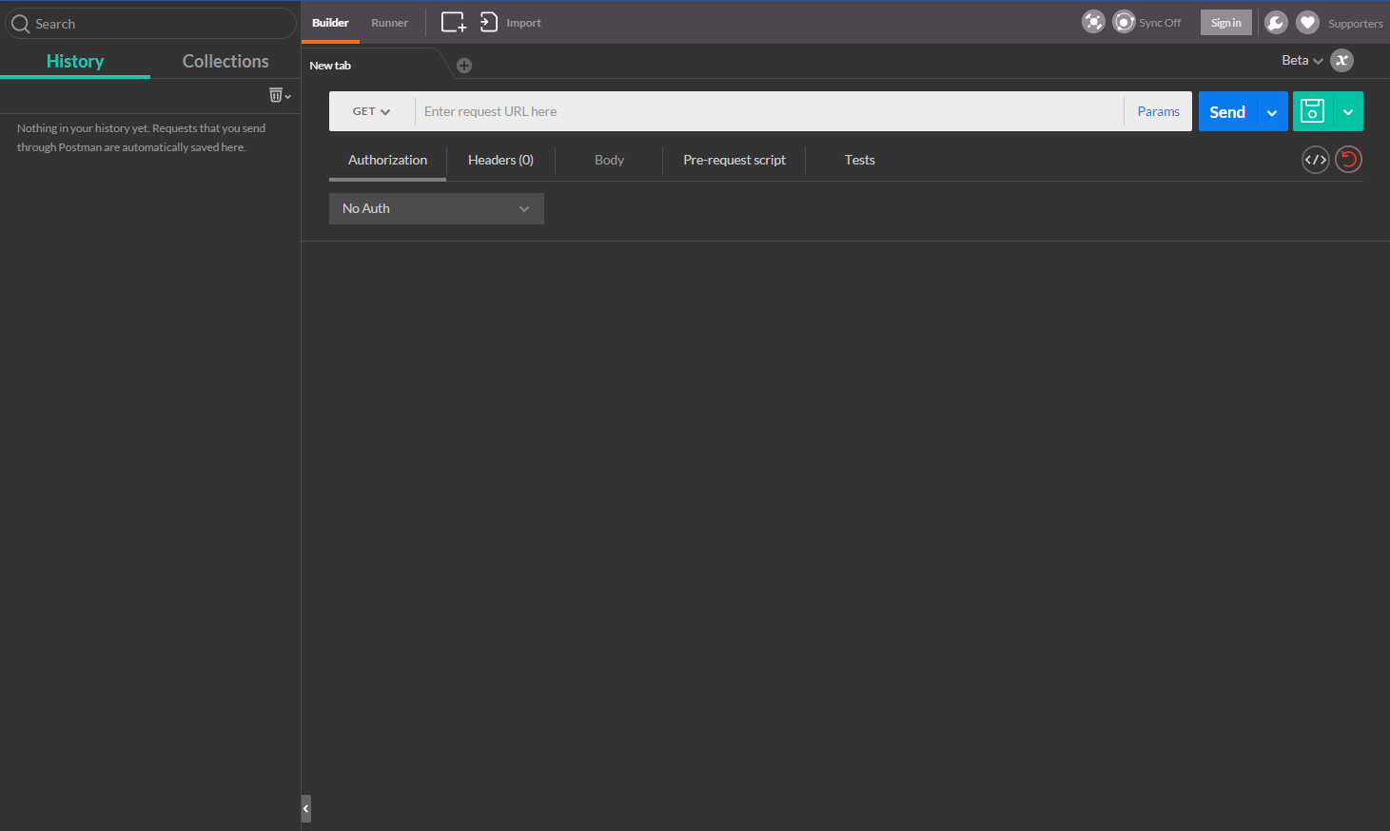

i

iii

vi

viii

vii

v

iv

ii

1. View recently sent requests or saved request collections
2. View and change request type with drop down menu
3. Click the *Import* button to add Postman Collections, environments, and more
4. Switch through the various tabs/settings to configure your request
5. Click the *Params* button to create and view request parameters
6. Click the *environment* button to manage environments
7. Click *Send* to send your request
8. Click the *floppy disk* button to add the current request to a collection
9. Click  then *Choose Files* and select all of our Postman Collection files and environments.
10. Click the  button then *manage environments* and select “Beta” to enter your username and password. Click *Submit* to save changes.

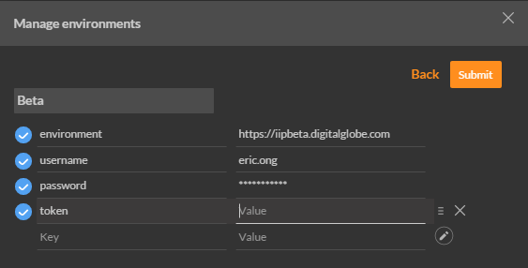

1. Exit the environment settings, click the  button again and from the drop down menu select “Beta” to switch to the Beta environment.
2. Switch to the *Collections* tab and select the “Get Token” request in the “OAuth2” folder.

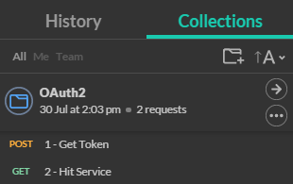

1. Under the *Authorization* tab, select *Basic Auth* from the drop down menu then set Username and Password to “{{username}}” and “{{password}}” then click *Update request*. 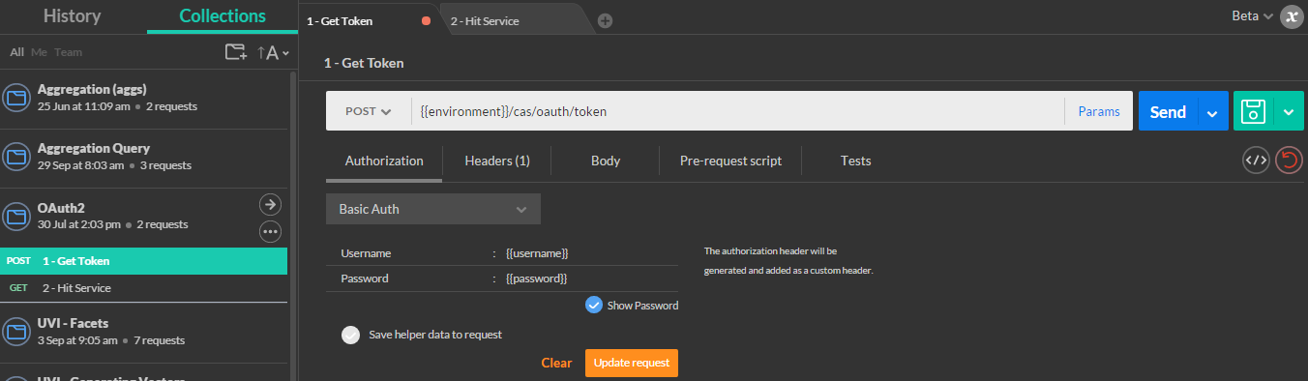
2. Click  and you should receive a response with your authentication token. Copy the value for the “access_token” (without quotes) and paste it in the token value for the corresponding environment (click the *environment* button then *manage environments*).

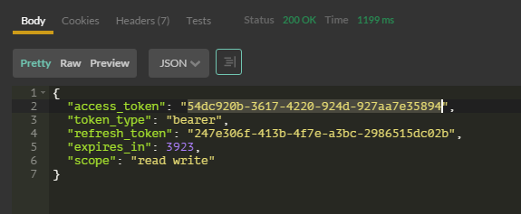 

If you have successfully been granted an authentication token and saved it to the corresponding environment proceed to the “Hit Service” request to test your authentication. A successful response looks like the following.

 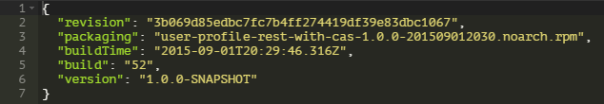

This response means you are ready to use the rest of our API!

**Example**: List Vector Sources (This request returns a list of available vector index ingestion sources for the given bounding box)

1. Under *Collections*, click the “Workflow: UVI Web – Basic from source with paging” folder and select the “1. List Vector Sources” request.

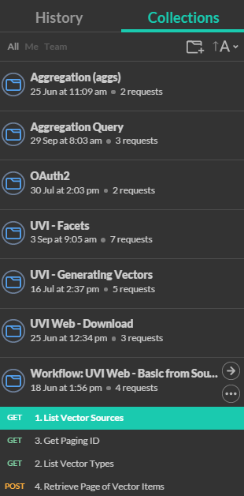

To view and modify the parameters of the request, click *Params*. In this instance, “left” is the left most Longitude value, “right” is the right most Longitude value, “upper” is the upper most Latitude value, and “lower” is the lower most Latitude value of the bounding box.

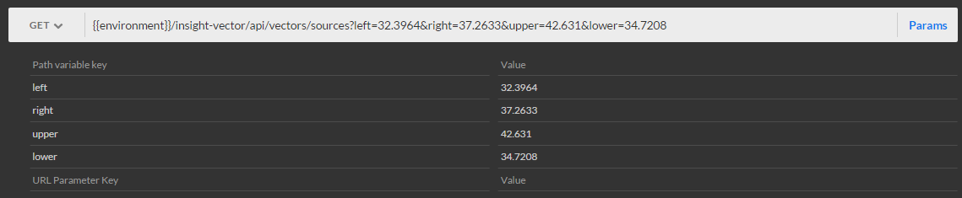

1. Once ready, click *Send* to retrieve the response.

