CS 462: Networks – ARQs with a Secured UDP Protocol

James Genac
Mark Salzman
Undergraduates at UW- Eau Claire
genacje@uwec.edu
salzmamy@uwec.edu

Abstract

The goal of this project was to implement three separate Automated Repeat Request (ARQ) algorithms for packet transmission: Stop and Wait, Go Back N, and Selective Repeat. The algorithm also includes Key Distribution Center style session key distribution for encrypted transmission. Being written in C++, the code is structured using the Object Oriented concepts of inheritance, polymorphism, and abstraction, encapsulating low level system calls into high level functions for good modularity.

1. Introduction

This paper shall serve three purposes: First, it shall detail the algorithms used to establish a secure connection and to transmit data. Second, it shall serve as documentation for the overall structure and design of the code. Last, it shall give a performance analysis of each of the three implemented algorithms, given a set of conditions.

2. Algorithms

2.1. KDC Protocol (Figure 2.1)

To establish a secure connection, a key distribution algorithm in which an initiator requests a session key from a trusted third party, a Key Distribution Center (KDC). The KDC stores a table of keys from its clients, and upon receiving a request from one of its clients for a connection with a peer, replies with a freshly generated session key, which it encrypts twice: One version of the key is encrypted for the initiator with its personal key, and another version of the key is encrypted with the intended recipient’s personal key, and re-encrypted with the initiator’s personal key. These keys are now sent from the KDC to the initiator, who stores the session key and decrypts the twice-encrypted key for the recipient. The initiator then sends the recipient’s encrypted session key to the recipient. The two nodes now share a session key, and handshake their connection. Authentication against replay attacks is avoided by using nonces in the request for a session key by the initiator as well as the handshaking protocol between the initiator and recipient.

2.2. Stop and Wait Protocol

Stop and Wait (SW) is the simplest ARQ that was implemented: A sender first performs a ping check on the recipient, and then proceeds to send packets one at a time. The receiver, upon receiving a packet, inspects the ID number of the packet and sends an acknowledgment (ack) packet back to the sender with this ID as a header. Should a packet or ack be lost during this time, the sender is designed to automatically resend a duplicate packet after a timeout interval, which is the average ping multiplied by a set integer. If the receiver is sent a duplicate packet, this packet is acked and discarded, so that sending may continue. This process continues until the entire file has been transmitted and acked, in which case the sender sends an ending packet, which alerts the receiver that the transmission is complete.

2.3. Go Back N Protocol

Go Back N (GBN) is a windowed ARQ in which the sender can achieve a higher bandwidth utilization by sending a window (successive sequence) of packets without having to ‘stop and wait’ for acks in between sends. The receiver functionality is no different from that of SW; it acks ordered and duplicate packets and discards out of order packets. After releasing a window of packets, the sender will wait a timeout interval for the ack of the last packet sent to return. If it does not return, the sender must re-transmit all packets in the current window that are beyond the last acked packet, and send successive new packets until another full window has been sent. Like SW, this process continues until the entire file has been transmitted and acked, in which case the sender sends an ending packet, which alerts the receiver that the transmission is complete.

2.4. Selective Repeat Protocol

Selective Repeat (SR) is a dual-windowed ARQ in which a sender may send a window of packets continuously without receiving an ack. The receiver also has a window in which it receives packets in an acceptable range and buffers them, even if they are out of order. Missing and unacked packets are repeated after a timeout interval for the individual packet expires. The sender and receiver windows, or ranges of acceptable packets, progress as the lowest file in the window is received or acked. When all packets have been acked individually, the transmission is complete.

3. Structure and Design

3.1. Language & Concepts (Figure 3.1)

This set of ARQs was written in C++, and exemplifies many Object Oriented concepts. First, abstraction and inheritance were used to capture generalities in the ideas of the KDC, Initiator, and Receiver: All of these entities needed to use a Connector object to handle all of the low level datagram calls, and all needed to share common methods of generating and validating nonces. Secondly, inheritance, abstraction, and polymorphism were used to capture the close similarities between all three TransferProtocols (SW, GBN, and SR). The varied content between the protocols was overridden by a polymorphic run_sender() or run_receiver() method, which contained the implementations of the specific protocol of the child class. Abstraction was particularly useful in code reuse for both of these examples, as to add code to all classes, one need only add a module to the abstract class.

3.2. Connector

Connector is an Object that encapsulates the functions of sockets, UDP/IP packets, and low level sending, receiving, and buffering of packets in a user friendly manner. Connector is also complete with built in CCRC32 and Blowfish modules for packet security and validation.

3.3. Blowfish

Packet security is achieved using a patched C++ version of Bruce Schneier’s Blowfish encryption algorithm [1]. Blowfish is a 64-bit block cipher with a maximum key length of 448 bits, and uses a Feistel network similar to that of AES and DES. Data entering into the Blowfish block cipher must be a multiple of 8 bytes, so the managing Connector class ensures that the packet size always satisfies this condition.

3.4. CCRC32

Validation of data through network passage is necessary for reliable file transmission. A Cyclic Redundancy Check (CRC) is an algorithm that forms a 32 bit codeword from an input array of any length. This codeword may be appended to the tail of the message before sending. Upon acquiring a message, a receiver may compute its own codeword and compare it to the tail – if bits got damaged during transmission, the computed codeword will differ from the received codeword. The damaged data can then be ignored, and re-transmission will occur in higher layers.

3.5. Transfer Metrics

In order to obtain statistical data for a performance analysis of the transmission code, a collect-and-report module was needed. Upon starting a transmission, a start timer is called in the module, which stores the time accurate to the microsecond; upon finishing, the end timer is called, and the difference between these times is the total transmission time. The TransferProtocol object also reports lost packets, the number of packets sent, and the total size of the file to the Metrics module. A report may now be easily issued, detailing all of the reported statistics, including the calculated transmission time and throughput in kilobytes per second.

4. Performance Analysis

4.1. General

All of the following tests were with a medium sized (20mb) .zip file containing executables and documents. Four trials of different packet sizes (4kb, 8kb, 32kb, 63kb) shall be done for each category: SW, GBN-window size 3, 8, and 16. Packet losses, transmit time and throughput will be measured in each analysis.

4.2. SW

Packet size: 4kb
Packet losses: 14
Transmit time: 16.14s
Throughput: 1317kbps

Packet size: 8kb
Packet losses: 7
Transmit time: 8.17s
Throughput: 2603kbps

Packet size: 32kb
Packet losses: 6
Transmit time: 5.95s
Throughput: 3583kbps

Packet size: 63kb
Packet losses: 5
Transmit time: 5.46s
Throughput: 3913kbps

Notes: Since SW relies solely upon packet size to utilize bandwidth, it achieves a significantly higher throughput as the packet size increases. Also, the number of lost packets should trend downwards as the packet size increases because less packets are sent. SW is notably accurate; it loses very few packets.

4.2. GBN

4.2.1. Window Size: 3
Packet size: 4kb
Packet losses: 26
Transmit time: 18.00s
Throughput: 1181kbps

Packet size: 8kb
Packet losses: 18
Transmit time: 11.73s
Throughput: 1812kbps

Packet size: 32kb
Packet losses: 24
Transmit time: 9.50s
Throughput: 2239kbps

Packet size: 63kb
Packet losses: 20
Transmit time: 7.70s
Throughput: 2765kbps
.
4.2.2. Window Size: 8
Packet size: 4kb
Packet losses: 32
Transmit time: 7.42s
Throughput: 2864kbps

Packet size: 8kb
Packet losses: 24
Transmit time: 6.34s
Throughput: 3355kbps

Packet size: 32kb
Packet losses: 24
Transmit time: 6.48s
Throughput: 3284kbps

Packet size: 63kb
Packet losses: 228
Transmit time: 15.32s
Throughput: 1390kbps

4.2.3. Window Size: 16
Packet size: 4kb
Packet losses: 32
Transmit time: 7.42s
Throughput: 2864kbps

Packet size: 8kb
Packet losses: 82
Transmit time: 9.85s
Throughput: 2218kbps

Packet size: 32kb
Packet losses: 739
Transmit time: 24.58s
Throughput: 865kbps

Packet size: 63kb
Packet losses: 330
Transmit time: 11.06s
Throughput: 1925kbps

Notes: GBN is a protocol that is highly prone to significant packet loss, especially if the network is busy. One miss of a packet early in a window will cause all subsequent sends to be in vain. There is a trend of packet loss significantly increasing with an increase in window size, but not with packet size. In lower window sizes, higher packet sizes allow the program to achieve a high bandwidth, but with higher window sizes, the bandwidth is adequately filled and thus an increase in packet size results in insignificant gains in throughput (or even losses in throughput).

4.3. SR

Selective repeat is not currently functional.

6. Note on Performance Evaluation

Variance of throughput may have been effected by the presence of more or less network traffic at the time of the text. However, it is useful to observe the trends within the categories, as those tests were all done at times where traffic was similar.

7. References

[1] http://www.schneier.com/blowfish.html
.

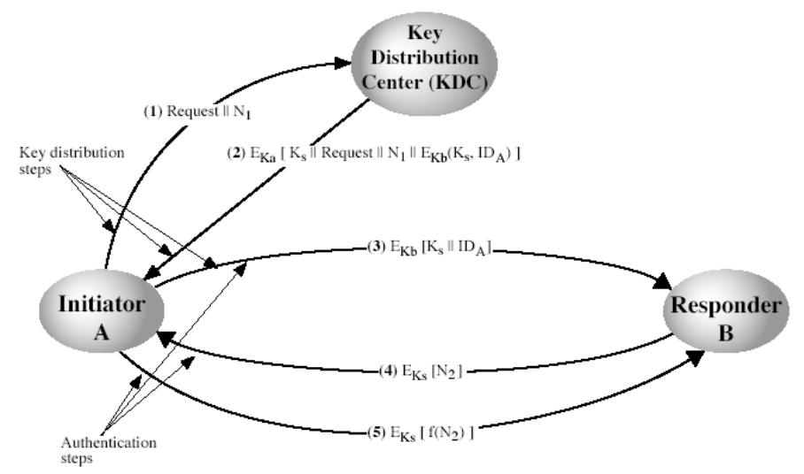

Figure 2.1 – Key Distribution Protocol

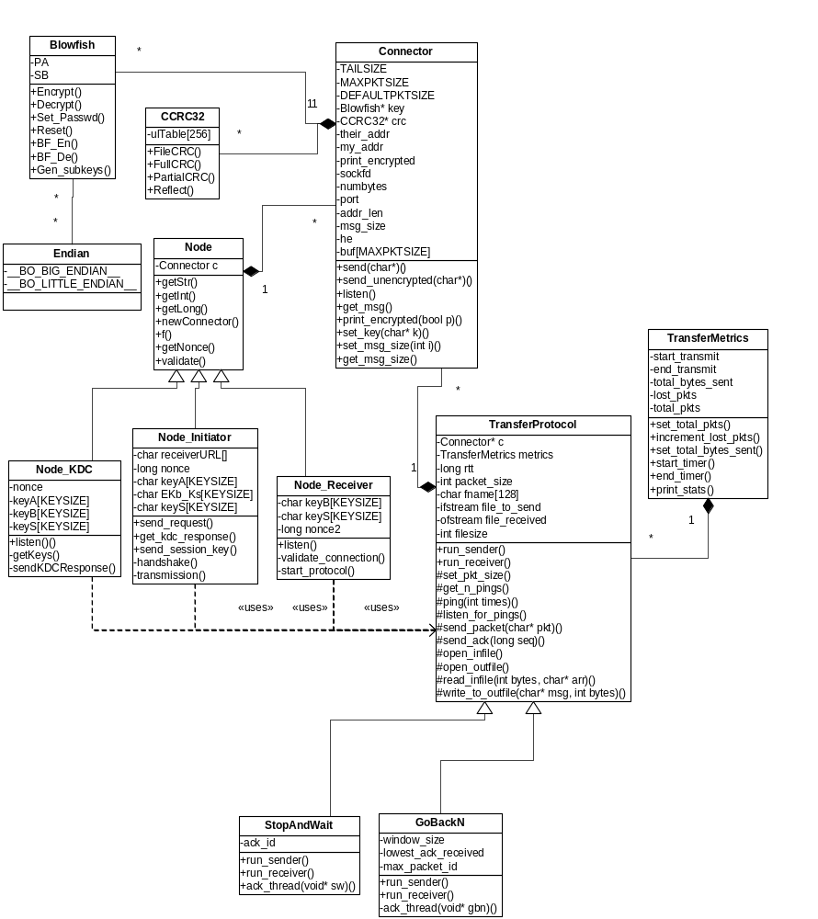
Figure 3.1 –UML Diagram

