pUML

phunctional UML editor

« User Manual »

|  |
| --- |
| **pUML User Manual** |

Contents

What is pUML? 3

Installation Instructions 4

Introduction to the pUML main window. 5

Create a New Diagram 6

Editing Your Diagram 9

Help / FAQ 10

# What is pUML?

pUML is a UML diagram drawing program developed by a team of students, currently attending the University of Idaho. This software was developed for a software engineering project, and is by no means considered to be complete, useful, or functional at time of this user manual publication.

What is currently available for use is the ability to create new diagrams and work on more than one diagram at a time. There are four diagram types available for your use which are use case, state chart, interaction, and collaboration diagrams. Within each diagram, you will be able to create, select, change description, move, and delete singular objects. With multiple objects you can do all of these things with the addition of connecting the objects and describing the connection.

At the time of this manual’s publication, there are still some basic functions that are not fully functional. Namely, the saving and loading of created UML diagrams are still in the works. There are also no current cut, copy, paste, import, and export functionality.

# Installation Instructions

Carefully follow the installation instructions to ensure pUML is successfully installed on your computer.

***Windows***

1. *Run* the installer from the download.
2. Select your preferred program file path (we recommend the default) from the Installation Wizard.
3. Click “Install”.
4. When installation has completed, click “Close”.

***Debian Linux***

1. In the Terminal type the command “dpkg –i puml-x.x.deb” where x.x represents the current version number that was downloaded.

# Introduction to the pUML main window.

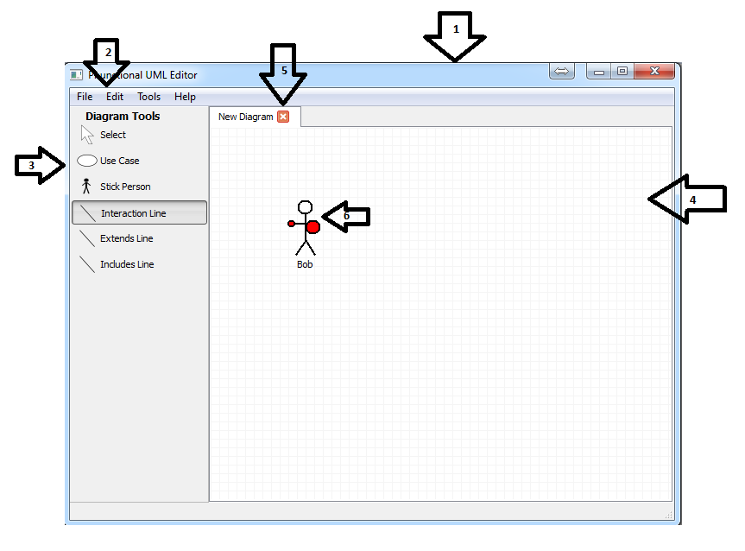

**1. Main Window**

**2. Main Window Toolbar**

**3. Canvas Toolbar**

**4. Canvas**

**5. Tabs for Additional UML Diagrams**

**6. Object on Canvas**

The elements shown on this page and their uses are described in greater detail throughout the remainder of this manual.

# Create a New Diagram

***When You First Start the Program***

1. Make sure that the “New” option on the left is highlighted.
2. Select the type of diagram that you would like to create and click “OK”.

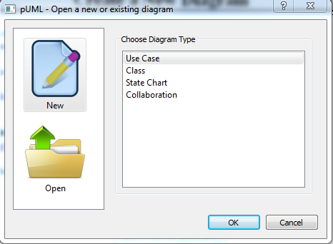

***While You Are Working on Another Diagram***

1. On the pUML main window toolbar, click “File.”
2. Click “New”

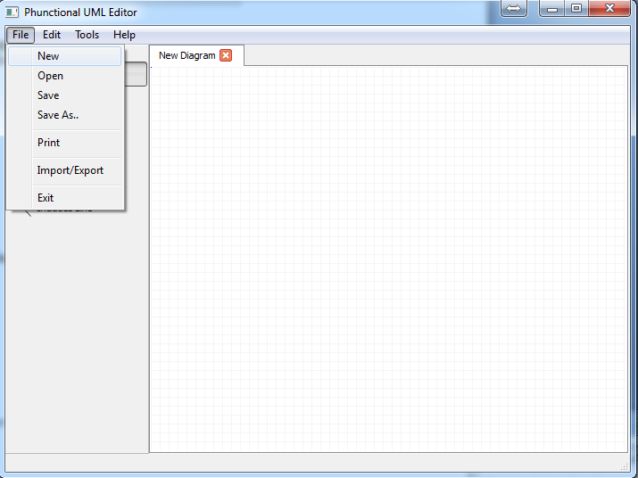

1. Highlight your desired diagram type from the list presented, and click “OK.”

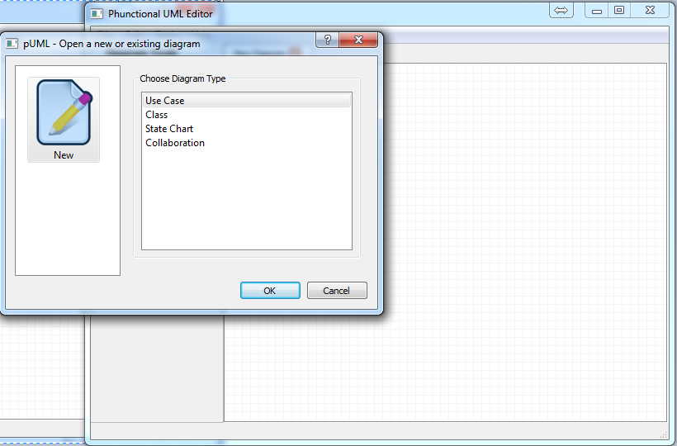

The shapes for your diagram type will appear in the toolbar to the left of the drawing canvas.

**How to place shapes on the canvas:**

1. Click on the desired shape in the toolbar.
2. Click on the canvas to place the selected shape at that location.

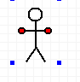 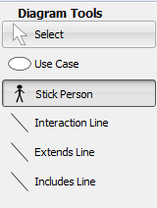

1. Right click on any object and click “properties” in the drop-down menu to add a title or description.

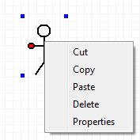 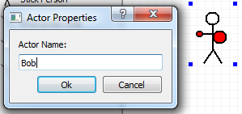

**How to place connectors:**

To place connectors, you must have at least two shapes already on the canvas. To connect the shapes:

1. Click on the desired connector in the toolbar.
2. Click down on the originating object on the canvas and holding the left mouse button down, drag the mouse to the object you’d like to connect to. This will place a connector between the two objects.

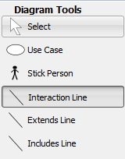 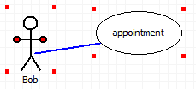 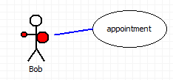

1. Right click on the connector to add a description.

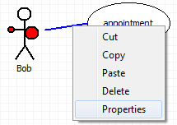

***Note:*** *some connectors have specific descriptions which may not be modified.*

# Editing Your Diagram

**Renaming an object or a connector:**

Right click on the object or connector to change the title or description.

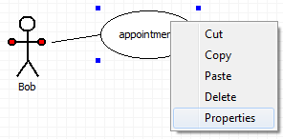 

**Deleting an object:**

There are two ways to delete an object.

1. Right click on the object and select delete.

or, 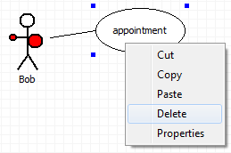

1. Click on the object and press the “Delete” key on your keyboard.  
   The object and any associated description will disappear.

***Warning:*** *When an object is deleted, any associated connectors will be deleted as well. Delete objects with care!*

**Deleting a connector:**

There are two ways to delete an object.

1. Right click on the connector and select delete.

or, 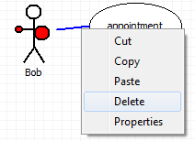

1. Click on the connector and press the “Del” key on your keyboard.  
   The connector and any associated title or description will be deleted.

***Note:*** *Deleting a connector will not delete any associated objects.*

# Help / FAQ

**HELP**

At this time, the only support for this program is this user manual, or by contacting us via Phunctional’s website <http://www.puml.net>.

**FAQ**

Q: How do I delete a pUML UML diagram?

A: Find the diagram on your computer and delete it the same way you would delete any other file on your computer.

Q: I want to embed a picture in my diagram that originates outside pUML.

A: This feature is not supported in pUML.

Q: Why are so many features unavailable?

A: This is an alpha release, we are still working on getting many features included in this program. In the meantime, please, be patient.

**Credits**

Josh Armstrong

Brian Bowles

Zach Curtis

Logan Evans

Jeremy Klas

Nate Krussel

Maxine Major

Morgan Weir

David Wells