PART 1:

DELIVERABLE 1 of 1

1:

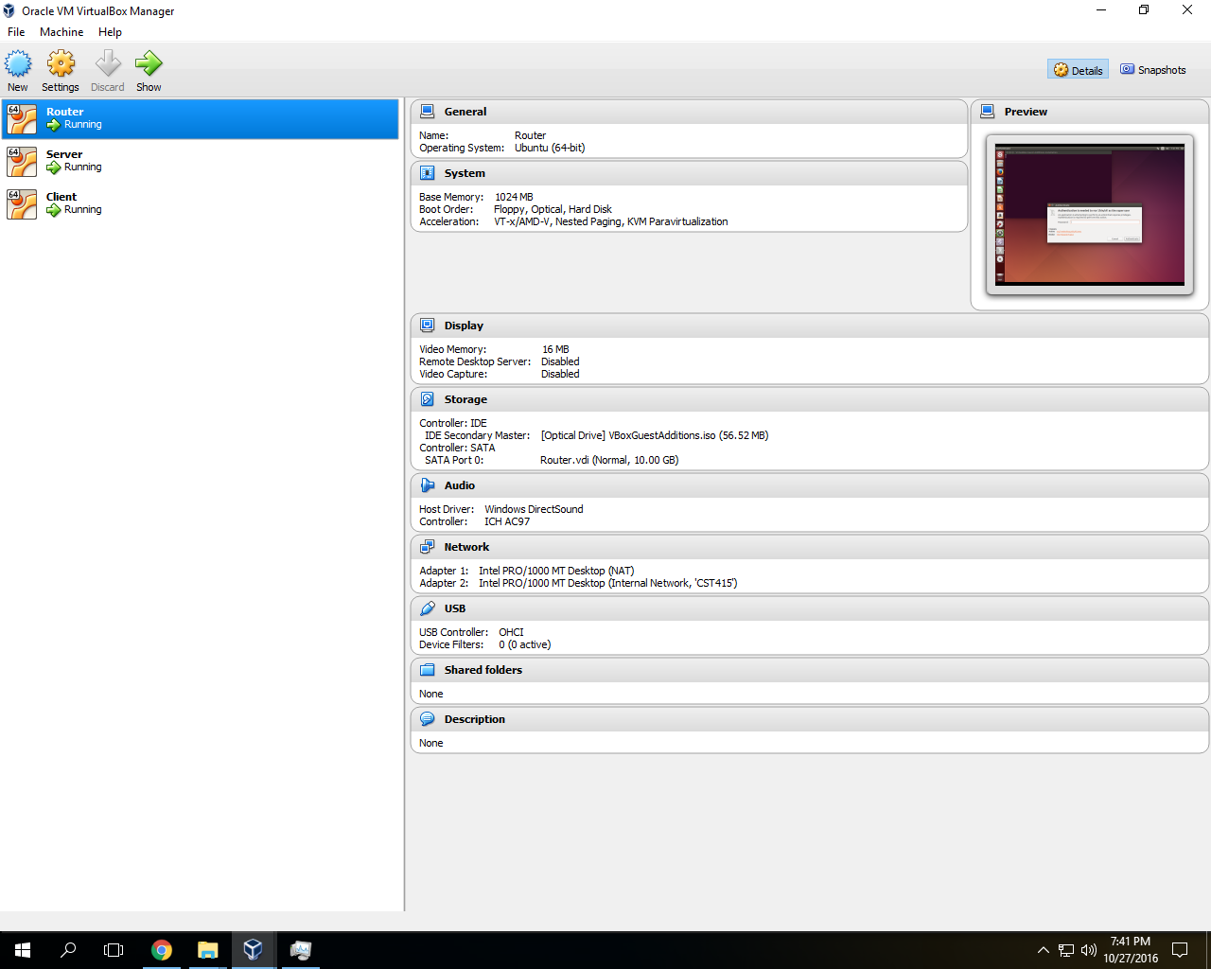

2:



3: (server)

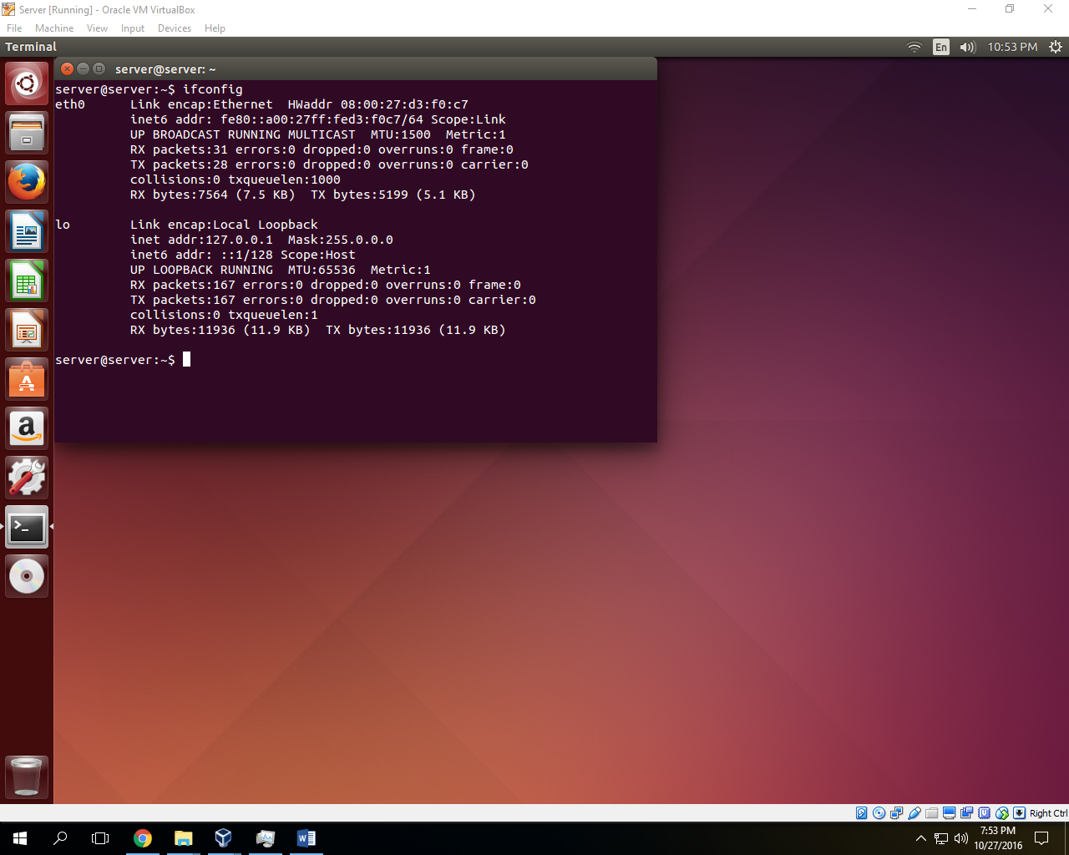

4: (client)

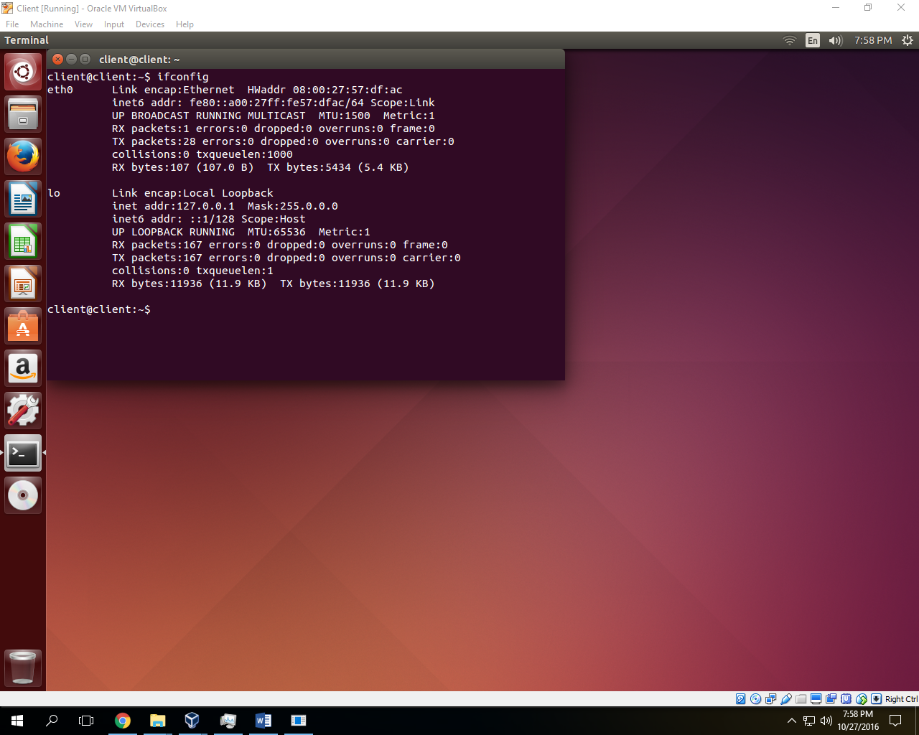

------------------------------------------------------------------------------------------------------------------------------------------  
Part 2: