Instructions:
Insert your responses in a bold red type face after each line item. Be sure to use all of your own words that demonstrate your understanding of the subject matter.

Your Name: _Cal Barkman_
Assignment Questions:
- Explain the difference (if any) between The Internet and The World Wide Web.
The Internet is a large group of interconnected computers using IPv4 and TCP/IP protocols to communicate information. The world wide web is a collection of web pages that are able to be accessed on the Internet.
- Explain the difference between HTTP and HTML
HTTP is a protocol that allows the collection and download of web pages from web servers. HTML is a markup language that converts text downloaded using HTTP into a web page that can be viewed using a web browser. HTTP can transfer information besides HTML web pages like flash, css, and javascript.
- Identify and describe three reasons why an organization may want to use middleware.
- Describe how MIME works and why we have it.
MIME works by taking binary data and converting it to an ASCII text based form for easy transmission over text based protocols. An example of this is to take some text plus an image such as a .jpg and send it using the SMTP protocol. All the data would be read into the email client as text data, but would be able to display the data as a picture using the converted binary data. To do this, they use bits 6 and 7 as a key to determine if the data is binary or text based with a 2b00 value indicating binary data. The efficiency of MIME is 3 bytes of input for every 4 bytes of text data output.
- Name and explain the two fundamental approaches to media access control.
- List four IEEE standards by number and name that are associated with the MAC sub-layer of the data link layer, and where each standard is associated with a different type of medium technology. For example, IEEE 802.11a, IEEE 802.11b, IEEE 802.11g, and IEEE 802.11n are all associated with a single medium technology; Wi-Fi, and would count as only one listed standard in response to this question
ARP
Eithernet?
MAC
IP? / IPv4?
- Most wireless LANs use a controlled access technology for media access control. The reasons for why a controlled access is used we will discuss in a later week when we study wireless LANs. For purposes of this assignment question, do not concern yourself with why controlled access is used, simply accept as a given that controlled access is used for Wi-Fi wireless LANs. Even when there is a strong and error-free wireless signal, and even when there may be only one wireless device attached to the access point, the actual realized throughout you experience on Wi-Fi is about one-half the technical specification’s transmission rate. Do you see controlled access as a reason for this lowered performance? Why or why not?
- Look at the Ethernet frame formats shown below. Do the contents of the field labeled “Source Address” represent the sender, receiver or if some other
networking device then please specify? Are the contents of this field an IP address, MAC address, or if another form of identification then please specify?
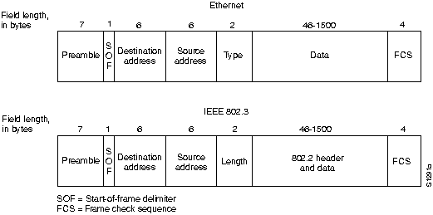
- The “Type” field in the upper Ethernet frame format of question 9 contains a value that defines the network layer protocol number. What Internet standards organization is directly responsible for managing and publishing network layer protocol number assignments?
- In reference to the Ethernet frame formats in the above question number 9, why would the engineers who designed Ethernet place the field labeled “Destination address” as the first field of the frame after the synchronization bits represented by the preamble and SOF fields?

