Please insert your answers into this document using a bold red type face. Thank you.
Submit your completed answers document to Blackboard in either MS Word of Open Office format.
You may make an unlimited number of Blackboard submissions. Only the most recent submission will be scored.

Exam is open-book, open-notes, and open-network. Exam is not open-neighbor or open-email/text or any other form of information exchange.
Exam closes at 8:15PM PDT Thursday, November 3rd. There will be no early warnings.
Note: To insert a new line without also creating a new list number, use the combination keystroke Shift-Enter.
Name: _Callahan Barkman_
- (4 points) What is the purpose of the OSI Reference Model?
Answer: To make networks more manageable and easier to transfer information between them.
- (4 points) What is the purpose of a data and network communications’ standard?
Answer: So every person on the network can communicate clearly and effectively, and any past or future devices on these networks can communicate.
- (3 points) Identify which of the three Internet standards organization from the list below that is most responsible for the functions described. We know that IANA is a department of ICANN. For purposes of this question assume the two are separate organizations with separate functional responsibilities, which in fact is much the way they actually operate.
Organizations: IETF, ICANN, IANA
Functions:
  - ____ICANN____ Approves and maintains a library of technical standards documents referred to as RFCs (Request for Comments).
  - ____IANA____ Assigns numbers to names such as IP addresses and protocol numbers, and insures unique number assignments across the Internet.
  - __IETF______ Assigns names to services as technically defined in RFCs to insure unique domain and protocol names across the entire Internet.
- (6 points) A transaction consists of two components, a request component and a response component. Below is an alphabetized list of steps that briefly describe the phases of a transaction from beginning to end. On the left write a sequence number (between 1 and 6) to indicate the order they will be processed, and on the right specify if it is the client or the server that is executing that respective step.
Seq. Client or Server
__1__ Generate Request _______client________
__4__ Generate Response ________server_______
___6_ Receive Response ________client_______
_3___ Receive Request _____server__________
___5_ Transmit Response _______server________
_2___ Transmit Request _______client________
- (4 points) List four IEEE standards by number and name that are associated with the MAC sub-layer of the data link layer, and where each standard is associated with a different type of medium technology. For example, IEEE 802.11a, IEEE 802.11b, IEEE 802.11g, and IEEE 802.11n are all associated with a single medium technology; Wi-Fi, and would count as only one listed standard in response to this question.
Answer: IEEE 802.3 – MAC
IEEE 802.11 – WIFI
IEEE 802.4 and 5 – token
IEEE 802.2 logical link control
???????????????????????
- (4 points) A hub (aka. multiport repeater) device is associated with the physical layer, switch and bridge devices are associated with the data link layer. Explain why hubs are not associated with the data link layer and why switches and bridges are not associated with the physical layer.
Answer: hubs just repeat information on all ports, they don’t actually do any special actions with the information. Switches and bridges read the MAC address and only echo information to the appropriate hardware port corresponding to that MAC address.
- (3 points) Explain the three components of the CSMA/CD media access control method.
Answer: CS: carrier sense – detects the absence of a transmission signal
MA: multiple access – all devices must have equal opportunity to detect CS
CD: collision detection – a sending device listens for its own bits being sent. When sending device receives bits different than what it sent, a collision is assumed.
- (4 points) Address Resolution Protocol (ARP) is used to discover and associate an unknown MAC address with a known IP address. All devices on a LAN (whether hubbed, switched, or bridged) receive the ARP request and response packets. A gratuitous ARP request and response is when a host machine advertises its own MAC and IP address for the purpose of other hosts attached to the same LAN to populate their respective routing tables. Do you see any security weaknesses with the use of a gratuitous ARP? Why or why not?
Answer: Yes, it allows any computer that communicates with an already populated device to communicate with any other device on that network without needing to go through the router or firewall. It also lets an attacker know which computers information they should be sniffing for without having to initiate a connection with the computer they wish to discover.
- (4 points) Wheel speed sensors (the clients) placed near each wheel on an automobile will send approximately one byte (8 bits) of information across a hard wired circuit to the vehicle’s Anti-lock Braking System (ABS) (the server) about five times a second to inform the system of its respective wheel’s speed. When brakes are applied and ABS via its sensors detects a wheel speed significantly slower than the others, ABS will assume the wheel is skidding and sends about one byte of data five times a second to the slower wheel’s brake commanding it to engage and disengage. This process continues until the wheel is no longer skidding. Of the two major transmission methods, synchronous and asynchronous, which would be the most efficient for this ABS application? Explain your answer.
Answer: Synchronous as we want to ensure that the connection happens no matter what. A missed communication could mean bad things to the system.
- (4 points) Of the two major transmission methods, synchronous and asynchronous, which would be the most efficient when you have lots of data to send? Explain your answer.
Answer: Asynchronous and use some sort of function to make sure you get all the data at the end. This ensures a more consistent transfer rate and any disconnects or latencies won’t cause ripples in the data transfer.
- (2 points) Of the two service orientations, connection oriented and connectionless oriented which orientation requires a session setup, session shutdown, session identification, and provides the sender with the knowledge that the receiver exists and is prepared to receive.
Answer: Connection oriented uses all of the things listed for communication.
- (2 points) Working up the five-layer TCP/IP Protocol Suite (Internet Model), beginning with the physical layer one, what is the name and number of the first layer where end-to-end connectivity is established?
Answer: 2 – data link
- (4 points) What popular transport layer protocol:
  - Will perform message segmentation when sending and segment re-assembly when receiving?
Answer: TCP
  - Is a connectionless oriented protocol often used by the DNS application?
Answer: ICMP
- (4 points) Explain the purpose of a:
  - Subnet – Separates a local network address space from the wider area network of the internet.
???? needs improvement
  - Subnet Mask - Determines which part of the IP address is addressable locally and which is part of the fixed prefix.
- (6 points) Each layer of the receiver (client or server) must de-multiplex the received Ethernet frame to determine the protocol of the next upper layer. With respect to this process, fill in the following blanks:
  - The ____ network_______ Layer uses the _____frame type________ field in the Ethernet Frame to determine the Network Layer protocol such as ARP, RARP, or IP.
  - The _____ transport_____ Layer uses the ______protocol value___ field in the IP Header to determine the Transport layer protocol such as ICMP, IGMP, TCP, or UDP.
  - The _____ application___ Layer use the ______port number________ field in the TCP/UDP Header to determine to which application the received message belongs.
- (4 points) Sequence the alphabetized list of devices below in order of their respective latency. The device with the least amount of latency should be number 1, and the device with the most amount of latency should be number 4:
Seq. No. Device Type
____3___ Bridge
____1___ Hub (aka. Multiport repeater)
____4___ Router
_____2__ Switch
- (2 points) VLANs are configured and operate only on ____Switches_______.
(Pick one: Routers
Firewalls
Switches
Hubs)
- (2 points) VLAN is a service provided exclusively within layer ___1 physical___ of the TCP/IP Reference Model. (Pick one: 1, 2, 3, 4, 5)
- (4 points) Provide two reasons why an organization may want to use a VLAN.
Answer: So they can connect two remote locations (say two different floors in a building) without having to directly connect the two networks. They can “virtualize” a network to behave as if they are on the same subnet when in reality they are on completely different networks.

- (5 points) Denoted in this diagram are devices A, B, C, D, E, F, G, H, I, and J. In reference to the diagram and from the alphabetized list of device types below, enter the device type for each of device A through J in the list below the diagram (next page). Assume this network is to use the lowest latency device type where possible, and that each device type is a single function device
Firewall
Gateway
Hub
Router
Switch
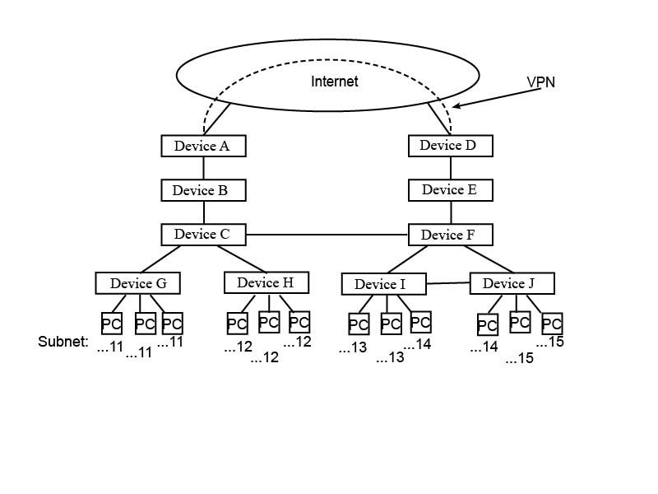
Device A = ____gateway____ Device F = ___router____
Device B = _____firewall_____ Device G = _____hub____
Device C = ____router______ Device H = ______hub___
Device D = _____gateway___ Device I = _______switch___
Device E = ____firewall_______ Device J = _____switch_____

