Help.

Add widgets to display the Profile Page:

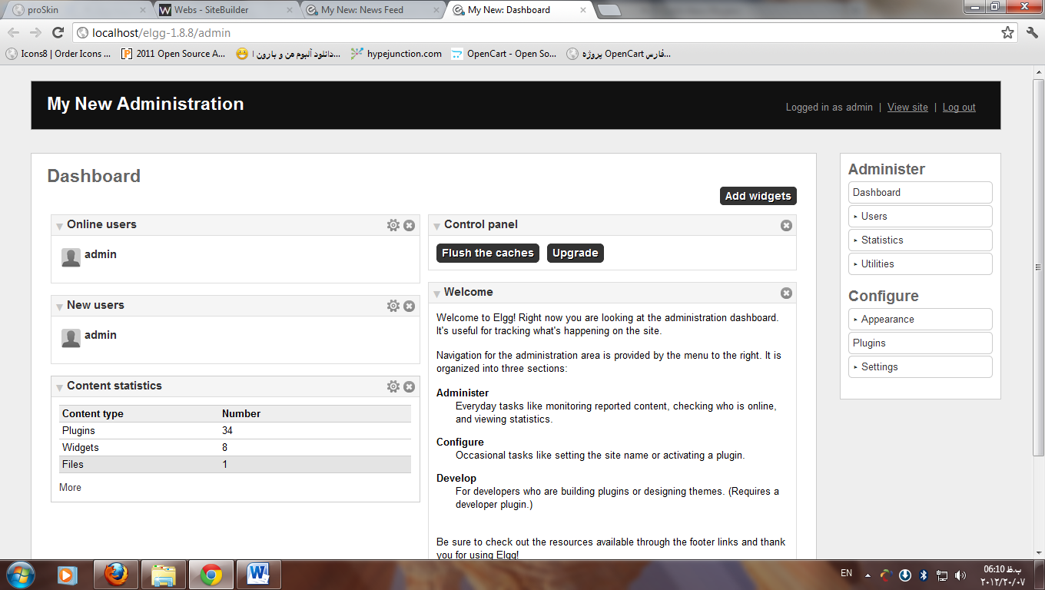1_ to site backend

# 2_ Appearance → Default Widgets→ Add widgets

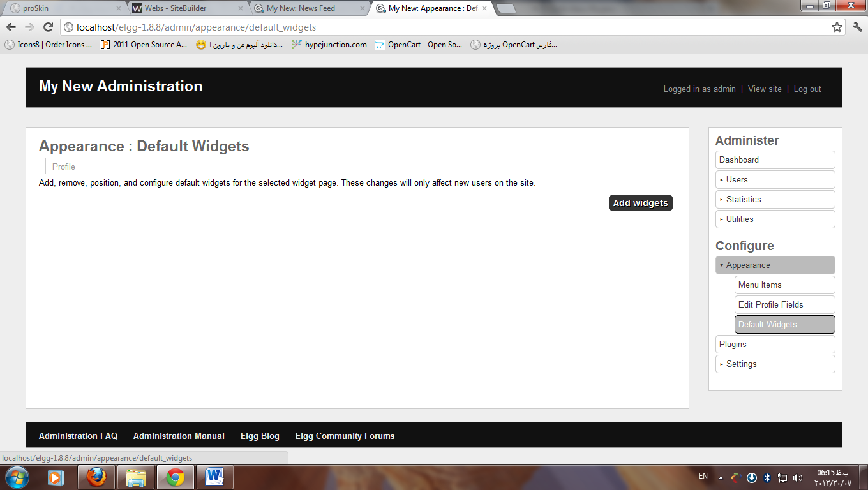

Please note:

After selecting the widget, the new registered users can see this widget.

For developers and Web designers

Display Add widget button

proSkin_theme\views\default\page\layouts → two_sidebar.php →

line37: // $show_add_widgets = elgg_extract('show_add_widgets', $vars, true);

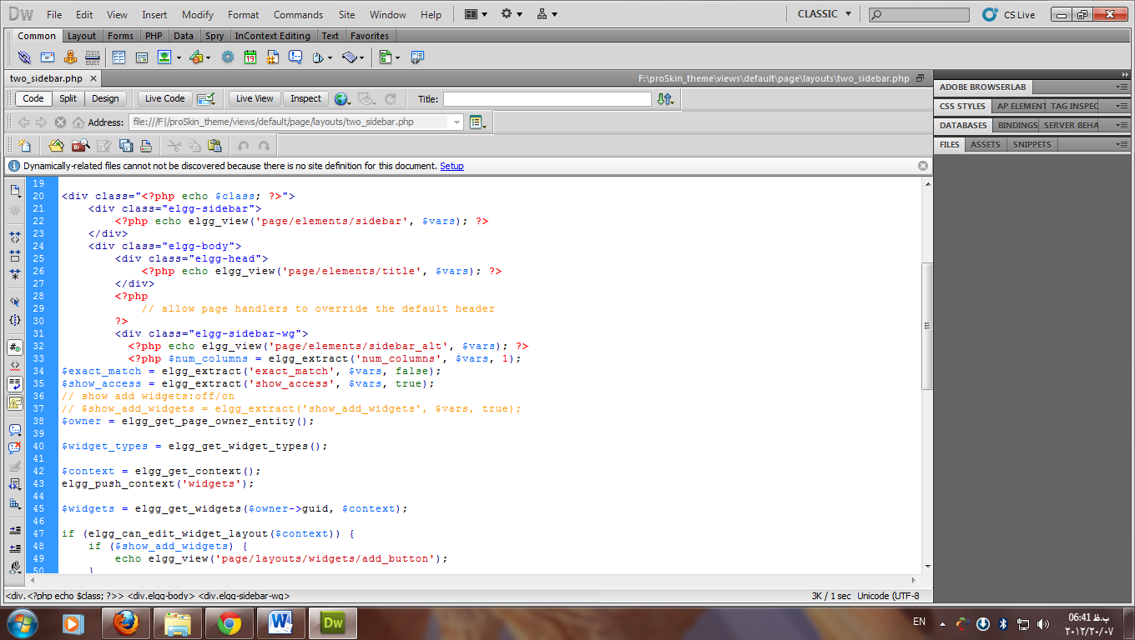

Please note:

this is not an option for users (Only for developers, designers or webmasters are)



By Saeid Iltork.