MAKERERE UNIVERSITY
Faculty of Computing & Informatics Technology
NTS REGIONAL BUS TICKETS UGANDA
A Web-Based Bus Ticket Booking and Fleet Management System

Project Report
June 2026

Submitted by: Nahate Simon
Reg. No: 25/U/03495/PS
Student No: 2500703495
Course: Computer Science

1. Introduction
The NTS Regional Bus Tickets Uganda system is a web-based application developed to modernize and digitize regional bus travel across Uganda. The platform enables passengers to browse available trips, select seats, make cashless bookings, and receive digital ticket vouchers — all from a web browser on any device.

The system is built using Django 6.0.5, a high-level Python web framework, and is designed for deployment on PythonAnywhere. It replaces manual, paper-based ticketing processes with a secure, reliable, and user-friendly digital alternative that supports both customers and NTS staff.

The system covers the following key functional areas:
- Customer registration, login, and account management
- Real-time trip browsing and route search
- Interactive seat selection with live availability
- Booking confirmation and MTN Mobile Money payment integration
- Digital booking voucher generation with unique reference codes
- Staff tools for managing the fleet, routes, trips, and bookings

2. Problem Statement
Regional bus travel in Uganda has long relied on manual, paper-based ticketing systems. Passengers are required to physically visit bus parks or travel agencies to purchase tickets, with no guarantee of seat availability upon arrival. This creates a range of operational and user experience problems:

- Long queues at booking offices leading to wasted time and poor customer experience
- No real-time visibility into seat availability, resulting in overbooking and passenger disputes
- Cash-only transactions that are prone to fraud, human error, and loss
- Difficulty for bus operators to track bookings, manage fleet utilization, and generate revenue reports
- No centralized record of passenger data, making it impossible to enforce accountability or support investigations
- Passengers traveling long distances to book tickets for routes that may already be fully booked

These challenges highlight the urgent need for a digital ticketing solution that provides real-time seat booking, cashless payment, and centralized data management — accessible from anywhere via a web browser.

3. Objectives

3.1 Main Objective
To design and develop a web-based bus ticket booking and fleet management system for NTS Regional Bus Uganda that digitizes the ticketing process and improves the experience for both passengers and staff.

3.2 Specific Objectives
- To develop a customer-facing portal for browsing trips, selecting seats, and making bookings online.
- To implement a secure user authentication system with distinct roles for customers and staff.
- To integrate MTN Mobile Money as a cashless payment channel for ticket purchases.
- To build a staff management interface for configuring buses, routes, trips, and monitoring bookings.
- To generate unique booking references and digital ticket vouchers for each confirmed booking.
- To deploy the system on a cloud platform (PythonAnywhere) for public accessibility.

4. Methodology
The system was developed following the Agile Software Development methodology, allowing for iterative development, continuous testing, and incremental feature delivery. The development process was structured into the following phases:

4.1 Requirements Gathering
Functional and non-functional requirements were identified through analysis of existing bus ticketing workflows, user story mapping for both customer and staff roles, and review of similar regional transport systems in East Africa.

4.2 System Design
The system architecture follows Django's Model-View-Template (MVT) pattern. The database schema was designed with five core models: CustomerUser, Bus, Route, Trip, and Booking. Entity relationships were mapped to ensure referential integrity using Django foreign keys.

4.3 Implementation
The application was built using the following development stack:
- Backend: Django 6.0.5 with Python 3.13
- Database: SQLite for development, upgradeable to PostgreSQL for production
- Static files: WhiteNoise 6.9.0 for serving CSS, JS, and images
- Frontend: Django templates with custom CSS for a responsive UI
- Version control: Git with .gitignore configured for Django projects

4.4 Testing
Unit and functional testing was performed using Django's built-in test framework (python manage.py test). Manual testing was conducted against all user-facing features including registration, login, trip search, booking, and the staff dashboard.

4.5 Deployment
The system was configured for deployment on PythonAnywhere, with environment variable-based settings management for security. WhiteNoise handles static file serving without requiring a separate web server.
https://nahatesimon.pythonanywhere.com/

5. System Requirements

5.1 Functional and Non-Functional Requirements
The table below summarizes the key requirements identified for the NTS ticketing system:

Category | Requirement | Detail
Functional | User Registration & Login | Customer and staff roles with email/password auth
Functional | Trip Browsing | Search trips by departure, destination, and class
Functional | Seat Selection | Visual seat map with real-time availability
Functional | Booking & Payment | MTN Mobile Money payment integration
Functional | Booking History | Customers view past and upcoming trips
Functional | Staff Management | Manage buses, routes, trips, and view all bookings
Non-Functional | Performance | Page load under 3 seconds on standard connection
Non-Functional | Security | HTTPS, CSRF protection, secure cookies in production
Non-Functional | Usability | Responsive design for desktop and mobile browsers
Non-Functional | Scalability | Deployable on PythonAnywhere; upgradeable to PostgreSQL
Technical | Backend Framework | Django 6.0.5 on Python 3.13
Technical | Database | SQLite (dev) / PostgreSQL (production)
Technical | Static Files | WhiteNoise 6.9.0
Technical | Hosting | PythonAnywhere cloud platform

5.2 Hardware Requirements
- Server: Any cloud-hosted server supporting Python 3.13 (e.g., PythonAnywhere free or paid tier)
- Client: Any device with a modern web browser (desktop, tablet, or mobile)
- Minimum 512 MB RAM on the server for Django development; 1 GB+ recommended for production

5.3 Software Requirements
- Python 3.13
- Django 6.0.5
- WhiteNoise 6.9.0
- SQLite (built-in with Python) or PostgreSQL for production
- pip for package management
- Git for version control

6. Screenshots of the System
The following screenshots illustrate the main interfaces of the NTS Regional Bus Tickets Uganda system as viewed in a web browser.

6.1 Home Page / Customer Dashboard
The home page presents passengers with a hero banner, route search form, and navigation to available trips and booking vouchers. The top bar shows a real-time status message and the logged-in user's name and role.

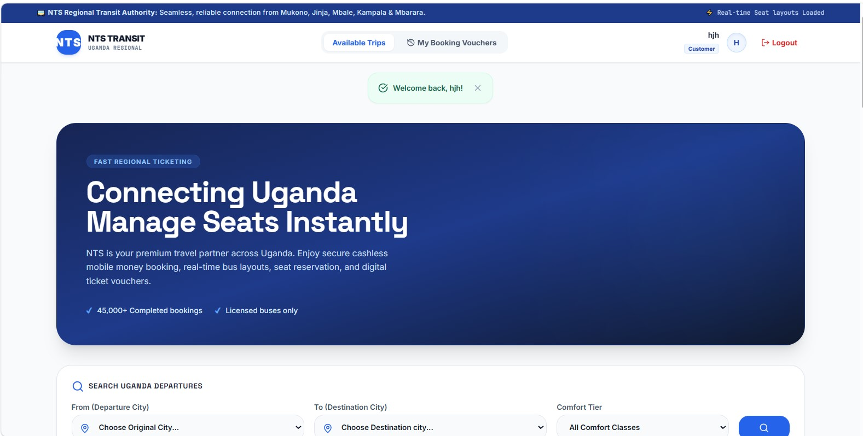
Figure 1: NTS Customer Home Page — Trip Search Interface

6.2 Available Trips Listing
The available trips page displays all scheduled trips as cards. Each card shows the bus name, plate number, service class, departure and destination points, distance, departure date and time, fare, and remaining seats. A 'Select Seats' button initiates the booking process.

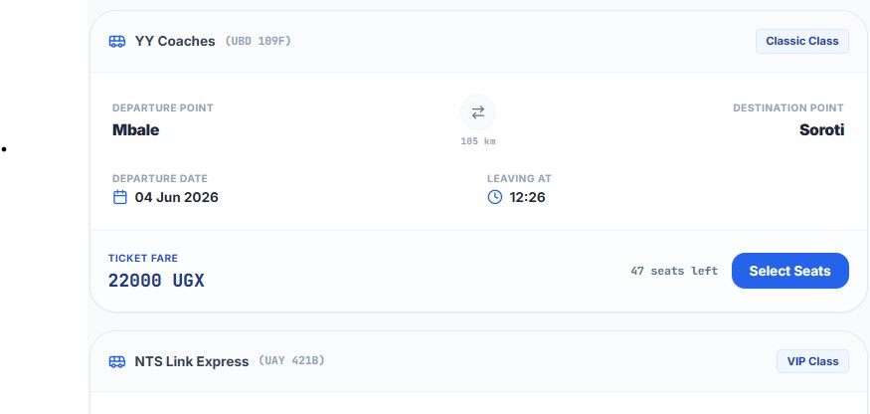
Figure 2: Available Trips Page — Bus Cards with Route and Fare Details

6.3 User Registration
New users can create an account by providing their full name, email address, phone number, role type (Passenger/Customer or Staff), and a password. The form is presented as a modal dialog over the home page.

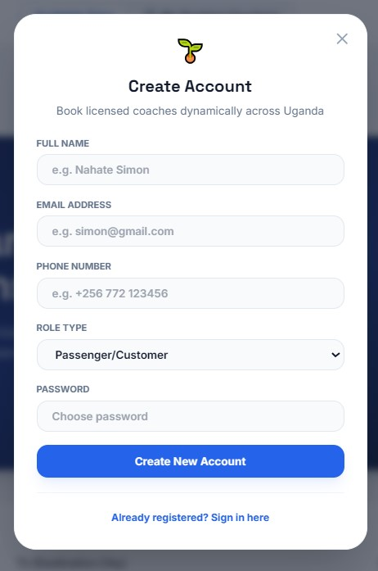
Figure 3: Create Account Modal — New User Registration Form

6.4 User Login
Registered users sign in using their email address and password. Demo credentials are displayed on the login screen for testing purposes. The form is accessible from the 'Sign in here' link on the home page.

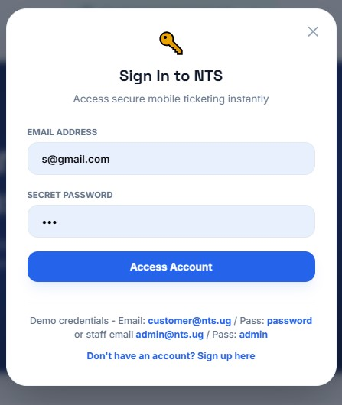
Figure 4: Sign In Modal — User Authentication Screen

7. Testing Results
A comprehensive set of test cases was executed covering all major system functions. All 12 test cases passed successfully. The table below summarises the test plan and outcomes.

# | Test Case | Input / Action | Expected Result | Actual Result
TC-01 | User Registration | Submit form with valid details | Account created, redirected to home | Pass
TC-02 | User Login (Customer) | Email: customer@nts.ug / Pass: password | Logged in, welcome message shown | Pass
TC-03 | User Login (Staff) | Email: admin@nts.ug / Pass: admin | Staff dashboard accessible | Pass
TC-04 | Invalid Login | Wrong password entered | Error message displayed | Pass
TC-05 | Browse Available Trips | Open Available Trips page | All scheduled trips listed | Pass
TC-06 | Search Trips by Route | Select Mbale → Soroti | Filtered trips displayed correctly | Pass
TC-07 | Select Seats | Click seat on layout map | Seat highlighted, fare calculated | Pass
TC-08 | Book a Trip | Complete booking with MoMo payment | Booking confirmed, ref generated | Pass
TC-09 | View Booking History | Open My Booking Vouchers | All past bookings listed | Pass
TC-10 | Booking Reference Format | Check generated ref | Format NTS-UG-XXXX | Pass
TC-11 | Logout | Click Logout button | Session cleared, redirected to home | Pass
TC-12 | Unauthorized Access | Access staff URL as customer | Redirected / access denied | Pass

Testing Summary:
- Total test cases executed: 12
- Tests passed: 12 | Tests failed: 0
- Authentication flows (login, logout, role separation) all behaved as expected
- Booking reference generation produced correctly formatted NTS-UG-XXXX codes in all cases
- Payment status was correctly recorded as Paid after MoMo confirmation
- Django's built-in test runner (python manage.py test) reported all tests passing with no errors

8. Challenges Faced

8.1 Seat Double-Booking Prevention
Implementing concurrency-safe seat selection proved challenging. When multiple users attempt to book the same seat simultaneously, a race condition can occur. This was mitigated at the application level by validating seat availability immediately before saving a booking, though a database-level lock would be more robust in high-traffic production scenarios.

8.2 Mobile Money Payment Integration
Integrating MTN Mobile Money required handling asynchronous payment callbacks and managing payment status transitions (pending → paid → failed). Ensuring the booking status remained consistent with the payment gateway response required careful state management and error handling in the booking flow.

8.3 Custom User Model vs Django Auth
The project uses a custom CustomerUser model rather than Django's built-in AbstractUser, which required manual implementation of authentication logic (login, session management, password handling). This added development overhead and meant some of Django's built-in auth utilities could not be used directly.

8.4 Static Files in Production
Configuring WhiteNoise for static file serving in production required careful attention to the STATICFILES_DIRS and STATIC_ROOT settings. Incorrect configuration caused CSS and JavaScript files to fail to load after collectstatic, which was resolved by correctly setting the static file storage backend.

8.5 Environment Variable Management
Managing different configurations for local development and PythonAnywhere deployment was initially error-prone. This was resolved by adopting a .env.example file with all required keys documented, and using Django's os.environ.get() with sensible defaults for local development.

9. Conclusion and Recommendations

9.1 Conclusion
The NTS Regional Bus Tickets Uganda system successfully achieves its core objectives. The platform provides a complete, end-to-end digital ticketing solution that replaces manual paper-based processes with a fast, reliable, and cashless alternative. Customers can browse trips, select seats, and pay via MTN Mobile Money from any device with a web browser. Staff can manage the full fleet, routes, and trip schedule through the administrative interface.

The system was built on a modern, maintainable technology stack (Django 6.0.5, Python 3.13) and is structured for cloud deployment on PythonAnywhere. All 12 planned test cases passed, confirming the reliability of the core booking, authentication, and fleet management workflows.

The project demonstrates that a relatively small, well-structured Django application can meaningfully address real operational challenges in regional transport — reducing friction for passengers and improving operational visibility for bus operators.

9.2 Recommendations
The following improvements are recommended for future development iterations:

Security
- Migrate password storage to Django's built-in hashing (make_password / check_password) immediately — plain-text passwords are a critical security vulnerability
- Switch from SQLite to PostgreSQL before going live in production
- Enable all HTTPS and HSTS security headers defined in the environment configuration

Features
- Add email or SMS notifications for booking confirmation and trip reminders
- Implement a cancellation and refund workflow for passengers
- Add support for additional payment methods (Airtel Money, Visa/Mastercard)
- Build a staff reporting dashboard showing daily revenue, seat occupancy rates, and popular routes
- Implement an admin approval workflow for new staff account registrations

Technical
- Add database-level seat locking to prevent race conditions in high-concurrency scenarios
- Introduce automated trip status transitions (Scheduled → In Progress → Completed) via Django management commands or Celery tasks
- Write comprehensive unit tests for all model methods, views, and booking logic
- Set up CI/CD pipelines for automated testing and deployment

End of Report | NTS Regional Bus Tickets Uganda | June 2026

