Saparbek Imanzhussip SE-2226

**LAB_WORK 2. INTRODUCTION TO THE MONGODB CONSOLE AND HOW TO INTERACT WITH THE DATABASE.**

**Objectives and Goals**

* Lab Objective: Familiarize oneself with the mongo console and utilities for interacting with the mongo database.
* Lab Goals: Gain proficiency in using the mongo console and third-party user interfaces for interacting with the mongo database.  
    
    
  **1.What are some ways to interact with the mongo database?**

There are several ways to interact with the MongoDB database, including:

* Using the mongo console: This is an interactive JavaScript interface shell for MongoDB that provides a powerful interface for system administrators and developers to test queries and operations directly with the database.
* Using drivers: MongoDB provides drivers for various programming languages, including Java, Python, Ruby, and Node.js. These drivers allow developers to interact with the database through their code.
* Using third-party graphical utilities: There are various graphical utilities developed by third-party firms that allow users to interact with the MongoDB database through a visual interface.
* Using HTTP or REST interfaces: MongoDB can also be interacted with via HTTP using either an HTTP or REST interface.

**2.Is it possible to interact with the mongo database through the WEB?**

Yes, it is possible to interact with the MongoDB database through the web using HTTP or REST interfaces. MongoDB provides a REST API that allows users to interact with the database using HTTP requests. Additionally, there are various third-party web-based interfaces available that allow users to interact with the MongoDB database through a web browser. These interfaces provide a visual interface for performing administrative functions and querying the database.

**3.What features does MongoDB Compass have?**

The features of MongoDB Compass include:

* Full CRUD functionality
* Query and aggregation pipeline execution
* Index management
* Schema analysis
* Real-time server stats
* Document validation rules
* Error reporting and data usage collection
* Automatic updates

**4.Describe the MongoDB Compass application interface.**

The MongoDB Compass application interface provides a user-friendly environment for interacting with MongoDB data. It includes navigation panels for browsing databases, collections, and documents, a visual query builder for constructing MongoDB queries, a document viewer for inspecting and editing data, tools for managing indexes, real-time server statistics, schema analysis features, and support for CRUD operations.

**5.What is the format of the command line commands?**

The format of the command line commands in MongoDB follows the syntax:

```<database object>.<collection>.<function> (<parameter list>)```

The parameter list is in JSON format and is used to specify the parameters for the command. Each command is applied to a specific database object, collection, and function, allowing for precise interaction with the MongoDB database.

**Screen Laboratory work:**

Import the companies.json to the COMPASS

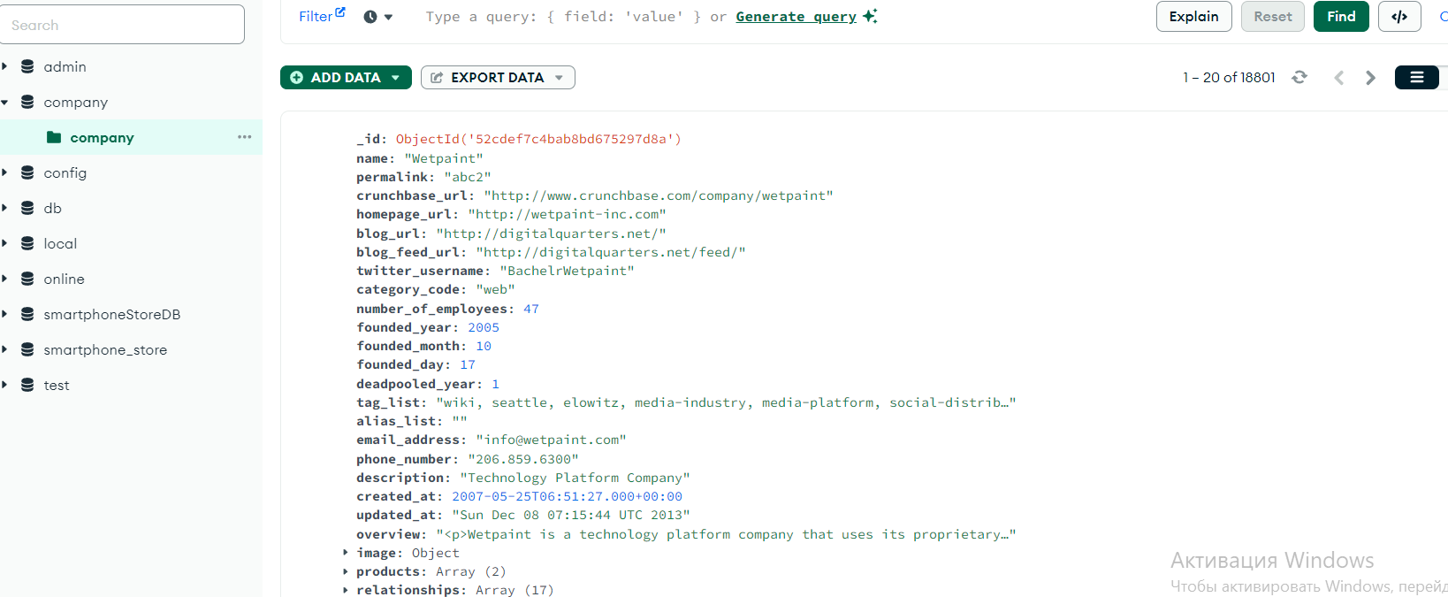

1. Find all the companies that include 'Facebook' on the name field.

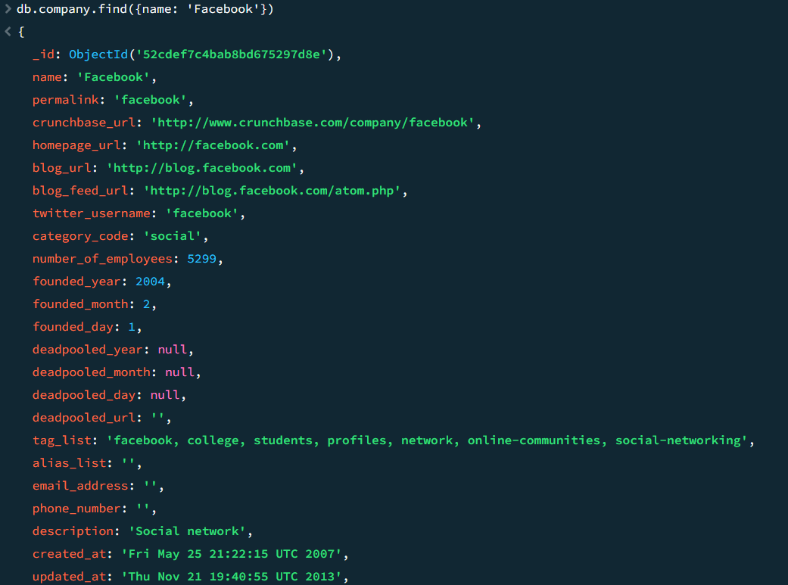

2 Find all the companies which category_code is 'web'. Retrive only their name field:

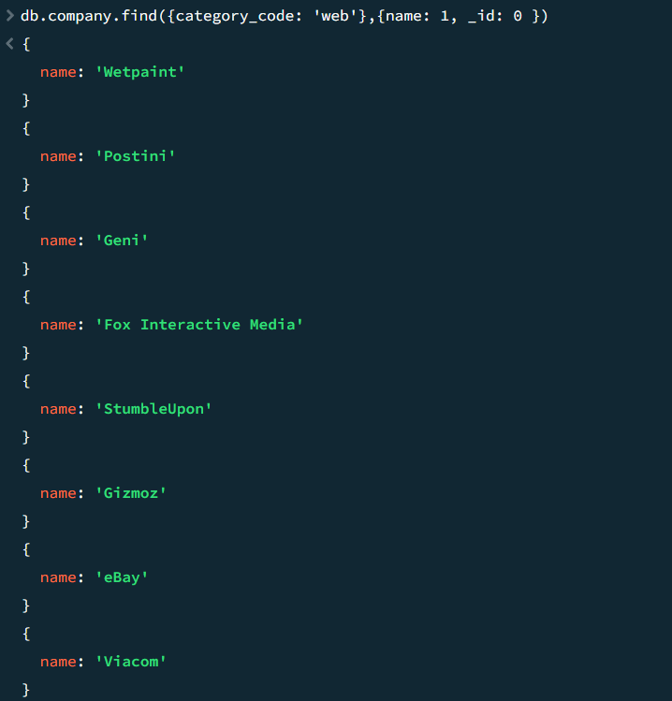

3. Find all the companies named "Twitter", and retrieve only their name, category_code and founded_year fields.

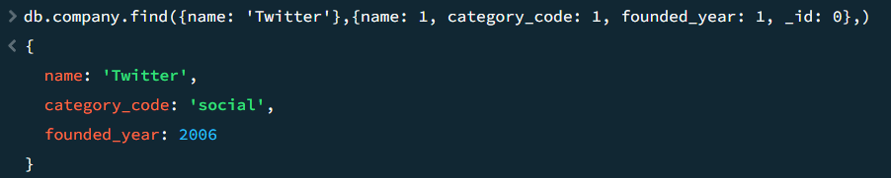

4. Find all the companies who have web as their category_code, but limit the search to 50 companies.



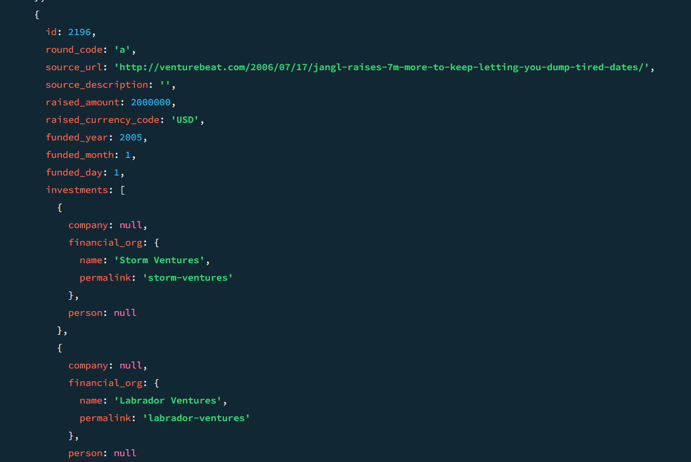

5.Find all the companies which category_code is 'enterprise' and have been founded in 2005. Retrieve only the name, category_code and founded_year fields

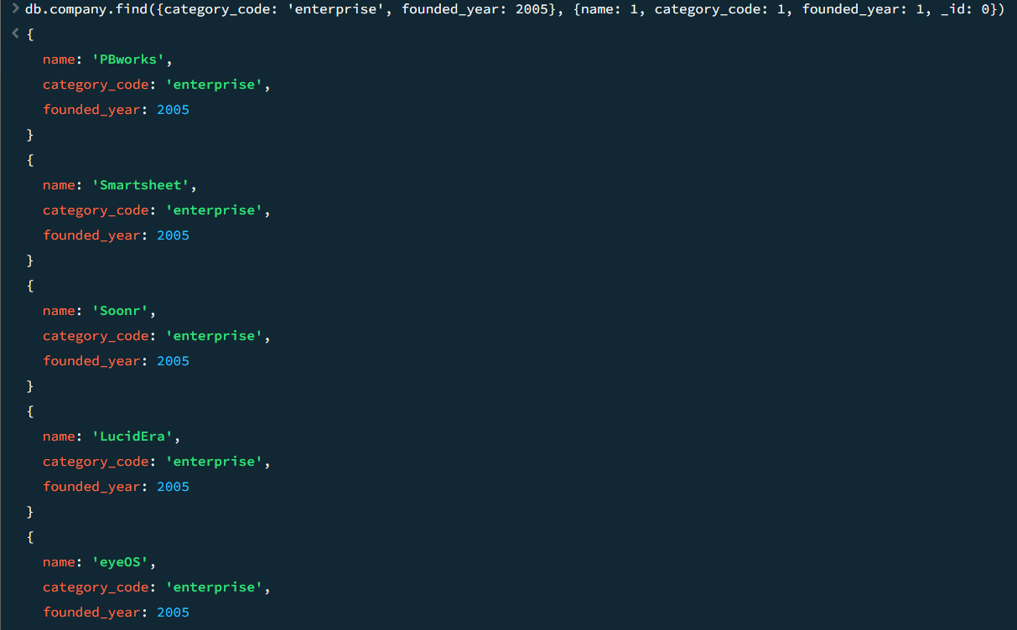

6. Find all the companies that have been founded on the 2000 or have 20 employees. Sort them descendingly by their number_of_employees.



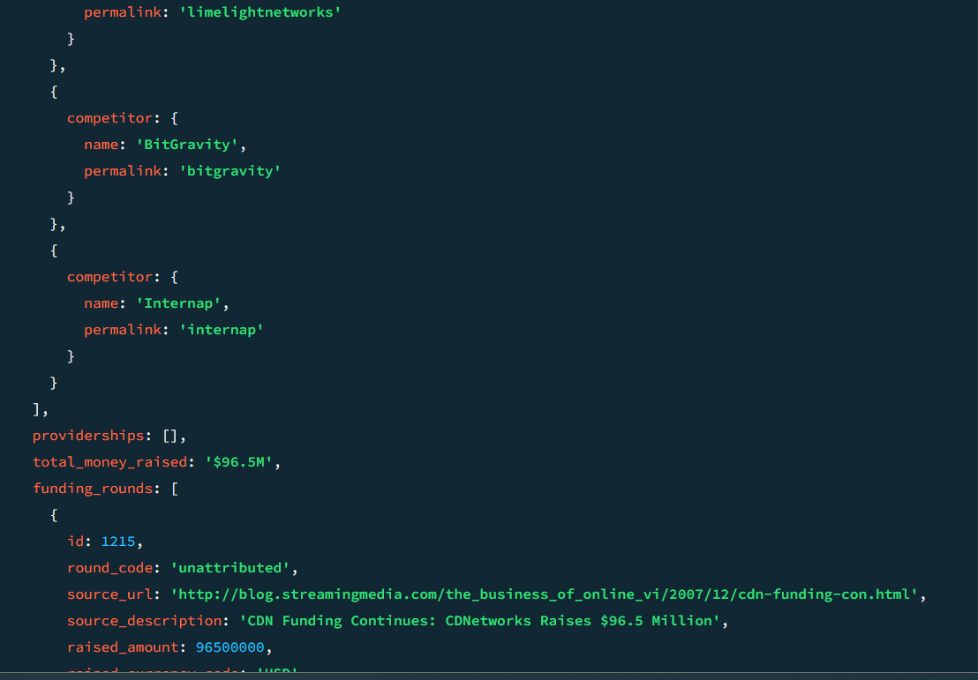

7. Find all the companies that do not include web nor social on their category_code. Limit the search to 20 documents and retrieve only their name and category_code.

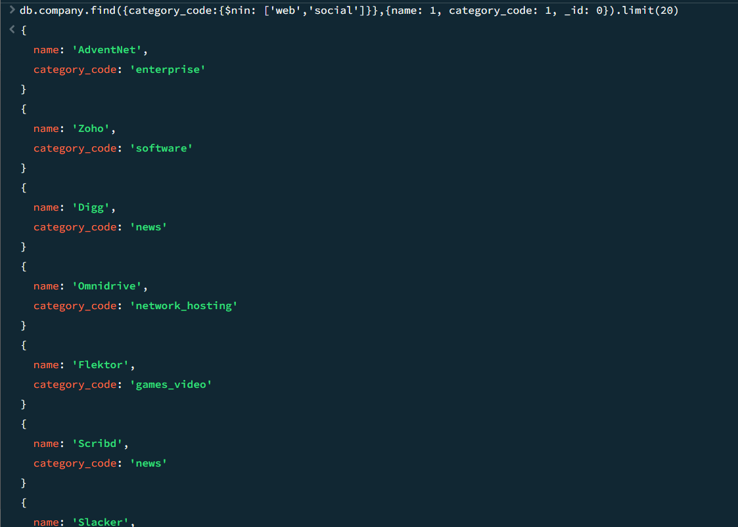

8. Find all the companies that were not founded on 'June'. Skip the first 50 results and retrieve only the founded_month and name fields.

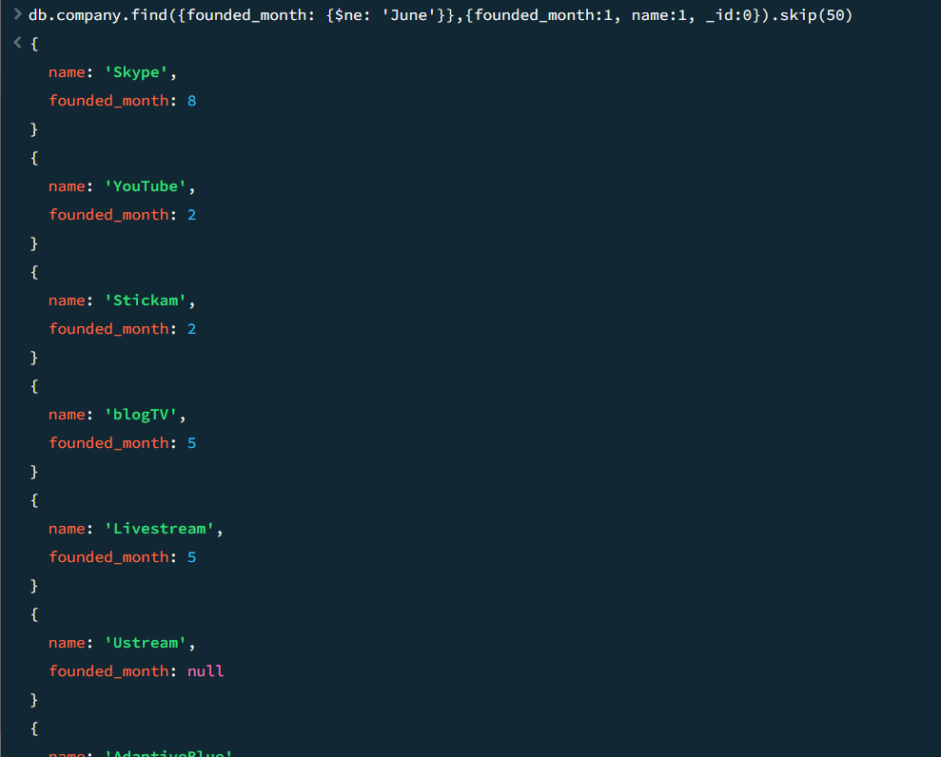

9. Find all the companies that have 50 employees, but do not correspond to the 'web' category_code.



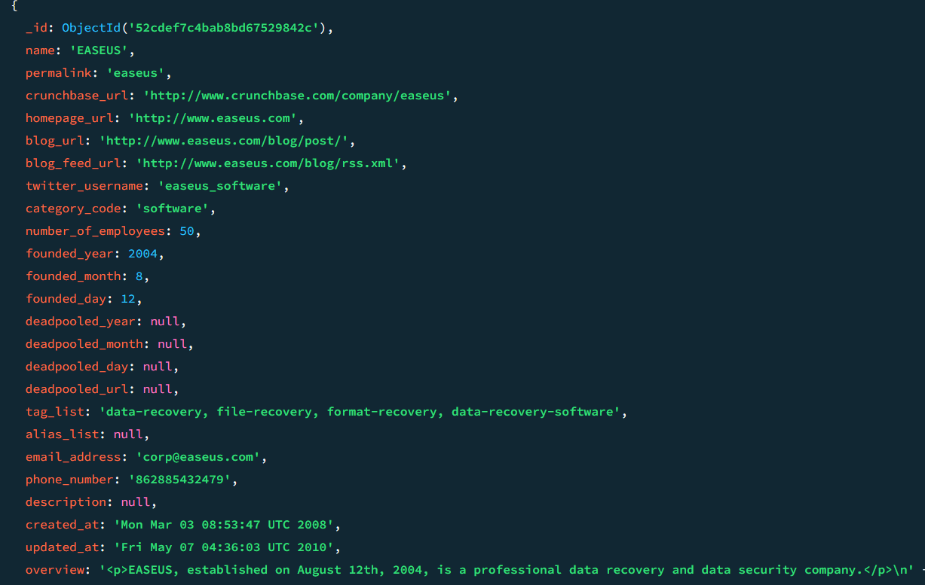

10. Find all the companies that have been founded on the 1st of the month, but does not have either 50 employees nor 'web' as their category_code. Retrieve only the founded_day and name and limit the search to 5 documents.

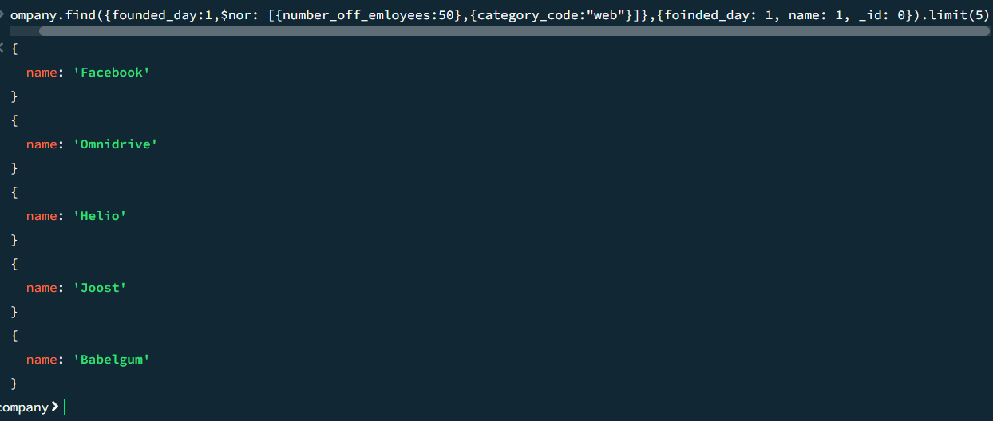

11. Find all the companies which the price_amount of the acquisition was 40.000.000. Sort them by name.



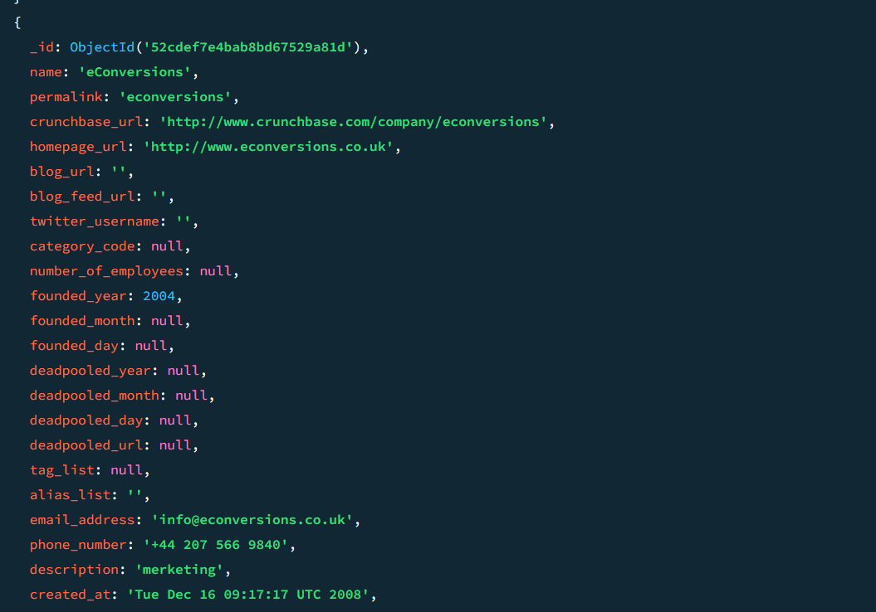  
12. Find all the companies that have been acquired on January of 2014. Retrieve only the acquisition and name fields.

