**Report on Observer and Factory Patterns Implementation**

**1.Introduction:**

* This report discusses the implementation of the Observer and Factory Patterns in a real-world scenario. These design patterns are fundamental in object-oriented programming and have been applied to a scenario related to a chat system.

**2.Observer and Factory Patterns:**

* **Observer Pattern:** The Observer Pattern is a behavioral design pattern where an object (subject) maintains a list of its dependents (observers) and notifies them of any state changes, usually by calling one of their methods. It is used for handling distributed event handling systems.
* **Factory Pattern:** The Factory Pattern is a creational design pattern that provides an interface for creating objects but allows subclasses to alter the type of objects that will be created. It abstracts the process of object creation.

**3.Chosen Real-World Scenario:**

* The chosen scenario is a chat system. In this context:
* **Observer Pattern** is applied to notify users of new messages in a chat room.
* **Factory Pattern** is applied to create different types of chat rooms, such as public and private chat rooms, with varying behaviors.

**4.Application of Observer and Factory Patterns:**

**Observer Pattern Application:**

* **Subject:** In our scenario, the **ConcreteChatRoom** class acts as the subject, maintaining a list of users (observers).
* **Observer:** The **ChatUser** class represents the observers who want to be notified when messages are sent in the chat room.
* **Concrete Subject:** The **ConcreteChatRoom** class implements the specific chat room where events (messages) are produced.
* **Concrete Observer:** The **ChatUser** class implements the observers' reactions to specific events (messages).

**Factory Pattern Application:**

* **Product:** The **ChatRoomType** interface defines the product interface.
* **Concrete Product(s):** **PublicChatRoom** and **PrivateChatRoom** classes are concrete implementations of chat rooms with distinct behaviors.
* **Factory:** The **ChatRoomFactory** interface defines the factory interface.
* **Concrete Factory:** The **ChatRoomFactoryImpl** class implements the creation of specific chat rooms.

**5.Code Screenshots with Explanations:**

**Observer Pattern:**

* **ConcreteChatRoom** class maintains the list of users (observers) and notifies them of messages. 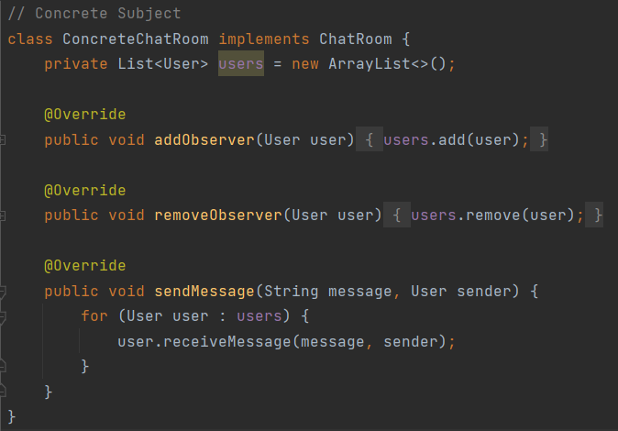
* **ChatUser** class represents users who receive and react to messages. 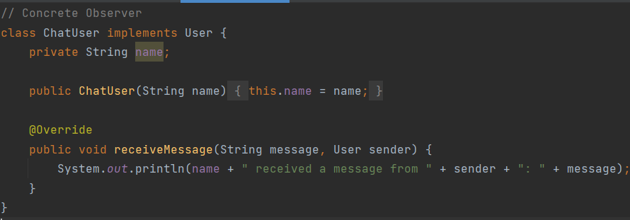

**Factory Pattern:**

* **ChatRoomType** and **Concrete Product(s)** define the product interface and specific implementations.

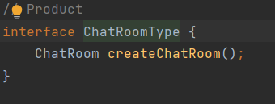

* **ChatRoomFactory** and **Concrete Factory** handle the creation of chat rooms. 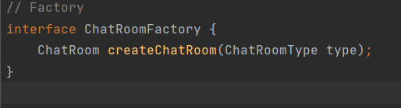

**6.Reflection on Challenges and Benefits:**

**Challenges:**

* Implementing the Observer Pattern correctly is essential to avoid infinite notification loops, as shown by the need to exclude the sender from notifications.
* Coordinating different chat room behaviors created by the Factory Pattern can be complex, depending on the requirements.

**Benefits:**

* The Observer Pattern enables a decoupled and efficient way to notify users of new messages without requiring them to actively check for updates.
* The Factory Pattern allows for dynamic creation of different chat room types, making the system more extensible. New chat room types can be added without modifying existing code.

In conclusion, the Observer and Factory Patterns have been successfully applied to a chat system scenario. The Observer Pattern efficiently handles notifications of messages, while the Factory Pattern allows the creation of chat rooms with diverse behaviors, making the system more extensible and maintainable. Challenges included avoiding infinite loops, but the benefits in terms of flexibility and modularity make these patterns valuable in this context.