1.

|  |  |  |  |  |  |  |  |  |  |
| --- | --- | --- | --- | --- | --- | --- | --- | --- | --- |
|  | a | b | c | d | e | f | g | h | I |
| A | 0 | 1 | 1 | 1 | 0 | 0 | 0 | 0 | 0 |
| B | 1 | 0 | 1 | 1 | 0 | 0 | 0 | 0 | 0 |
| C | 1 | 1 | 0 | 1 | 0 | 0 | 0 | 0 | 0 |
| D | 1 | 1 | 1 | 0 | 0 | 1 | 0 | 0 | 0 |
| E | 0 | 0 | 0 | 0 | 0 | 1 | 0 | 0 | 0 |
| F | 0 | 0 | 0 | 1 | 1 | 0 | 0 | 0 | 0 |
| G | 0 | 0 | 0 | 0 | 0 | 0 | 0 | 1 | 1 |
| h | 0 | 0 | 0 | 0 | 0 | 0 | 1 | 0 | 0 |
| i | 0 | 0 | 0 | 0 | 0 | 0 | 1 | 0 | 0 |

Breadth from b: bacdfe

ghi

Dept from b : bacdfe

2.

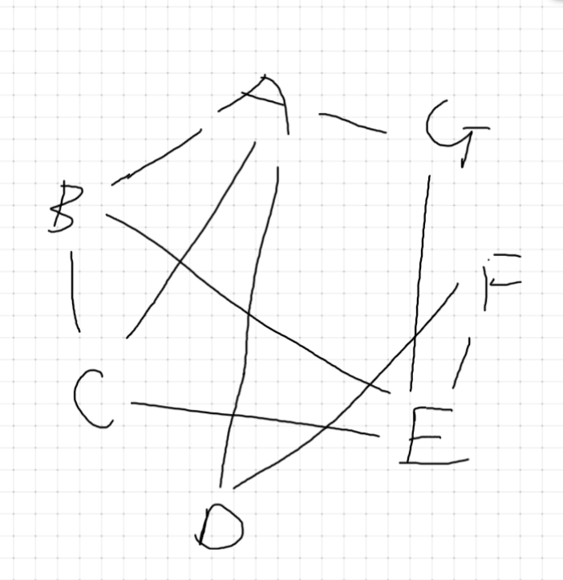

Breadth from a : abcefgd

3.

Breadth from a: abcdfgehijk

Dept : abcdfge

4.

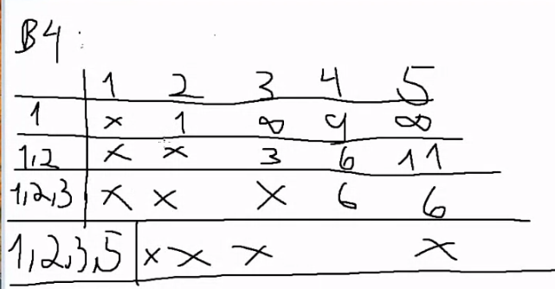

|  |  |  |  |  |
| --- | --- | --- | --- | --- |
|  | 2 | 3 | 4 | 5 |
| 1 | 1,1 | inf | 9,1 | Inf |
| 12 | - | 2,2 | 5,2 | 10,2 |
| 123 | - | - | 5,2 | 3,3 |
| 1235 |  |  |  |  |

5. nhan la 6

6.

|  |  |  |  |  |  |
| --- | --- | --- | --- | --- | --- |
|  | b | c | d | e | F |
| A | 7,a | 9,a | inf | 16,a | inf |
| ab | - | 9,a | 17,b | 16,a | inf |
| abc | - | - | 13,c | 2,c | inf |
| abce | - | - | 13,c | - | 9,e |
| abcef |  |  |  |  |  |

7. 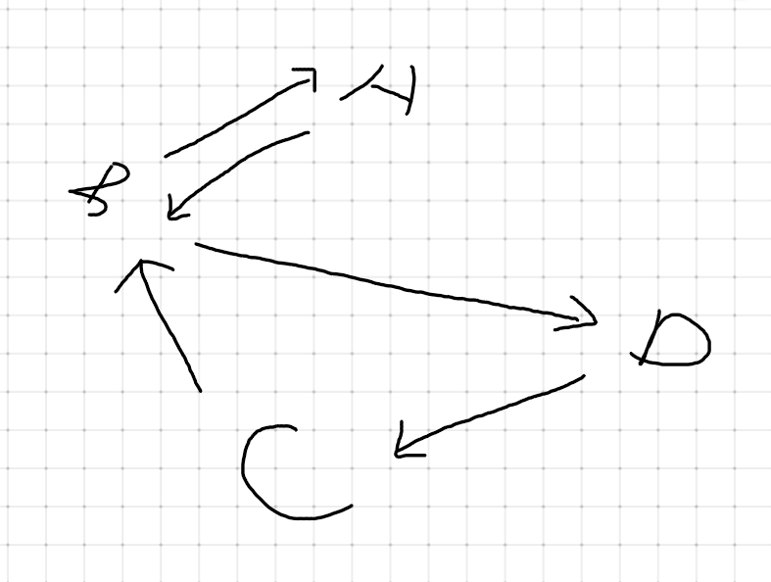

8. 