This study analyzes Google search trends to understand how public interest in major financial asset classes fluctuates in response to broader economic concerns. The four search terms selected for this analysis are "Gold Price," "Bitcoin Price," "Stocks," and "Inflation." These terms were chosen to represent distinct yet interconnected parts of the financial landscape and the public's reaction to it. Gold is viewed as a safe and traditional investment. Bitcoin is a newer and more volatile digital asset. Stocks are a common investment option, and inflation tells us how fast prices are increasing around the world. Because these financial concepts are related, their search trends often rise and fall during the same events.
Google Trends does not show actual price levels or market performance. Instead, it shows how often people search for these terms relative to the highest search interest point in the timeframe. The numbers scale from 0 to 100, with 100 meaning the most popular moment for that search. This allows us to see public interest and concern levels even when we do not know the exact number of searches. When search interest rises sharply, it often means that something major is happening in the world — such as market crashes, cryptocurrency booms, or economic fears — that makes people seek more information.
Over the ten-year period, several noticeable spikes in search interest appear in the graph, and each one connects to real economic events happening around the world. For example, in early 2020, the COVID-19 pandemic began, which caused major uncertainty and fear in global financial markets. Stock prices dropped very quickly, and many businesses closed temporarily. Because of this, many people searched for information about “stocks” to understand why the market was crashing and whether their money was safe. In 2017 and again in 2021, search interest for “bitcoin price” increased sharply. These peaks happened because bitcoin’s price rose to record highs, and the media talked about cryptocurrency as a new and exciting way to invest. This made many new investors curious about buying digital currency.
Search interest in “gold price” also increased during times when inflation was rising or when people felt unsure about the future of the economy. Gold is commonly viewed as a safe investment during times of crisis, so many searched to learn whether buying gold could help protect their savings. Meanwhile, interest in “inflation” was low before the pandemic. However, beginning in 2021, when the cost of everyday items like food, housing, and fuel began to rise, searches for inflation increased a lot. This continued into 2022 and 2023 as many countries experienced high living costs and supply chain. Overall, the graph shows a strong connection between financial stress and online search behavior. When people feel worried about money, investments, and prices, they go online to look for answers. The changes in search interest over time highlight how closely public attention follows major global economic.
For this analysis, I chose Worldwide data to understand global attention and concern. This broader view is important because financial issues such as inflation, market crashes, and cryptocurrency news are not limited to a single country. People all over the world use the internet to research financial decisions, and major events are experienced across continents due to globalization and international media coverage. By looking at worldwide data, we can better see how many different populations respond at the same time to shared financial pressures.
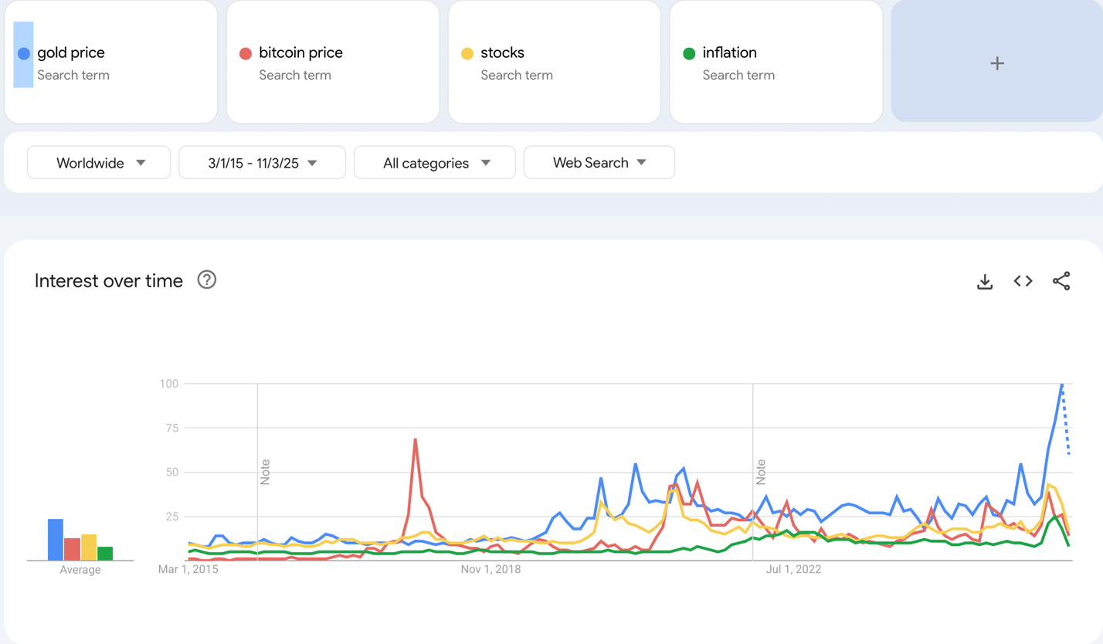
The graph shows that economy-wide shocks increase search interest across all four terms. During the pandemic in 2020, concerns about losing jobs, savings, and investments made people search for information about stocks and gold. Major global inflation concerns in 2022 and 2023 created strong search interest in inflation and “gold price,” as families around the world felt the cost of groceries, housing, and fuel rising quickly. Meanwhile, bitcoin captured public attention during technological and financial excitement — especially when large companies and investors publicly discussed cryptocurrencies. All these trends reinforce the idea that when people feel financially unsure, they try to learn more about investment options and economic threats.
World news strongly supports the patterns seen in the Google Trends graph. According to BBC News (2022), inflation levels rose rapidly after the pandemic due to supply shortages, higher demand, and the cost of shipping goods across borders. This concern led individuals and investors to look for alternatives to protect the value of their money. As a result, gold searches increased because gold is viewed as a stable asset during times of inflation. In addition, CNBC (2021) reported that bitcoin reached record price levels as large companies like Tesla and major investors showed support for cryptocurrency. This publicity explains the dramatic spikes in “bitcoin price” searches in 2017 and 2021, when many new people became interested in buying digital currency for the first time. These news findings show that search behavior changes based on major financial developments around the world.
Google Trends also provides related queries, such as “gold price today,” “crypto market,” “economic recession,” “stock market news,” and “inflation rate.” These related searches show that people are not just curious — they are actively trying to understand financial situations that could affect their daily lives. Many people search questions like “Is recession coming?” or “Should I invest in bitcoin?” which shows a direct connection between news events and personal decision making.
This study could be expanded in several useful ways. One option is to include additional financial terms such as “mortgage rates,” “US dollar value,” “retirement savings,” or “interest rates,” which are all important topics during inflation periods. Another improvement could be to compare different regions like North America, Europe, and Asia to see whether search patterns differ by country. Researchers could also connect search spikes to specific news headlines and financial reports to better understand timing and cause-and-effect. Finally, future studies could use the exported CSV data to perform statistical analysis on the size of spikes and how long public interest lasts. All these ideas would help deepen our understanding of how real-world events shape search behavior and financial

References

BBC News. (2022). Global inflation concerns rise as economic recovery slows. https://www.bbc.com

Reuters. (2025, July 14). Bitcoin climbs to record $123,153.22 as U.S. cryptocurrency policy advances.

Reuters. https://www.reuters.com/business/bitcoin-crosses-120000-record-high-2025-07-14/

