Sarcasm Detection in News Headline Data Using Data Mining Techniques
Introduction: In recent years sentiment analysis is very popular analyzing topic in the field of artificial intelligence specifically in machine leaning and data mining. Sentiment analysis is about to provide feelings to the machine. Some popular sentiment datasets are twitter review, restaurant review and some datasets about abusive contents. In this research we have chosen a dataset which contain news headlines of some articles along with labels which are a headline is sarcastic or not. We have applied two different data mining techniques as well as a deep learning approach for constructing a classifier for each method which can be classified after that between sarcastic or non sarcastic news headline and also for a comparative study among all those approaches.
Dataset Description: Our dataset is about News Headlines dataset for Sarcasm Detection which have been collected from two news website. TheOnion aims at producing sarcastic versions of current events and from those events collection has been done all the headlines from News in Brief and News in Photos categories (which are sarcastic) as well as real (and non-sarcastic) news headlines from HuffPos and rather have been uploaded a website name Kaggle and we have collected this dataset from there. This dataset has some advantages over twitter dataset like since news headlines are written by professionals in a formal manner, there are no spelling mistakes and informal usage. This reduces the sparsity and also increases the chance of finding pre-trained embeddings. Furthermore, since the sole purpose of TheOnion is to publish sarcastic news, it contain high-quality labels with much less noise as compared to Twitter datasets. Unlike tweets which are replies to other tweets, this obtained news headlines are self-contained. This would be helpful for teasing apart the real sarcastic elements. Every tuple of this dataset contain 3 attributes which are is_sarcastic: 1 if the record is sarcastic otherwise 0, headline: the headline of the news article and article_link: link to the original news article. Useful in collecting supplementary data.
Implementation Details: The dataset is in json format. We have read the data using pandas library and converts it into dataframe and later we have dropped one feature article link which is unnecessary in this analysis. Then we have preprocessed the data in following steps:
1. At first we have replaced all the non alphabatic letters through space of each records of the input feature using regular expression.
2. Then we have converted all letters into lower case letters and after that we tokenized a sentence word by word using split function.
3. Then we have applied portertemmer algorithm for word stemming .
4. After stemming we have joined all the stemmed word of a sentence again and saved it into a variable.
5. Then we have append above variable into a corpus list which is a collection of stopwords.
6. At last we have converted corpus string into a numeric array through countvectorizer and saved in a variable x. Which is our bag of words model. We saved the output label into a variable y.
Then we have split all the data and labels into training and testing data and labels ina ratio of 80: 20 . After that we have applied two different classification algorithm into training data which include decision tree and naive bayes and then a multilayer perceptron to the training dataset.
At first we have applied naive bayes with multinomial distribution in the training data and constructed a classifier then we have test the work of this classifier through test data. Then we have applied decision tree algorithm in training data. We have initialize the max_depth of the decision tree is 3 to reduce time and the complexity of memory allocation and we also have initialized random state 26 so that the training sequence of random sample cannot change after each iteration. After that we have test this constructed decision tree classifier through test data. At last we have applied multilayer perceptron with one input layer , one output layer and 6 hidden layers. We have initialized kernel_initializers of all the layers into uniform so that random weight is generated using uniform distribution for our model. We have used rectified linear unit activation function in all the hidden layers as well as input layer and sigmoid activation function for the output layer since we have a binary class in output label. We have used adam optimizer for optimizing error in training of our model and binary cross entropy loss function for having a binary class.
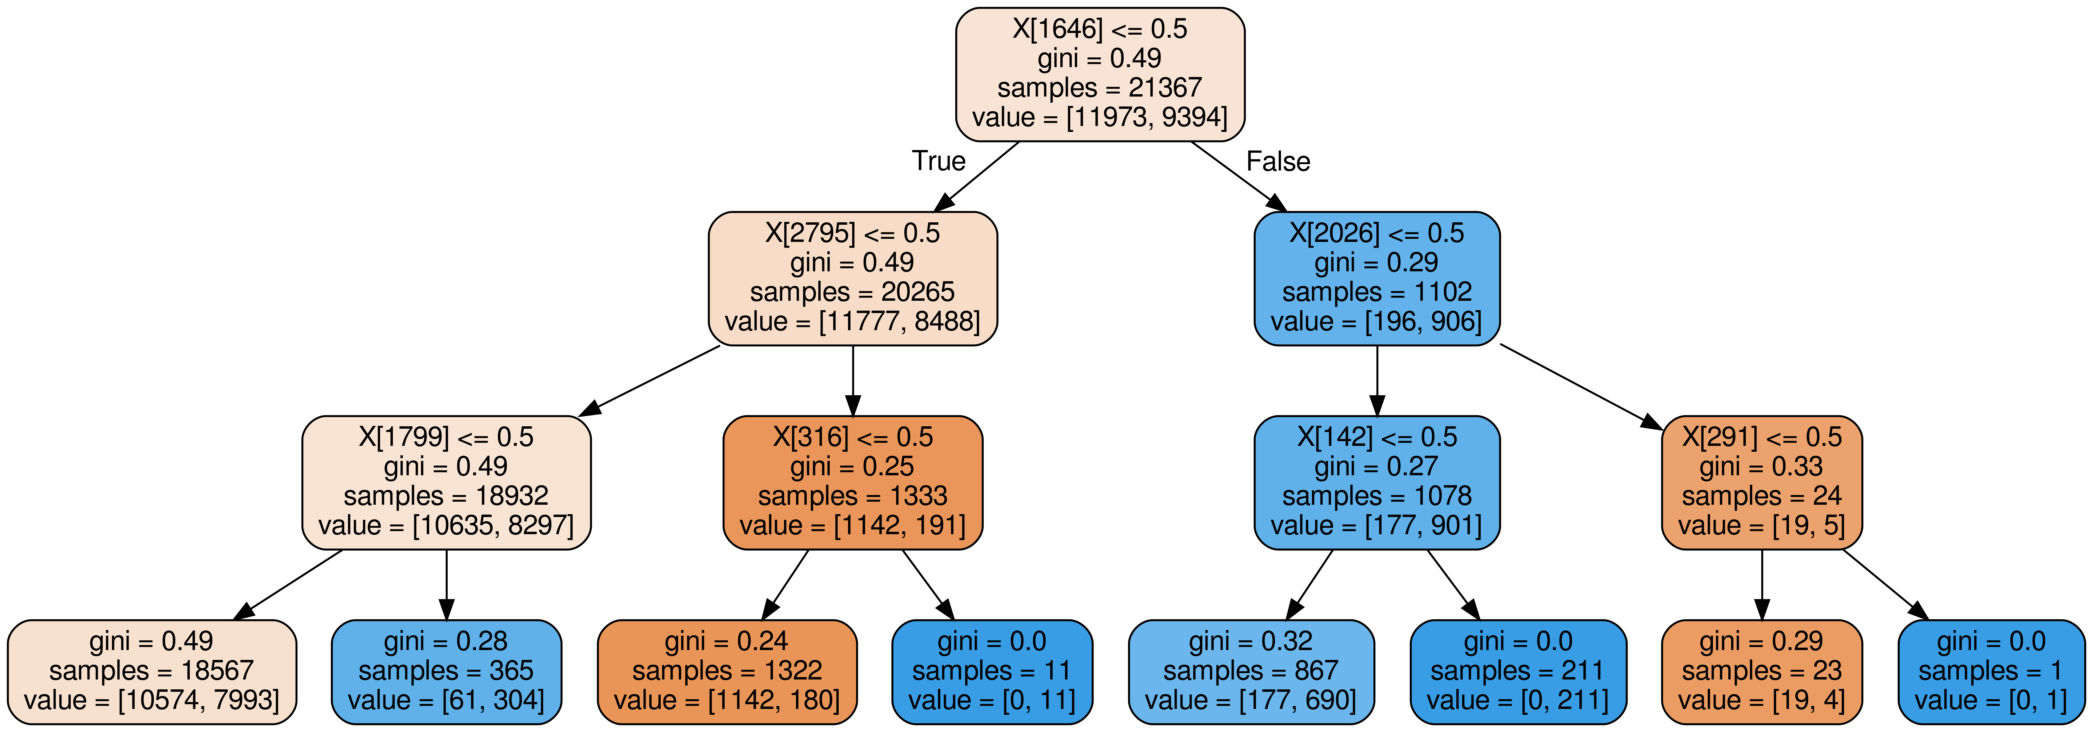
Figure1 : Constructed decesion tree model

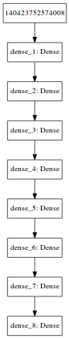

Figure 2 : Constructed Multilayer Perceptron Model
Result and Analysis : To evaluate the performance of the classifiers applied in this work, we use primary performance indicators based on confusion matrix shown in following tables . This matrix contains information about real and predicted classifications carried out by the classification models. Performance metrics of such systems are commonly evaluated using the information in the matrix.
Actual Class | Predicted Class
Actual Class |  | Yes | No
Actual Class | Yes | TP = 2365 | FN = 647
Actual Class | No | FP = 602 | TN = 1728

Table 1: Confusion Matrix of naive bayes classifier
Accuracy - measures the rate of the correctly classified instances.
Accuracy = (TP +TN) / (TP + FN + FP + TN) = (2365 +1728) / 5342 = 0.7661924372894046
Precision: It is the fraction of relevant instances among the retrieved instances. It is also called positive predictive.
Precision = TP / TP + FP = 2365 / (2365 + 602) = 0.80
Recall: It isthe fraction of relevant instances that have been retrieved over the total amount of relevant instances. It is also called positive sensitivity.
Recall = TP / TP + FN = 2365 / (2365 + 647) = 0.79
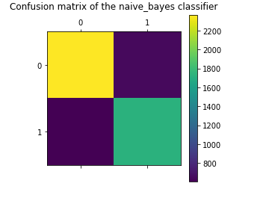

Actual Class | Predicted Class
Actual Class |  | Yes | No
Actual Class | Yes | TP = 2365 | FN = 647
Actual Class | No | FP = 602 | TN = 1728

Table 2: Confusion Matrix of decision tree classifier
Accuracy = (TP +TN) / (TP + FN + FP + TN) = (2365 +1728) / 5342 = 0.7661924372894046
Precision = TP / TP + FP = 2365 / (2365 + 602) = 0.80
Recall = TP / TP + FN = 2365 / (2365 + 647) = 0.79
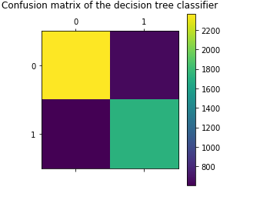

Actual Class | Predicted Class
Actual Class |  | Yes | No
Actual Class | Yes | TP = 2429 | FN = 583
Actual Class | No | FP = 599 | TN = 1731

Table 3: Confusion Matrix of mlp classifier
Accuracy = (TP +TN) / (TP + FN + FP + TN) = (2429 +1731) / 5342 = 77.87345563459378
Precision = TP / TP + FP = 2429/ (2429 + 599) = 0.80
Recall = TP / TP + FN = 2429 / (2429 + 583) = 0.81
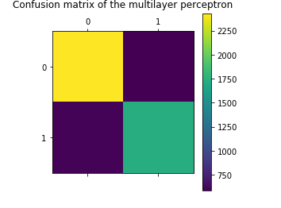

inevitability of precision,recall,F1score : In this analysis we want to measure how meaningful is a positive result from our constructed classifiers with respect to the baseline probabilities of this problem. Since this is a binary classification problem and we know that precision-recall work better rather than sensitivity and specificity when positive class is more interesting than the negative class in binary classification hence we have used precision-recall in this problem for our result analysis.F1 Score is the weighted average of Precision and Recall. This score takes both false positives and false negatives into account. F1 is usually more useful than accuracy. Accuracy works best if false positives and false negatives have similar cost. Since sometimes f1 score works better than accuracy and vice versa hence we have measured both F1 score and accuracy in this case.
Interpretation : In above case we have found same accuracy in testing data in case of decision tree and naive bayes which is 76.61% as well as same precision and recall 80% and 79% but when we have tested some samples collected randomly from this dataset both classifiers behave differently in same samples. We have choose 5 samples for our testing purpose and have fed both the naive bayes and decision tree classifier and we observed that the first classifier misclassified only one sample whereas the second classifier misclassified in two samples . In this observation we conclude that though they have generated similar confusion matrix but their behavior on each tuple is different. The multilayer perceptron model have provided highest accuracy with highest recall 77.87% and 81% respectively comparing above two classifiers but it is time consuming and complex . We only selected 10 epochs along with batch size 50 and we have reached 99.71% training accuracy after running 10 epochs but the average elapsed time of running of each epoch was 30 seconds which means total 300 seconds or five minutes have been passed for training this model which is a huge amount of time in this type of study. The structure is complex since we have 6 hidden layers and we have implemented 3000 neurons in input neuron and reduce into one in the output layer of the output neuron. Hence we conclude that in case of classifying accurately mlp is the best classifier among all three classifiers but in case of less complexity and timing the naive bayes and decision tree are better than nlp. In comparaing naive bayes with decision tree we cannot say which will be a better classifier.
Graph of comparative analysis : 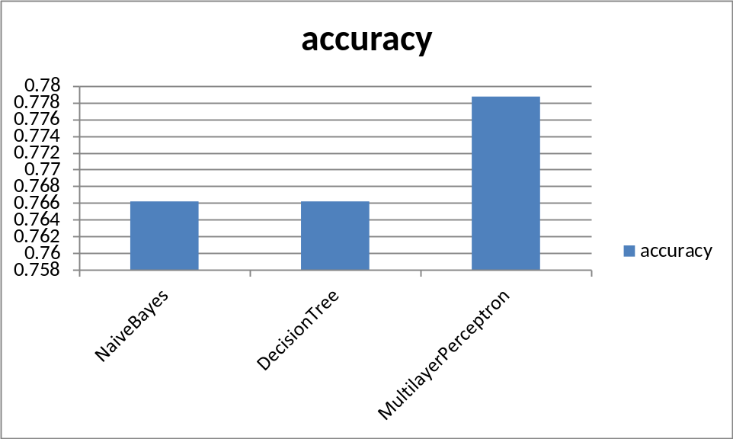
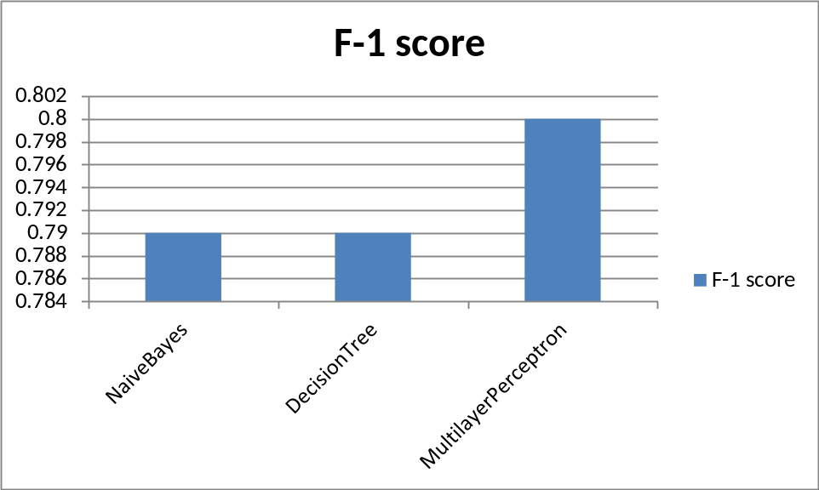
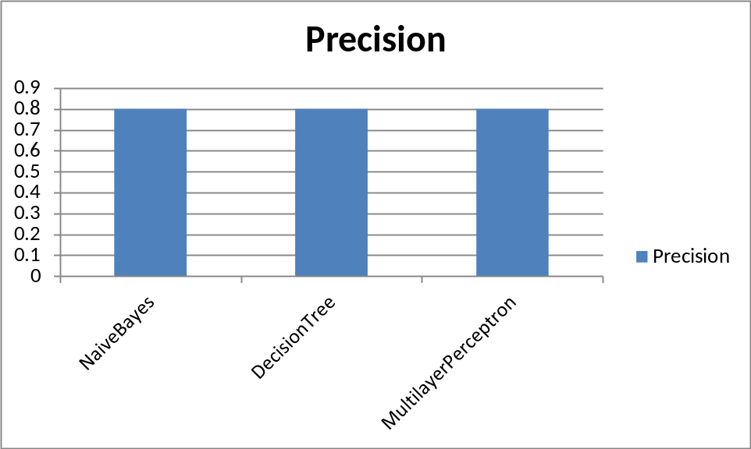
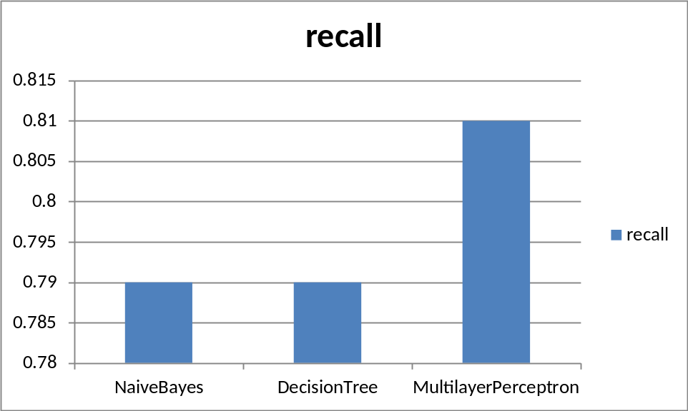
Conclusion : Since sentiment analysis is popular in recent years and this is a different kind of sentiment data rather than twitter data and also a better and clean data in comparing twitter data we have understand very much how sentiment analyzing works after working with this dataset. We have implemented three different data mining techniques and have achieved highest accuracy 77.87% and we want to better accuracy than this . That’s why in near future we want to apply some other data mining techniques or hybrid data mining techniques of above methods for achieve better accuracy.

