**MP1-Part-1**

**By- Md Mustafizur Rahman (mr4xb)**

**Section 1.1 (Zipf’s Law)**

**1.1.1 Text Normalization Module**

**Public** String Normalize1(String token){

token = token.replaceAll("([?:!.,;])*", " ");

token = token.replaceAll("\\W+", "");

token = token.toLowerCase();

**if** (token.matches("\\d+"))

**return** "NUM";

**else**

**return** token;

}

**1.1.2 Curves for TTF fitting Zipf’s Law**

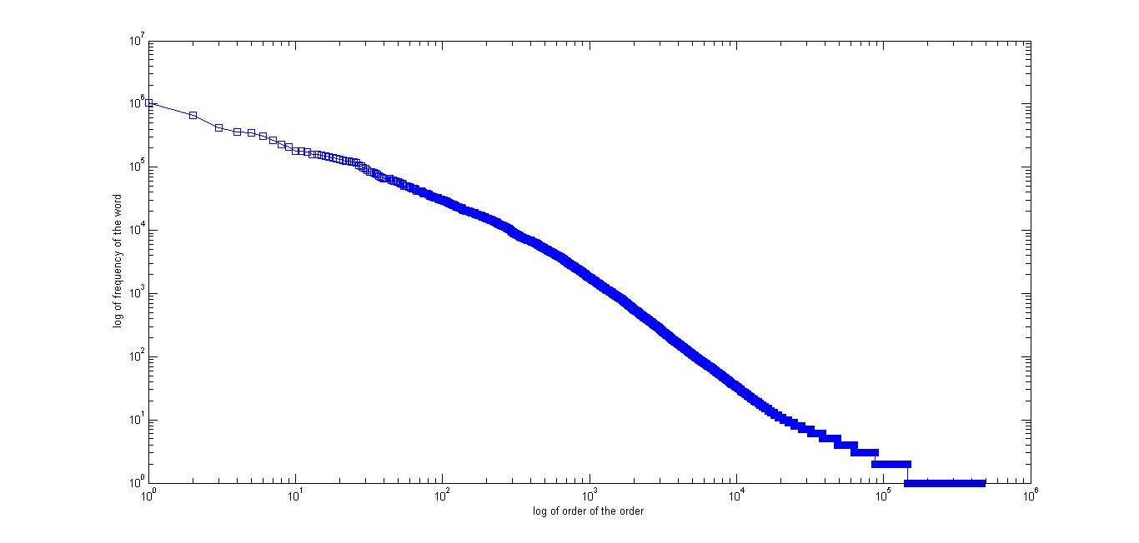

*Figure 1: Log log plot for TTF Unigram*

For the calculation of unigrams, we simply count the number of times a single word appears against the whole Yelp (small_dataset). Then we rank these wordlist according to their frequency. For the purpose of plotting we use here the Matlab loglog function (see figure. 1).

Whether it is linear or not? : To check this, we simply try to fit the data using linear regression. In this case, we have used the polyfit function of Matlab and found the slope is -0.9375with a constant 11.7713.

**1.1.2 Curves for DF fitting Zipf’s Law**

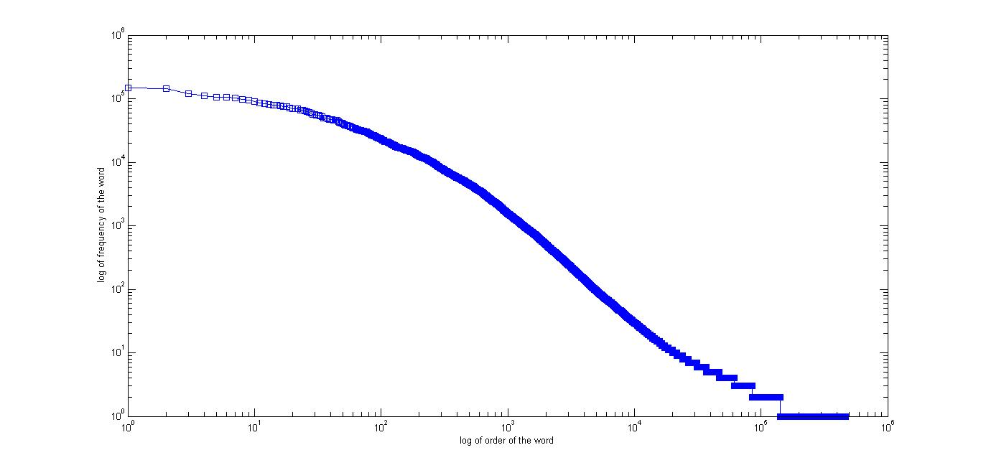

*Figure 2: Log log plot for DF Unigram*

For the calculation of unigrams, we simply count the number of documents in which a single word appears against the whole Yelp (small_dataset). Then we rank these wordlist according to their frequency. For the purpose of plotting we use here the Matlab loglog function (see figure. 2).

Whether it is linear or not? : To check this, we simply try to fit the data using linear regression. In this case, we have used the polyfit function of Matlab and found the slope is -0.9156 with a constant 11.4928.

**1.1.3.TTF or ZF which one is better linear fit?**

In order to answer this question, we estimate the linear fitting function for both TTF and DF.

Let us assume that, f1 and f2 are the original log(y) for TTF and DF respectively. And est(f1) and est(f2) are the estimated linear fitting function. Then we simply calculate the root mean square error (RMSE) between the original and estimated function for both the TTF and DF. We have found that RMSE for TTF is: 0.3308 and RMSE for DF is 0.3283. From RMSE we can say that DF fits Zipf’s law slightly better that TTF.

**Why Zipf’s Law better for DF?**

Zipf’s law states that probability that a word chosen randomly from the text will be the word of rank r. In case of DF the frequency of the wordlist changes very smoothly than TTF list. This is because TTF will have more value than DF. For example, the frequency difference between the two top most ranked word is 372930 and 5267 for unigram and DF respectively. So, we think this is the main reason why Zipf’s Law fits better for DF.

**1.2.1 Restaurant Related Stopword List**

Please note that in the following list we only have listed the stopwords related to restaurant reviews (using the top 100 N-gram). The initial stopword list from smart word list is not included here.

*restaur*

*servic*

*delici*

*nice*

*time*

*menu*

*price*

*eat*

*back*

*the_food*

*good*

*love*

*food*

*make*

*friend*

*order*

*great*

*this_place*

**1.2.2 The Size of the controlled vocabulary**

After performing all the steps suggested in the MP1-Part1 (removing all the vocabulary smaller than 50 and removing the all the stopwords from final stopwords list), the size of the controlled vocabulary is 49517.

**1.2.3. Top 50 N-gram from controlled vocabulary**

|  |  |  |
| --- | --- | --- |
| **n-gram** | **DF** | **Idf** |
| well | 25223 | 2.397489 |
| want | 24435 | 2.411274 |
| chicken | 24184 | 2.415758 |
| tast | 24055 | 2.418081 |
| look | 23611 | 2.426172 |
| pretti | 23493 | 2.428348 |
| definit | 22251 | 2.451937 |
| came | 22059 | 2.4557 |
| the_best | 21460 | 2.467656 |
| wait | 21261 | 2.471702 |
| tabl | 21221 | 2.47252 |
| fri | 21212 | 2.472704 |
| sauc | 21031 | 2.476426 |
| drink | 20860 | 2.479972 |
| thing | 20783 | 2.481578 |
| first | 20718 | 2.482938 |
| think | 20638 | 2.484618 |
| alway | 20368 | 2.490338 |
| went | 20038 | 2.497432 |
| flavor | 19919 | 2.500019 |
| them | 19878 | 2.500913 |
| fresh | 19793 | 2.502774 |
| better | 19550 | 2.508139 |
| over | 19117 | 2.517866 |
| say | 19108 | 2.518071 |
| dish | 19108 | 2.518071 |
| peopl | 18867 | 2.523583 |
| know | 18652 | 2.528561 |
| meal | 18483 | 2.532514 |
| night | 18458 | 2.533101 |
| salad | 18296 | 2.53693 |
| bar | 17829 | 2.548159 |
| side | 17681 | 2.551779 |
| the_servic | 17650 | 2.552541 |
| lot | 17550 | 2.555009 |
| never | 17484 | 2.556645 |
| made | 17366 | 2.559586 |
| serv | 17221 | 2.563228 |
| give | 17214 | 2.563404 |
| staff | 17145 | 2.565149 |
| way | 17128 | 2.565579 |
| right | 17003 | 2.568761 |
| take | 16990 | 2.569093 |
| amaz | 16971 | 2.569579 |
| lunch | 16885 | 2.571785 |
| bit | 16714 | 2.576206 |
| enjoy | 16701 | 2.576544 |
| again | 16590 | 2.57944 |
| perfect | 16534 | 2.580908 |
| dinner | 16532 | 2.580961 |

**1.2.3. Bottom 50 N-gram from controlled vocabulary**

|  |  |  |
| --- | --- | --- |
| **n-gram** | **df** | **idf** |
| poblano_soup | 50 | 5.100316 |
| been_awesom | 50 | 5.100316 |
| experi_which | 50 | 5.100316 |
| okay_ve | 50 | 5.100316 |
| go_look | 50 | 5.100316 |
| prefer_for | 50 | 5.100316 |
| realli_mess | 50 | 5.100316 |
| littl_touch | 50 | 5.100316 |
| still_crave | 50 | 5.100316 |
| realli_late | 50 | 5.100316 |
| what_exact | 50 | 5.100316 |
| the_lowest | 50 | 5.100316 |
| orang_blossom | 50 | 5.100316 |
| after_three | 50 | 5.100316 |
| robot | 50 | 5.100316 |
| are_surpris | 50 | 5.100316 |
| did_veri | 50 | 5.100316 |
| but_quick | 50 | 5.100316 |
| my_nephew | 50 | 5.100316 |
| extra_flavor | 50 | 5.100316 |
| also_deliv | 50 | 5.100316 |
| in_dc | 50 | 5.100316 |
| she_found | 50 | 5.100316 |
| newcom | 50 | 5.100316 |
| great_present | 50 | 5.100316 |
| ten_buck | 50 | 5.100316 |
| dive_but | 50 | 5.100316 |
| awesom_ve | 50 | 5.100316 |
| talk_me | 50 | 5.100316 |
| smile_or | 50 | 5.100316 |
| same_server | 50 | 5.100316 |
| start_up | 50 | 5.100316 |
| right_NUM | 50 | 5.100316 |
| squeez_of | 50 | 5.100316 |
| petit_zinc | 50 | 5.100316 |
| up_ani | 50 | 5.100316 |
| and_empti | 50 | 5.100316 |
| francisco_and | 50 | 5.100316 |
| dinner_place | 50 | 5.100316 |
| right_had | 50 | 5.100316 |
| heaven_we | 50 | 5.100316 |
| some_salsa | 50 | 5.100316 |
| stuck_out | 50 | 5.100316 |
| onli_drink | 50 | 5.100316 |
| been_help | 50 | 5.100316 |
| pretti_gross | 50 | 5.100316 |
| bad_here | 50 | 5.100316 |
| fresh_great | 50 | 5.100316 |
| the_furnitur | 50 | 5.100316 |
| then_start | 50 | 5.100316 |

**1.3.1 Cosine Similarity**

**public** **double** norm(_SparseFeature[] fs) {

**double** sum = 0;

**for** (_SparseFeature feature: fs){

**double** value = feature.getValue();

sum += value * value;

}

**return** Math.*sqrt*(sum);

}

**public** **double** cosine_Similarity(_SparseFeature[] spVct1, _SparseFeature[] spVct2) {

**double** similarity = 0;

**int** i = 0, j = 0;

**while** (i < spVct1.length && j < spVct2.length) {

_SparseFeature temp1 = spVct1[i];

_SparseFeature temp2 = spVct2[j];

**if** (temp1.getIndex() == temp2.getIndex()) {

similarity += temp1.getValue() * temp2.getValue();

i++;

j++;

} **else** **if** (temp1.getIndex() > temp2.getIndex())

j++;

**else**

i++;

}

similarity = similarity / (norm(spVct1)* norm(spVct2));

**return** similarity;

}

**1.3.2 Top 3 most similar documents for all 5 review in query.json**

**Similar docs for 0 in query.json**

**1st Document**

Doc id:114800 (doc id from the internal counter of my code)

Doc cosine similarity:0.2809187989142376

Doc Author:Raymond W.

Doc Content:On one hand, I wanted to not like this place so that I could fill my review by making fun of the name, but I really enjoyed this place. I came in after a drink with a friend and I got the seafood combination egg noodles ($8.95). The portion was large with a good amount of seafood and of which was cooked perfectly. The noodles had just enough crispy to go with the thick sauce that I know and love with pan fried noodles. The shrimp was de-veined which is always a plus, especially at a Chinese restaurant. My friend got the moo shu vegetables and seemed to enjoy it as well.The only down side is the size of the place caused us to share a table with a couple that seemed a bit moody.

Doc Date:2012-04-15

**2nd Documnet**

Doc id:75326 (doc id from the internal counter of my code)

Doc cosine similarity:0.2785035081970047

Doc Author:Ellie R.

Doc Content:Great chinese food. I went here for lunch and got the chicken lo mein with egg drop soup and an egg roll. Everything was delicious. Will definitely come back again.

Doc Date:2014-05-07

**3rd Document**

Doc id:117406 (doc id from the internal counter of my code)

Doc cosine similarity:0.2697751155065531

Doc Author:Jillian O.

Doc Content:Quan's has it's pros and cons like any other business. Unfortunately the pros cannot be found in the food.Lemme start by saying that they are one of few Chinese restaurants in the area open late AND delivers. Prices aren't bad (i'm used to "hood" New York Chinese food thats really cheap & deliciously greasy :D) but that's about where the good things end.My delivery guy was surprisingly rude & the food was disappointing & a little cold. I ordered beef w/ broccoli, scallion pancakes & crab rangoon. The rangoon was the best of the meal. My broccoli was seriously overcooked & pretty much inedible. Scallion pancakes were fine but I can't stand a cheap dipping sauce which is exactly what I got. It was basically salted brown water.Despite my disappointments, I do hear good things about this restaurant so maybe I just ordered on a bad day or ordered the wrong thing. I hear their chicken lo mein is great so I just may give them one more shot if my regular place is closed.

Doc Date:2010-10-27

----------------------------------------------

**Similar docs for 1 in query.json**

**1st Document**

Doc id:76315 (doc id from the internal counter of my code)

Doc cosine similarity:0.25504565722230566

Doc Author:Shradha A.

Doc Content:The butternut squash ravioli was good.

Doc Date:2013-11-15

**2nd Document**

Doc id:1198 (doc id from the internal counter of my code)

Doc cosine similarity:0.2518533539171783

Doc Author:darcy e.

Doc Content:This dinner was nothing special, the food was fine for a neighborhood restaurant., the wine was over priced and the servers seemed wound up and tense. I will say the pasta seemed fresh but the flavors were bland and the plating was sloppy. We did decide to try a dessert and my impression is that their desserts are brought in from a vendor, the Chocolate mousse cake was nothing special and they served a over cooked Flan instead of a more traditional Panna Cotta.When it comes to a neighborhood italian Restaraunt I  would choose Divinos on Alabama near Woodhead any day and go to the chocolate bar for dessert.

Doc Date:2011-11-12

**3rd Document**

Doc id:41868 (doc id from the internal counter of my code)

Doc cosine similarity:0.24135600947863667

Doc Author:Alicia R.

Doc Content:Great place for date night, whether with your significant other or a good friend! Came here on one of the recent chilly days with my boyfriend for a nice meal. I started off with one of the tasty wine cocktails and the "cavolo nero, verza, e Bietola," which was exactly what I what I wanted it to be - savory, sweet, nutty and makes you feel good. For our entrees, I chose the gnocchi di funghi and the bf had the paccheri puccini. Both were excellent, and I was especially impressed by the paccheri puccini as it had fennel, which I don't usually like, but it worked pretty well in that dish. We finished everything off with a panna cotta al yogurt - my first time having panna cotta, and it was pretty good. Food was great, our server very friendly, and the interior is upbeat yet relaxing. They also have some Italian food items for sale. Definitely need to come again!

Doc Date:2014-02-20

----------------------------------------------

**Similar docs for 2 in query.json**

**1st Document**

Doc id:160995 (doc id from the internal counter of my code)

Doc cosine similarity:0.25796962582599375

Doc Author:Steven C.

Doc Content:Great food, great service! The atmosphere was welcoming and the staff was great. Good spot to meet up with friends. I had the tacos and they were pretty tasty. Do not expect authentic tacos, but really good regardless. Plus the pico de gallo was surprisingly better than expected.

Doc Date:2011-05-05

**2nd Document**

Doc id:162143 (doc id from the internal counter of my code)

Doc cosine similarity:0.24417376331687374

Doc Author:Mary V.

Doc Content:Traspasada, I love you. The quickest, tastiest, most awe-inspiring tacos in the whole damn city. Oh, how I love you.

Doc Date:2013-08-13

**3rd Document**

Doc id:102849 (doc id from the internal counter of my code)

Doc cosine similarity:0.2428121168798057

Doc Author:David T.

Doc Content:great food, great taco bar too..call ahead to order or hit the taco bar, waiting in line there can take up the entire lunch hour.  I would have given it 5 stars, but the line just doesn't move fast enough

Doc Date:2011-11-13

----------------------------------------------

**Similar docs for 3 in query.json**

**1st Document**

Doc id:127771 (doc id from the internal counter of my code)

Doc cosine similarity:0.21915180071248472

Doc Author:Alison C.

Doc Content:Mei Mei's Street Kitchen is absolutely amazing. It's hard to think of any other place where I've had as great of an experience with dining as I did at Mei Mei's. Something to note is that their menu changes seasonally as different items increase/decrease in availability because they use local ingredients to ensure freshness of taste, sustainability, and community support. When talking to some of the staff, I learned that the chefs and employees dream up of each dish, making their inspirations and ideas a reality through careful thought, collaboration, and execution. It's obvious from the way the workers get along and the dynamic in the restaurant that the employees are like family. I came here to meet some people with a friend, and we sampled quite a few dishes, sharing them amongst each other. To start, we had a few vegetable dishes. First came the Roasted Mushrooms, which was probably the tastiest mushroom dish I've ever had. I would order this dish for myself as my main entree on my next visit... This is coming from a girl who isn't a big fan of mushrooms in general. Three different types of mushrooms with parsnips, enveloped in butter and house malt vinegar and topped with arugula. Absolutely delicious. The Smacked Cucumber Salad followed, with crunchy chunks of cucumber mixed with a tangy dressing and sweet peanuts. Then came another favorite of mine, the Stir Fried Local Greens. That night, the green was collard greens, and it was stir-fried with chili oil and topped with garlic panko. I'm used to collard greens being a side doused heavily in butter, cream, and bacon a la southern food style, so this stir-fried version was a refreshingly light and different approach. Also delicious. Our dishes transitioned to main entrees with The Double Awesome, which is a scallion pancake wrapped around pesto, cheddar cheese, and a poached egg. This was a great pairing of flavors and tastes as good as it sounds, but you MUST get it with bacon. It really makes this dish, and is a fantastic addition to the sharp cheese and oozy yolk of the egg. Next came the Hot Times Curry. This was a green curry with chicken, peas, green tomatoes, and arugula topping over a bed of rice. There was also a rhubarb relish to help counter the heat of the dish, which added a nice kick to a fresh and fragrant dish. The curry was another one of my favorites of the evening. The Sweet & Sour Pork, which was chunks of fatty pork doused in a gochujang (Korean sweet chili paste) hozon sauce over a mound of sticky rice, arrived soon after. The meat was tender, juicy, and well seasoned, and the sticky rice was crispy around the edge. Definitely a welcomingly different texture to the meat. The Northeast Family Farms Bavette Steak dish came next, with a two-hour process kalbi marinated steak, caramelized parsnips, and arugula garnish. The time taken for this dish is apparent because of the tenderness and melt-in-your-mouth quality of the meat. It is cooked to perfection with a pink middle and slightly crisp edge. The parsnips were also a nice addition to the dish, with a sweet, buttery flavor. Our final entree was the special of the evening, a salmon dish. This chefs' creation was a fillet of salmon on a fennel paste and maple miso paste, garnished with candied beets, fennel, and arugula. To me, this was THE best dish of the evening. The salmon was soft, and the two pastes added extra depth to the flavor. A bite of those three elements and a beet slice on top was phenomenal.We finished off our meal with the Strawberries and Cream dessert, which consisted of macerated strawberries topped with fresh cream and black sesame shortbread bits. Fresh and light, with a just unique enough spin from the black sesame, this was the perfect way to end an unparalleled meal. I would like to give a shout out to the chefs here for not only doing a quality job with the taste, but also creatively plating each dish for a beautiful presentation. Two chefs also personally came out to introduce and explain some of the entrees to us, which was an unexpectedly pleasant and personal touch to the service that evening. Mei Mei's, you've reignited some of my excitement for dining and food. Thank you for such a fantastic dinner experience!

Doc Date:2014-07-06

**2nd Document**

Doc id:30780 (doc id from the internal counter of my code)

Doc cosine similarity:0.21766016327153542

Doc Author:Simon L.

Doc Content:Wow - meat lovers beware: your bellies going to be getting bigger!Racks hang with roast duck, bbq pork, chicken.An order of soy sauce chicken yields an entire chicken leg - the thigh and drumstick - skin still on. Firm meat ensconced in a sweet but salty soy flavor pulls easily from the bone - the entire leg is chopped into thin slices to make consumption a bit more convenient. The meat has been braised for hours in a rich soy stock and is served barely warmed with shredded scallions on top. A side of braised cabbage also sits on a large portion of white rice. The small order of hot and sour soup is sour with pickles, thick with rich broth and packed with tofu and mushroom. Wow, again, totally excellent place.

Doc Date:2014-05-29

**3rd Document**

Doc id:142862 (doc id from the internal counter of my code)

Doc cosine similarity:0.21711748393391414

Doc Author:Christina A.

Doc Content:Phenomenal! Can you say OBSESSED?I had heard some great things about Izakaya Wa and was really excited to try it. The first thing you will notice is the building itself is very unique, it looks like a little chateau. Magical? yes. Unexpected? yes! The stars were in our favor that night as we actually waited less than 15 minutes after initially being quoted and hour wait. A Saturday night miracle!We started with a glass of 10 Span Chardonnay and a draught Dry Asahi beer. Both were cold and crisp and hit the spot. It's actually very special to get Dry Asahi on draught, I never really see it anywhere. Next order of business was to narrow down what we wanted to eat. The menu is quite expansive and there are many good choices. Our first dish was the Tako Sunomono salad. The octopus was perfect, not chewy not mushy. Perfectly al dente and briny. The cucumbers and seaweed added a very refreshing crispness to it. UMAMI in my mouth! Next we ordered nigiri sushi: tuna, salmon, king crab, mackerel, and Japanese red snapper. Really wanted Toro but they were out. *P.S. all of the sushi fish is fresh, not frozen so when it's gone it's gone!* Again, the salmon was buttery, the king crab was a generous portion and had a subtle sweetness. Very solid choices.  Our server let us know that they had a special available called Oden, it is primarily served in the Winter and is a comfort food- kind of like a hot pot or stew. We were intrigued and ordered it. Our Oden had various fishcakes, turnip, boiled/ marinated egg in a really flavorful broth. It was served with a side of Japanese mustard and was so unexpected and good. Next we had a small plate of Oshinko-Japanese pickles while we were deciding on our next round of food. The pickles were spot on, briny, salty, sour and sweet and so addictive. There was eggplant, cucumbers, radish and other various veggies. Our next round of food was grilled skewers. We had the grilled shitake mushrooms, shishito peppers and the pork belly. Holy shit...ake! best mushrooms I've ever eaten, buttery and silky. yum. The shishito peppers were not hot but did lend a bite of heat and tons of smoky flavor from being grilled. I really appreciated them. We loved the pork belly too, just melt in your mouth goodness with a bit of white onion to give it a little crunch.We had finished a few rounds of drinks at this point and what better thing to order than some deep fried goodness. We got the prawn and veggie tempura and the seaweed dusted fries. The tempura came with a green tea salt instead of the usual tentsuyu dipping sauce. It was strange at first not to be dipping into the tempura sauce, but we found that we never really missed it. The tempura was hot, light and airy. It was perfect tempura. I know a lot of people think, oooh tempura isn't really that special. But IT IS! So many places do it injustice and when you find a place that does it the right way, its just *special* I would pass on the fries with seaweed powder so you have more room in your belly  to try other tapas.We are true gluttons and ended our feast with Udon and Curry. We got the pork Katsu curry- Heaven in your mouth! just order it! and the Kitsune Udon noodles, which has the tofu skin in a gentle but complex broth. Again UMAMI heaven and just the right way to end our meal. We had fantastic conversation with our servers and other patrons sitting near us. The servers all lended each other a hand when needed and Izakaya Wa ran like a well oiled machine. They were crazy busy that night but I was so impressed with the level of food prepared, the thought and process that went into the preparation and the execution of the dishes and also with the service. I really can't  say enough good things. Jessica, Christina, Akira-San. Everyone made it outstanding. I am already day dreaming about what to order next time... I can't wait to go back!

Doc Date:2014-01-27

----------------------------------------------

**Similar docs for 4 in query.json**

**1st Document**

Doc id:9347 (doc id from the internal counter of my code)

Doc cosine similarity:1.0

Doc Author:Patricia S.

Doc Content:Pretty great so far. They use Amaya Coffee beans which I (gasp!) prefer to Greenway. I've been three times now and on each visit, my drink was perf. The siphon coffee tasted very clean and smooth. I like the interior's layout and there is plenty of seating, inside and out. However,  you're out of luck if you don't manage to get a seat at one of those comfy leather chairs or the long bench along the back wall. The stools they use were really uncomfortable for myself and everyone in our party of 4. Maybe it's a clever way to keep people from lingering there too long.I've tried a few of their pastries but I'm mostly into their beef empanadas. I will always choose something savory over a sweet in the morning. I hope they always have those available.All in all, a pretty winsome place.

Doc Date:2014-06-18

**2nd Document**

Doc id:9378 (doc id from the internal counter of my code)

Doc cosine similarity:0.2645520685446229

Doc Author:Vivian M.

Doc Content:Dropped by on a Saturday morning with family to try out the siphon coffee. It was wonderful. So great that I wished we'd ordered more. A large siphon is really only for two ;-(. Smooth and awesome taste. Worth the wait if u can entertain your kiddo with one of their breakfast tacos or pastries. Will definitely make another trip back sometime. Also liked their seating layout as I didn't feel like the chairs were in a jumble and I was going to trip and fall before I got more coordinated from my caffeine fix. Yes, I need coffee that bad.

Doc Date:2014-06-09

**3rd Document**

Doc id:162492 (doc id from the internal counter of my code)

Doc cosine similarity:0.26209402848431573

Doc Author:Monica C.

Doc Content:Empanadas are the best!!!!  Coffee is really good.

Doc Date:2012-09-06

**1.3.3 Type of Restaurant specifies in query.json**

**Review no. 0 in query.json:**

Restaurant type: ***Chinese Restaurant***

Explanation: Considering the most 3 similar document. Take a fragment in each of this file.

1st similar doc fragment: ****“The shrimp was de-veined which is always a plus, especially at a ***Chinese*** ***restaurant***.”****

2nd Similar doc fragment: ****“Great ***chinese*** food”*****

3rd Simiar doc fragment: **** “Lemme start by saying that they are one of few ***Chinese*** restaurants in the area” ****

**Review no. 1 in query.json:**

Restaurant type: ***Some food like butternut, panna cotta etc***

Explanation: Considering the most 3 similar document. Take a fragment in each of this file.

1st similar doc fragment: ****“ The ***butternut*** squash ***ravioli*** was good”****

2nd Similar doc fragment: ****“ instead of a more traditional ***Panna Cotta***”*****

3rd Simiar doc fragment: **** “We finished everything off with a ***panna cotta*** al yogurt” ****

**Review no. 2 in query.json:**

Restaurant type: ***taco restaurant*** [i.e. Taco is a **Mexican** Dish]

Explanation: Considering the most 3 similar document. Take a fragment in each of this file.

1st similar doc fragment: ****“ I had the ***tacos*** and they were pretty tasty”****

2nd Similar doc fragment: ****“ most awe-inspiring ***tacos*** in the whole damn city”*****

3rd Simiar doc fragment: **** “great food, great ***taco*** bar too” ****

**Review no. 3 in query.json:**

Restaurant type: ***Asian Food (tuna, salmon, chicken,rice crab, mashroom, Japanese sushi)***

Explanation: Considering the most 3 similar document. Take a fragment in each of this file.

1st similar doc fragment: Times Curry. This was a green curry with ***chicken***, peas, green tomatoes, and arugula topping over a bed of ***rice***”****

2nd Similar doc fragment: ****“ A side of braised cabbage also sits on a large portion of white ***rice***”*****

3rd Simiar doc fragment: **** Next we ordered nigiri sushi: ***tuna***, ***salmon***, king crab, mackerel, and Japanese red snapper.” ****

**Review no. 4 in query.json:**

Restaurant type: ***Coffee restaurant***

Explanation: Considering the most 3 similar document. Take a fragment in each of this file.

1st similar doc fragment: ****“ They use Amaya ***Coffee*** beans which I (gasp!) prefer to Greenway”****

2nd Similar doc fragment: ****“ Dropped by on a Saturday morning with family to try out the siphon ***coffee***”*****

3rd Simiar doc fragment: **** “***Coffee*** is really good” ****