**Project Final Report**

**Course Information**

**Course:** CSE 480 Web Database Programming (Sections 1)

**Instructor:** Abdus Satter, Adjunct Faculty, CSE Dept.

**Project Name**

|  |  |
| --- | --- |
| **Title of Project** | **Doctor Appointment System** |
| **Student**  **(ID & Name)** | **Nahid Hossain(2016-2-60-136)** |

**Project Purpose**

The purpose of this project is to manage all the process of Doctor Appointment System. The admin side purpose of this project is to an admin can add doctor required information and also can manage them like delete update. On the other hand a logged in user can get appointment of doctor and delete appointment. At the same time normal (not logged in) user can search doctor visit doctor profile.

**Project Goals and Objectives**

The goals and objectives of the inventory management system are as follows:

1. To allow the admin to add, delete and update the doctors.
2. To allow the admin to delete the user and view the user info
3. To allow the admin to view the patient appointment information and delete, update.
4. To allow the user to search doctor and visit doctor profile.
5. To allow the authenticated user to get appointment of a doctor.
6. To allow the authenticated user to update and delete the appointment.

**Project Description**

This type of system is really beneficial in current time in the age of internet. Because now everything is available in the internet and internet also available all over the world. So anyone can pick up their phone or laptop to get appointment of a renowned doctor of the country. They can book an appointment within less than a minute. Through this system user can search doctors and can find the best doctor for his/her problem. They can find out doctor based on their name specialization and doctor city. So through user can manage all those thing without any hassle and without wasting their valuable time. At the same time logged in user can book the appointment of their preferred doctor and in the user account section they can get update of their appointment detail. Authenticated user can delete and update their appointment. On their other hand admin can logged in and can add, delete, update doctor. Admin also can manage user and patient information. This way using this system doctor appointment system can be managed properly and easily.

**Scope**

This system admin can manage doctor, user and patient appointment information. User also can search doctor and book appointment of doctor. So this system can be use for any type of doctor appointment and hospitals or clinic also can use this system.

**System Users**

• Administrators: Has full privilege on the systems functions. Admin can delete, add and update doctor info. Admin also can delete user and delete/update appointment.

• Patient (user): Patient don’t have full privilege on the system. Patient only can search doctor and book appointment (when logged in) and delete/update them.

**Database**

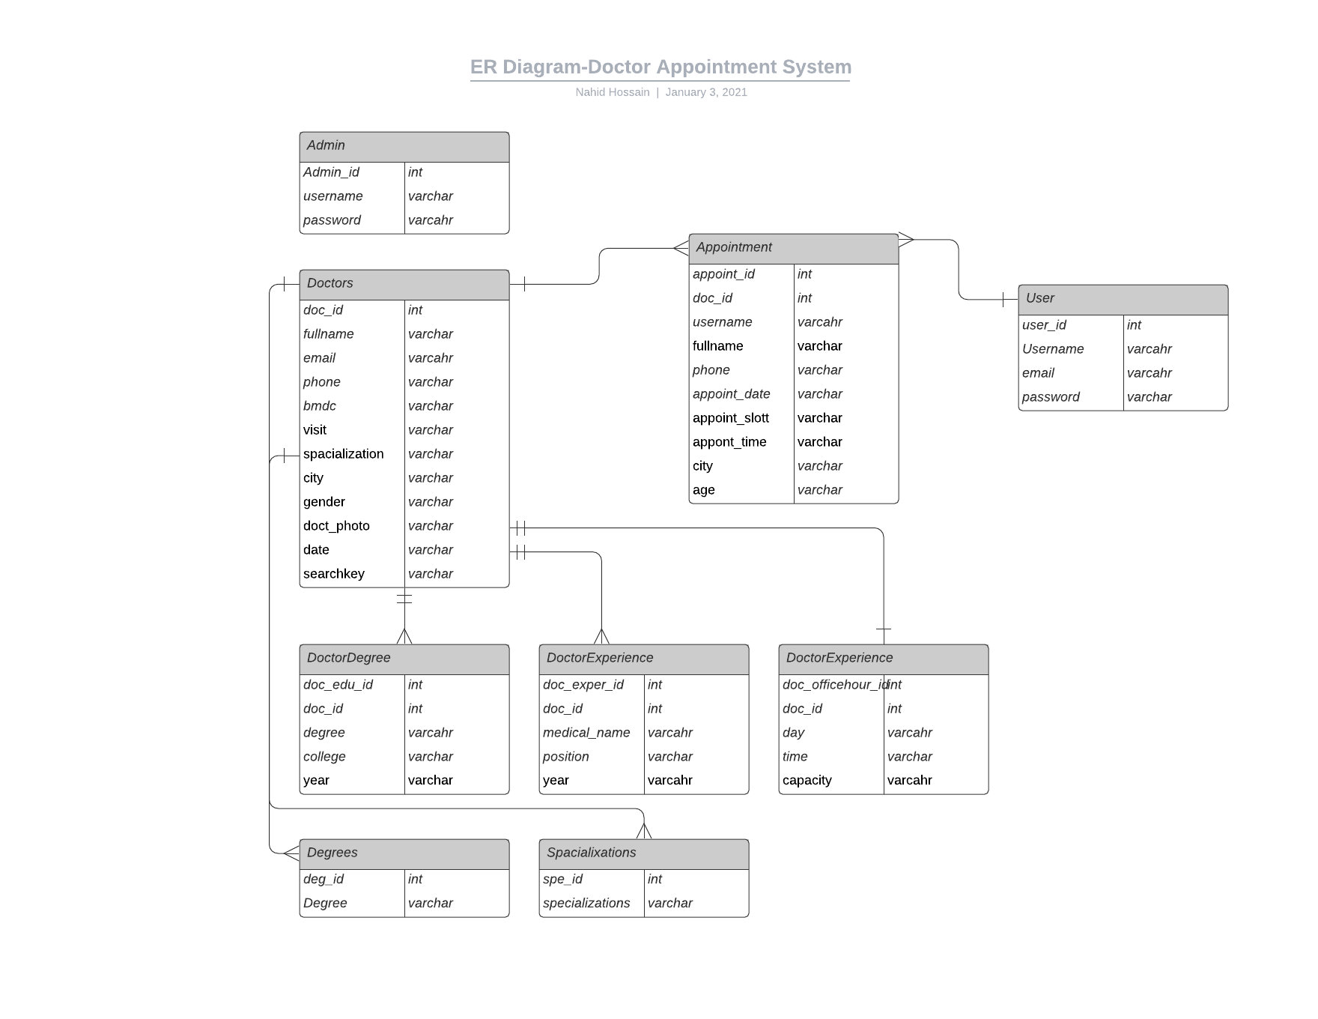

**Processes:**

**Admin Site:**

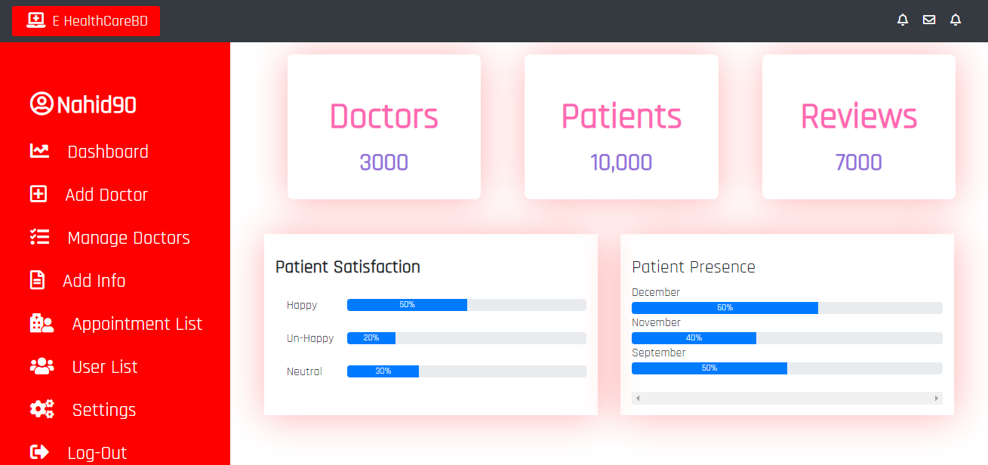

Admin Home: From this page admin can navigate to all the page.

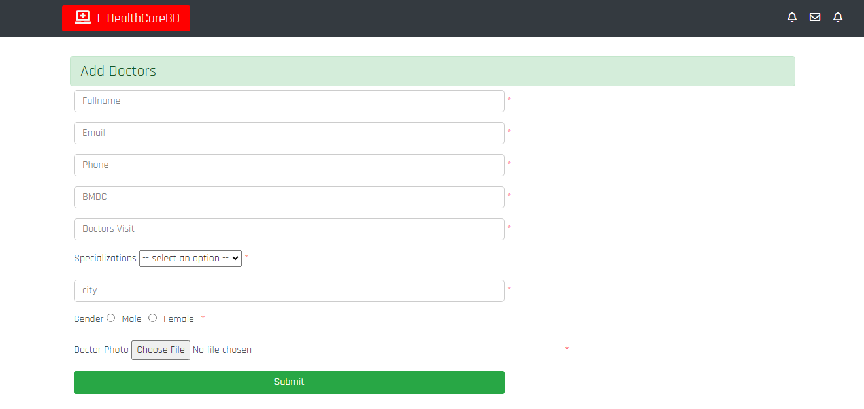

Add Doctor: Using this page admin can add new doctor to database.

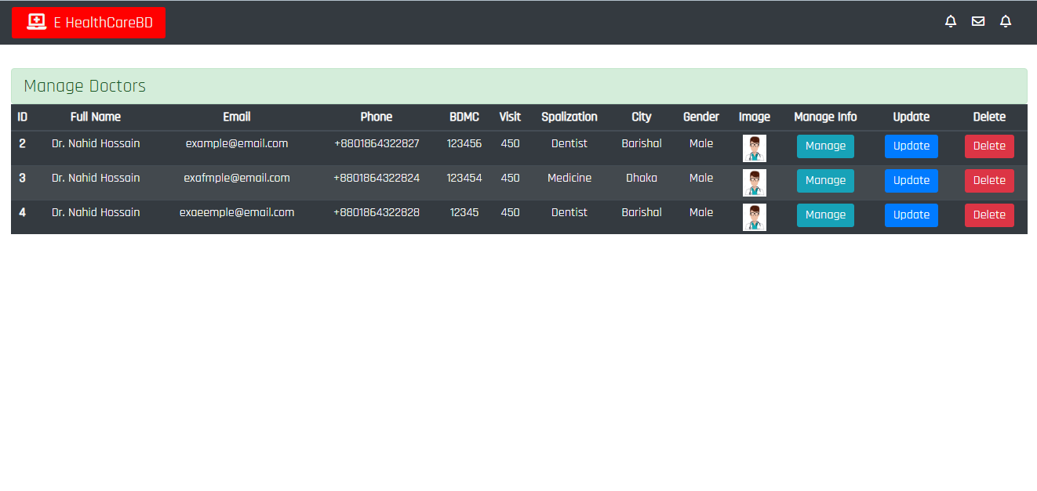

Doctor Manage: Admin can delete update and also can navigate to manage page.

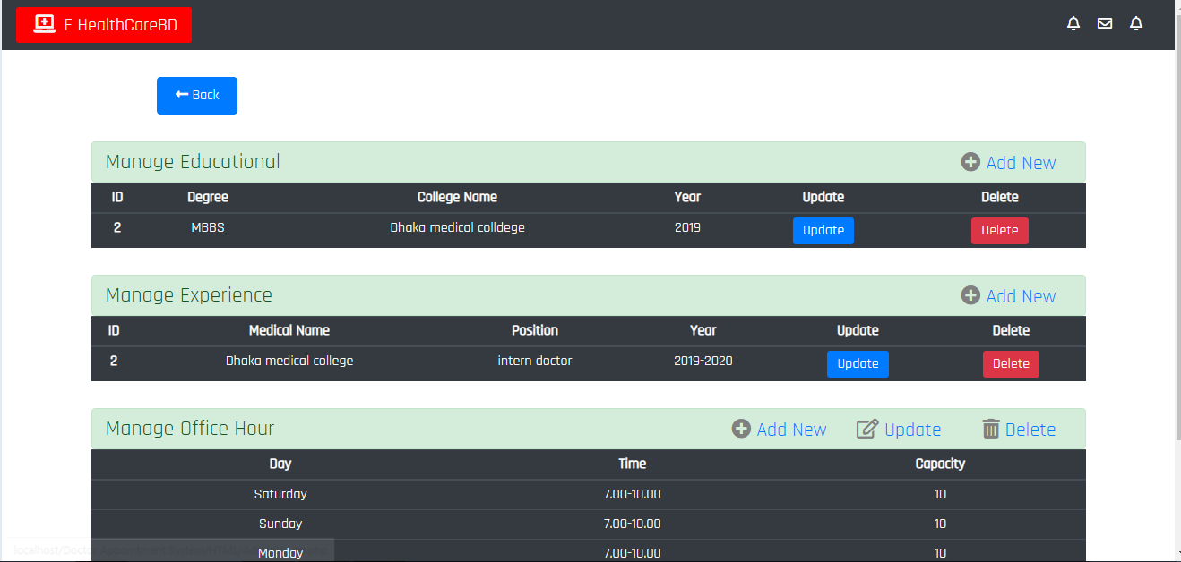

Doctor Profile manage: Admin can add/update/delete doctor educational information experience and office hour.

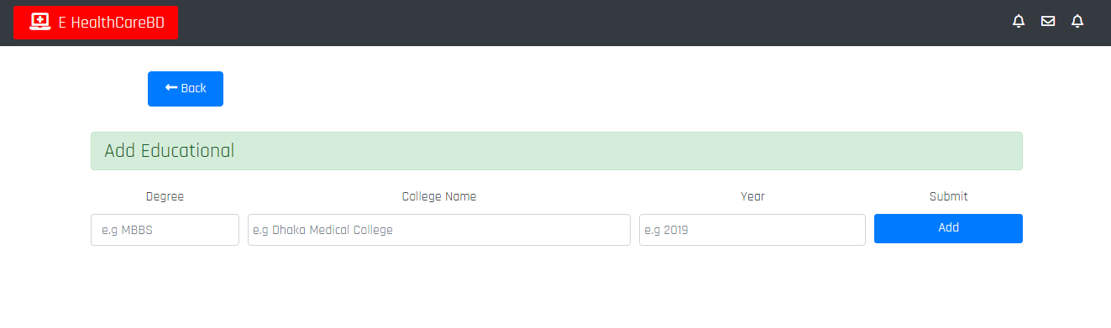

Add Educational: Admin can add doctor educational information.

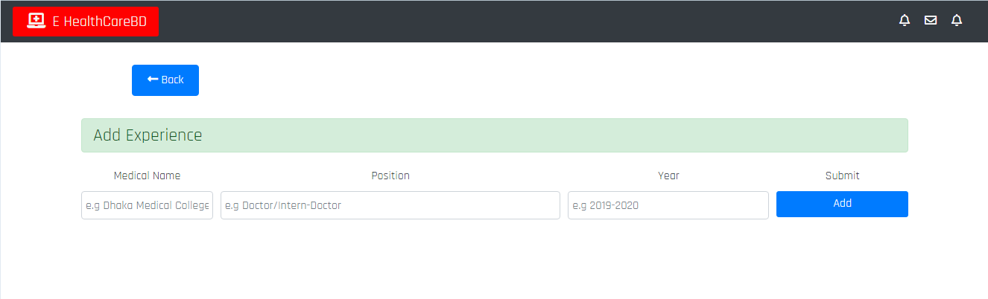

Add Experience: Admin can add doctor experience information.

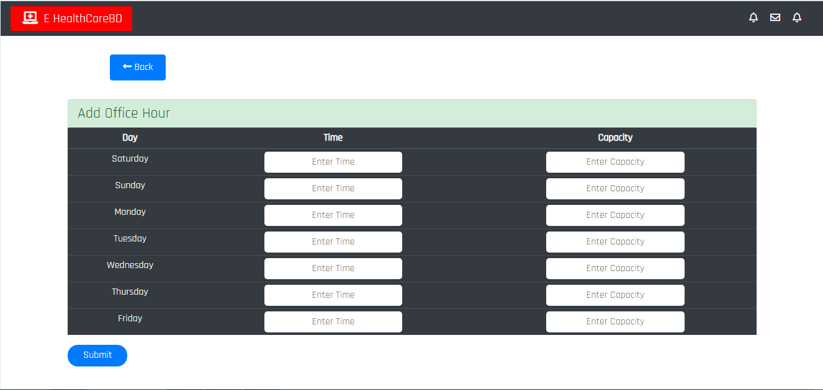

Add Office Hour: Admin can add doctor office hour information.

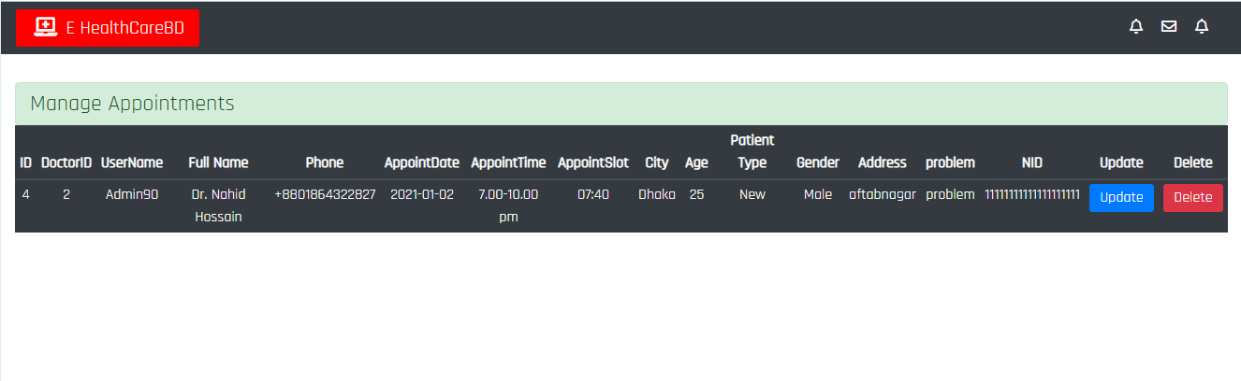

Appointment List: Admin can delete/update appointments.

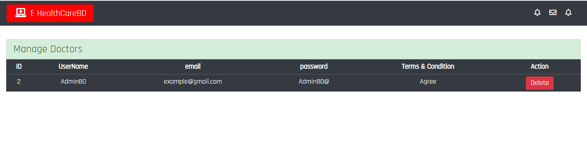

User: Admin can delete user.

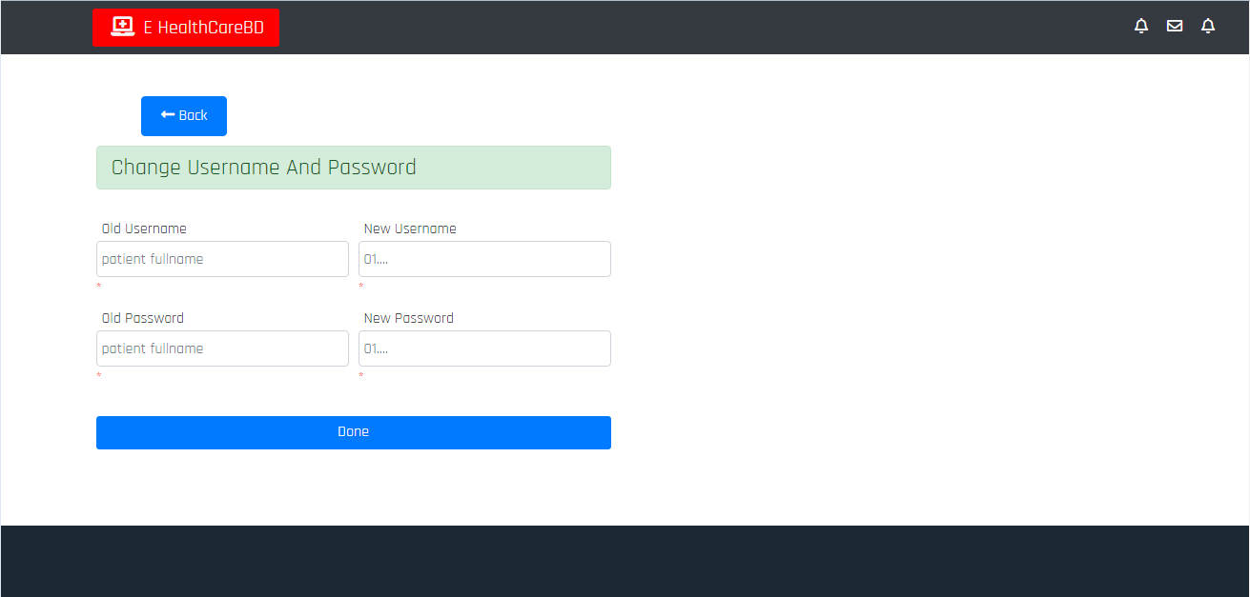

Admin username and password change: Admin can change user name and password with valid previous user name and password.

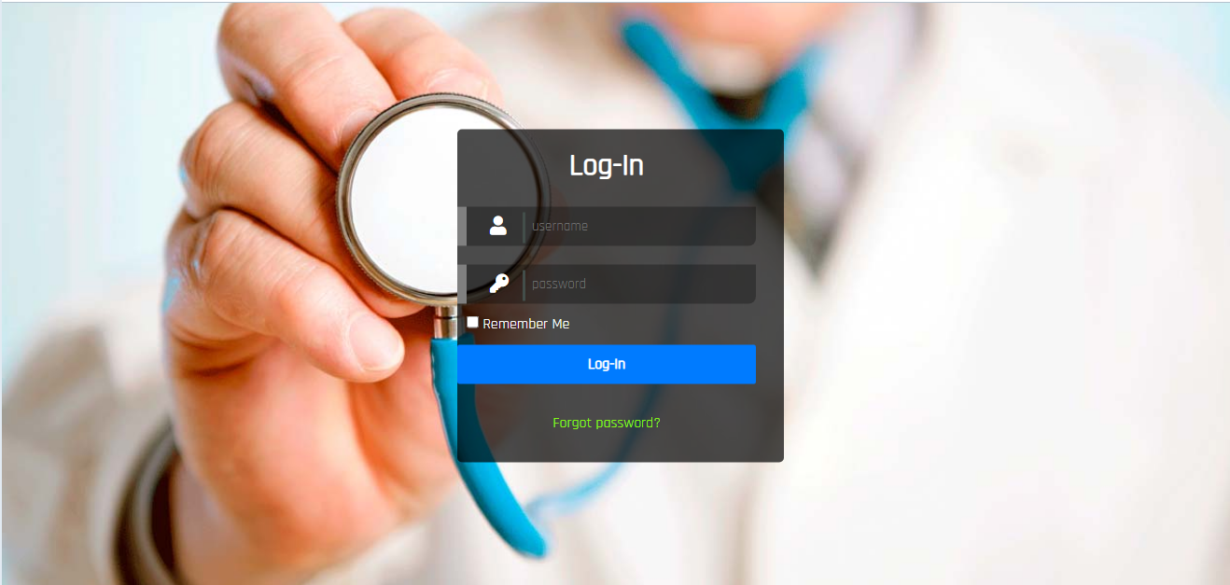

Login: Admin and user login.

**User Side:**

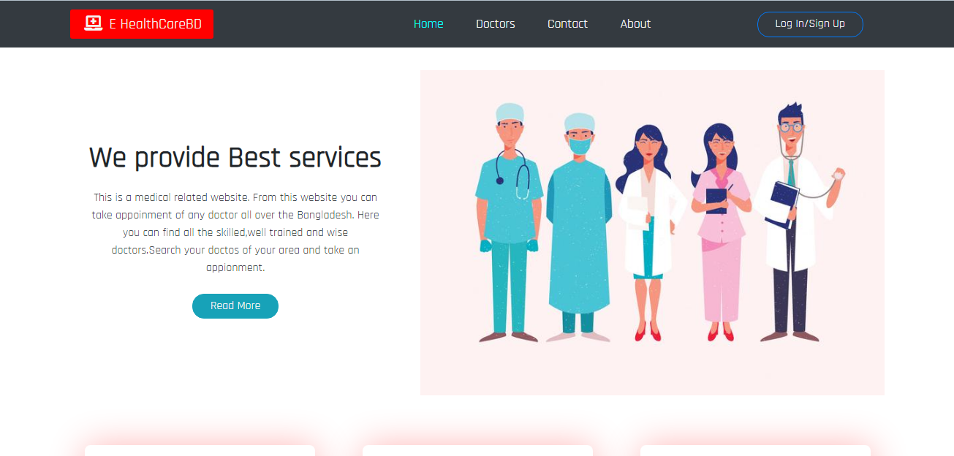

Index: User site home page.

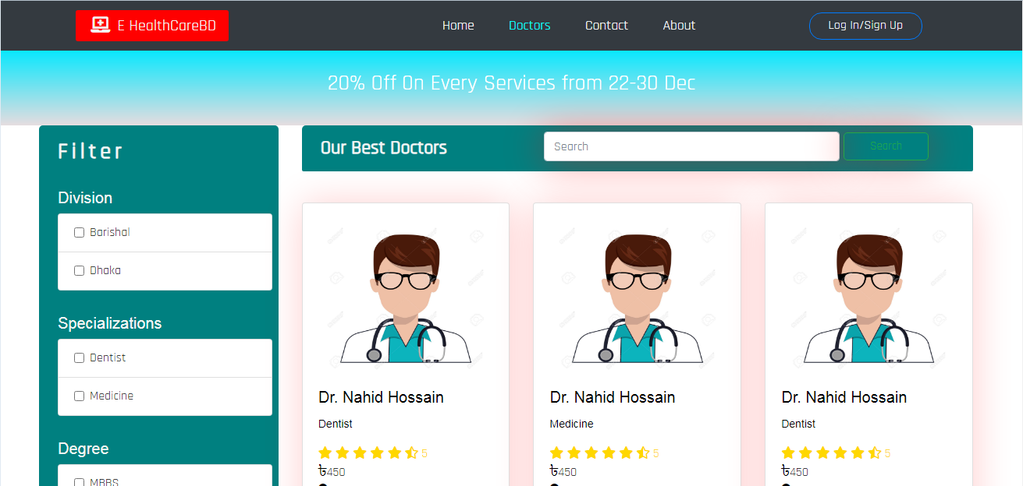

Doctor: Show all doctors. User can view doctor profile and can get appointment.

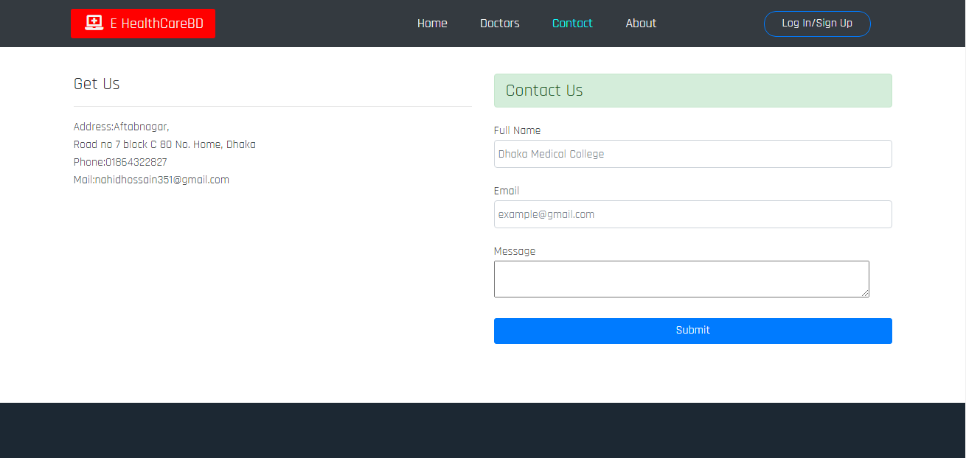

Contact: User can contact with admin.

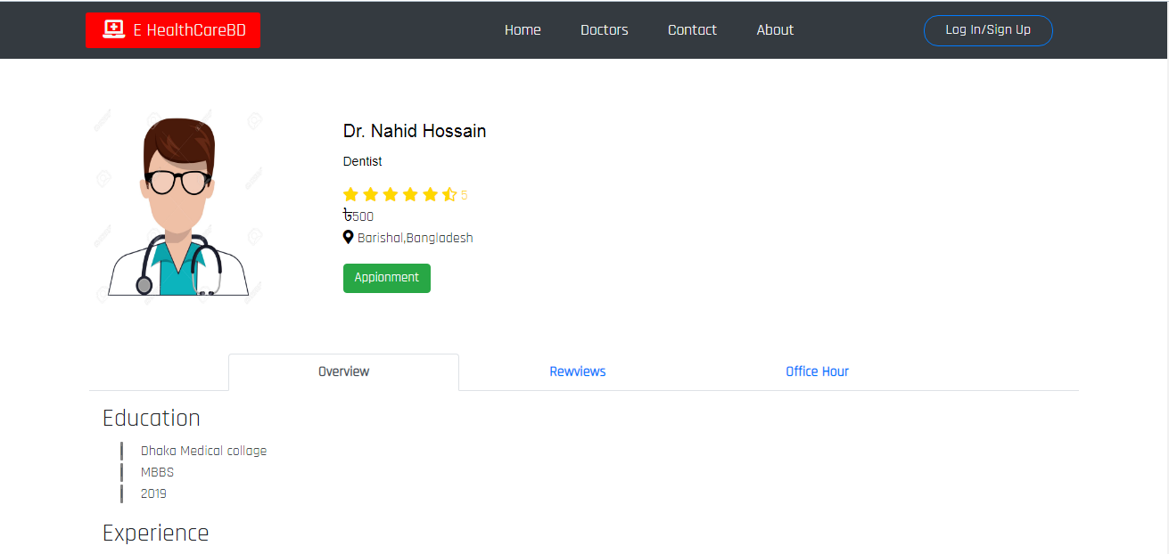

Doctor profile: User can visit doctor profile to learn more about doctor.

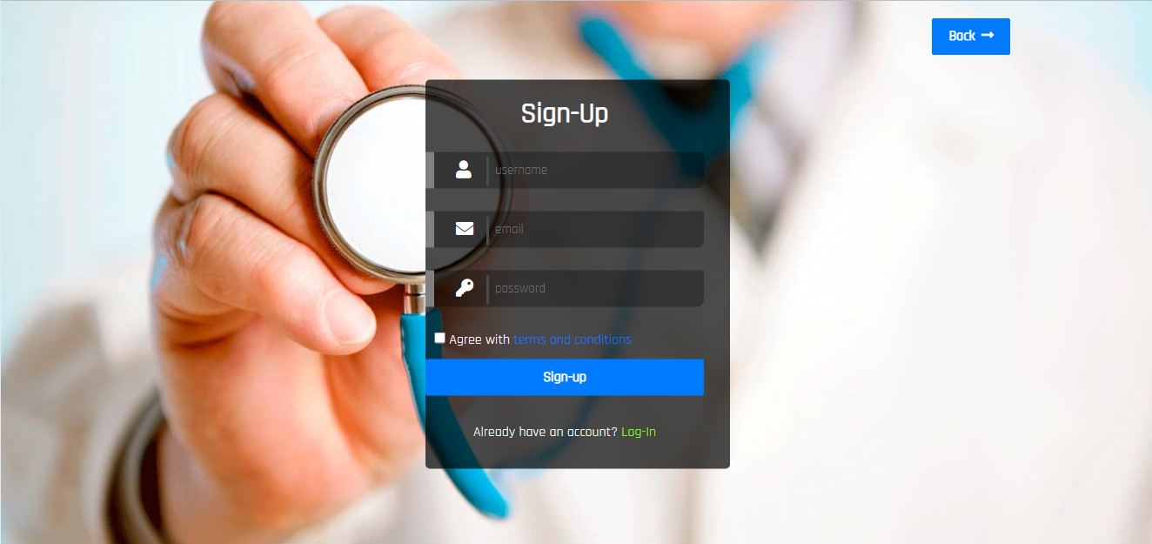

Signup: User signup.

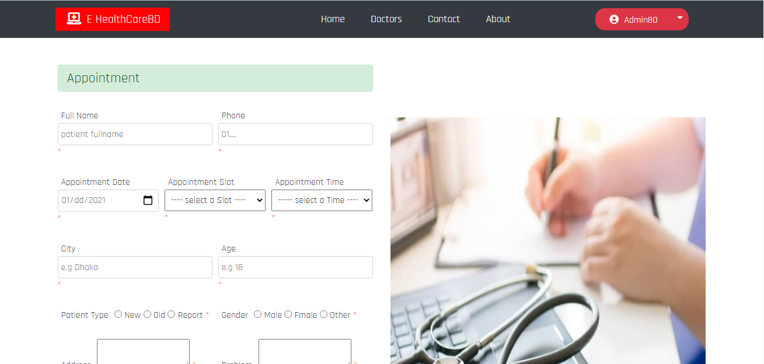

Appointment: User can book appointment while logged in.

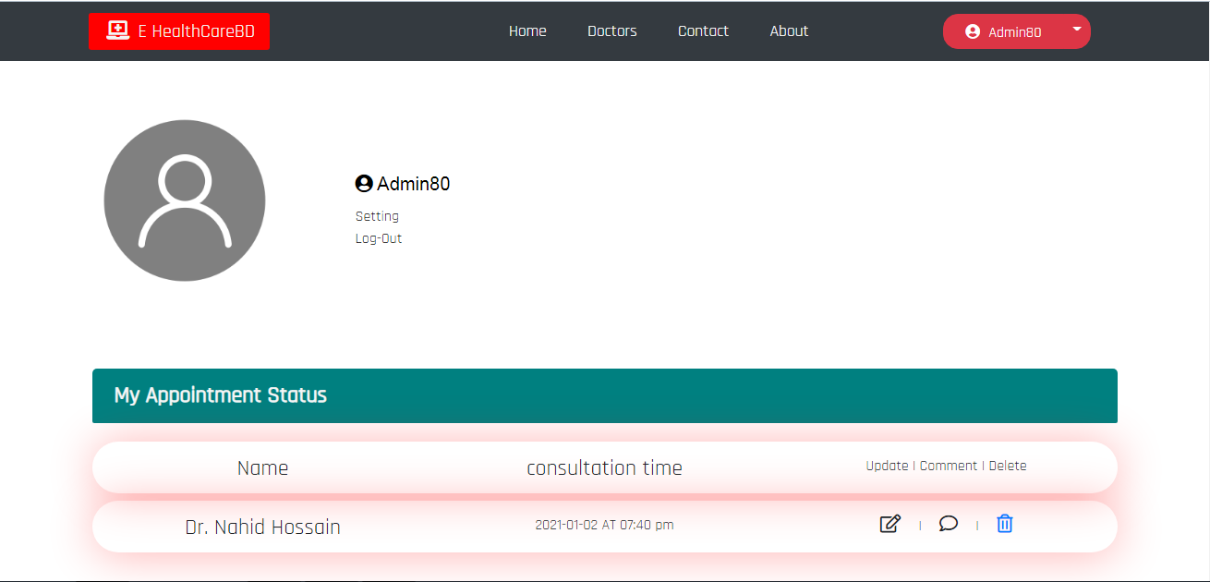

User profile: Here user can get all the updates. Also can delete appointment.

**Technology**

Server site Language: PHP

Frontend Language: Javascript

Design: HTML, CSS

Web API:JSON

Backend Language: MySql Database