

**Bangabandhu Sheikh Mujibur Rahman Science and Technology University, Gopalganj-8100, Bangladesh**

**Project Report for the Degree of B.Sc. Engineering**

**EduAssess360 – Exam and Preparation App**

**Nahidul Islam Shakin­­** Student ID: 18CSE246 Department of Computer Science and Engineering Bangabandhu Sheikh Mujibur Rahman Science and Technology University, Gopalganj-8100, Bangladesh

Supervised by

**Dr. Mrinal Kanti Baowaly** Associate Professor Department of Computer Science and Engineering Bangabandhu Sheikh Mujibur Rahman Science and Technology University, Gopalganj-8100, Bangladesh

**Statement of orgininality**

This project report, titled “**EduAssess360 – Exam and Preparation App**”, is submitted as a part of the requirements for B.Sc. Engineering at department of Computer Science and Engineering, Bangabandhu Sheikh Mujibur Rahman Science and Technology University, Gopalganj-8100. The content presented herein is a result of my independent effort, research, and development work.

I affirm that:

The ideas, design, and implementation of this project are my original work unless otherwise acknowledged.

All external sources, references, and contributions are properly cited and credited.

This project has not been submitted, either wholly or in part, for any other course, degree, diploma, or examination at this institution or elsewhere.

I take full responsibility for the authenticity and integrity of the work presented in this report. Any violations of intellectual property rights or academic integrity, whether intentional or accidental, are solely my responsibility.

…………………………...

Signature of the Candidate

Date:

**Name**: Nahidul Islam Shakin

**Student** ID: 18CSE246

**Session**: 2018-2019

Department of Computer Science and Engineering

Bangabandhu Sheikh Mujibur Rahman Science and Technology University, Gopalganj-8100, Bangladesh

**Project Approval**

The project titled “**EduAssess360 – Exam and Preparation App**” submitted by student ID: **18CSE246** has been accepted as satisfactory in partial fulfillment of the requirement for the degree of **Bachelor of Science in Computer Science and Engineering** at **Bangabandhu Sheikh Mujibur Rahman Science and Technology University, Gpalganj-8100, Bangladesh**

1. …………….…………...... **Supervisor**

Date:

**Name** : Dr. Mrinal Kanti Baowaly

**Designation** : Associate Professor

Department of Computer Science and Engineering

Bangabandhu Sheikh Mujibur Rahman Science and Technology University, Gopalganj-8100

1. …………….…………...... **Examiner**

Date:

**Name** :

**Designation** :

1. …………….…………...... **External Examiner**

Date:

**Name** :

**Designation** :

Abstract 6

Acknowledgment 7

Chapter 1: Introduction 8

Overview 8

Features 8

Project Significance 9

Goals and Objectives 9

Chapter 2: System Design and Development 10

Implementation Details 10

Architecture 10

Deployment 10

Chapter 3: Use Cases and Functionality 11

Detailed Use Cases 11

Chapter 4: Testing and Feedback 13

User Feedback 13

Testing Metrics 13

Chapter 5: Future Enhancements and Challenges 14

Future Enhancements 14

Challenges and Risks 14

Chapter 6: Project Outcomes and Benefits 15

Deliverables 15

Benefits 15

Chapter 7: Application Screenshots 16

Admin Panel: Home Screen 16

Admin Panel: Add Exam Page 17

Admin Panel: Add Question Page 18

Student Homepage 19

Student Exam List Page 20

Student Main Exam Page 21

Firebase Database Overview 22

Chapter 8: Conclusion 24

# Abstract

The inefficiencies in traditional exam preparation often hinder student performance and result in wasted time. EduAssess360 addresses these challenges by introducing an AI-powered mobile application that offers personalized study materials, detailed performance analytics, and category-specific exams. This application leverages technologies such as Flutter, Firebase, and sqflite to deliver a seamless user experience across platforms.

Through features like AI-generated notes, a reward system, and multi-role functionalities (Student, Teacher, Admin), EduAssess360 ensures tailored learning solutions and fosters academic success. Performance evaluations show high usability and satisfaction among beta testers, paving the way for future enhancements like multilingual support and VR-based interactive learning. By merging user-centric design with cutting-edge technology, EduAssess360 redefines the landscape of exam preparation, offering a comprehensive and innovative solution.

# Acknowledgment

I would like to express my deepest gratitude to the Almighty for granting me the strength and ability to complete this project successfully. I am immensely thankful to my supervisor - **Dr. Mrinal Kanti Baowaly**, whose invaluable guidance, encouragement, and expertise have been instrumental in shaping the development of this application.

My heartfelt appreciation goes to my family, friends, and colleagues for their constant support and motivation throughout this journey. I am also grateful to all the beta testers who provided constructive feedback, helping to refine and improve the app. Their insights have been a cornerstone of this project's success.

Lastly, I thank everyone who directly or indirectly contributed to the realization of EduAssess360. This project stands as a testament to the collaborative effort and dedication of all involved.

# Chapter 1: Introduction

## Overview

The traditional approach to exam preparation often lacks personalization, efficiency, and clarity. Students frequently face difficulties in identifying their weak areas, accessing focused study materials, and receiving actionable feedback. These issues lead to suboptimal preparation and wasted time searching for resources.

EduAssess360 is a comprehensive solution designed to address these challenges. This AI-powered mobile application provides tailored study resources, generates performance analyses, and offers feedback on areas of improvement, enhancing learning efficiency and exam readiness. The platform aims to revolutionize the learning process by integrating advanced technology and user-centric design.

## Features

EduAssess360 offers a variety of features to enhance the learning experience:

* **MCQ Exam System:** Supports multiple-choice questions with integrated syllabus and notes.
* **Category-wise Exam:** Custom exams for SSC, HSC, undergraduate levels, and more.
* **AI-Generated Notes:** Based on user performance, the AI provides study material and suggestions for improvement.
* **Pre-exam Resources:** Offers syllabus, suggestions, and guides to save preparation time.
* **Reward and Leveling System:** Encourages engagement by rewarding high-performing users and allowing them to upgrade levels.
* **Subscription and Payment System:** Includes paid features such as advanced notes, exams, and other resources accessible through a points-based payment system.
* **Teacher Panel:** Allows educators to create questions and receive feedback for quality improvement.
* **Admin Panel:** Facilitates control over question approval, point distribution, and other administrative functions.

## Project Significance

EduAssess360 directly addresses the inefficiencies in current exam preparation methods by leveraging artificial intelligence to:

* Identify and target user weaknesses.
* Provide tailored solutions for improvement.
* Save time and effort spent on resource discovery.

## Goals and Objectives

**Primary Goals:**

* To improve exam preparation efficiency through personalized feedback.
* To provide a platform for structured learning and category-specific exams.
* To ensure accessibility to necessary study resources in one application.

**Objectives:**

* Develop a cross-platform mobile app for Android and iOS.
* Implement an AI system for result analysis and resource generation.
* Design admin and teacher panels for efficient content and user management.

# Chapter 2: System Design and Development

## Implementation Details

**Technology** Stack

* Framework: Flutter framework using Dart programming language.
* Databases: Firebase and sqflite for local and remote data storage.
* Version Control: GitHub for collaborative development.
* Tools: Android Studio for mobile app development and Windows for admin and teacher panels.

## Architecture

EduAssess360 follows the MVVM (Model-View-ViewModel) architecture, ensuring a clean and maintainable codebase. The Agile methodology was adopted for iterative development, enabling regular sprints and continuous feedback.

## Deployment

* Mobile Platforms: Google Play Store and Apple App Store.
* Admin and Teacher Panels: Windows-based software.

# Chapter 3: Use Cases and Functionality

## Detailed Use Cases

* **Scenario 1: Student Preparation and Exam** A student logs into EduAssess360 to prepare for an upcoming exam. They select the category and access the syllabus and notes provided. After studying, they attempt an MCQ exam. Upon completion, the AI analyzes their performance, identifies weaknesses in mathematics, and recommends additional practice questions and resources.

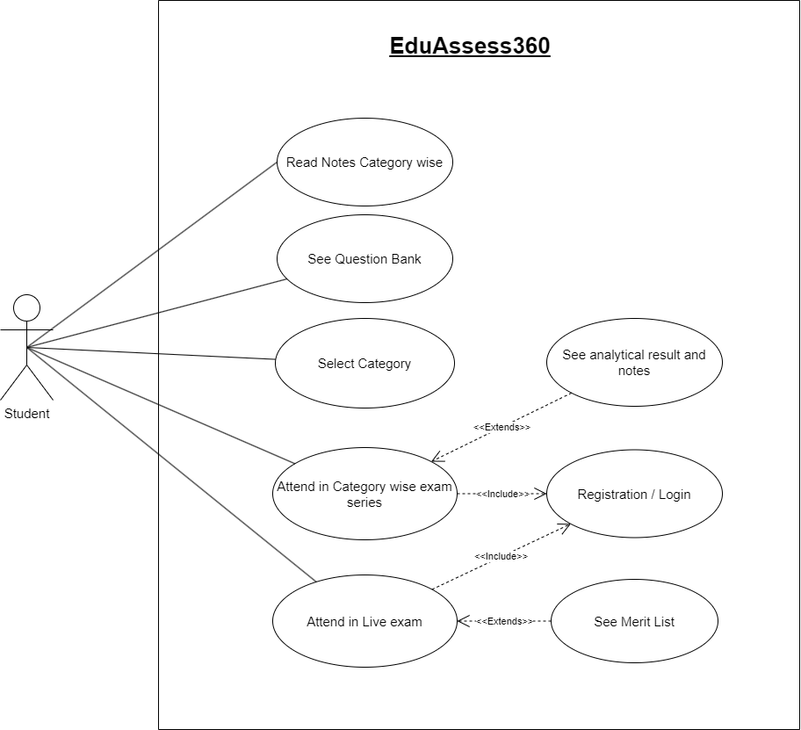

Fig. 3.1 : Student Use Case Diagram

**Scenario 2: Admin Managing Content** The admin logs into the admin panel to review newly submitted questions and manage point distributions for premium users. They also monitor the database for synchronization between Firebase and sqflite, ensuring seamless performance.

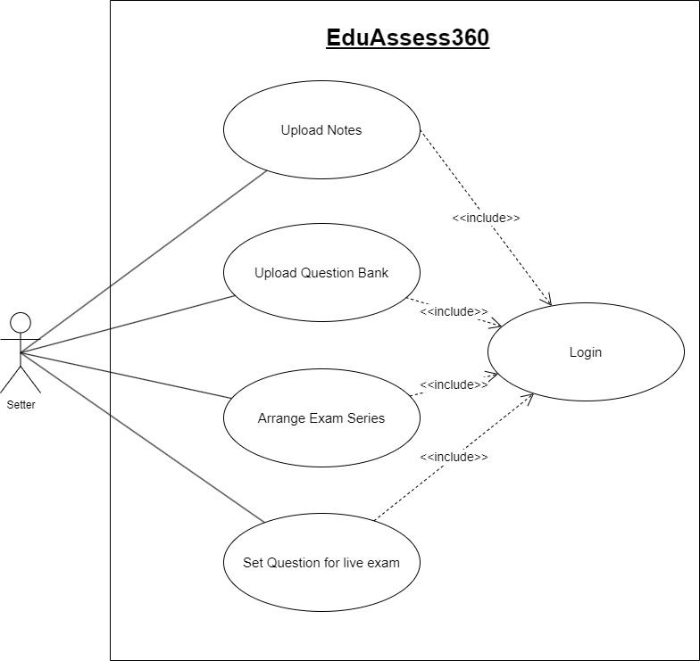

Fig. 3.2 : Admin Use Case Diagram

# Chapter 4: Testing and Feedback

## User Feedback

Beta testers highlighted the app’s intuitive interface and appreciated the AI-generated insights. Suggestions included adding more question categories and improving response times for large datasets.

## Testing Metrics

* Performance Testing: Verified the app’s speed and reliability under various conditions.
* Usability Testing: Ensured that users of different age groups could navigate the app with ease.
* Security Testing: Confirmed data encryption and protection against unauthorized access.

# Chapter 5: Future Enhancements and Challenges

## Future Enhancements

* Multilingual Support: Introduce features to support multiple languages for diverse user bases.
* Interactive Learning: Integrate VR technology for immersive study sessions.
* Enhanced AI: Develop more sophisticated algorithms for predicting user performance trends.
* Offline Mode: Allow access to core features without an active internet connection.

## Challenges and Risks

**Challenges:**

* Ensuring synchronization between local (sqflite) and remote (Firebase) databases.
* Achieving accurate performance analysis through AI algorithms.
* Maintaining compatibility across Android and iOS platforms.

**Risks:**

* Dependency on third-party libraries.
* Adhering to app store policies.
* Data security and privacy concerns.

# Chapter 6: Project Outcomes and Benefits

## Deliverables

* A fully functional cross-platform mobile application.
* Admin panel for content and user management.
* Teacher panel for question creation and feedback integration.
* AI algorithms for result analysis and note generation.

## Benefits

* Time-efficient preparation through AI-curated resources.
* Improved exam performance via detailed feedback.
* Enhanced user engagement with gamification and reward systems.
* Streamlined resource management for educators through dedicated panels.

# Chapter 7: Application Screenshots

To provide a better understanding of the application’s functionality and user interface, the following screenshots are included:

## Admin Panel: Home Screen

* **Description**: This screen displays the administrative dashboard, offering quick access to critical management features like user monitoring, content approval, and system settings.

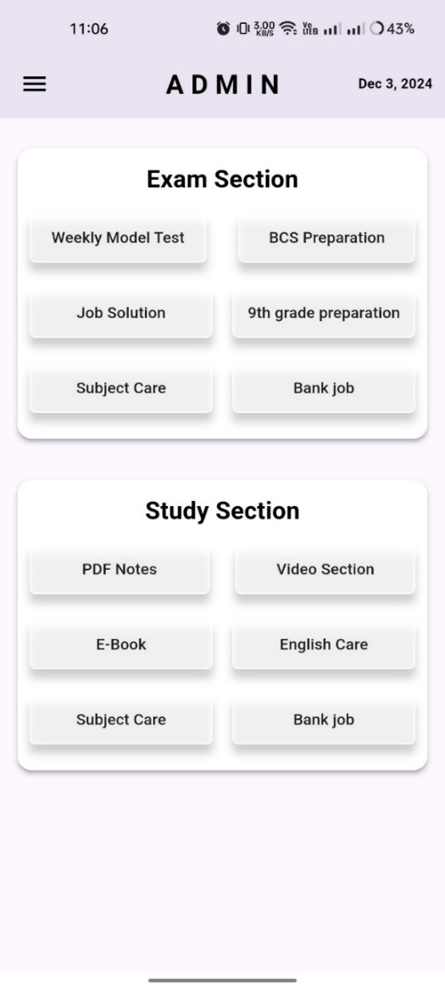

Fig. 7.1 : Admin Home Page

## Admin Panel: Add Exam Page

* **Description**: This page enables admins to create new exams by defining parameters such as exam type, subject category, and difficulty levels.

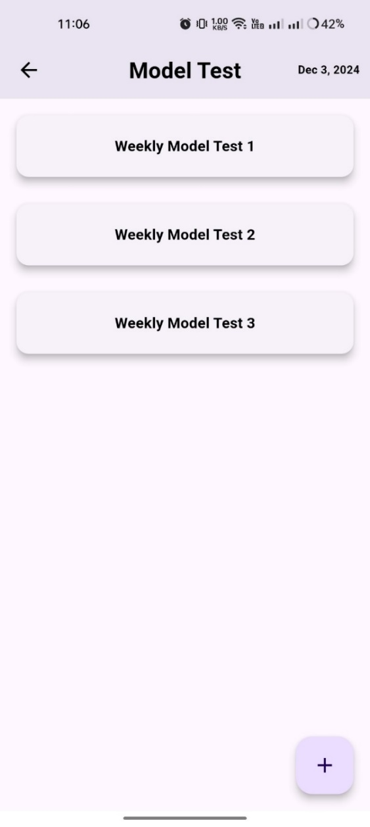 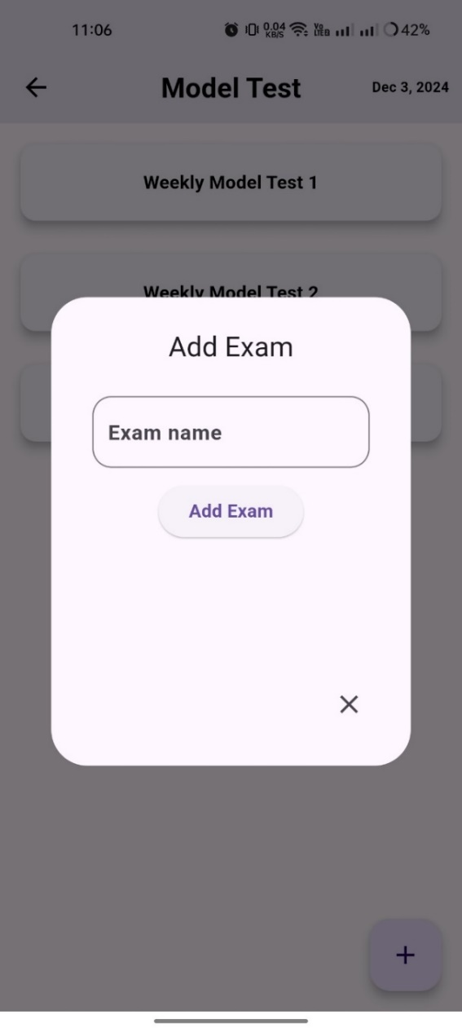

Fig. 7.2 : Admin Exam List Page Fig. 7.3 : Admin Add Exam Page

## Admin Panel: Add Question Page

* **Description**: Allows admins or teachers to input new questions, categorize them by subject and topic, and link them to specific exams.

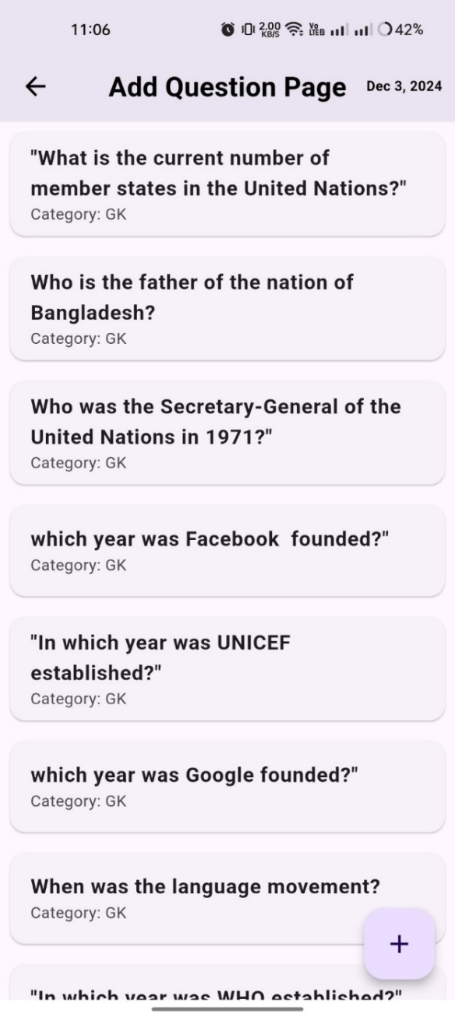 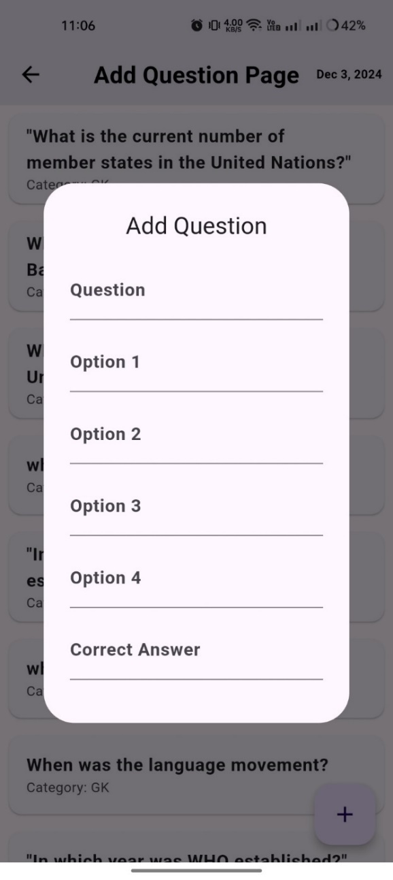

Fig. 7.4 : Admin Exam Question List Page Fig. 7.5 : Admin Add Question Page

## Student Homepage

* **Description**: This is the starting interface for students, showcasing accessible features such as exams, performance reports, and study materials.

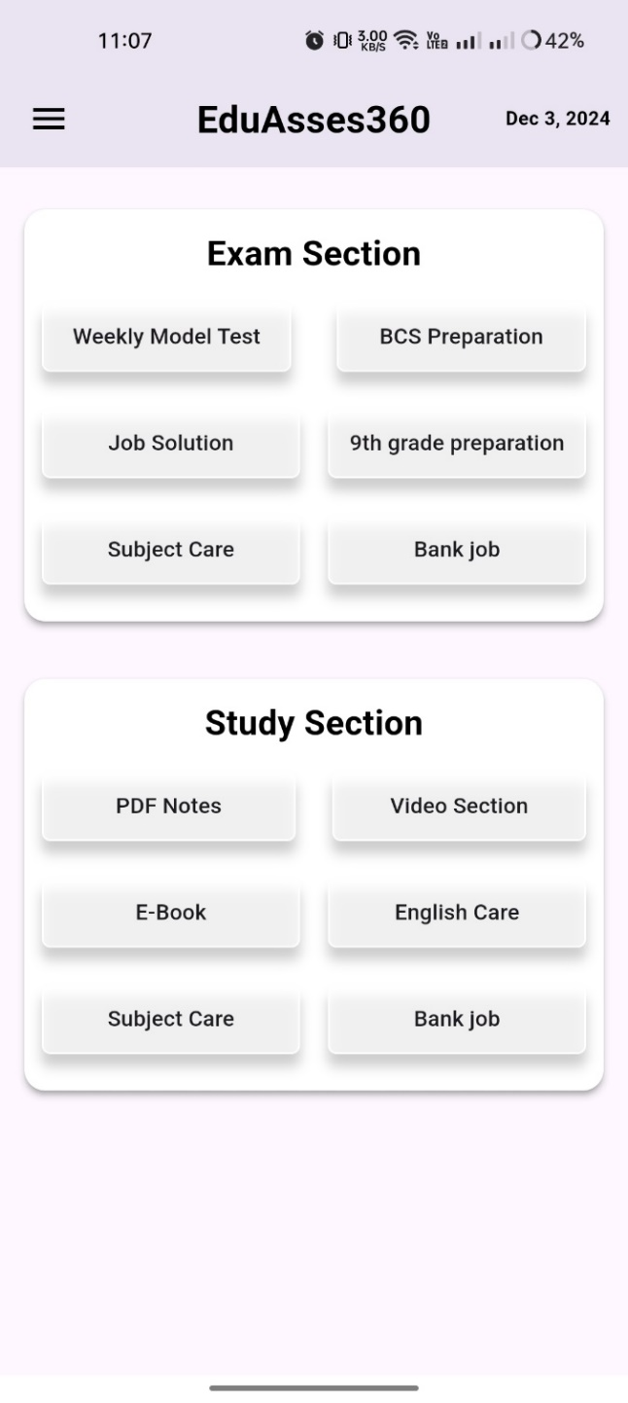

Fig. 7.6 : Student Home Page

## Student Exam List Page

* **Description**: Lists available exams categorized by subject or difficulty, allowing students to select their preferred preparation module.

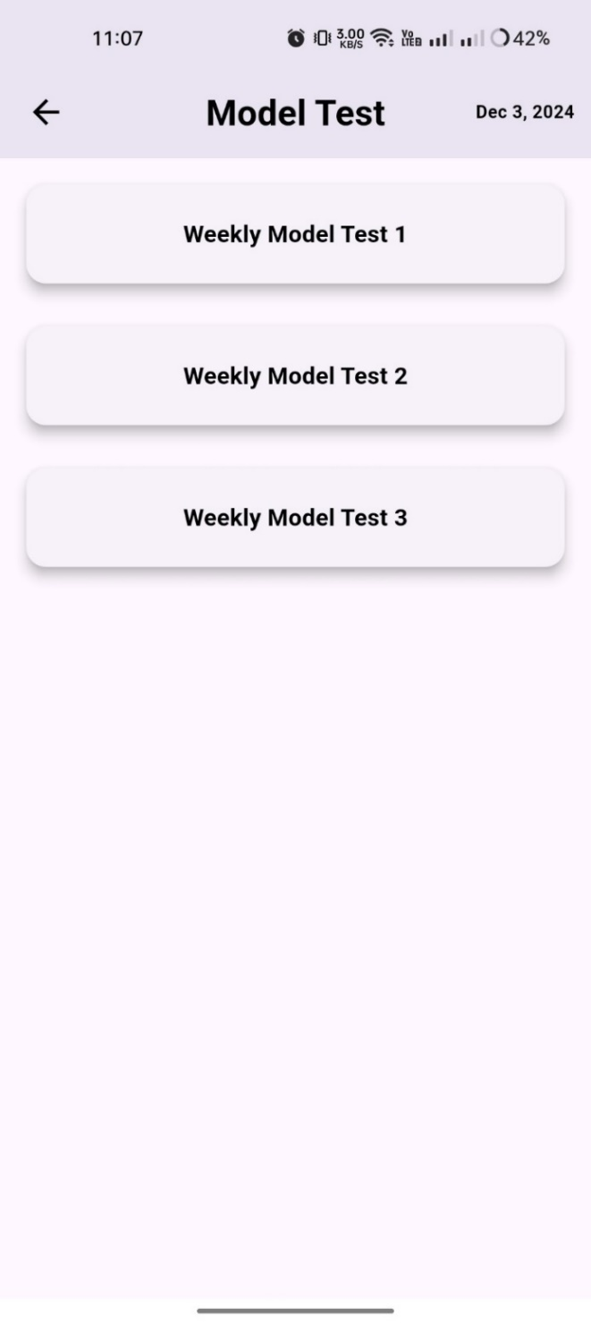

Fig. 7.7 : Student Exam List Page

## Student Main Exam Page

* **Description**: The interactive exam interface where students can attempt MCQs, track their progress, and submit answers for evaluation.

**•** 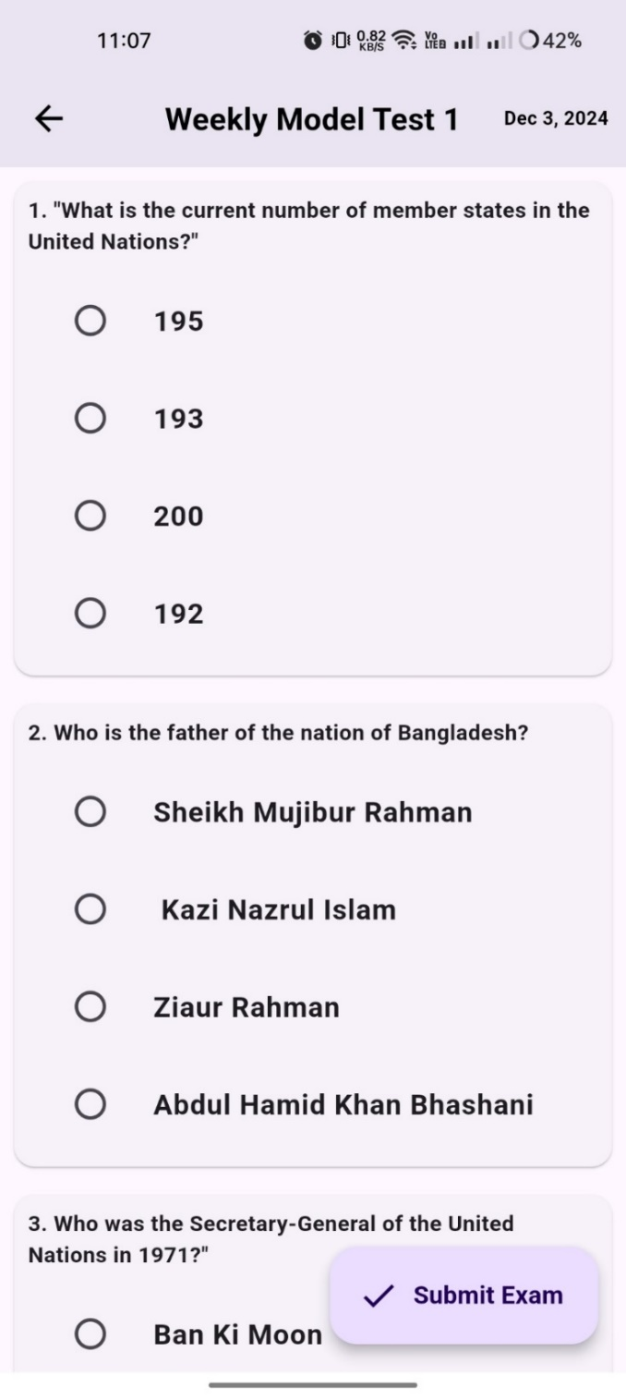

Fig. 7.8 : Student Attend Exam Page

## Firebase Database Overview

* **Description**: Displays the backend architecture showcasing data storage and retrieval mechanisms, ensuring efficient app functionality.

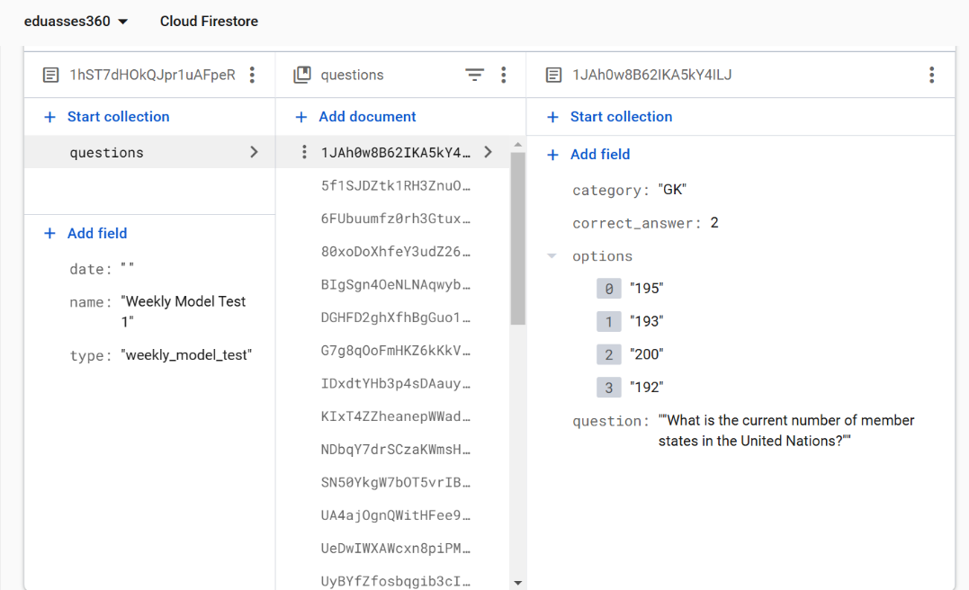

Fig. 7.9 : Question in Remote Database (Firebase)

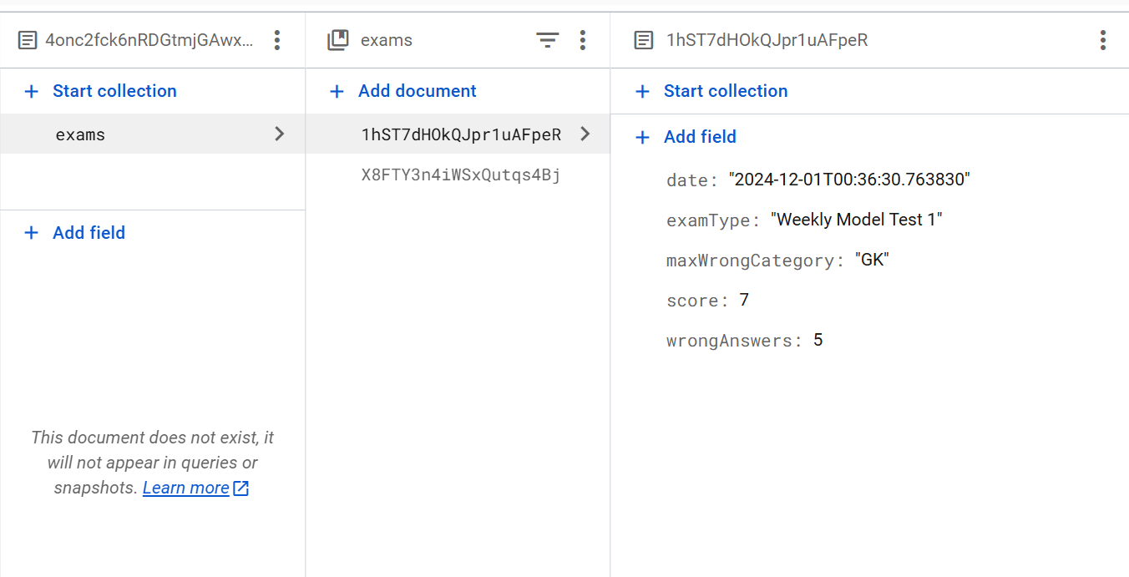

Fig. 7.10 : Student Dataqbase

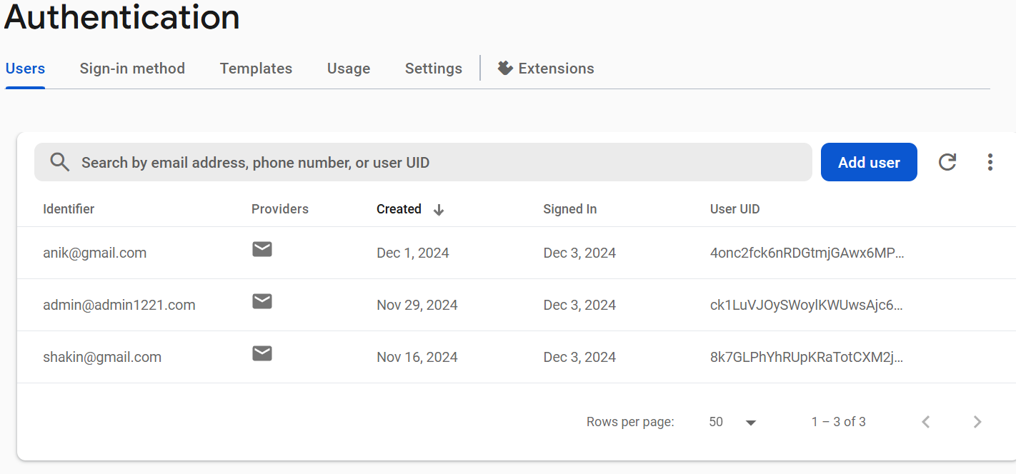

Fig. 7.11 : Firebase Authentication

# Chapter 8: Conclusion

EduAssess360 redefines exam preparation by merging advanced technology with user-centric design. By addressing common pain points in learning, the app provides a robust platform for personalized and efficient preparation, paving the way for better academic outcomes.

This application stands out in its ability to streamline exam preparation through innovative features such as AI-driven feedback, performance analysis, and tailored study materials. The integration of gamification elements like rewards and leveling systems fosters continuous user engagement and motivation. Additionally, the inclusion of pre-exam resources saves time and effort for students, enabling them to focus on effective learning strategies.

EduAssess360 also empowers educators with tools to create and manage quality content, supported by insightful analytics on student interactions and question performance. Administrators benefit from seamless content moderation and management, ensuring the app maintains its high standards.

Looking ahead, EduAssess360’s potential for expansion into interactive and immersive learning experiences positions it as a revolutionary tool in educational technology. By leveraging advancements in artificial intelligence and user experience design, the app has the capability to cater to a broader audience and continuously adapt to evolving educational needs.

In summary, EduAssess360 is more than just an exam preparation tool; it is a comprehensive learning ecosystem designed to enhance academic success and redefine the boundaries of traditional education.