Chapter 4

Methodology
This chapter describes the design of PoisonGuard-RAG, the defense proposed in this thesis, and the experimental methodology used to evaluate it. Section 4.1 states the design principles. Section 4.2 presents the overall architecture and the adaptive risk model. Section 4.3 details each of the eight pipeline stages, with most attention given to the evidence-arbitration stage that carries the main contribution. Section 4.4 summarises the procedure as an algorithm, Section 4.5 records how the design evolved from version 1 to the final version 5 and why, and Sections 4.6 to 4.9 describe the datasets, attacks, baselines, metrics, statistical tests, ablation design and reproducibility measures.

4.1 Design Principles
PoisonGuard-RAG is built on four principles that follow directly from the gaps identified in Chapter 2.
- Anchor trust in the model's own knowledge. A corpus-poisoning attacker controls retrieved text but cannot change the weights of the generator. The model's parametric answer is therefore produced without any retrieved passage in its context and is used as the reference point. Retrieved evidence that conflicts with a confident parametric answer cannot overrule it.
- Read evidence in isolation, then vote. Instead of asking one LLM call to consolidate all passages (as TrustRAG does), each passage is read on its own and reduced to a short answer. Answers are then grouped and counted. A single persuasive poisoned passage can no longer steer the reading of the others, and every decision is traceable to the passages that supported it.
- Count sources, not copies (sybil resistance). PoisonedRAG places several near-identical poisoned passages for the same target. Passages that look coordinated are either removed or merged into one source group, so five copies of the same claim count as one witness.
- Never buy robustness with refusals. An earlier version refused whenever evidence was weak, which lowered the attack success rate simply by answering less (35% refusals on HotpotQA). The final design always produces a best-effort answer on benign questions, so robustness is measured on answered questions and refusals are reserved for detected instruction injection.
Two further engineering principles apply throughout: stages that do not need an LLM do not use one (Stages 1–5 and 7 run on small classifiers, regular expressions and embeddings), and LLM calls that are independent of each other are issued concurrently.

4.2 System Architecture
Figure 4.1 shows the complete pipeline. A question passes through eight stages (S1–S8). Every stage reads and writes a shared per-query state object (question, normalised prompt, retrieved passages, per-passage trust and source group, running risk, answer and an audit trace). Stages S2 and S3–S5 contribute detector scores to a running risk value R, which later stages read to tighten their own behaviour; this is the adaptive cascade. Only S6 calls the generator LLM.
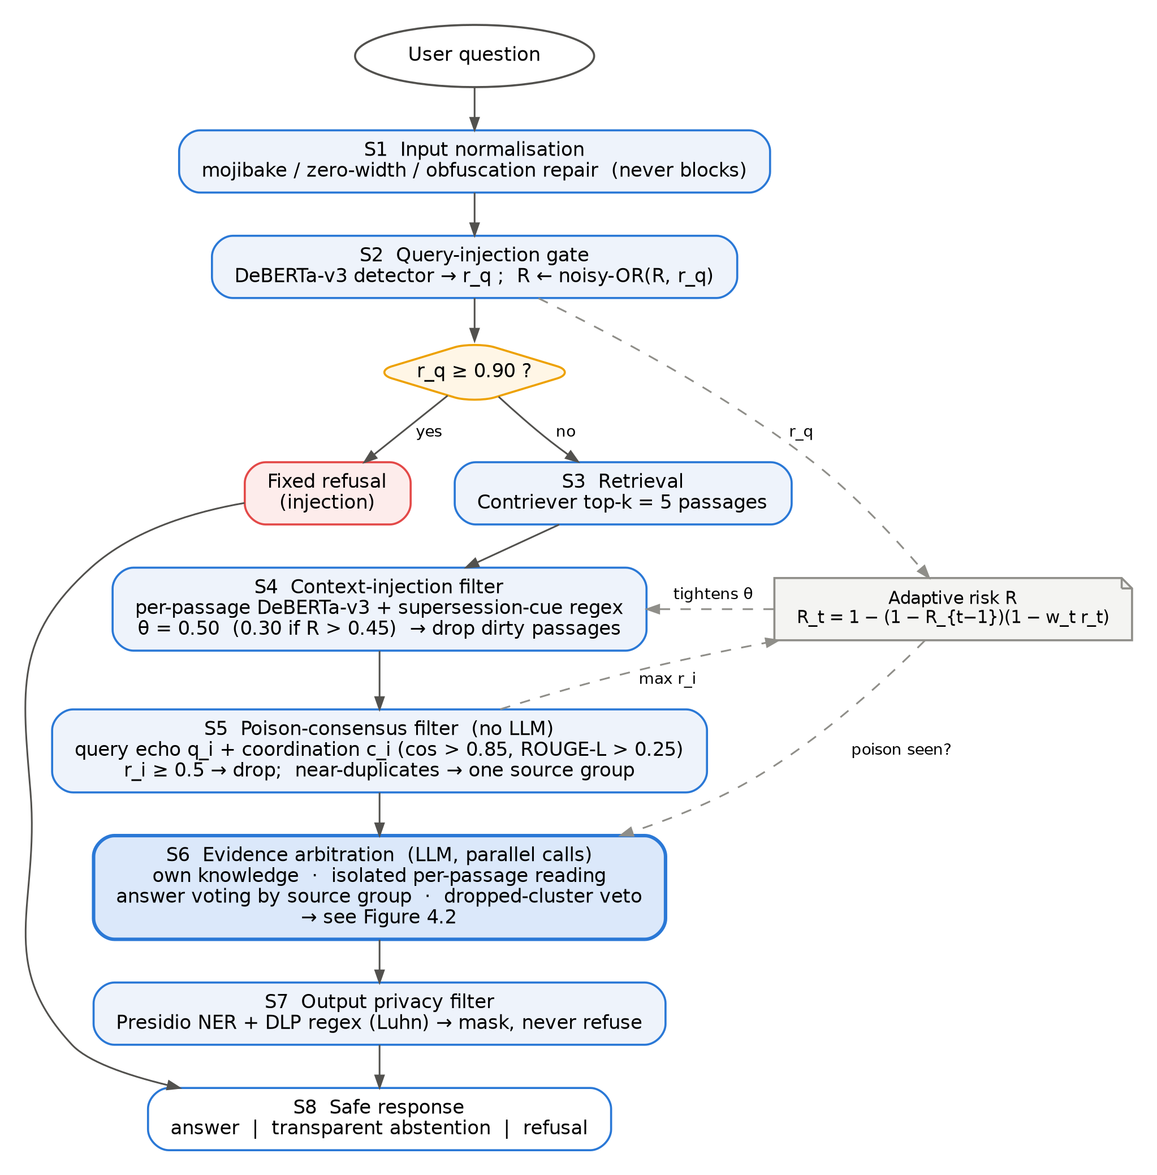
Figure 4.1: Overall architecture of PoisonGuard-RAG (final version, v5). Dashed arrows show how the adaptive risk R is updated and read.

4.2.1 Adaptive Risk Model
Each detector t emits a score r_t in [0, 1] with a stage weight w_t. The running risk is updated by a weighted noisy-OR, so evidence can only accumulate and a single confident detector is sufficient to raise R:
R_t = 1 − (1 − R_{t−1}) · (1 − w_t · r_t), R_0 = 0
The weights are w = 1.0 for the query- and context-injection detectors and w = 0.8 for the poison-consensus score. R is used in two places: S4 tightens its dropping threshold from 0.50 to 0.30 when R > 0.45, and S6 treats a query as "poison seen" when S5 dropped at least one passage or R ≥ 0.5.

4.3 Pipeline Stages
Table 4.1: Summary of the eight pipeline stages.
Stage | Purpose | Method | Key parameters | LLM?
S1 Input normalisation | Undo obfuscation | ftfy repair, zero-width / hidden-character removal, whitespace and contraction normalisation, decoding of obfuscated payloads | max 4,000 chars; never blocks | No
S2 Query-injection gate | Direct prompt injection | LLM-Guard DeBERTa-v3 classifier (protectai/deberta-v3-base-prompt-injection-v2) | hard block if r_q ≥ 0.90 | No
S3 Retrieval | Fetch evidence | Contriever dense retrieval [25] | top-k = 5 | No
S4 Context-injection filter | Indirect injection in passages | Same DeBERTa-v3 classifier per passage + supersession-cue regex ("this corrects earlier reports…") | θ = 0.50, 0.30 if R > 0.45 | No
S5 Poison-consensus filter | Knowledge-corruption poison | Query-echo and pairwise coordination scores (Section 4.3.2); source grouping | drop if r_i ≥ 0.5 | No
S6 Evidence arbitration | Decide the answer | Own knowledge + isolated reading + grouped voting + veto + best effort (Section 4.3.3) | token-F1 ≥ 0.6; ≥ 2 witnesses | Yes (3–8 calls, concurrent)
S7 Output privacy filter | Data leakage | Presidio NER + DLP regex, Luhn check for card numbers | masks, never refuses | No
S8 Safe response | Format output | Answer, transparent abstention, or fixed refusal | — | No

4.3.1 Stages S1–S4: Input and Injection Defences
S1 normalises the question so that later detectors see the text a human would see (for example, a payload hidden with zero-width characters or Unicode look-alikes). It never refuses; an over-length input is recorded, not blocked. S2 scores the normalised question with a DeBERTa-v3 prompt-injection classifier. Only a confident detection (r_q ≥ 0.90) blocks the request; lower scores are fused into R. An earlier content-safety gate (Llama-Guard-1B) was removed because on the benchmark it refused 20 of 1,000 benign questions and caught no attack. S3 retrieves the top five passages with Contriever, exactly as in PoisonedRAG and TrustRAG. S4 scans each passage with the same classifier and a regular expression for "supersession cues", the planted-correction phrasing typical of indirect injection. Passages above the threshold θ are dropped; θ tightens adaptively when the query already looks risky.

4.3.2 Stage S5: Poison-Consensus Filter
PoisonedRAG poison contains no instruction, so injection detectors cannot see it. S5 instead scores two structural signatures of retrieval-optimised poison, with no LLM call and with thresholds fixed in advance:
- Query echo q_i: the longest common token subsequence between the question and the passage prefix, divided by the question length. Poison is often written as "question ⊕ false statement" to maximise retrieval similarity.
- Coordination c_i: several poisoned passages for one target are near-paraphrases. For every pair (i, j), c_i = max_j σ((cos_ij − 0.85)/0.02) · σ((ROUGE-L_ij − 0.25)/0.03), where cos is the BGE-M3 embedding cosine similarity and σ is the logistic function. The thresholds 0.85 and 0.25 are TrustRAG's published values, reused unchanged.
r_i = 1 − (1 − 0.9 · σ((q_i − 0.75)/0.05)) · (1 − 0.9 · c_i)
Passages with r_i ≥ 0.5 are dropped and R is updated with max_i r_i (w = 0.8). Passages linked by a coordination score ≥ 0.5 that survive are placed in the same source group, so the arbitration stage counts them as one witness. S5 deliberately cannot detect a single isolated poisoned passage (there is nothing for it to be coordinated with); that case is handled by S6.

4.3.3 Stage S6: Knowledge-Anchored Evidence Arbitration
S6 is the core of the defense. Its decision logic is shown in Figure 4.2 and consists of six steps.
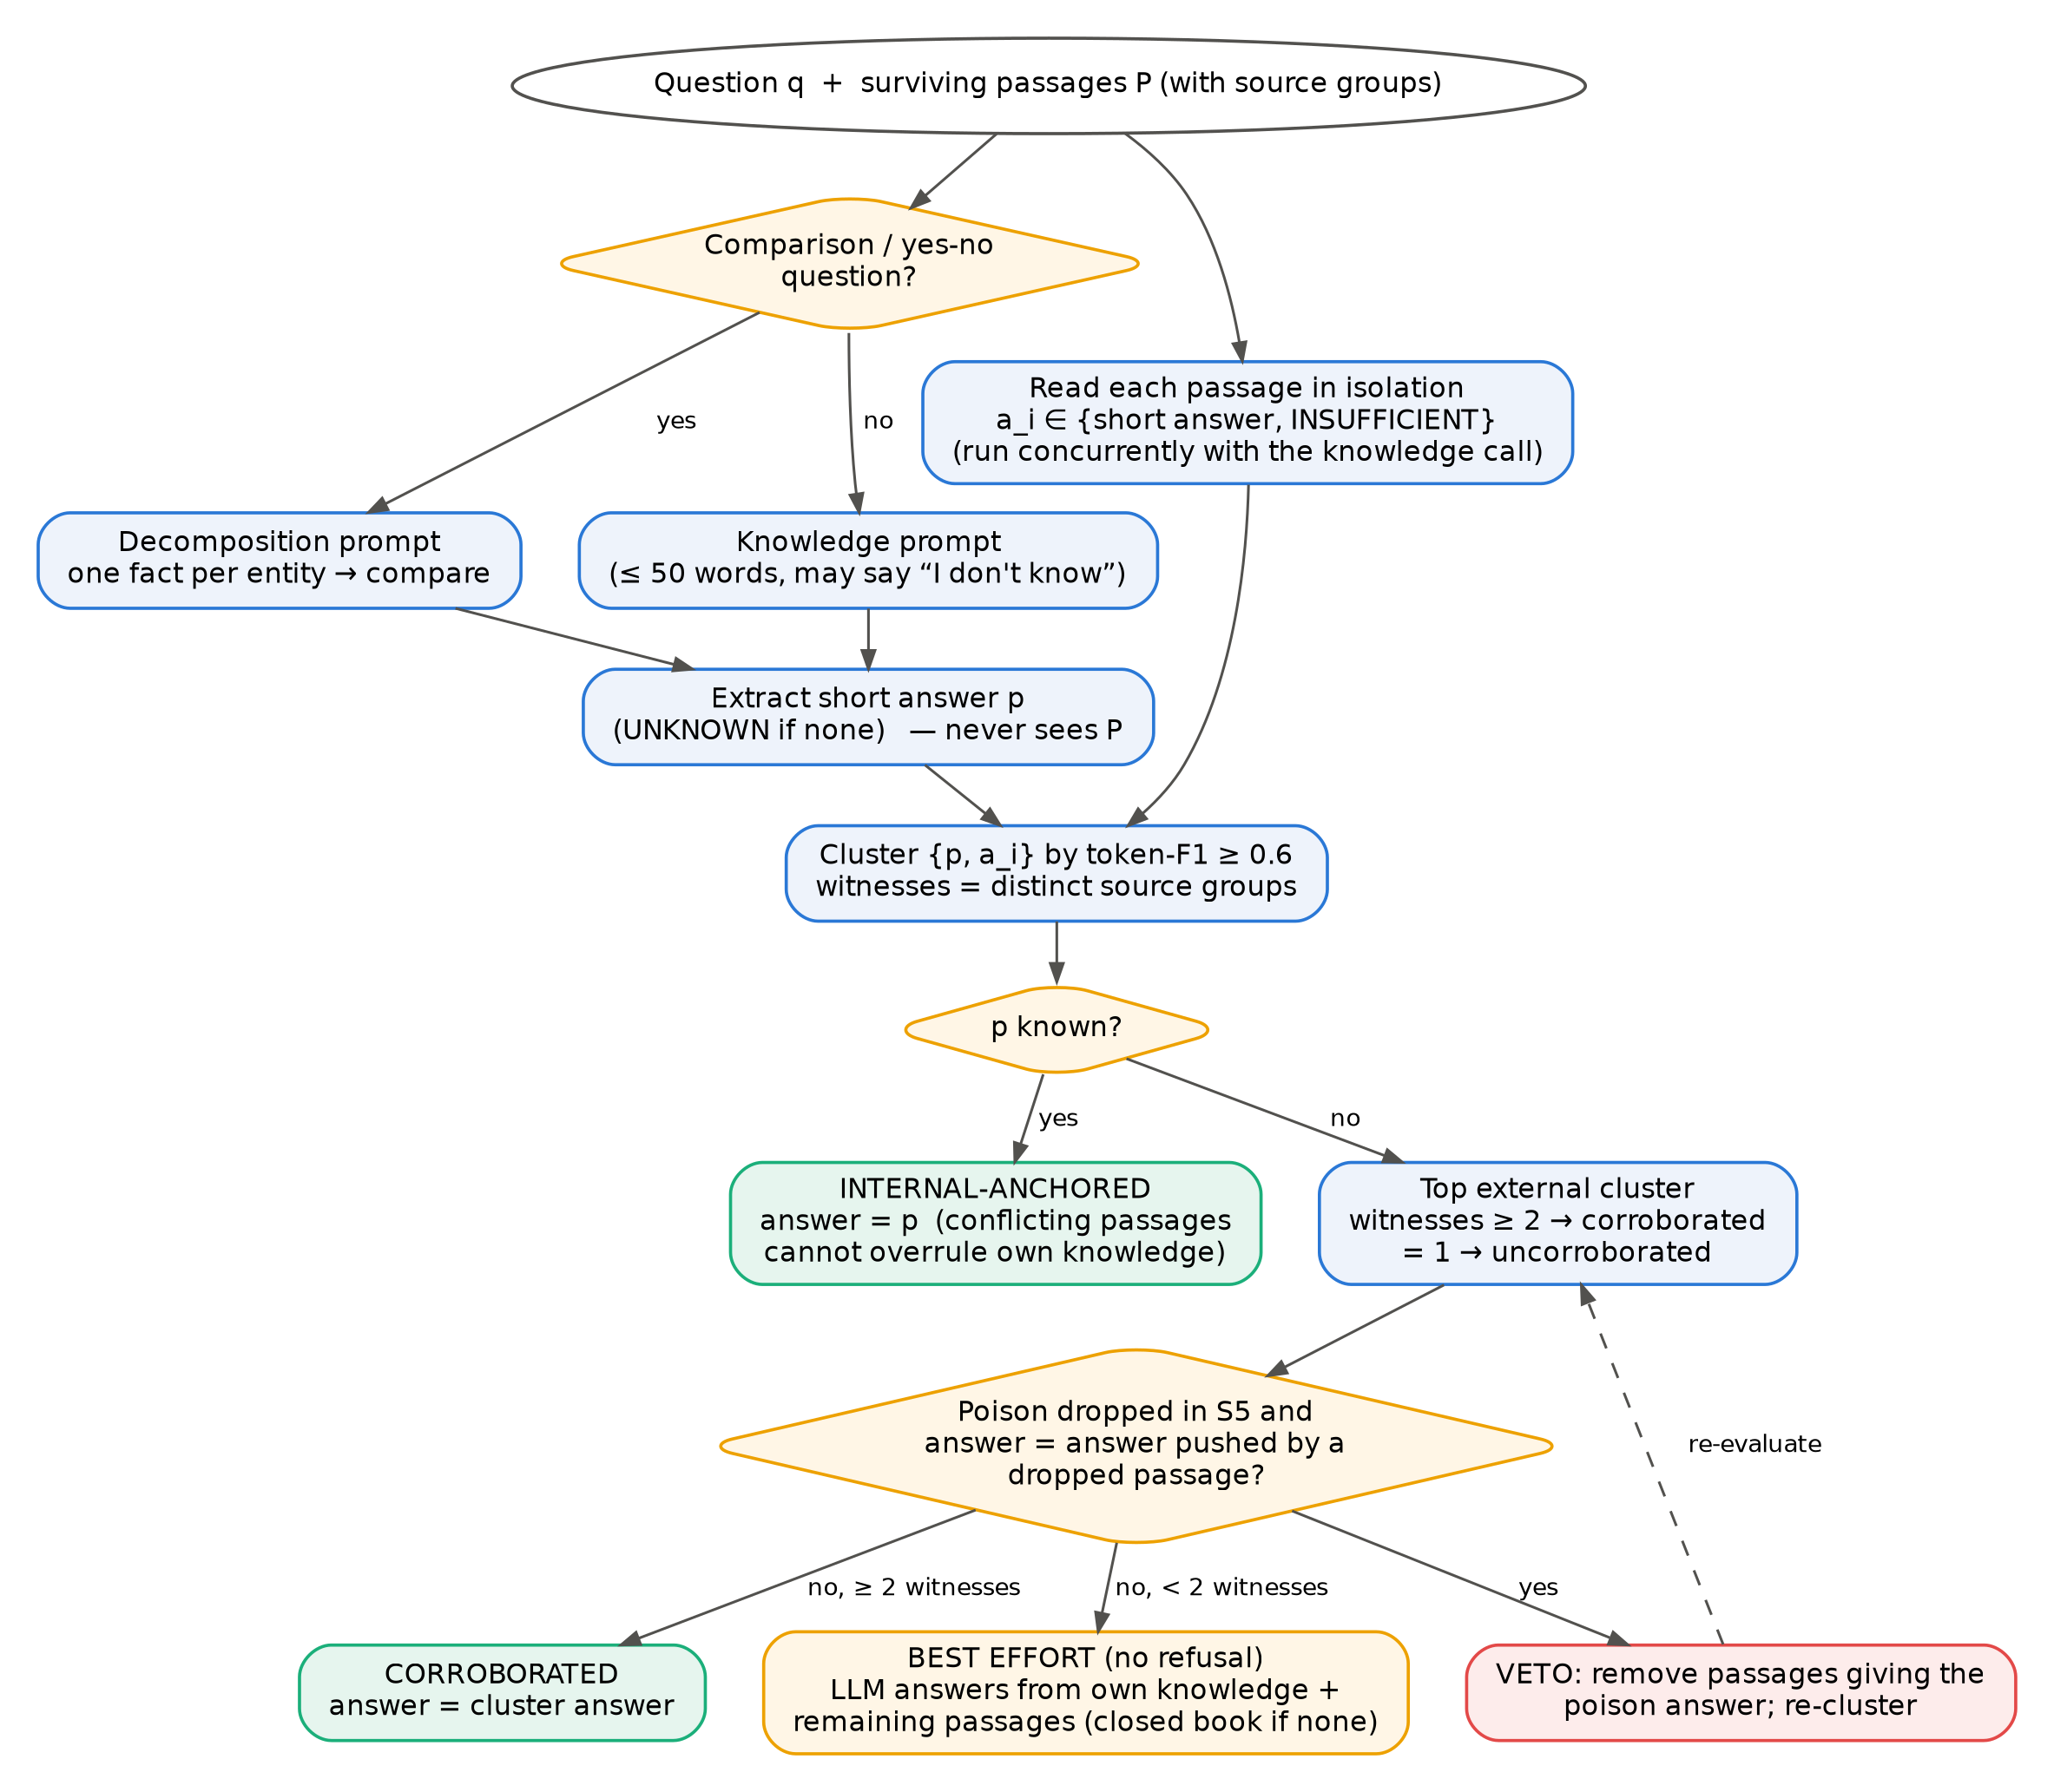
Figure 4.2: Decision logic of the evidence-arbitration stage (S6).
Step 1 — Parametric knowledge. The generator is asked for a short statement (at most 50 words) answering the question, and is explicitly allowed to say "I don't know". For comparison and yes/no questions (detected by a leading auxiliary verb or an "A or B?" ending), a decomposition prompt is used instead: the model first recalls one short fact about each entity and only then compares them. This addresses a failure observed on HotpotQA, where one-shot recall confidently produced wrong comparisons (for example, placing two airports in the same state). A second call extracts a short answer p from the statement, or UNKNOWN. This step never sees any retrieved passage, so a poisoned corpus cannot influence it. Hedged statements such as "I don't know X; however, it was Y" are passed to the extractor rather than discarded, so they count as knowing Y.
Step 2 — Isolated passage reading. Each surviving passage is read on its own with a prompt that returns a short answer a_i or INSUFFICIENT. Because these calls and the Step 1 call do not depend on each other, they are issued concurrently.
Step 3 — Clustering and witness counting. The answers {p, a_1, …, a_n} are grouped: two answers match if their normalised token sets are nested or their token-level F1 is at least 0.6. For each cluster, the number of witnesses is the number of distinct source groups (the parametric answer is its own group), and its weight is the sum of the best passage trust (1 − r_i) per group.
Step 4 — Decision. If p is known, the answer is internal-anchored: the cluster containing p wins, whether or not passages agree. Passages that disagree are recorded as a conflict but cannot overrule the model's own knowledge. If p is UNKNOWN, the strongest external cluster is corroborated when it has at least two independent witnesses and uncorroborated otherwise.
Step 5 — Dropped-cluster veto (new in v5). If S5 removed passages for this query, one removed passage is read to learn which answer the coordinated group was pushing. If the candidate external answer equals it, the passages giving that answer are treated as members of the poison group that slipped through the filter: they are removed and the decision is re-evaluated. This closes two failure modes seen during development: near-copies of the poison that evaded S5 outvoting a single clean passage, and a correct lone passage being suppressed because it merely mentioned the same entity as the poison.
Step 6 — Best-effort answer. When no internal or corroborated answer exists, the generator receives its own knowledge statement plus the remaining passages and must give its best answer rather than refuse. If nothing remains, the answer is closed-book, which a corpus-poisoning attacker cannot influence. For internal-anchored answers, the final response is the short answer followed by the knowledge statement.

4.3.4 Stages S7–S8: Output Controls
S7 masks personal and secret data in the answer (e-mail, phone, card numbers confirmed by the Luhn check, national-ID patterns, API keys and bearer tokens) using Presidio named-entity recognition and deterministic regular expressions. It never refuses; a Llama-Guard output gate from an earlier version was removed because it refused 10 of 1,000 benign answers and caught no attack. S8 returns the answer, a transparent abstention message if no answer could be formed, or a fixed refusal if S2 blocked the query.

4.4 Algorithm
Algorithm 1 gives the complete procedure for one query.
Algorithm 1 PoisonGuard-RAG (v5)
Input: question q; Output: response
1 x ← Normalise(q); R ← 0
2 r_q ← InjectionScore(x); R ← NoisyOR(R, r_q, 1.0)
3 if r_q ≥ 0.90 then return REFUSAL
4 P ← Retrieve(x, k = 5)
5 θ ← 0.30 if R > 0.45 else 0.50
6 P ← {p ∈ P : InjectionScore(p) < θ and not SupersessionCue(p)}
7 for each p_i ∈ P: r_i ← NoisyOR(Echo(x,p_i), Coord(p_i,P)) // no LLM
8 D ← {p_i : r_i ≥ 0.5}; P ← P \ D; G ← SourceGroups(P); R ← NoisyOR(R, max r_i, 0.8)
9 in parallel: K ← Knowledge(x) [Decompose(x) if comparison]; a_i ← ReadAlone(p_i, x) ∀ p_i ∈ P
10 p ← Extract(K, x)
11 d ← Arbitrate(p, {a_i}, G) // internal / corroborated / uncorroborated / abstain
12 if d ∈ {corroborated, uncorroborated} and D ≠ ∅ then
13 a_D ← ReadAlone(D[0], x)
14 if Same(d.answer, a_D) then P ← {p_i : not Same(a_i, a_D)}; d ← Arbitrate(p, {a_i : p_i ∈ P}, G)
15 if d ∈ {internal, corroborated} then y ← d.answer
16 else y ← BestEffort(x, K, P) // no refusal; closed book if P = ∅
17 return SafeResponse(MaskPII(y))

4.5 Design Evolution
The pipeline was developed iteratively. Every change was motivated by an error analysis on the development questions only (PoisonedRAG targets 1–50) and was frozen before the held-out test questions (targets 51–100) were run. Table 4.2 records the path.
Table 4.2: Evolution of the design. All tuning used development questions 1–50 only.
Version | Main change | Reason (development evidence)
v1–v2.1 | Original 13-step multi-vector pipeline adapted to the PoisonedRAG benchmark | Content-safety gates (Llama-Guard) blocked benign questions and caught no poisoning attack; removed
v3.1 | Isolated per-passage reading and knowledge-anchored voting; abstain when a lone passage survives under poison | Low ASR, but 28% of clean HotpotQA questions were refused (72% answered)
v3.2 | Joint reading of all passages as a fallback | Tested and not adopted: reopened the channel that isolated reading closes
v4 | Read hedged knowledge statements; best-effort answer instead of refusal; hide a lone passage under poison | Refusals eliminated; HotpotQA mean ACC 44.0 → 65.6 on the test half
v5 (final) | Decomposition for comparison / yes-no questions; dropped-cluster veto; concurrent LLM calls | Dev HotpotQA ACC +2 to +6 over v4 at every rate; median latency roughly halved

4.6 Experimental Setup

4.6.1 Datasets and Split
Experiments follow the PoisonedRAG [1] and TrustRAG [2] protocol on three question-answering datasets from the BEIR benchmark: Natural Questions (NQ) [27], HotpotQA [28] (multi-hop) and MS-MARCO [29]. For each dataset PoisonedRAG provides 100 target questions, each with a correct answer, an attacker-chosen incorrect answer and five poisoned passages. The 100 targets are split into a development half (targets 1–50), used for all design decisions and error analysis, and a held-out test half (targets 51–100), run once with the frozen final system and used for every headline number. The development half is additionally reported for the all-100 comparison with published results, clearly marked as such.

4.6.2 Threat Models and Attacks
- PoisonedRAG corpus poisoning [1] at poison rates of 100%, 80%, 60%, 40%, 20% and 0% (5, 4, 3, 2, 1 or 0 poisoned passages merged with the clean candidates and ranked by Contriever score, keeping the top five). Poisons are used without the question prefix, as in TrustRAG's main table.
- Prompt injection (PIA): four clean passages plus one passage instructing the model to output the incorrect answer.
- Adaptive attack (style-diverse): each of the five poisoned passages is rewritten by the LLM in a different style (encyclopedia entry, news report, forum answer, textbook excerpt, fact-check), so the passages no longer look alike and evade the coordination filter.
- Adaptive attack (knowledge mimicry): the attacker queries the same LLM with PoisonGuard-RAG's own knowledge prompt but forces the incorrect answer, producing poison written in the style of the model's own knowledge statement.
Both adaptive attacks keep the retrieval rank of the original poison (retrieval-matched), isolating the effect of the defense from the effect of retrieval.

4.6.3 Systems Compared
Table 4.3: Systems compared.
System | Description
No retrieval (closed book) | The generator answers the question alone; tests whether a defense merely ignores retrieval
Vanilla RAG | Top-5 passages concatenated into the TrustRAG prompt
TrustRAG (reproduced) | Official code: K-means + n-gram filtering, internal-knowledge extraction and LLM consolidation
RobustRAG, InstructRAG, AstuteRAG, TrustRAG | Numbers reported in the TrustRAG paper (Tables 1–2), shown for reference only
PoisonGuard-RAG v4 / v5 | Previous and final version of the proposed system

4.6.4 Implementation
All systems use the same generator, Llama-3.1-8B-Instruct [26] served locally with Ollama (temperature 0, fixed seed, 4,096-token context), and the same Contriever retrieval lists. Generalisation is tested with a second generator, Mistral-Nemo-12B, for which the TrustRAG paper also reports results. Everything runs on a single consumer laptop at zero monetary cost; all latencies are measured on that machine with the same queue, so they are directly comparable across systems.

4.7 Evaluation Metrics
- Accuracy (ACC): share of questions whose response contains the correct answer.
- Attack success rate (ASR): share of questions whose response contains the attacker's answer and not the correct one.
- Two matching rules. The paper rule uses substring matching exactly as TrustRAG's code does. Because it rewards long answers on yes/no questions ("no" is found inside "know"), a strict whole-word rule is also reported and applied identically to every system.
- Utility: clean accuracy (0% poison), refusal rate, and accuracy on the retrieval-needed subset (questions the closed-book model gets wrong).
- Filter quality: poison recall, precision and clean-passage retention of the passage filters; ASR among queries where at least one poisoned passage reached the generator.
- Detection: AUROC of the pipeline risk score for "at least one poisoned passage in the top five".
- Cost: mean wall-clock seconds per query, with a per-stage breakdown.

4.8 Statistical Analysis and Ablation Design
Because every system answers the same questions, comparisons are paired. For each (question, poison-rate) pair the outcomes of two systems are compared, and the discordant pairs are tested with a two-sided exact McNemar (sign) test. Differences in mean ACC and ASR are reported with 95% bootstrap confidence intervals (2,000 resamples, clustered by question). A difference is called a win only when the test is significant at 0.05; otherwise the systems are reported as statistically equivalent.
The contribution of each component is measured by an ablation on the held-out questions (NQ and HotpotQA, poison rates 100%, 60% and 20%), removing one component at a time while keeping everything else fixed:
Table 4.4: Ablation design.
Ablation | What is removed | Question it answers
no_arbitration | S6 replaced by plain generation over surviving passages | How much of the robustness comes from isolated reading and voting?
no_internal | Parametric answer set to UNKNOWN | How much comes from anchoring on the model's own knowledge?
no_consensus | S5 poison-consensus filter disabled | Is the filter needed once arbitration exists?
no_decompose | Standard knowledge prompt for comparison questions | Does decomposition help multi-hop yes/no questions?
no_lonefix | Dropped-cluster veto disabled | Does the veto reduce ASR at mid poison rates?

4.9 Reproducibility
All runs are resumable jobs executed by a single queue runner, and every query writes one JSON record containing the question, the final answer, both metrics, the number of poisoned passages retrieved and reaching the generator, all per-stage scores, the arbitration decision and per-stage timings. The development and test halves are stored in separate directories, and the frozen test results of each version are archived before any later change. Tables and figures are regenerated from these records by scripts, so every reported number can be traced to individual queries.

