
AMERICAN INTERNATIONAL UNIVERSITY-BANGLADESH
Faculty of Science and Technology
Department of Computer Science
CSC 3215: Web Technologies
Semester: Summer 2025-26 Group No: 10 Section: J
Group Members:
SL. | Student ID | Name | Role | Signature
1 | 22-47788-2 | Muhtasim Fuad Nahin | Group Leader
2 | 23-50440-1 | Sudipto Samadder Dipro | Member
3 | 23-50496-1 | MD Shahariar Shiam | Member
4 |  |  | Member

Project Title
MediBook — An Online Doctor Appointment and Clinic Booking System
Short Description
MediBook is a web-based doctor appointment and clinic booking system that lets patients find doctors by specialty and reserve available time slots online, doctors manage their schedules and consultations, and an administrator oversee the whole platform. The goal is to replace slow, phone-and-queue-based booking with a simple, smooth online workflow. The system is built with HTML, CSS, and JavaScript on the front end and PHP with a MySQL database on the back end. It uses PHP sessions and cookies for authentication, JSON for structured data exchange, and AJAX so that searching for doctors and booking a slot happen instantly without reloading the page.
Introduction
Booking a doctor's appointment is still a largely manual process for many clinics: patients call the front desk, wait in a queue, and often have no clear view of which doctors are available or when. This leads to double-booked slots, long waiting times, and a poor experience for both patients and clinic staff. MediBook addresses this by moving the entire booking process online through a single, easy-to-use web application.
The system supports three types of users. Patients can register, search for doctors by specialty, view available time slots, book an appointment, cancel it if needed, and rate a doctor after a completed visit. Doctors can publish their available time slots, accept, reject, or complete appointment requests, and record consultation notes. An administrator verifies doctor accounts, manages the list of specialties, monitors all appointments, and keeps the platform clean by managing user accounts. Together these roles cover a realistic end-to-end clinic booking workflow while staying within the scope of the course.
Background Study
Traditional appointment management in small clinics relies on phone calls, physical registers, or spreadsheets. These methods are error-prone: a slot may be booked twice, cancellations are hard to track, and patients cannot see real-time availability. Larger commercial platforms such as online health-service portals have shown that letting patients self-serve their bookings reduces front-desk load and no-shows, but such systems are often too heavy and feature-rich for a small clinic or an academic project.
MediBook takes the core, most valuable ideas from those platforms — specialty-based doctor search, real-time slot availability, and role-based access — and implements them with the standard web technologies covered in this course. The front end uses HTML, CSS, and client-side JavaScript validation, while the back end uses PHP in a Model-View-Controller structure with a MySQL database. Sessions and cookies handle login and the "remember me" feature, JSON is used to carry data between the browser and the server, and AJAX makes doctor search and slot booking feel instant. This keeps the project simple and smooth to build while still demonstrating every required web technology.
ER Diagram
The Entity-Relationship diagram below shows the database schema of MediBook. The central "users" table stores patients, doctors, and the admin, distinguished by the "role" column. Each appointment and each review references two users — the patient and the doctor — while a slot belongs to a doctor. "specialties" is a reference list managed by the admin, from which a doctor's specialty is chosen.
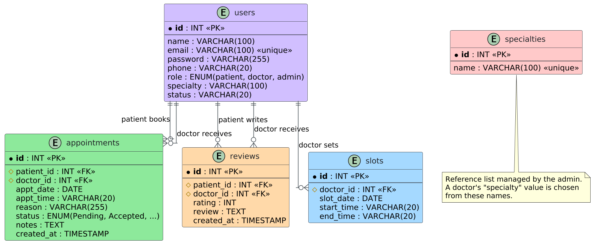
Figure 1: ER Diagram of MediBook (database schema)
Use Case Diagram
The use case diagram below shows the three actors of MediBook — Patient, Doctor, and Admin — together with the use cases available to each. Common use cases (Register, Login, Logout, Manage Profile, Change / Reset Password, and View Dashboard) are shared by all actors, while each actor also has its own distinct set of use cases. The diagram also includes an <<extend>> relationship (Book Appointment extends Search Doctors) and an <<include>> relationship (Complete Appointment includes Write Prescription Notes).
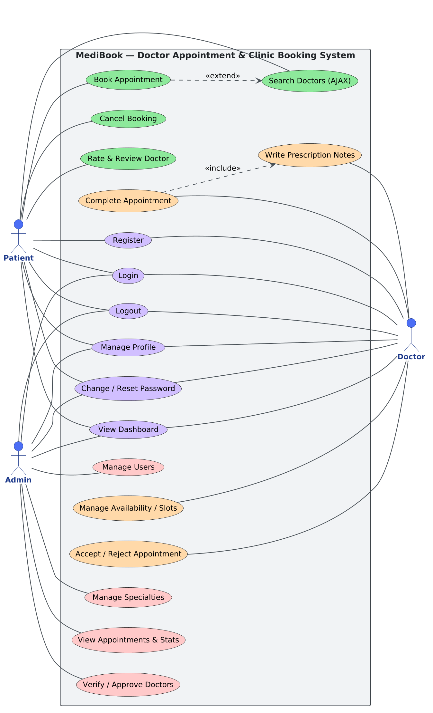
Figure 2: Use Case Diagram of MediBook
UI (Figma/Sketch)
The interface was designed and built directly in HTML and CSS with a consistent layout across every page (a header, a top navigation bar, a main content area, and a footer). The screens below show the final user interface of the system, grouped by user type.
Common Pages (available to all users)
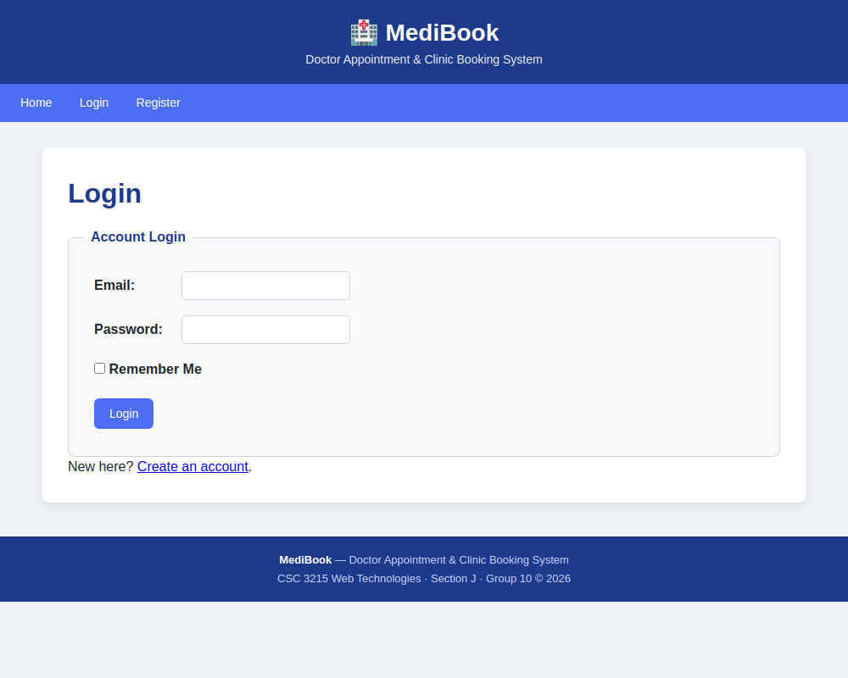
Figure 3: Login page
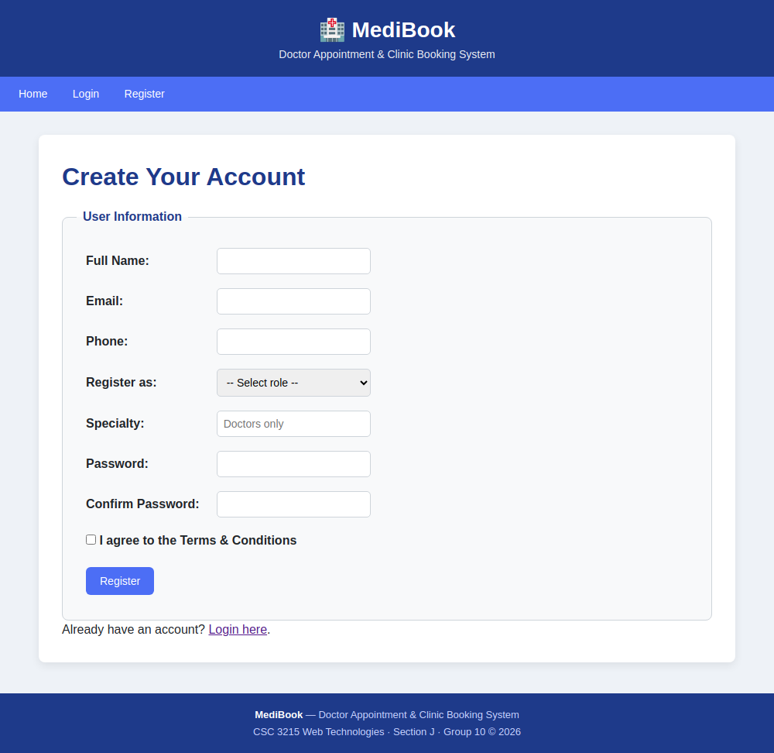
Figure 4: Registration page
Patient
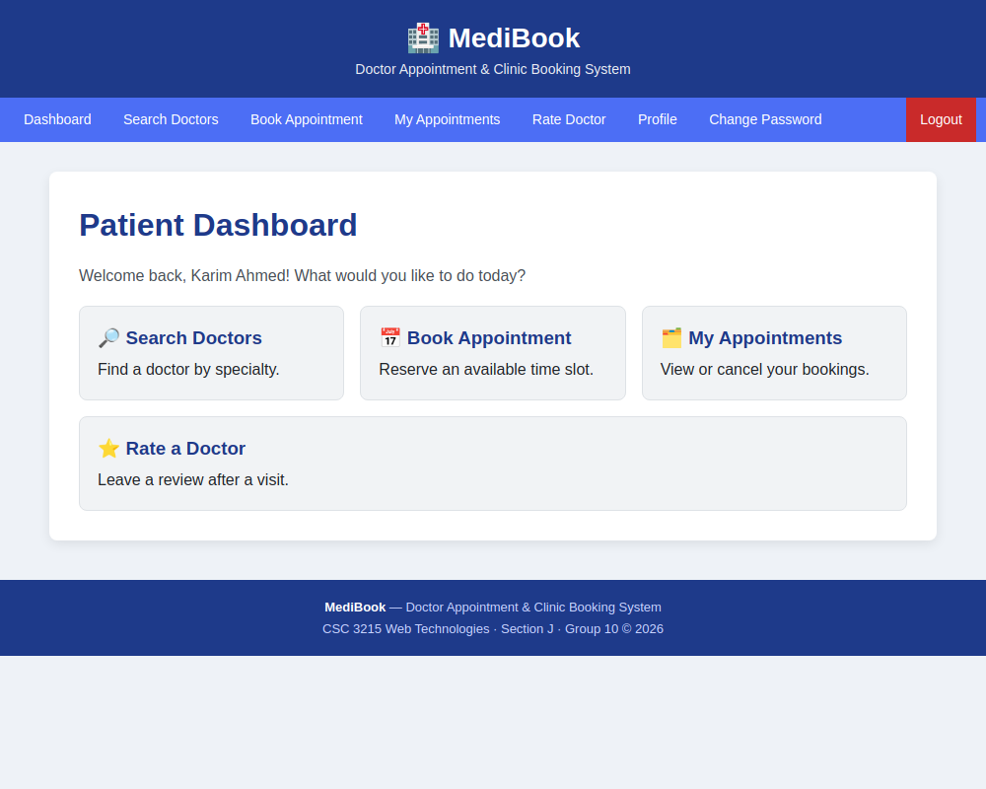
Figure 5: Patient dashboard
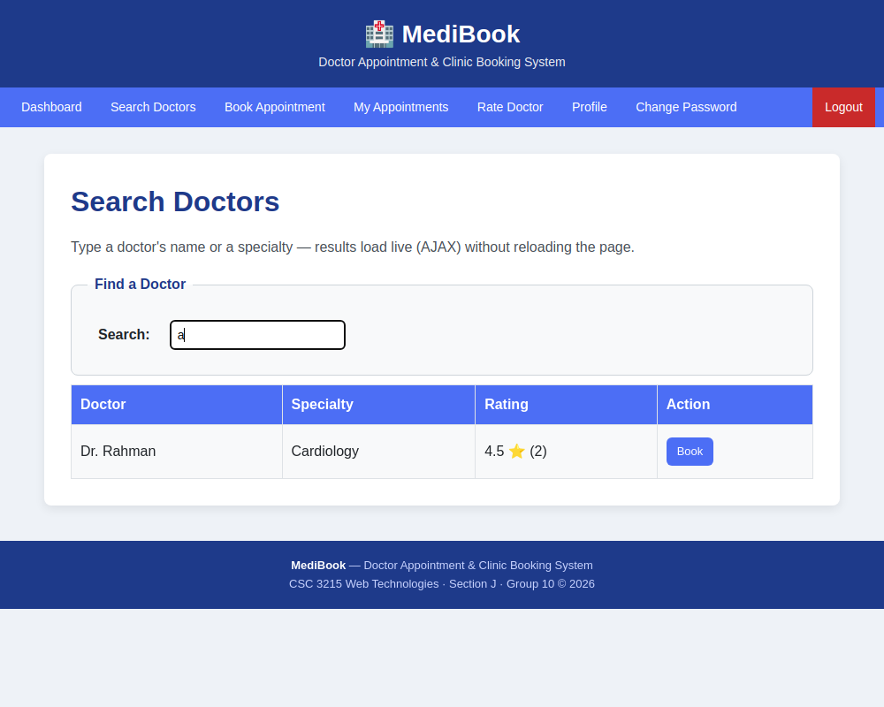
Figure 6: Search doctors — live AJAX search with ratings
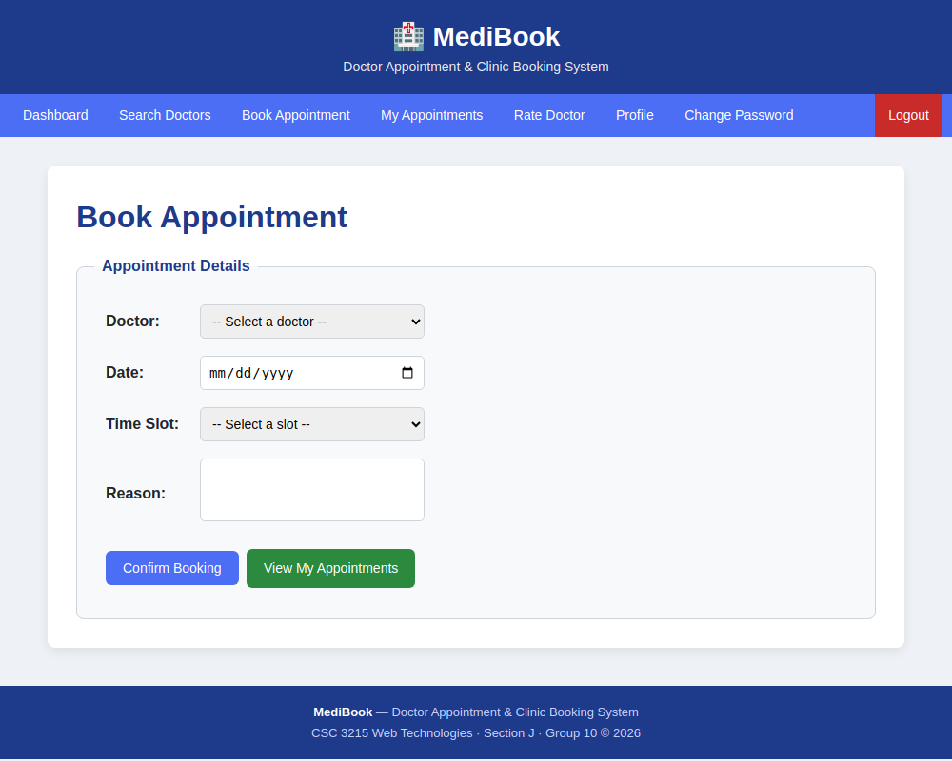
Figure 7: Book an appointment
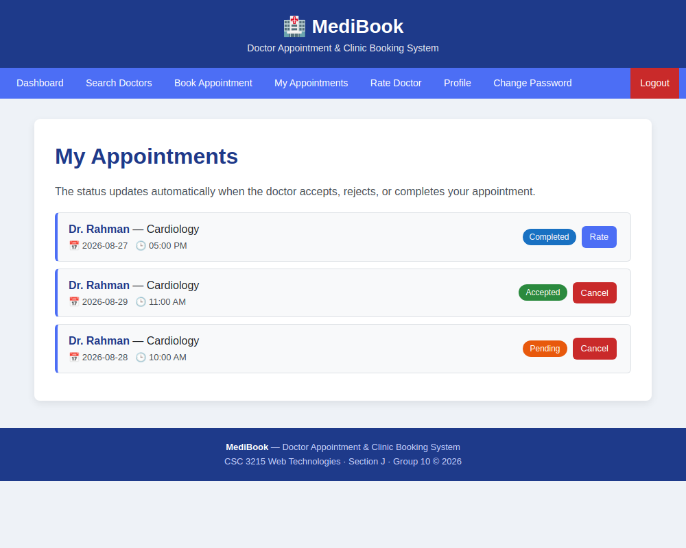
Figure 8: My appointments
Doctor
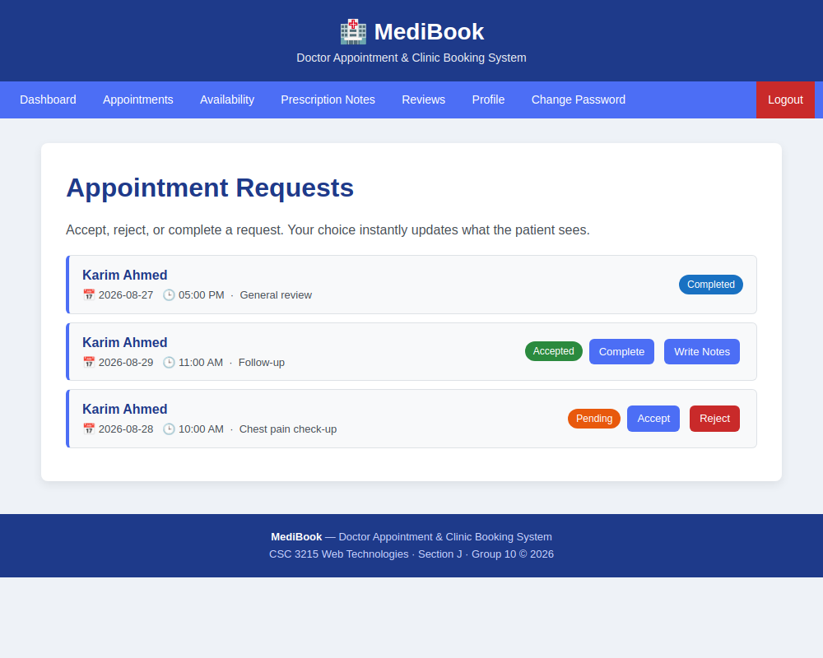
Figure 9: Doctor — appointment requests
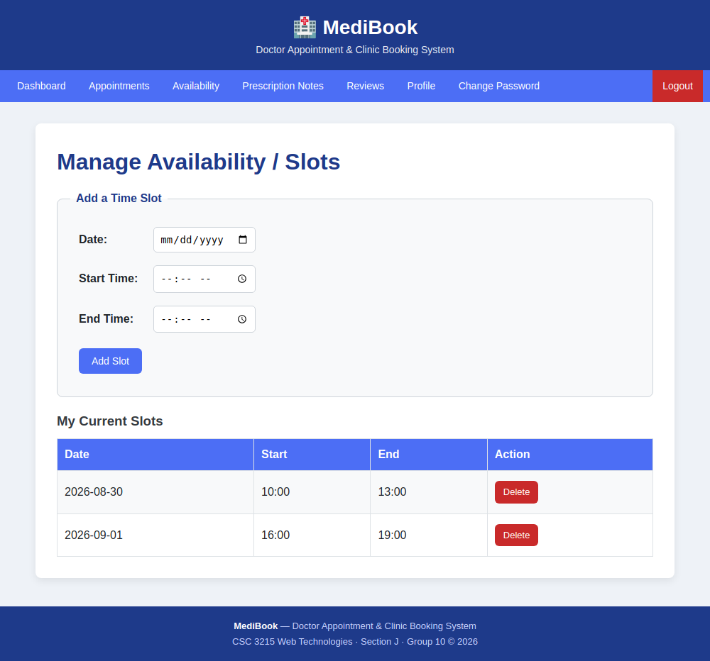
Figure 10: Doctor — manage availability
Admin
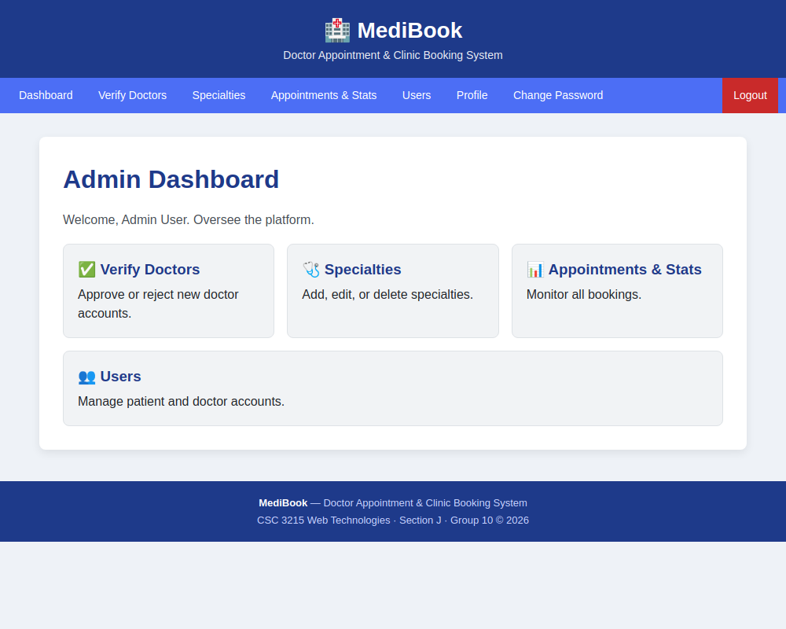
Figure 11: Admin dashboard
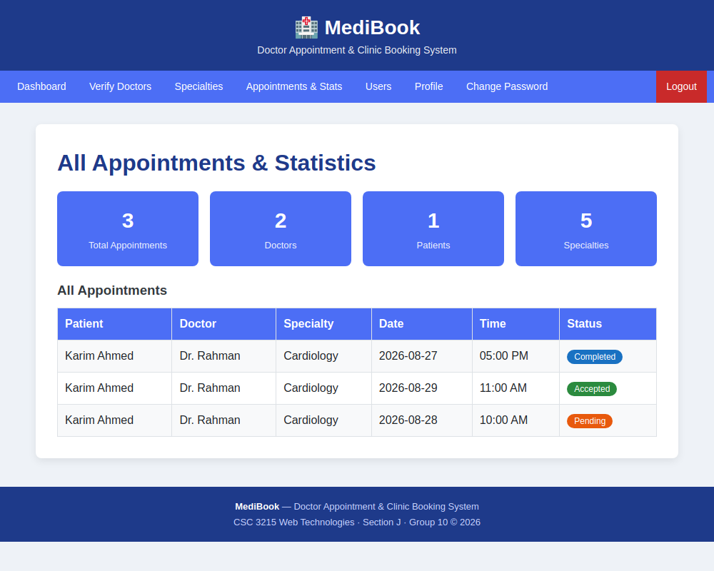
Figure 12: Admin — appointments & statistics

Types of User: 1. Admin 2. Doctor 3. Patient
Common Features (Available to All Users)
● Authentication
1. Login to the system
2. Logout from the system
3. User registration

● Account Management
1. Change or reset password
2. Manage profile information (view, edit, delete)
● Dashboard
1. Access a personalized dashboard after login
Specific Features by User Type
● Features of Admin
1. Verify and approve (or reject) new doctor accounts before they go live
2. Manage the list of medical specialties/departments (add, edit, delete)
3. View all appointments across the system with simple statistics (totals, per specialty)
4. Manage user accounts — deactivate or remove patients and doctors
● Features of Doctor
1. Set and manage available time slots (create, edit, delete availability)
2. Accept, reject, or mark appointments as completed
3. Write prescription / consultation notes for completed appointments

● Features of Patient
1. Search doctors by specialty using live AJAX search (results update without page reload)
2. Book an available time slot and cancel an existing booking
3. Rate and review a doctor after a completed appointment
N.B: Each user type must have at least 3 distinct features different from the others. Additional features may be added if desired. Proposals with generic, incomplete, or duplicated features across user types will receive reduced marks under the criteria below.

