BasaChai
Step 5 — Use Case Diagram & Use Case Descriptions
Rental House-Hunting Platform (Django REST Framework + React)

1. Document Information
Project | BasaChai — Rental House-Hunting Platform
Document | Step 5 — Use Case Diagram & Use Case Descriptions
Purpose | Turn the Step 4 requirements into actor-goal use cases, show them in a UML use case diagram, and trace every use case back to the Step 4 functional requirements (FR) and business rules (BR). The document is the base for the later BPMN, database design, API design, SDD, implementation and test steps.
Source of truth | Step 4 — Functional & Non-Functional Requirements, latest version received 2026-10-20 and re-checked on 2026-10-21 (45 FR, 22 NFR, 13 BR, 9 OD; finalized decisions). Steps 1-3 are supporting context. No FR, NFR, BR or OD ID was created, renumbered or re-prioritised in this document.
Technology context | React frontend, Django REST Framework backend, PostgreSQL, JWT authentication.
Target market | Dhaka, Bangladesh — urban rental market.
Related files | Available companion file: Step5_Traceability_Matrix.xlsx. The separately referenced editable draw.io diagram and validation-summary text file are not present in this workspace.
Document status | Updated after confirmed UQ-01 and UQ-09 decisions; aligned with Step 4 (45 FR, 22 NFR, 13 BR, 9 OD). Covers UC-01 to UC-30. Remaining open issues are listed in Section 6.
ID convention | UC-nn = use case (this document). FR-nn / NFR-nn / BR-nn / OD-nn = Step 4 IDs. ISS-nn = issue found while cross-checking Step 4. ASM-nn = assumption made in this document. V-nn = validation check.

2. Actors
Three actors are used, matching Step 4 Section 3. Permissions below come from Step 4 (FR-04, BR-01, BR-02, BR-10 and the role table). The backend must enforce them; hiding a button in the frontend is not a security control (FR-04).

Home Seeker / Tenant
Role / main goals | Primary user. Wants to find, evaluate, shortlist and compare rental properties and decide which are worth a physical visit.
Can do | • Register, log in, log out, manage own profile (UC-01 to UC-04)  • Search and filter published listings, view details and the owner's public profile (UC-11 to UC-13)  • Shortlist, view shortlist, remove, compare up to 3 (UC-14 to UC-17)  • Message the owner about a property (UC-18, UC-19)  • Submit a viewing request and see its status (UC-20, UC-21)  • Report a listing (UC-23)
Cannot do | • Create, edit, publish, remove or change the availability of any listing  • See or change another user's shortlist, messages or viewing requests  • Answer viewing requests, review reports or moderate listings  • Create an Admin account

Property Owner / Landlord
Role / main goals | Secondary user. Provides accurate, up-to-date listings and responds to seekers.
Can do | • Register, log in, log out, manage own profile (UC-01 to UC-04)  • Create, update, publish/unpublish, remove own listings, manage images, update availability (UC-05 to UC-10), see own listings (UC-29)  • Read and reply to text, image, and voice messages about own properties (UC-19)  • Accept or reject viewing requests for own properties (UC-22)  • View moderation feedback on own listings (UC-28)
Cannot do | • Manage or see another owner's listings, messages or viewing requests (BR-02)  • Review reports or moderate listings (BR-10)  • Start a conversation (FR-29 lets the Home Seeker start it; the owner replies)  • Create an Admin account

Admin / Moderator
Role / main goals | Keeps listing content trustworthy by handling reports.
Can do | • Log in and log out (UC-02, UC-03); the account is created by a controlled process, not public registration (BR-01, OD-09)  • Review reports, update report status, moderate listings (UC-24 to UC-26)  • Record moderation feedback for owners (UC-27)
Cannot do | • Be created through public registration (BR-01)  • Act as Home Seeker or Property Owner  • Respond to viewing requests: only the owner of the property can (FR-34)

3. Use Case Diagram
BasaChai-er use case diagram-gulo system-er main activities ebong user-ra system-er sathe kivabe interact kore, ta dekhay. Prothom diagram-e shob 29 ta use case ekshathe dekhano hoyeche. Baki diagram-gulo use case-gulo-ke alada category-te vag koreche, jate shohoje pora o bojha jay.
Diagram-e actor ar use case-er majhe line thakle bujhay je actor oi activity-r sathe involved. Ei diagram-gulote simple connection use kora hoyeche; <<include>> ba <<extend>> relationship use kora hoyni, karon current use case-gulor jonno egulo proyojon chilo na. Related use case-gulo tader ID diye description-e reference kora hoyeche.
Admin-er jonno alada registration use case nei, karon Admin account separate setup process-er maddhome create kora hoy (BR-01). Moderation notification-er jonno email service-er use UC-27-e explain kora hoyeche; tai email service-ke diagram-e separate actor hisebe dekhano hoyni.

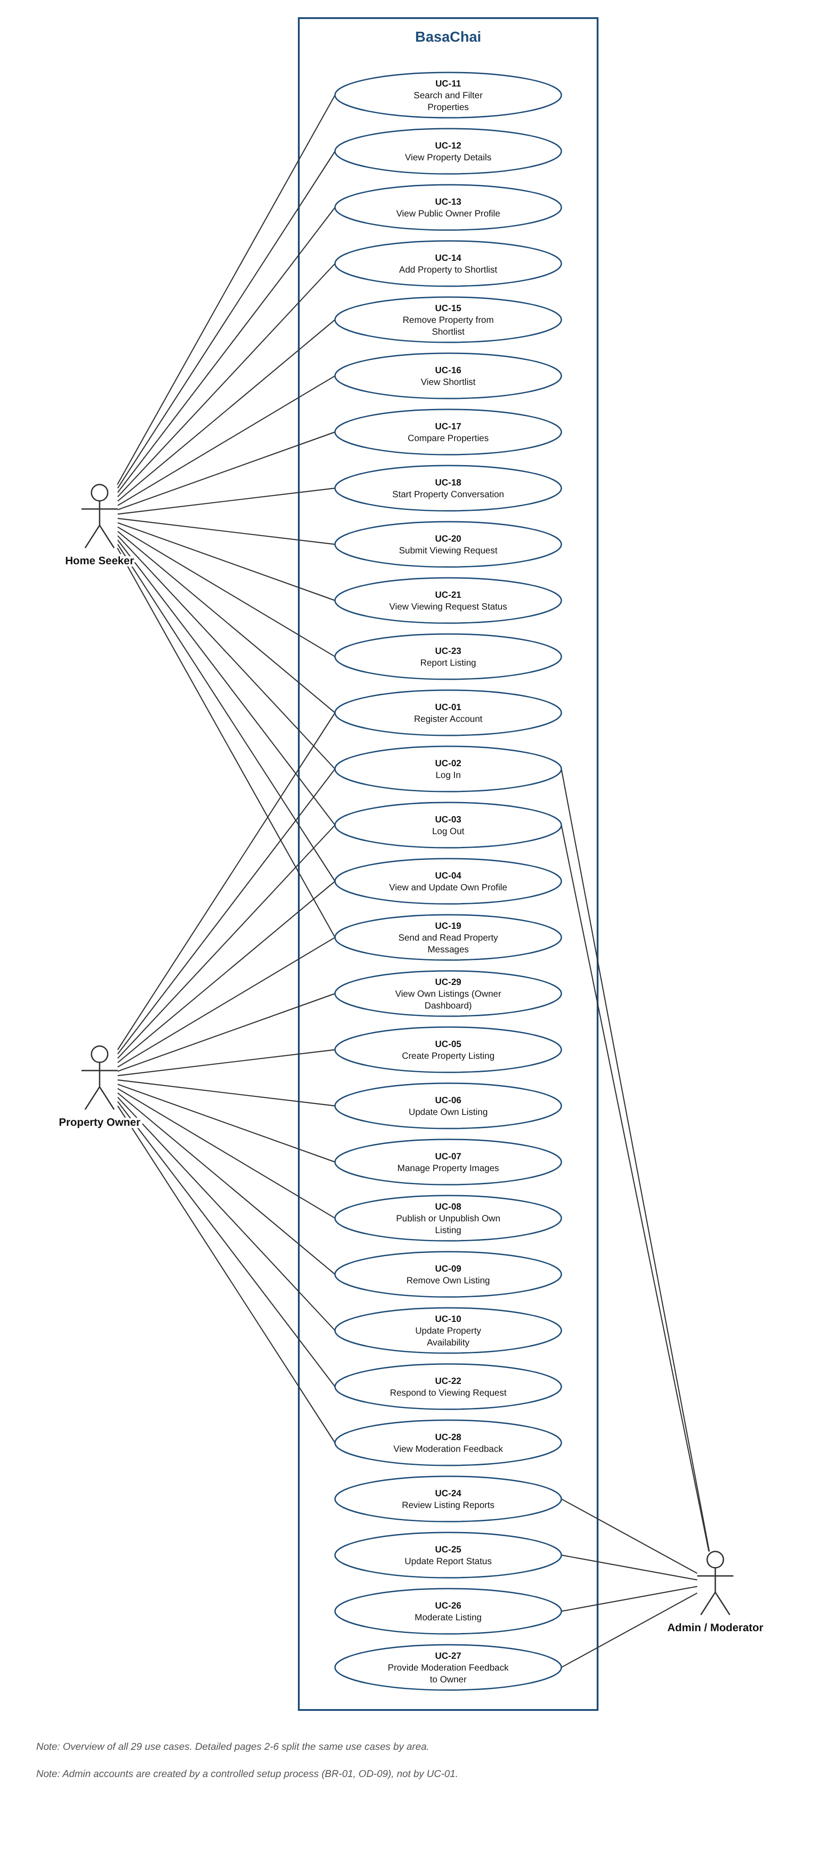
Figure 1. Overview — all 30 use cases of the BasaChai system.

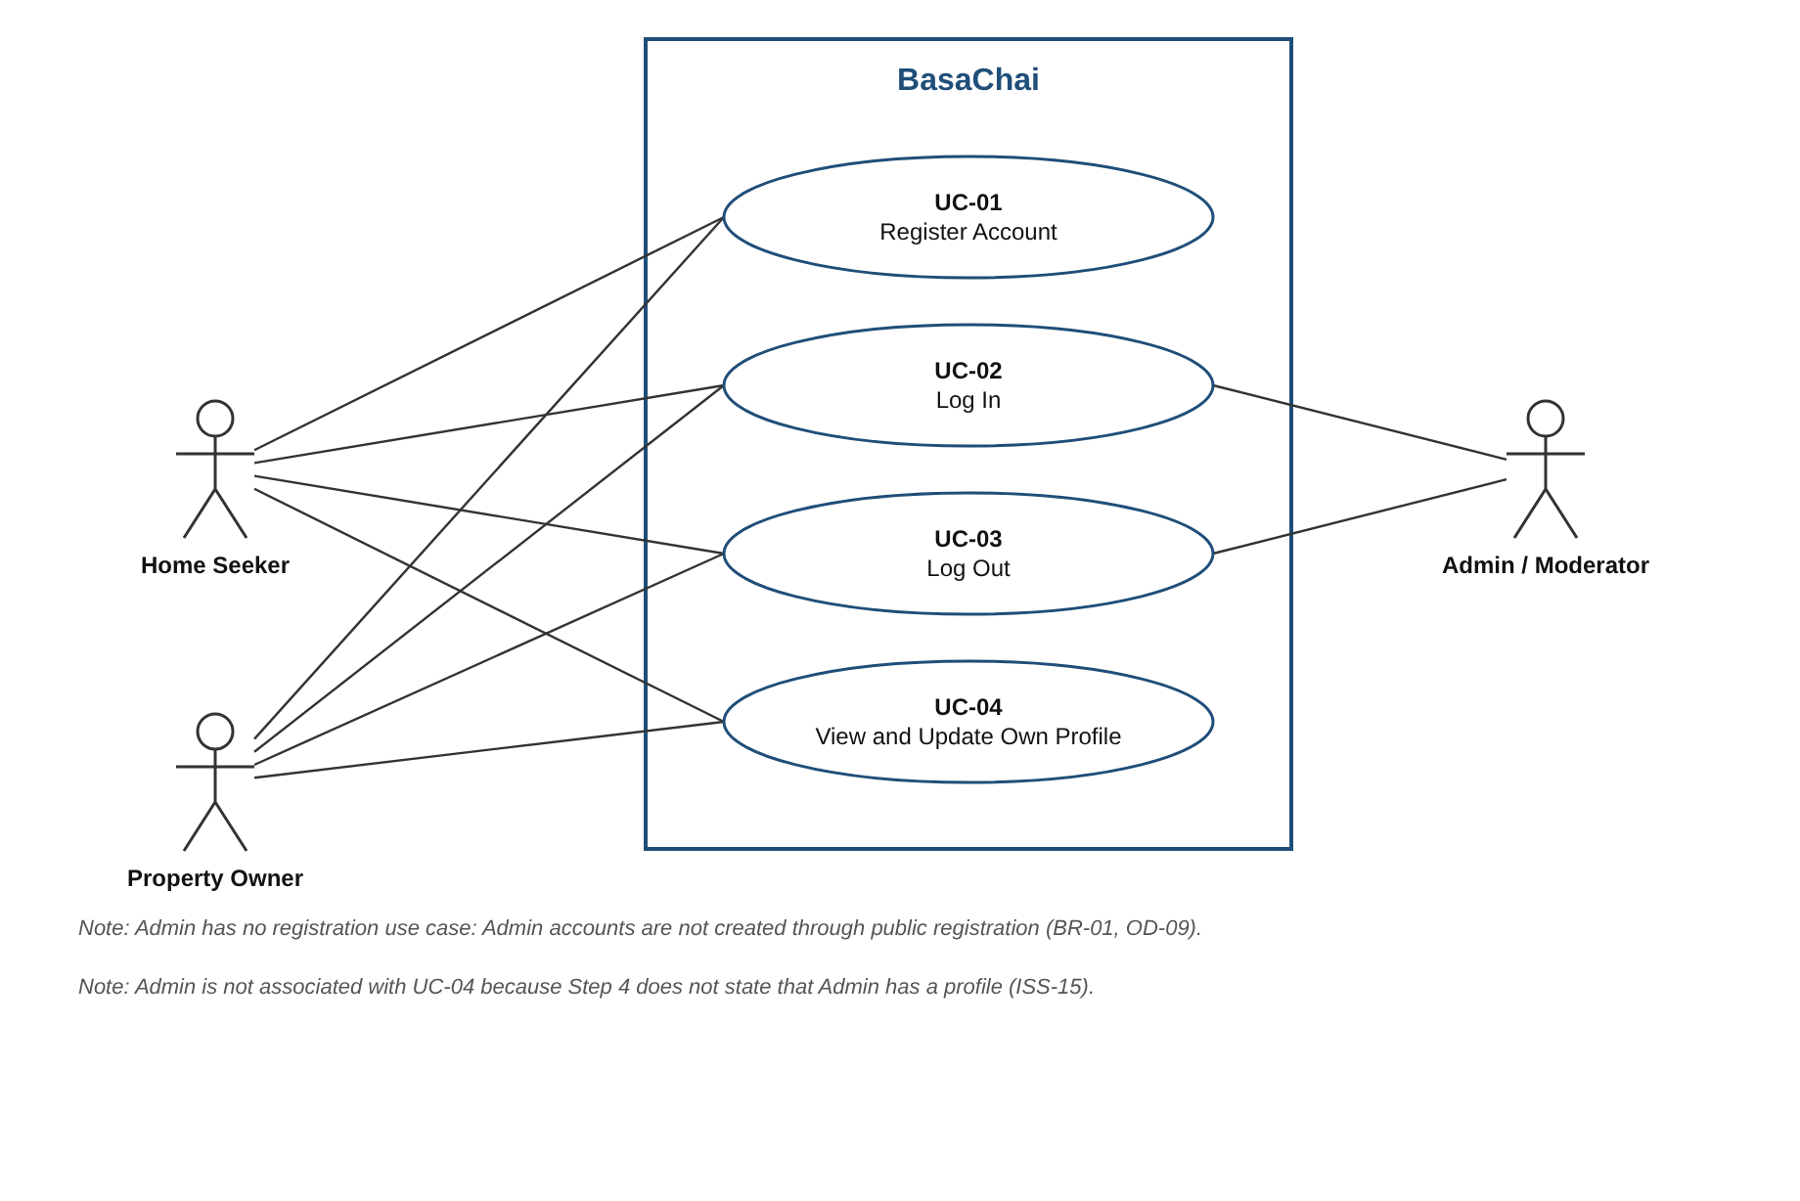
Figure 2. Account and access (UC-01 to UC-04)
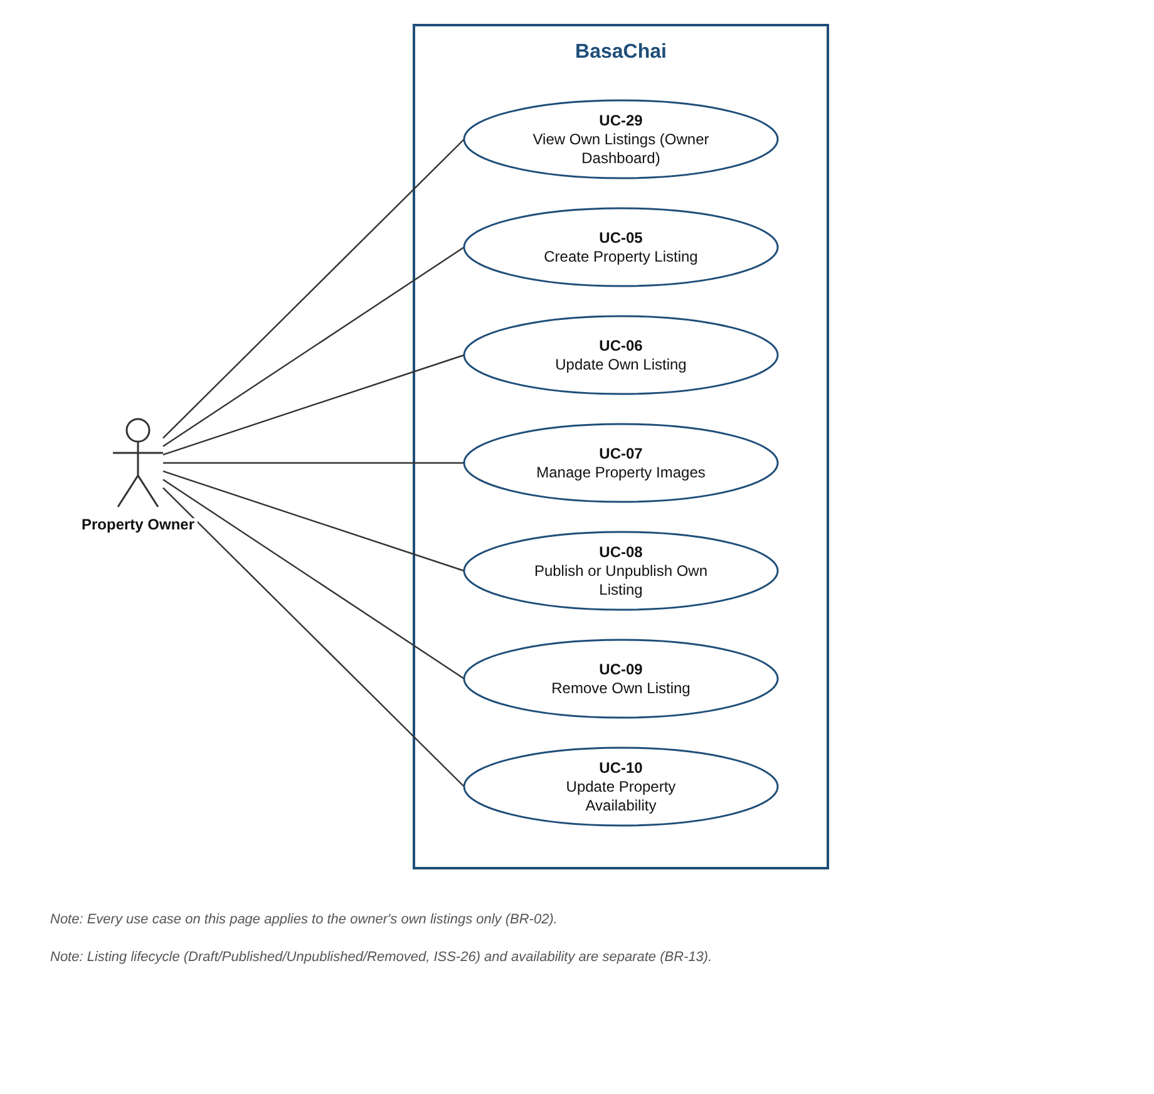
Figure 3. Owner listing management (UC-05 to UC-10 and UC-29)
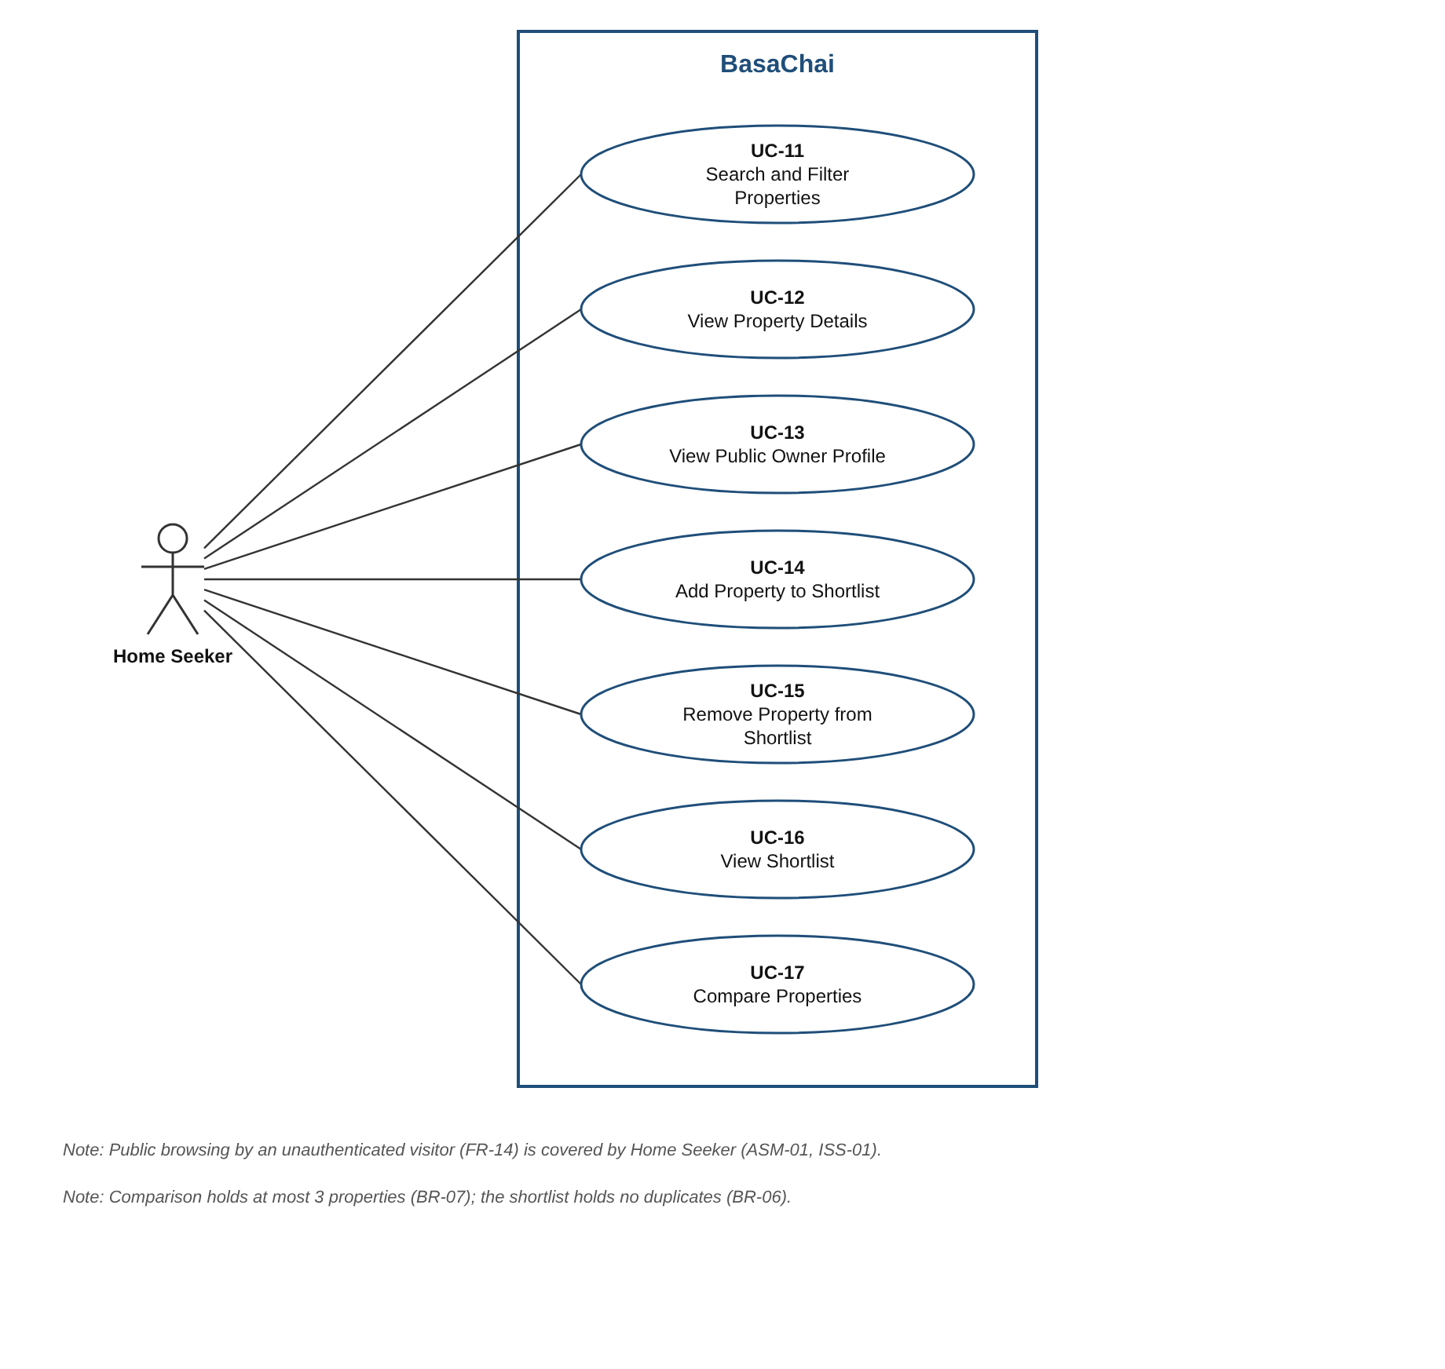
Figure 4. Search, evaluate, shortlist and compare (UC-11 to UC-17)
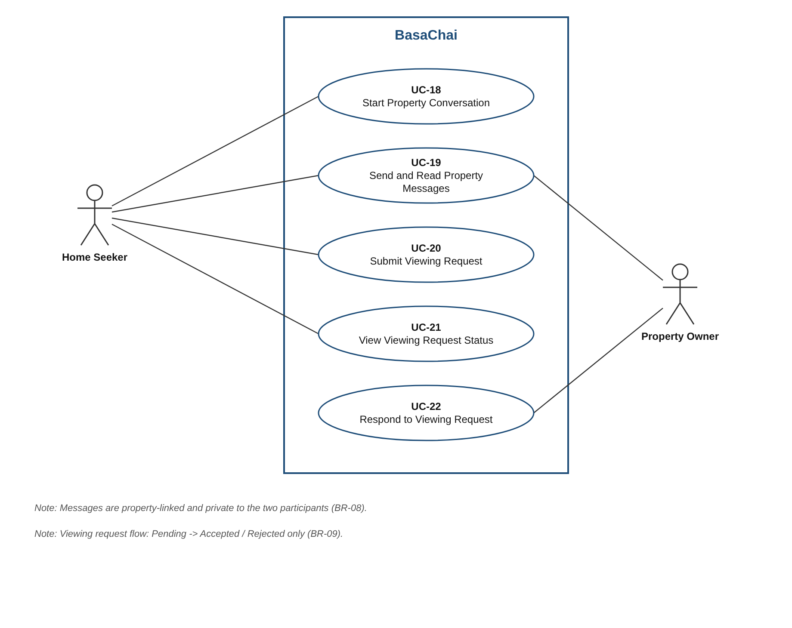
Figure 5. Communication and viewing requests (UC-18 to UC-22)
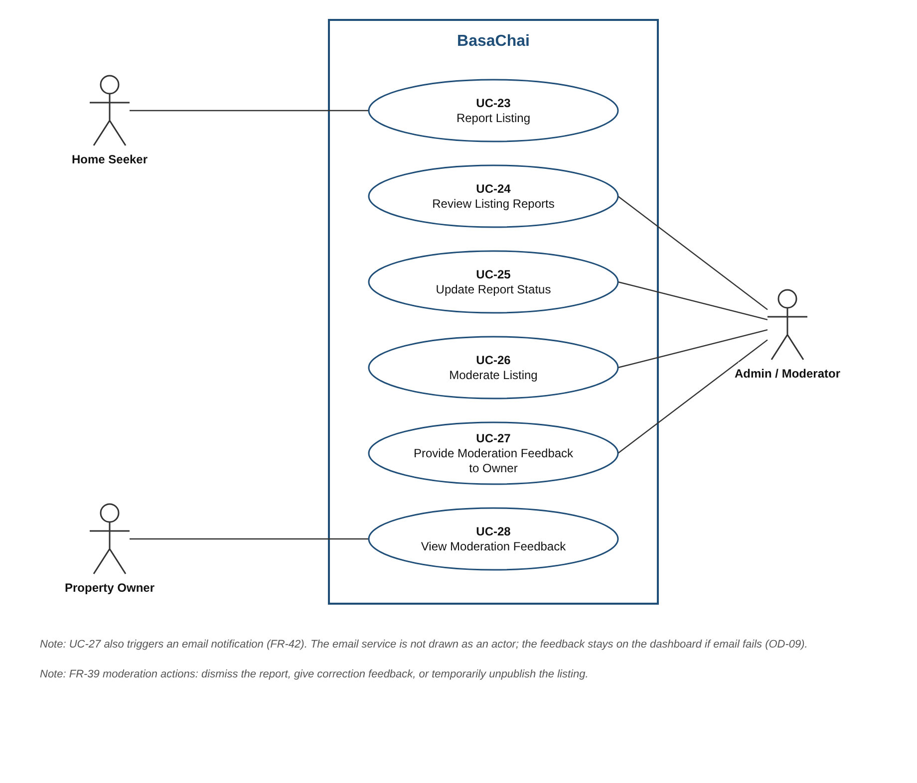
Figure 6. Reporting and moderation (UC-23 to UC-28)

3.1 Actor and use case associations
Actor | Associated use cases | Count
Home Seeker | UC-01, UC-02, UC-03, UC-04, UC-11, UC-12, UC-13, UC-14, UC-15, UC-16, UC-17, UC-18, UC-19, UC-20, UC-21, UC-23,UC-30 | 17
Property Owner | UC-01, UC-02, UC-03, UC-04, UC-05, UC-06, UC-07, UC-08, UC-09, UC-10, UC-19, UC-22, UC-28, UC-29 | 14
Admin / Moderator | UC-02, UC-03, UC-24, UC-25, UC-26, UC-27 | 6

4. Use Case Descriptions
Each use case is one actor goal supported by Step 4. Flows are numbered so they can be turned into test cases. Alternative flows use the step number they branch from (for example 5a branches from step 5). 'S1' marks a system-triggered flow. Priority is the Step 4 priority of the use case's primary FR (ASM-02).

4.1 Use case index
ID | Use case | Primary actor | Priority
UC-01 | Register Account | Visitor (unauthenticated user; not an account role) | High
UC-02 | Log In | Visitor or existing account holder | High
UC-03 | Log Out | Home Seeker, Property Owner or Admin / Moderator | High
UC-04 | View and Update Own Profile | Home Seeker, Property Owner, or dual-role user | High
UC-05 | Create Property Listing | Property Owner | High
UC-06 | Update Own Listing | Property Owner | High
UC-07 | Manage Property Images | Property Owner | High
UC-08 | Publish or Unpublish Own Listing | Property Owner | High
UC-09 | Remove Own Listing | Property Owner | High
UC-10 | Update Property Availability | Property Owner | High
UC-11 | Search and Filter Properties | Home Seeker | High
UC-12 | View Property Details | Home Seeker | High
UC-13 | View Public Owner Profile | Visitor or any signed-in user | Medium
UC-14 | Add Property to Shortlist | Home Seeker | High
UC-15 | Remove Property from Shortlist | Home Seeker | High
UC-16 | View Shortlist | Home Seeker | High
UC-17 | Compare Properties | Home Seeker | Medium
UC-18 | Start Property Conversation | Home Seeker | Medium
UC-19 | Send and Read Property Messages | Home Seeker or Property Owner | Medium
UC-20 | Submit Viewing Request | Home Seeker | Medium
UC-21 | View Viewing Request Status | Home Seeker | Medium
UC-22 | Respond to Viewing Request | Property Owner | Medium
UC-23 | Report Listing | Home Seeker | Medium
UC-24 | Review Listing Reports | Admin / Moderator | Medium
UC-25 | Update Report Status | Admin / Moderator | Medium
UC-26 | Moderate Listing | Admin / Moderator | Medium
UC-27 | Provide Moderation Feedback to Owner | Admin / Moderator | Medium
UC-28 | View Moderation Feedback | Property Owner | Medium
UC-29 | View Own Listings (Owner Dashboard) | Property Owner | High
UC-30 | Cancel Own Viewing Request | Home Seeker | Medium

4.2 Descriptions

UC-01 Register Account
Use Case ID | UC-01
Use Case Name | Register Account
Primary Actor | Visitor (unauthenticated user; not an account role)
Supporting Actor | None
Goal | Create one account with Home Seeker, Property Owner or both roles.
Preconditions | 1. User is not logged in.
Trigger | User selects Register.
Main Success Flow | 1. User opens registration.2. User selects Home Seeker, Property Owner, or both.3. User enters required information and submits.4. System validates the fields and unique email.5. System creates one account and assigns the selected public role memberships.6. System confirms the account is ready to log in (UC-02).
Alternative / Exception Flows | 5a. Required field is invalid or email is already registered: show a field-level error and do not create another account.2a. Admin / Moderator is requested: reject the registration; privileged access is setup-controlled only (FR-01, BR-01).
Postconditions | One account exists with the selected Home Seeker, Property Owner, or both memberships. No Admin / Moderator membership is created by registration.
Related FR IDs | FR-01 — Account Registration (High)
Relevant BR IDs | BR-01 — Admin accounts cannot be created through public registration
Priority (Step 4, primary FR) | High
Notes / open items | Email is the unique login identifier (UQ-07). Email/phone OTP verification is not mandatory in the initial release (OD-08). An existing user can add the other public role through UC-04 without creating another account.

UC-02 Log In
Use Case ID | UC-02
Use Case Name | Log In and Recover Password
Primary Actor | Visitor or existing account holder
Supporting Actor | None
Goal | Authenticate an existing account or recover its password by email.
Preconditions | 1. User has an account. (Admin accounts are created through a controlled process, not public registration: BR-01, OD-09.)
Trigger | User selects Log In.
Main Success Flow | 1. User enters the registered email and password.2. System verifies the credentials.3. System issues an authenticated session and returns all role memberships.4. The app exposes both Home Seeker and Property Owner capabilities when both roles are assigned; no second account or role switch is needed.5. Later requests are authorized server-side by role membership and ownership (FR-04).
Alternative / Exception Flows | 2a. Credentials are invalid: show a generic error that does not reveal which field was wrong (FR-02).1a. User selects Forgot Password and submits an email. System returns the same generic response for existing and unknown emails. If the email belongs to an account, send a time-limited, single-use recovery link.2b. User submits a valid recovery link and a new password; system changes the password on the existing account. Expired/invalid links are rejected. Recovery never creates an account (FR-45).
Postconditions | User is authenticated with the account's assigned role set, or the existing account password is recovered. Role-restricted actions use role membership. Password recovery creates no account.
Related FR IDs | FR-02 ? Login (High)FR-04 ? Role-Based Access (High)FR-45 ? Password Recovery (High)
Relevant BR IDs | BR-01 — Admin accounts cannot be created through public registration
Priority (Step 4, primary FR) | High
Notes / open items | The email delivery provider remains the Step 7 Q-02 decision. Recovery responses do not disclose whether an email has an account.

UC-03 Log Out
Use Case ID | UC-03
Use Case Name | Log Out
Primary Actor | Home Seeker, Property Owner or Admin / Moderator
Supporting Actor | None
Goal | End the authenticated session securely.
Preconditions | 1. User is logged in.
Trigger | User selects Log Out.
Main Success Flow | 1. User selects Log Out.  2. System clears the client-side authentication state and stored access/refresh tokens.  3. System revokes the current refresh token (blacklisting is required by FR-03).  4. System returns the user to the public home page, where they can continue browsing listings without logging in.
Alternative / Exception Flows | 3a. The revoked refresh token is later used to get a new access token: system rejects it (FR-03).  3b. The existing access token may stay valid until it expires; after expiry, protected API requests are rejected (FR-03).
Postconditions | 1. User is no longer authenticated on the client.  2. The refresh token is revoked.  3. Protected pages require login again.
Related FR IDs | FR-03 — Logout (High)
Relevant BR IDs | None specifically (see Notes)
Priority (Step 4, primary FR) | High
Notes / open items | Step 4 now requires refresh-token revocation (FR-03), so the earlier open question ISS-14 is resolved.

UC-04 View and Update Own Profile
Use Case ID | UC-04
Use Case Name | View and Update Own Profile
Primary Actor | Home Seeker or Property Owner
Supporting Actor | None
Goal | View and update the user's own profile and add the missing public role to the same account.
Preconditions | 1. User is logged in.
Trigger | User opens the profile page.
Main Success Flow | 1. User opens account settings.2. System shows the account profile and assigned roles.3. User edits permitted profile fields or selects Add Home Seeker / Add Property Owner.4. System adds the missing public role to the same account and returns the updated role set.5. Admin / Moderator cannot be selected or added through this flow (FR-01, FR-04, BR-01).
Alternative / Exception Flows | 4a. Invalid profile values are rejected without changing existing data.5a. User requests Admin / Moderator access: reject the request; privileged access is setup-controlled (BR-01).
Postconditions | 1. The user's own profile is updated.  2. Other users' private profile data is unchanged.
Related FR IDs | FR-05 ? Profile Management (High)FR-04 ? Role-Based Access (High)FR-01 ? Account Registration (High)
Relevant BR IDs | None specifically (see Notes)
Priority (Step 4, primary FR) | High
Notes / open items | Profile fields are not defined in Step 4. Whether the Admin has a profile is not stated, so Admin is not associated with this use case (ISS-15).

UC-05 Create Property Listing
Use Case ID | UC-05
Use Case Name | Create Property Listing
Primary Actor | Property Owner
Supporting Actor | None
Goal | Create a new rental listing as a Draft.
Preconditions | 1. User is logged in as Property Owner.
Trigger | Owner selects Create Listing.
Main Success Flow | 1. Owner opens the listing form.  2. Owner enters location/area, monthly rent, property type, bedrooms, bathrooms, description and amenities.  3. Owner optionally adds images (UC-07).  4. Owner submits the form.  5. System validates the data (FR-10).  6. System saves the listing with status Draft, linked to the owner's account.  7. System confirms; the Draft is not visible in public search.
Alternative / Exception Flows | 5a. Rent is not positive, a required text field is empty, or a bedroom/bathroom count is negative: system rejects the save with field-level errors (FR-10, BR-03).  5b. An image has an invalid type or size: system rejects that image (FR-10, FR-11).  1a. User is not a Property Owner: system rejects the request (FR-04).
Postconditions | 1. A Draft listing exists, owned by the creating owner.  2. The listing is not publicly discoverable until published (UC-08).
Related FR IDs | FR-07 — Create Property Listing (High)  FR-10 — Listing Field Validation (High)  FR-04 — Role-Based Access (High)  FR-40 — Validation and Action Feedback (High)
Relevant BR IDs | BR-02 — Owner manages only own listings  BR-03 — Rent must be positive; minimum rent cannot exceed maximum rent  BR-04 — Only published, discoverable listings appear in public discovery; removed listings do not  BR-13 — Listing lifecycle status and availability status are separate concepts; only Published listings are publicly discoverable
Priority (Step 4, primary FR) | High
Notes / open items | A Draft may have no availability confirmation date. A listing cannot be published until its owner confirms availability and the date is recorded (FR-07, FR-12).

UC-06 Update Own Listing
Use Case ID | UC-06
Use Case Name | Update Own Listing
Primary Actor | Property Owner
Supporting Actor | None
Goal | Change the details of an existing own listing.
Preconditions | 1. User is logged in as Property Owner.  2. The listing belongs to the owner.
Trigger | Owner selects Edit on one of their listings.
Main Success Flow | 1. Owner opens their listing for editing.  2. Owner changes listing details.  3. Owner submits the changes.  4. System validates the data (FR-10).  5. System saves the changes and refreshes last-updated for the changed user-visible listing information (FR-13).  6. System confirms the update.
Alternative / Exception Flows | 4a. Validation fails: system shows errors and keeps the old data (FR-10, BR-03).  1a. The listing belongs to another owner: system rejects the request (FR-08, BR-02).
Postconditions | 1. The listing is updated.  2. Last-updated is refreshed after a user-visible content change and remains separate from availability_confirmed_at (BR-05).
Related FR IDs | FR-08 — Update Own Listing (High)  FR-10 — Listing Field Validation (High)  FR-13 — Listing Update Information (Medium)  FR-04 — Role-Based Access (High)  FR-40 — Validation and Action Feedback (High)
Relevant BR IDs | BR-02 — Owner manages only own listings  BR-03 — Rent must be positive; minimum rent cannot exceed maximum rent  BR-05 — Availability status and confirmation date are separate; old confirmation does not guarantee availability
Priority (Step 4, primary FR) | High
Notes / open items | Resolved by approved decision (ISS-10): user-visible content changes (title, description, rent, location, property details, facilities) and listing-image changes refresh last-updated. Availability reconfirmation alone does not. The timestamps remain separate.

UC-07 Manage Property Images
Use Case ID | UC-07
Use Case Name | Manage Property Images
Primary Actor | Property Owner
Supporting Actor | None
Goal | Upload and manage images of an own listing.
Preconditions | 1. User is logged in as Property Owner.  2. The listing belongs to the owner.
Trigger | Owner selects Add/Manage Images on a listing.
Main Success Flow | 1. Owner opens the image section of their listing.  2. Owner selects image file(s) to upload.  3. System checks the image format (JPG, JPEG, PNG or WebP), file size (maximum 5 MB) and image count (maximum 5 per listing) as set in FR-11.  4. System stores the images and shows them in the listing.  5. Owner may remove or replace images (assumed meaning of 'manage', ASM-07).
Alternative / Exception Flows | 3a. Unsupported format, file larger than 5 MB, or the listing already has 5 images: system rejects the upload with a clear error message (FR-10, FR-11).  4a. Upload fails: system shows a clear message and the listing stays unchanged (FR-11).
Postconditions | 1. The listing's images reflect the owner's changes.
Related FR IDs | FR-11 — Property Images (High)  FR-10 — Listing Field Validation (High)  FR-04 — Role-Based Access (High)
Relevant BR IDs | BR-02 — Owner manages only own listings
Priority (Step 4, primary FR) | High
Notes / open items | FR-11 fixes the limits (5 images, JPG/JPEG/PNG/WebP, 5 MB each) and Step 4 OD-03 now confirms them. Nothing is open for this use case.

UC-08 Publish or Unpublish Own Listing
Use Case ID | UC-08
Use Case Name | Publish or Unpublish Own Listing
Primary Actor | Property Owner
Supporting Actor | None
Goal | Make an own listing publicly discoverable, or withdraw it from public view without removing it.
Preconditions | 1. User is logged in as Property Owner.  2. The listing belongs to the owner.
Trigger | Owner selects Publish or Unpublish on a listing.
Main Success Flow | 1. Owner opens their listing.  2. Owner selects Publish.  3. System checks that all required listing fields and validation rules are satisfied, and that the listing has at least one valid image (FR-07, FR-11).  4. System sets the status to Published; the listing becomes eligible for public discovery.  5. System confirms. (Unpublish: owner selects Unpublish; the status becomes Unpublished, and the listing is hidden from public search and discovery. The owner can publish it again later, FR-09.)
Alternative / Exception Flows | 3a. Required fields/image conditions or a recorded availability confirmation are missing: system refuses to publish and explains what is missing (FR-07, FR-12).  1a. The listing belongs to another owner: system rejects the request (FR-09, BR-02).  1b. The listing is removed: the normal publish action is rejected (FR-07, FR-09).  2a. The listing has an active moderation hold: the system rejects the owner's publish request and explains that the listing must be reviewed and released by an authorised Admin / Moderator before it can be published again (FR-09, FR-39).
Postconditions | 1. Published listing: eligible for public discovery only after availability confirmation is recorded (FR-07, FR-12, BR-04).  2.Unpublished listing: hidden from public search and discovery. The owner can publish it again only if no moderation hold is active and all publication conditions are satisfied (FR-09, FR-39).  3. Availability status is unchanged (BR-13).
Related FR IDs | FR-09 — Manage Own Listing (High)  FR-07 — Create Property Listing (High)  FR-04 — Role-Based Access (High)
Relevant BR IDs | BR-02 — Owner manages only own listings  BR-04 — Only published, discoverable listings appear in public discovery; removed listings do not  BR-13 — Listing lifecycle status and availability status are separate concepts; only Published listings are publicly discoverable
Priority (Step 4, primary FR) | High
Notes / open items | The publication image requirement is defined in FR-07. An owner cannot republish a listing while an active moderation hold exists. The owner may publish the listing again after an authorised Admin / Moderator releases the hold, provided all publication conditions are satisfied (FR-07, FR-09, FR-39).

UC-09 Remove Own Listing
Use Case ID | UC-09
Use Case Name | Remove Own Listing
Primary Actor | Property Owner
Supporting Actor | None
Goal | Remove an own listing from public discovery permanently (lifecycle status Removed).
Preconditions | 1. User is logged in as Property Owner.  2. The listing belongs to the owner.
Trigger | Owner selects Remove on a listing.
Main Success Flow | 1. Owner selects Remove on their listing.  2. System asks the owner to confirm.  3. Owner confirms.  4. System sets the lifecycle status to Removed.  5. System removes the listing from public search and property discovery.  6. System keeps the property reference and status in existing authorised conversation and viewing-request history.
Alternative / Exception Flows | 3a. Owner cancels the confirmation: no change.  1a. The listing belongs to another owner: system rejects the request (FR-09, BR-02).  6a. The owner later tries to publish the Removed listing with the normal publish action: system rejects it (FR-07, FR-09).
Postconditions | 1. Listing status is Removed and no longer publicly discoverable.  2. Shortlists show it as removed (FR-25).  3. Existing conversation/request history is preserved (details of visibility: OD-04).
Related FR IDs | FR-09 — Manage Own Listing (High)  FR-04 — Role-Based Access (High)
Relevant BR IDs | BR-02 — Owner manages only own listings  BR-04 — Only published, discoverable listings appear in public discovery; removed listings do not  BR-13 — Listing lifecycle status and availability status are separate concepts; only Published listings are publicly discoverable
Priority (Step 4, primary FR) | High
Notes / open items | What details of a removed listing remain visible in history is open (OD-04). Removed is treated as a status, not a hard delete (ASM-05).

UC-10 Update Property Availability
Use Case ID | UC-10
Use Case Name | Update Property Availability
Primary Actor | Property Owner
Supporting Actor | None
Goal | Mark a listing Available or Unavailable and reconfirm that the information is current.
Preconditions | 1. User is logged in as Property Owner.  2. The listing belongs to the owner.
Trigger | Owner selects Still Available or Not Available in the dashboard, or confirms availability before publishing.
Main Success Flow | 1. Owner opens their listing.  2. Owner selects Still Available or Not Available.  3. System sets availability to Available or Unavailable and records the response time as availability_confirmed_at. Availability reconfirmation alone does not change last-updated.  4. System shows both values on the listing.
Alternative / Exception Flows | S1. A scheduled system task sends an in-app reminder on Day 5 and another on Day 7 after the last confirmation. At 7 days without a response it sets availability to Needs Reconfirmation. The dashboard keeps a pending notice with Still Available and Not Available actions until the owner responds (FR-12, OD-01).  1a. The listing belongs to another owner: system rejects the request (FR-04, BR-02).
Postconditions | 1. Availability status is one of Available, Unavailable, Needs Reconfirmation.  2. The last-confirmed date is stored separately from lifecycle status and last-updated; reconfirmation alone does not refresh last-updated (BR-05, BR-13, FR-13).
Related FR IDs | FR-12 — Availability Status (High)  FR-13 — Listing Update Information (Medium)  FR-04 — Role-Based Access (High)
Relevant BR IDs | BR-02 — Owner manages only own listings  BR-05 — Availability status and confirmation date are separate; old confirmation does not guarantee availability  BR-13 — Listing lifecycle status and availability status are separate concepts; only Published listings are publicly discoverable
Priority (Step 4, primary FR) | High
Notes / open items | FR-09 covers lifecycle only; FR-12 covers availability. The daily scheduled job, Day 5/Day 7 reminders, and Needs Reconfirmation transition are confirmed (OD-01). FR-13/ISS-10 also confirms that visible listing-content and image changes refresh last-updated; availability reconfirmation alone does not.

UC-11 Search and Filter Properties
Use Case ID | UC-11
Use Case Name | Search and Filter Properties
Primary Actor | Home Seeker
Supporting Actor | None
Goal | Find relevant published rental properties using location, rent, type, bedrooms and availability.
Preconditions | 1. None for browsing. Step 4 FR-14 allows an unauthenticated visitor to browse; this is documented as an assumption (ASM-01, ISS-01).
Trigger | User opens the property search page.
Main Success Flow | 1. User opens the search page.  2. User enters filters: location/area, minimum and maximum rent, property type, number of bedrooms, availability.  3. System validates the filter input.  4. System returns only Published listings (not Unpublished, Draft or Removed) that satisfy all selected filters (AND). The availability filter supports Available, Unavailable and Needs Reconfirmation.  5. System shows results with availability labels, sorted and paginated. Published listings that are Unavailable stay visible with a clear Unavailable label unless the user filters them out (FR-18, BR-13).  6. User changes sort/page or refines the filters; the user may open a result (UC-12).
Alternative / Exception Flows | 3a. Minimum rent is greater than maximum rent: system shows a validation error (FR-16, BR-03).  4a. No listing matches: system shows an empty state (FR-15, FR-41).  4b. Invalid filter value or invalid page number: system handles it gracefully (FR-17, FR-19).  4c. API/network failure: system shows an error state with a retry option (FR-41).  5a. A result is Needs Reconfirmation: show a clear notice that availability is unconfirmed and do not present the listing as currently Available (FR-14, FR-12, BR-05).  6a. User selects a login-required action while logged out: system asks the user to log in and returns them to the property details page after successful login.
Postconditions | 1. No data is changed.  2. Draft, Unpublished and Removed listings were not shown (BR-04).
Related FR IDs | FR-14 — Browse Published Listings (High)  FR-15 — Search by Location (High)  FR-16 — Filter by Rent (High)  FR-17 — Filter by Property Type and Bedrooms (High)  FR-18 — Combined Filters (High)  FR-19 — Sort and Pagination (Medium)  FR-41 — Empty, Loading, and API Error States (High)
Relevant BR IDs | BR-03 — Rent must be positive; minimum rent cannot exceed maximum rent  BR-04 — Only published, discoverable listings appear in public discovery; removed listings do not  BR-05 — Availability status and confirmation date are separate; old confirmation does not guarantee availability  BR-13 — Listing lifecycle status and availability status are separate concepts; only Published listings are publicly discoverable
Priority (Step 4, primary FR) | High
Notes / open items | Step 4 FR-14 does not say explicitly whether Published listings that are Unavailable appear in search. This document follows FR-18 (the availability filter includes Unavailable) and BR-13 (availability is separate from publication), so they appear with a clear label and can be filtered out (ISS-07).

UC-12 View Property Details
Use Case ID | UC-12
Use Case Name | View Property Details
Primary Actor | Home Seeker
Supporting Actor | None
Goal | Evaluate a property's suitability before deciding on a physical visit.
Preconditions | 1. The listing is Published (for example reached from search or shortlist).
Trigger | User selects a property.
Main Success Flow | 1. User opens a property from search results or the shortlist.  2. System shows rent, location, property type, rooms, amenities, description and images.  3. System shows the owner's public information (see UC-13).  4. System shows the availability status with the last-confirmed date and, separately, the last-updated date (FR-13, BR-05).  5. System marks missing values as missing and unconfirmed availability with a clear label (FR-21, BR-11).  6. User may shortlist (UC-14), message the owner (UC-18), request a viewing (UC-20) or report the listing (UC-23).
Alternative / Exception Flows | 2a. A field has no value: system shows it as missing; it never invents a value (FR-21, BR-11).  2b. The listing is no longer published or was removed: system shows a not-available message instead of the details (assumption ASM-12).
Postconditions | 1. No data is changed.  2. The user can judge the property online; the platform does not guarantee its actual physical condition (BR-12).
Related FR IDs | FR-20 — Property Details (High)  FR-21 — Missing or Unconfirmed Information (High)  FR-13 — Listing Update Information (Medium)  FR-06 — Public Owner Profile (Medium)
Relevant BR IDs | BR-05 — Availability status and confirmation date are separate; old confirmation does not guarantee availability  BR-11 — Missing information is shown as unknown/missing, never assumed  BR-12 — Platform does not guarantee actual physical condition of a property  BR-13 — Listing lifecycle status and availability status are separate concepts; only Published listings are publicly discoverable
Priority (Step 4, primary FR) | High
Notes / open items | Step 4 does not require a visible disclaimer for BR-12 (ISS-19).

UC-13 View Public Owner Profile
Use Case ID | UC-13
Use Case Name | View Public Owner Profile
Primary Actor | Home Seeker
Supporting Actor | None
Goal | See the owner's public profile information before contacting the owner.
Preconditions | 1. User is viewing a property's details (UC-12).
Trigger | User selects the owner's name or profile link on the details page.
Main Success Flow | 1. User opens the owner profile from a listing.2. System displays the approved public profile fields and role labels.3. A dual-role owner displays both Home Seeker and Property Owner labels.4. The Home Seeker label describes platform participation and does not imply rental intent.
Alternative / Exception Flows | 2a. Private or internal data (password, private contact data, internal account data) is never shown (FR-06).
Postconditions | 1. No data is changed.
Related FR IDs | FR-06 — Public Owner Profile (Medium)
Relevant BR IDs | None specifically (see Notes)
Priority (Step 4, primary FR) | Medium
Notes / open items | Only public role labels and approved profile fields are returned; email, phone, Admin / Moderator status and other private data are not exposed (FR-06, NFR-09).

UC-14 Add Property to Shortlist
Use Case ID | UC-14
Use Case Name | Add Property to Shortlist
Primary Actor | Home Seeker
Supporting Actor | None
Goal | Save a suitable property for later review and comparison.
Preconditions | 1. User is logged in as Home Seeker.  2. The property is visible to the user (assumed Published, ASM-10).
Trigger | User selects Save/Shortlist on a property.
Main Success Flow | 1. User selects Shortlist on a property.  2. System adds the property to the user's own shortlist.  3. System shows confirmation feedback.
Alternative / Exception Flows | 2a. The property is already in the shortlist: system does not create a duplicate (FR-22, BR-06).  1a. User is not logged in: system asks the user to log in and returns them to the property page after successful login so the user can continue the shortlist action (FR-22).
Postconditions | 1. The property appears once in the user's shortlist.
Related FR IDs | FR-22 — Add to Shortlist (High)  FR-04 — Role-Based Access (High)
Relevant BR IDs | BR-06 — No duplicate property in one seeker's shortlist
Priority (Step 4, primary FR) | High
Notes / open items | None.

UC-15 Remove Property from Shortlist
Use Case ID | UC-15
Use Case Name | Remove Property from Shortlist
Primary Actor | Home Seeker
Supporting Actor | None
Goal | Remove a property that is no longer of interest.
Preconditions | 1. User is logged in as Home Seeker.  2. The property is in the user's shortlist.
Trigger | User selects Remove on a shortlisted property.
Main Success Flow | 1. User selects Remove on a shortlisted property.  2. System removes it from the user's shortlist.  3. System shows action feedback.
Alternative / Exception Flows | 1a. The property is not in the user's shortlist (or belongs to another user's shortlist): system rejects the request (FR-24, FR-04).
Postconditions | 1. The property is no longer in the active shortlist (FR-23).
Related FR IDs | FR-23 — Remove from Shortlist (High)  FR-04 — Role-Based Access (High)
Relevant BR IDs | None specifically (see Notes)
Priority (Step 4, primary FR) | High
Notes / open items | None.

UC-16 View Shortlist
Use Case ID | UC-16
Use Case Name | View Shortlist
Primary Actor | Home Seeker
Supporting Actor | None
Goal | See all saved properties in one place and their current status.
Preconditions | 1. User is logged in as Home Seeker.
Trigger | User opens the shortlist page.
Main Success Flow | 1. User opens their shortlist.  2. System lists the user's saved properties.  3. System shows each property's availability status (Available, Unavailable or Needs Reconfirmation) and a clearly separate indication if the listing was removed (FR-25).  4. User may open details (UC-12), remove a property (UC-15) or select properties to compare (UC-17).
Alternative / Exception Flows | 2a. The shortlist is empty: system shows an empty state (FR-41).  2b. Another user's shortlist is requested: system rejects the request (FR-24, FR-04).  2c. A listing was removed: its lifecycle status is shown separately from availability and it does not reappear in public search (FR-25, BR-04).  2d. A listing was Unpublished: the shortlist shows its name, status and previously saved comparison data and marks it Unpublished / not publicly available; full property details are not available until it is published again (FR-25).
Postconditions | 1. No data is changed.
Related FR IDs | FR-24 — View Shortlist (High)  FR-25 — Shortlist Status (Medium)  FR-41 — Empty, Loading, and API Error States (High)  FR-04 — Role-Based Access (High)
Relevant BR IDs | BR-04 — Only published, discoverable listings appear in public discovery; removed listings do not  BR-13 — Listing lifecycle status and availability status are separate concepts; only Published listings are publicly discoverable
Priority (Step 4, primary FR) | High
Notes / open items | FR-25 now covers Unpublished listings in the shortlist (shown as Unpublished / not publicly available, with the saved name, status and comparison data; full details stay hidden until the listing is published again). What the comparison view (FR-28) and existing conversations (FR-32) show for an Unpublished listing is still not stated (ISS-31).

UC-17 Compare Properties
Use Case ID | UC-17
Use Case Name | Compare Properties
Primary Actor | Home Seeker
Supporting Actor | None
Goal | Compare up to three shortlisted properties side by side to decide which are worth visiting.
Preconditions | 1. User is logged in as Home Seeker.  2. The shortlist contains the properties to compare.
Trigger | User selects properties in the shortlist and chooses Compare.
Main Success Flow | 1. User selects one to three shortlisted properties.  2. User opens the comparison view.  3. System shows rent, location, property type, bedrooms/bathrooms, amenities, availability and update/confirmation information side by side (FR-27).  4. System shows missing data as blank/unknown and keeps unavailable or removed status visible (FR-28, BR-11).  5. User reviews the comparison and decides which properties are worth visiting.
Alternative / Exception Flows | 2a. User tries to add a fourth property: system shows a clear limit message (FR-26, BR-07).  2b. The property is not in the user's shortlist: it cannot be selected for comparison (FR-26).
Postconditions | 1. No data is changed.  2. The system does not declare a 'best' property (FR-28).
Related FR IDs | FR-26 — Compare Properties (Medium)  FR-27 — Comparison Attributes (Medium)  FR-28 — Comparison Missing Data (Medium)  FR-21 — Missing or Unconfirmed Information (High)
Relevant BR IDs | BR-07 — Comparison holds at most 3 properties  BR-11 — Missing information is shown as unknown/missing, never assumed  BR-05 — Availability status and confirmation date are separate; old confirmation does not guarantee availability
Priority (Step 4, primary FR) | Medium
Notes / open items | FR-26 says 1-3 properties; comparing one property is of little use (ISS-16). Whether a comparison is saved is not specified.

UC-18 Start Property Conversation
Use Case ID | UC-18
Use Case Name | Start Property Conversation
Primary Actor | Home Seeker
Supporting Actor | None
Goal | Ask the owner about a specific property.
Preconditions | 1. User is logged in as Home Seeker.  2. User is viewing the property's details.
Trigger | User selects Contact Owner / Message Owner on a property.
Main Success Flow | 1. User selects Message Owner on a property.  2. System reuses the existing conversation for this Home Seeker account and listing, preserving its message history, or creates one if none exists; different listings have separate conversations (UQ-01).  3. System opens the conversation, where the user sends the first message (UC-19).
Alternative / Exception Flows | 2a. User is unauthenticated or lacks Home Seeker membership: reject (FR-29, FR-04).2b. Listing is Unavailable, Unpublished or Removed: reject starting a new conversation; retain existing history according to FR-32 and OD-04.2c. listings.owner_id equals the requesting account id: reject; a user cannot start a conversation with their own listing (FR-29).
Postconditions | 1. A conversation exists, linked to the property, the seeker and the owner (BR-08).
Related FR IDs | FR-29 — Start Property Conversation (Medium)  FR-32 — Existing Conversation after Listing Status Change (Medium)  FR-04 — Role-Based Access (High)
Relevant BR IDs | BR-08 — Messages are accessible only to authorised participants and linked to a property
Priority (Step 4, primary FR) | Medium
Notes / open items | One conversation is reused per Home Seeker account and listing; different listings have separate conversations (UQ-01, FR-29). Existing Published-listing and availability restrictions remain governed by FR-29 and FR-32.

UC-19 Send and Read Property Messages
Use Case ID | UC-19
Use Case Name | Send and Read Property Messages
Primary Actor | Home Seeker or Property Owner
Supporting Actor | None
Goal | Exchange basic text messages about a property and read the history (owner replies included).
Preconditions | 1. User is logged in as Home Seeker or Property Owner.  2. User is a participant of the conversation.
Trigger | User opens a conversation, or the seeker/owner selects Send.
Main Success Flow | 1. User opens a conversation linked to a property.  2. System shows the message history.  3. User types a text message and sends it.  4. System validates the message and stores it in the conversation history.  5. The other participant opens the conversation, reads the message and replies the same way.
Alternative / Exception Flows | 4a. The message is empty or exceeds the length limit: system rejects it (FR-30, OD-06).  1a. A user who is not a participant requests the conversation: system rejects the request (FR-31, BR-08).  1b. The listing became Unavailable or Removed: participants can still read the old history (FR-32).  2a. No messages yet / loading / API error: relevant empty, loading or error state is shown (FR-41).
Postconditions | 1. The message is part of the conversation history, visible only to the two participants (BR-08).
Related FR IDs | FR-30 — Send Text Message (Medium)  FR-31 — Conversation History and Privacy (Medium)  FR-32 — Existing Conversation after Listing Status Change (Medium)  FR-41 — Empty, Loading, and API Error States (High)  FR-04 — Role-Based Access (High)
Relevant BR IDs | BR-08 — Messages are accessible only to authorised participants and linked to a property
Priority (Step 4, primary FR) | Medium
Notes / open items | Message length limit and spam control are open (OD-06). Advanced real-time chat is out of scope (Step 3/Step 4), so new messages may need a refresh (ASM-08).

UC-20 Submit Viewing Request
Use Case ID | UC-20
Use Case Name | Submit Viewing Request
Primary Actor | Home Seeker
Supporting Actor | None
Goal | Ask the owner for a physical visit at a preferred date and time.
Preconditions | 1. User is logged in as Home Seeker.  2. User is viewing the property's details.
Trigger | User selects Request Viewing on a property.
Main Success Flow | 1. User selects Request Viewing.  2. User enters the preferred date and time.  3. User submits the request.  4. System validates the date/time.  5. System creates the request linked to the property, the seeker and the owner with status Pending.  6. System confirms and shows the request in the user's request list (UC-21).
Alternative / Exception Flows | 4a. Date/time is past or invalid: reject (FR-33, OD-05).1a. User lacks Home Seeker membership: reject (FR-04).1b. listings.owner_id equals the requesting account id: reject; a user cannot request a viewing of their own listing (FR-33).4b. Listing is not Published and shown as Available: refuse. If the same Home Seeker already has a Pending request for this listing, refuse a second request. A new request may be submitted after a prior request is Rejected or Cancelled; an Accepted request follows the existing workflow (FR-33, UQ-09).
Postconditions | 1. A request with status Pending exists (BR-09).
Related FR IDs | FR-33 — Submit Viewing Request (Medium)  FR-04 — Role-Based Access (High)  FR-40 — Validation and Action Feedback (High)
Relevant BR IDs | BR-09 — Viewing request starts as Pending; owner may Accept or Reject and requesting Home Seeker may Cancel; invalid transitions rejected
Priority (Step 4, primary FR) | Medium
Notes / open items | A Home Seeker may cancel their own Pending request (FR-36, FR-44, BR-09, UC-30). No minimum notice period or owner response deadline is enforced (OD-05); alternative-time negotiation is not supported (FR-36).

UC-21 View Viewing Request Status
Use Case ID | UC-21
Use Case Name | View Viewing Request Status
Primary Actor | Home Seeker
Supporting Actor | None
Goal | Check the current status of their viewing requests, including whether the owner accepted or rejected a request or whether it remains pending or was cancelled.
Preconditions | 1. User is logged in as Home Seeker.
Trigger | User opens their viewing requests.
Main Success Flow | 1. User opens their viewing requests.  2. System shows each request with its current status: Pending, Accepted, Rejected, or Cancelled.  3. User uses the result to plan the physical visit outside the platform.
Alternative / Exception Flows | 1a. Another seeker's request is requested: system rejects the request (FR-35, FR-04).  2a. No requests/loading / API error: relevant state is shown (FR-41).
Postconditions | 1. No data is changed.
Related FR IDs | FR-35 — View Request Status (Medium)  FR-41 — Empty, Loading, and API Error States (High)  FR-44 — Cancel Own Viewing Request (Medium)  FR-04 — Role-Based Access (High)
Relevant BR IDs | BR-09 — Viewing request starts as Pending; owner may Accept or Reject and requesting Home Seeker may Cancel; invalid transitions rejected
Priority (Step 4, primary FR) | Medium
Notes / open items | None.

UC-22 Respond to Viewing Request
Use Case ID | UC-22
Use Case Name | Respond to Viewing Request
Primary Actor | Property Owner
Supporting Actor | None
Goal | Accept or reject a visit request for one's own property.
Preconditions | 1. User is logged in as Property Owner.  2. A Pending viewing request exists for the owner's property.
Trigger | Owner opens a Pending viewing request.
Main Success Flow | 1. Owner opens the viewing requests for their own properties.  2. Owner selects a Pending request.  3. Owner chooses Accept or Reject.  4. System checks that the transition is valid (Pending to Accepted/Rejected).  5. System updates the request status.  6. The seeker can see the new status (UC-21).
Alternative / Exception Flows | 4a. The request is no longer Pending (already accepted, rejected, or cancelled): system rejects the action (FR-36, BR-09).  1a. The request belongs to another owner's property: system rejects the action (FR-34, BR-02).  1b. A user who is not the owner of that property, including an Admin, tries to respond: system rejects the action (FR-34, FR-04).
Postconditions | - If the owner responds successfully, the request status is Accepted or Rejected (BR-09). A Cancelled request cannot be accepted or rejected.
Related FR IDs | FR-34 — Respond to Viewing Request (Medium)  FR-36 — Viewing Request State Validation (Medium)  FR-44 — Cancel Own Viewing Request (Medium)  FR-04 — Role-Based Access (High)
Relevant BR IDs | BR-02 — Owner manages only own listings  BR-09 — Viewing request starts as Pending; owner may Accept or Reject and requesting Home Seeker may Cancel; invalid transitions rejected
Priority (Step 4, primary FR) | Medium
Notes / open items | FR-34 now says only the property owner can respond (ISS-02 resolved). No FR describes the owner's list of incoming requests; it is implied (ISS-05).

UC-23 Report Listing
Use Case ID | UC-23
Use Case Name | Report Listing
Primary Actor | Home Seeker
Supporting Actor | None
Goal | Report a Published listing owned by another Property Owner as suspicious, misleading or inappropriate.
Preconditions | 1. User is authenticated as a Home Seeker.  2. The listing is Published and owned by another Property Owner. The Home Seeker does not own the listing, including through any Property Owner account or role they also hold.
Trigger | User selects Report on a listing.
Main Success Flow | 1. User selects Report Listing.  2. User enters the reason.  3. User submits the report.  4. System stores the report linked to the listing with status Submitted.  5. System shows a confirmation.
Alternative / Exception Flows | 3a. The reason is empty: system rejects the report (FR-37).  1a. User is not authenticated: system asks them to log in (FR-37). 1b. Caller does not have the Home Seeker role (for example, a Property Owner-only or Admin / Moderator account): system rejects the report (FR-04, FR-37). 2a. The listing is not Published: system rejects the report. 2b. The Home Seeker owns the listing, including under a Property Owner account or role associated with them: system rejects the report (FR-04, FR-37).
Postconditions | 1. A report exists and appears in the Admin report queue (UC-24).
Related FR IDs | FR-37 — Report Listing (Medium)  FR-04 — Role-Based Access (High)  FR-40 — Validation and Action Feedback (High)
Relevant BR IDs | BR-10 — Only authorised Admin / Moderator reviews reports and takes moderation action
Priority (Step 4, primary FR) | Medium
Notes / open items | Confirmed rule: only an authenticated Home Seeker may report a Published listing owned by another Property Owner. A user with both Home Seeker and Property Owner roles may report only as a Home Seeker and cannot report a listing they own; a Property Owner-only account cannot report. Admin / Moderator reviews and moderates submitted reports. A submitted report starts in Submitted status. Only Admin / Moderators review and update its status.

UC-24 Review Listing Reports
Use Case ID | UC-24
Use Case Name | Review Listing Reports
Primary Actor | Admin / Moderator
Supporting Actor | None
Goal | See submitted reports and examine the reported listings.
Preconditions | 1. User is logged in as an authorised Admin / Moderator.
Trigger | Admin opens the report queue.
Main Success Flow | 1. Admin opens the report queue.  2. System lists reports with their status.  3. Admin opens a report and its listing.  4. Admin reviews the reason and the listing content.
Alternative / Exception Flows | 1a. A Home Seeker or Property Owner requests the queue: system rejects the request (FR-38, FR-04, BR-10).  2a. The queue is empty: an empty state is shown (FR-41).
Postconditions | 1. No data is changed until Admin updates the status (UC-25) or moderates (UC-26).
Related FR IDs | FR-38 — Review Reports (Medium)  FR-04 — Role-Based Access (High)
Relevant BR IDs | BR-10 — Only authorised Admin / Moderator reviews reports and takes moderation action
Priority (Step 4, primary FR) | Medium
Notes / open items | None.

UC-25 Update Report Status
Use Case ID | UC-25
Use Case Name | Update Report Status
Primary Actor | Admin / Moderator
Supporting Actor | None
Goal | Record the outcome of reviewing a report.
Preconditions | 1. User is logged in as Admin.  2. A report has been submitted (UC-24).
Trigger | Admin moves a Submitted report to Under Review, then moves it to Resolved or Rejected.
Main Success Flow | 1. Admin moves a Submitted report to Under Review, then moves it to Resolved or Rejected.  2. System saves the new status.  3. System shows the updated report status in the Admin queue.
Alternative / Exception Flows | 1a. A non-Admin user attempts the action: system rejects it (FR-38, BR-10).  1b. The report is not in the required preceding status: reject the transition (FR-38, BR-10).
Postconditions | 1. User is logged in as an authorised Admin / Moderator.
Related FR IDs | FR-38 — Review Reports (Medium)  FR-04 — Role-Based Access (High)
Relevant BR IDs | BR-10 — Only authorised Admin / Moderator reviews reports and takes moderation action
Priority (Step 4, primary FR) | Medium
Notes / open items | Report statuses follow Submitted -> Under Review -> Resolved or Rejected (UQ-05). Report status is separate from listing status.

UC-26 Moderate Listing
Use Case ID | UC-26
Use Case Name | Moderate Listing
Primary Actor | Admin / Moderator
Supporting Actor | None
Goal | Apply the report outcome and any applicable moderation actions to a reported listing. Feedback and explicit unpublishing are independent and may both be applied.
Preconditions | 1. User is logged in as an authorised Admin / Moderator.  2. A report on the listing is Under Review, or it was resolved by a feedback action and needs a separate explicit unpublish action (UC-27).
Trigger | Admin decides what to do with the reported listing.
Main Success Flow | 1. Admin / Moderator may record a report outcome (UC-25), provide correction feedback (UC-27), and/or explicitly unpublish the listing for a policy violation. Feedback and unpublishing are separate actions and are not mutually exclusive.  2. The system applies the action.  2. Correction feedback sets the report to Resolved and does not change listing lifecycle. Explicit unpublishing sets the listing to Unpublished and activates the existing moderation hold; it leaves the report status unchanged. Either action may be applied without the other, and both may apply to the same report (FR-39, FR-42).  4. When a moderation hold is released, the system removes the moderation restriction. The owner can then publish the listing again if all publication conditions of FR-07 are satisfied (FR-07, FR-09, FR-39).  5. The system preserves report status independently from listing lifecycle: feedback may resolve the report, while unpublishing alone preserves its current status. Neither action automatically removes a listing.
Alternative / Exception Flows | 1a. A user without Admin / Moderator permission attempts this action: system rejects the request (FR-42, BR-10).  2a. A user without permission attempts an action: system rejects it (FR-39, BR-10). A valid feedback/unpublish combination is allowed; report status changes only through the report workflow or the explicit feedback outcome.  3a. Admin / Moderator attempts to release a moderation hold on a listing that has no active moderation hold: system rejects the action and explains that no moderation hold is active (FR-39).
Postconditions | 1. Report status changes only through the report workflow: feedback may resolve it; unpublishing alone preserves its current status (for example, Under Review). Listing lifecycle changes only through explicit moderation action.  2. An unpublished listing is not publicly discoverable (BR-04, BR-13).  3. After a moderation hold is released, the owner can publish the listing again if all publication conditions are satisfied (FR-07, FR-09, FR-39).
Related FR IDs | FR-39 — Moderation Action (Medium)  FR-04 — Role-Based Access (High)  FR-07 — Create Property Listing (High)  FR-09 — Manage Own Listing (High)
Relevant BR IDs | BR-10 — Only authorised Admin / Moderator reviews reports and takes moderation action  BR-13 — Listing lifecycle status and availability status are separate concepts; only Published listings are publicly discoverable  BR-04 — Only published, discoverable listings appear in public discovery; removed listings do not
Priority (Step 4, primary FR) | Medium
Notes / open items | Report status follows UQ-05: Submitted -> Under Review -> Resolved or Rejected. Feedback may set a report to Resolved without changing listing lifecycle. Explicit unpublishing may be done before or after feedback; it sets listing lifecycle to Unpublished and leaves the report status unchanged. Feedback and unpublishing are independent and may both apply (FR-39, FR-42).

UC-27 Provide Moderation Feedback to Owner
Use Case ID | UC-27
Use Case Name | Provide Moderation Feedback to Owner
Primary Actor | Admin / Moderator
Supporting Actor | Email Service (system, not drawn as an actor)
Goal | Tell the owner what must be corrected in a reported listing.
Preconditions | 1. User is logged in as Admin.  2. A reported listing needs correction or action (UC-24).
Trigger | Admin selects Add Feedback on a reviewed report.
Main Success Flow | 1. Admin enters the reason / required correction for the listing's owner.  2. System records the feedback against the report, listing and owner; the report becomes Resolved. The listing lifecycle is unchanged unless a separate explicit unpublish action is taken (FR-42, UQ-05).  3. System triggers an email notification to the owner's registered email address.  4. System confirms that the feedback was recorded.
Alternative / Exception Flows | 3a. Email delivery fails: the feedback stays available on the owner's dashboard (FR-42, OD-09).  1a. A non-Admin user attempts the action: system rejects it (FR-42, BR-10).
Postconditions | 1. Feedback is stored and visible to the concerned owner and authorised users only. The report is Resolved; listing lifecycle is unchanged by feedback.  2. An email notification was attempted.
Related FR IDs | FR-42 — Listing Moderation Feedback & Notification (Medium)  FR-39 — Moderation Action (Medium)  FR-04 — Role-Based Access (High)
Relevant BR IDs | BR-10 — Only authorised Admin / Moderator reviews reports and takes moderation action
Priority (Step 4, primary FR) | Medium
Notes / open items | The email service/provider is not specified (OD-09). Feedback and explicit unpublishing are independent and may both apply to the same report (ISS-30); feedback does not unpublish a listing, and unpublishing does not change report status.

UC-28 View Moderation Feedback
Use Case ID | UC-28
Use Case Name | View Moderation Feedback
Primary Actor | Property Owner
Supporting Actor | None
Goal | See what the Admin asked to correct and then update the listing.
Preconditions | 1. User is logged in as Property Owner.  2. Moderation feedback exists for one of the owner's listings.
Trigger | Owner opens the dashboard or follows the email notification.
Main Success Flow | 1. Owner opens their dashboard.  2. System shows the moderation feedback for the owner's own listings.  3. Owner reads the feedback.  4. Owner updates the listing if needed (UC-06).
Alternative / Exception Flows | 2a. No feedback exists: an empty state is shown.  2b. Feedback for another owner's listing is requested: system rejects the request (FR-42, FR-04).
Postconditions | 1. No data is changed by viewing.
Related FR IDs | FR-42 — Listing Moderation Feedback & Notification (Medium)  FR-08 — Update Own Listing (High)  FR-04 — Role-Based Access (High)
Relevant BR IDs | BR-02 — Owner manages only own listings
Priority (Step 4, primary FR) | Medium
Notes / open items | FR-42 places moderation feedback on the owner dashboard, and FR-43 defines the dashboard as the owner's list of own listings. The owner's lists of incoming viewing requests and conversations are still not defined by an FR (ISS-05).

UC-29 View Own Listings (Owner Dashboard)
Use Case ID | UC-29
Use Case Name | View Own Listings (Owner Dashboard)
Primary Actor | Property Owner
Supporting Actor | None
Goal | See all of the owner's own listings in one place and reach the actions for each.
Preconditions | 1. User is logged in as Property Owner.
Trigger | Owner opens the dashboard / listing-management page.
Main Success Flow | 1. Owner opens the dashboard.  2. System lists only the owner's own listings.  3. System shows each listing's publication status and availability status clearly (FR-43). For Published listings, it shows the availability confirmation notice and Still Available / Not Available actions when due (OD-01).  4. Owner opens the relevant action for a listing: update details (UC-06), publish/unpublish (UC-08), remove (UC-09), or respond to a pending availability notice with Still Available / Not Available (UC-10, OD-01).
Alternative / Exception Flows | 2a. The owner has no listings yet: an empty state is shown (assumed, FR-41 does not name this page).  2b. Another owner's listings are requested: system rejects the request (FR-43, BR-02, FR-04).
Postconditions | 1. No data is changed by viewing.
Related FR IDs | FR-43 — Owner Dashboard — View Own Listings (High)  FR-04 — Role-Based Access (High)
Relevant BR IDs | BR-02 — Owner manages only own listings  BR-13 — Listing lifecycle status and availability status are separate concepts; only Published listings are publicly discoverable
Priority (Step 4, primary FR) | High
Notes / open items | FR-43 (High) is part of the core release list in Step 4 Section 7 and of the owner journey in Section 8.2. FR-42 also places moderation feedback on the owner dashboard (UC-28).

UC-30 Cancel Own Viewing Request
Use Case ID | UC-30
Use Case Name | Cancel Own Viewing Request
Primary Actor | Home Seeker
Supporting Actor | None
Goal | Cancel the Home Seeker’s own viewing request while it is still Pending.
Preconditions | - User is logged in as Home Seeker.  - A viewing request created by the user exists with status Pending.
Trigger | Home Seeker chooses to cancel their own Pending viewing request.
Main Success Flow | - Home Seeker opens their viewing requests.  - System shows the current status of each request.  - Home Seeker selects their own Pending request and chooses Cancel.  - System verifies that the user created the request and its current status is Pending.  - System changes the request status to Cancelled.  - System displays the updated status to the Home Seeker.  - The Property Owner can no longer accept or reject the cancelled request (UC-22).
Alternative / Exception Flows | - 3a. The request is not Pending: system rejects the cancellation and shows the current status.  - 4a. The request belongs to another Home Seeker: system rejects the action.  - 5a. A system error prevents cancellation: the status remains unchanged and an error message is shown.
Postconditions | - On success, the request status is Cancelled.  - The cancelled status cannot transition to another status.
Related FR IDs | - FR-35 — View Request Status (Medium)  - FR-36 — Viewing Request State Validation (Medium)  - FR-44 — Cancel Own Viewing Request (Medium)  - FR-04 — Role-Based Access (High)  - FR-41 — Empty, Loading, and API Error States (High)
Relevant BR IDs | - BR-09 — Viewing request state and valid transitions  - BR-02 — Owner manages only own listings
Priority (Step 4, primary FR) | Medium
Notes / open items | None

5. Requirement Traceability Matrix
5.1 maps each use case to the Step 4 requirements it realises. FR titles and priorities are copied from Step 4. Cross-cutting requirements are explained in 5.4. The same data is in BasaChai_Step_5_Traceability_Matrix.xlsx.

5.1 Use case to requirements
Use Case ID | Use Case Name | Primary Actor | Related FR IDs | Relevant BR IDs | Priority
UC-01 | Register Account | Visitor (unauthenticated user; not an account role) | FR-01 Account Registration | BR-01 | High
UC-02 | Log In | Visitor or existing account holder | FR-02 LoginFR-04 Role-Based AccessFR-45 Password Recovery | BR-01 | High
UC-03 | Log Out | Home Seeker, Property Owner or Admin / Moderator | FR-03 Logout | — | High
UC-04 | View and Update Own Profile | Home Seeker, Property Owner, or dual-role user | FR-05 Profile ManagementFR-04 Role-Based AccessFR-01 Account Registration (add role) | — | High
UC-05 | Create Property Listing | Property Owner | FR-07 Create Property Listing  FR-10 Listing Field Validation  FR-04 Role-Based Access  FR-40 Validation and Action Feedback | BR-02, BR-03, BR-04, BR-13 | High
UC-06 | Update Own Listing | Property Owner | FR-08 Update Own Listing  FR-10 Listing Field Validation  FR-13 Listing Update Information  FR-04 Role-Based Access  FR-40 Validation and Action Feedback | BR-02, BR-03, BR-05 | High
UC-07 | Manage Property Images | Property Owner | FR-11 Property Images  FR-10 Listing Field Validation  FR-04 Role-Based Access | BR-02 | High
UC-08 | Publish or Unpublish Own Listing | Property Owner | FR-09 Manage Own Listing  FR-07 Create Property Listing  FR-04 Role-Based Access | BR-02, BR-04, BR-13 | High
UC-09 | Remove Own Listing | Property Owner | FR-09 Manage Own Listing  FR-04 Role-Based Access | BR-02, BR-04, BR-13 | High
UC-10 | Update Property Availability | Property Owner | FR-12 Availability Status  FR-13 Listing Update Information  FR-04 Role-Based Access | BR-02, BR-05, BR-13 | High
UC-11 | Search and Filter Properties | Home Seeker | FR-14 Browse Published Listings  FR-15 Search by Location  FR-16 Filter by Rent  FR-17 Filter by Property Type and Bedrooms  FR-18 Combined Filters  FR-19 Sort and Pagination  FR-41 Empty, Loading, and API Error States | BR-03, BR-04, BR-05, BR-13 | High
UC-12 | View Property Details | Home Seeker | FR-20 Property Details  FR-21 Missing or Unconfirmed Information  FR-13 Listing Update Information  FR-06 Public Owner Profile | BR-05, BR-11, BR-12, BR-13 | High
UC-13 | View Public Owner Profile | Visitor or any signed-in user | FR-06 Public Owner ProfileFR-20 Property Details | — | Medium
UC-14 | Add Property to Shortlist | Home Seeker | FR-22 Add to Shortlist  FR-04 Role-Based Access | BR-06 | High
UC-15 | Remove Property from Shortlist | Home Seeker | FR-23 Remove from Shortlist  FR-04 Role-Based Access | — | High
UC-16 | View Shortlist | Home Seeker | FR-24 View Shortlist  FR-25 Shortlist Status  FR-41 Empty, Loading, and API Error States  FR-04 Role-Based Access | BR-04, BR-13 | High
UC-17 | Compare Properties | Home Seeker | FR-26 Compare Properties  FR-27 Comparison Attributes  FR-28 Comparison Missing Data  FR-21 Missing or Unconfirmed Information | BR-07, BR-11, BR-05 | Medium
UC-18 | Start Property Conversation | Home Seeker | FR-29 Start Property Conversation  FR-32 Existing Conversation after Listing Status Change  FR-04 Role-Based Access | BR-08 | Medium
UC-19 | Send and Read Property Messages | Home Seeker or Property Owner | FR-30 Send Text Message  FR-31 Conversation History and Privacy  FR-32 Existing Conversation after Listing Status Change  FR-41 Empty, Loading, and API Error States  FR-04 Role-Based Access | BR-08 | Medium
UC-20 | Submit Viewing Request | Home Seeker | FR-33 Submit Viewing Request  FR-04 Role-Based Access  FR-40 Validation and Action Feedback | BR-09 | Medium
UC-21 | View Viewing Request Status | Home Seeker | FR-35 View Request Status  FR-41 Empty, Loading, and API Error States  FR-04 Role-Based Access | BR-09 | Medium
UC-22 | Respond to Viewing Request | Property Owner | FR-34 Respond to Viewing Request  FR-36 Viewing Request State Validation  FR-04 Role-Based Access | BR-02, BR-09 | Medium
UC-23 | Report Listing | Home Seeker | FR-37 Report Listing  FR-04 Role-Based Access  FR-40 Validation and Action Feedback | BR-10 | Medium
UC-24 | Review Listing Reports | Admin / Moderator | FR-38 Review Reports  FR-04 Role-Based Access | BR-10 | Medium
UC-25 | Update Report Status | Admin / Moderator | FR-38 Review Reports  FR-04 Role-Based Access | BR-10 | Medium
UC-26 | Moderate Listing | Admin / Moderator | FR-39 Moderation Action  FR-04 Role-Based Access  FR-07 Create Property Listing  FR-09 Manage Own Listing | BR-10, BR-13, BR-04 | Medium
UC-27 | Provide Moderation Feedback to Owner | Admin / Moderator | FR-42 Listing Moderation Feedback & Notification  FR-39 Moderation Action  FR-04 Role-Based Access | BR-10 | Medium
UC-28 | View Moderation Feedback | Property Owner | FR-42 Listing Moderation Feedback & Notification  FR-08 Update Own Listing  FR-04 Role-Based Access | BR-02 | Medium
UC-29 | View Own Listings (Owner Dashboard) | Property Owner | FR-43 Owner Dashboard — View Own Listings  FR-04 Role-Based Access | BR-02, BR-13 | High
UC-30 | Cancel Own Viewing Request | Home Seeker | FR-44 — Cancel Own Viewing Request (Medium)  FR-35 — View Request Status (Medium)  FR-36 — Viewing Request State Validation (Medium)  FR-04 — Role-Based Access (High)  FR-41 — Empty, Loading, and API Error States (High) | BR-02, BR-09 | Medium

5.2 FR to use case coverage
Every Step 4 FR is listed. 'Direct' means the FR is realised by a use case; 'Cross-cutting' means it applies to many use cases and is not an actor goal of its own.
FR ID | FR title (Step 4) | Priority | Use cases | Coverage | Note
FR-01 | Account Registration | High | UC-01, UC-04 | Direct
FR-02 | Login | High | UC-02 | Direct
FR-03 | Logout | High | UC-03 | Direct
FR-04 | Role-Based Access | High | UC-02, UC-04, UC-05, UC-06, UC-07, UC-08, UC-09, UC-10, UC-14, UC-15, UC-16, UC-18, UC-19, UC-20, UC-21, UC-22, UC-23, UC-24, UC-25, UC-26, UC-27, UC-28, UC-29 | Cross-cutting | Role-based access is enforced server-side for every role-restricted use case (explicitly mapped where it matters).
FR-05 | Profile Management | High | UC-04 | Direct
FR-06 | Public Owner Profile | Medium | UC-12, UC-13 | Direct
FR-07 | Create Property Listing | High | UC-05, UC-08, UC-26 | Direct
FR-08 | Update Own Listing | High | UC-06, UC-28 | Direct
FR-09 | Manage Own Listing | High | UC-08, UC-09, UC-26 | Direct
FR-10 | Listing Field Validation | High | UC-05, UC-06, UC-07 | Direct
FR-11 | Property Images | High | UC-07 | Direct
FR-12 | Availability Status | High | UC-10 | Direct
FR-13 | Listing Update Information | Medium | UC-06, UC-10, UC-12 | Direct
FR-14 | Browse Published Listings | High | UC-11 | Direct
FR-15 | Search by Location | High | UC-11 | Direct
FR-16 | Filter by Rent | High | UC-11 | Direct
FR-17 | Filter by Property Type and Bedrooms | High | UC-11 | Direct
FR-18 | Combined Filters | High | UC-11 | Direct
FR-19 | Sort and Pagination | Medium | UC-11 | Direct
FR-20 | Property Details | High | UC-12 | Direct
FR-21 | Missing or Unconfirmed Information | High | UC-12, UC-17 | Direct
FR-22 | Add to Shortlist | High | UC-14 | Direct
FR-23 | Remove from Shortlist | High | UC-15 | Direct
FR-24 | View Shortlist | High | UC-16 | Direct
FR-25 | Shortlist Status | Medium | UC-16 | Direct
FR-26 | Compare Properties | Medium | UC-17 | Direct
FR-27 | Comparison Attributes | Medium | UC-17 | Direct
FR-28 | Comparison Missing Data | Medium | UC-17 | Direct
FR-29 | Start Property Conversation | Medium | UC-18 | Direct
FR-30 | Send Text Message | Medium | UC-19 | Direct
FR-31 | Conversation History and Privacy | Medium | UC-19 | Direct
FR-32 | Existing Conversation after Listing Status Change | Medium | UC-18, UC-19 | Direct
FR-33 | Submit Viewing Request | Medium | UC-20 | Direct
FR-34 | Respond to Viewing Request | Medium | UC-22 | Direct
FR-35 | View Request Status | Medium | UC-21 | Direct
FR-36 | Viewing Request State Validation | Medium | UC-22 | Direct
FR-37 | Report Listing | Medium | UC-23 | Direct
FR-38 | Review Reports | Medium | UC-24, UC-25 | Direct
FR-39 | Moderation Action | Medium | UC-26, UC-27 | Direct
FR-40 | Validation and Action Feedback | High | UC-05, UC-06, UC-20, UC-23 | Cross-cutting | Validation / action / permission feedback applies to every use case; it is referenced in alternative flows rather than being a separate actor goal.
FR-41 | Empty, Loading, and API Error States | High | UC-11, UC-16, UC-19, UC-21 | Cross-cutting | Empty, loading and API-error states apply to every screen; explicitly mapped only to UCs named in FR-41's acceptance criteria (search, shortlist, message, request views).
FR-42 | Listing Moderation Feedback & Notification | Medium | UC-27, UC-28 | Direct
FR-45 | Password Recovery | High | UC-02 | Direct
FR-43 | Owner Dashboard — View Own Listings | High | UC-29 | Direct
FR-44 | Cancel Own Viewing Request | Medium | UC-30 | Direct

5.3 BR to use case coverage
BR ID | Business rule (short, from Step 4) | Use cases
BR-01 | Admin accounts cannot be created through public registration | UC-01, UC-02
BR-02 | Owner manages only own listings | UC-05, UC-06, UC-07, UC-08, UC-09, UC-10, UC-22, UC-28, UC-29, UC-30
BR-03 | Rent must be positive; minimum rent cannot exceed maximum rent | UC-05, UC-06, UC-11
BR-04 | Only published, discoverable listings appear in public discovery; removed listings do not | UC-05, UC-08, UC-09, UC-11, UC-16, UC-26
BR-05 | Availability status and confirmation date are separate; old confirmation does not guarantee availability | UC-06, UC-10, UC-11, UC-12, UC-17
BR-06 | No duplicate property in one seeker's shortlist | UC-14
BR-07 | Comparison holds at most 3 properties | UC-17
BR-08 | Messages are accessible only to authorised participants and linked to a property | UC-18, UC-19
BR-09 | Viewing request starts as Pending; owner may Accept or Reject and requesting Home Seeker may Cancel; invalid transitions rejected | UC-20, UC-21, UC-22, UC-30
BR-10 | Only authorised Admin / Moderator reviews reports and takes moderation action | UC-23, UC-24, UC-25, UC-26, UC-27
BR-11 | Missing information is shown as unknown/missing, never assumed | UC-12, UC-17
BR-12 | Platform does not guarantee actual physical condition of a property | UC-12
BR-13 | Listing lifecycle status and availability status are separate concepts; only Published listings are publicly discoverable | UC-05, UC-08, UC-09, UC-10, UC-11, UC-12, UC-16, UC-26, UC-29

5.4 Requirements that are not use cases
- FR-04 (role-based access), FR-40 (validation and action feedback) and FR-41 (empty, loading and API error states) apply to nearly every use case. They are shown in the matrix where the Step 4 acceptance criteria name the use case, and they are not separate use cases.
- Non-functional requirements (22 items, NFR-01 to NFR-22) are quality constraints and are not mapped to use cases. NFR-05 (authorization), NFR-06 (validation), NFR-09 (privacy) and NFR-13 (data integrity) are the ones most directly linked to the use case rules above and will be tested through them in the test plan.
- OD-07 (performance test set-up) affects NFR-10 testing only and is not part of the use cases.
- Admin account creation (BR-01, OD-09) happens through a controlled setup process (Django superuser/setup) outside the application's actor goals, so it has no use case.

6. Assumptions and Open Decisions
Step 4 Section 9 records confirmed decisions. This document applies the decisions that affect use cases; additional unresolved questions are tracked separately in Section 6.2.

6.1 Confirmed decisions from Step 4 Section 9
ID | Decision area (Step 4) | Affected use cases | Confirmed decision | Status
OD-01 | Availability freshness | UC-10, UC-11, UC-12, UC-17 | Published listings have a confirmation date. Reminders are sent in-app on Day 5 and Day 7; after 7 days without response status becomes Needs Reconfirmation and remains until an owner action. Both owner actions update the confirmation date; last-updated stays separate. | Confirmed default — Step 4 Section 9
OD-02 | Listing and Availability Status | UC-05, UC-08, UC-09, UC-10, UC-26 | Listing lifecycle status and availability status are maintained separately. Lifecycle statuses: Draft, Published, Unpublished, Removed. Availability statuses: Available, Unavailable, Needs Reconfirmation. | Confirmed default — Step 4 Section 9
OD-03 | Image limits | UC-05, UC-07 | Confirmed in Step 4 (FR-11): maximum 5 images, JPG/JPEG/PNG/WebP, 5 MB each. | Confirmed in Step 4
OD-04 | Removed listing history | UC-09, UC-18, UC-19 | Removed listings are excluded from public search. Property references and relevant historical information remain available in existing authorised conversation and viewing-request history. | Confirmed default — Step 4 Section 9
OD-05 | Viewing request timing | UC-20, UC-21, UC-22, UC-30 | Past date/time viewing requests are rejected. A Home Seeker can cancel their own Pending viewing request. Minimum notice period and owner response deadline are not mandatory in the initial release. | Confirmed default — Step 4 Section 9
OD-06 | Message length and rate | UC-19 | Messages have a maximum length of 2,000 characters. Empty or whitespace-only messages are rejected. Basic rate limiting is applied to reduce spam; the exact rate limit is defined during implementation. | Confirmed default — Step 4 Section 9
OD-08 | Account verification | UC-01, UC-02 | Email/phone OTP verification is not mandatory in the initial release. Required information and a unique login identifier are validated. | Confirmed default — Step 4 Section 9
OD-09 | Admin Account Creation & Moderation Feedback | UC-02, UC-27, UC-28 | Admin accounts are created through the controlled Django superuser/setup process. Moderation feedback remains available on the dashboard even if email notification fails. | Confirmed default — Step 4 Section 9

6.2 Issues found while cross-checking Step 4
These are conflicts, gaps and ambiguities. None were silently resolved: the 'Handling' column shows what this document does for now. If you decide on a resolution, the Step 4 text should be updated and the affected use cases re-checked.
ID | Type | Finding | Handling in Step 5 | Suggested resolution
ISS-01 | Resolved by clarified terminology | FR-14 uses Visitor for public browsing; Visitor is an unauthenticated user, not an account role. | Step 4/5 actor descriptions identify Visitor as unauthenticated; no account role is added. | Resolved by clarification; no Visitor role or table is introduced.
ISS-04 | Resolved by confirmed decision | Only authenticated Home Seekers may report Published listings owned by another Property Owner. A dual-role user may report only as a Home Seeker and cannot report a listing they own; Property Owner-only accounts cannot submit reports. | UC-23 and FR-37 state the confirmed Home Seeker permission and ownership check; Admin / Moderator reviews and moderates reports. | Resolved by the confirmed project decision.
ISS-05 | Missing requirement (reduced) | FR-43 defines the owner's list of own listings and FR-42 places moderation feedback on the owner dashboard. Still missing: FRs for the owner's list of incoming viewing requests and of conversations (implied by FR-34 and FR-31). | Incoming requests and conversations are treated as part of UC-22 and UC-19. | Add FRs for 'View Incoming Viewing Requests' and 'View Conversations', or state explicitly that FR-34 and FR-31 include them.
ISS-06 | Missing requirement | Step 3 says Admin can 'manage users' and 'monitor listings'. Step 4 has no FR for user management or general listing monitoring (only report review and moderation). | No use case created. | Either add FRs or narrow the Step 3 wording.
ISS-07 | Resolved by confirmed decision | FR-14 says only Published listings appear in public discovery, but does not say whether Published listings that are Unavailable are shown. FR-18 has an Unavailable availability filter and BR-13 keeps availability separate from publication, which implies they appear. | UC-11 shows Published Unavailable listings with a clear label and lets the user filter them out (FR-18, BR-13). | Add one sentence to FR-14: Unavailable listings are shown with an Unavailable label unless filtered out.
ISS-10 | Resolved by approved decision | FR-13/ISS-10 is resolved: user-visible listing-content and image changes refresh last-updated; availability reconfirmation alone does not. Keep updated_at separate from availability_confirmed_at. | UC-06 and UC-07 follow the content/image update rule; UC-10 reconfirms availability without refreshing last-updated. | No open decision remains for ISS-10.
ISS-11 | Resolved by confirmed decision | One conversation per Home Seeker account and listing; repeat contact reuses it and preserves history; different listings have separate conversations (UQ-01). Existing eligibility rules remain in FR-29/FR-32. | UC-18 now states reuse and the listing-status refusal rules. | Resolved by UQ-01; no additional conversation-count decision remains.
ISS-12 | Resolved by confirmed decision | Only Published listings shown as Available accept requests. One Pending request per Home Seeker/listing; a new request may follow Rejected or Cancelled; Accepted follows the existing workflow (UQ-09). | UC-20 and FR-33 state the confirmed rule. | Resolved by UQ-09.
ISS-13 | Resolved by confirmed decision | UQ-05 confirms Submitted -> Under Review -> Resolved or Rejected. Report status remains separate from listing lifecycle. ISS-30 is resolved: feedback and explicit unpublishing are independent and may both apply. Feedback may set the report to Resolved without changing listing lifecycle; unpublishing changes listing lifecycle and leaves report status unchanged; neither action automatically triggers the other. | UC-25 and UC-26 follow the confirmed UQ-05 transition workflow. | Resolved by UQ-05: Submitted -> Under Review -> Resolved or Rejected. Report status remains separate from listing status.
ISS-15 | Missing requirement | Registration fields (FR-01), profile fields (FR-05) and public owner profile fields (FR-06) are not listed. It is also unclear whether Admin has a profile. | Admin is not associated with UC-04. Fields are left unspecified in UC-01, UC-04 and UC-13. | List the fields (can be done in Step 6 data design).
ISS-16 | Minor ambiguity | FR-26 says 1-3 properties may be compared; comparing one property has little value. Whether a comparison is saved is not stated. | UC-17 follows the wording (1-3). | Consider requiring at least 2 properties.
ISS-17 | Partly resolved: password recovery added (FR-45); password change and account deactivation not in current scope. | The initial release now includes email-based recovery of the existing account. No password-change or account-deactivation flow is specified. | UC-02 includes the recovery flow; Admin registration restrictions remain in UC-01. | Close password recovery gap. Keep password change and account deactivation out of scope unless separately approved.
ISS-18 | Observation | Step 3 listed 'visit-related communication' under Viewing Support, but FR-33/FR-35 have no message or note attached to a request. Messaging (UC-19) covers the need indirectly. | No link between a viewing request and a conversation is modelled. | Confirm that separate messaging is enough.
ISS-19 | Observation | BR-12 states the platform does not guarantee physical condition, but no FR requires a visible disclaimer. | UC-12 postcondition mentions BR-12 only. | Consider adding a UI notice requirement.
ISS-24 | Dependency | FR-06 (Public Owner Profile) is Medium and in the workflow-completion group of Section 7, but FR-20 (High) expects 'owner public info' on the details page. | UC-12 includes owner public information; UC-13 is the separate profile view. | Decide the minimum owner information shown in the core release.
ISS-30 | Resolved by approved decision | ISS-30 is resolved: feedback and explicit unpublishing are separate actions and may both be applied to the same report. Feedback does not unpublish; unpublishing does not change report status. | UC-26 and UC-27 permit feedback and unpublishing as independent actions; either may be performed before or after the other where applicable. | No open decision remains for ISS-30. Preserve the UQ-05 report status workflow independently from listing lifecycle.
ISS-31 | Missing requirement (reduced) | FR-25 now covers Unpublished listings in the shortlist. Still not stated: what the comparison view (FR-28) and existing conversations (FR-32) show for an Unpublished listing. | UC-16 follows FR-25; UC-17 and UC-19 follow FR-28 and FR-32 as written. | Add Unpublished handling to FR-28 and FR-32.

6.3 Assumptions made in this document
ID | Assumption
ASM-01 | The diagram has exactly three actors (Home Seeker, Property Owner, Admin / Moderator). An unauthenticated visitor (FR-14) is covered by Home Seeker, and the email service in FR-42 is a system supporting actor described in text only.
ASM-02 | Step 4 gives priorities to FRs, not to use cases. The use case priority shown is the priority of its primary FR (the first FR listed for it), copied unchanged from Step 4.
ASM-03 | Listing status has four values: Draft, Published, Unpublished and Removed, as used in FR-07, FR-09, FR-14, FR-39, BR-13 and OD-02.
ASM-04 | Admin is associated only with Log In, Log Out and the moderation use cases.
ASM-05 | Removed is a soft status (history remains), as implied by FR-09 and OD-04.
ASM-06 | A newly submitted report starts with status Submitted (FR-38, UQ-05).
ASM-07 | 'Manage property images' (FR-11) means add, replace and remove images.
ASM-08 | Messaging is request/response; new messages may appear after refresh or periodic fetch (advanced real-time chat is out of scope).
ASM-09 | The owner's lists of own listings, incoming viewing requests and conversations exist, as implied by FR-34, FR-31 and FR-42 (see ISS-05).
ASM-10 | A Home Seeker can shortlist only listings that are publicly visible to them.
ASM-11 | One use case is written per distinct user goal. No <<include>> or <<extend>> relationships are used because they are not needed; related use cases are referenced by ID in flows.
ASM-13 | FR-38 is titled 'Review Reports', and the actor is named 'Admin / Moderator' everywhere in this document.
ASM-12 | If a listing is no longer Published (or was Removed) when a seeker opens it, the details page shows a not-available message.

6.4 Issues from earlier versions resolved by the latest Step 4
Earlier versions of this document (v0.1 and v0.2) listed these issues. The latest Step 4 resolves them, and this version applies the change. Issue IDs are kept stable, so gaps in the 6.2 numbering are resolved items.
ID | How Step 4 resolved it
ISS-02 | FR-34 now says only the owner of the property can accept or reject a viewing request; the 'authorised admin' wording is gone. UC-22 is Property Owner only (Admin rejected).
ISS-03 | FR-42 priority is now Medium, so 'Should Have' no longer appears. UC-27 and UC-28 show Medium.
ISS-07 | FR-18 now supports an availability filter (Available, Unavailable, Needs Reconfirmation). The remaining wording gap in FR-14 is tracked in 6.2 (ISS-07).
ISS-08 | FR-09 now defines Unpublished as its own status that the owner can publish again (not Draft). The follow-up inconsistencies ISS-26 and ISS-29 are also resolved (see below).
ISS-09 | FR-07 now requires all required listing fields, validation rules and at least 1 valid image before a listing can be published. UC-08 follows this.
ISS-14 | FR-03 now requires refresh-token revocation (blacklisting) at logout.
ISS-25 | The FR-38 row is intact again (title 'Review Reports'), and Step 4 now uses 'Admin / Moderator' in BR-10 and Section 8.3.
ISS-26 | BR-13, OD-02 and the Section 11 checklist now list four lifecycle statuses (Draft, Published, Unpublished, Removed).
ISS-27 | OD-03 now says the image limits are confirmed in FR-11 (5 images, JPG/JPEG/PNG/WebP, 5 MB each).
ISS-28 | FR-43 is now in the Section 7 core release list and the Section 8.2 owner journey, and Section 3 lists viewing own listings on the dashboard.
ISS-29 | FR-09 and FR-39 now define a moderation hold: the owner cannot publish a listing that an Admin / Moderator unpublished until the hold is released. UC-08 and UC-26 follow this.
ISS-32 | FR-07 now requires at least 1 valid image to publish; a Draft can still be saved without an image.
(new FR) | FR-43 added an owner dashboard listing own listings (UC-29).
(overlap) | FR-09 no longer says 'unavailable mark'; availability is only in FR-12. FR-25 now uses the FR-12 availability values and shows Removed separately.

7. Conclusion
The 30 use cases cover all 45 functional requirements of Step 4: 41 are realised directly by at least one use case, and FR-04, FR-40 and FR-41 are cross-cutting rules that are also referenced inside the use cases where Step 4 names them. All 13 business rules are referenced by at least one use case.
Actor permissions must be enforced on the server, not only in the React interface. In Django REST Framework this means role-based permission classes plus object-level ownership checks: a Property Owner may act only on own listings and on the viewing requests and conversations of those listings; a Home Seeker may see only own shortlist, messages and requests; only an Admin may use the report queue and moderation functions. Admin accounts must never be created through the public registration endpoint.
A Visitor means an unauthenticated request, not a role or account; public browsing is available without login. The use cases follow BasaChai's core promise: a Home Seeker can find suitable homes (UC-11 to UC-13), compare options (UC-14 to UC-17), ask the owner (UC-18, UC-19) and request a visit only for the properties that are worth it (UC-20 to UC-22), while owners keep listings accurate (UC-05 to UC-10) and moderation keeps content trustworthy (UC-23 to UC-28). The platform does not replace physical inspection and does not guarantee a property's physical condition (BR-12).
Review the remaining issues identified in Section 6 against the latest Step 4 and Step 5 documents. OD-01 to OD-09 have confirmed decisions in Step 4 Section 9; OD-05 and OD-06 are no longer unresolved. ISS-04 was resolved by the confirmed Home Seeker-only reporting rule and ownership check. ISS-10 and ISS-30 are resolved by the approved content timestamp and independent moderation-action decisions. ISS-25 to ISS-29 and ISS-32 from the earlier draft were resolved in the latest Step 4. Other remaining issues (ISS-01, ISS-05, ISS-06, ISS-07, ISS-15 to ISS-19, ISS-24 and ISS-31) may be reviewed during Step 6 or addressed in a later Step 4 revision, where relevant.

8. Validation Summary
Pass = checked against the generated files and the parsed Step 4 text. Needs Review = the check cannot be closed until you decide an open item. Not Verified = could not be checked in this environment. Because no application exists yet, 'Pass' means the documentation is consistent, not that software behaviour is tested.
Result: 31 Pass, 0 Needs Review, 4 Not Verified (total 35).
ID | Check | Status | Evidence / note
V-01 | Every use case is supported by at least one Step 4 FR | Pass | 30 use cases; each lists 1+ FR IDs that exist in Step 4.
V-02 | Use case IDs are unique and sequential (UC-01..UC-30) | Pass | 30 unique IDs.
V-03 | All FR and BR IDs used exist in the Step 4 source (titles/priorities are copied from the parsed Step 4 text, not retyped) | Pass | Step 4 parsed: 45 FR, 22 NFR, 13 BR, 9 OD. IDs not found: none.
V-04 | Every Step 4 FR is mapped to a use case or classified as cross-cutting | Pass | All 45 FR mapped; cross-cutting FR-04, FR-40, FR-41 are also mapped where Step 4 names them. Unmapped: none.
V-05 | Every Step 4 BR is referenced by at least one use case | Pass | All 13 BR referenced. Unreferenced: none.
V-06 | .drawio XML is well-formed and uses native draw.io shapes (umlActor, ellipse, edges); no embedded images | Pass | Parsed with an XML parser: 6 pages. Native shapes only.
V-07 | Every diagram connector references an existing actor and use case | Pass | Dangling connectors: none.
V-08 | Overview diagram associations equal the actor permissions in the use case descriptions | Pass | 36 associations in the overview diagram; expected 36; differences: none.
V-09 | Detail pages 2-6 together show the same associations as the overview | Pass | Detail pages: 36 associations; differences: none.
V-10 | Home Seeker cannot manage another user's listing (no association with UC-05..UC-10) | Pass | Diagram has no Home Seeker association with listing management; UC-06/08/09/10 also reject non-owners.
V-11 | Property Owner manages only own listings and the viewing requests of own properties | Pass | UC-05..UC-10 and UC-22 contain an 'own listing/own property' precondition and a rejection flow (BR-02).
V-12 | Admin-only moderation is restricted (UC-24..UC-27 associated with Admin only; non-Admin rejection flows present) | Pass | Verified from diagram edges. FR-34 now restricts viewing-request responses to the property owner (ISS-02 resolved).
V-13 | A Visitor is an unauthenticated user, not an account role. Admin accounts are not created through public registration | Pass | UC-01 offers only Home Seeker/Property Owner and rejects the Admin role (BR-01); Admin has no registration association.
V-14 | Same property cannot be duplicated in a shortlist | Pass | UC-14 alternative flow 2a (FR-22, BR-06).
V-15 | Comparison holds at most three properties | Pass | UC-17 alternative flow 2a (FR-26, BR-07). Minor: ISS-16.
V-16 | Messages are linked to a property and private to participants | Pass | UC-18/UC-19 (FR-29, FR-31, BR-08). One conversation per Home Seeker account and listing; existing conversation reused (UQ-01).
V-17 | Viewing request follows Pending to Accepted/Rejected or Cancelled | Pass | UC-20 to UC-22 and UC-30 (FR-33, FR-35, FR-36, FR-44, BR-09). Cancellation, listing eligibility, and duplicate-Pending behavior are confirmed and covered (UQ-09).
V-18 | Listing lifecycle status and availability status are kept separate | Pass | UC-08 changes lifecycle only; UC-10 changes availability only (BR-13). Unpublished is a listing status (FR-09), and BR-13/OD-02 list four values.
V-19 | Draft, Unpublished and Removed listings are not publicly discoverable | Pass | UC-05, UC-08, UC-09, UC-11, UC-26 (BR-04, BR-13, FR-14).
V-20 | Published listings that are Unavailable appear in search with a clear label and can be filtered (FR-18, BR-13) | Pass | UC-11 follows FR-18 and BR-13. FR-14 does not say this explicitly (ISS-07).
V-21 | Moderation feedback is available on the owner dashboard | Pass | UC-27 stores feedback; UC-28 shows it to the concerned owner (FR-42). FR-43 defines the dashboard's list of own listings.
V-22 | Feedback remains available if the email notification fails | Pass | UC-27 alternative flow 3a (FR-42, OD-09). Email provider and retry behaviour are not specified.
V-23 | Only the property owner can respond to viewing requests (FR-34); Admin cannot | Pass | UC-22 has Property Owner only; Admin not associated in the diagram (ISS-02 resolved).
V-24 | Step 4 is internally consistent for the lifecycle status set (Draft/Published/Unpublished/Removed) | Pass | BR-13, OD-02 and the Section 11 checklist list four values.
V-25 | An Admin-unpublished listing cannot be republished by the owner without approval | Pass | FR-09 and FR-39 define the moderation hold; UC-08 alternative flow 2a and UC-26 follow it.
V-26 | FR-38 title and description are intact in Step 4 | Pass | FR-38 is titled 'Review Reports' and the actor is 'Admin / Moderator'.
V-27 | Image limits in FR-11 agree with confirmed decision OD-03 | Pass | OD-03 now confirms the FR-11 limits.
V-28 | New FR-43 (Owner Dashboard) is covered by a use case | Pass | UC-29 View Own Listings. FR-43 is in the Step 4 Section 7 release plan and the Section 8.2 owner journey.
V-29 | No out-of-scope feature appears in the use case descriptions | Pass | Keyword scan of all use case text; hits: none.
V-30 | No <<include>>/<<extend>> relationships or implementation details (tables, endpoints, tokens) drawn as use cases | Pass | Diagram contains only associations between actors and use cases.
V-31 | Word document opens and renders (converted with LibreOffice, reloaded with python-docx, pages inspected) | Pass | Rendered to PDF and inspected page by page.
V-32 | Diagram opened in the real draw.io application | Not Verified | No draw.io application is available in this environment; only XML structure was validated.
V-33 | SVG/PNG previews are exports from draw.io | Not Verified | They are rendered by the generator from the same layout model as the .drawio file, not exported from draw.io. They should look the same; fonts may differ slightly.
V-34 | Word document opened in Microsoft Word itself | Not Verified | Checked with LibreOffice and python-docx only.
V-35 | Runtime behaviour (permissions, validation, token handling) of the real application | Not Verified | Not applicable yet: no implementation exists. These checks verify the documentation only.

UML (Unified Modelling Language): Eta software system-er structure, behaviour, ar interaction diagram-er maddhome represent korar ekta standard language.
SDD = Software Design Description (sometimes Software Design Document) — software-ta kibhabe design o implement hobe seta document kore. Ekhane architecture, modules/components, database design, API design, technology stack, security, etc. thakte pare.
BPMN = Business Process Model and Notation — kono business process-er step, decision, participant, ebong workflow standard diagram diye represent korar notation.
BasaChai example:
- SDD: BasaChai-er Django REST Framework backend, React frontend, PostgreSQL database, JWT authentication, models, API endpoints—egulo kibhabe design kora hobe.
- BPMN: Home Seeker property search korbe → listing details dekhbe → owner-er sathe contact korbe → viewing request pathabe → owner accept/reject korbe.

