BasaChai
Step 7: System Architecture
Rental House-Hunting Platform for Dhaka, Bangladesh
Item | Detail
Document | System Architecture Document (Step 7)
Version and status | final
Date | 25 October 2026
Authoritative sources | Step 4 (Functional and Non-Functional Requirements, latest), Step 5 (Use Cases, latest), Step 6 (combined BPMN diagram). Step 3 is used for context only.
Companion files | Five architecture diagrams are embedded in this document. Separate Mermaid (.mmd), PNG and SVG companion files are not present in this workspace.
What this document does not do | It does not change Steps 4, 5 or 6, and it does not contain the database schema, the endpoint catalogue or application code.

How decisions are labelled
Label | Meaning
Source ID (FR-xx, NFR-xx, BR-xx, OD-xx, UC-xx, ASM-xx, ISS-xx) | A fact or decision stated in Step 4 or Step 5. It is cited, not re-decided here.
PD-xx Proposed decision | An architecture choice made in this document where the sources are silent. It can be changed without affecting any requirement.
AS-xx Assumption | Something this document relies on that the sources do not state.
Q-xx Open question | A genuine unresolved point that needs your decision. A stated default is given so work is not blocked.

Summary
Home Seeker and Property Owner memberships may coexist on one account; Admin/Moderator remains controlled
The design is deliberately small: a modular monolith with seven business modules, no message queue, no WebSockets and no separate services. Every permission, ownership and status rule is enforced on the server. The React app only improves usability and never acts as a security boundary (FR-04).
Property images are uploaded through the API, validated on the server, and stored outside the web server's local disk. Email is used only to notify an owner about moderation feedback (FR-42).
What needs your decision? Two open questions remain in Section 10.4: the production image storage provider (Q-01) and the email delivery mechanism (Q-02). Availability reconfirmation (Q-03) is resolved: every Published listing has a confirmation date, with Day 5/Day 7 in-app reminders and Needs Reconfirmation after 7 days without response. The report-permission decision (Q-04) remains confirmed by Step 4 FR-37 and Step 5 UC-23.

1. Purpose, scope and architecture goals

1.1 Purpose
This document explains how BasaChai is structured and how its parts work together. It gives the later database design, API design and implementation steps a shared foundation: which components exist, what each one is responsible for, where the rules are enforced, and how the system runs in development and on Render.

1.2 Scope of Step 7
No formal Step 7 template was supplied. This document therefore uses a concise, implementation-oriented system design structure. It covers:
- the confirmed technology stack and what each component is responsible for;
- the high-level architecture, the interactions between frontend, backend, database and external services, and the domain rules the backend must enforce;
- authentication, role-based authorization and ownership checks;
- image upload, validation and storage;
- error handling, validation and other cross-cutting requirements;
- development and production deployment, and the decisions, assumptions and constraints behind them.
Deliberately not included: the detailed database schema or ERD, the full API endpoint catalogue, UI design and application code. These belong to later steps.

1.3 Sources and what was verified
Source | What was used | Verified
Step 4 | Requirements, business rules, decisions OD-01 to OD-09 (Section 9, headed "Confirmed Decision"), out-of-scope list. | 45 FR (FR-01 to FR-45)
Step 5 | Use cases, assumptions ASM-01 to ASM-13, issue list ISS-xx, technology context. | 30 use cases (UC-01 to UC-30).
Step 6 | The combined BPMN diagram (four lanes: Admin/Moderator, Property Owner, Platform, Home Seeker), used to cross-check status rules and flows. | No separate Step 6 text document was supplied, so the BPMN diagram files were used.
Step 3 | Context only. Its wording is older (see conflict C-3 in Section 10.3). | Not authoritative.

1.4 Architecture goals
Goal | Why (source) | Where addressed
Enforce security and privacy on the server | FR-04, NFR-04, NFR-05, NFR-09, BR-01, BR-02, BR-08 | Section 5
Keep business status rules correct | NFR-13, BR-05, BR-09, BR-13, FR-36 | Section 4.3
Stay simple enough for one junior developer | NFR-15, NFR-16, scope exclusions in Step 4 Section 10 | Section 3
Be testable | NFR-17, NFR-18 | Section 7.8
Deploy on Render with configuration kept out of code | NFR-07, NFR-08, NFR-20, NFR-22 | Section 8
Handle failures gracefully and work on small screens | FR-40, FR-41, NFR-01 to NFR-03, NFR-11 | Sections 3.5, 7.2, 7.3
Give search and detail pages acceptable performance | NFR-10, NFR-12, OD-07 | Section 7.4

1.5 Confirmed exclusions and their architectural effect
Step 4 excludes the following from the initial release. The architecture therefore contains no component for them.
Excluded | Consequence for the architecture
Payments, rental contracts, post-rental management | No payment gateway, no contract or document service.
AI/ML recommendations, chatbot | No AI service or model hosting.
Advanced real-time chat | Messages use normal request/response calls with periodic refresh (ASM-08). No WebSockets and no message broker.
Complex calendar integration | A viewing request stores a preferred date and time only. No calendar service.
OTP or email verification at registration (OD-08) | No verification service or SMS provider.

2. Technology stack and component responsibilities

2.1 Confirmed stack
Layer | Technology | Source | Notes
Frontend | React single-page application | Project brief, Step 5 technology context | Responsive, accessible UI (NFR-01 to NFR-03).
Backend | Django REST Framework | Project brief, Step 5 technology context | JSON REST API.
Database | PostgreSQL | NFR-22 | Local PostgreSQL in development, Render PostgreSQL in production.
Authentication | JWT | FR-02, FR-03, UC-02 | Logout must revoke the refresh token on the server (FR-03).
Hosting | Render | NFR-22, project brief | Production deployment target.
User roles | Home Seeker and Property Owner memberships may coexist on one account; Admin/Moderator remains controlled | Step 4 Section 3, ASM-01 | Admin accounts are created through a controlled setup process, not public registration (BR-01, OD-09).

2.2 Proposed supporting components
The sources fix the five technologies above and nothing else. The libraries below are proposed, mainstream defaults so that a junior developer does not have to guess. Any of them can be replaced without changing a requirement.
Area | Proposed component | Used for
Backend | djangoRestFramework- Simplejwt with its token blacklist app | JWT issuing, refresh, and refresh-token revocation at logout (FR-03).
Backend | django-cors-headers | Allow only the frontend origin to call the API.
Backend | django-filter | Combined search filters (FR-15 to FR-18).
Backend | Pillow | Verify that an uploaded file really is an image (Section 6).
Backend | gunicorn, psycopg, a DATABASE_URL parser, a .env loader | Production server, PostgreSQL driver, configuration (NFR-20).
Backend (optional) | drf-spectacular | Generate OpenAPI documentation for NFR-16 and NFR-21.
Frontend | Vite, React Router | Build tooling and client-side routing.
Frontend | fetch or axios with one shared API client | Attach the access token, refresh it once on 401, map errors.
Frontend (optional) | TanStack Query | Loading, error and refetch states (FR-41).
Testing | Django/DRF test client (or pytest-django); Vitest with React Testing Library | NFR-17, NFR-18.
To be chosen | Image storage service (Q-01), email delivery service (Q-02) | See Sections 6 and 7.7.

2.3 Component responsibilities
Component | Is responsible for | Must not
React app (browser) | Screens and routing; form usability checks; attaching and refreshing tokens; showing loading, empty and error states; responsive and accessible layout; showing publication status and availability status separately (BR-13). | Act as a security boundary; hold secrets; decide business facts such as effective availability or allowed status changes.
Django REST API | Authentication; role and ownership checks; validation; business rules and status changes; persistence; image validation and storage orchestration; triggering moderation emails; consistent error responses. | Trust anything sent by the client; return stack traces or internal details (NFR-14).
PostgreSQL | Durable data; integrity constraints (foreign keys, uniqueness, checks) as a second line of defence (NFR-13). | Store image files; carry business logic in triggers.
Image storage | Holding image files and serving them by URL. | Hold any other business data.
Email service | Delivering the moderation feedback notification (FR-42). | Be required for a feature to succeed: delivery failure must not lose the feedback (OD-09).
Render | Hosting, HTTPS, environment variables, deployment. | Be assumed to keep local files between deployments (see Section 8.5).

3. High-level system architecture

3.1 Architecture style
PD-01. Single-page app plus one modular-monolith API. The React app is built and served as static files. One Django REST Framework application provides every API. Inside it, the code is split into business modules (Section 3.3) that map to the requirement groups in Step 4.
Why this fits: there is one developer and one deployable unit, which keeps Render setup, debugging and testing simple, and the requirements need no independent scaling, asynchronous processing or real-time delivery. Microservices, a task queue and WebSockets are therefore not used. If a later release adds real-time chat or heavy background work, the module boundaries below are where the system can be split.
The diagram follows on the next page.

3.2 Architecture diagram
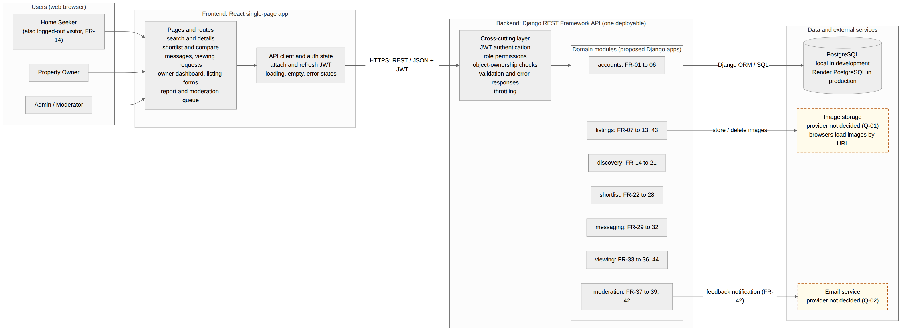
Figure 1: High-level system architecture (source: 01_System_Architecture.mmd). Dashed boxes are external services whose provider is not yet decided.
Reading the diagram. All three roles reach the same React app. The app calls the API over HTTPS with a JWT. Each request passes through the same cross-cutting layer (authentication, role-membership authorization, account-ownership/participant check, validation, error handling, throttling) before it reaches a business module. Only the API talks to PostgreSQL, the image store for writes, and the email service. Browsers read property images directly from the image store by URL.

3.3 Backend modules
PD-02. Seven business modules plus a shared core. Each module is proposed to be one Django app. The names are proposals and do not fix any database table. The table shows which requirements each module owns.
Module | Responsibility | Requirements | Use cases | Key rules
accounts | Registration for Home Seeker and Property Owner only; login, logout, token refresh; role; profile; public owner profile. | FR-01 to FR-06, FR-45 | UC-01 to UC-04, UC-13 | BR-01, OD-08, OD-09
listings | Owner listing lifecycle (Draft, Published, Unpublished, Removed); images; availability data; last-updated date; owner dashboard. | FR-07 to FR-13, FR-43 | UC-05 to UC-10, UC-29 | BR-02, BR-03, BR-05, BR-13, OD-01 to OD-04
discovery | Public browse, search, filters, sorting, pagination, listing details, missing and unconfirmed information flags. | FR-14 to FR-21 | UC-11, UC-12 | BR-04, BR-05, BR-11, BR-12, BR-13
shortlist | Add, remove and view shortlist; status of shortlisted items; comparison of up to 3. | FR-22 to FR-28 | UC-14 to UC-17 | BR-06, BR-07
messaging | Property-linked private conversations and messages; one conversation per Home Seeker account and listing, reusing history on repeat contact; behaviour when a listing changes status; message limits (UQ-01). | FR-29 to FR-32 | UC-18, UC-19 | BR-08, OD-04, OD-06
viewing | Viewing requests only for Published listings shown as Available; at most one Pending request per Home Seeker/listing; a new request may follow Rejected or Cancelled; owner response, seeker status check and cancellation remain per the existing workflow (UQ-09). | FR-33 to FR-36, FR-44 | UC-20 to UC-22, UC-30 | BR-09, OD-05
moderation | Reports, Admin review queue, Submitted -> Under Review -> Resolved/Rejected status flow, correction feedback, explicit temporary unpublish with moderation hold, hold release, and owner notification. | FR-37 to FR-39, FR-42 | UC-23 to UC-28 | BR-10, OD-09
core (shared) | Permission classes, pagination, error handler, throttling, shared validators, settings. | FR-40, NFR-14, NFR-16 | None | None

Dependency rule. listings is the central module: shortlist, messaging, viewing and moderation all refer to a listing. They reach it through its service functions or query helpers, not by editing its data directly, so that the status rules in Section 4.3 live in one place.

3.4 Layering inside the backend
PD-03. Business rules live in a service layer, not in views. Views stay thin. Rules that decide whether an action is allowed, such as "can this viewing request become Cancelled", are plain functions that can be tested without HTTP.
Layer | Does | Example
View (DRF viewset or API view) | Receives the request, applies authentication and checks role membership, calls a serializer and a service, returns the response. | Owner submits a response to a viewing request.
Serializer | Validates the shape and values of input; converts model data to JSON. | Rent must be greater than 0 (BR-03); message length (FR-30).
Service function | Applies business and status rules inside one database transaction; may call storage or email. | Change a viewing request from Pending to Accepted only if the caller owns the property (FR-36, BR-09).
Model and ORM | Persists data; database constraints back up the rules (NFR-13). | Unique shortlist entry per seeker and listing (FR-22).

3.5 Frontend structure
The React app is organised by area and a small shared layer:
- Public area: search and filter results, listing details, public owner profile. No login required (FR-14).
- Authentication pages: register, login. Logout clears stored tokens (FR-03).
- Home Seeker area: shortlist and comparison, conversations, viewing requests and their status, report form.
- Property Owner area: dashboard of own listings with statuses, listing and image forms, availability confirmation, conversations, incoming viewing requests, moderation feedback.
- Admin/Moderator area: report queue, report review and actions.
- Shared layer: one API client (token attach, single refresh attempt, error mapping), an auth context, route guards, and reusable components for form fields, error banners, loading and empty states, pagination, status badges and an image with a fallback.
Route guards only hide screens a user cannot use. The server decides what is allowed (FR-04). Publication status and availability status are shown as two separate badges, and an overdue availability is never shown as a confirmed "Available" (BR-13, FR-21).

4. Component interactions and domain rules

4.1 Request lifecycle
Every user action follows the same path:
- The browser loads the React app from the static site. Search and details pages call the API without a token (FR-14). Other pages call it with Authorization: Bearer <access token>.
- The API authenticates the token, determines the required capability from the account's role memberships, loads objects only within the caller's allowed scope, validates inputs, and applies business-status rules. Conversation creation, viewing requests, and reports compare listings.owner_id with the same requesting account ID regardless of active role; own listings are rejected. Admin / Moderator remains separately controlled.
- Changes run inside one database transaction. Success returns JSON; any failure returns the consistent error response (Section 7.2).
- The React app shows the result, or a loading, empty or error state (FR-41).

4.2 Interactions by capability
Capability | Frontend | Backend module | Database | External
Register with one or both public roles, add missing role, log in, log out, refresh, recover existing account by email (FR-01 to FR-05, FR-45) | Forms; store, attach and clear tokens | accounts | Users, blacklisted refresh tokens | None
Profile and public owner profile (FR-05, FR-06) | Profile form; owner profile block on details | accounts | User profile data | None
Browse, search, filter, sort, paginate (FR-14 to FR-19) | Filter form, results list, pagination, empty and error states | discovery | Read queries over Published listings | Images loaded by URL
Listing details (FR-20, FR-21, FR-13) | Details page with separate status badges and unknown/stale labels | discovery | Read listing, images, owner | Images loaded by URL
Create, update, publish, unpublish, remove own listing; dashboard (FR-07 to FR-10, FR-43) | Listing form, dashboard with status per listing | listings | Listings, status | None
Property images (FR-11) | File picker, preview, errors | listings | Image records (file reference) | Image storage
Availability confirmation and in-app reminders (FR-12) | Day 5/Day 7 reminder; Still Available / Not Available actions | listings | Availability and last-confirmed date | None
Shortlist and compare (FR-22 to FR-28) | Shortlist page, compare view (max 3) | shortlist | Shortlist entries | None
Conversations (FR-29 to FR-32) | Conversation list and thread; periodic refresh | messaging | Conversations, messages | None
Viewing requests (FR-33 to FR-36, FR-44) | Request form; status list; owner response; cancel | viewing | Viewing requests, status | None
Report listing; review and act (FR-37 to FR-39) | Report form; Admin queue and review screen | moderation | Reports, moderation hold, status | None
Moderation feedback and email (FR-42) | Owner sees feedback on dashboard | moderation | Feedback record | Email service

4.3 Status rules the backend must enforce
These rules come from Steps 4 and 5. The Step 6 BPMN draws the same rules and was used as a cross-check. They are enforced in the service layer (PD-03) and backed by database constraints where practical (NFR-13).

Listing lifecycle and moderation hold
Status | In public discovery? | Rules from the sources
Draft | No | Created when required values are valid. Needs all applicable FR-07 conditions before it can be published.
Published | Yes (BR-04, BR-13) | Only Published, discoverable listings appear in public search.
Unpublished | No | Set by the owner, or by an Admin through an explicit moderation action (FR-39). Shortlists show it as Unpublished / not publicly available (FR-25).
Removed | No | Cannot be published again with the normal action (OD-02). Conversation and viewing-request history is preserved (OD-04).

Publish check. An owner can publish a Draft or Unpublished listing only if the FR-07 conditions are met (valid required fields, at least one valid image), the listing is not Removed, and no moderation hold exists (FR-39, OD-02). A current owner availability confirmation must also be recorded (FR-12). A moderation hold is set when an Admin temporarily unpublishes a listing for a policy violation and stays until an Admin releases it. Releasing the hold does not republish the listing; the owner publishes again.

Availability (separate from the lifecycle)
Rule | Source
Availability status is Available, Unavailable or Needs Reconfirmation, stored and displayed separately from lifecycle status. Published listings require availability_confirmed_at. | FR-12, BR-13, OD-02
The system stores availability_confirmed_at separately from updated_at. Content or image changes refresh updated_at; a Still Available / Not Available confirmation updates availability_confirmed_at only. Publishing requires an initial owner confirmation. | FR-12, UC-10
A daily scheduled task sends an in-app reminder on Day 5 and Day 7. If the owner has not responded by 7 days, it sets Needs Reconfirmation and creates the Day 7 notification. The owner dashboard keeps a pending notice and offers Still Available / Not Available. Needs Reconfirmation is never presented as Available; confirmation date and last-updated date remain separate. | OD-01, FR-12, FR-21
An overdue availability must never be presented as confirmed Available. | BR-13, BR-05

PD-10. A daily scheduled task processes availability confirmation cycles. On Day 5 it creates the in-app reminder; on Day 7 it creates the second reminder and changes the stored availability status to NEEDS_RECONFIRMATION if the owner has not responded. The owner dashboard shows the pending notice and Still Available / Not Available actions. Each response stores a new confirmation date and clears the current reminder cycle. A Published listing cannot have an empty confirmation date. Email reminders are planned, subject to Q-02 provider selection.

Viewing request
From | To | Who may do it | Source
(new) | Pending | A logged-in Home Seeker, for a valid future date and time on a property that accepts requests | FR-33, BR-09, OD-05, UC-20
Pending | Accepted or Rejected | The Property Owner of that property only | FR-34, FR-36, BR-09, UC-22
Pending | Cancelled | The requesting Home Seeker only; the owner can then no longer accept or reject | FR-36, FR-44, OD-05, UC-30
Accepted, Rejected, Cancelled | Any other status | Nobody. Incompatible actions are rejected | FR-36

No minimum notice period and no owner response deadline are enforced in the initial release (OD-05). Alternative-time negotiation is not supported (FR-36). UC-20 4a and 4b state the confirmed rules: past or invalid dates are rejected; requests require Published + shown Available; only one Pending request per Home Seeker/listing; new requests may follow Rejected or Cancelled (FR-33, UQ-09).

Reports
Report status is Submitted, Under Review, Resolved or Rejected (FR-38, UQ-05). Only an authorised Admin/Moderator can access the queue and change report status (BR-10). Feedback and explicit unpublishing are independent and may both apply: feedback may set the report to Resolved without changing listing lifecycle; unpublishing sets listing lifecycle to Unpublished and leaves report status unchanged. Report status and listing lifecycle remain separate.

Conversations
Rule | Source
A conversation links one seeker, one owner and one property. Only those participants can read it. | FR-29, FR-31, BR-08
A message is plain text, 1 to 2,000 characters, not empty or whitespace only. Basic rate limiting applies. | FR-30, OD-06
Listing Unavailable: existing conversations continue, no new conversation can start. Unpublished or Removed: history stays readable, no new message and no new conversation. | FR-32, OD-04

5. Authentication, authorization and ownership

5.1 Authentication design
PD-04. JWT access token plus rotating refresh token, with server-side revocation. The login endpoint returns a short-lived access token and a longer-lived refresh token. When the access token expires, the app sends the refresh token and receives a new access token. Logout sends the refresh token to the API, which blacklists it, and then the app clears its stored tokens (FR-03). An access token that has already been issued stays valid until it expires, so its lifetime should be short. Proposed starting values, adjustable by environment variable: access token 15 to 30 minutes, refresh token 7 days.
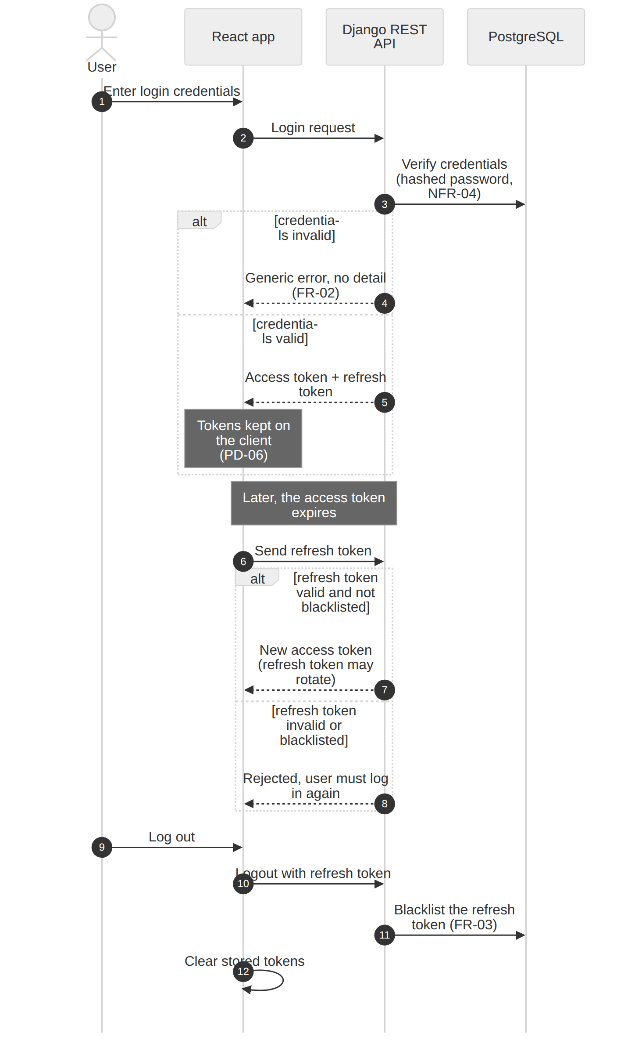
Figure 3: Login, token refresh and logout (source: 03_Authentication_Token_Lifecycle.mmd).
- Registration accepts only the Home Seeker and Property Owner roles. Admin/Moderator accounts are never created through public registration (FR-01, BR-01, OD-09).
- Login failure returns a generic error that does not reveal which part was wrong (FR-02). Registration validates required information and a unique login identifier; no OTP or email verification is required (OD-08).
- Passwords use the framework's established password hashing and are never returned by the API (NFR-04).
- Basic email-based password recovery is included in FR-45: it recovers the existing account and never creates an account. OTP verification, password change and account deactivation are not designed here (ISS-17 in Step 5).

5.2 Where the client keeps tokens
PD-06. Tokens are kept in browser storage, with a short access-token lifetime and a rotating refresh token. FR-03 already assumes tokens are stored on the client. Because the React app and the API live on different Render addresses, httpOnly cookies would add cross-site cookie and CSRF complexity that is not justified for this release.
The trade-off is that a cross-site scripting flaw could read the tokens. It is reduced by: React escaping all output; showing messages and listing text as plain text, never as HTML; adding no third-party scripts; and validating input on the server. If the project later needs stronger protection, moving the refresh token to an httpOnly cookie is a contained change in the API client and the login endpoints.

5.3 Roles, permissions and ownership checks
PD-05. One account may have Home Seeker, Property Owner, or both public role memberships. Registration may assign either or both; account settings may add the missing public role. Admin/Moderator membership remains controlled and cannot be self-granted. PD-07. Four checks run on every protected request in this order: authenticate the token; check the required role membership (using the account's assigned memberships); load the object only inside the caller's allowed ownership/participant scope; then apply business rules and status checks. DRF permission classes enforce role membership; scoped queries enforce ownership. Conversation, viewing-request and report creation also compare listings.owner_id with the requesting account ID regardless of role and reject equality.
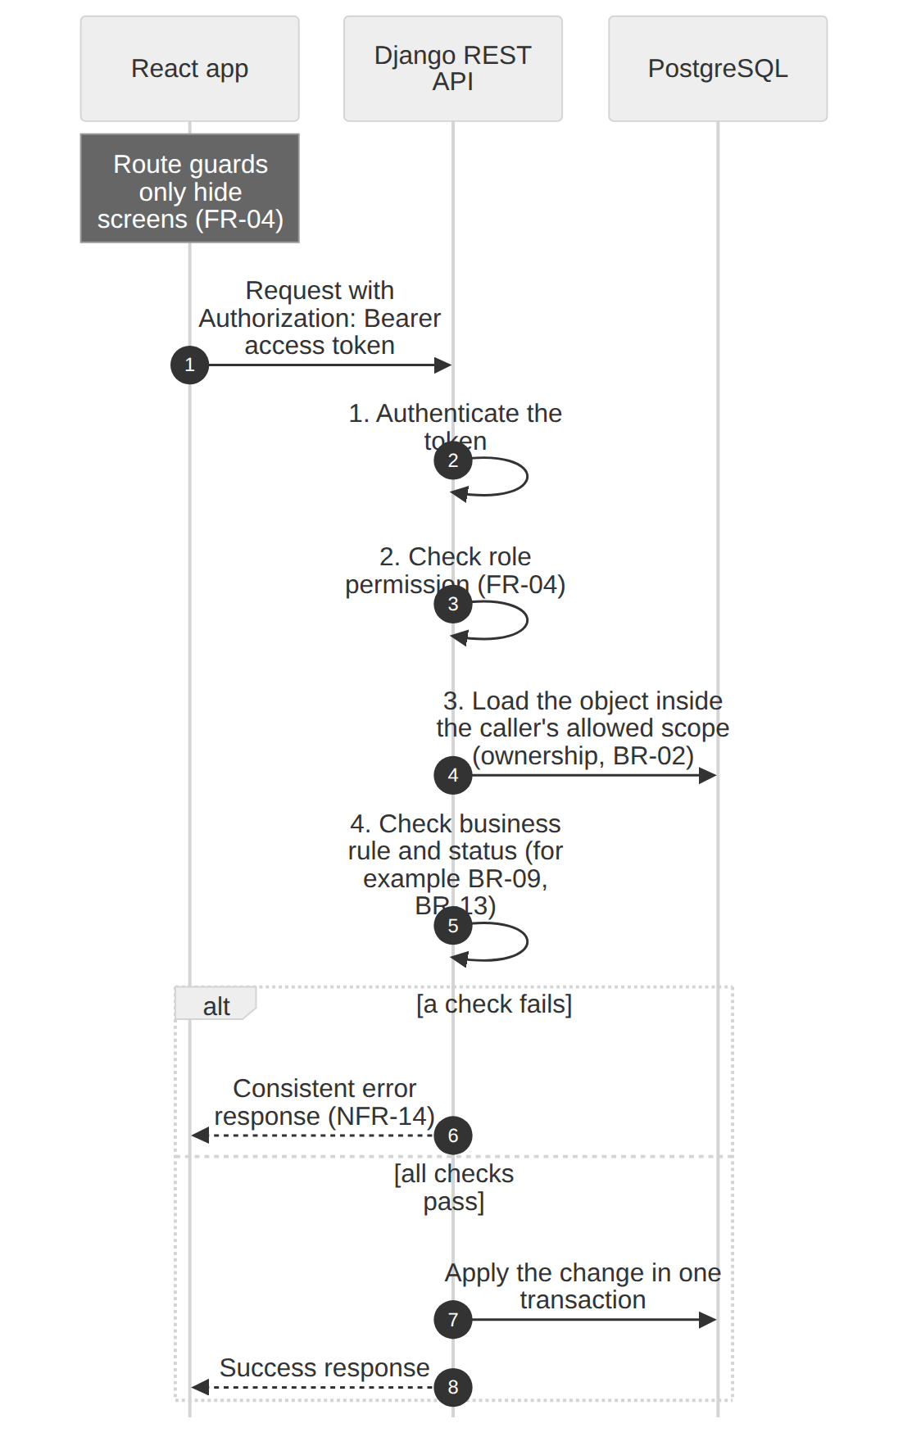
Figure 4: Authorisation checks on a protected request (source: 04_Authorization_Checks.mmd).
Response codes (proposed): 401 when the caller is not authenticated or the token is invalid; 403 when the role is wrong; 404 when the object is outside the caller's scope, so the API does not reveal that another user's private object exists; 400 for validation errors; 409 for a status change the current status does not allow.

Authorization matrix
Capability | Visitor | Home Seeker | Property Owner | Admin / Moderator | Source
Browse, search, details, public owner profile | Yes | Yes | Yes | Yes | FR-14, FR-06
Create, update, publish, unpublish, remove a listing; dashboard; images; availability | No | No | Own listings only | No (moderation actions only) | FR-07 to FR-12, FR-43, BR-02
Shortlist and compare | No | Own shortlist | No | No | FR-22 to FR-28, BR-06
Start a conversation | No | Yes | No | No | FR-29
Read and send messages | No | Own conversations | Own conversations | No | FR-30, FR-31, BR-08
Submit a viewing request | No | Yes | No | No | FR-33, FR-14
Accept or reject a viewing request | No | No | Owner of that property only | No | FR-34, UC-22
Cancel a viewing request | No | Requester, while Pending | No | No | FR-36, FR-44
Report a listing | No | Yes | No | No | FR-37, UC-23
Report queue, review, moderation actions, hold release | No | No | No | Yes | FR-38, FR-39, BR-10
See moderation feedback | No | No | Own listings only | Authorised Admin | FR-42

"Visitor" means a logged-out user. The sources do not define a Visitor role (ISS-01); this word only describes a request without a token, and no Visitor role is added to the system.

5.4 Admin/Moderator provisioning
Admin/Moderator accounts are created by the controlled setup process, for example Django's createsuperuser against the production database from a secure environment (OD-09). AS-01: accounts created this way are given the Admin/Moderator role, so the setup step must set it. No registration or promotion endpoint exists.

5.5 Rate limiting
Message sending is rate limited (OD-06). PD-11 uses DRF throttling for this; the exact limit is chosen and tested during implementation, as OD-06 states. Throttling login attempts is an optional hardening step and is not required by the sources.

6. Property image upload, validation and storage

6.1 Requirements that apply
Requirement | Rule
FR-11, OD-03 | Maximum 5 images per listing. JPG, JPEG, PNG and WebP only. Maximum 5 MB per image. Clear error when a file is rejected.
FR-07 | A listing needs at least one valid image to be published. A Draft can be saved without one.
UC-07, ASM-07 | The owner can add, replace and remove images of their own listing. A storage failure leaves the listing unchanged.
NFR-11 | Size and type limits are enforced. Layout must not break when an image is slow or missing.
NFR-06, FR-04, BR-02 | Validation happens on both client and server; only the owner of the listing may change its images.

6.2 Upload flow
PD-09. Images are uploaded through the API, not directly to the storage provider. The server stays the single place where rules are enforced, and the provider can be changed later because the code talks to Django's storage abstraction, not to a provider directly.
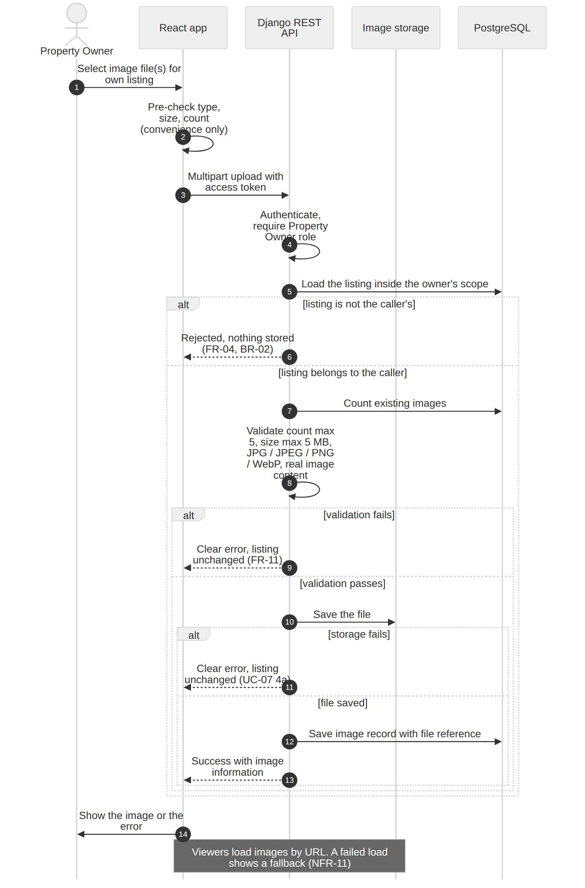
Figure 5: Property image upload (source: 05_Image_Upload_Flow.mmd).

6.3 Server-side validation
Check | Rule | Source
Authentication and role | Caller is a logged-in Property Owner. | FR-04
Ownership | The listing belongs to the caller. Otherwise nothing is stored. | BR-02, NFR-05
Count | Existing images plus new images must not exceed 5. | OD-03, FR-11
Size | Each file is at most 5 MB. Check the real received size, not only a client-supplied value. | OD-03
Type | Extension and detected content are one of JPG, JPEG, PNG, WebP. Verify by opening the file as an image (Pillow). Reject empty, corrupt or renamed non-image files. | OD-03, NFR-11
File name | Store under a generated unique name. Do not trust the uploaded file name. | Good practice (PD-09)
Replace or remove | Validate and save the new file first, then delete the old one, so a failure never leaves the listing with fewer images than before. | UC-07

6.4 Storage
The database stores a reference and basic metadata for each image. The file itself is not stored in PostgreSQL. In development the storage setting points to a local media folder. In production it must point to storage that survives restarts and redeployments.
Why local disk is not enough on Render. According to Render's documentation (checked 25 October 2026), a service's filesystem is ephemeral and changes are lost on redeploy or restart unless a persistent disk is attached, and persistent disks are available only for paid web services. A listing image saved to the web server's own disk would therefore disappear, which would break FR-07 and FR-11 in production.
Option | Fit | Notes
A. Local disk on the web service | Not suitable for production | Ephemeral on Render. Suitable only for local development.
B. Render persistent disk | Possible | Paid web service only; ties the service to one instance. Adds cost and deployment constraints.
C. S3-compatible object storage (for example AWS S3, Cloudflare R2, Backblaze B2) | Recommended default | Files survive deployments; served by URL; works through Django's storage abstraction.
D. Hosted image service (for example Cloudinary) | Good alternative | Easy upload and delivery; adds a vendor library. Check current free-tier terms.
E. Images stored inside PostgreSQL | Not recommended | Grows the database quickly and complicates backups and queries.

Q-01 (needs your decision): which production storage to use. Until decided, this document assumes option C or D behind Django's storage abstraction, and local storage in development.

6.5 Serving and displaying images
- Published listing images are read by the browser directly from the storage URL, so image traffic does not go through the API.
- AS-03: image URLs are public but use unguessable names. A Draft listing's images could be opened by anyone who knows the exact URL. Signed, expiring URLs are a possible later hardening step and are not required by the sources.
- The frontend uses fixed image areas so the layout does not shift, lazy loads list images, gives every image alternative text, and shows a fallback when an image fails to load (NFR-11, NFR-03).
- AS-02: images of a Removed listing are kept, in line with the soft-removal and history rule (OD-04). The sources define no deletion rule for them.
- Not designed because the sources do not ask for them: thumbnail generation, image reordering, choosing a cover image.

7. Error handling, validation and cross-cutting concerns

7.1 Validation layers
Layer | Purpose | Examples
React form | Fast feedback for the user. Never trusted. | Required fields, file type and size before upload (NFR-06).
DRF serializer | Authoritative validation of shape and values. | Rent greater than 0 and minimum not above maximum (BR-03, FR-16); counts not negative (FR-10); message 1 to 2,000 characters (FR-30); page number (FR-19); preferred date not in the past (FR-33).
Service function | Status and ownership rules. | Allowed viewing-request transitions (FR-36); publish conditions and moderation hold (FR-07, FR-39); comparison limit of 3 (BR-07).
Database constraints | Last line of defence for integrity. | Foreign keys, required fields, uniqueness of a shortlist entry (BR-06) (NFR-13).

7.2 Error handling
PD-08. One error response shape for the whole API (NFR-14, NFR-16). A single DRF exception handler converts every expected failure into this shape. The final field names are fixed during API design; the example shows the intent.
{ "error": {
"code": "validation_error",
"message": "Please correct the highlighted fields.",
"fields": { "rent": ["Rent must be greater than 0."] }
} }
Situation | Status | Behaviour
Invalid input | 400 | Field-level messages the form can show next to each field (FR-40).
Not logged in, or token invalid or expired | 401 | The API client tries one refresh, then sends the user to login.
Wrong role | 403 | Clear "not allowed" message.
Object missing or outside the caller's scope | 404 | Same response for both cases, so existence is not revealed.
Status change not allowed | 409 | Message states the current status and why the action is refused (FR-36).
Too many requests | 429 | Message asks the user to wait (OD-06).
Unexpected server error | 500 | Generic message only. Details go to the server log, never to the client. Production runs with debug off.

7.3 Frontend states
Every screen that loads data handles four states: loading, empty, error with a retry action, and success (FR-41). Actions confirm success or show the validation or permission failure clearly (FR-40). The shared API client maps status codes to messages, so screens do not repeat this logic. On Render's free tier the first request after an idle period can be slow (Section 8.5), so the loading state must be visible.

7.4 Search and performance
- Search filters (location, rent range, property type, bedrooms, availability) are combined with AND and run in the database through query parameters (FR-15 to FR-18). Results are paginated with the page size set by FR-19, and an invalid page number is rejected.
- Only Published, discoverable listings are queried (BR-04). The availability filter uses the same computed condition as the badge (PD-10).
- PD-14 (indexing and queries): index the columns used by the common filters and sorts, and use select_related and prefetch_related on list and detail endpoints so that a result page does not issue one query per row (NFR-12).
- NFR-10 is measured, not assumed: OD-07 requires testing on a representative dataset in a documented environment and reporting whether 95% of common read and search requests finish within 2 seconds.

7.5 Security controls
Control | Practice | Source
HTTPS | Required in production. Django is configured to trust the platform's forwarded-protocol header and to redirect or refuse plain HTTP. Local HTTP is acceptable. | NFR-08
Secrets | Secret key, database URL and keys come from environment variables. A .env.example lists the names without values. | NFR-07, NFR-21
Debug and hosts | Debug off and an explicit allowed-hosts list in production. | NFR-20
CORS | Only the frontend origin may call the API. | NFR-20 (good practice)
CSRF | Tokens are sent in the Authorization header, so cookie-based CSRF does not apply. Revisit if tokens ever move to cookies (PD-06). | PD-06
Output safety | React escapes output; user text is shown as plain text; the API never returns raw passwords. | NFR-04, NFR-09
Privacy | Users reach only their own private data: profile, shortlist, conversations, viewing requests. | NFR-09, BR-08
Logs | Application logs go to standard output. They must not contain passwords, tokens or message text. | NFR-09

7.6 Message delivery
Messages use normal request and response calls. The app loads the conversation when it is opened and refreshes it periodically while it stays open, plus a manual refresh option (ASM-08). AS-04: a refresh interval of roughly 15 to 30 seconds is enough and can be tuned. No WebSockets are used because advanced real-time chat is out of scope.

7.7 Moderation email notification
PD-12. The feedback record is saved first; the email is attempted afterwards and its failure never undoes the record. The flow is: the Admin records feedback (UC-27); the API saves it in a transaction; after the transaction commits, the API asks the email service to notify the owner (FR-42); if sending fails, the error is logged and the feedback still appears on the owner's dashboard (OD-09). No task queue is introduced; a short timeout on the call keeps a slow email service from blocking the response.
Render constraint. According to Render's documentation (checked 25 October 2026), free web services cannot send outbound traffic on the standard SMTP ports 25, 465 and 587. A plain SMTP setup would fail on the free tier. An email provider that is called over HTTPS avoids this, or a paid instance can be used. In development, Django's console email backend prints the message instead of sending it. Q-02 asks you to choose.

7.8 Testing
NFR-17 requires automated tests for core business rules and permissions, and NFR-18 requires a documented command that runs them before a release. The proposed test layers are:
Layer | What it proves | Examples from NFR-17
Service tests (no HTTP) | Status rules and calculations. | Viewing-request transitions; effective availability; publish conditions; comparison limit.
API tests (DRF test client) | Authentication, role, ownership and validation through the real endpoints. | Login and logout with token revocation; listing ownership; combined filters; duplicate shortlist prevention; message privacy; moderation permission.
Frontend smoke tests | Key screens render and handle error states. | Login, search, details, shortlist, key forms.
Manual checks | What automation does not cover. | Chrome, Edge and Firefox smoke test (NFR-19); 360px mobile layout (NFR-02); keyboard use and visible focus (NFR-03).

PD-15. Use Django's test tooling (or pytest-django) for the backend and Vitest with React Testing Library for the frontend. A continuous-integration service is optional and not required by the sources.

7.9 Documentation
The README covers prerequisites, local setup, environment variable names, migration, run and test commands (NFR-21). Optionally, OpenAPI documentation generated from the API supports NFR-16 and NFR-21.

8. Deployment architecture

8.1 Development and production environments
Aspect | Local development | Production (Render)
Frontend | Vite development server | Render Static Site serving the built React files
Backend | Django development server | Render Web Service running Django under gunicorn
Database | Local PostgreSQL (NFR-22) | Render PostgreSQL (NFR-22)
Images | Local media folder | External storage (Q-01)
Email | Console email backend | Email provider reached over HTTPS (Q-02)
Configuration | .env file, not committed (NFR-07) | Environment variables in the Render dashboard (NFR-07, NFR-20)
HTTPS | Not required; local HTTP acceptable (NFR-08) | Required (NFR-08)
Debug and hosts | Debug on | Debug off; explicit allowed hosts
API address and CORS | Local frontend and API origins | Production frontend origin only

The diagram follows on the next page.

8.2 Deployment diagram
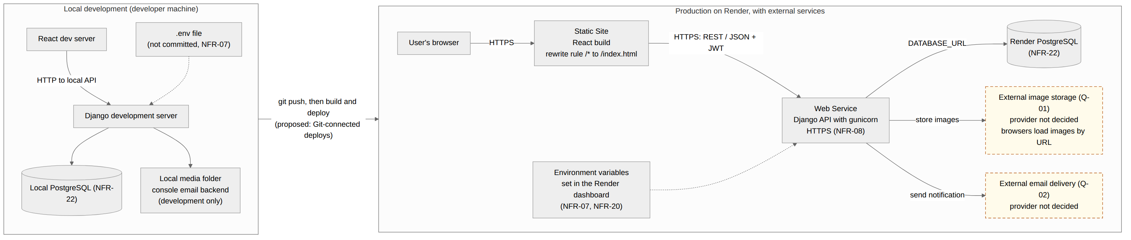
Figure 2: Development and production deployment (source: 02_Deployment.mmd). Dashed boxes are external services whose provider is not yet decided.
Reading the diagram. The developer works locally against local PostgreSQL. Pushing the code to the Git repository triggers a build and deploy on Render (proposed, PD-13). In production the browser loads the React build from the static site, which calls the Django web service; the web service reads the Render PostgreSQL database through DATABASE_URL and reaches the image store and email service over HTTPS. Environment variables are set in the Render dashboard and never committed.

8.3 Render services
PD-13. Three Render pieces plus two external services.
- Static Site for the React build. Build with the project's build command and publish the output folder. Add a rewrite rule that sends every path to /index.html; without it, opening or refreshing a client-side route such as a listing page would fail (Render redirects and rewrites documentation).
- Web Service for the Django API, started with gunicorn. Database migrations run as part of the deploy, before the new version serves traffic. Because the production API returns JSON only, no static-file serving is needed for the application. If the developer enables Django's own admin site for personal use, static-file serving would then be needed; that site is not part of the requirements.
- PostgreSQL database created in Render, connected through DATABASE_URL.
- External image storage (Q-01) and external email delivery (Q-02).

8.4 Configuration
PD-16 (configuration). One settings module reads its values from environment variables, with development defaults, or separate development and production settings files that do the same (NFR-20). Names below are proposals; secret values are never written in code or documentation.
Variable | Used by | Purpose
DJANGO_SECRET_KEY | API | Django signing key (NFR-07).
DJANGO_DEBUG | API | Must be off in production.
DJANGO_ALLOWED_HOSTS | API | Hostnames the API accepts.
DATABASE_URL | API | PostgreSQL connection supplied by Render.
CORS_ALLOWED_ORIGINS | API | The production frontend origin.
JWT_ACCESS_LIFETIME_MINUTES, JWT_REFRESH_LIFETIME_DAYS | API | Token lifetimes (PD-04).
Storage settings (names depend on Q-01) | API | Credentials and bucket or account name for image storage.
Email settings (names depend on Q-02) | API | Provider key and sender address.
VITE_API_BASE_URL | Frontend build | Address of the API, fixed when the frontend is built.

The repository includes a .env.example with these names and no secret values, and the README explains each one (NFR-21).

8.5 Render platform constraints that affect the design
The facts below come from Render's documentation and were checked on 25 October 2026. Plans and limits change, so confirm them again before deploying.
Constraint | Effect on BasaChai | Response
A free web service spins down after 15 minutes without traffic and takes extra time to start on the next request. | The first request after idle can be slow, which affects any response-time measurement (NFR-10, OD-07). | Show clear loading states (FR-41). State the Render plan used when reporting performance.
A free PostgreSQL database expires 30 days after creation (with a short grace period) and has no backups. | A long-running demo cannot rely on a free database as durable storage. | Plan to upgrade the database, or recreate and reseed it. Keep a seed-data script.
The filesystem of a service is ephemeral; persistent disks need a paid web service. | Uploaded images saved locally would be lost. | Use external image storage (Section 6.4, Q-01).
Free web services cannot send outbound traffic on SMTP ports 25, 465 and 587. | Plain SMTP email would fail on the free tier. | Use an email provider over HTTPS, or a paid instance (Section 7.7, Q-02).
Static sites need a rewrite rule for client-side routes. | Direct links to listing pages would otherwise return an error. | Add the /* to /index.html rewrite (Section 8.3).

8.6 Release flow
- Develop and test locally; run the documented test command and require it to pass before a release (NFR-18).
- Push to the Git repository; Render builds and deploys the static site and the web service (PD-13).
- Confirm the migration step succeeded, then smoke test login, search, details and one owner action on the deployed site.
- Create Admin/Moderator accounts through the controlled setup process (OD-09, AS-01).

9. Decisions, assumptions, constraints and risks

9.1 Proposed decisions
All entries are proposals made in this document. None of them changes a requirement, and each can be revised.
ID | Decision | Reason | Revisit if
PD-01 | React SPA plus one modular-monolith Django REST API. | One developer, one deployable unit, no real-time or async need. | Real-time chat or heavy background work is added.
PD-02 | Seven business modules plus a shared core, as Django apps. | Maps to Step 4 requirement groups (NFR-15). | A module grows too large.
PD-03 | Business rules in a service layer, not in views. | Testable status rules (NFR-17). | Never needed for simple CRUD only.
PD-04 | JWT access token plus rotating refresh token with server-side blacklist. | Meets FR-03 revocation. | Token lifetimes need tuning.
PD-05 | One account may hold either or both public roles; Admin/Moderator membership is set only through the controlled setup process. A Visitor is an unauthenticated request, not an account role. | Matches the three roles and BR-01. | Role-specific profile attributes are introduced.
PD-06 | Tokens kept in browser storage with short access lifetime. | FR-03 assumes client-stored tokens; avoids cross-site cookie work. | Stronger XSS protection is required.
PD-07 | Four ordered checks per request; 404 for objects outside the caller's scope. Conversation creation reuses one row per Home Seeker account/listing; viewing requests require a Published listing shown as Available and are unique while Pending (UQ-01, UQ-09). | Server-side authorization and privacy (NFR-05, NFR-09). | Clients need to distinguish 403 from 404.
PD-08 | One consistent JSON error shape. | NFR-14, NFR-16. | API design finalises field names.
PD-09 | Images uploaded through the API; storage behind Django's storage abstraction. | One place for rules; provider can change. | Uploads become large or slow.
PD-10 | Stored availability_status is used in filters; NEEDS_RECONFIRMATION is never presented as currently Available. | A daily scheduled task is required to create Day 5/Day 7 in-app reminders and apply the Day 7 status transition. Email reminders remain planned until Q-02 is decided. | Q-03 is resolved: every Published listing has a confirmation date; the daily task sends Day 5/Day 7 in-app reminders and sets Needs Reconfirmation at 7 days without response.
PD-11 | DRF throttling for message rate limiting. | OD-06 requires basic rate limiting. | Limits prove too strict or loose.
PD-12 | Email sent after commit; failure logged, feedback kept. | FR-42, OD-09. | Email must be guaranteed (then add a queue).
PD-13 | Render Static Site, Web Service and PostgreSQL with Git-connected deploys. | Matches NFR-22 and the Render target. | Plan or platform limits change.
PD-14 | Indexed filters and select_related/prefetch_related for query optimisation. | NFR-12 | Measurements show a slow query.
PD-15 | Django test tooling or pytest-django; Vitest and React Testing Library. | NFR-17, NFR-18. | The developer prefers other tools.
PD-16 | Environment-variable configuration, with development and production settings handled appropriately. | NFR-07, NFR-20 | Configuration requirements change.

9.2 Assumptions
ID | Assumption
AS-01 | Admin/Moderator accounts created through the setup process are given the Admin/Moderator role.
AS-02 | Images of a removed listing are kept, consistent with preserved history (OD-04). The sources define no deletion rule.
AS-03 | Image URLs are public but unguessable; a Draft listing's images are protected only by URL secrecy.
AS-04 | A messaging refresh interval of about 15 to 30 seconds is sufficient (ASM-08).
AS-05 | The owner's lists of incoming viewing requests and conversations exist (ASM-09). Step 4 has no FR for them yet (ISS-05), so the API design must specify them.
AS-06 | One backend instance and portfolio-scale data are enough. No horizontal scaling is designed.

9.3 Constraints from the sources
- Stack: React, Django REST Framework, PostgreSQL, JWT, Render (NFR-22).
- Home Seeker and Property Owner memberships may coexist on one account; Admin/Moderator remains controlled
- Excluded in the initial release: payments, rental contracts, post-rental management, AI/ML recommendations, chatbot, advanced real-time chat, complex calendar integration.
- Images: at most 5 per listing, JPG, JPEG, PNG or WebP, at most 5 MB each (OD-03). Messages: at most 2,000 characters (OD-06).
- Server-side enforcement of permissions and ownership with automated tests (NFR-05, NFR-17).

9.4 Risks
Risk | Impact | Mitigation
Image storage is not chosen (Q-01). | Production uploads are lost on redeploy if local disk is used. | Decide before implementing production image upload; keep storage behind the abstraction.
Email delivery is not chosen (Q-02) and free-tier SMTP is blocked. | Moderation emails never arrive, although feedback still shows on the dashboard. | Choose an HTTPS email provider; OD-09 already keeps feedback safe.
A missing ownership check on one endpoint. | A user reads or changes another user's data. | Query scoping by default; one ownership test per endpoint group (NFR-17).
Free-tier limits (spin-down, database expiry). | Slow first load; demo database disappears after 30 days. | Loading states; seed script; plan upgrade (Section 8.5).
Slow list queries. | Search misses the NFR-10 target. | Indexes, query review, measured test (OD-07).
Scope growth (real-time chat, payments). | Architecture complexity beyond a portfolio project. | Keep Step 4 Section 10 exclusions; revisit PD-01 only if they enter scope.

10. Consistency check against Steps 4 to 6

10.1 Facts checked
Item | Result
45 functional requirements | Matches: FR-01 to FR-45.
22 non-functional requirements | Matches: NFR-01 to NFR-22.
13 business rules | Matches: BR-01 to BR-13.
30 use cases | Matches: UC-01 to UC-30.
Stack: React, Django REST Framework, PostgreSQL, JWT, Render | Matches Step 5 technology context and NFR-22.
Three role types; one account may hold both public roles | Matches Step 4 Section 3 and ASM-01.
Initial-release exclusions | Match Step 4 Section 10.
Decisions OD-01 to OD-09 | Used as confirmed (see conflict C-1).
Step 6 | The combined BPMN diagram was supplied; no separate Step 6 text document was found.

10.2 How each non-functional requirement is addressed
NFR | Architecture response | Section
NFR-01 Usability | Consistent shared components and labels; main flow is search, details, shortlist. | 3.5
NFR-02 Responsive layout | Responsive layout; checked at 360px width. | 3.5, 7.8
NFR-03 Accessibility basics | Keyboard use, visible focus, contrast, image alternative text. | 3.5, 6.5, 7.8
NFR-04 Password storage | Framework password hashing; passwords never returned. | 5.1
NFR-05 Authorization enforcement | Role permission classes and ownership scoping, with tests. | 5.3
NFR-06 Input validation | Client and server validation layers. | 7.1
NFR-07 Secret management | Environment variables; .env.example without values. | 7.5, 8.4
NFR-08 Transport security | HTTPS in production; local HTTP allowed. | 7.5, 8.1
NFR-09 Privacy of user data | Query scoping for profile, shortlist, messages, requests. | 5.3, 7.5
NFR-10 Read/search performance | Indexes and measured test (OD-07). | 7.4
NFR-11 Image handling | Size and type limits; fallback display. | 6
NFR-12 Query efficiency | select_related and prefetch_related; query review. | 7.4
NFR-13 Data integrity | Service-layer status rules plus database constraints. | 3.4, 4.3, 7.1
NFR-14 Error handling | One error shape and status mapping. | 7.2
NFR-15 Maintainable structure | Business modules and shared frontend layer. | 3.3, 3.5
NFR-16 API consistency | Shared error shape; optional OpenAPI documentation. | 7.2, 7.9
NFR-17 Automated testing | Service, API and frontend test layers. | 7.8
NFR-18 Regression safety | One documented test command before release. | 7.8, 8.6
NFR-19 Browser compatibility | Manual smoke test in Chrome, Edge and Firefox. | 7.8
NFR-20 Configuration separation | Environment-driven settings. | 8.1, 8.4
NFR-21 Documentation | README and .env.example; optional OpenAPI. | 7.9, 8.4
NFR-22 Local and production PostgreSQL | Local PostgreSQL and Render PostgreSQL. | 8.1

10.3 Source conflicts and how this document treats them
These are inconsistencies inside the source documents. None needs a decision from you; each is treated as shown.
ID | Conflict | Treatment
C-1 | Resolved: Step 4 Section 9 now identifies OD-01 to OD-09 as confirmed decisions, consistent with its heading and Step 5. | No conflict remains after the Step 4 introduction was aligned with the confirmed-decision table.
C-2 | FR-35 and the Section 11 checklist now include Cancelled, consistent with FR-36, FR-44, BR-09, OD-05 and UC-30. | Cancelled is a valid status (Section 4.3); FR-35 and the checklist now state this.
C-3 | Step 3 describes two main roles and an Admin who manages users; Step 4 defines three roles with a limited Admin function (ISS-06). | Step 4 is followed. No user-management module is designed.
C-4 | FR-12 calls the 7-day rule an "initial rule"; OD-01 confirms it. | The 7-day rule is used as confirmed.
C-5 | UC-20 has no "not logged in" flow, while FR-14 requires login to submit a viewing request. | The API requires authentication for this action (FR-04); no conflict in the design.
C-6 | The Step 6 BPMN source and editable XML match; the SVG carries the current role, ownership, conversation-reuse and viewing-request rules. The combined PNG has a manually updated annotation but is not a fresh render of the SVG. | The combined PNG annotation is current, while its underlying diagram rendering remains from the earlier export; use the BPMN/SVG source for the full current diagram.

10.4 Open questions that need your decision
ID | Question | Why it matters | Default used here
Q-01 | Which storage should hold property images in production? | Render's service filesystem is ephemeral, so local storage loses uploads. Needed before production image upload (UC-07). | Django storage abstraction with S3-compatible storage or a hosted image service; local folder in development.
Q-02 | Which production email delivery mechanism should serve moderation feedback (FR-42) and planned availability reminders? | The production provider is not selected. The decision affects moderation feedback delivery and the optional planned email reminder channel for availability reconfirmation. | Use a provider reachable over HTTPS; use console delivery in development. Failed feedback email must not lose the saved feedback.
Q-03 (Resolved) | Availability confirmation and expiry rules (resolved by OD-01). | The approved OD-01 rule requires a confirmation date before publication, Day 5 and Day 7 in-app reminders, and Needs Reconfirmation after 7 days without response. The scheduled task applies the status transition. ISS-10 is resolved: content and image changes refresh last-updated; availability reconfirmation alone does not. | Resolved by the approved rule: Published listings require a confirmation date; the owner confirms before publishing, and no response for 7 days produces Needs Reconfirmation.
Q-04 | Who may submit listing reports? (Resolved) | The confirmed rule is authenticated Home Seekers may report only another Property Owner's Published listing. Home Seekers cannot report listings owned by the requesting account; Property Owner-only accounts cannot report. Admin / Moderators review and moderate submitted reports. | Follow Step 4 FR-37 and Step 5 UC-23. Check ownership against the requesting account; do not add account linking. A separate unlinked Property Owner account belonging to the same person cannot be detected in the initial release.

No other point blocks the architecture.

10.5 Carried forward to later steps
These are not open issues for Step 7. They belong to database design and API design and are already tracked in Step 5:
- database schema and ERD, and the endpoint catalogue and API contract;
- the one-conversation-per-Home-Seeker/listing rule is resolved by UQ-01;
- viewing-request rules are resolved by UQ-09; report status transitions follow UQ-05 (Submitted -> Under Review -> Resolved or Rejected);
- the exact field lists of the listing and profile (ISS-15) and the owner's lists of incoming requests and conversations (ISS-05).

