DAX Query View
Documentation — Movies Dataset
Power BI Desktop | DAX Query View

Level 1: Basic Table Queries & Filtering

Q1 — Top Rated Movies
Write a DAX query using EVALUATE and TOPN to list the top 5 highest-rated movies based on IMDb Rating.
DAX Query:
EVALUATE
TOPN(
5,
movies,
movies[IMDb Rating], DESC
)
ORDER BY
movies[IMDb Rating] DESC
Result:
The query returns the 5 movies with the highest IMDb ratings, led by The Shawshank Redemption (9.3), The Godfather (9.2), The Dark Knight (9.0), and a tie between Schindler's List and Pulp Fiction (8.9).
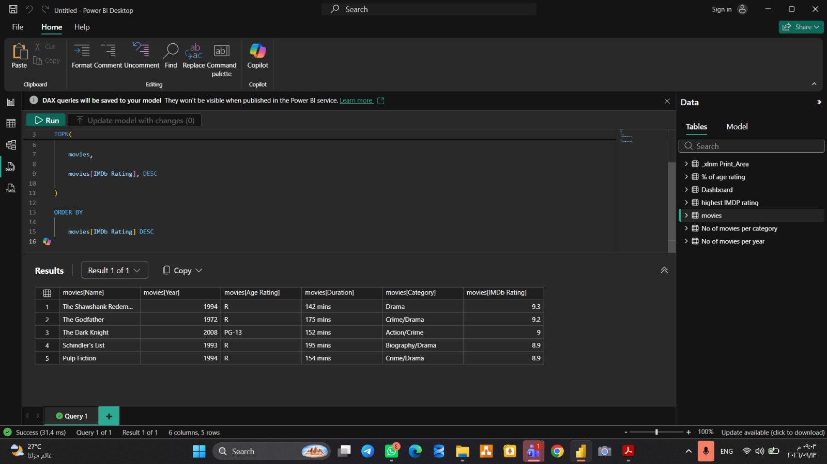
Screenshot — Q1: TOPN query result (Top 5 rated movies)

Q2 — Filtered Dataset
Write a DAX query using FILTER to display all movies released after the year 2010 that have an Age Rating of "R".
DAX Query:
EVALUATE
FILTER(
movies,
movies[Year] > 2010 &&
movies[Age Rating] = "R"
)
Result:
The query executed successfully but returned 0 rows, meaning the dataset contains no movies released after 2010 with an "R" Age Rating.
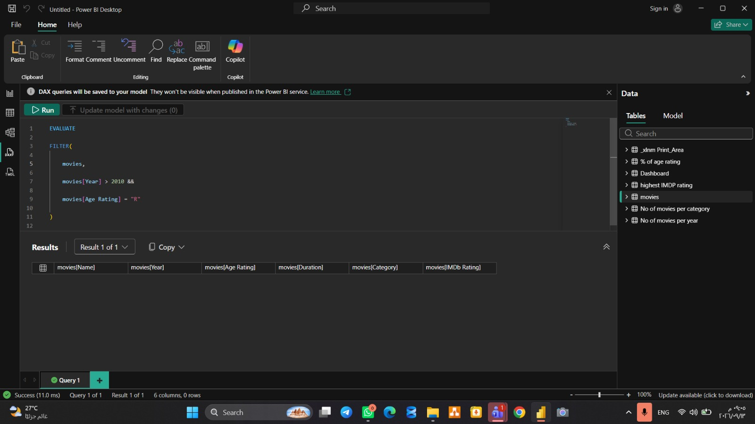
Screenshot — Q2: FILTER query result (0 matching rows)

Level 2: Summarization & Grouping (SUMMARIZE)

Q3 — Category Breakdown
Write a DAX query using SUMMARIZE to display each Category along with the total number of movies (Total Movies) and the average IMDb rating (Avg Rating), sorted by Avg Rating in descending order.
DAX Query:
EVALUATE
SUMMARIZE(
movies,
movies[Category],
"Total movies", COUNTROWS(movies),
"Avg Rating", AVERAGE(movies[IMDb Rating])
)
ORDER BY
[Avg Rating] DESC
Result:
The query returns 21 rows, one per category, with Action/Crime at the top (9.0 average) followed by Action/Sci-Fi (8.6) and Crime/Drama (8.51).
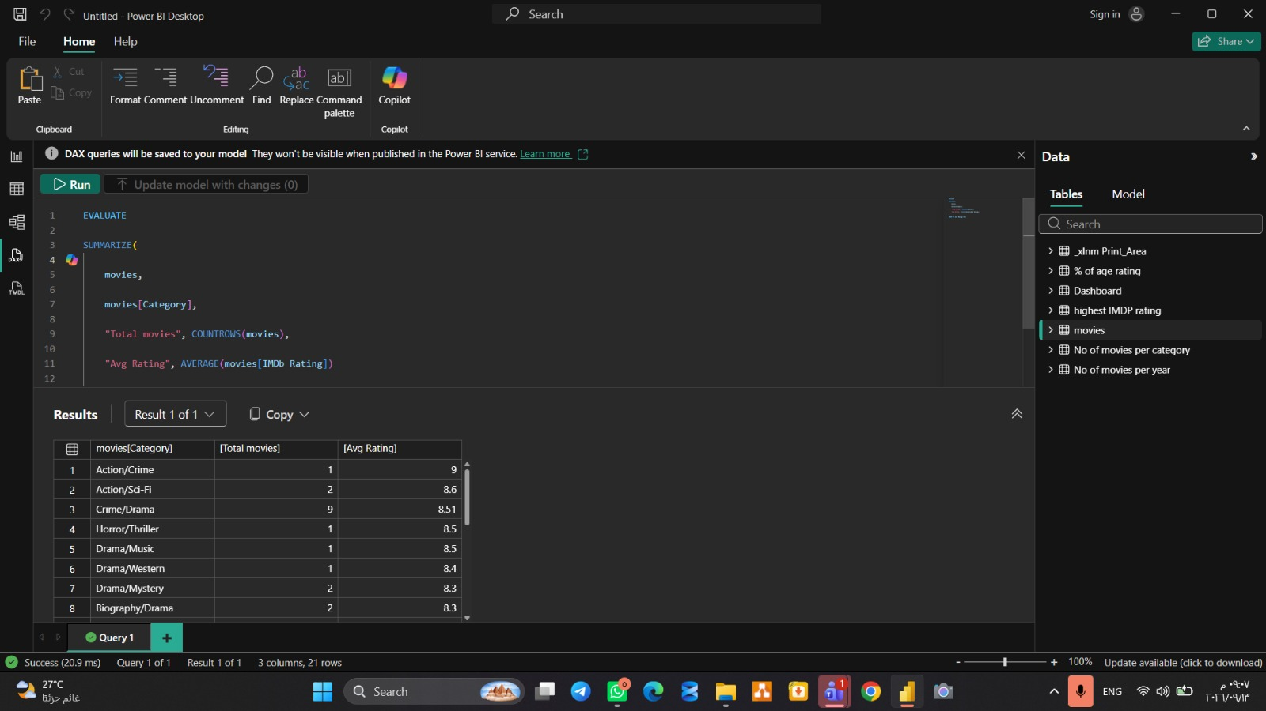
Screenshot — Q3: SUMMARIZE by Category (Total Movies & Avg Rating)

Q4 — Age Rating Analysis
Write a DAX query to summarize the Movies table by Age Rating, showing the count of movies and the highest IMDb rating (Max Rating) in each rating group.
DAX Query:
EVALUATE
SUMMARIZE(
movies,
movies[Age Rating],
"Count of Movies", COUNTROWS(movies),
"Max Rating", MAX(movies[IMDb Rating])
)
ORDER BY
[Max Rating] DESC
Result:
Three Age Rating groups are returned: R (31 movies, max rating 9.3), PG-13 (14 movies, max rating 9), and PG (5 movies, max rating 8.6).
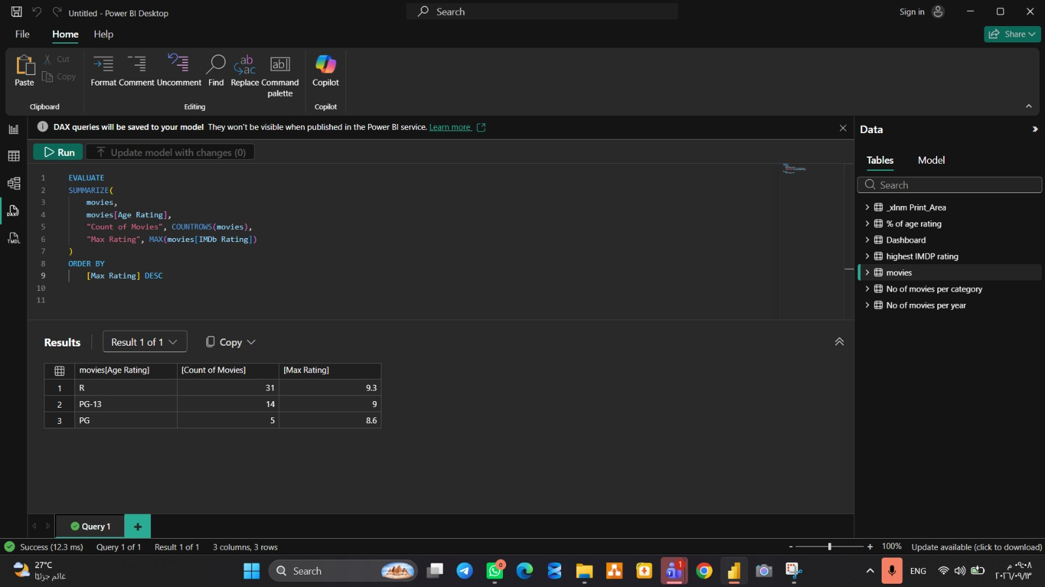
Screenshot — Q4: SUMMARIZE by Age Rating (Count & Max Rating)

Level 3: Testing Measures with DEFINE Blocks

Q5 — Local Measure Testing
Use a DEFINE block to create two local measures — [Total Movies] = COUNTROWS(movies) and [High Rated Movies] = CALCULATE(COUNTROWS(movies), movies[IMDb Rating] >= 8.5) — then write an EVALUATE statement to group these measures by Year.
DAX Query:
DEFINE
MEASURE movies[Total Movies] = COUNTROWS(movies)
MEASURE movies[High Rated Movies] =
CALCULATE(COUNTROWS(movies), movies[IMDb Rating] >= 8.5)

EVALUATE
SUMMARIZE(
movies,
movies[Year],
"Total Movies", [Total Movies],
"High Rated Movies", [High Rated Movies]
)
ORDER BY
movies[Year] ASC
Result:
The query returns 24 rows, one per release year, showing the total number of movies and how many of them scored 8.5 or higher on IMDb — for example, 1942 had 1 movie total with 1 high-rated, and 1994 had 3 movies with all 3 high-rated.
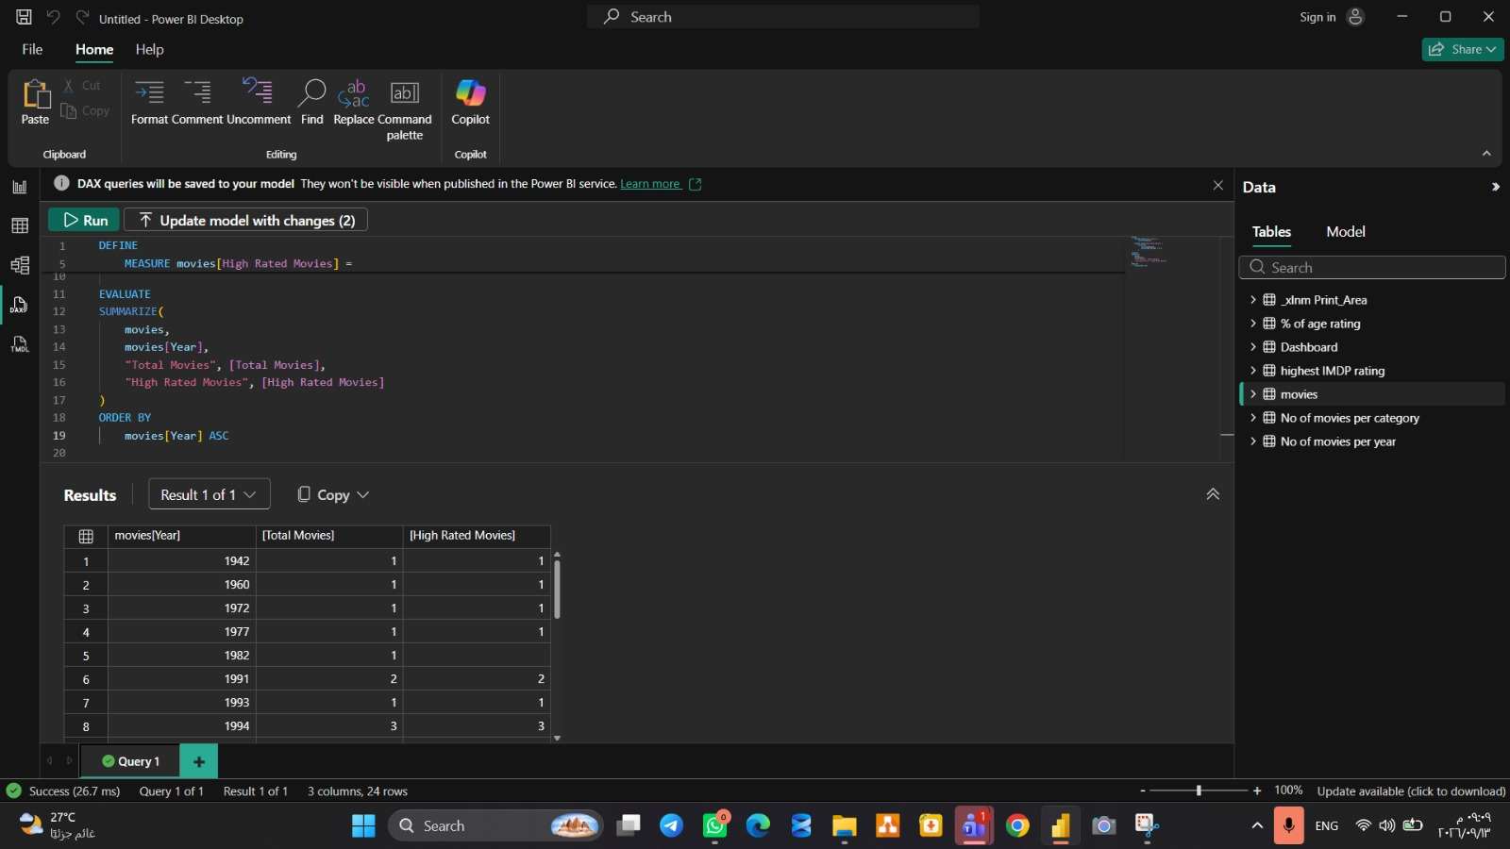
Screenshot — Q5: DEFINE block with local measures grouped by Year

Q6 — Single Value Evaluation via ROW
Write a DAX query using ROW to return a single-row summary showing the overall average IMDb rating and the total count of all movies in the dataset.
DAX Query:
EVALUATE
ROW(
"Overall Average IMDb Rating", AVERAGE(movies[IMDb Rating]),
"Total Movies", COUNTROWS(movies)
)
Result:
The query returns a single row summarizing the full dataset: an overall average IMDb rating of 8.26 across a total of 50 movies.
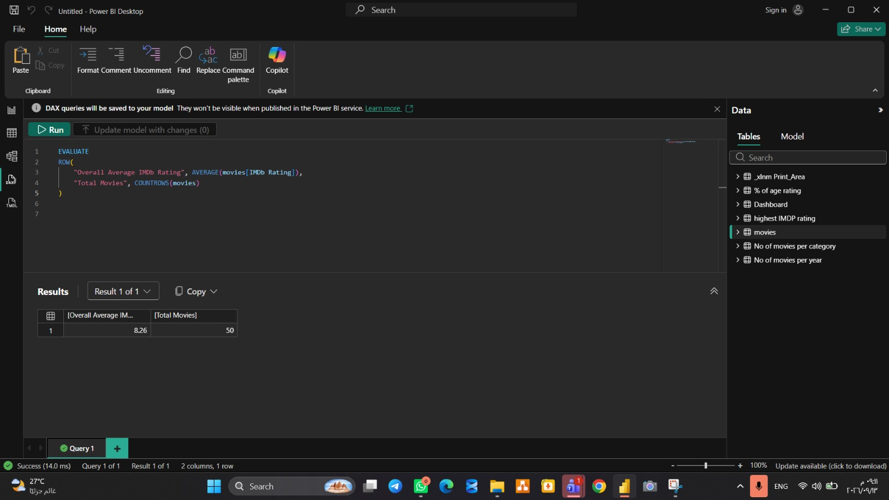
Screenshot — Q6: ROW query result (Overall summary)

