DEPARTMENT OF SOFTWARE ENGINEERING

***MOBILE APP DEVELOPMENT***

***EVENT FINDER APP***

*Submitted By:*

**Taneesha (22SW082)**

**Nahl Memon (22SW107)**

*Course Instructor:*

**Ms. Mariam Memon**

*Date:* **October 27, 2025**

**INDEX**

* **Problem Identification ====================1.1**
* **Proposed Solution ====================1.2**
* **Functionalities ====================2.1**
* **Responsive UI ====================3.1**
* **Data Storage ====================4.1**
* **Packages ==================== 4.2**
* **Errors and Debugging =============== 5.1**

1. **Problem Identification**

In today’s busy world, it can be hard to keep track of what’s happening around us. Information about local events, such as concerts, seminars, or community meetups, is often scattered across different platforms like social media, websites, and even word-of-mouth. Because of this, many people end up missing great opportunities to connect with others, build networks, or simply enjoy local experiences.

This problem is especially difficult for smaller events, which often struggle to get noticed. Without a single platform to showcase them, these events can easily go overlooked, leaving organizers and local businesses at a disadvantage.

An **Event Finder App** can address this by providing a single, easy-to-use platform where users can discover local events in one place. Whether it's a weekend workshop, a networking event, or a friendly gathering, the app ensures people stay connected to their community while helping smaller events gain the visibility they need.

1. **Proposed Solution**

The **Event Finder App** is a smart and modern solution to the common problem of missing out on local events. Built with Flutter as a cross-platform mobile app, it offers a seamless and consistent experience for both Android and iOS users. With just a few taps, anyone can discover and explore what’s happening nearby. The app includes two main roles.

* **Admins** are event organizers or community managers who can create, edit, and manage event listings in one place. This helps them avoid scattered flyers or outdated posts and ensures their events reach the right audience.
* **Users** can browse a wide range of local events such as sports, workshops, fairs, community gatherings, and concerts, and save the ones that interest them. All event details including dates, locations, and descriptions are available in one convenient place, making it simple to stay informed and connected with the community.

1. **Functionalities:**

**i. Seamless Event Discovery:**  
The Event Finder App allows users to easily explore a variety of local events such as concerts, workshops, meetups, and community gatherings in one convenient place. Instead of switching between different social media platforms or websites, users can browse or use the search feature to find events by name, keyword, or location.

**ii. Interests and Personalization:**  
Users can save events they find interesting to keep track of them later. The app uses Provider state management to create a personalized experience by suggesting similar events based on saved interests and activity, helping users stay connected with what matters most to them.

**iii. Sort Events by Category:**  
To make browsing more efficient, the app offers category buttons such as All, Community, Workshop, Concert, Fair, and Sports. Users can quickly filter and view events that match their interests without unnecessary scrolling.

**iv. Simple Event Management:**  
Admins can easily add, update, and manage events through a straightforward dashboard. The interface requires no technical expertise, making it simple for organizers to keep event details accurate and up to date.

**v. Support for All Events:**  
The app ensures both large and small events receive equal visibility. It helps smaller community activities gain attention, promoting inclusivity and encouraging greater local participation.

The **Event Finder App** is more than just an event directory. It’s a game-changer for both event seekers and organizers. With its simple design, powerful features, and seamless experience, it helps people stay connected, engaged, and always in the loop. Ready to never miss out on local happenings again? This app is your one-stop shop for community connection!

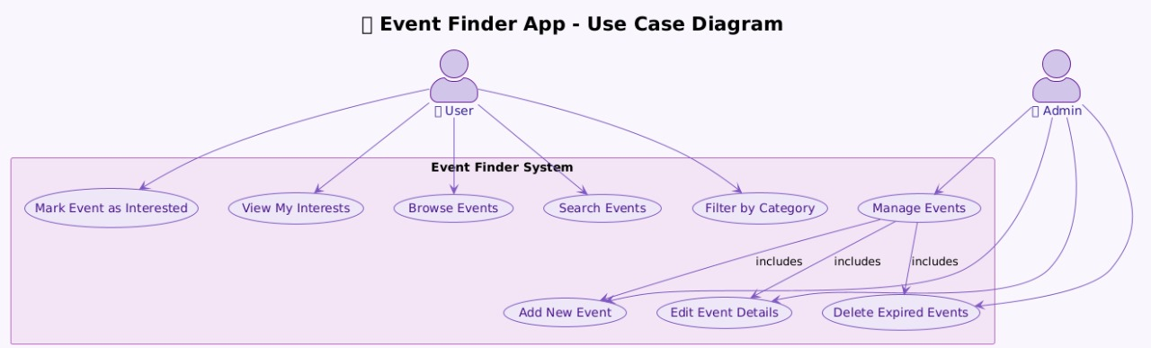

1. **Responsive User Interfaces**

The **Event Finder App** is designed with responsive layouts using Flutter’s adaptive widgets such as Expanded, ListView, and MediaQuery. This ensures that the interface adjusts smoothly across phones and tablets.

* The **Home Screen** displays a dynamic list of events with interactive event cards.
* The **Event Details Screen** provides detailed information in a visually balanced format.
* The **Admin Screens** includes options for adding and editing events efficiently.

**Laptop View:**

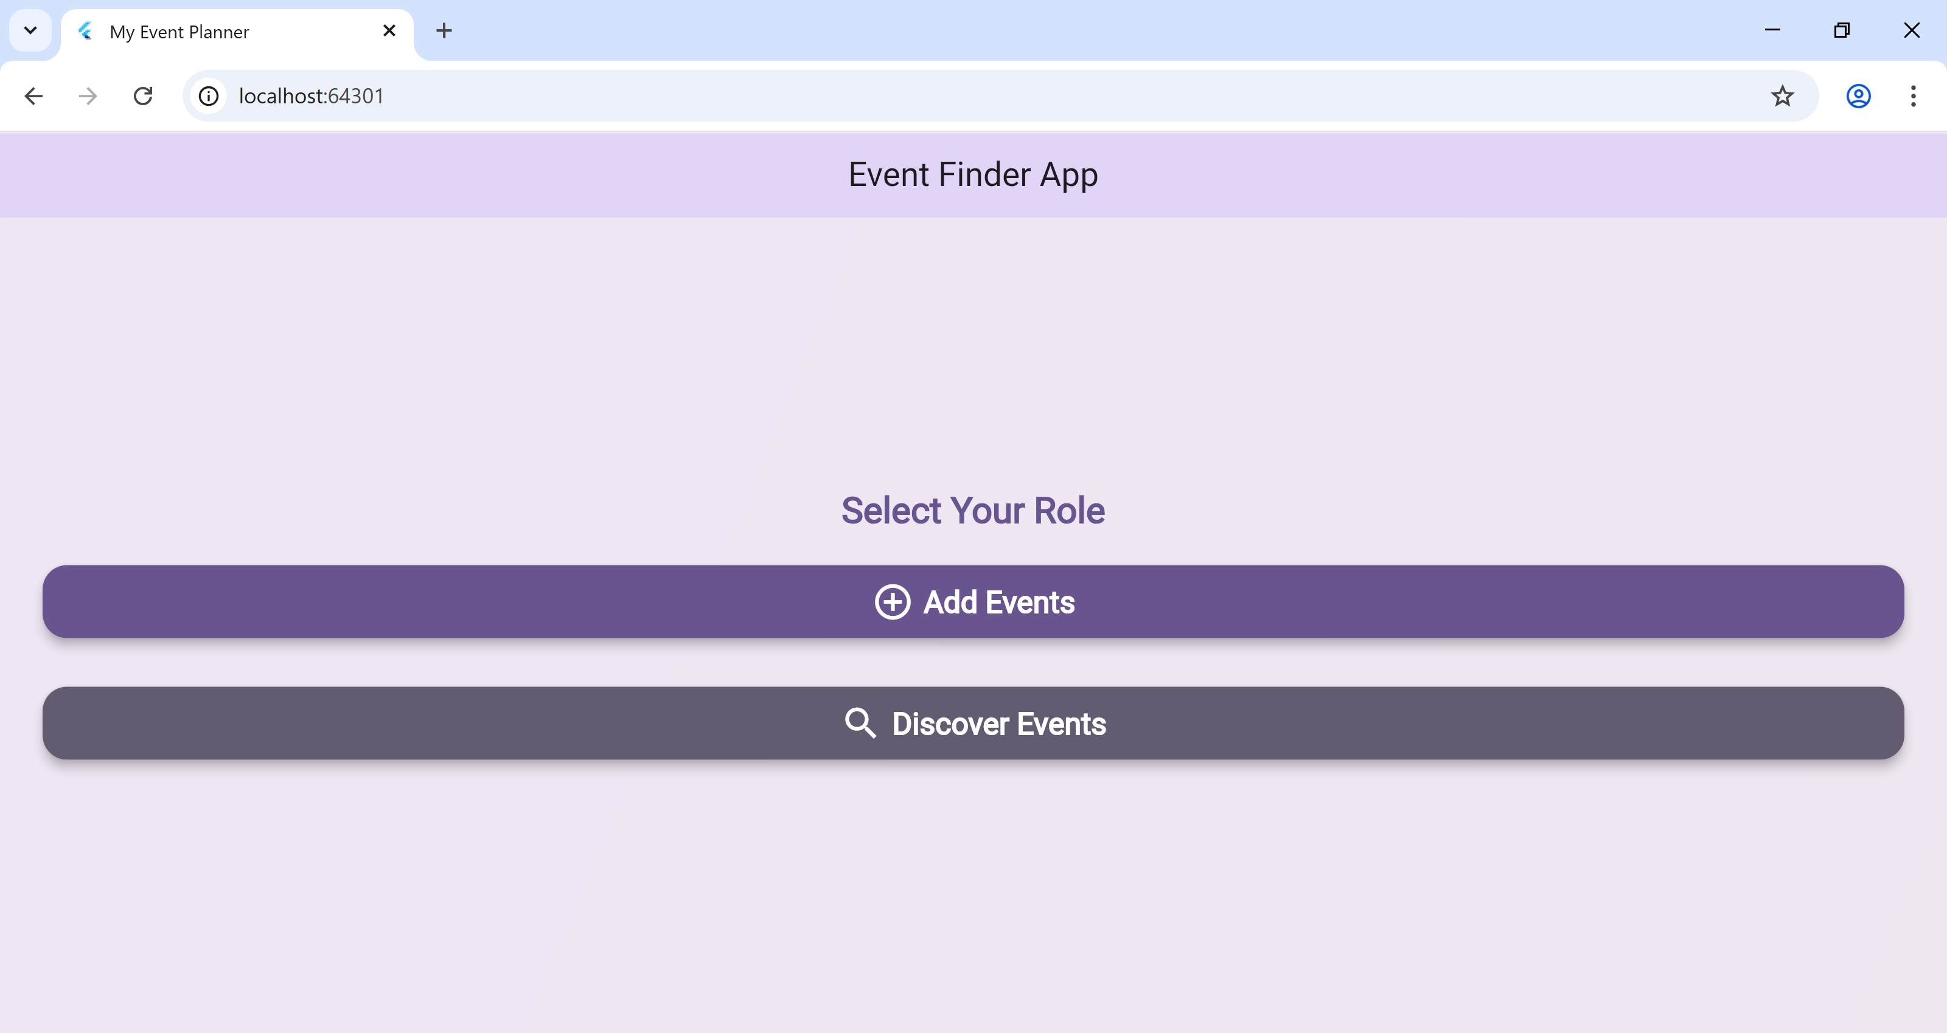

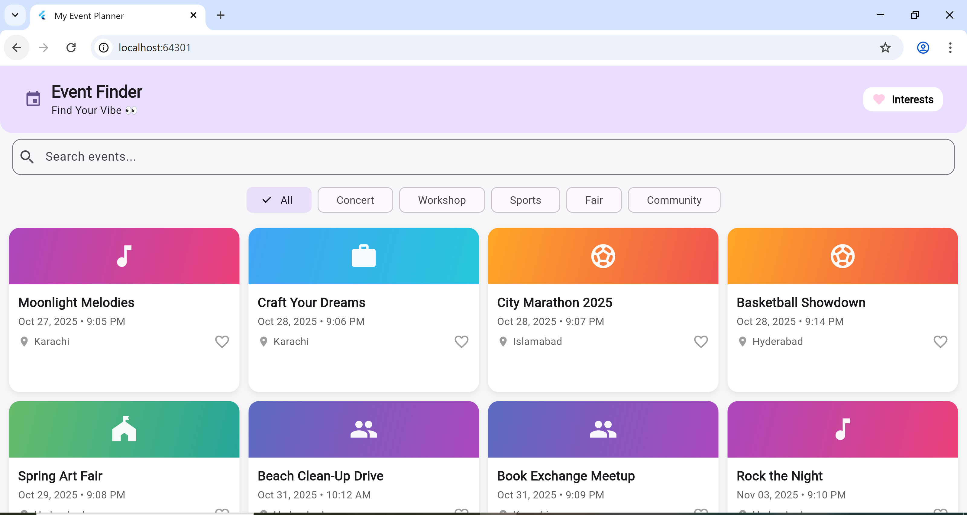

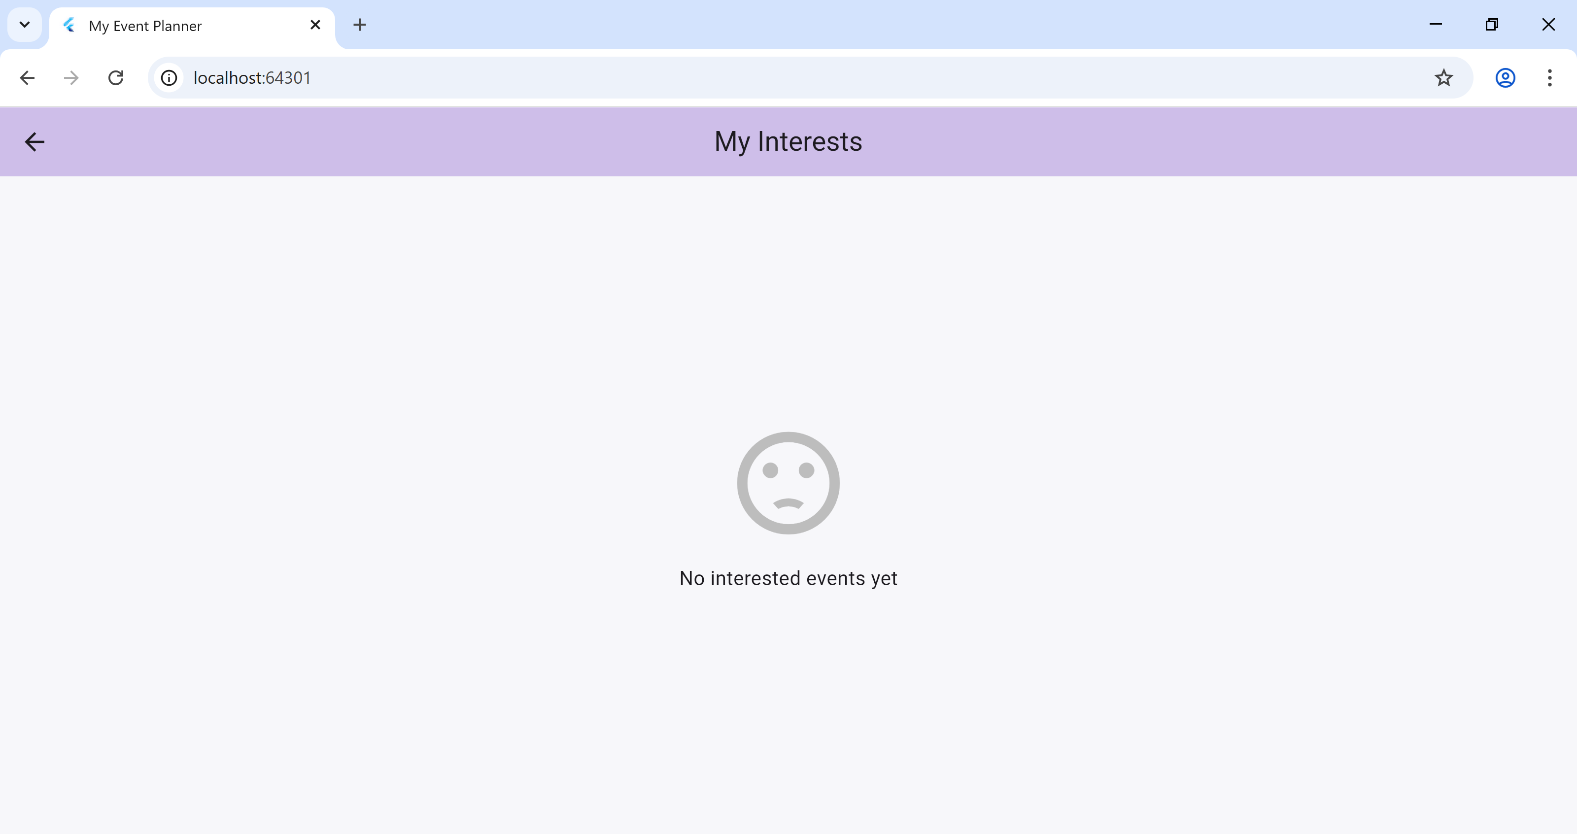

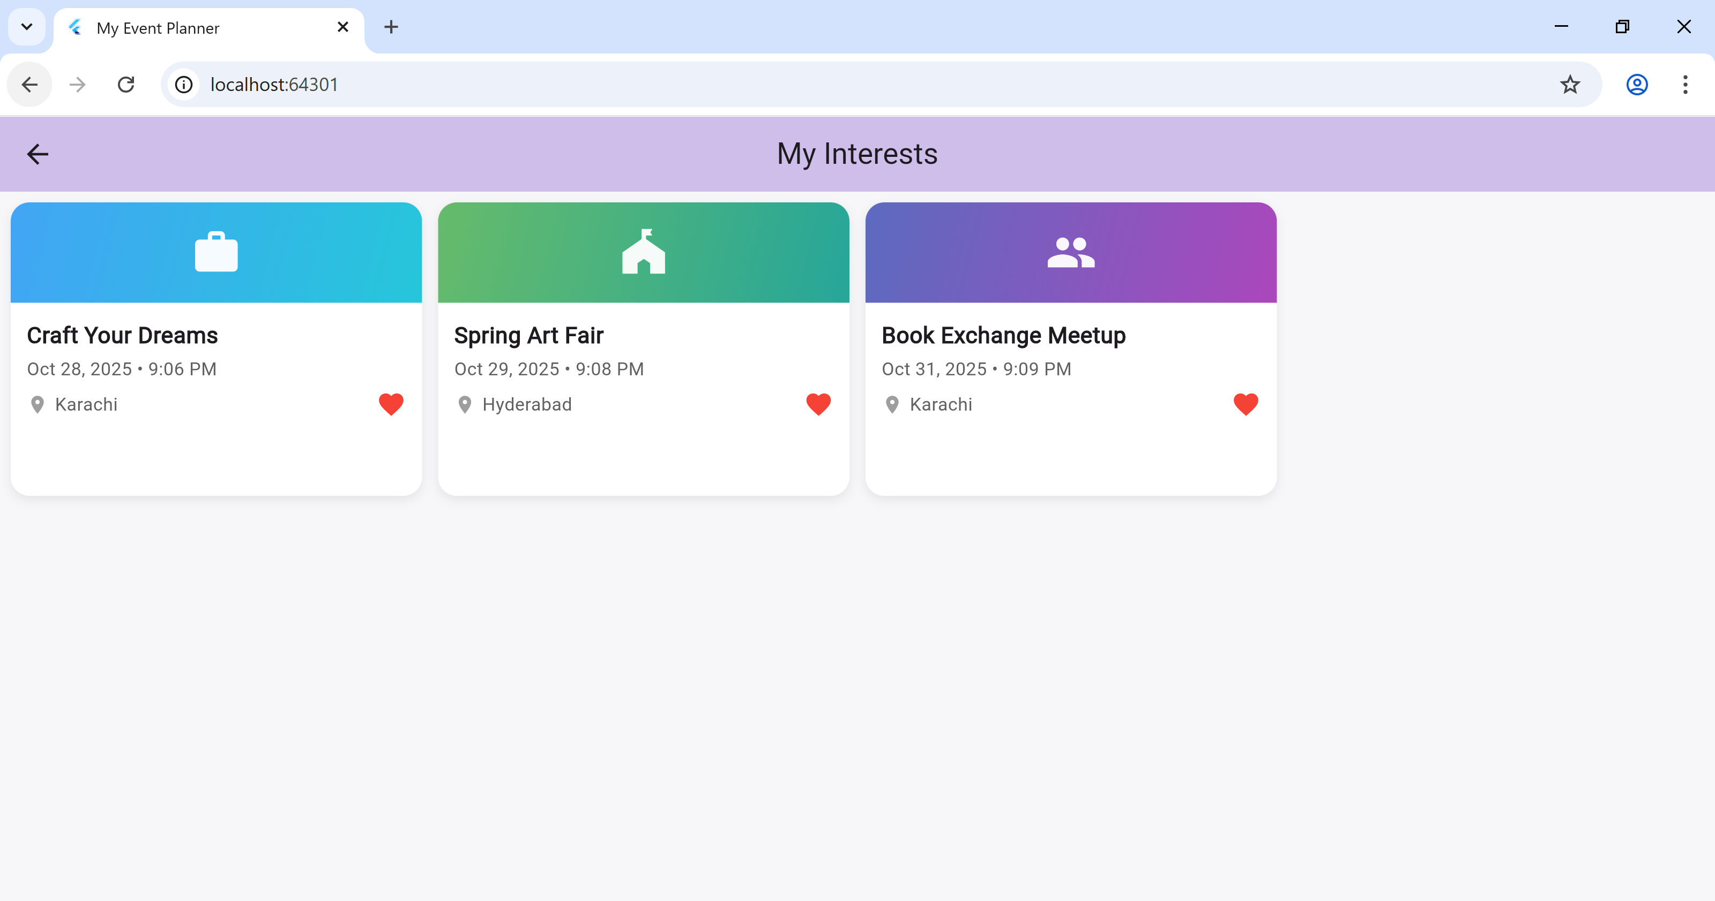

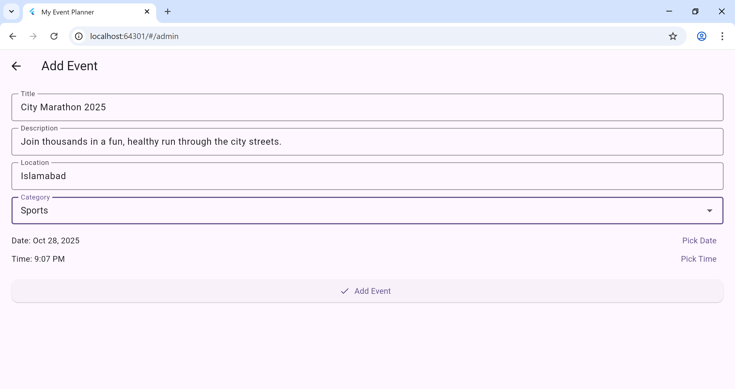

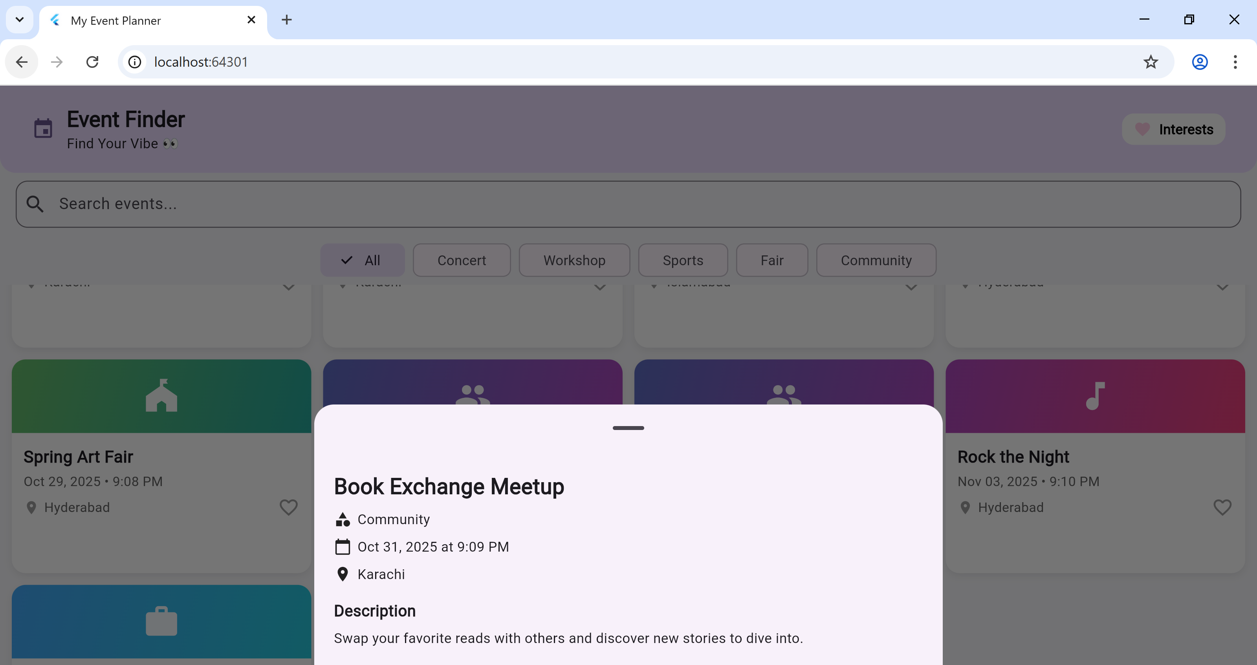

**Phone View:**

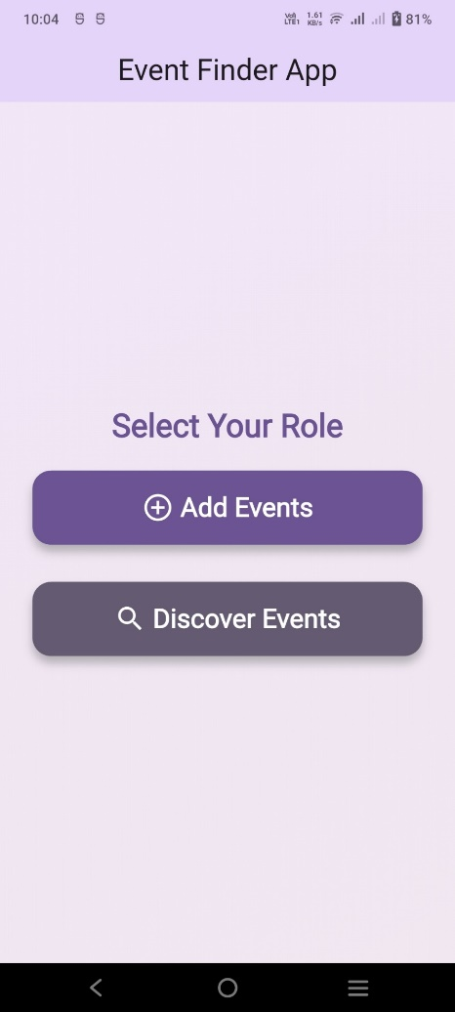 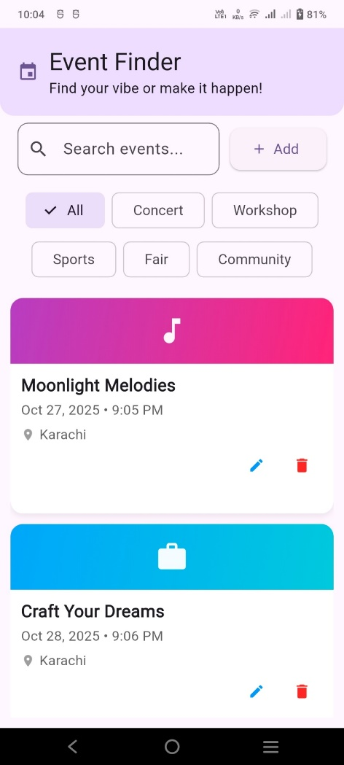

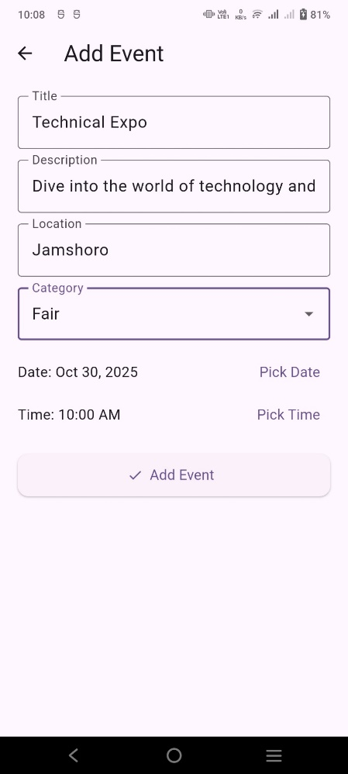 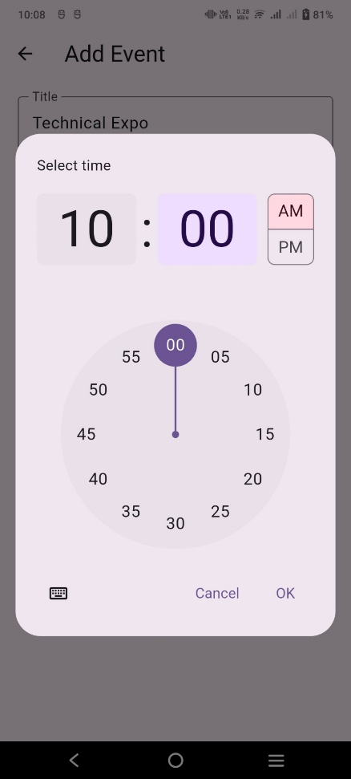 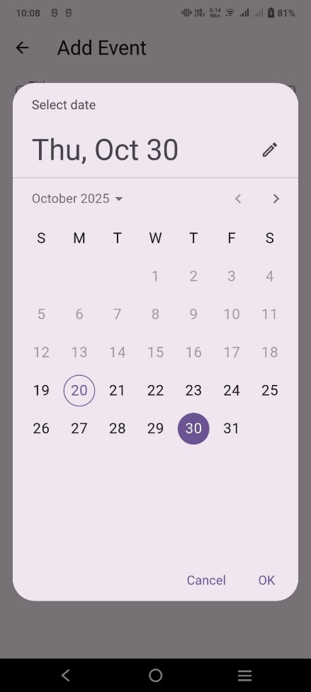

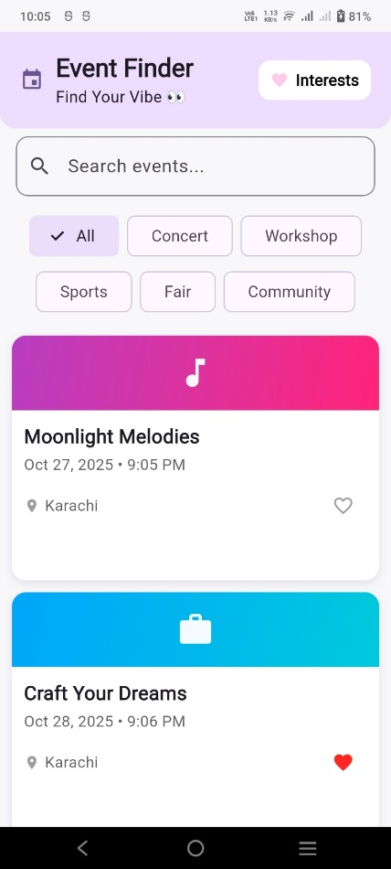 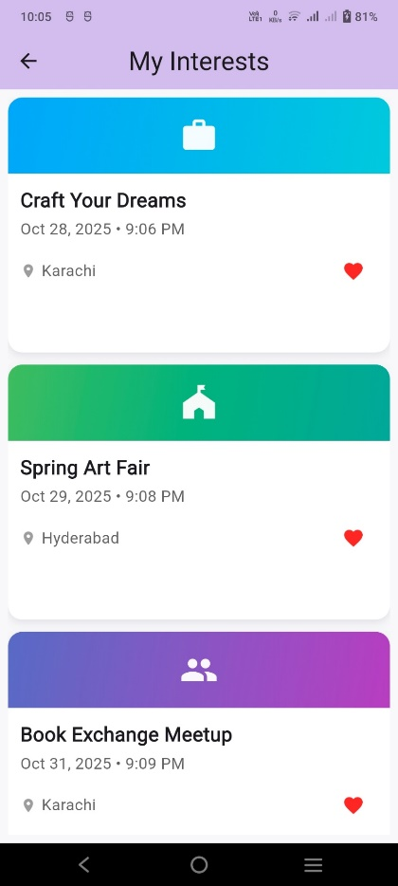 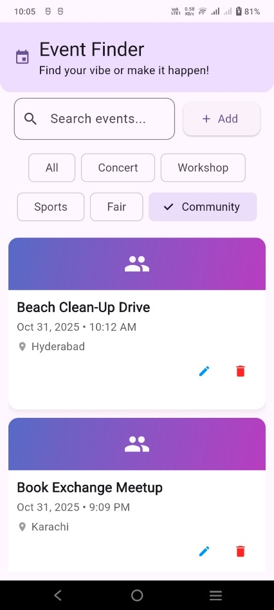

1. **Data Storage**

The app uses **Firebase Cloud Firestore** as its data storage solution.

**Justification for using Firebase:**

* The app requires event data to be shared between users and admins, which cannot be achieved with local storage.
* Firebase allows seamless cloud-based data sharing and updates in real time.
* It provides real-time synchronization so that any changes made by admins, such as adding or updating events, are instantly reflected for all users.
* It offers secure, cloud-based storage, removing the need for local databases and ensuring users can access event data from any device.
* It includes built-in authentication and data security features, protecting sensitive information and ensuring only authorized access.
* It supports scalability, making it ideal for handling a growing number of events and users without affecting performance.

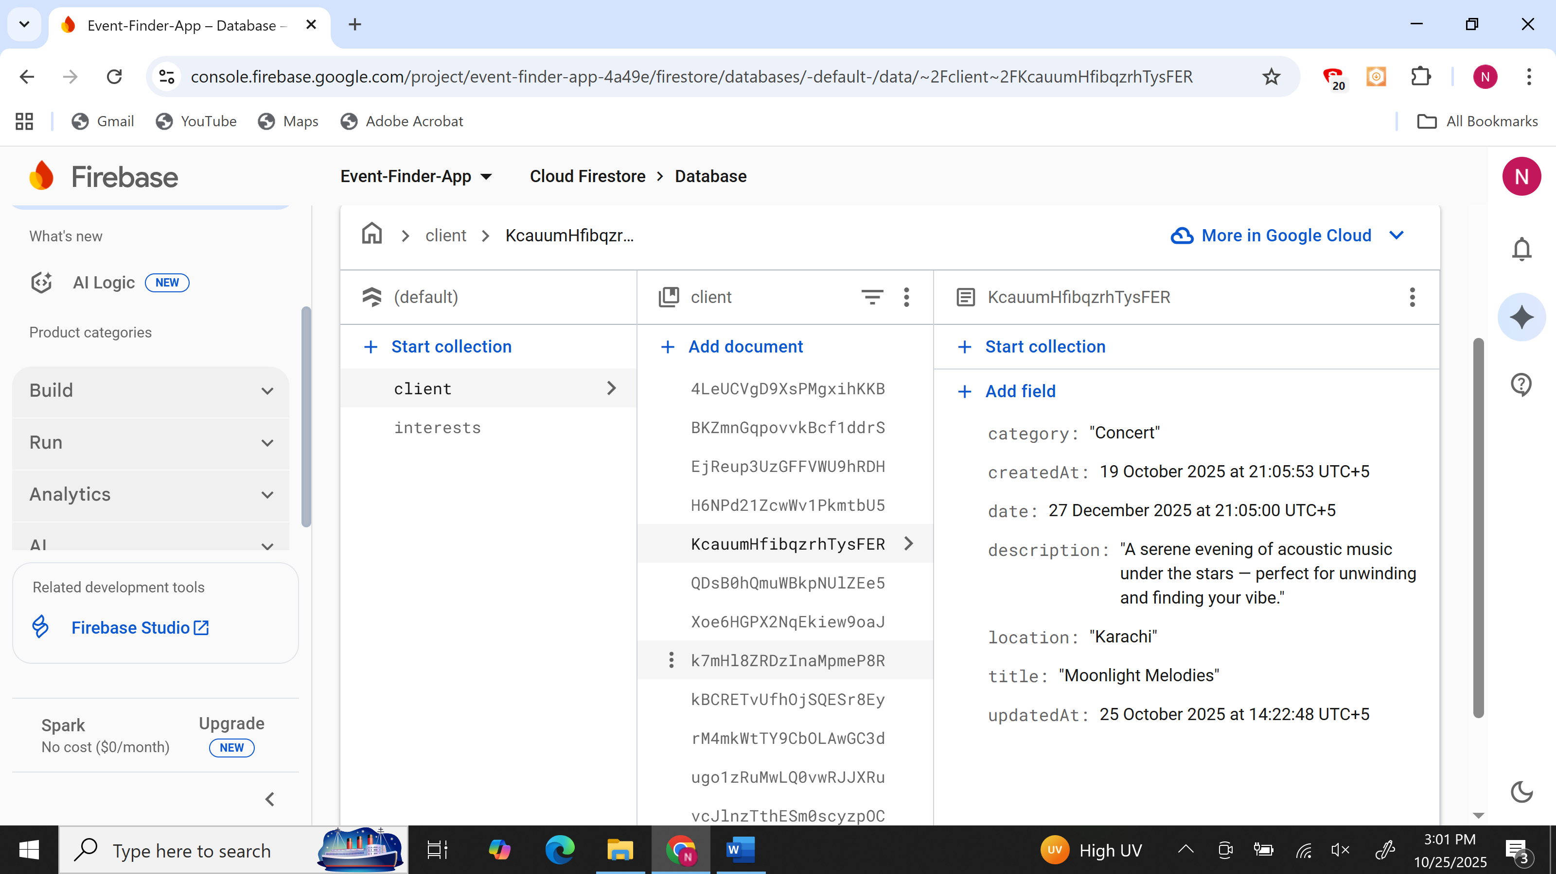

1. **APIs/Packages/Plug-ins Used**

The following Flutter packages and plug-ins have been used in the application:

|  |  |
| --- | --- |
| **Package** | **Purpose / Justification** |
| firebase_core | Initializes Firebase in the app for backend services. |
| cloud_firestore | Enables CRUD operations for event data in Firestore. |
| provider | Implements efficient state management for favorite events and UI updates. |
| flutter/material.dart | Provides standard widgets and UI components for responsive design. |

These packages ensure smooth functionality, state consistency, and easy integration of Firebase with the Flutter framework.

1. **Errors and Debugging**

During development, several issues were encountered and resolved as part of the learning and implementation process:

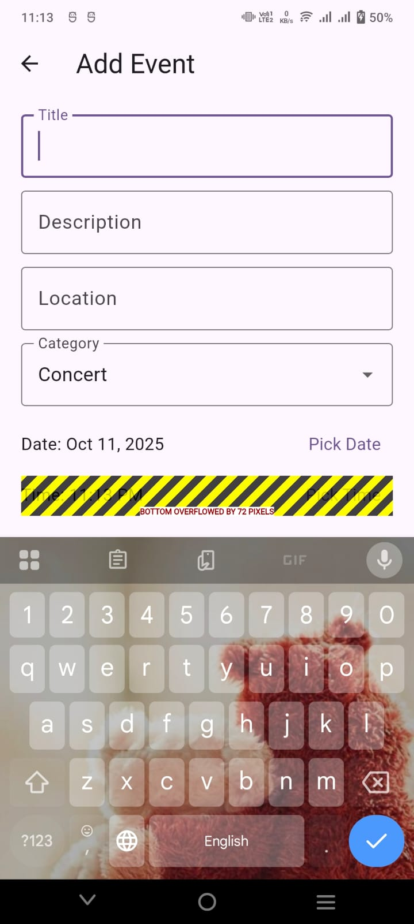

1. **Bottom Overflow Error**

* **Error:** “Bottom overflowed by 72 pixels” appeared when the keyboard opened on the Add Event screen.
* **Debugging:** Fixed by adding resizeToAvoidBottomInset: true in the Scaffold and wrapping the form in a SingleChildScrollView.

1. **Device Connection Error**

* **Error:** The app wasn’t running on a physical mobile device due to repeated connection and debugging issues.
* **Debugging:** Instead of relying on unstable device connections, the APK file was manually copied and installed on the phone. This ensured proper testing on a real device without depending on USB debugging stability.

1. **Widget Overflow in Admin Event Card**

* **Error:** Text or buttons in event cards overflowed on smaller screens. The card layout used fixed widths that didn’t scale across devices.
* **Debugging:** Wrapped text widgets inside **Flexible** and used MediaQuery.of(context).size.width for responsive sizing.

**Conclusion**

The **Event Finder App** is a powerful solution that transforms the way we discover and engage with local events. By consolidating all event information into one accessible, responsive platform, it eliminates the frustration of searching through multiple channels. Built with **Flutter** for cross-platform support, real-time cloud storage, and efficient state management, the app ensures a seamless, dynamic experience across **Android** and **iOS** devices.

This project tackles a complex engineering challenge, integrating key components like **user interaction**, **database connectivity**, and **multi-device adaptability**. The result is a robust platform that not only meets the technical requirements but also delivers real value to both event organizers and attendees. With **creative problem-solving** and a deep technical foundation, the app makes local event discovery effortless, empowering users to stay connected with their communities.

The **Event Finder App** is more than just a tool—it's a game-changer, fostering community engagement, supporting smaller events, and ensuring you never miss out on what’s happening around you.