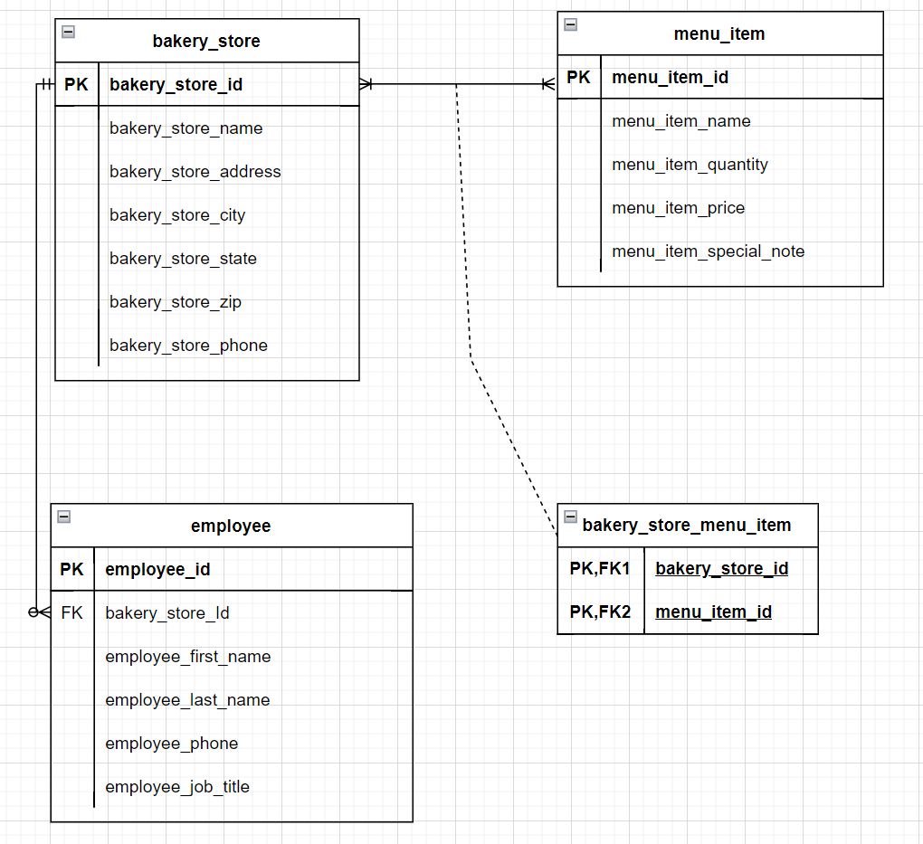

Treat as customer

Treat as petstore and customer join eg petstore customer id