INFRASTRUCTURE AUTOMATION PORTAL
Solution Design & Standard Operating Procedures
Self-service Linux & Windows server provisioning on VMware and Hyper-V, highly available on nginx + keepalived, integrated with Azure DevOps and Terraform
Item | Detail
Document | Infrastructure Automation Portal – Solution Document & SOP
Version | 1.0
Date | 07 October 2026
Owner | Unix / Infrastructure Automation Team
Repository | github.com/nahmad23/Azure_Arc_frontend
Deployment branch | claude/stoic-maxwell-p3ubfj (use main after it is merged)
Ansible controller | uxus1sitaans011 – /data/ansible/Azure_Arc_frontend
Portal URL | http://10.192.2.153/ (VIP)
Classification | Internal

Revision history
Version | Date | Author | Change
1.0 | 07-Oct-2026 | Infrastructure Automation Team | First release: HA nginx, provisioning portal, Azure DevOps pipeline, SOPs

Contents
1. Purpose and Scope
1.1 What is covered
1.2 Out of scope
1.3 Audience
2. Solution Overview
2.1 What the solution does
2.2 Components
2.3 Architecture
2.4 Request flow
2.5 Environment details
2.6 How high availability works
3. Repository and Server Layout
3.1 Repository layout
3.2 Files on each node
3.3 Services, ports and logs
4. Prerequisites and Access
5. SOP-01 – Set Up the Ansible Controller
6. SOP-02 – Deploy or Redeploy the Solution
6.1 Safer deployment: BACKUP node first
6.2 What the playbook does on each node
7. SOP-03 – Health Check and Validation
8. SOP-04 – High Availability Failover Test
9. SOP-05 – Standard Change Process (any code or configuration change)
10. SOP-06 – Change the Homepage (look and feel)
10.1 Change the portal name
10.2 Replace the logo with your company logo
10.3 Change colours
10.4 Change a field label, hint, order or required flag
10.5 Add a menu item to the sidebar
11. SOP-07 – Change Dropdown and Checkbox Values (catalog.yaml)
11.1 Catalog sections
11.2 Examples
11.3 Apply the change
12. SOP-08 – Add a New Field to the Form
13. SOP-09 – Go Live: Azure DevOps, Sign-in and HTTPS
13.1 Part A – Azure DevOps pipeline
13.2 Part B – Microsoft Entra ID sign-in
13.3 Part C – HTTPS and DNS
13.4 Part D – Settings and deployment
14. Rollback Procedure
14.1 Standard rollback (preferred)
14.2 Emergency rollback (no time to revert)
14.3 Take one node out of service
15. SOP-10 – Change the VIP or a Node IP, or Replace a Node
15.1 Change the VIP
15.2 Change a node IP
15.3 Replace or rebuild a node
16. SOP-11 – Rotate Secrets and Credentials
17. Troubleshooting Guide
17.1 First steps for any problem
17.2 Symptom → cause → fix
17.3 Useful diagnostic commands
18. Command Cheat Sheet
Appendix A – Configuration Variables (group_vars/frontend.yml)
Appendix B – Pipeline Parameters and Request Data
B.1 Parameters sent by the portal
B.2 Keys inside requestJson
Appendix C – Screenshots

If the table of contents is empty, right-click it in Word and choose Update Field.

1. Purpose and Scope
This document describes the Infrastructure Automation Portal end to end and gives step-by-step Standard Operating Procedures (SOPs) to deploy it, check it, change it and fix it. Anyone on the team should be able to follow it without prior knowledge of the code.

1.1 What is covered
- The high-availability web tier: two Ubuntu nodes running nginx, with a keepalived floating IP (VIP).
- The provisioning portal: a FastAPI + HTMX web application that collects server requests.
- The integration with Azure DevOps: the portal queues a pipeline that runs the existing Terraform code on VMware vSphere and Microsoft Hyper-V (SCVMM).
- The Ansible automation that builds and updates all of the above from the controller.
- How to change the homepage, the form, the dropdown values and the configuration safely.
- Troubleshooting, rollback and credential rotation.

1.2 Out of scope
- The Terraform modules themselves (owned by the infrastructure team; the pipeline calls them).
- Azure DevOps agent build-out and vCenter / SCVMM administration.

1.3 Audience
Unix / infrastructure engineers who operate the portal, and developers who change the form or the pipeline.

2. Solution Overview

2.1 What the solution does
- Users open http://10.192.2.153/ and fill in a six-section form: Request Information, Server Details, Compute Resources, Access & Security, Automation Options, and Approval / Change Information.
- The portal validates every answer (hostname rules, catalog values, static IP inside the VLAN subnet, dates, change ticket for Production).
- On submit it queues the Azure DevOps provisioning pipeline with the request. The pipeline runs terraform plan, waits for approval for Production, then runs terraform apply.
- The result page shows the pipeline run status live and links to the run in Azure DevOps. The Requests page lists recent runs.
- Both nodes run the same software. If nginx or the portal fails on the active node, the VIP moves to the other node in about 3 to 5 seconds.

2.2 Components
Component | Technology | Runs on | Purpose
Floating IP / HA | keepalived (VRRP, unicast) | Both nodes | Holds VIP 10.192.2.153 on the healthy node with the highest priority
Web server | nginx 1.24 | Both nodes, ports 80 / 443 | Reverse proxy to the portal, /healthz endpoint, optional TLS
Portal application | Python FastAPI + HTMX + Jinja2, served by uvicorn | Both nodes, 127.0.0.1:8000, systemd service provisioning-portal | Form, validation, Azure DevOps calls, request status
Configuration management | Ansible | Controller uxus1sitaans011 | Installs and configures everything (site.yml)
Pipeline | Azure DevOps YAML pipeline | Azure DevOps + self-hosted agents | pipelines/provision-vm.yml: validate, plan, approve, apply
Infrastructure as code | Terraform (existing code) | Azure DevOps agents | Builds the VM on VMware or Hyper-V
Sign-in (go-live) | Microsoft Entra ID (OIDC) | Microsoft cloud | Who can submit requests
Source control | GitHub | github.com/nahmad23/Azure_Arc_frontend | Single source of truth for all code and config

2.3 Architecture
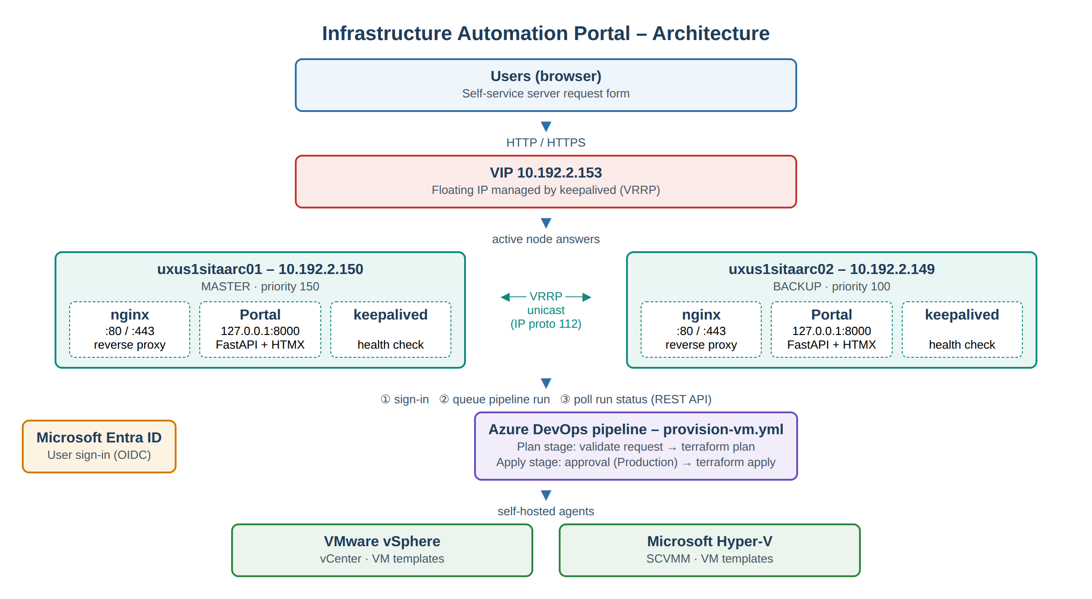
Figure 1 – Architecture of the Infrastructure Automation Portal

2.4 Request flow
- The user browses to the VIP. The active node's nginx forwards the request to the portal on 127.0.0.1:8000.
- (After go-live) the portal redirects the user to Microsoft Entra ID to sign in. Requester name and email are then taken from the sign-in.
- As the user fills in the form, HTMX refreshes the dependent fields: datacenters follow the location, VLANs follow the network, the platform table follows the OS, and so on.
- On Submit, the portal validates the request against catalog.yaml. Errors are shown next to the fields, with the entered values kept.
- The portal calls the Azure DevOps REST API (POST _apis/pipelines/{id}/runs) with the parameters platform, osFamily, hostname, environment, requestType, requestedBy and requestJson.
- The pipeline writes requestJson to request.auto.tfvars.json, runs terraform plan, waits for approval if the environment is Production, then runs terraform apply.
- The result page polls the run status every 10 seconds until it shows Succeeded or Failed.

2.5 Environment details
Item | Value
Ansible controller | uxus1sitaans011, repository at /data/ansible/Azure_Arc_frontend
Node 1 (MASTER) | uxus1sitaarc01 – 10.192.2.150 – keepalived priority 150
Node 2 (BACKUP) | uxus1sitaarc02 – 10.192.2.149 – keepalived priority 100
Virtual IP (VIP) | 10.192.2.153/24 (VRRP router id 51, unicast between the nodes)
Operating system | Ubuntu 24.04 LTS (nginx 1.24, Python 3.12)
Portal URL | http://10.192.2.153/ (HTTPS once a certificate and DNS name are added)
Portal mode at handover | Dry-run (no pipeline is queued) and sign-in disabled – see SOP-09 to go live

2.6 How high availability works
- keepalived on each node runs /usr/local/bin/check_nginx.sh every 2 seconds. It checks that nginx is running, that http://127.0.0.1/healthz answers, and that the portal answers on http://127.0.0.1:8000/healthz.
- If the check fails twice on the MASTER, its priority drops by 60 (150 → 90). The BACKUP (100) is now higher, takes the VIP and sends gratuitous ARP so the network learns the new location.
- When the MASTER is healthy again, it takes the VIP back (higher priority).
- Deployments run one node at a time (serial: 1), and every nginx change is tested with nginx -t before reload. A bad change stops on the first node while the other keeps serving.
- Both nodes use the same session key, so users stay signed in after a failover.

3. Repository and Server Layout

3.1 Repository layout
All code and configuration lives in the Git repository. Never edit files directly on the nodes: the next deployment overwrites them.
Path | What it is | Change it when…
ansible/site.yml | Main playbook: common → portal → nginx → keepalived | Rarely (adding a role)
ansible/inventory/hosts.ini | The two nodes and the SSH user | Node IPs or SSH user change
ansible/group_vars/frontend.yml | All settings: VIP, TLS, portal mode, Azure DevOps, Entra ID | Most configuration changes
ansible/host_vars/uxus1sitaarc0{1,2}.yml | MASTER / BACKUP state and priority | Swapping which node is primary
ansible/roles/common | Base packages, sysctl, firewall (ufw) incl. VRRP | Firewall rules
ansible/roles/portal | Installs the portal: venv, systemd unit, settings file, catalog | Service settings
ansible/roles/nginx | nginx install and site template (frontend.conf.j2) | Proxy, TLS, headers
ansible/roles/keepalived | VIP config, health-check script, notify script | HA behaviour
portal/catalog.yaml | Every dropdown and checkbox value on the form | Adding an OS, VLAN, approver, AD group…
portal/app/templates/base.html | Page frame: sidebar, header, logo, dry-run banner | Homepage look, menu, logo
portal/app/templates/index.html | Homepage: breadcrumb + form | Breadcrumb text
portal/app/templates/_form.html | The six form sections and their fields | Labels, hints, field order, new fields
portal/app/templates/_*.html | Small fragments refreshed by HTMX (datacenters, VLANs, IP fields…) | Behaviour of a dependent field
portal/app/templates/_submitted.html | Summary page after submit | When adding a field
portal/app/static/app.css | All styling; colours are variables at the top | Colours, fonts, spacing
portal/app/models.py | Server-side validation of every field | Validation rules, new fields
portal/app/main.py | Web routes (pages, fragments, submit) | New dependent field or page
portal/app/ado.py | Azure DevOps client and pipeline parameters | Pipeline parameters
portal/app/auth.py, config.py | Entra ID sign-in; PORTAL_* settings | Rarely
portal/tests/test_portal.py | Automated tests (pytest) | Every code change
pipelines/provision-vm.yml | Example Azure DevOps pipeline | Terraform paths, agent pools, stages
scripts/check-ha.sh | Checks the VIP and both nodes | —

3.2 Files on each node
Path on node | Purpose
/opt/provisioning-portal/src/ | Portal application code (copied by Ansible)
/opt/provisioning-portal/venv/ | Python virtual environment with the portal's packages
/etc/provisioning-portal/portal.env | Portal settings and secrets (mode 0640, root:portal)
/etc/provisioning-portal/catalog.yaml | Deployed copy of the form catalog
/etc/systemd/system/provisioning-portal.service | systemd unit for the portal (user portal)
/etc/nginx/conf.d/frontend.conf | nginx site: proxy to the portal, /healthz, TLS
/etc/keepalived/keepalived.conf | VRRP instance, VIP, peers, health check
/usr/local/bin/check_nginx.sh | Health check used by keepalived
/usr/local/bin/keepalived_notify.sh | Logs VIP state changes to syslog (tag keepalived-notify)
/etc/ufw/before.rules | Contains the VRRP allow rule for the peer node

3.3 Services, ports and logs
Service | Port | Log command
nginx | 80 (and 443 with TLS) | journalctl -u nginx; /var/log/nginx/access.log, error.log
provisioning-portal | 127.0.0.1:8000 (local only) | journalctl -u provisioning-portal -f
keepalived | VRRP, IP protocol 112 | journalctl -u keepalived; journalctl -t keepalived-notify

4. Prerequisites and Access
Requirement | Detail
Controller access | SSH to uxus1sitaans011 as a user who can run the playbook (the examples use root)
Node access | SSH key from the controller to both nodes, user in inventory/hosts.ini with sudo
GitHub | Read access to nahmad23/Azure_Arc_frontend (write access to change code)
Outbound from nodes | PyPI (or an internal mirror) during deployment; dev.azure.com and login.microsoftonline.com once live
Network | Both nodes and the VIP in the same VLAN; VRRP (IP protocol 112) allowed between the nodes
Azure DevOps (go-live) | Project, pipeline, PAT or service principal with Build: Read & execute
Entra ID (go-live) | App registration, client secret, redirect URI over HTTPS
Important: Back up ansible/credentials/portal_secret_key on the controller. It is created on the first run, is not stored in Git, and must stay the same on both nodes. If it is lost, a new one is generated and all users are signed out once.

5. SOP-01 – Set Up the Ansible Controller
Do this once on a new controller. On uxus1sitaans011 it is already done.
- Install Python, Git, rsync and SSH client (Ubuntu shown):
sudo apt update
sudo apt install -y python3 python3-venv git rsync openssh-client
python3 -m venv ~/ansible-venv
source ~/ansible-venv/bin/activate # run in every new shell
pip install ansible
ansible --version
- Clone the repository and install the Ansible collections:
mkdir -p /data/ansible && cd /data/ansible
git clone https://github.com/nahmad23/Azure_Arc_frontend.git
cd Azure_Arc_frontend
git checkout claude/stoic-maxwell-p3ubfj # or main after merge
cd ansible
ansible-galaxy collection install -r requirements.yml
- Set up SSH key access to both nodes:
ssh-keygen -t ed25519 -f ~/.ssh/id_ed25519 -N "" # skip if a key exists
ssh-copy-id <user>@10.192.2.150
ssh-copy-id <user>@10.192.2.149
- Check inventory/hosts.ini has the right ansible_user, then test the connection and sudo:
cd /data/ansible/Azure_Arc_frontend/ansible
ansible frontend -m ping
ansible frontend -b -m command -a "id -u" # must print 0 on both nodes

6. SOP-02 – Deploy or Redeploy the Solution
Use this for the first installation and for every change. The playbook is idempotent: running it again only changes what differs.
- Log in to the controller and go to the repository:
cd /data/ansible/Azure_Arc_frontend
git status # must be clean, or contain only your intended changes
git pull origin claude/stoic-maxwell-p3ubfj
cd ansible
- Check the syntax and preview the changes (dry run):
ansible-playbook site.yml --syntax-check
ansible-playbook site.yml --check --diff
Note: On brand-new servers the --check run may stop at a service that is not installed yet. That is expected; the real run installs it.
- Deploy. The playbook updates one node at a time:
ansible-playbook site.yml # add --ask-vault-pass once secrets are vaulted
- Confirm the recap shows failed=0 for both nodes.
- Run the health check in SOP-03.

6.1 Safer deployment: BACKUP node first
For bigger changes, deploy to the BACKUP node first, test it directly on its own IP, then deploy to the MASTER. Users stay on the MASTER until it is updated.
ansible-playbook site.yml -l uxus1sitaarc02 # BACKUP only
curl -s http://10.192.2.149/healthz # test node 2 directly
# open http://10.192.2.149/ in a browser and check the change
ansible-playbook site.yml -l uxus1sitaarc01 # then the MASTER

6.2 What the playbook does on each node
Role | Main actions
common | Installs curl and rsync, enables net.ipv4.ip_nonlocal_bind, opens ports 80/443 and VRRP from the peer in ufw
portal | Creates user portal, copies the code, builds the venv (umask 0022), writes portal.env and catalog.yaml, installs and starts provisioning-portal, waits for /healthz
nginx | Installs nginx, removes the default site, writes frontend.conf, tests with nginx -t, reloads, checks /healthz
keepalived | Installs keepalived, writes keepalived.conf and the health-check and notify scripts, reloads

7. SOP-03 – Health Check and Validation
Run after every deployment and whenever someone reports a problem. Commands run on the controller from /data/ansible/Azure_Arc_frontend/ansible.
# | Check | Command | Expected result
1 | Services running | ansible frontend -b -m shell -a "systemctl is-active provisioning-portal nginx keepalived" | active / active / active on both nodes
2 | Portal answers on each node | ansible frontend -m uri -a "url=http://127.0.0.1:8000/healthz return_content=true" | "status":"ok" on both nodes
3 | Only node 1 holds the VIP | ansible frontend -b -m shell -a "ip -4 -br addr | grep -w 10.192.2.153 || echo 'no VIP here'" | VIP on uxus1sitaarc01; 'no VIP here' on uxus1sitaarc02
4 | VIP and nodes answer | ../scripts/check-ha.sh 10.192.2.153 10.192.2.150 10.192.2.149 | VIP UP served-by=uxus1sitaarc01; both nodes UP
5 | Homepage through VIP | curl -sI http://10.192.2.153/ | head -3 | HTTP/1.1 200 OK (307 to /login once sign-in is on)
6 | Browser test | Open http://10.192.2.153/ and submit a test request | Summary page; status moves to Succeeded (dry-run) or links to the Azure DevOps run (live)

8. SOP-04 – High Availability Failover Test
Run after the first installation, after HA changes, and in each maintenance window. Users may see a few seconds of errors during the test.
- In a second terminal on the controller, start a live monitor and leave it running:
while true; do echo "$(date +%T) $(curl -s -m 1 -D - -o /dev/null http://10.192.2.153/healthz | grep -i x-served-by || echo DOWN)"; sleep 0.5; done
- Test 1 – the portal fails on node 1. Stop it and watch the monitor switch to uxus1sitaarc02 within about 5 seconds, then start it again and watch it return:
ansible uxus1sitaarc01 -b -m service -a "name=provisioning-portal state=stopped"
ansible uxus1sitaarc01 -b -m service -a "name=provisioning-portal state=started"
- Test 2 – nginx fails on node 1:
ansible uxus1sitaarc01 -b -m service -a "name=nginx state=stopped"
ansible uxus1sitaarc01 -b -m service -a "name=nginx state=started"
- Test 3 – the whole node is lost (keepalived stopped, or a reboot in a maintenance window):
ansible uxus1sitaarc01 -b -m service -a "name=keepalived state=stopped"
ansible uxus1sitaarc01 -b -m service -a "name=keepalived state=started"
# maintenance window only:
ansible uxus1sitaarc01 -b -m reboot
- Review the VIP history on both nodes:
ansible frontend -b -m shell -a "journalctl -t keepalived-notify --since today --no-pager | tail"
Tip: Pass criteria: the monitor always recovers to served-by uxus1sitaarc02 within about 5 seconds of a failure, and back to uxus1sitaarc01 after recovery. Exactly one node holds the VIP at any time.

9. SOP-05 – Standard Change Process (any code or configuration change)
Follow this for every change, however small. It keeps Git as the single source of truth and makes rollback easy.
- Raise a change ticket if the change affects Production users (per your change policy).
- Update your copy of the repository on the controller:
cd /data/ansible/Azure_Arc_frontend
git pull origin claude/stoic-maxwell-p3ubfj
- Make the change using the matching SOP: homepage (SOP-06), dropdown values (SOP-07), new field (SOP-08), settings (group_vars/frontend.yml).
- Test locally before deploying (portal code or catalog changes). This runs the automated tests and a preview copy of the portal on the controller, port 8090:
python3 -m venv ~/portal-venv && source ~/portal-venv/bin/activate
pip install -r portal/requirements-dev.txt # first time only
cd portal
pytest -q # all tests must pass
PORTAL_CATALOG_PATH=catalog.yaml PORTAL_AUTH_MODE=none PORTAL_DRY_RUN=true \
uvicorn app.main:create_app --factory --host 0.0.0.0 --port 8090 --reload
# open http://<controller-ip>:8090/ in a browser, check the change, then Ctrl+C
cd ..
- Review and commit the change with a clear message, and push it to GitHub:
git status
git diff
git add -A
git commit -m "Portal: add VLAN-130 to Production network (CHG0012345)"
git push origin claude/stoic-maxwell-p3ubfj
- Deploy with SOP-02 (BACKUP node first for bigger changes).
- Validate with SOP-03, and SOP-04 if HA was touched.
- If anything is wrong, roll back with section 14.
Warning: Never edit files directly on the nodes (for example /etc/nginx/conf.d/frontend.conf or /opt/provisioning-portal/src). The next playbook run overwrites them, and the two nodes drift apart.

10. SOP-06 – Change the Homepage (look and feel)
The homepage is the page frame (sidebar, header, banner) plus the form. All files are under portal/app/. After any change: test locally, commit, deploy (SOP-05).
What to change | File | What to edit
Portal name in the header and browser tab | ansible/group_vars/frontend.yml | portal_app_title: "Infrastructure Automation Portal"
Subtitle under the name | templates/base.html | <span class="brand-sub">Welcome to the …</span>
Logo | templates/base.html + static/ | Replace the <svg class="logo"> block (see 10.2)
Colours | static/app.css | Variables in the :root block at the top (see 10.3)
Sidebar menu items | templates/base.html | <a class="side-item"> entries in <nav class="sidebar">
Breadcrumb (blue/red arrows) | templates/index.html | <ol class="crumbs"> items
Dry-run banner text | templates/base.html | <div class="banner">
Legend (Required / Optional / Display only) | templates/_form.html | <div class="legend"> at the top of the form
Section titles, field labels, hints | templates/_form.html | section(…), select(…), text(…) calls (see 10.4)
Submit / Reset buttons | templates/_form.html | <div class="card-foot"> at the bottom
Summary page after submit | templates/_submitted.html | <dl class="summary"> rows
Footer "Served by …" | templates/base.html | <footer class="footer">

10.1 Change the portal name
- Edit ansible/group_vars/frontend.yml, then deploy. No code change is needed:
portal_app_title: "UnitedLex Infrastructure Automation Portal"

10.2 Replace the logo with your company logo
- Copy the logo file (PNG or SVG, about 46 px high) to portal/app/static/logo.png.
- In portal/app/templates/base.html, replace the whole <svg class="logo" …> … </svg> block with:
<img class="logo" src="/static/logo.png" alt="">
- In portal/app/static/app.css, let the logo keep its proportions:
.logo { width: auto; height: 46px; }

10.3 Change colours
All colours are variables at the top of portal/app/static/app.css. Change the value and every place that uses it follows.
Variable | Default | Used for
--sidebar | #2e3338 | Left menu background
--sidebar-active | #2a7ab8 | Selected menu item
--blue | #2f6fa5 | Breadcrumb, links, focus
--red | #c0392b | Current breadcrumb step, Submit button, errors
--req | #a3302a | Required-field labels
--page | #eef1f4 | Page background
--s1 … --s6 | blue, teal, purple, red, orange, green | Accent colour of sections 1 to 6

10.4 Change a field label, hint, order or required flag
Fields in _form.html are built with three macros. Edit the text inside the call; move the whole line to change the order.
{{ select("department", "Department", catalog.departments, v, errors) }}
{{ text("application", "Application Name", v, errors, attrs='placeholder="e.g. ARC"') }}
{{ textarea("comments", "Additional Comments", v, errors, required=False) }}
# ^ form field name ^ label shown hint="…" adds the italic hint
Important: required=False only changes the label colour. Whether a field is really required is decided in portal/app/models.py. Change both, and update the test in portal/tests/test_portal.py.

10.5 Add a menu item to the sidebar
<a href="https://wiki.example.com/portal" class="side-item" target="_blank">
<svg><use href="#i-help"/></svg><span>Help</span></a>
Icons available in _icons.html: i-grid, i-list, i-help, i-user, i-signout, i-cloud, i-cog, i-fields, i-id, i-server, i-cpu, i-shield, i-bolt, i-check, i-refresh.

11. SOP-07 – Change Dropdown and Checkbox Values (catalog.yaml)
Every list on the form comes from portal/catalog.yaml. This is the most common change and needs no Python or HTML. Each entry has an id (sent to the pipeline and Terraform) and a label (shown to the user).
Important: The id values must match what your Terraform code expects (template names, VLAN / port-group names, datacenter codes). Agree any new id with the Terraform owner before adding it.

11.1 Catalog sections
Section in catalog.yaml | Form field(s)
departments | Department
environments | Environment (prod is treated as Production: change ticket required)
request_types | Request Type (rebuild and clone show the Existing Server field)
platforms → images | Infrastructure table; template used for each OS on each platform
operating_systems | Operating System (family linux/windows drives the hostname length rule)
locations → datacenters | Server Location and its Datacenters
server_roles | Server Role
compute | CPU list and Custom range, Memory, OS Disk, Additional Disk range, Disk Type
networks → vlans | Network and its VLANs (cidr and gateway are used to check static IPs)
domains, ad_groups | Domain, AD Groups
security_options | Section 4 checkboxes (default: true = ticked by default)
automation_options | Section 5 checkboxes
approvers | Approver

11.2 Examples

Add a VLAN to the Production network
networks:
- id: production
label: Production
vlans:
- {id: vlan-110, label: "VLAN-110 (App)", cidr: 10.192.10.0/24, gateway: 10.192.10.1}
- {id: vlan-130, label: "VLAN-130 (Web)", cidr: 10.192.30.0/24, gateway: 10.192.30.1} # new

Add an operating system and its templates
operating_systems:
- {id: win2025, label: Windows Server 2025, family: windows} # new

platforms:
vmware:
images:
win2025: tpl-win2025 # template name in vCenter
scvmm:
images:
win2025: vhdx-win2025 # template name in SCVMM (omit if not available)

Add a datacenter, an approver and an AD group
locations:
- id: us
label: US
datacenters:
- {id: us1, label: US1}
- {id: us2, label: US2} # new

approvers:
- {id: dc-manager, label: "Datacenter Manager"} # new

ad_groups:
- {id: GRP_DBA_Access, label: GRP_DBA_Access} # new

11.3 Apply the change
- Check the YAML is valid: python3 -c "import yaml; yaml.safe_load(open('portal/catalog.yaml'))" (no output means OK).
- Run the tests and preview locally (SOP-05 step 4). Some tests use the sample values; if you remove a value a test uses, update VALID in portal/tests/test_portal.py.
- Commit, push and deploy (SOP-02). The playbook copies the catalog to /etc/provisioning-portal/catalog.yaml and restarts the portal on each node.
- Refresh the browser and check the new value appears.

12. SOP-08 – Add a New Field to the Form
Worked example: add a required Patch Group dropdown to Compute Resources. The same seven places apply to any new field.
# | File | Change
1 | portal/catalog.yaml | Add the list of choices (dropdowns only)
2 | portal/app/catalog.py | Load the new list
3 | portal/app/models.py | Add the field to ProvisionRequest and validate it
4 | portal/app/templates/_form.html | Show the field on the form
5 | portal/app/templates/_submitted.html | Show it on the summary page
6 | portal/tests/test_portal.py | Add it to the test data and test the rule
7 | Pipeline / Terraform | Read the new key from requestJson (request.auto.tfvars.json)

Step 1 – catalog.yaml
patch_groups:
- {id: group-a, label: "Group A (1st Sunday)"}
- {id: group-b, label: "Group B (3rd Sunday)"}

Step 2 – catalog.py (in Catalog.__init__, next to the other lists)
self.patch_groups = _options(data.get("patch_groups"))

Step 3 – models.py
Add the attribute to the ProvisionRequest dataclass, above requested_by (fields with defaults must stay last):
patch_group: str
In parse_request, validate it in the Compute section:
patch_group = require("patch_group", catalog.ids(catalog.patch_groups), "Choose a patch group.")
And pass it when building the request near the end of the function:
patch_group=patch_group,
For an optional free-text field use optional_text("field", 100) instead of require(…), and required=False in the template.

Step 4 – _form.html (inside the Compute Resources grid)
{{ select("patch_group", "Patch Group", catalog.patch_groups, v, errors,
hint="Monthly patch window for this server.") }}

Step 5 – _submitted.html (in the Compute summary)
<dt>Patch group</dt><dd>{{ catalog.label(catalog.patch_groups, req.patch_group) }}</dd>

Step 6 – tests
Add "patch_group": "group-a", to the VALID dictionary in portal/tests/test_portal.py, and a test for the rule:
def test_patch_group_required(client):
assert "Choose a patch group" in post(client, patch_group=None).text

Step 7 – pipeline and Terraform
The new key appears automatically in requestJson and therefore in request.auto.tfvars.json. Declare it in Terraform (or map it in the pipeline's "write tfvars" step):
variable "patch_group" {
type = string
default = ""
}
Finally run pytest -q, preview locally, commit, push and deploy (SOP-05).
Tip: A field whose choices depend on another field (like Datacenter depending on Location) needs a small fragment template and a route. Copy the pattern of _datacenters.html and its entry in the fragment list in portal/app/main.py.

13. SOP-09 – Go Live: Azure DevOps, Sign-in and HTTPS
At handover the portal runs in dry-run mode with sign-in disabled. The portal refuses to start with sign-in disabled once dry-run is off, so parts A, B and C go live together.

13.1 Part A – Azure DevOps pipeline
- Copy pipelines/provision-vm.yml into the repository that holds the Terraform code. Adjust tfDir, the agent pool names, the variable group, the Terraform backend key and the TF_VAR_* secrets.
- In Azure DevOps: Pipelines → New pipeline → Existing YAML file → select the file → Save (do not run).
- Note the pipeline ID: the definitionId= number in the pipeline's URL.
- Create the Environments vm-provisioning-prod, vm-provisioning-preprod, vm-provisioning-test, vm-provisioning-dev. On vm-provisioning-prod add Approvals and checks → Approvals.
- Run the pipeline once by hand for a Dev test VM and click Permit for the variable group, environments and agent pool. Otherwise portal runs wait for this permission.
- Create a PAT for a service account with scope Build: Read & execute (or use a service principal with Queue builds permission and set portal_ado_auth: service_principal).

13.2 Part B – Microsoft Entra ID sign-in
- Entra ID → App registrations → New registration (single tenant). Redirect URI type Web: https://<portal-dns-name>/auth/callback.
- Certificates & secrets → New client secret. Copy the value now.
- App roles → create Provisioning.Requester and assign the users or groups who may submit requests (Enterprise applications → Users and groups).

13.3 Part C – HTTPS and DNS
- Create a DNS record for the portal name (for example provisioning.unitedlex.global) pointing to 10.192.2.153.
- Get a certificate for that name from your CA. Save the certificate and key on the controller as ansible/files/portal.crt and ansible/files/portal.key (do not commit the key).

13.4 Part D – Settings and deployment
- Encrypt each secret with Ansible Vault and paste the output into ansible/group_vars/frontend.yml, replacing the empty value:
cd /data/ansible/Azure_Arc_frontend/ansible
ansible-vault encrypt_string '<pat-value>' --name portal_ado_pat
ansible-vault encrypt_string '<client-secret-value>' --name portal_entra_client_secret
- Set the remaining values in group_vars/frontend.yml:
nginx_tls_enabled: true
nginx_tls_cert_src: "{{ playbook_dir }}/files/portal.crt"
nginx_tls_key_src: "{{ playbook_dir }}/files/portal.key"

portal_dry_run: false
portal_ado_org_url: https://dev.azure.com/<organisation>
portal_ado_project: <project>
portal_ado_pipeline_id: "<id>"

portal_auth_mode: entra
portal_entra_tenant_id: <tenant-guid>
portal_entra_client_id: <application-client-id>
portal_entra_redirect_uri: https://provisioning.unitedlex.global/auth/callback
portal_allowed_groups: [Provisioning.Requester]

# only if the nodes use a proxy for the internet:
# portal_proxy_env: {HTTPS_PROXY: "http://proxy:8080", NO_PROXY: "localhost,127.0.0.1"}
- Deploy with the vault password, then validate:
ansible-playbook site.yml --ask-vault-pass
- Browse to https://<portal-dns-name>/, sign in, and submit a Dev request. Check the run in Azure DevOps: parameters, terraform plan, and the VM created.
- Submit a Production request and confirm it waits for approval in Azure DevOps.

14. Rollback Procedure
Every deployment is a Git commit, so rolling back means deploying the previous commit.

14.1 Standard rollback (preferred)
cd /data/ansible/Azure_Arc_frontend
git log --oneline -10 # find the bad commit
git revert <bad-commit-id> # creates a new commit that undoes it
git push origin claude/stoic-maxwell-p3ubfj
cd ansible && ansible-playbook site.yml

14.2 Emergency rollback (no time to revert)
cd /data/ansible/Azure_Arc_frontend
git checkout <last-good-commit-id> # temporary, detached state
cd ansible && ansible-playbook site.yml
cd .. && git checkout claude/stoic-maxwell-p3ubfj # return afterwards, then fix and revert properly

14.3 Take one node out of service
To move all users to the other node while you investigate (the VIP moves within seconds):
ansible uxus1sitaarc01 -b -m service -a "name=keepalived state=stopped"
# … investigate …
ansible uxus1sitaarc01 -b -m service -a "name=keepalived state=started"

15. SOP-10 – Change the VIP or a Node IP, or Replace a Node

15.1 Change the VIP
- Reserve the new IP in IPAM (same subnet as the nodes).
- Edit ansible/group_vars/frontend.yml: frontend_vip: <new-ip> (and frontend_vip_cidr if the mask differs).
- Deploy (SOP-02). keepalived removes the old VIP and adds the new one.
- Check: ansible frontend -b -m shell -a "ip -4 -br addr" – only node 1 shows the new VIP, nobody shows the old one. If the old VIP is still there: ip addr del <old-ip>/24 dev <interface> on that node.
- Update DNS, firewall rules and documentation (this document, section 2.5).

15.2 Change a node IP
Update ansible_host in ansible/inventory/hosts.ini and deploy. Both keepalived configs are rebuilt because each node lists the other as its unicast peer.

15.3 Replace or rebuild a node
- Build the new server with the same hostname and IP, Ubuntu 24.04, SSH key access and sudo.
- Stop keepalived on the old node if it is still running.
- Deploy to the new node only: ansible-playbook site.yml -l <node>.
- Run SOP-03 and SOP-04.

16. SOP-11 – Rotate Secrets and Credentials
Secret | Where | How to rotate | Impact
Azure DevOps PAT | portal_ado_pat (vault) in group_vars | Create new PAT → encrypt_string → replace value → deploy → submit a Dev test | None if done before expiry
Entra client secret | portal_entra_client_secret (vault) | New secret in app registration → encrypt_string → replace → deploy → test sign-in | None
Service principal secret | portal_ado_client_secret (vault) | As above | None
keepalived password | keepalived_auth_pass in group_vars (max 8 chars) | Change → deploy in a maintenance window → SOP-04 | Brief VIP flap while nodes differ
Portal session key | ansible/credentials/portal_secret_key on controller | Delete the file → deploy (a new key is generated for both nodes) | All users sign in again
TLS certificate | ansible/files/portal.crt/.key | Replace files → deploy | None
Note: Set calendar reminders for PAT and client-secret expiry dates. An expired PAT shows users the error "Azure DevOps rejected the credentials".

17. Troubleshooting Guide

17.1 First steps for any problem
- Run the health check (SOP-03) to see which component and which node is affected.
- Read the logs of that component on that node:
ansible uxus1sitaarc01 -b -m shell -a "journalctl -u provisioning-portal --no-pager -n 50"
ansible uxus1sitaarc01 -b -m shell -a "journalctl -u keepalived --no-pager -n 50"
ansible uxus1sitaarc01 -b -m shell -a "tail -50 /var/log/nginx/error.log"
- Find the symptom in the table below. If the active node is broken and the fix will take time, move users to the other node (section 14.3).

17.2 Symptom → cause → fix
Symptom | Likely cause | Fix
Playbook fails at "Verify nginx health endpoint" with 404 | nginx still serves the Ubuntu default site (a reload did not happen). Fixed in the playbook in October 2026. | ansible <node> -b -m service -a "name=nginx state=reloaded"; check /etc/nginx/sites-enabled/ has no other site, then rerun the playbook.
Playbook fails at "Wait for the portal to answer /healthz": Connection refused | The portal service is not running. The playbook prints its status and log below the error. | Read the printed journal lines and match them to the next rows.
Portal log: status=203/EXEC … Permission denied | Virtualenv created under a restrictive umask (027) so user portal cannot run it. Fixed in the playbook (umask 0022 + auto-rebuild). | Rerun the playbook. If it persists, check that /opt is not mounted noexec: findmnt -no OPTIONS --target /opt.
Portal log: RuntimeError: PORTAL_AUTH_MODE=none with PORTAL_DRY_RUN=false … | Safety check: dry-run turned off without sign-in. | Configure Entra ID (SOP-09) or set portal_dry_run: true.
Portal log: RuntimeError: Azure DevOps needs: PORTAL_ADO_… | A required Azure DevOps setting is empty. | Fill in the named variable in group_vars/frontend.yml and redeploy.
Portal log: ModuleNotFoundError | Python packages did not install (no access to PyPI). | Set portal_proxy_env or portal_pip_extra_args (internal mirror), delete /opt/provisioning-portal/venv on the node, redeploy.
Browser shows 502 Bad Gateway | nginx is up but the portal is down on that node. | systemctl status provisioning-portal on the node; fix per rows above. keepalived should already have moved the VIP.
Both nodes hold the VIP (split brain) | VRRP packets between the nodes are blocked. | On node 2: timeout 5 tcpdump -ni any 'ip proto 112' – packets from 10.192.2.150 must arrive. Check ufw (/etc/ufw/before.rules), NSG / hypervisor firewall.
VIP does not move when node 1 fails | Health check script not failing, or keepalived stopped on node 2. | Run /usr/local/bin/check_nginx.sh; echo $? on node 1 (non-zero when broken). Check journalctl -u keepalived on both nodes.
VIP moved but users cannot reach it | Network ignores the gratuitous ARP, or the hypervisor blocks a second IP on the VM. | Allow MAC/IP address changes (VMware security policy / Hyper-V MAC spoofing) for both VMs; clear the ARP cache on the gateway.
Form error: "Azure DevOps rejected the credentials" | PAT expired, revoked or missing the Build: Read & execute scope. | Rotate the PAT (SOP-11).
Form error: "Azure DevOps returned 404: …" | Wrong organisation URL, project or pipeline ID. | Check portal_ado_org_url, portal_ado_project, portal_ado_pipeline_id.
Form error: "Azure DevOps returned 400: Unexpected parameter …" | Pipeline YAML parameters do not match what the portal sends. | Compare the pipeline parameters with Appendix B; update the pipeline.
Run stays Queued for a long time | Waiting for Permit on the variable group / environment / pool, waiting for Production approval, or no agent online. | Open the run in Azure DevOps (link on the result page) and act on the message shown.
Sign-in error or redirect loop | Redirect URI mismatch, HTTP instead of HTTPS, or expired client secret. | Redirect URI in the app registration must equal portal_entra_redirect_uri exactly; rotate the secret if expired.
"You are signed in but not authorised" | User not assigned the app role / not in an allowed group. | Assign the user to Provisioning.Requester (or the group in portal_allowed_groups).
Users signed out after a failover | Different session keys on the two nodes. | Deploy both nodes from the same controller (credentials/portal_secret_key is shared).
New dropdown value not visible | Catalog not deployed, YAML error, or browser cache. | Check /etc/provisioning-portal/catalog.yaml on the node; journalctl -u provisioning-portal for YAML errors; refresh with Ctrl+F5.
nginx: socket() [::]:80 failed (97: Address family not supported) | IPv6 disabled on the node. | Set nginx_listen_ipv6: false in group_vars and redeploy.
Hostname warning: "already resolves in DNS" | A DNS record exists for that name. | Expected warning: confirm the name is free or choose another.

17.3 Useful diagnostic commands
# Start the portal by hand as its service user and see any error directly
ansible uxus1sitaarc01 -b -m shell -a "cd /opt/provisioning-portal/src && sudo -u portal bash -c 'set -a; . /etc/provisioning-portal/portal.env; set +a; timeout 8 /opt/provisioning-portal/venv/bin/uvicorn app.main:create_app --factory --host 127.0.0.1 --port 8001' 2>&1 | tail -30"

# Test the nginx configuration
ansible frontend -b -m command -a "nginx -t"

# Who holds the VIP, and VRRP traffic
ansible frontend -b -m shell -a "ip -4 -br addr"
ansible uxus1sitaarc02 -b -m shell -a "timeout 5 tcpdump -ni any 'ip proto 112' -c 5"

# Health check result as keepalived sees it
ansible frontend -b -m shell -a "/usr/local/bin/check_nginx.sh; echo rc=\$?"

18. Command Cheat Sheet
Run from /data/ansible/Azure_Arc_frontend/ansible on the controller.
Task | Command
Deploy everything | ansible-playbook site.yml
Deploy one node | ansible-playbook site.yml -l uxus1sitaarc02
Dry run with diff | ansible-playbook site.yml --check --diff
Service status | ansible frontend -b -m shell -a "systemctl is-active provisioning-portal nginx keepalived"
Restart the portal | ansible frontend -b -m service -a "name=provisioning-portal state=restarted"
Reload nginx | ansible frontend -b -m service -a "name=nginx state=reloaded"
Portal logs (live, on a node) | journalctl -u provisioning-portal -f
VIP location | ansible frontend -b -m shell -a "ip -4 -br addr | grep -w 10.192.2.153 || echo no VIP"
Check VIP and nodes | ../scripts/check-ha.sh 10.192.2.153 10.192.2.150 10.192.2.149
VIP history | ansible frontend -b -m shell -a "journalctl -t keepalived-notify --since today --no-pager"
Move users off node 1 | ansible uxus1sitaarc01 -b -m service -a "name=keepalived state=stopped"
Run portal tests | cd ../portal && pytest -q
Encrypt a secret | ansible-vault encrypt_string '<value>' --name <variable>

Appendix A – Configuration Variables (group_vars/frontend.yml)
Variable | Current value | Meaning
frontend_vip / frontend_vip_cidr | 10.192.2.153 / 24 | Floating IP and prefix
keepalived_interface | "" (default-route NIC) | NIC that carries the VIP
keepalived_router_id | 51 | VRRP id, unique on the VLAN
keepalived_auth_pass | set (max 8 chars) | VRRP shared password
keepalived_unicast | true | Unicast VRRP between the two nodes
nginx_tls_enabled / _cert_src / _key_src | false / "" / "" | HTTPS with the given certificate
manage_firewall | true | Open 80/443 and VRRP in ufw
portal_enabled | true | nginx proxies to the portal (false = static site in frontend/)
portal_app_title | Infrastructure Automation Portal | Name in header and tab
portal_secret_key | from credentials/portal_secret_key | Session signing key, same on both nodes
portal_dry_run | true | Validate only; do not queue pipelines
portal_ado_org_url / _project / _pipeline_id / _branch | empty / refs/heads/main | Pipeline to queue
portal_ado_auth | pat | pat or service_principal
portal_ado_pat, portal_ado_client_* | empty (vault) | Azure DevOps credentials
portal_ado_ca_bundle | "" | CA file for an on-prem Azure DevOps Server
portal_auth_mode | none | entra or none
portal_entra_tenant_id / _client_id / _client_secret / _redirect_uri | empty | Entra ID app registration
portal_allowed_groups | [] | App roles or group object IDs allowed to submit
portal_proxy_env | not set | HTTPS_PROXY / NO_PROXY for pip and outbound calls
portal_port (role default) | 8000 | Local port of the portal
portal_pip_extra_args (role default) | [] | e.g. internal PyPI mirror

Appendix B – Pipeline Parameters and Request Data

B.1 Parameters sent by the portal
Parameter | Values | Purpose
platform | vmware | scvmm | Terraform directory (terraform/<platform>) and agent pool
osFamily | linux | windows | OS-specific steps
hostname | e.g. UXUS1ARCWRK01 | Run name and Terraform state key
environment | prod | preprod | test | dev | Approval environment vm-provisioning-<environment>
requestType | new | rebuild | clone | Choose the flow
requestedBy | requester email | Audit
requestJson | JSON of the whole request | Written to request.auto.tfvars.json

B.2 Keys inside requestJson
Section | Keys
1 Request | requester_name, requester_email, department, environment, request_type, source_server
2 Server | hostname, platform, os, os_family, os_template, location, datacenter, server_role, application, business_owner, technical_owner
3 Compute | cpu, memory_gb, os_disk_gb, additional_disk_gb, disk_type, network, vlan, ip_assignment, ip_address, prefix_length, gateway
4 Security | domain_join, domain, ad_groups[], security{monitoring, backup, vulnerability_scan, ansible_hardening, edr_av}
5 Automation | automation{terraform_provisioning, ansible_hardening, domain_join, zabbix_agent, monitoring_config, backup_config, security_baseline, patch_config}
6 Approval | business_justification, change_ticket, approver, planned_date, required_by_date, comments, requested_by
Note: Values entered by users reach pipeline scripts only through environment variables (never pasted into script text), so free text such as comments cannot inject commands. Keep this pattern when you extend the pipeline.

Appendix C – Screenshots
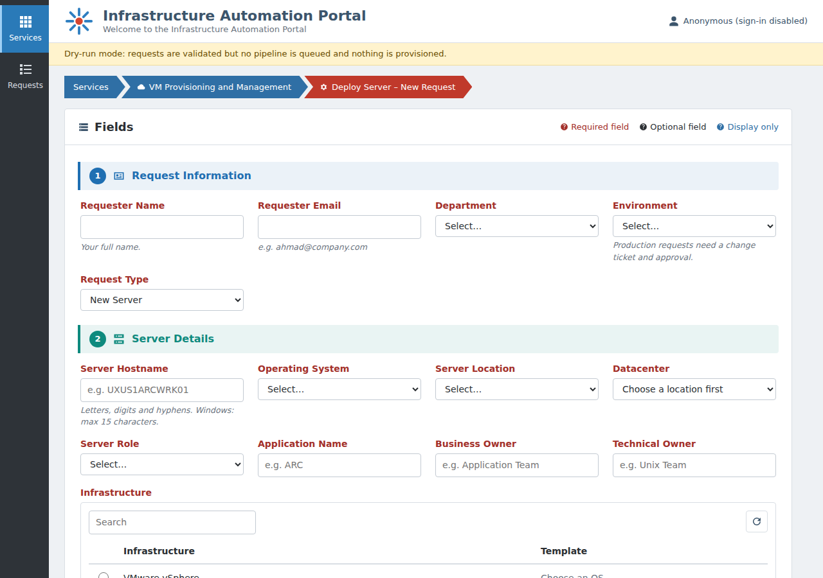
Figure 2 – Homepage: sidebar, header, breadcrumb and the start of the form
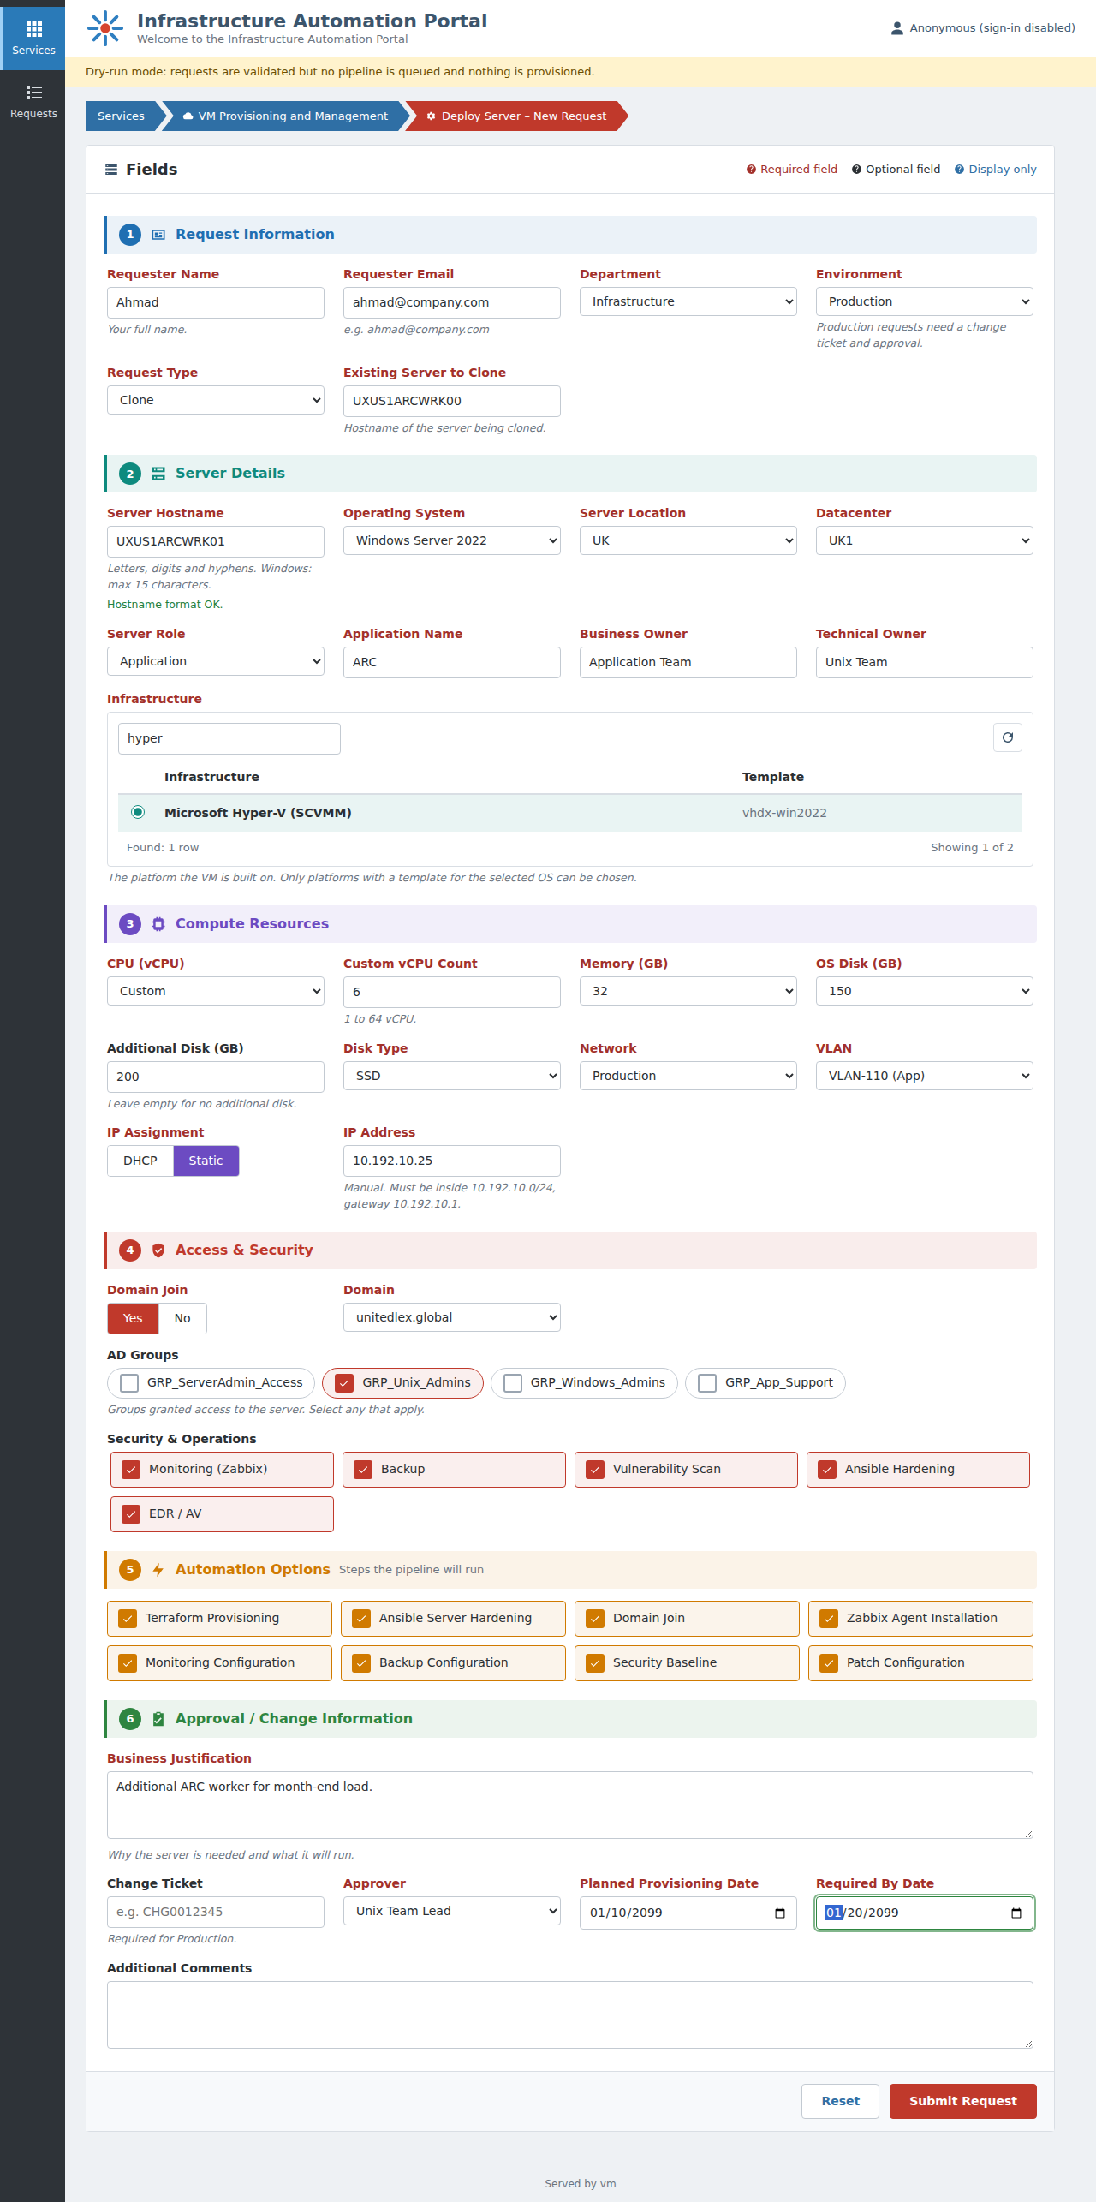
Figure 3 – The complete form filled in (Windows clone on Hyper-V with a static IP)
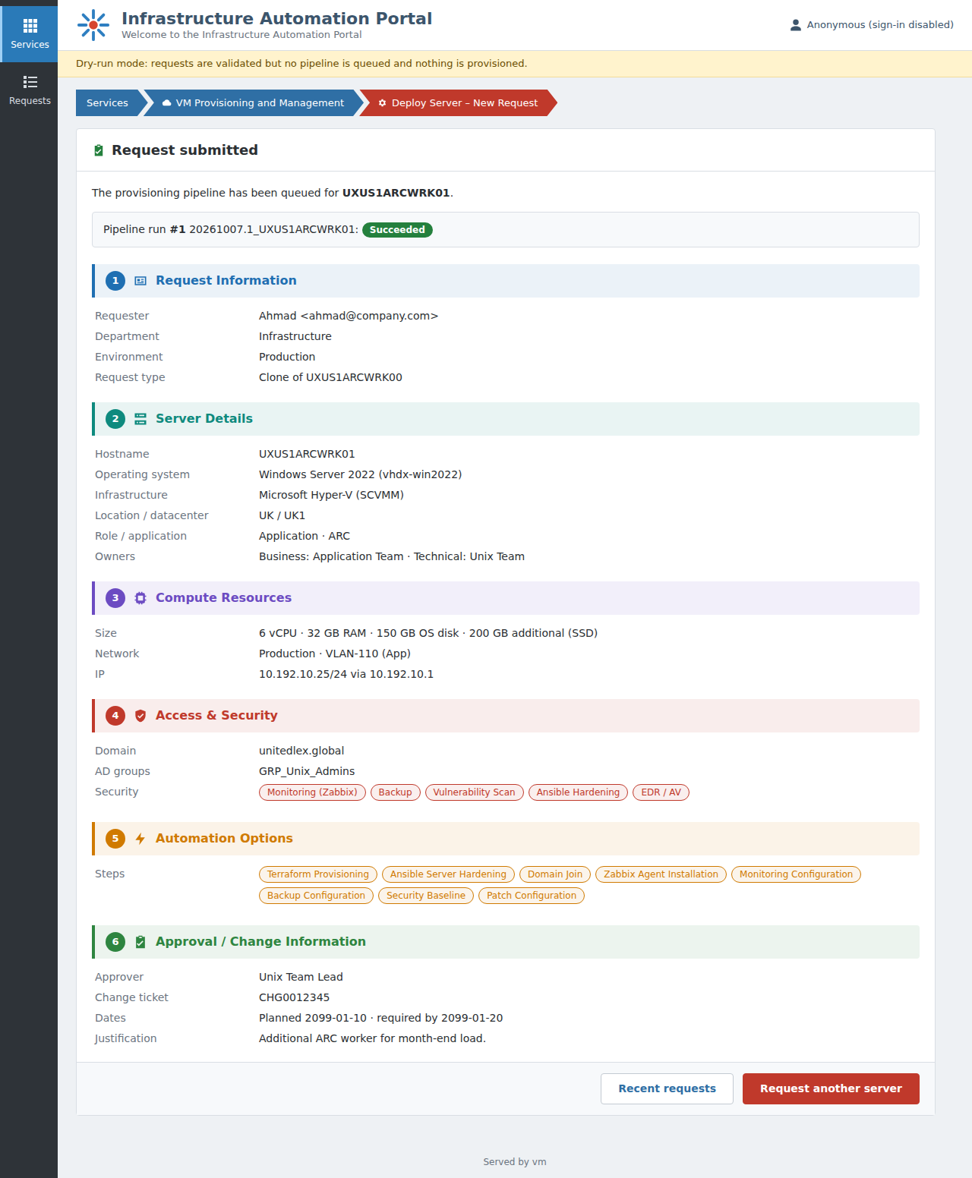
Figure 4 – Summary page after submission, with the live pipeline run status
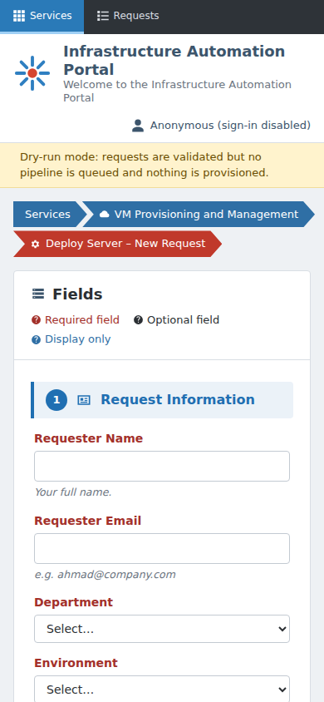
Figure 5 – The portal on a phone

