Counting Versus Testing the Destination: A Simulation Study of Layered Defences Against SMS OTP Flooding and Pumping
Naveed Ahmed*
College of Computer and Information Science, Prince Sultan University, Riyadh, Saudi Arabia
*Corresponding author. E-mail: nahmed@psu.edu.sa
Abstract
Endpoints that send one-time passwords via SMS must be reachable before any account exists, and they are abused to waste a service’s messaging budget (flooding) or to earn part of the termination fee on a colluding operator’s number ranges (SMS pumping). Existing defenses limit the request source, score each request with labeled traffic, or block destination prefixes, but a service that sees only its own traffic has no controlled evidence of which destination signal to act on, the number of sends to a block or the fate of their codes, nor of what either costs the legitimate users who share a block with an attacker. This study evaluates in simulation a twelve-step defense for a registration flow, which draws trust from app attestation, signed sessions and verification outcomes, against a seven-control baseline, five simpler designs and 25 attacker profiles, and compares those two label-free destination policies under two protocols committed before their runs. Results show that attacks carrying a signature in the request are contained at a low cost to simulated users, whereas a residential attacker with farmed CAPTCHA scores is only rationed, by refusing half of first-time users. On the destination, short-window counters of SMS sent per number block, selected at a benign service target, leaked 6 to 48 messages against four concentrated 20-minute pumpers at 0.06 to 0.43 points of attack-free completion, where the default sequential tests of verification outcomes leaked 19 to 452 at the busiest density; on seeds and workloads held out from selection, the frozen counter met its leakage and benign-cost claims and leaked no more than the tests in all but 13 of 144 cells, all against an instantly verifying carrier, but failed both service-under-attack claims when the pumper shared blocks with real users. Unfitted estimates ordered the policies’ mean leakage in 18 of 18 decisive boundary cells with the counter’s cold-start bound and 17 with its warm-start bound; their crossing is algebraic, not a measured switching point, and the counter loses its advantage against paced or widely spread pumpers. These findings rest on simulated users and assumed calibration. For operators they give a tested ordering of destination policies against short, concentrated pumping, and identify the quota per block, and the competition for it on a shared block, as what decides a counter’s cost.
Keywords: SMS pumping; Artificially inflated traffic; One-time password; Rate limiting; Sequential tests; Fraud prevention

1 Introduction
Most online services verify a phone number by sending a code via SMS from an endpoint that must be reachable before any account exists, at a tenth of a cent to twenty cents per message. Two abuses follow from that design. A flooder makes the service send to numbers it does not own, so the service pays for messages nobody asked for; a pumper sends to a range whose operator shares the termination fee, so the service’s SMS budget becomes the attacker’s income, a technique that MITRE catalogues as resource hijacking (MITRE Corporation, 2026). Pumping is the SMS form of international revenue-share fraud, whose voice form was estimated at $10.76 billion a year in 2015 (Sahin et al., 2017). The sums at a single service are not small: Twitter’s owner said in 2023 that pumping had cost the company approximately $60 million a year (Commsrisk, 2023), and Huh et al. (2025) found as many attack requests as genuine ones in three months of one large service’s authentication logs.
Defenses act at three points on the path of a request. At the source, services limit requests per address, session and device, challenge them with CAPTCHAs, block known proxies and restrict destination countries, and risk-based authentication combines such signals into a score with graded responses (Wiefling et al., 2019). At the messaging vendor, Twilio’s Fraud Guard blocks destination prefixes and countries whose traffic departs from an account’s history (Twilio Inc., 2026c), and its per-number pumping risk score advises friction from 60 and refusal above 90 (Twilio Inc., 2026a). On a service’s own logs, Huh et al. (2025) detect attack requests one at a time with gradient-boosted trees, at 89.6% recall and 0.19% false positives on web traffic, and Zaliskyi and Odarchenko (2026) count application-to-person sends per number prefix in five-minute windows and quarantine a prefix that crosses a threshold.
Each of these rests on an assumption that the literature has tested and found wanting. Source-side limits assume that an identity is scarce; without a trusted authority, one entity can present as many identities as it likes (Douceur, 2002). Addresses are not scarce either: five residential proxy services relayed through 6.2 million addresses in 238 countries, 90% of them for under fifteen minutes each and 2.2% of them on any blacklist (Mi et al., 2019), and carrier-grade NAT, deployed in more than 90% of cellular networks, puts dozens of subscribers behind one address and makes address reputation “all but infeasible” (Richter et al., 2016). A CAPTCHA costs an attacker about a dollar per thousand solutions from a labor market that was already paying ten dollars per thousand in 2007 (Motoyama et al., 2010). Supervised detection needs labels, which Huh et al. (2025) derived from traffic peaks after the fact, and a decision taken per request can be probed one threshold at a time. Prefix counting acts on the one key a pumper cannot rotate away from, since it is paid only on its partner’s ranges, but the thresholds that stopped 95% and 63% of two incidents in the data of Zaliskyi and Odarchenko (2026) also blocked 58% of a legitimate marketing campaign.
The two closest studies therefore each act on one destination signal, and neither measures what acting on it costs. Huh et al. (2025) report that about 92% of attack requests fell on prefixes with zero conversion, against 21% for genuine traffic, so whether codes are entered is informative; but the signal enters a classifier that needs labeled traffic and was not released because it is deployed. Zaliskyi and Odarchenko (2026) act on send counts alone, without outcomes, and conclude that counts by themselves cannot safely separate inflated traffic from a campaign. Neither reports what a destination policy costs the legitimate users who share a number block with the attacker, neither reports its cost when there is no attack, and neither fixed the setting it would select before seeing the evaluation traffic. A service that sees only its own traffic is thus left without controlled evidence on the question it can act on: whether to count sends per block or to test the outcomes of their codes, at what quota or threshold, and at what price to its own users.
This paper makes that comparison in simulation, inside a complete defense for a registration flow. We start from a baseline of seven controls, v1, and show how an attacker within a stated threat model breaks each of eight assumptions behind them. The twelve-step redesign takes the platform from an attestation rather than a header, binds requests to signed sessions, checks the number before a message is paid for, builds reputation from whether earlier codes were entered, scores each request into one of five responses, and enforces a hard budget; on the destination it offers two label-free policies keyed on the 8-digit number block, a short-window counter of sends and sequential tests of code outcomes. Seven designs and 25 scripted attacker profiles, from a single address to pumpers that enter codes, fake delivery receipts or buy challenge solutions, run over simulated users on a simulated clock. Two protocols were committed before their runs: the first selects destination settings on tuning seeds at a benign service target, and the second, written after that selection, freezes the selected counter and tests five claims on seeds and workloads held out from selection. The implementation, the protocols and every run’s configuration and outcome are public (Ahmed, 2026). Everything is simulated: three behavioral parameters have published counterparts and the rest are assumptions, so the results describe this generator rather than real traffic.
The study asks one question in three parts. On the source side, how much of the flooding that a seven-control baseline admits does a twelve-step redesign contain, at what cost in completed registrations, and through which layer? Where identities are cheap, when does reputation built from verification outcomes stop separating an attacker from the users whose keys it shares, and what does rationing then cost and depend on? On the destination, where a pumper is paid, does counting sends per number block or testing the outcomes of their codes leak less, under which conditions does the answer reverse, and what does either policy cost the legitimate users who share a block, with and without an attack? This paper makes the following contributions:
- an analysis of eight gaps in a seven-control baseline, a twelve-step design that closes them, and an open implementation with a regression test for each of the replay and concurrency defects found on the way;
- measurements of where outcome-based reputation stops separating an attacker from the users whose keys it shares, and of what rationing then costs and depends on;
- two predeclared comparisons of destination policies, a send counter against sequential tests of code outcomes, selected at a stated service target and charged with their failures and with their collateral damage to users who share a block with the attacker;
- unfitted estimates of when counting leaks less than testing, derived from the rules and the attack rate alone and checked against the measurements over attacks of up to an hour.
Section 2 reviews related work; Section 3 gives the baseline, the threat model and the design with its leakage estimates; Section 4 the methodology; Section 5 reports the results; Section 6 discusses them and states the limitations; Section 7 concludes.

2 Related work
We group prior work by where it acts on the path of an OTP request, from the client through the service and its messaging vendor to the operator that terminates the message (Figure 1), and close with the gap this study addresses (Table 1).
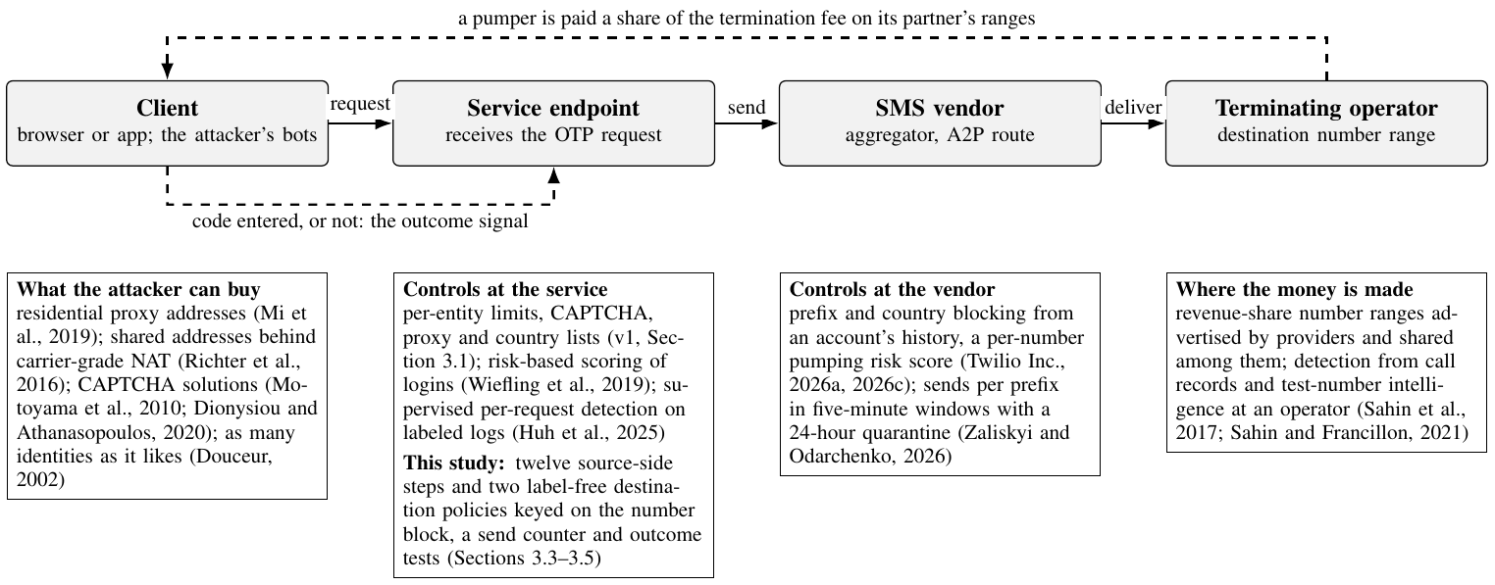
Fig. 1. Defenses Along the Path of an OTP Request.

2.1 Revenue-share fraud and the destination as the attacker’s asset
In international revenue-share fraud, a fraudster obtains “pseudo” premium-rate numbers from websites that pay for traffic and generates calls to them; a transit operator short-stops the calls, keeps the termination fee and shares it with the fraudster. The taxonomy of Sahin et al. (2017) sets the scheme among frauds that persist because call routing is opaque, each operator knowing only the next hop, and because operators are reluctant to share pricing, routes or fraud findings with competitors. Sahin and Francillon (2021) then measured the market from the supply side, collecting 3,149,793 distinct test numbers that twelve such providers advertised between January 2016 and November 2019 across 238 destinations. The ranges are a managed asset: 80% of them were shared across providers, which subdivide a hijacked block among themselves, and 70% lay inside valid numbering plans. From this intelligence and from call histories, the authors built a random-forest detector for an operator’s call records that reached 98% accuracy at 0.28% false positives, where blocking the two-digit neighborhood of a known test number caught 63%. Both studies concern voice telephony, and the detector needs the test-number intelligence and the call histories of an operator. The lesson for SMS is that the number range, not the calling identity, is what the fraudster must keep, and that a party seeing only its own traffic detects the fraud late. An OTP endpoint is in a weaker position still: it holds neither intelligence nor call histories, only its own sends and whether their codes were entered. That is why the policies of Section 3.5 are keyed on the 8-digit block and use only those two quantities.

2.2 Detecting artificially inflated SMS traffic
Huh et al. (2025) trained gradient-boosted trees on 9.4 million SMS authentication logs from nineteen countries, reaching 89.6% recall at 0.19% false positives on web traffic and 91.1% at 0.11% on app traffic. The logs came unlabeled from one large service over three months of 2023; the authors labeled attacks inside traffic peaks, as web identities with four or more requests and no successful validation in a day, or app number-and-device pairs never validated, and treated requests outside peaks as genuine. Two models, with 18 and 13 features at three levels (the request, the identity’s history, and country-wide aggregates over 24 hours), run per request before the message is sent. Approximately 73% of web attacks sent four or fewer requests per identity a day, defeating per-entity limits, and destination signals were the strongest: about 92% zero conversion for attacks against 21% for genuine traffic, and 91% of app attacks fell on prefixes with more than 30 distinct numbers in a day against 0.01% of genuine requests. The same data show the counter-move: in three countries, about 82% of attack requests validated their codes, which the authors attribute to attackers avoiding conversion-rate rules. Their detector requires labeled traffic and acts per request; the cost to legitimate users is reported as false positives only, and the model was not released because it is deployed. Their data show that destination aggregation is informative; we add a controlled comparison of two label-free ways to act on it per block, from send counts or code outcomes, and of their cost to users sharing a block. Theirs was not reproduced, so the two are not ranked.
Zaliskyi and Odarchenko (2026) count A2P sends per prefix (a number less its last three digits) in fixed or rolling five-minute windows and quarantine a prefix for 24 hours past a day or night threshold. On metadata of two confirmed incidents fixed windows blocked 95% and 63% of the traffic, and 58% of a legitimate marketing campaign; counting unique recipients blocked 2% of the campaign and none of the first incident. The authors conclude that message counts alone cannot safely separate inflated traffic from a campaign; they do not use verification outcomes. Theirs is a send counter judged on real traffic by messages blocked; ours compares a counter with outcome tests at a service target, in simulation, by what users sharing a block lose; the numbers are not comparable.
The messaging vendors act one hop later. Twilio’s Fraud Guard analyzes an account’s historical traffic and blocks sends to a destination prefix or country whose pattern departs from it, with three protection levels and claimed false-positive rates under 1% and 2% (Twilio Inc., 2026c); its SMS Pumping Risk Score rates a number from 0 to 100 from Fraud Guard, risky carriers, traffic patterns and low conversion, and advises friction from 60 and refusal above 90 (Twilio Inc., 2026a). Graded destination action is therefore established practice, but the signals and models are undisclosed, so no product was benchmarked.
Taken together, these works establish that attacks concentrate on destination prefixes and avoid converting, that counts alone misfire on campaigns, and that some campaigns now enter codes to pass conversion rules. None of them compares counting with outcome testing on the same traffic, fixes its setting before the evaluation runs, or charges a policy with the registrations it costs the users of a shared block. Those are the questions of Sections 5.5–5.7, and the attackers that enter codes, fake receipts and build trust (Table 2) are modeled on the counter-move above.

2.3 Source-side controls and the attacker’s market
What a source-side control costs an attacker has been measured. Motoyama et al. (2010) bought CAPTCHA solutions from eight retail services at $1 to $20 per thousand, found that the wage for solving had fallen from $10 per thousand in 2007 to about a dollar by 2009, and measured a median response of 14 seconds at error rates of 10% to 20%; human labor had displaced automated solvers, and the authors conclude that a CAPTCHA limits access to attackers whose business is profitable despite that cost rather than keeping machines out. Dionysiou and Athanasopoulos (2020) classify the machine-learning solvers that have since appeared. Addresses have a market too: Mi et al. (2019) infiltrated five residential proxy providers and observed 6,183,876 addresses in 238 countries and 52,905 ISPs, 95% of them residential, 90% relaying for under 870 seconds and 2.2% on any blacklist; Richter et al. (2016) found carrier-grade NAT in more than 90% of cellular networks, with 64 subscribers behind one address where each receives a thousand ports, and conclude that address reputation and blacklisting become “all but infeasible” there. Behind both markets lies the older observation of Douceur (2002) that without a trusted authority one entity can present many identities, so a signed session provides continuity, not scarcity. Risk-based authentication, which Wiefling et al. (2019) probed at eight large services, scores a login from its address, user agent, resolution, time and similar features into risk buckets and asks for a further factor above a threshold; every service that showed such behavior used the address, and none disclosed its procedure. Step 7 of our design resembles it, but scores a request made before any account exists, so the account history that risk-based authentication relies on is absent. Client puzzles (Dean and Stubblefield, 2001) would add a computational price per request; they were not evaluated.
These measurements say what an attacker can buy. For a defense they imply that per-identity controls tax identity reset rather than prevent it, and that the question for a residential attacker is not whether it can be told from a person but what rationing it costs the people it resembles. Sections 5.3 and 5.4 measure that in this design.

2.4 Sequential tests and change detection
Our block tests are Wald’s sequential tests (Wald, 1945) run as Page’s cumulative sums (Page, 1954), with a floor parameter that selects between the two (Section 3.5). Quickest change detection minimizes detection delay under false-alarm constraints (Veeravalli and Banerjee, 2012), and a CUSUM’s parameters follow from the error rates it must meet (NIST/SEMATECH, 2026); windowed statistics and the time-uniform confidence sequences of Howard et al. (2021), which stay valid at any stopping time, were not evaluated, so ‘testing’ below means our conversion and speed tests only, and their error rates are reported empirically rather than derived.

2.5 Attacks on the code once sent
Malware on the handset or a social-engineering call can take a code after it is delivered (Mulliner et al., 2013; Siadati et al., 2017). Those attacks begin where this paper stops: it asks whether a message should be sent at all, and leaves the protection of a delivered code aside.

2.6 Summary of the gap
Table 1 compares the works closest to this study on the evidence they use, the signal they act on, where they act, and whether they measure the cost to legitimate users. Across them, the destination is agreed to be where a pumper is exposed, and three ways to act on it are in use: a supervised model with labels, a count per prefix, and a vendor’s undisclosed score. What none supplies is a controlled comparison, under a protocol fixed before the runs, of the two signals a service can compute without labels, with the cost to the users who share a block made part of the result. This study supplies that comparison, in simulation, together with the source-side layers it sits in.
Table 1
Comparison of Related Work with This Study.
Work | Evidence | Signal acted on | Where it acts | Cost to legitimate users | Left open for an OTP service
Sahin and Francillon (2021) | Operator call records; 3.1 million test numbers advertised by 12 providers, 2016–2019 | Distance of the called number to advertised ranges and call history; labels from matched test numbers | Per call, at an operator | A false-positive rate (0.28%), not harm to callers | Voice calls; needs number intelligence and call histories an OTP endpoint does not hold
Huh et al. (2025) | One service’s 9.4 million SMS authentication logs, 19 countries, three months | Per-request features with prefix-level counts and conversion; labels derived from traffic peaks | Per request at the service, before the message is sent | False positives only (0.19% web, 0.11% app) | Needs labels; the deployed model was not released; a per-request decision can be probed
Zaliskyi and Odarchenko (2026) | Aggregator delivery metadata: two confirmed incidents and one legitimate campaign | Sends, or unique recipients, per prefix in five-minute windows; no labels | Per prefix, with a 24-hour quarantine | Share of a campaign blocked (58%; 2% with unique recipients) | Outcomes unused; thresholds that stop incidents block campaigns; no per-user cost
Twilio Inc. (2026a); Twilio Inc. (2026c) | Vendor-wide traffic across accounts; documentation only | Departure from an account’s history per prefix and country; a per-number score from carriers, patterns and conversion | Before the send, at the vendor; bands at 60, 75 and 90 | Claimed false-positive rates under 1% and 2% | Signals and models undisclosed; cannot be benchmarked or reproduced
Wiefling et al. (2019) | Black-box tests of eight services with 224 accounts | Address, user agent, resolution, time and similar login features scored into risk buckets | Per login to an existing account | Not measured; re-authentication observed | Scores a login, not a request made before any account exists; procedures undisclosed
This study | Simulation: 25 attacker profiles, seven designs, two predeclared protocols; code and every run public | Sends per number block; sequential tests of code outcomes per block; no labels | Per 10 000-number block at the service, before the message is sent | Attack-free benign cost and extra harm under attack, per cohort, in completed registrations | Simulated users and assumed calibration; no real traffic replayed

3 Threat model and design
This section describes the baseline that the design replaces, the attacker it must resist, the twelve steps and two destination policies of the design, and the estimates of leakage that follow from its rules.

3.1 The v1 baseline and its gaps
The baseline, v1, is the registration endpoint before this work: it sends a code to any unregistered number once seven controls pass, in the order of Algorithm 1. A request from a known VPN or proxy address is refused. The platform is read from a client header, and a request that claims iOS or Android skips the two checks that web requests face, a reCAPTCHA v3 score threshold and an origin check. The number’s country must be on an allow-list unless the request carries the bulk flag; the body must be within a length limit and the number not on an exclusion list unless the request comes from a test server. One message per number per minute, five requests per address per minute and static caps per platform and country complete the controls. Each cap is a counter that is read when the check runs and incremented after every check has passed, and the response names the control that refused.
Each control rests on an assumption that an attacker within the threat model of Section 3.2 breaks, and the eight gaps below follow from the rules, not from observed abuse; Algorithm 1 marks where each opens. (A) The platform exemptions trust a client claim, so any request can send the header for iOS and skip the reCAPTCHA and origin checks. (B) Five requests per address assume that addresses are scarce; a residential proxy pool supplies a fresh address per request, nothing throttles a subnet or an autonomous system, and no client identity survives an address change. (C) A number is sent to without validation, so numbers that cannot exist, numbers on dead ranges and generated sequences cost the same as a real message. (D) The country allow-list is the only notion of destination cost; premium-rate and revenue-share prefixes inside an allowed country cost many times a standard message, and a pumper targets exactly those. (E) Every limit is per key, so a wide attack that stays under each cap burns the budget without bound; nothing watches total volume or spend. (F) A limit checks its counter and increments it as two operations, so two concurrent requests on different instances both pass. (G) The bulk and test paths skip checks but need no stronger authentication than a normal request, so a leaked flag is a bypass. (H) Every decision is pass or fail and the response names the control that refused, so an attacker can probe each threshold, stay under it, and enumerate registered numbers.
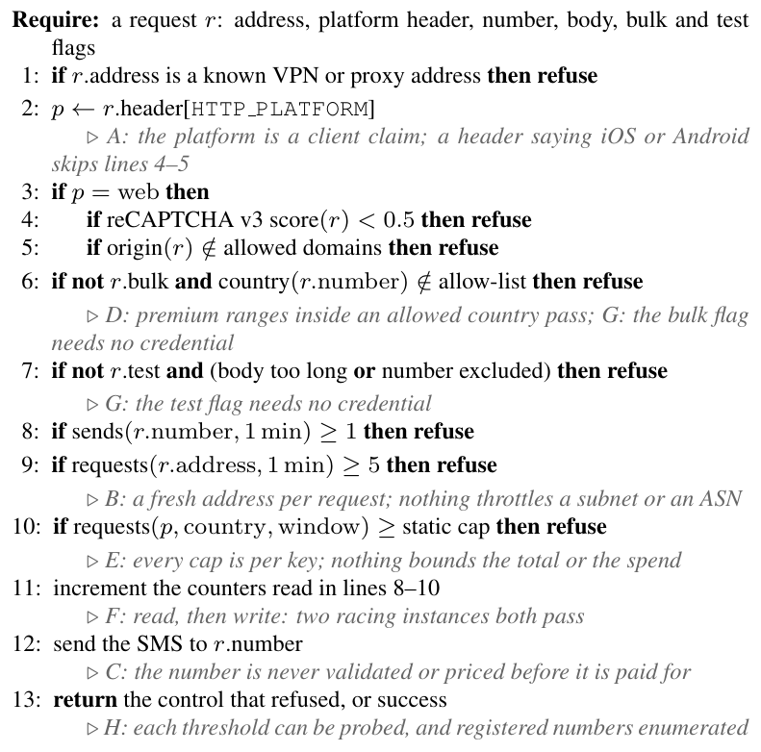
Algorithm 1. The v1 baseline, as the evaluated pipeline applies it to a code request; each comment names the gap the preceding rule opens.

3.2 Threat model
The attacker is a party that wants the service to send as many messages as possible, or as many as possible to numbers that pay it. The first is a flooder: the service pays per message, and the attacker’s gain is the service’s loss. The second is a pumper, paid a share of the termination fee by the operator that terminates its ranges; it earns nothing on any other number, so its traffic concentrates on the blocks it is paid for. The share is not public, and Section 5.8 reports instead the share at which each scripted pumper breaks even. Figure 2 places the attacker’s capabilities and limits on the path of a request.
At the client, the attacker runs scripts behind residential proxies in the service’s own country, with a fresh address per request, or from a datacenter abroad, or spread at a low rate over twenty autonomous systems. It buys human-like reCAPTCHA v3 tokens from solving services at about 0.3 cents each, so a score threshold alone does not stop it. It mints a fresh browser fingerprint per request, pre-ages fingerprints for hours, or reuses one two-day-old profile; it can present a forged platform header; and it draws numbers at random, walks them upward, or takes them from its partner’s blocks. It knows every threshold, the parameters of the destination tests and the timing of the workers, and it sees only the one uniform response that Section 3.3 describes.
On its own ranges, a pumper’s operator can do what a real recipient could: enter the code it receives, within a second or after a human-like delay, or only when a block’s statistic nears its threshold; report deliveries as failed, so that a billed send feeds no test; and verify on hundreds of identity-and-number pairs for ten or thirty minutes to build trusted history before flooding with the same pairs. It can spread over three to three hundred blocks, at full rate or paced to a counter’s quota, and it can buy a solution for every interactive challenge.
Three things it cannot do. It cannot forge an app attestation, so a platform established at Step 0 is evidence rather than a claim. It cannot earn on a range its partner does not terminate, which is why the destination is the one key it cannot rotate away from. And it cannot make a stranger enter a code, so a code entered on a block that real users share is honest evidence about that block; what a code entered on the attacker’s own number buys it is measured, not assumed. Attacks on a code after delivery (Section 2.5) and compromise of the service, its vendors or the attestation providers are outside the model. Table 2 lists the 25 profiles that instantiate these capabilities; pool size, rate and CAPTCHA class are drawn per seed.
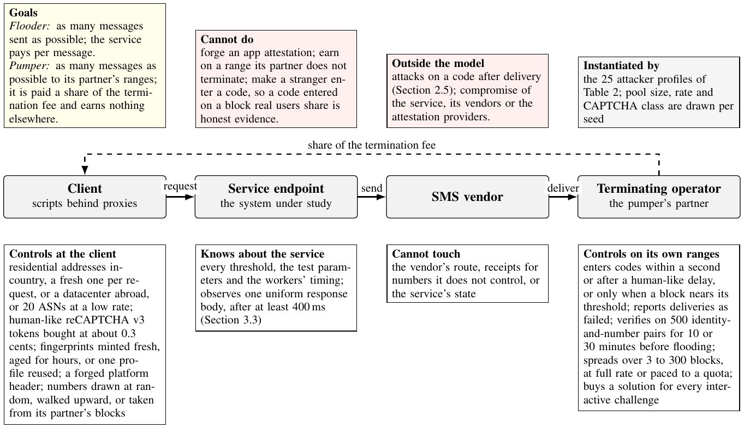
Fig. 2. The Threat Model on the Path of a Request.

3.3 The pipeline and the risk score
No message is paid for before every check passes, and cheap checks run first. Trust comes from evidence the client cannot forge, an attestation, a server-signed session, and the fate of earlier codes, though such evidence can be manufactured (Section 5.8). A request passes the twelve steps of Figure 3, which marks on each step the gaps of Section 3.1 it closes (FB: the feedback loop), until it is refused. Step 0 takes the platform only from a valid App Attest or Play Integrity result. Each limit and reservation is one atomic Redis operation, but the enclosing steps are not one transaction: on the normal path, a refused request returns its per-number claims and counter slot, and the hourly budget is reserved only for a message about to be enqueued, a reservation rather than a completed dispatch; a crash between them can leak reservations (Section 4). Address limits and source caps count requests, except that a request Step 11 challenges returns its source-cap count. Every outcome after Step 0, except the challenge, returns one HTTP 200 body after at least 400 ms, a floor that cannot hide longer work.
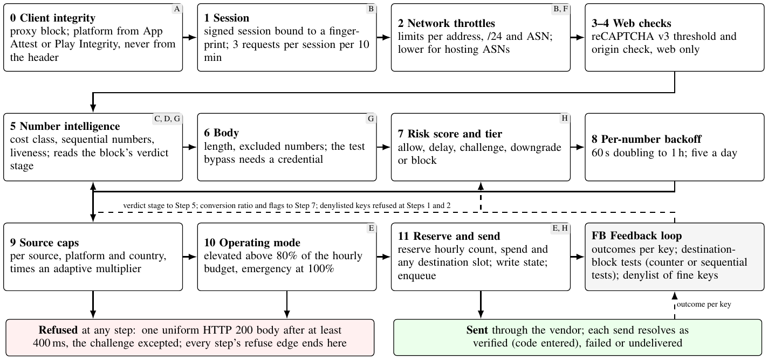
Fig. 3. The Twelve Steps of the Design and the Feedback Loop.
Step 7 computes
s=i​wixi+wcmax0,θ−rminθ+wsf+wmi−wvvn−wfvf 1
where the $x_{i}$ are request signals (CAPTCHA score, hosting ASN, fingerprint age, session requests, country mismatch, number class), $r_{min}$ is the lowest conversion ratio over the request’s keys (address to destination block), $θ=0.3$, $w_{c}=25$, $f$ and $i$ flag a flooded key and one whose codes are entered within seconds, and $v_{n}$, $v_{f}$ mark a number and fingerprint with verified history; other weights are 5 to 25 (Ahmed, 2026). Tiers start at 20, 40, 60, and 80: allow, delay (a doubling wait), challenge ($−20$ when solved), downgrade (push or WhatsApp), and block.

3.4 The feedback loop
A send resolves as verified when its code is entered, fails after five incorrect attempts or two minutes past the delivery receipt, and is undelivered without a receipt in 60 s or with a failed receipt; only the first two count toward reputation. A positive receipt after a negative one reopens the send; a late verification reclassifies it, but an issued verdict stands. Each transition records its effects and its time in the same compare-and-set, and a recovery sweep completes the work of a dead process; each effect type applies at most once, and exactly once if the sweep runs within 20 minutes. Reputation counts land in the transition’s hour, and a block keeps its latest outage failure time; however, a block’s statistic accumulates in processing order, and a verdict is dated at the event that completes the crossing; thus, a late event can backdate a verdict that contains later evidence, moving its expiry and the next test’s start (by 10 min in one diagnostic). Simulated runs apply events in time order, but concurrent live instances may not, because a transition is committed before its effects apply; thus, the same dependence holds live unless a block’s effects are serialized.

3.5 Destination policies
A pumper is confined to its partner’s ranges but can rotate numbers and blocks within them. Destination policies are keyed on the 8-digit block (10 000 numbers); therefore, protection weakens as a pumper spreads.

3.5.1 Sequential tests
The conversion statistic assumes that users verify with $p_{ℓ}=0.8$ and a flooder with $p_{a}=0.1$: a failure adds $ln\frac{1−p_{a}}{1−p_{ℓ}}=1.50$, a verification $ln\frac{p_{a}}{p_{ℓ}}=−2.08$. The speed statistic assumes that a machine enters a verified code within five seconds with $q_{a}=0.9$ and a person with $q_{ℓ}=0.2$, because autofill removes the keystroke (Google LLC, 2026; Web Incubator Community Group, 2026); it adds $1.50$ or $−2.08$. A verdict is issued, and the statistic is reset when either exceeds $h=ln1000=6.91$. The floor $S_{t}=max\left(−ch, S_{t−1}+\text{increment}\right)$ sets the memory: unbounded $c$ is Wald’s test, $c=0$ Page’s cumulative sum; the default is $c=1$. A first verdict makes the block’s first-time clients pass a challenge for an hour; a second within the hour moves them off SMS, refusing those without another channel.

3.5.2 Counters
A counter limits the number of SMS sent per block in a daily or short refilling window. Step 11 reserves a slot and decides the stage in one atomic operation when an SMS is about to be sent, so concurrent requests cannot skip the challenge. Past the limit, a graded counter challenges first-time clients, and past twice the limit moves them off SMS; a refusing counter refuses. Clients with verified history are exempt from both policies; therefore, a code entered on a pumper’s number can buy that number an exemption. A token bucket of the same rate (burst 4 or 12; its challenge-tier bucket refills independently, unlike RFC 2697’s (Heinanen and Guerin, 1999)) and the counter combined with the tests were also explored.

3.6 Capacity controls
Step 9 multiplies its caps by 0.25 to 1.5 according to a baseline job comparing each key with its expected rate, learned from the pipeline’s hourly counters; without history, the static cap stands. Verified history avoids adaptive reduction, not the static caps or the budget, which bounds SMS count and spend, not vendor or fallback costs.

3.7 Leakage estimates and a heuristic crossover
We compare the SMS sent to a pumper’s number over an attack of $T≤60$ minutes, by a pumper that solves no challenge and holds no verified history. Against the sequential tests, one reaching $B$ blocks with $N$ requests at rate $λ$ leaks about
$$L≈min\left(N,kB+λτ\right) \left(2\right)$$
before its first verdict, where $k=⌈h/1.50⌉=5$ and $τ$, the time a send stays unresolved, is the resolution timeout plus the delivery delay plus half the timeout worker’s period (2.55 minutes) if the carrier never verifies, and seconds if it verifies at once. Judged, such a pumper is held for the verdict’s hour; therefore, for $T≤60$ Equation (2) also estimates the attack’s total, ignoring prior credit and outage suspension. A carrier verifying a share $σ$ of codes with a human-like delay gives the conversion statistic an expected increment of $σ\left(−2.08\right)+\left(1−σ\right)\left(1.50\right)$, zero at $σ^{\text{*}}=0.42$; above it, the statistic drifts away from a verdict.
A counter of $q$ sends per block opens a window with the block’s first reserved SMS and closes it after the window length. A pumper that finds its blocks’ counters empty (a cold start) sends at most
$$L_{c}≤min\left(N,qBw\right), w=⌈T/\text{window}⌉ \left(3\right)$$
whatever its carrier does with the codes. If a legitimate send has already opened a window on block $b$, using $c_{b}≥1$ slots, the pumper can also take the remaining ${\left(q−c_{b}\right)}^{\text{+}}$ before at most $w$ further windows open, so in general
Lc≤minN,qBw+b open​q−cb+≤minN,Bqw+q−1 4
Solving challenges doubles these bounds, and a verified history exempts a client from them. While neither policy’s estimate reaches $N$, the cold-start bound lies below the tests’ estimate when
$$B\left(qw−k\right)<λτ \left(5\right)$$
and a warm start adds the residual quota to the left side. Equation (5) is the algebraic crossing of two simplified quantities, neither of which is an empirically established switching point or a necessary condition: other limits can hold either policy below its estimate. A carrier that games outcomes may never be judged, so the tests’ leakage approaches $N$.
In the code, every send takes a slot, verified clients’ included. If a block’s sends arrive as a Poisson stream with mean $m$ per window and all reach the counter, a window holds $1+X$ of them, $X∼Poisson\left(m\right)$, and the idealized share beyond the quota is $E\left[{\left(1+X−q\right)}^{\text{+}}\right]/\left(1+m\right)$: 7.3% at $m=q/2$ and 27% at $m=q$ for $q=4$. This is not a challenge rate: exempt clients take slots without challenge, and challenge failures, the second tier and earlier gates are ignored. The estimates use only the rules, configuration, and attack rate; what an excess send costs a user needs the simulation.

4 Methodology

4.1 Implementation
Approximately 4 000 lines of Python implement the pipeline on in-memory and Redis backends. Up to release 2.8.3, the simulator’s in-memory store let a sorted set expire a fixed time after its first write, whereas Redis kept it while written to; therefore, the simulated outage detector and Step 5 lost recent observations. Release 2.9.0 follows Redis in every rule compared, checked by differential tests, and every study was rerun with it; earlier releases repaired seven replay and concurrency defects, each with a regression test. Of 453 tests, 19 used a real redis-server, 18 tested specific interleavings of two instances, not all. Step 11 was still not one transaction: a crash after its reservations leaked reserved slots or resolved the send as undelivered. The implementation was a research prototype.

4.2 Simulation
The pipeline runs against scripted vendor fakes on a simulated clock. After a warm-up of ten minutes (30 or 130 for pumping), attacks run over legitimate traffic at 20 requests per minute. Simulated users verify 80% of codes after a lognormal delay (median 22 s; 2 s for the 20% using autofill); 70% of numbers are reachable on WhatsApp; 90% of users complete a challenge; 20% are returning account holders with a stable fingerprint, a trusted number, and verified history; thus, the results for returning users describe trusted identities only. Separate random streams provide all scenarios at the same seed with the same users.
Three behavioral parameters have published counterparts: genuine conversion (one provider’s 68% or more (Twilio Inc., 2026b); ours 60%–90%) and the never-converting destinations and identity churn of Section 2; the rest are assumptions. Table 2 groups the attacker profiles by capability and marks the destination policies each faced (S, sequential tests; C, counters; B, block-limit; parameters in results/ attacker_profiles.md). Attackers draw pool size, rate, and CAPTCHA class per seed, which explains 92% [80, 98] of the variance of the farm’s leakage in a nested design (ten configurations, three seeds each). Brackets in the text and tables, and bars and bands in the figures, are 95% percentile-bootstrap intervals over seeds, paired per seed for differences; they describe variation under this generator, not uncertainty about real traffic.

4.3 Two protocols and their chronology
A supplementary map (results/ study_map.md) gives each study’s seeds. The first protocol, committed before its runs, fixed the matched comparison and a robustness study over 12 Latin-hypercube points (conversion 0.6–0.9 and five other behavioral parameters) and a held-out family (60 to 120 attack requests a minute, 50 000 to 500 000 addresses, heterogeneous legitimate traffic), with claims C1–C5 that hold if true in 90% of cells, a benchmark convention, not a confidence level. The matched comparison changes only the destination policy and, at three block densities, selects on tuning seeds the least leakage summed over four concentrated pumpers among settings at or above the tuning target, the default’s completion minus 0.5 points. The robustness study’s first run failed C1 in 32 of 108 cells because attack and no-attack runs drew different users; we fixed the pairing, a fix that followed a result, and reran every study. The second protocol (claims K1–K5) was written after the matched comparison had selected three counters and committed before its runs; six of its seed values had served other robustness points, never selection. Both were rerun unchanged with 2.9.0 (9 919, 7 925 and 240 runs, each carrying its code hash); against 2.8.0, total leakage changed in 855 of 17 964 comparable runs, but the principal selections, eligibility decisions, and claim counts did not; one auxiliary setting (false alarms matched at unbounded credit) moved from T1000 to T300 under both protocols (artifact change report).

4.4 Designs and metrics
Seven designs: v1, v1-corrected (attested platform), budget-only (sessions, static caps, budget), block-limit (a refusing counter of five sends per block per day), conversion-only and speed-only (v2 minus one block test), and v2. A seed is contained when leakage stays at most 5% of the attack rate from some minute to the window’s end, for five minutes or more. Attributable loss compares the same requests with the policy enforced and absent, net of the reverse, in points of offered users: on attack-free traffic it is the benign cost, on the attacked trace the extra harm relative to the attacked no-policy arm. Degradation compares the attacked trace with attack-free operation under the same policy.
Table 2
Attacker Profiles, Capabilities, and Policies.
Capability | Profiles | Policies
A signature in the request (5) | One address; datacenter rotation abroad; a premium-rate prefix; numbers walked upward; the farm with an unattested iOS header | S, B
Looks like a person (7) | Residential bot; farmed CAPTCHA with fresh or aged fingerprints; one 48-hour-old browser profile | S, B
 | Low and slow, 2 or 10 requests/min over 20 ASNs; datacenter rotation buying challenge solutions | S
Games outcomes or trust (8) | Pumpers on elevated-cost or standard ranges verifying within 1 s, or 60% after 30 s | S
 | Threshold-aware and receipt-faking carriers; three trust builders (500 identity/number pairs verify for 10 or 30 min, then flood) | S, C
Concentrated on the destination (5) | Four pumpers on three blocks (carrier never verifies, verifies within 1 s or 60% after 30 s, or buys challenges); a poisoner on users’ blocks | S, C
Spread (generated) | 3 to 300 blocks, at full rate or at most the counter’s quota per block | S, C

5 Results

5.1 What is contained, and at what cost
Table 3
Leakage and User Impact Across Designs.
 | caps lifted: leaked |  |  | caps on, v2
Attacker | v1 | BL | v2 | leaked | refused | completed
Single client | 5.6 | 0.3 | 0.3 | 0.3 | 1.1 | 79.1
Datacenter rotation | 69.0 | 69.0 | 0.0 | 0.0 | 1.1 | 79.1
Premium pumping | 99.4 | 1.0 | 0.0 | 0.0 | 1.1 | 79.1
Sequential numbers | 99.4 | 1.0 | 11.5 | 10.7 | 3.5 | 77.5
Reused profile | 99.5 | 99.5 | 22.5 | 17.4 | 8.6 | 74.2
Residential bot | 37.2 | 37.2 | 37.2 | 29.9 | 16.2 | 69.6
Farmed CAPTCHA | 99.5 | 99.5 | 99.5 | 45.6 | 54.0 | 45.5
Aged fingerprints | 99.5 | 99.5 | 99.5 | 45.6 | 54.0 | 45.5
Forged header | 100.0 | 99.5 | 99.5 | 45.6 | 54.0 | 45.5
Table 3 gives the leaked share (%, mean of per-run shares) of about 600 attack requests in 20 minutes over 30 seeds under v1, block-limit (BL) and v2 with source caps lifted, and under v2 with caps on, with the first-time users refused and all users completing (%); supplementary Table S1 (results/ design_table.md) gives every design with intervals. Datacenter rotation leaks nothing under v2 because it scores in the challenge tier and declines challenges; Step 5 refuses the premium range, and the session cap holds the single client to two messages (Table 3); in all 108 robustness cells, these attacks leaked under 5% at completion within two points of the paired no-attack run (claim C1). The walk leaks 61 [53, 70] messages before its block’s verdict (block-limit: five), and the reused profile 89 [83, 95].
The farm leaks 99.5% with caps lifted under every design; v2’s adaptive cap holds it to 229 [215, 244] messages, 46%, by refusing 54% [47, 60] of first-time users, so 45.5% complete instead of 76.4% under v1: rationing (claim C5 held in 36 of 36 cells).

5.2 Conditional effects of each layer
In the ablation grid (90 effects, each conditional on all other layers, unadjusted intervals; artifact), removing the adaptive caps lets the farm leak 310 [194, 421] more messages; the risk engine, feedback loop, and block key hold the walk by 166, 152, and 121 messages, and the loop holds the reused profile by 138. The key acts only through the loop (interaction $−121$ [$−141$, $−101$]).

5.3 Where reputation stops separating
A farmed-CAPTCHA attacker uses an address and fingerprint once and shares its country, prefix, and residential ASN with every legitimate user; thus, its failures penalize everyone: over an hour with caps lifted (five seeds), up to twice the legitimate rate, 99 to 100% of it leaks, since a shared key stays above 0.3 conversion until failures outnumber legitimate sends about 1.7 to one. At ten times, 70% leaks while 17% of legitimate users are challenged and 3.2% refused (claim C2, at least 90% leaked with caps lifted, held in 34 of 36 cells). No single score change separates better: a fresh-fingerprint weight of 40 stops it only by challenging 47% of legitimate users. In the settings run, reputation separated an attacker only on keys its sends dominated (Douceur, 2002).

5.4 What rationing costs, and what it depends on
When separation fails, the cap is the lever: over ten seeds, the default lets 47% of the farm’s requests through and refuses 41% of all legitimate users, the tightest setting 20% and 64%. Both assume an oracle job that is told the legitimate rate and runs every minute; running every five minutes or hourly, it lets 75%–96% through. Learning the rate from the pipeline’s counters, the deployed job leaks 193 [161, 229] messages with a clean three-week profile, 340 [239, 441] more on a cold start, 106 [62, 151] more with a stale profile, and 45 [10, 77] more with a poisoned one.

5.5 Pumping against the sequential tests
Table 4
Containment Results for Concentrated Pumping Attacks.
Carrier, design | Leaked | Contained | Containment | First verdict | Codes
 | (msgs) | (seeds) | (min) | (min) | entered
never verifies: v1 | 570 [419, 736] | 0/10 | – | – | 0
v2 default | 90 [71, 114] | 10/10 | 3.5 [3.1, 3.9] | 3.0 | 0
verifies within 1 s: v2 default | 19 [17, 21] | 10/10 | 1.4 [1.1, 1.7] | 0.4 | 19
verifies 60% after 30 s: v2 default | 452 [365, 539] | 0/10 | – | 11.6 | 272
v2 default, 60 min | 1 067 [839, 1 310] | 2/10 | 47.0 [42.0, 52.0] | 25.5 | –
buys challenges: v2 default | 106 [87, 127] | 10/10 | 4.3 [3.8, 4.9] | 3.0 | 0
Table 4 covers concentrated pumpers on three blocks with caps lifted over ten seeds: messages leaked of about 574 requests in 20 minutes, seeds contained, mean minutes to containment (contained seeds) and to the first verdict (seeds with one), and codes entered. The speed test catches a carrier verifying within a second at 19 messages, while the carrier verifying 60% with human-like delay is contained in none of the ten 20-minute runs: its first verdict comes at minute 11.6 on average and 452 messages leak; in an hour, 1 067 leak and two of ten runs are contained, at minute 47.0 on average. Claim C3 (containment with at most 30% leaked) held in 36 of 36 cells.
Across 18 spread configurations, leakage follows the blocks touched: with 30 blocks, five to seven runs in ten are still contained. Unsaturated, Equation (2) errs by 1.6 to 7.9 messages per run (1%–13%, ten configurations); saturated, it overstates by up to 91.

5.6 Destination policies: where the counter wins, and where it fails
Table 5
Leakage and Benign-User Impact Across Carrier Types.
Setting (selected as) | NV | IV | HL | CB | Compl. | Benign | Chall. | Events
none | 319 | 566 | 570 | 405 | 64.13% | – | 1.53% | 0
sequential T1000, c1 (default) | 90 | 19 | 452 | 106 | 64.12% | 0.01 | 1.64% | 6.5
sequential T300, c0 (selected at tuning target) | 88 | 14 | 126 | 98 | 63.77% | 0.37 | 6.54% | 334.3
counter, graded, 4 per 10 min (selected) | 24 | 24 | 24 | 48 | 64.07% | 0.06 | 2.38% | 0
counter, graded, 160 per day (selected daily) | 319 | 409 | 408 | 405 | 64.11% | 0.02 | 1.87% | 0

5.6.1 At a benign service target
Table 5 reports the first protocol at 200 blocks (144 legitimate sends per block a day; tuning seeds 100–102, evaluation seeds 0–9): 20-minute leakage against the never-verifying (NV), instant (IV), human-like (HL) and challenge-buying (CB) carriers and, from 24-hour attack-free runs at 65% conversion, completion, benign cost (points), users challenged and verdict events a day; the tuning target is 63.95%. Figure 4 plots each setting’s completion against its leakage summed over the four pumpers’ runs of a seed (not one combined attack), with the tuning target dotted; its unlabeled points are sequential settings matched to the default’s false alarms at other credits (key: results/ figure1_key.md). Figure 5 gives each selected setting’s leakage minus the default’s, paired per seed (negative: leaks less). The sequential setting selected at the tuning target holds the human-like carrier to 126 messages only by raising 334 false verdict events a day, and misses the target by 0.18 points on seeds 0–9. The graded counter of four sends per block per ten minutes leaks 24 against each outcome-reading carrier and 48 against the challenge buyer, at 0.06 points; counters selected at the sparser settings leak 6 to 18 at 0.15 to 0.35 points (up to 0.43 at 80%). With the full grid and density-specific attacks (E5) the rule selects the same counters, and so do other objectives on the tuning runs (worst-case leakage, a first-time-loss constraint, each attacker alone, 2 000 random mixes), except the instant verifier alone and 3 mixes at 200 blocks; on fresh seeds the counter leaked least of the winners against every attacker but the instant verifier (25, against 15 and 16). On seeds 300–309 the 1 000-block counter falls 0.12 points below its target, yet no seed-and-conversion cell fails the paired check (the evaluation default minus 0.5 points).
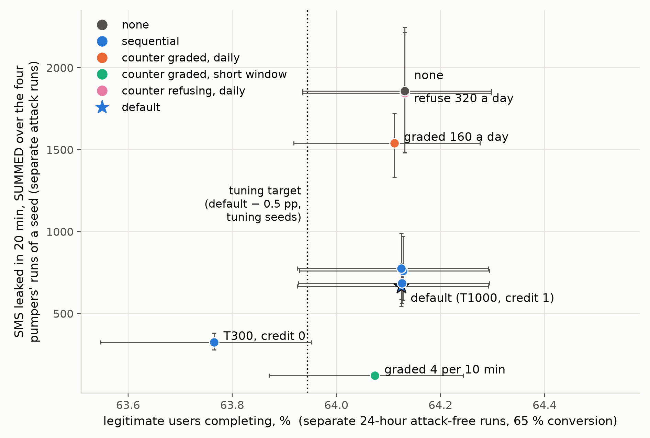
Fig. 4. Leakage vs. Legitimate-User Completion Across Settings.
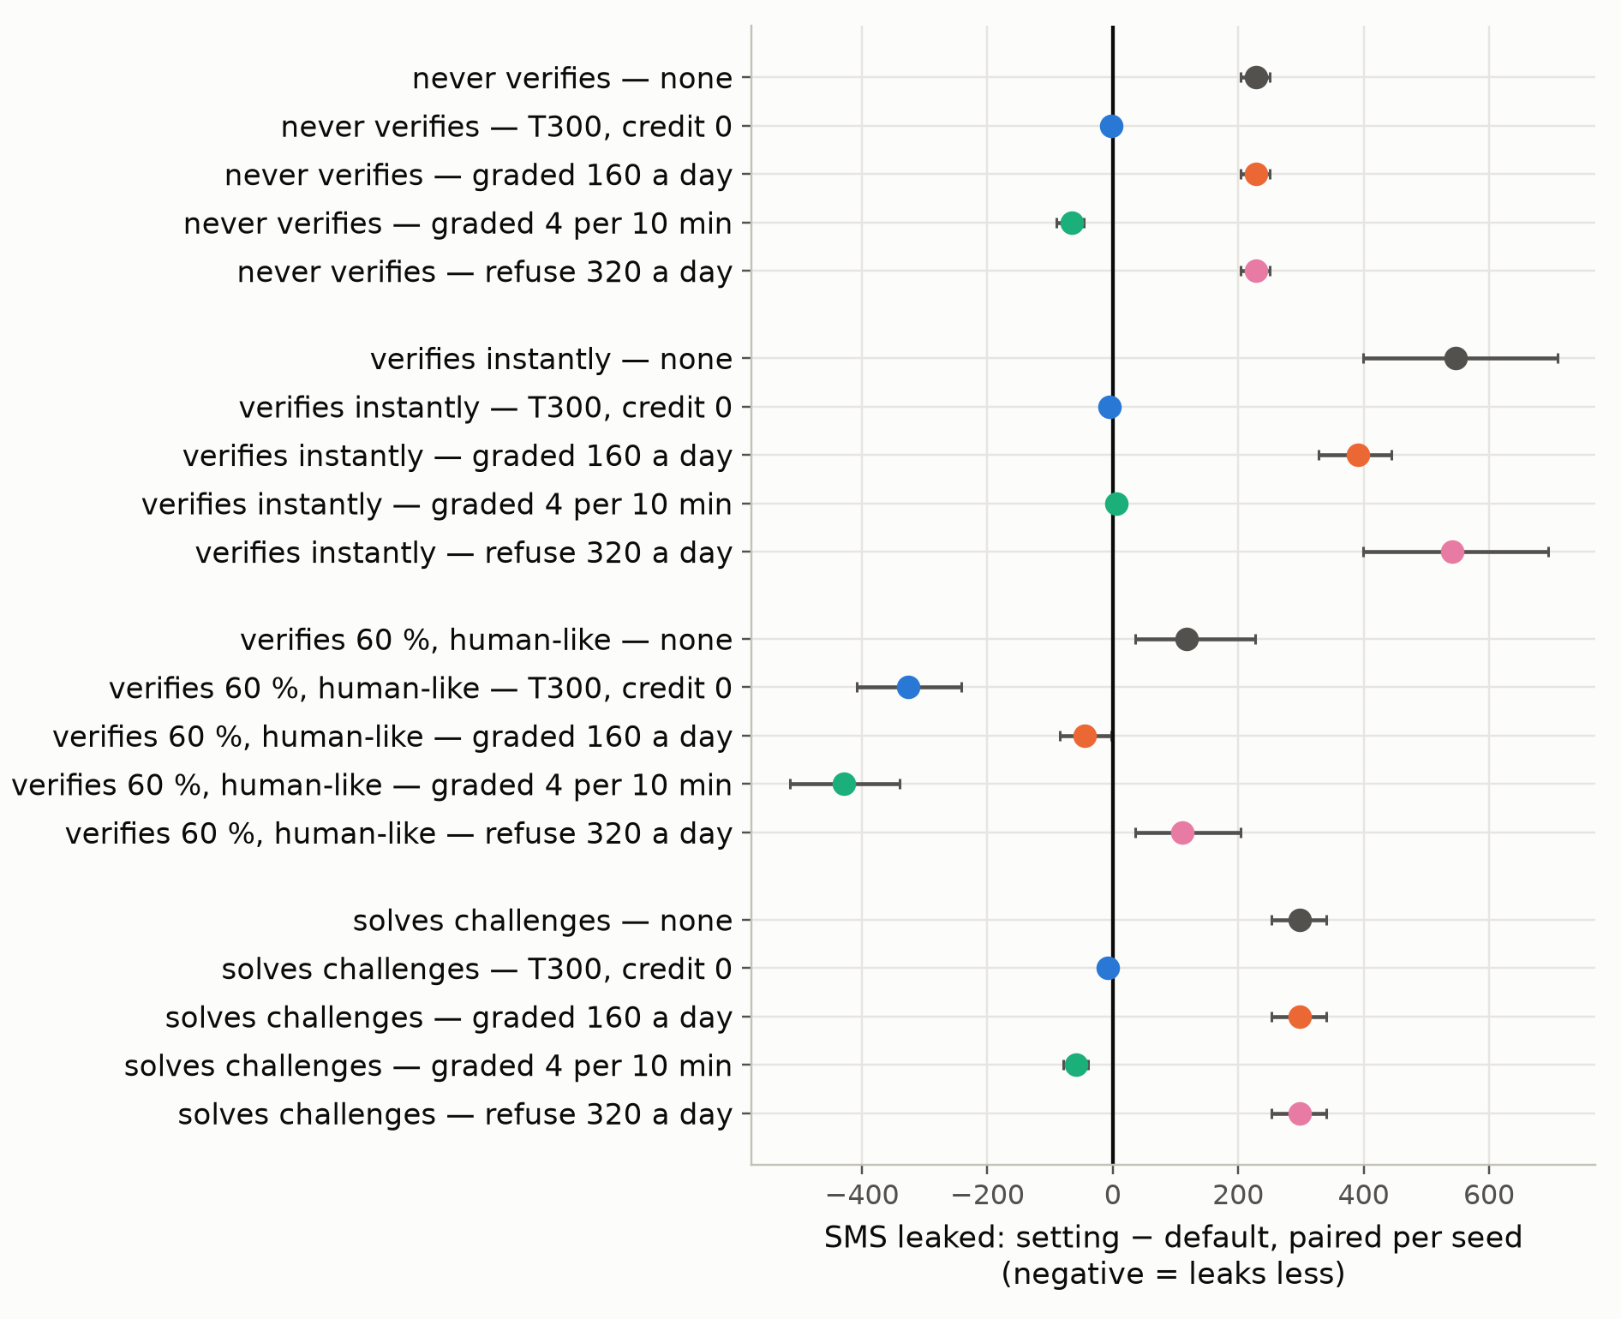
Fig. 5. Leakage Difference from the Default Across Attack Types.
Table 6
Held-Out Evaluation of the Principal Counter.
Claim | Statement | True / cells | IV | Result
K1 | Leaks at most 10% of attack requests | 144/144 (100%) | 36/36 | holds
K2 | Attack-free attributable loss at most 0.5 points | 36/36 (100%) | – | holds
K3 | Attributable loss under attack at most 0.5 points | 127/144 (88%) | 32/36 | fails
K4 | Leaks no more than the default sequential tests | 131/144 (91%) | 23/36 | holds pooled, not for IV
K5 | Attributable loss under attack at most the default’s plus 0.25 points | 93/144 (65%) | 23/36 | fails

5.6.2 Under a second protocol
Table 6 covers 12 shifted points of the held-out family, with held-out attack rates and pools, three seeds each and a 20-minute pumper on three blocks real users share; a claim holds if true in 90% of cells, which share workloads and seeds and are not independent, and IV marks the instant verifier’s cells. Frozen and run on this family, the counter leaked 33, 34, 33, and 62 messages against the four carriers, where the default leaked 287, 36, 344, and 287, and no policy 451 to 1 857, at a benign cost of 0.13 [0.09, 0.17] points, and failed both service-under-attack claims: 13 of the 17 cells that broke K3 lie at the three points with the most legitimate traffic, where users and pumper compete for one quota; K5 failed in 51 cells over 11 of 12 points. The counters selected for sparser traffic cost 4.7 and 5.8 points here even without an attack: the quota must match the traffic.
Table 7
Leakage and User Harm Under Shared-Block Pumping.
 |  | Extra harm against |  | Degradation against |  | Benign
 |  | attacked, no policy |  | attack-free, same policy |  | cost
 | Leaked | all users | attacked | all users | attacked | all
Policy | (SMS) | ($≈$1 200) | blocks ($≈$18) |  | blocks | users
none | 5 509 [4 409, 6 567] | – | – | 0.19 | 8.0 [5.1, 10.7] | –
sequential, default | 1 149 [953, 1 340] | −0.07 | −1.0 [−2.8, 0.8] | 0.10 | 7.0 [4.7, 9.1] | 0.02
sequential T300, c0 | 397 [312, 481] | 0.13 | 0.9 [−1.3, 3.3] | 0.12 | 8.9 [6.0, 11.7] | 0.20
counter, 4 per 10 min | 403 [386, 418] | −0.05 | −3.2 [−5.0, −1.1] | 0.07 | 4.8 [2.9, 6.7] | 0.07
counter + sequential | 190 [179, 201] | −0.04 | −3.1 [−5.1, −0.7] | 0.07 | 4.9 [3.0, 6.8] | 0.08
token bucket, burst 4 | 424 [412, 437] | −0.12 | −3.1 [−5.1, −0.7] | 0.07 | 4.9 [2.8, 7.0] | 0.00
token bucket, burst 12 | 545 [531, 559] | −0.11 | −2.1 [−4.3, 0.2] | 0.08 | 5.9 [3.3, 8.8] | 0.00

Table 8
User Harm Under a Full-Block Poisoning Attack.
 | Leaked | Extra harm against attacked,
 |  | no policy
Policy | (SMS) | all users | first-time users
none | 1 976 | – | –
sequential, default | 1 357 | 1.09 [0.59, 1.59] | 1.36
sequential T300, c0 | 858 | 2.55 [2.04, 3.07] | 3.20
counter, 4 per 10 min | 1 662 | 0.72 [0.44, 1.02] | 0.91
counter + sequential | 1 286 | 1.43 [0.88, 1.97] | 1.79
token bucket, burst 4 | 1 877 | 0.12 [0.04, 0.23] | 0.16
token bucket, burst 12 | 1 974 | 0.00 [0.00, 0.00] | 0.00
Tables 7 and 8 report E1 at 200 blocks (60-minute attacks, seeds 300–309): a pumper on three blocks real users share, and a poisoner flooding all 200 blocks. Leakage under the pumper is summed over the four carriers’ runs of a seed, which can hide a carrier on which a policy loses (per carrier: artifact); harm is net completions lost in points, averaged over the carriers (negative: a gain), with intervals for leakage and the attacked blocks in Table 7 and for all users’ extra harm in Table 8. In Table 7, against the attacked no-policy arm, the counter cost all users nothing on average and gained the attacked blocks’ users three points on average, since without a destination policy, the pumper exhausts their blocks and the hourly budget; with the human-like carrier alone, it cost them 1.9. Against the attack-free operation, every evaluated policy left those users 5 to 9 points worse off on average (2 to 12 per carrier; 8 with none): none shields a block an attacker shares. Counter and tests together, explored outside the frozen claims, leaked least summed over the four carriers but not against the instant verifier (28; T300, c0: 22), and under the poisoner (Table 8) cost all users most of the counters and buckets and leaked more than T300, c0. A token bucket with a burst of 4 spared the poisoner’s users only by letting almost everything through; with two untuned settings, neither limiter dominated, and we ranked only the implemented policies. Returning users, all simulated with verified history, lost nothing.

5.6.3 The operating boundary and adaptive attackers
Figure 6 shows the counter’s operating boundary (E4, seeds 300–304): in (a), the attributable loss of the three hot blocks’ users against their legitimate rate, attack-free and with a never-verifying pumper on those blocks; in (b, c), leakage in 20 and 60 minutes against the blocks a pumper uses, at full rate or paced, with Equations (2)–(4) for the full-rate pumper as hollow markers. All horizontal axes and the vertical axes of (b, c) are logarithmic, and lines join sampled settings without locating a crossover. Attack-free, the counter costs a block’s users nothing at one send per ten minutes, 2.3 points at four and 5.5 at eight, far below the idealized share beyond the quota (27% at four), since most challenged users complete or switch to WhatsApp; without WhatsApp, eight sends cost 13.2. A 30-minute launch at three times the normal rate costs its blocks’ users 16 points. Over 60 minutes (Figure 6c) the default leaked 110, 144 and 242 messages on 3, 10 and 30 blocks, against 105, 139 and 240 from Equation (2) ($λτ≈90$), and the counter 71, 240 and 679 against its cold-start bound of 72, 240 and 720. Once 7 messages sent, exempt, to real users’ trusted numbers are set aside, no counter run that started cold (44 of 100) exceeded Equation (3); three warm ones did, by 5 or 6 messages, and none exceeded Equation (4). With these unfitted inputs Equation (5) ordered the policies’ mean leakage in 18 of 18 decisive cells (two ties at $N$), and with the warm-start term in 17, missing where the estimates differ by 0.8 messages (30 blocks, 20 minutes; measured difference 6.6 [−27.2, 42.4]); per seed, 76 of 78 decisive comparisons agree. The algebraic crossing lies near five blocks for an hour and 30 for twenty minutes, where the nearest measured differences (three and 30 blocks) do not exclude zero; it is not a measured switching point. Paced to the quota, a pumper leaks about as much under the counter as with no policy (71 against 72 on three blocks in an hour), and 23 under the tests.
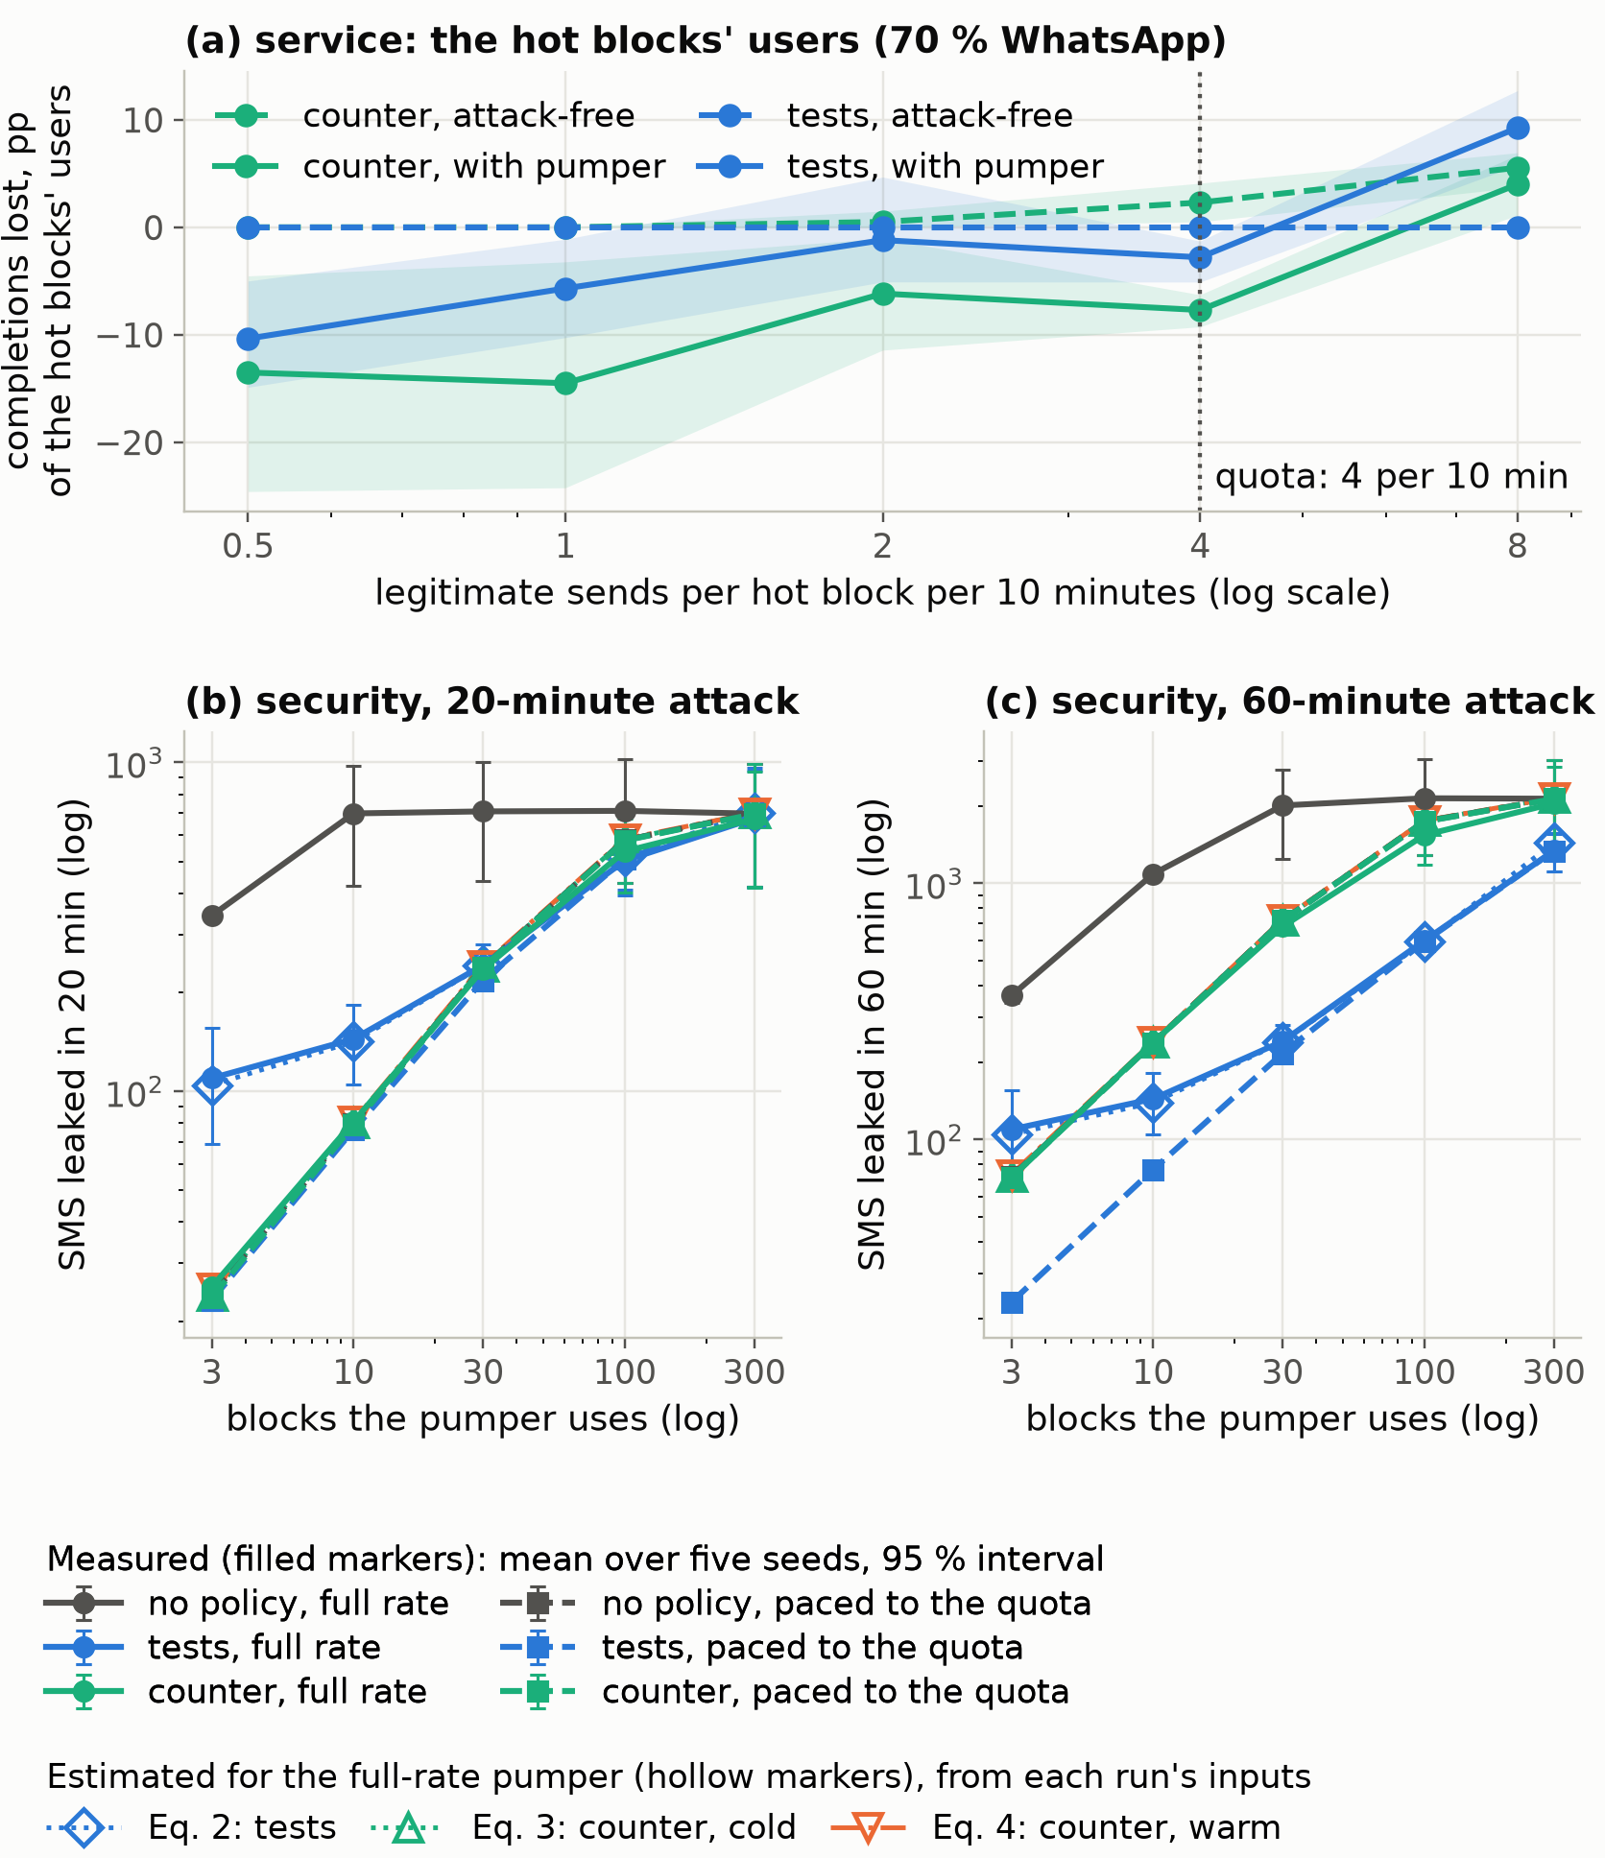
Fig. 6. Operating Boundary of the Counter.
Against adaptive attackers (E3), the counter held the threshold-aware carrier, receipt faker, and concentrated trust builder to 24 to 36 messages (502 to 665 under the default), but not trust builders on random numbers (577, as under the default); over 360 minutes, the human-like carrier gained 81 messages an hour under the counter, and 753 under the default.

5.7 What destination policies cost legitimate users
On one block, 20 000 Monte Carlo trials per cell give the probability of a verdict within 30 legitimate sends: 0.09% [0.06, 0.14] at 80% conversion with 20% autofill, 1.9% at 65% and 19.5% at 50%. Over 24 hours, the default raises 0.5 verdict events a day on 200 busy blocks at 80% conversion and 6.5 at 65%, where they meet 30 of about 28 800 requests (claim C4 held in 18 of 18 cells).
A poisoner flooding for 20 min the 20 blocks legitimate users concentrate on (caps lifted, ten seeds) raises 16 verdict events meeting 98 legitimate requests, 33 never completing; against observe-only operation on the same trace, enforcement costs 12.7 [4.6, 22.9] completions, 3.1% of users (6.3% without WhatsApp; 23.9% with a 24-hour denylist). One that stops after ten minutes leaves verdicts meeting 406.5 requests afterwards, an attributable loss of 46.2 [16.9, 79.8]. Grading limits the harm; it caps it neither at the challenge nor at the attack’s duration.

5.8 Adaptive attackers, economics and overhead
The leakages of these scripted adaptations are not bounds. Against v2 with caps lifted, a datacenter attacker buying every challenge solution leaks 55, and a threshold-aware carrier and a receipt faker leak 570 each, drawing no verdict.
If pumpers earn a share of the 0.1422 USD retail price and pay an event-level bill, they break even at a share of 0.043 under v1 and 0.054 to 0.271 under v2 (the instant verifier 1.310); over 360 minutes under the counter, the human-like carrier needs 1.048. These are break-even shares for scripted attackers under assumed prices, not bounds or criminal profit.
On a real Redis (four vCPUs, four workers), sends cost 13.8 ms (median) and 21.1 ms (99th percentile), and 133 requests per second passed at concurrency 128 with the 400 ms floor and 50 ms vendor calls. With fast vendors, response times distinguished no pair of five outcome classes (smallest Kolmogorov–Smirnov $p=0.051$). Under an adversarial mixture, 81% of sends overran the floor, and response-time thresholds separated sends from refusals with 88% balanced accuracy on the fitted run and, fitted on a new run, 95 to 99.9% on two others: a separation on that machine, not a deployment accuracy.

6 Discussion and limitations

6.1 Lessons
In the scripted workloads, carriers that verify with human-like delay, fake receipts, or know the thresholds defeated our outcome tests but not a short-window counter. Within an hour of a verdict, the counter’s allowance, unlike the tests’, grows with the windows an attack spans; over longer campaigns, verdicts expire and the tests leak again. Equation (5) summarizes this for pumpers that solve no challenge and hold no exemption. Its inputs are in an operator’s logs; the cost of an excess send, competition under attack, and exemption abuse come only from the simulation. The counter and tests together, with a quota set from each block’s traffic, is a hypothesis for real traffic, not a recommendation.

6.2 Limitations
Everything was simulated, and calibration was assumed. Both protocols were written by the author for the author’s generator, the second knowing which counters had won. Some results follow from the generator (a perfect premium list, a datacenter attacker that declines challenges, returning users who always present verified history), and selection used an unweighted sum of four scripted pumpers’ leakage and a mean service target met on tuning seeds, which guarantees no service level elsewhere. Close rankings rest on ten or fewer seeds, and costs that round to zero are not shown equivalent. Per-client quotas within a block, carrier spend ceilings, bounded exemptions, tuned token buckets, and other sequential statistics lie outside the evaluated policies. Vendor adapters are untested live, and the timing result holds only for the observer tested. Destination policies challenge people for what strangers sharing their block did, and deployment under the GDPR or Saudi Arabia’s PDPL needs a lawful basis and a route for refused users.

7 Conclusions and future work
This study asked how a service that verifies phone numbers by SMS should defend an endpoint that must answer strangers, and in particular which of two label-free destination signals, the number of sends to a number block or the outcomes of the codes sent, it should act on when a pumper is paid on the destination. We answered it in simulation: a twelve-step redesign of a seven-control baseline ran against 25 scripted attacker profiles and six other designs, and the two destination policies were compared under two protocols committed before their runs, with the cost to legitimate users made part of the result.
On the source side, the design contains the attacks that carry a signature in the request, a single address, a datacenter range, a premium prefix, a walked number sequence or a forged header, at a low cost to simulated users, and the ablation attributes that containment to the adaptive caps, the risk engine, the feedback loop and the block key. Against a residential attacker that resembles a person, outcome-based reputation stops separating once its failures land on keys that legitimate users share; in the settings run, it separated an attacker only on keys its sends dominated. What remains is rationing, whose cost depends on how well the cap tracks the legitimate rate: the deployed job leaked 193 messages with a clean three-week profile and 340 more on a cold start, while the default cap refused 41% of legitimate users. On the destination, counting sends leaked less in aggregate than our outcome tests against concentrated pumpers, although not reliably against an instantly verifying carrier; the frozen counter failed its service claims when the attacker shared blocks with real users and lost its advantage against wide, paced and trust-building pumpers. Within an hour, unfitted estimates ordered the policies’ mean leakage in 18 of 18 decisive boundary cells with the cold-start bound and 17 with the warm-start bound, missing a near tie; the crossing was algebraic, not a measured switching point. Without an attack, the default tests raise 0.5 verdict events a day on 200 busy blocks at 80% conversion and 6.5 at 65%, and a counter of four sends per ten minutes costs a block’s users 2.3 points.
For an operator, the practical content is an ordering, not a recommendation. Against short, concentrated pumping on a few blocks, a counter of sends per block whose quota matches the block’s legitimate traffic leaked less than tests of code outcomes and cost its users less, and the inputs of the estimate that orders the two, the attack rate, the blocks touched and the time a send stays unresolved, are in an operator’s logs; the cost of an excess send, the competition for a quota on a shared block and the abuse of exemptions come only from the simulation. The quota must match the traffic: counters selected for sparser blocks cost 4.7 and 5.8 points on busier ones even without an attack. Every number describes scripted attackers and simulated users under assumed calibration, not real traffic, and close rankings rest on ten or fewer seeds.
Replaying real traffic is the experiment this paper most needs: it would test the assumed calibration, the cost of an excess send to users who share a block, and the quota a counter needs per block. The policies left outside the evaluation, per-client quotas within a block, bounded exemptions, tuned token buckets and windowed or time-uniform statistics, could then be compared under the same predeclared protocols.

Declaration of generative AI and AI-assisted technologies in the writing process
The author used Claude (Anthropic) for code, evaluation, drafting and editing; checked numbers against the recorded results and claims against the code; and takes full responsibility for the content.

CRediT authorship contribution statement
Naveed Ahmed: Conceptualization, Methodology, Software, Validation, Investigation, Writing – original draft, Writing – review & editing.

Declaration of competing interest
The author declares no known competing financial interests or personal relationships that could have appeared to influence this work.

Data availability
No human or real traffic data was used. Code, protocols (config/), every run’s configuration and outcome and the sources of headline numbers (results/) are at https://github.com/nahmedpsu/OTP-DDOS, release 2.9.1 (tag v2.9.1), which runs unchanged the code of release 2.9.0 (tag v2.9.0, commit 9af3100) that produced the results (code_identity.md); the 2.8.0 results are in results/ historical_2.8. These files are the supplementary material.

References
Ahmed, N., 2026. OTP Guard: a layered SMS validation, risk-scoring and rate-limiting pipeline against OTP flood abuse (version 2.9.1). https://github.com/nahmedpsu/OTP-DDOS, tag v2.9.1. Results produced by 2.9.0 (commit 9af3100), whose executable code 2.9.1 keeps; 2.8.0 results (commit 1c277a0) in results/historical_2.8.
Commsrisk, 2023. Elon Musk says Twitter lost $60mn a year because 390 telcos used bot accounts to pump A2P SMS. https://commsrisk.com/elon-musk-says-twitter-lost-60mn-a-year-because-390-telcos-used-bot-accounts-to-pump-a2p-sms/. Trade press; the figure is the company’s own claim.
Dean, D., Stubblefield, A., 2001. Using client puzzles to protect TLS, in: 10th USENIX Security Symposium, USENIX Association.
Dionysiou, A., Athanasopoulos, E., 2020. SoK: Machine vs. machine – A systematic classification of automated machine learning-based CAPTCHA solvers. Computers & Security 97, 101947. https://doi.org/10.1016/j.cose.2020.101947.
Douceur, J.R., 2002. The Sybil attack, in: Peer-to-Peer Systems (IPTPS 2002), Springer. pp. 251–260. https://doi.org/10.1007/3-540-45748-8_24.
Google LLC, 2026. SMS retriever API overview. https://developers.google.com/identity/sms-retriever/overview. Accessed 2026-10-01.
Heinanen, J., Guerin, R., 1999. A single rate three color marker. RFC 2697, Internet Engineering Task Force. https://doi.org/10.17487/RFC2697.
Howard, S.R., Ramdas, A., McAuliffe, J., Sekhon, J., 2021. Time-uniform, nonparametric, nonasymptotic confidence sequences. The Annals of Statistics 49, 1055–1080. https://doi.org/10.1214/20-AOS1991.
Huh, J.H., Shin, H., Ahn, S., Yi, H., Cho, J., Kim, T., Lim, M., Choi, N., 2025. Preventing artificially inflated SMS attacks through large-scale traffic inspection, in: 34th USENIX Security Symposium, USENIX Association, Seattle, WA.
Mi, X., Feng, X., Liao, X., Liu, B., Wang, X., Qian, F., Li, Z., Alrizah, S., Chen, L., Qian, Y., 2019. Resident evil: Understanding residential IP proxy as a dark service, in: 2019 IEEE Symposium on Security and Privacy (S&P), IEEE. https://doi.org/10.1109/SP.2019.00011.
MITRE Corporation, 2026. Resource hijacking: SMS pumping, technique T1496.003, MITRE ATT&CK. https://attack.mitre.org/techniques/T1496/003/. Accessed 2026-10-01.
Motoyama, M., Levchenko, K., Kanich, C., McCoy, D., Voelker, G.M., Savage, S., 2010. Re: CAPTCHAs – understanding CAPTCHA-solving services in an economic context, in: 19th USENIX Security Symposium, USENIX Association.
Mulliner, C., Borgaonkar, R., Stewin, P., Seifert, J.P., 2013. SMS-based one-time passwords: Attacks and defense, in: Detection of Intrusions and Malware, and Vulnerability Assessment (DIMVA 2013), Springer. pp. 150–159. https://doi.org/10.1007/978-3-642-39235-1_9.
NIST/SEMATECH, 2026. CUSUM control charts, section 6.3.2.3, e-handbook of statistical methods. https://www.itl.nist.gov/div898/handbook/pmc/section3/pmc323.htm. Accessed 2026-10-02.
Page, E.S., 1954. Continuous inspection schemes. Biometrika 41, 100–115. https://doi.org/10.2307/2333009.
Richter, P., Wolsing, F., Chandrasekaran, A., Padmanabhan, R., Allman, M., Bush, R., Feldmann, A., 2016. A multi-perspective analysis of carrier-grade NAT deployment, in: Proceedings of the 2016 ACM Internet Measurement Conference (IMC), ACM. https://doi.org/10.1145/2987443.2987474.
Sahin, M., Francillon, A., 2021. Understanding and detecting international revenue share fraud, in: Network and Distributed System Security Symposium (NDSS), Internet Society. https://doi.org/10.14722/ndss.2021.24051.
Sahin, M., Francillon, A., Gupta, P., Ahamad, M., 2017. SoK: Fraud in telephony networks, in: 2017 IEEE European Symposium on Security and Privacy (EuroS&P), IEEE. https://doi.org/10.1109/EuroSP.2017.40.
Siadati, H., Nguyen, T., Gupta, P., Jakobsson, M., Memon, N., 2017. Mind your SMSes: Mitigating social engineering in second factor authentication. Computers & Security 65, 14–28. https://doi.org/10.1016/j.cose.2016.09.009.
Twilio Inc., 2026a. SMS pumping risk score (Lookup v2). https://www.twilio.com/docs/lookup/v2-api/sms-pumping-risk. Accessed 2026-10-01.
Twilio Inc., 2026b. Verify API. https://www.twilio.com/en-us/user-authentication-identity/verify. Accessed 2026-10-03.
Twilio Inc., 2026c. Verify fraud guard. https://www.twilio.com/docs/verify/preventing-toll-fraud/sms-fraud-guard. Accessed 2026-10-01.
Veeravalli, V.V., Banerjee, T., 2012. Quickest change detection. arXiv:1210.5552 (book chapter).
Wald, A., 1945. Sequential tests of statistical hypotheses. The Annals of Mathematical Statistics 16, 117–186. https://doi.org/10.1214/aoms/1177731118.
Web Incubator Community Group, 2026. WebOTP API. https://github.com/WICG/WebOTP. Accessed 2026-10-01.
Wiefling, S., Lo Iacono, L., Dürmuth, M., 2019. Is this really you? An empirical study on risk-based authentication applied in the wild, in: ICT Systems Security and Privacy Protection (IFIP SEC 2019), Springer. pp. 134–148. https://doi.org/10.1007/978-3-030-22312-0_10.
Zaliskyi, M., Odarchenko, M., 2026. Artificially inflated traffic in A2P messaging: Window-based detection models and prefix-level analysis for fraud mitigation. Science-Based Technologies 69, 89–98. https://doi.org/10.18372/2310-5461.69.20735.

