******Marak Alliance** +

LOCAL CONTENT CONFERENCE 2018

01 - 02 MAY

Venue: Crowne Plaza Houston 8686 Kirby Drive, Houston, Texas 77054

**CONFERENCE AGENDA**

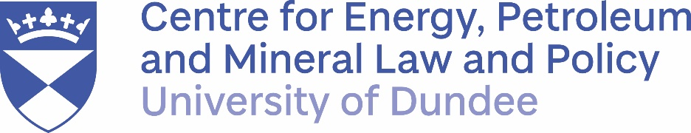

**CONFERENCE AGENDA**

Day 1:

07.30 - 09.00 Registration/Breakfast

09.00 – 09.30 Opening Remarks by Willy Olsen, Senior Adviser, INTSOK

9.30 -10.30 General plenary: local content in extractive industries: Are the benefits outweighing the costs? Moderator: Roger Tissot, Senior Consultant, Rene Roger Tissot Consultant

10.30 – 11.00 Coffee/networking break

11.00 - 12.00: How can economic diversification be effectively achieved through local content?

Lead Presenter: Christopher Sheldon, Sector Manager for Oil, Gas and Mining at World Bank Group

Q & A to Panel (government representative from Nigeria/Brazil/Mexico/Ghana) views from MNC and developmental international organization) • Measuring efforts to calculate cost/benefit of local content in extractive industries • Costs and benefits beyond public relations excitement • Rents vs Linkages? Some initial observations from case studies •

12.00-13.00: Lunch

13.00- 14.30: Financing natural resource development projects with strong local content

Lead Presenter: Christian Spano Head of Mining and Metals, World Economic Forum

Panel Q & A: - The role of the IFIs? World Bank? AFDB? How would World Bank's decision to generally stop financing oil/gas project after 2019 affect local content development? What are other long-term financing options from international institutions? - What's the current position of EU, WTO on local content policies

14.30 – 15.00: How can local content policies be shaped to accommodate investments in renewable energy to meet UN Sustainable Development Goals: (panel comprising representatives of UN, WTO, IMF, OECD, local companies, MNCs and policy makers)

Lead Presenter: Jorge Aviles, Senior Advisor, Stakeholder Engagement /Indigenous Relations. TransAlta, Calgary, Alberta

15.00-15.30 How progressive and sustainable are your country’s/company’s local content strategy/linkages? Backward? Forward? Lateral? - Local Content from perspective of Norway experience, and emerging economies: challenges and importance of building linkages

Lead Presenter: Willy Olsen, Senior Adviser, INTSOK

15.30 – 17.30: Coffee Break/Networking break

17.00 - 19.00: Gala dinner

Day 2

07.30 - 8.30 Breakfast

8.30 - 9.30 Opening address

9.30 – 10.30 Local Content Implementation from the Perspective of MNCs:

Panel Moderator: Roger Tissot, Senior Consultant at Rene Roger Tissot Consultants

Representatives from MNCs will present achievements and bottlenecks emanating from local content policies as well as challenges

10.30-11.00 Coffee/ networking break

11.00-12.00 Challenges/opportunities of local content implementation for a company operating in an environment where local content is part of the regulatory reality.

Lead Presenter: Andrea Moreno, Chief Compliance Officer of Grupo Mieres Angola

2nd Presenter: Jeff Geipel of Engineer Without Borders: Mining Local Procurement Reporting Mechanism (LPRM) – Can any LPRM strategy be applied in oil/gas local content implementation?

3rd Presenter: Luis Miranda, Director, Miranda Alliance, Houston: Local Content in Gabon & Cameroon – Trends and Developments

4th Presenter: Local Content as a tool for transformation in resource-rich developing economies: A look at Ghana’s mining industry

12.00 - 13.00 Lunch break:

13.00 -13.30 Challenges of regulating local content in the gas sector

Presenters:

* Hon. Fred Agbedi, Chairman, House Committee on Gas, Nigerian National Assembly
* Hon. Emmanuel Ekon, Chairman, House Committee on Local Content, Nigerian National Assembly

13.30 - 14.00 Challenges of Implementing Local Content in Mozambique’s Gas Sector

- Presenter: Fernando Nhantumbo, Partner at MP Consultores Ltda, Tete City, Mozambique

14.00 – 14.30 Local Content and Procurement Requirements in Oil and Gas Contracts: Regional Trends in the Middle East and North Africa

Lead Presenter: Dr. Damilola Olawuyi, Professor of Energy and Environmental Law, HBKU Law School, Qatar Foundation.

14.30 – 14.45 Local Content Implementation from the Perspective of Oil Servicing Companies

-Lead Presenter: Sam E. Onwa – Senior Director, Sub Sahara Africa, Baker Hughes

14.45 –15.00 Global High-Tech Procurement Solutions versus Domestication of Supply Chain Networks

- MNCs utilize international supply chains with technology such as advanced analytics, Internet of Things; Machine Learning; Artificial Intelligence and blockchains to drive efficiencies (to reduce length of contracting cycle, cost/time schedules etc). How can local suppliers eliminate inefficiencies due to procurement technology gaps to meet expectations of MNCs?

Presenter: Jean-Pierre Foehn, President and Founder, Almato, a leader in Order to Cash, Logistics and Field Data Management processes.

15.00 – 15.30 – Cocktail/Canapés/networking

15.30 – 16.00 Making Local Content Work: Bringing it All Together:

Panel comprising stakeholders from NOC, MNC, OSC and local company representatives will discuss the right environment for building a sustainable local content framework attractive for investors and host countries.

16.00 – 16.15 - Conference summary and closing remarks. A white paper will be prepared and distributed to attendees after the Conference