*Link youtube:
- Kênh youtube: https://youtube.com/@thornofgrief?si=9Byi2HtUch2u2Z4l
- Danh sách phát: https://youtube.com/playlist?list=PLQh1Urylt75M&si=zKUCIDb1Vj-BaIBL
*Thực hành:
- Ip pfsense
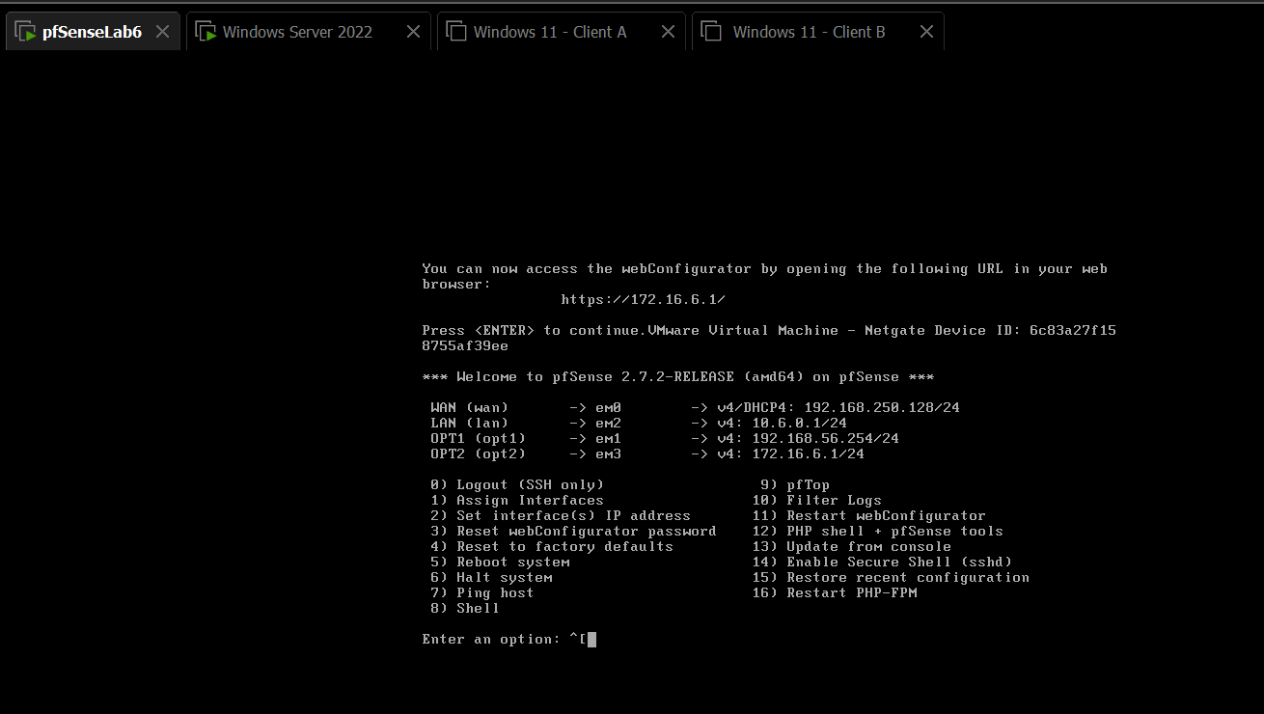
- ip window server(ADDS)
