

IT342-G4
System Integration and Architecture

System Design Document (SDD)

Project Title: QuickQueue
Prepared By: Reyes, Christian Andrey Villareal

Version: 0.2
Date: 03/02/2026
Status: Review

REVISION HISTORY TABLE
Version | Date | Author | Changes Made | Status
0.1 | 2/18/2026 | Christian Andrey V. Reyes | Initial draft | Draft
0.2 | 03/02/2026 | Christian Andrey V. Reyes | Added API specifications,  Added UI/UX designs and Plan | Review

TABLE OF CONTENTS
Contents
EXECUTIVE SUMMARY 4
1.0 INTRODUCTION 5
2.0 FUNCTIONAL REQUIREMENTS SPECIFICATION 5
3.0 NON-FUNCTIONAL REQUIREMENTS 8
4.0 SYSTEM ARCHITECTURE 9
5.0 API CONTRACT & COMMUNICATION 10
Authentication Endpoints 11
User Registration 11
User Login 11
6.0 DATABASE DESIGN 13
7.0 UI/UX DESIGN 14
8.0 PLAN 17

EXECUTIVE SUMMARY
1.1 Project Overview
QuickQueue is a mobile-based queue management system that allows users to obtain virtual queue numbers for service offices such as clinics, banks, and government agencies. The system reduces physical waiting lines by providing real-time queue updates and notifications.
1.2 Objectives
1. Provide a virtual queue system to minimize long waiting times
2. Allow users to monitor queue status remotely
3. Implement a simple and user-friendly mobile application
4. Enable real-time queue updates and notifications
5. Ensure secure access through user authentication
1.3 Scope
Included Features:
• User registration and login
• Service location selection
• Virtual queue number generation
• Queue status monitoring
• Queue notifications
Excluded Features:
• Online payments
• Appointment scheduling
• Multi-language support
• Advanced analytics
• Offline mode

1.0 INTRODUCTION
1.1 Purpose
This document defines the system design of QuickQueue, including functional requirements, system architecture, database design, and implementation plan. It serves as a reference for development and integration.

2.0 FUNCTIONAL REQUIREMENTS SPECIFICATION
2.1 Project Overview
Project Name: QuickQueue
Domain: Queue Management System
Primary Users: General public and service office staff
Problem Statement: Long waiting lines waste time and cause inconvenience for users.
Solution: A mobile application that provides virtual queue numbers and real-time updates.
2.2 Core User Journeys
Journey 1: First-Time User
1. User installs the app
2. Registers and logs in
3. Selects a service location
4. Takes a queue number
5. Monitors queue status

Journey 2: Returning User
1. Logs in
2. Selects service location
3. Takes a new queue number
4. Receives notification when turn is near
2.3 Feature List (MoSCoW)
MUST HAVE
1. User authentication
2. Service location selection
3. Virtual queue number generation
4. Queue status display
5. Queue notification

SHOULD HAVE
1. Estimated waiting time
2. Queue cancellation

COULD HAVE
1. Favorite locations
2. Queue history

WON’T HAVE
1. Payments
2. Appointment booking
3. Admin analytics dashboard

2.4 Detailed Feature Specifications
Feature: User Authentication
• Screens: Register, Login
• Fields: Email, Password
• API: /auth/register, /auth/login

Feature: Take Queue Number (Transactional Function)
• Users select service location
• System generates queue number
• API: POST /queue/take

Feature: Queue Status
• Displays current number and estimated wait time
• API: GET /queue/status

Feature: Queue Notification
• Alerts user when their turn is near
2.5 Acceptance Criteria
AC-1: Take Queue Number
Given the user is logged in
When the user selects a service location
Then a virtual queue number is generated

AC-2: Queue Notification
Given the user is waiting
When the queue reaches near their number
Then the user receives a notification

3.0 NON-FUNCTIONAL REQUIREMENTS
3.1 Performance
• Queue updates ≤ 2 seconds
• Support at least 100 concurrent users

3.2 Security
• HTTPS communication
• JWT authentication
• Secure password hashing

3.3 Compatibility
• Android API Level 24+
• Modern web browsers

3.4 Usability
• Simple interface
• Minimal steps to take queue
• Clear queue information

4.0 SYSTEM ARCHITECTURE
4.1 Component Diagram
Note: This should be a component diagram
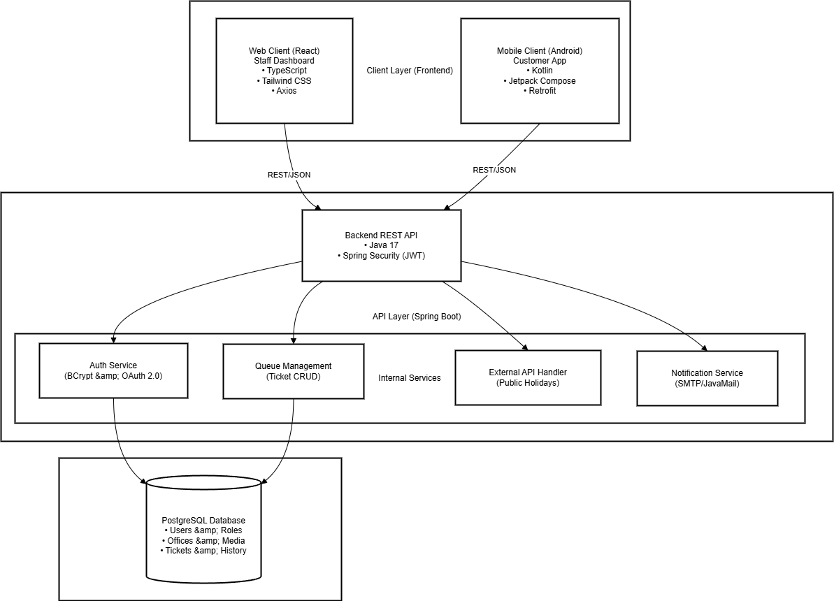
Technology Stack:
- Backend: Java 17, Spring Boot 3.x, Spring Security (JWT), and Spring Data JPA.
- Database: PostgreSQL 14+.
- Web Frontend (Staff Dashboard): React 18, TypeScript, Tailwind CSS, and Axios.
- Mobile (Customer App): Kotlin, Jetpack Compose, Retrofit, and Room.
- Build Tools: Maven (Backend), npm/yarn (Web), and Gradle (Android).
- Deployment: Railway/Heroku (Backend), Vercel/Netlify (Web), and APK (Mobile).

5.0 API CONTRACT & COMMUNICATION
5.1 API Standards
Base URL | https://api.quickqueue.com/api/v1
Format | JSON for all requests/responses
Authentication | Bearer token (JWT) in Authorization header
Response Structure | {  "success": boolean,  "data": object|null,  "error": {  "code": string,  "message": string,  "details": object|null  },  "timestamp": string  }

5.2 Endpoint Specifications

Authentication Endpoints

User Registration
Description | User Registration
API URL | /auth/register
HTTP Request Method | POST
Format | JSON for all requests/responses
Authentication | None
Request Payload | {  “email”: <email>,  “password”: <password>,  “firstname”: <firstname>,  “lastname”: <lastname>,  }
Response Structure | {  "success": boolean,  "data": {  "user": {  "email": "<email>",  "firstname": "<firstname>",  "lastname": "<lastname>"  },  "accessToken": "<token>",  "refreshToken": "<token>"  },  "error": {  "code": "string",  "message": "string",  "details": "object|null"  },  "timestamp": "string"  }

User Login
Description | User Login
API URL | /auth/login
HTTP Method | POST
Format | JSON for all requests/responses
Authentication | None
Request Payload | {  “email”: <email>,  “password”: <password>,  }
Response Structure | {  "success": boolean,  "data": {  “user”: {  “email”: <email>,  “firstname”: <firstname>,  “lastname”: <lastname>,  “role”: <role>,  },  “accessToken”: <token>,  “refreshToken”: <token>,  },  "error": {  "code": string,  "message": string,  "details": object|null  },  "timestamp": string  }

User Logout
Description | User Login
API URL | /auth/logout
HTTP Method | POST
Format | JSON for all requests/responses
Authentication | Bearer token (JWT)
Request Payload | None
Response Structure | {  "success": true,  "data": {  "message": "Logged out successfully"  },  "error": null,  "timestamp": "2026-02-28T20:58:36Z"  }

5.3 Error Handling

HTTP Status Codes
- 200 OK: Successful request.
- 201 Created: Resource (like a ticket or user) successfully created.
- 400 Bad Request: Invalid input or validation failure.
- 401 Unauthorized: Authentication failed or JWT expired.
- 403 Forbidden: Role-based access denied (e.g., Customer trying to access Admin endpoints).
- 404 Not Found: The requested office or ticket does not exist.
- 409 Conflict: Duplicate entry (e.g., joining the same queu
Error Code Examples

Example 1 | {  "success": false,  "data": null,  "error": {  "code": "AUTH-001",  "message": "Invalid credentials",  "details": "Email or password is incorrect"  },  "timestamp": "2026-02-28T21:00:00Z"  }
Example 2 | {  "success": false,  "data": null,  "error": {  "code": "VALID-001",  "message": "Validation failed",  "details": {  "email": "Email is required",  "password": "Must be at least 8 characters"  }  },  "timestamp": "2026-02-28T21:05:00Z"  }
Example 3 | {  "success": false,  "data": null,  "error": {  "code": "AUTH-003",  "message": "Insufficient permissions",  "details": "Admin role is required to perform this action"  },  "timestamp": "2026-02-28T21:10:00Z"  }
Example 4 | {  "success": false,  "data": null,  "error": {  "code": "DB-001",  "message": "Resource not found",  "details": "The requested Office ID does not exist"  },  "timestamp": "2026-02-28T21:15:00Z"  }
Example 5 | {  "success": false,  "data": null,  "error": {  "code": "BUSINESS-001",  "message": "Service Unavailable",  "details": "Office is currently closed due to a Public Holiday"  },  "timestamp": "2026-02-28T21:20:00Z"  }
Example 6 | {  "success": false,  "data": null,  "error": {  "code": "SYSTEM-001",  "message": "Internal server error",  "details": "An unexpected error occurred. Please try again later."  },  "timestamp": "2026-02-28T21:25:00Z"  }

Common Error Codes
- AUTH-001: Invalid credentials
- AUTH-002: Token expired
- AUTH-003: Insufficient permissions
- VALID-001: Validation failed
- DB-001: Resource not found
- DB-002: Duplicate entry
- BUSINESS-001: Service Unavailable (e.g., Office Closed/Insufficient stock)
- SYSTEM-001: Internal server error

6.0 DATABASE DESIGN
6.1 Entity Relationship Diagram
Note: This should be an ERD (Database Schema)
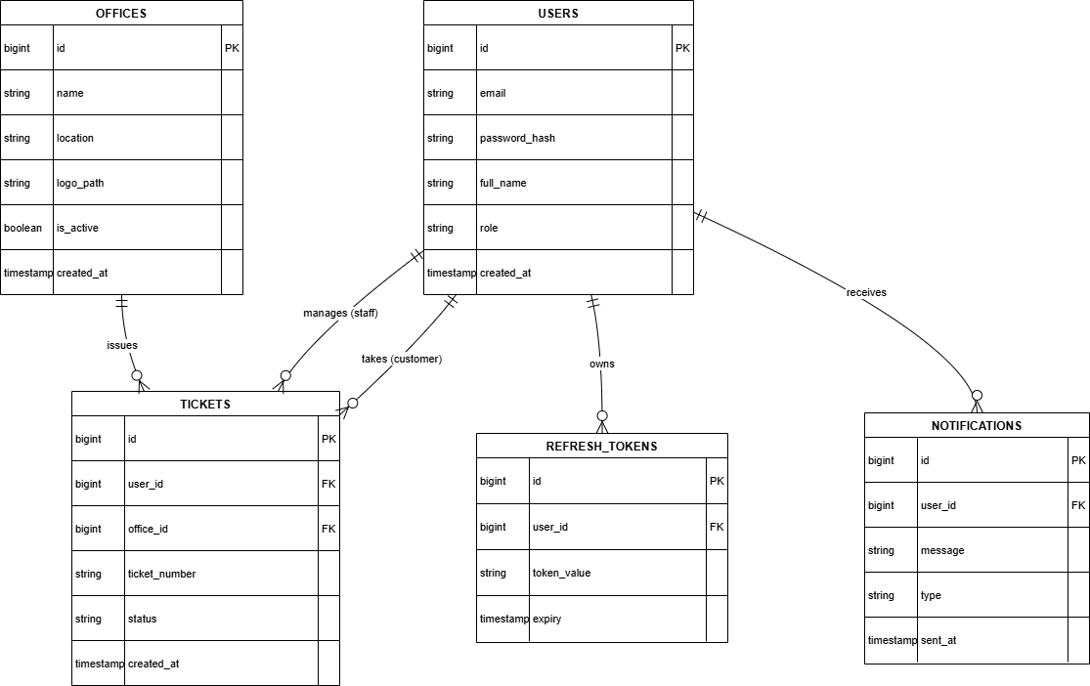
Detailed Relationships:
- One-to-Many: User → Tickets (Customer): A registered user in the USERS table can take multiple virtual queue tickets in the TICKETS table over time.
- One-to-Many: User → Tickets (Staff): A user with a staff role can manage or process multiple queue tickets issued by their respective office.
- One-to-Many: Offices → Tickets: Each service office (e.g., bank, clinic) defined in the OFFICES table is responsible for issuing multiple unique queue tickets to customers.
- One-to-Many: User → Refresh_Tokens: For security and session management, a single user can own multiple active or expired refresh tokens to maintain their authenticated state.
- One-to-Many: User → Notifications: A user can receive multiple system-generated notifications, such as "Your turn is next" alerts or account updates, stored in the NOTIFICATIONS table.

Key Tables:
- USERS: Stores core account information including email, hashed passwords, and assigned system roles (Customer or Staff).
- OFFICES: Defines service locations, including their physical address and the path to their branding assets (logo).
- TICKETS: The central transactional table that links a specific user to an office with a unique ticket number and current status.
- NOTIFICATIONS: Tracks communication history, including the specific message content and delivery type.
- REFRESH_TOKENS: Manages JWT lifecycle to ensure secure, persistent logins without requiring constant password re-entry.
Table Structure Summary:
- USERS: id, email, password_hash, full_name, role, created_at
- OFFICES: id, name, location, logo_path, is_active, created_at
- TICKETS: id, user_id, office_id, ticket_number, status, created_at
- NOTIFICATIONS: id, user_id, message, type, sent_at
- REFRESH_TOKENS: id, user_id, token_value, expiry

7.0 UI/UX DESIGN
7.1 Web Application Wireframes
Login Page
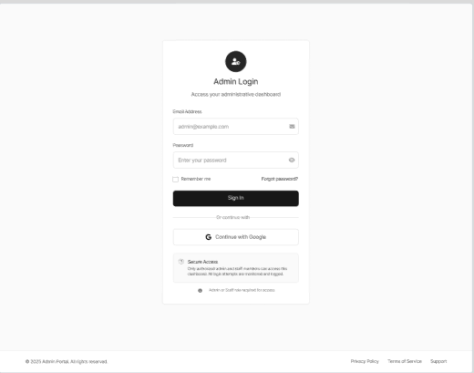
Dashboard
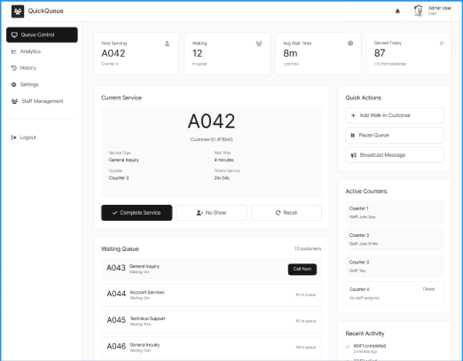
Office Register Page
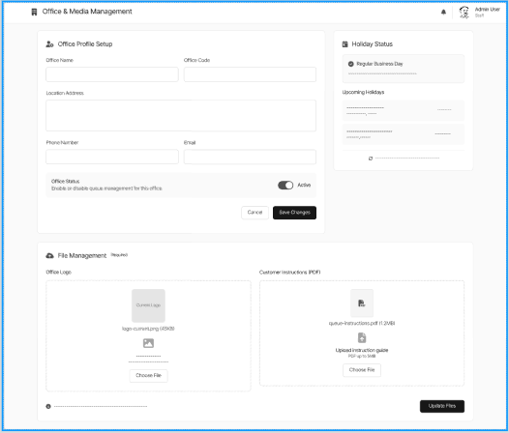
Order and Ticket History Page
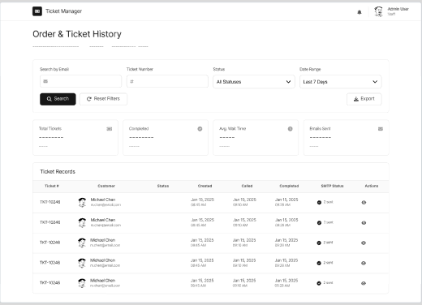

Admin Login Page
Header: Circular user avatar, "Admin Login" title, and instructional sub-header.
Form Area: Input fields for "Email Address" and "Password" with leading icons.
Action Row: "Sign In" primary button, "Remember me" checkbox, and "Forgot password?" link.
Social Auth: Horizontal divider with text, and a "Continue with Google" button.
Security Footer: Information box titled "Secure Access" with technical policy text.

Dashboard (Live Queue Control)
Sidebar Navigation: Vertical menu with links (Queue Control, Analytics, History, Settings, Staff Management) and a "Logout" button.
Header Metrics: Row of four cards showing "Now Serving," "Waiting," "Avg Wait Time," and "Served Today".
Current Service Card: Large display for active Ticket Number, Service Type, Customer ID, and service timers.
Service Actions: Row of three buttons: "Complete Service," "No Show," and "Recall".
Waiting Queue List: Scrollable vertical list showing upcoming Ticket IDs, wait times, and "Call Next" buttons.
Utility Sidebar: Cards for "Quick Actions," "Active Counters," and a "Recent Activity" log.

Office Register Page (Office & Media Management)
Office Profile Setup: Form containing fields for Office Name, Office Code, Location Address, Phone Number, and Email.
Holiday Status: Card showing "Regular Business Day" status, a list of upcoming holidays, and an "Office Status" toggle switch.
File Management: Two interactive drop zones for "Office Logo" and "Customer Instructions (PDF)" with upload icons and "Choose File" buttons.
Footer Actions: "Cancel" and "Save Changes" buttons for the profile, and an "Update Files" primary button.

Order and Ticket History Page
Filter Bar: Top horizontal section with search fields for Email and Ticket Number, status dropdown, date range picker, and "Search," "Reset Filters," and "Export" buttons.
History Summary: Row of four summary cards for Total Tickets, Completed, Avg. Wait Time, and Emails Sent.
Ticket Records Table: Data grid with columns for Ticket #, Customer (with avatar), Status, and timestamps for Created, Called, and Completed.
Audit Column: "SMTP Status" indicator showing successful notification delivery and a separate "Actions" column.

7.2 Mobile Application Wireframes
Splash Screen
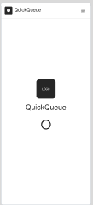

Login Page
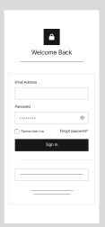
Registration Page
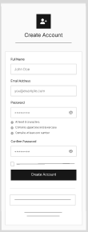

Dashboard Page
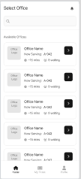
Ticket Page
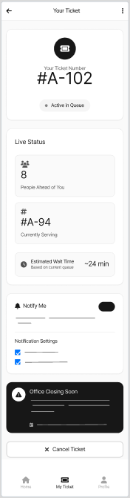
Notification Screen
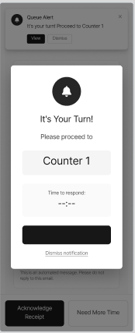
Profile Setting Page
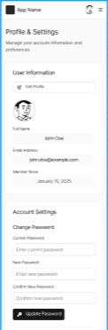
Profile Page
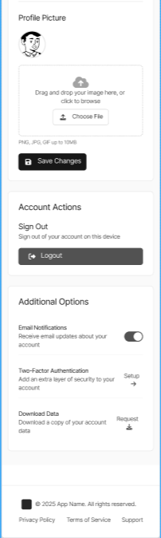
Splash Screen
Header: [App Logo Icon]
Body: [QuickQueue Brand Name]
Footer: [Loading Spinner Icon]
Login Page
Header: [Secure Lock Icon] [Welcome Back Title]
Form Area: [Email Address Input] [Password Input]
Options: [Remember Me Checkbox] [Forgot Password Link]
Primary Action: [Sign In Button]
Registration Page
Header: [User Add Icon] [Create Account Title]
Form Area: [Full Name Input] [Email Address Input] [Password Input] [Confirm Password Input]
Validation: [Password Strength Requirements Checklist]
Primary Action: [Create Account Button]
Select Office (Home)
Header: [Select Office Title] [Notification Bell Icon]
Search: [Office Search Bar with Magnifying Glass]
Content: [Available Offices List] [Office Logo Placeholder] [Office Name] [Now Serving Ticket #] [Estimated Wait Time] [Waiting Customer Count] [Navigate Arrow Button]
Navigation: [Home Icon] [My Ticket Icon] [Profile Icon]
Ticket Page
Header: [Back Arrow] [Your Ticket Title] [More Options Menu]
Ticket Card: [Ticket Icon] [Your Ticket Number Label] [#A-102] [Active in Queue Badge]
Live Status: [People Ahead of You Count] [Currently Serving Ticket #] [Estimated Wait Time with Clock Icon]
Notifications: [Notify Me Toggle] [Notification Settings Checkboxes]
Alert: [Office Closing Soon Warning Card with Icon]
Action: [Cancel Ticket Button with X Icon]
Notification Screen
Overlay: [Queue Alert Modal] [Bell Icon] [It's Your Turn Title]
Content: [Counter Assignment Label] [Counter 1 Display] [Time to Respond Timer]
Actions: [Acknowledge Receipt Button] [Need More Time Button] [Dismiss Notification Link]
Profile & Settings Page
Header: [App Logo] [User Avatar Thumbnail] [Menu Icon] [Profile & Settings Title]
User Info: [Edit Profile Button] [User Avatar] [Full Name Display] [Email Address Display] [Member Since Date]
Password: [Current Password Input] [New Password Input] [Confirm New Password Input] [Update Password Button]
Profile Picture: [Picture Preview] [Image Upload Drag and Drop Zone] [Choose File Button] [Save Changes Button]
Account Actions: [Logout Button with Icon]
Options: [Email Notifications Toggle] [Two-Factor Authentication Setup Link] [Download Data Request Link]

Mobile-Specific Features:
- Touch-optimized buttons (min 44x44px)
- Gesture support (swipe, pull-to-refresh for queue updates)
- Push notifications and overlays for real-time turn alerts
- Bottom navigation for main actions (Home, My Ticket, Profile)
- Simplified forms for mobile input (Registration and Login)

Design System:
- Typography: Clean, modern sans-serif typeface (e.g., Inter or Roboto) to ensure high readability across mobile devices and web dashboards.
- Color Palette: A primary brand color for main actions (e.g., "Take Ticket", "Sign In"), neutral grays for backgrounds and secondary text, and semantic colors (e.g., Red for "Cancel Ticket" or warnings, Green for active/success states).
- Iconography: Consistent, minimalist SVG icons (e.g., Secure Lock, Notification Bell, User Avatar, Back Arrow) to aid quick visual navigation and comprehension.
- Component Library: Reusable UI elements including standardized input fields with leading icons, cards for queue status, and interactive modals for notifications.
- Spacing & Grid: An 8pt grid system utilizing Tailwind CSS spacing utilities and Jetpack Compose modifiers to ensure consistent padding, margins, and alignment across all screens.
- Accessibility: High color contrast ratios, dynamic text sizing support, and touch-optimized interactive elements (minimum 44x44px).

8.0 PLAN
8.1 Project Timeline
Phase 1: Planning & Design (Week 1-2)
Week 1: Requirements & Architecture
Day 1-2: Project setup and documentation
Day 3-4: Complete FRS and NFR Day
5-7: System architecture design
Week 2: Detailed Design
Day 1-2: API specification
Day 3-4: Database design
Day 5-6: UI/UX wireframes
Day 7: Implementation plan finalization
Phase 2: Backend Development (Week 3-4)
Week 3: Foundation
Day 1: Spring Boot setup with dependencies
Day 2: Database configuration and entities
Day 3: JWT authentication implementation
Day 4: User management endpoints
Day 5: Product CRUD operations
Week 4: Core Features
Day 1: Cart functionality
Day 2: Order management
Day 3: Search and filtering
Day 4: Error handling and validation
Day 5: API documentation and testing
Phase 3: Web Application (Week 5-6)
Week 5: Frontend Foundation
Day 1: React setup with TypeScript
Day 2: Authentication pages (login, register)
Day 3: Product listing page
Day 4: Product detail page
Day 5: Shopping cart implementation
Week 6: Complete Web Features
Day 1: Checkout flow
Day 2: Order history and confirmation
Day 3: Admin dashboard
Day 4: Responsive design polish
Day 5: API integration and testing
Phase 4: Mobile Application (Week 7-8)
Week 7: Android Foundation
Day 1: Android Studio setup and project structure
Day 2: Authentication screens
Day 3: Product browsing
Day 4: Shopping cart
Day 5: API service layer
Week 8: Complete Mobile App
Day 1: Checkout flow
Day 2: Order management
Day 3: UI polish and animations
Day 4: Testing on emulator/device
Day 5: APK generation and documentation
Phase 5: Integration & Deployment (Week 9-10)
Week 9: Integration Testing
Day 1: End-to-end testing across platforms
Day 2: Bug fixes and optimization
Day 3: Security review
Day 4: Performance testing
Day 5: Documentation updates
Week 10: Deployment
Day 1: Backend deployment (Railway/Heroku)
Day 2: Web app deployment (Vercel/Netlify)
Day 3: Mobile APK distribution
Day 4: Final testing
Day 5: Project submission
Milestones:
- M1 (End Week 2): All design documents complete
- M2 (End Week 4): Backend API fully functional
- M3 (End Week 6): Web application complete
- M4 (End Week 8): Mobile application complete
- M5 (End Week 10): Full system deployed and integrated
Critical Path:
- Authentication system (Week 3)
- Office location and Queue management API (Week 3-4)
- Virtual ticket generation functionality (Week 4)
- Live queue tracking and notification triggers (Week 6)
- Cross-platform testing (Week 9)
Risk Mitigation:
- Start with simplest working version of each feature
- Test integration points early and often
- Keep backup of working versions
- Focus on core functionality before enhancements

