**3. Competitive Analysis**

*Change based on instructor’s feedback*

**4. Data Definition**

*This should be reasonably consistent with Milestone 1 but should be expanded as needed and refined as per feedback. Major data items that comprise of sub-data items have to be defined in full (list all its sub-data items, and for images/video list formats, max size etc.). You must use all the data definitions and names consistently in all documents, including GUI text. Focus on data items unique and important to your application and avoid explaining obvious things like Internet,, Browser, Cloud, etc. Be sure to cover ALL items critical to your project and especially those providing a competitive advantage. At this stage data describing user privileges, registration info and main info (raw data, metadata, supporting data) have to be fully defined (as much as it is possible at this stage)*

1. Campus Snapshots — A dynamic web system that publishes information about on campus events and problems, in addition to allowing students to contribute by submitting information about issues happening in real time.
2. General user – user + admin
3. User – A person (student, faculty, staff) that utilizes the web system to make posts about events and/or problems.
4. Admin – A team consisting of members from the university’s facility management, responsible to monitor the activity Campus Snapshots, and solve the problems that are reported.
5. User ID
6. Password
7. Problem — Any event that can disrepute students’ everyday life (*Ex: A building build closed or school transportation system not working)*
8. Event
9. Database — A collection of information that is organized so that it can be easily accessed, managed and updated.
10. Photo – format, size
11. Video –

**6. High-level functional requirements**

|  |  |
| --- | --- |
| Priority Level | Functional requirement |
|  | 1. The application shall offer information about events and problems |
| 1  1  1  1  1  1  1  3  1  2  2 | * 1. The general user shall be able to create a new account   2. The general user shall be able to change his/her password   3. The general user shall be able to reset a forgotten password   4. The general user shall be able to login to his/her account   5. The general user shall be able to logout from his/her account   6. The user shall be able to create a new post   7. The user shall be able to upload photos to their post   8. The user shall be able to upload a video to their post   9. The user shall be able to read and add comments to a post   10. The user shall be able to search for an existing post   11. The user shall be able to view the latest posts on his main page |
|  | 1. The application shall offer a notification system |
| 1  2  3  3  3 | 2.1 The admin shall receive an in-app alert and an email when a new problem is reported  2.2 The user shall receive an in-app alert when the status of a reported problem changes  2.3 The user shall be able to opt for receiving notifications via SMS and/or email  2.4 The user shall be able to choose what kind of notifications he/she wants to receive (reported problem updates / upcoming events)  2.5 Calendar |
|  | 1. The admin shall be able to manage the reported problems |
| 1  1 | 3.1 Each reported problem should have a status report (reported, in process, solved)  3.2 The admin shall be able to change the status of a problem |

**8. High-level system architecture and database organization**

1. High-level Architecture

The high-level architecture of Campus Snapshots is modeled using a layered approach, where the top layer supports the user interface and the bottom layer is the system database.

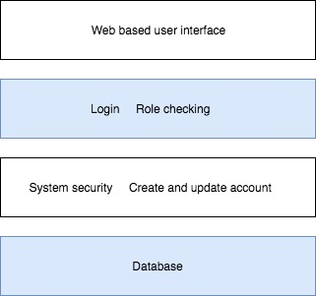

1. DB organization

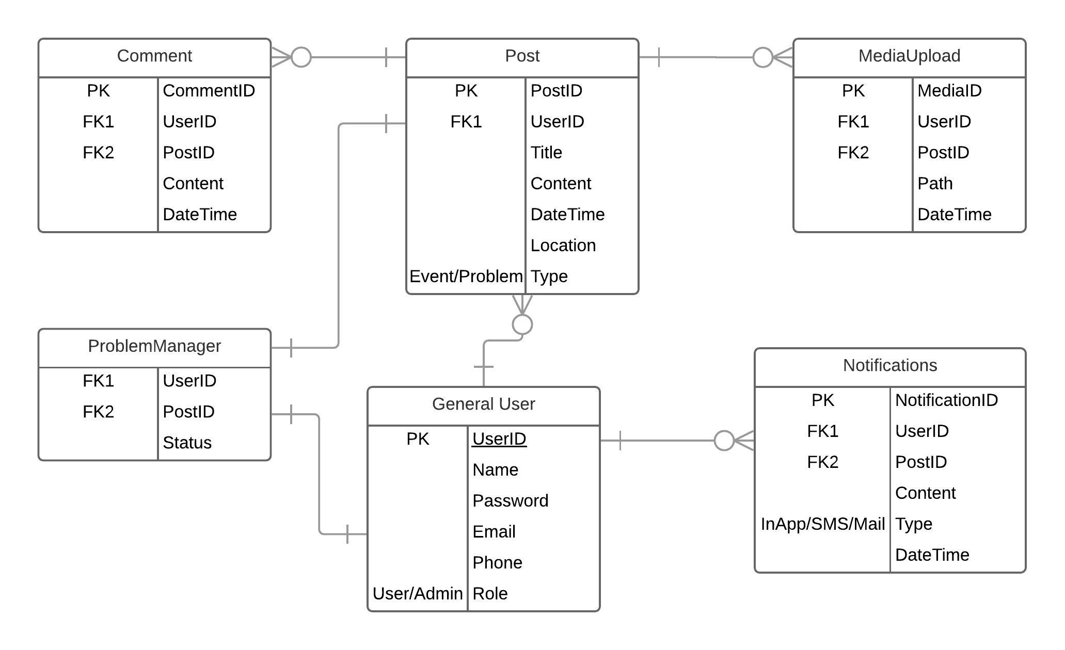

1. Media storage
2. Search /filter architecture and implementation
3. Your own APIs
4. Describe any significant non-trivial algorithm or process ( rating, ranking)

**9. High-level UML diagram**

class diagram

component and deployment diagram

**10. Key risks for project**