Table of Contents

contents1. Introduction………………………………………………………………………………………………………………….01

1.1 Purpose…………………………………………………………………………………………………………………………………….01

1.2 Scope………………………………………………………………………………………………………………………………………..01

1.3 Definitions, Acronyms, and Abbreviations…………………………………………………………………01

1.4 References……………………………………………………………………………………………………………………………..01

1.5 Overview………………………………………………………………………………………………………………………………….01

2. Overall Description……………………………………………………………………………………………………………………..01

2.1 Product Perspective…………………………………………………………………………………………………………….01

2.2 Product Features………………………………………………………………………………………………………………….02

2.3 User Classes and Characteristics…………………………………………………………………………………02

2.4 Operating Environment……………………………………………………………………………………………………..02

2.5 Design and Implementation Constraints…………………………………………………………………….02

2.6 User Documentation…………………………………………………………………………………………………………..03

3. Specific Requirements……………………………………………………………………………………………………………..03

3.1 Functional Requirements……………………………………………………………………………………….…………03

3.2 Non-Functional Requirements……………………………………………………………………………………….03

3.2.1 Performance………………………………………………………………………………………………………….………03

3.2.2 Reliability…………………………………………………………………………………………………………….………….03

3.2.3 Security……………………………………………………………………………………………………………….………….04

3.2.4 Usability…………………………………………………………………………………………………………….……………04

3.2.5 Scalability………………………………………………………………………………………………………….……………04

3.2.6 Compatibility………………………………………………………………………………………………………………….05

4. External Interface Requirements…………………………………………………………………………………………05

4.1 User Interfaces………………………………………………………………………………………………………………….....05

4.2 Hardware Interfaces……………………………………………………………………………………………………….…05

4.3 Software Interfaces……………………………………………………………………………………………………….…..05

4.4 Communication Interfaces………………………………………………………………………………………………05

5. System Features………………………………………………………………………………………………………………………..06

5.1 Feature 1: User Registration and Authentication……………………………………………………06

5.2 Feature 2: Music Streaming and Playback…………………………………………………………….…06

5.3 Feature 3: Playlist Management…………………………………………………………………………………..06

5.4 Feature 4: Search and Discovery………………………………………………………………………………..06

5.5 Feature 5: Social Sharing and Interaction………………………………………………………….……06

[Add more features as needed]

6. Other Non-Functional Requirements…………………………………………………………….07

6.1 Performance Requirements………………………………………………………………………..07

6.2 Security Requirements…………………………………………………………………………………08

6.3 Privacy Requirements…………………………………………………………………………………..08

[Add more non-functional requirements as needed]

7. Constraints……………………………………………………………………………………………………………….08

7.1 Technology Constraints…………………………………………………………………………………08

7.2 Time Constraints…………………………………………………………………………………………….08.

7.3 Budget Constraints……………………………………………….……………………………………….08

8. System Quality Attributes………………………………………………………………………………………..……………………………….08

8.1 Availability………………………………………………………………………….……….……………………….08

8.2 Maintainability…………………………………………………………………………………………………….09

8.3 Portability…………………………………………………………………………………………………………….09

[Add more quality attributes as needed]

9. Appendices……………………………………………………………………………………………………………………09

9.1 Glossary…………………………………………………………………………………………………………………..09

9.2 Use Case Diagrams…………………………………………………………………………………………….09

9.3 Class Diagrams…………………………………………………………………………………………………….09

9.4 Sequence Diagrams……………………………………………………………………………………………10

[Include any relevant diagrams and additional information]

**1. Introduction**

**1.1 Purpose**

The purpose of this document is to define the software requirements for a Spotify Clone, a music streaming application. It outlines the features, functionalities, and constraints of the system.

**1.2 Scope**

The Spotify Clone aims to replicate the core features of the popular music streaming service Spotify. It allows users to register, authenticate, stream and playback music, manage playlists, and discover new music. It also includes social sharing and interaction features.

**1.3 Definitions**, Acronyms, and Abbreviations

[List any relevant terms and their definitions]

**1.4 References**

[List any external references or documents used]

**1.5 Overview**

This document provides a detailed description of the requirements for the Spotify Clone. It includes an overall description of the system, specific requirements, external interface requirements, system features, non-functional requirements, constraints, system quality attributes, and appendices.

**2. Overall Description**

**2.1 Product Perspective**

The Spotify Clone is an independent software application that operates as a standalone music streaming service. It is not affiliated with or connected to the original Spotify service.

**2.2 Product Features**

The key features of the Spotify Clone include:

- User registration and authentication

- Music streaming and playback

- Playlist management

- Search and discovery

- Social sharing and interaction

**2.3 User Classes and Characteristics**

The Spotify

Clone caters to two main user classes:

**1. General Users**: These are the regular users who register, log in, stream music, create and manage playlists, and interact with other users.

2. Administrators: These are the system administrators who manage user accounts, music catalog, and system settings.

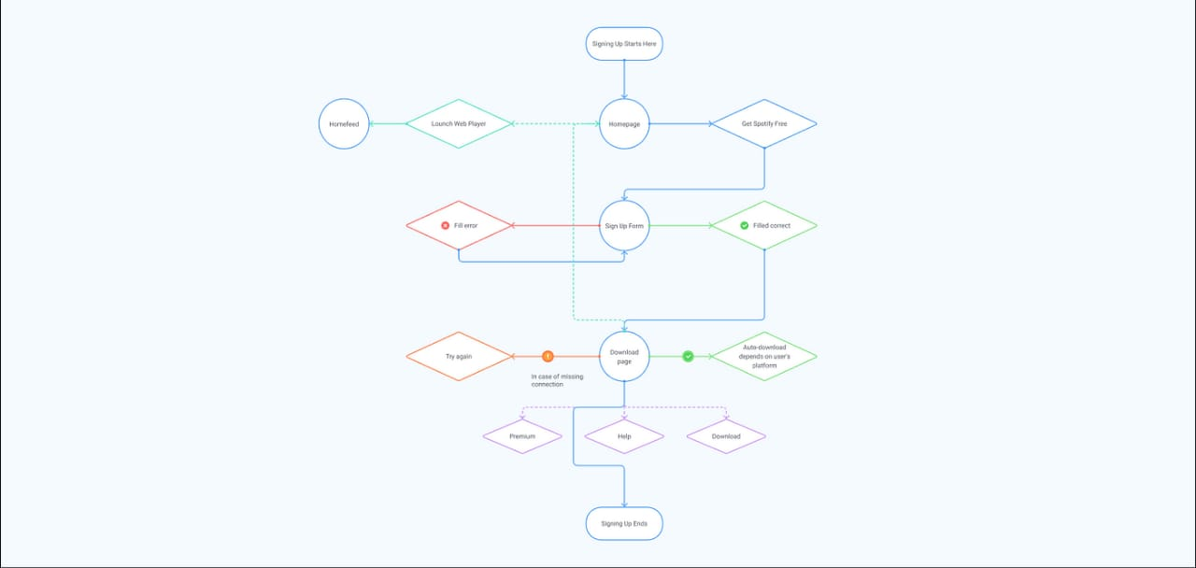

**2.4 Operating Environment**

The Spotify Clone is designed to run on various platforms, including desktop and mobile devices. It supports popular operating systems such as Windows, macOS, iOS, and Android.

**2.5 Design and Implementation Constraints**

- The Spotify Clone should be developed using modern web development technologies.

- It should comply with industry-standard security practices to ensure the safety of user data.

- The application should be scalable to accommodate a large number of concurrent users.

**2.6 User Documentation**

The Spotify Clone should provide comprehensive user documentation, including user guides and tutorials, to help users navigate and utilize the application effectively.

**3. Specific Requirements**

**3.1 Functional Requirements**

[List the functional requirements of the Spotify Clone, such as user registration, music streaming, playlist management, etc.]

**3.2 Non-Functional Requirements**

**3.2.1 Performance**

- The system should provide smooth music streaming and playback without significant delays.

- The application should handle a large number of concurrent users without performance degradation.

**3.2.2 Reliability**

- The Spotify Clone should be highly reliable, ensuring minimal downtime and system failures.

- It should provide proper error handling and gracefully recover from failures.

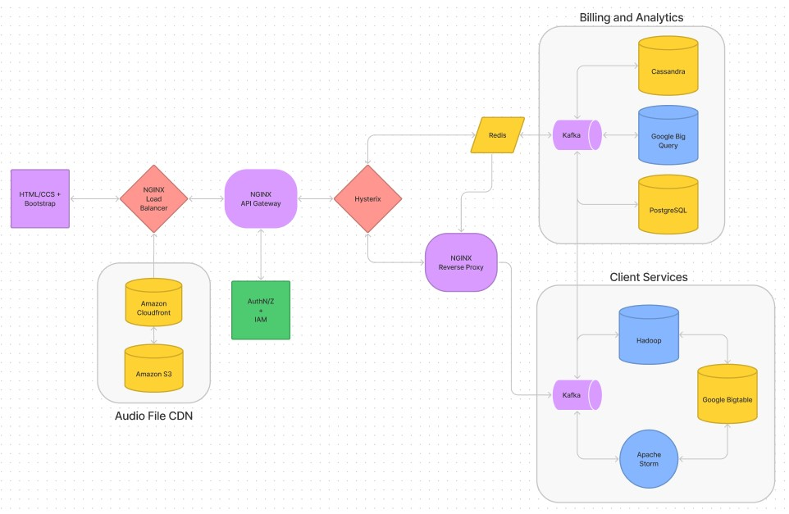

**3.2.3 Security**

- The application should employ secure authentication mechanisms to protect user accounts.

- User data, including personal information and music preferences, should be securely stored and transmitted.

**3.2.4 Usability**

- The user interface should be intuitive, easy to navigate, and aesthetically pleasing.

- The application should provide appropriate feedback and help users understand its features and functionalities.

**3.2.5 Scalability**

- The system should be scalable to accommodate increasing numbers of users and growing music catalogs.

**3.2.6 Compatibility**

- The application should be compatible with popular web browsers and mobile devices.

- It should adhere to web standards and support different screen sizes and resolutions.

**4. External Interface Requirements**

**4.1 User Interfaces**

- The user interface should be responsive, visually appealing, and provide an enjoyable user experience.

- It should include screens for user registration, authentication, music playback, playlist management, and social interactions.

**4.2 Hardware Interfaces**

- The Spotify Clone should be compatible with standard hardware components, including audio devices and speakers.

**4.3 Software Interfaces**

- The application should integrate with external music libraries or APIs to retrieve and stream music.

- It should utilize appropriate software frameworks and libraries for efficient development.

**4.4 Communication Interfaces**

- The Spotify Clone should communicate with external servers and databases securely over HTTP or HTTPS protocols.

5. System Features

**5.1 Feature 1: User Registration and Authentication**

- Users should be able to create new accounts with valid email addresses and passwords.

- The system should provide secure authentication and authorization mechanisms.

**5.2 Feature 2: Music Streaming and Playback**

- Users should be able to search for songs, albums, artists, and genres.

- The application should support streaming and playback of music tracks with proper controls (play, pause, skip, etc.).

- It should maintain a history of played songs for each user.

5.3 Feature 3: Playlist Management

- Users should be able to create, modify, and delete playlists.

- The application should allow users to add songs to playlists and manage their order.

**5.4 Feature 4: Search and Discovery**

- The system should provide advanced search functionalities to help users discover new music.

- Users should be able to browse music by genres, artists, albums, and curated playlists

.

**5.5 Feature 5: Social Sharing and Interaction**

- Users should be able to follow other users, view their profiles, and see their public playlists.

- The application should allow users to share playlists and songs on social media platforms.

- Users should be able to like, comment on, and share their thoughts about songs and playlists.

**6. Other Non-Functional Requirements**

**6.1 Performance Requirements**

- The application should load quickly and respond to user actions without significant delays.

- The system should efficiently handle a large number of concurrent users and requests.

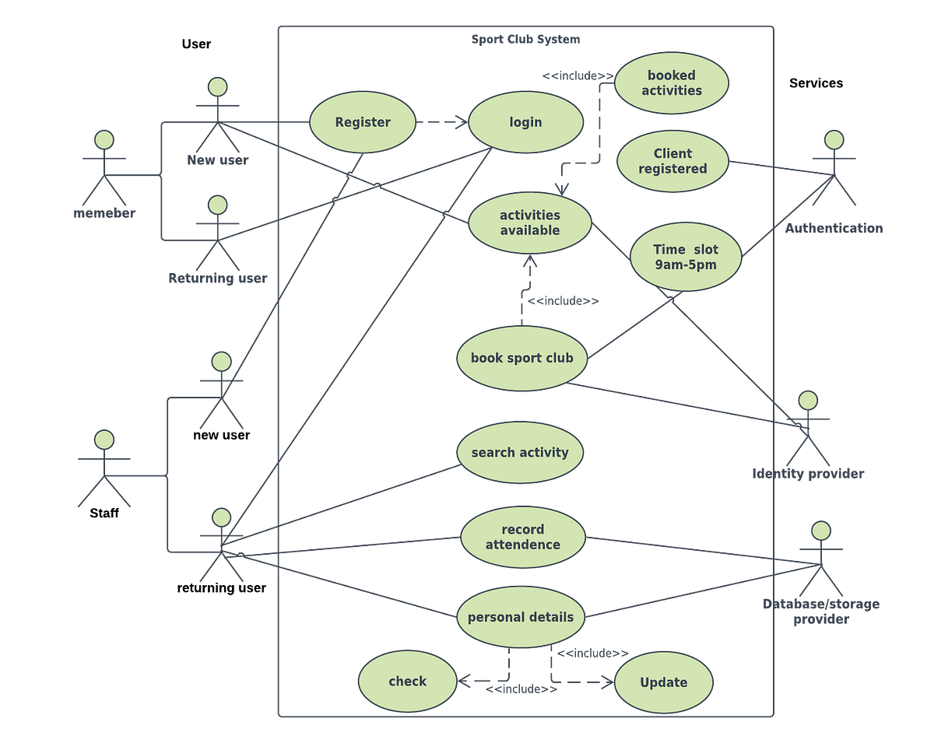

**6.2 Security Requirements**

- User passwords should be securely stored using appropriate encryption techniques.

- The application should protect against common security threats, such as cross-site scripting (XSS) and SQL injection.

**6.3 Privacy Requirements**

- The system should comply with privacy regulations and protect user data from unauthorized access or disclosure.

**7. Constraints**

**7.1 Technology Constraints**

- The Spotify Clone should be developed using specific programming languages, frameworks, and libraries.

- It should be compatible with modern web browsers and mobile platforms.

**7.2 Time Constraints**

- The development of the Spotify Clone should adhere to the agreed-upon project timeline.

**7.3 Budget Constraints**

- The project should be completed within the allocated budget.

**8. System Quality Attributes**

**8.1 Availability**

- The application should have high availability, ensuring that it is accessible to users most of the time.

- Maintenance and downtime should be scheduled during low-traffic periods.

**8.2 Maintainability**

- The code should be well-organized, modular, and follow best practices to facilitate future enhancements and bug fixes.

- Proper documentation should be provided for easy maintenance and understanding of the system.

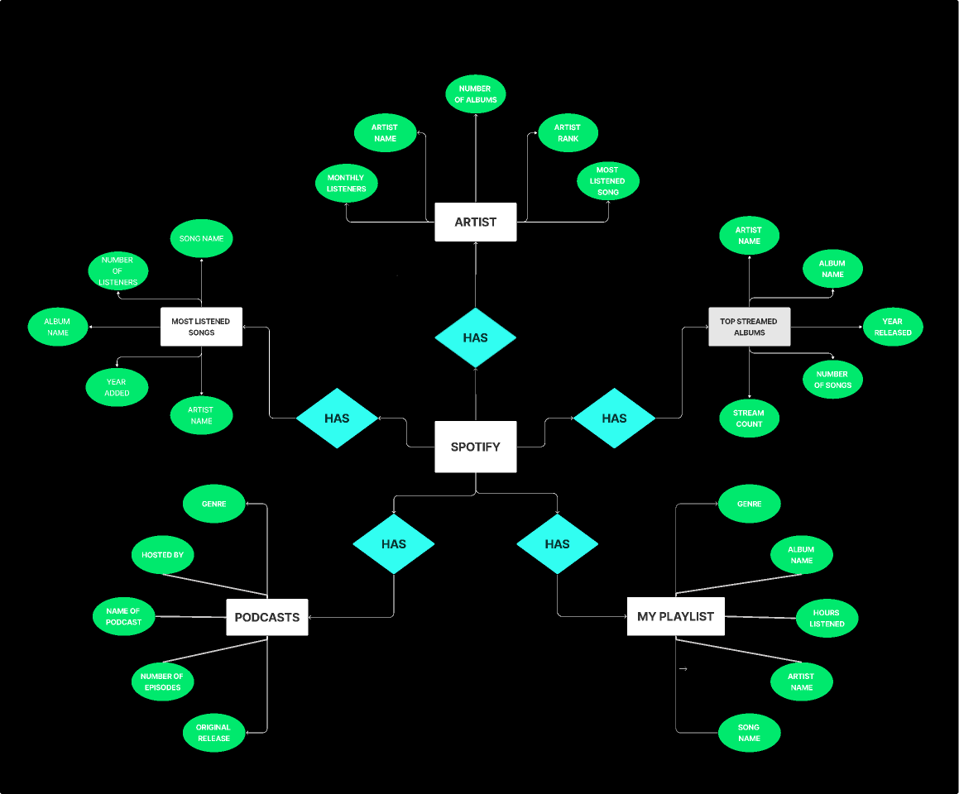

**8.3 Portability**

- The Spotify Clone should be designed to be portable across different operating systems and devices without significant modifications.

**9. Appendices**

**9.1 Glossary**

[Include a glossary of terms used in the document]

**9.2 Use Case Diagrams**

[Include relevant use case diagrams]

**9.3 Class Diagrams**

[Include relevant class diagrams]

**9.4 Sequence Diagrams**

[Include relevant sequence diagrams]

[Add any additional appendices or relevant information as needed]

Note: This is a sample template for a Software Requirement Specification (SRS) document for a Spotify Clone. It is essential to tailor this document to your specific project requirements and needs.