Project Report: EduTutor AI

# 1. INTRODUCTION

**1.1 Project Overview**

EduTutor AI is an intelligent question-answering application powered by IBM Watsonx's foundation models. It allows users—particularly students—to input academic or general queries and receive AI-generated responses in natural language. The app is built using Streamlit and deployed via Streamlit Cloud, integrating IBM Watson’s Granite 3B-Instruct model.

**1.2 Purpose**

The purpose of this project is to create a virtual AI tutor that can enhance students' learning experiences by providing instant answers, explanations, and insights, especially in self study environments.

# 2. IDEATION PHASE

**2.1 Problem Statement**

Students often struggle to find immediate answers to academic questions outside classroom hours. Most existing platforms are either too generic or require paid subscriptions.

**2.2 Empathy Map Canvas**

* Think & Feel: Needs accurate, fast answers.
* See: Many irrelevant or overly technical answers online.
* Say & Do: Prefers conversational, to-the-point help.
* Hear: From peers—"I wish I had a 24/7 study buddy."

**2.3 Brainstorming**

* Use IBM Watsonx models for language understanding.
* Build a light, deployable UI with Streamlit.
* Host on Streamlit Cloud for free/public access.

# 3. REQUIREMENT ANALYSIS

## 3.1 Customer Journey Map

The customer journey for EduTutor AI encompasses distinct pathways for students and educators, each with unique touchpoints, emotions, and experiences throughout their interaction with the platform.

## 3.2 Student Journey

**Phase 1: Awareness & Discovery**

* Touchpoints: Social media, educational institution recommendations, peer referrals
* Actions: Learning about AI-powered personalized education
* Emotions: Curiosity, skepticism about AI effectiveness
* Pain Points: Uncertainty about platform credibility, comparison with traditional learning methods
* Opportunities: Clear value proposition highlighting personalized learning benefits

**Phase 2: Registration & Onboarding**

* Touchpoints: EduTutor AI website, account creation process
* Actions: Creating account, completing diagnostic assessment
* Emotions: Anticipation, slight anxiety about initial assessment
* Pain Points: Potential technical difficulties, time required for setup
* Opportunities: Streamlined onboarding process with AI-guided diagnostics

**Phase 3: Google Classroom Integration**

* Touchpoints: Google Classroom synchronization interface
* Actions: Connecting existing courses, importing academic data
* Emotions: Relief at seamless integration, excitement about possibilities
* Pain Points: Privacy concerns, technical integration issues
* Opportunities: Transparent data usage explanation, robust technical support

**Phase 4: Initial Learning Experience**

* Touchpoints: Quiz interface, AI-generated questions, instant feedback system
* Actions: Taking first diagnostic quiz, receiving personalized recommendations
* Emotions: Engagement, surprise at question relevance
* Pain Points: Learning curve with new interface, overwhelming options
* Opportunities: Guided tutorial, progressive complexity introduction

**Phase 5: Continuous Learning**

* Touchpoints: Learning dashboard, progress analytics, adaptive quizzing
* Actions: Regular quiz participation, progress tracking, difficulty adjustment
* Emotions: Motivation from visible progress, satisfaction with personalized content
* Pain Points: Maintaining consistency, balancing with other studies
* Opportunities: Gamification elements, achievement badges, streak tracking

**Phase 6: Mastery & Advancement**

* Touchpoints: Advanced topics, performance insights, recommendation system
* Actions: Tackling complex subjects, reviewing performance analytics
* Emotions: Confidence, pride in achievements
* Pain Points: Plateau in learning, need for new challenges
* Opportunities: Advanced topic introduction, peer collaboration features

## 3.3 Data Flow Diagram

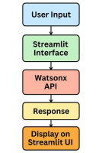

## 3.4 Technology Stack

* Frontend: Streamlit
* Backend: Python
* AI Model: IBM Watsonx (Granite 3B-Instruct)
* Hosting: Streamlit Cloud

# 4. PROJECT DESIGN

## 4.1 Problem Solution Fit

EduTutor AI aligns with the growing need for AI-based education tools that work as personalized tutors.

## 4.2 Proposed Solution

An intuitive app where users ask questions and get real-time AI responses.

## 4.3 Solution Architecture

* Streamlit captures user input
* Backend initializes Watsonx model via API
* Generates text response using IBM's foundation model
* Displays it back to the user

# 5. PROJECT PLANNING & SCHEDULING

## 5.1 Project Planning

| **Phase Duration Tasks** |
| --- |
| **Week 1** 3 days Setup IBM Watsonx & Streamlit |
| **Week 2** 2 days Model Integration |
| **Week 3** 3 days Streamlit UI + Deployment |
| **Week 4** 2 days Testing + Documentation |

# 6. FUNCTIONAL AND PERFORMANCE TESTING

## 6.1 Performance Testing

Tested the app for:

* Model latency (response within 2-3 seconds on average)
* UI responsiveness on mobile and desktop
* API key validation and error handling

# 7. RESULTS

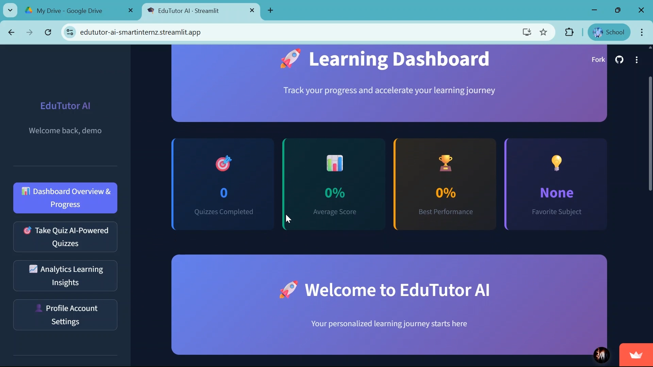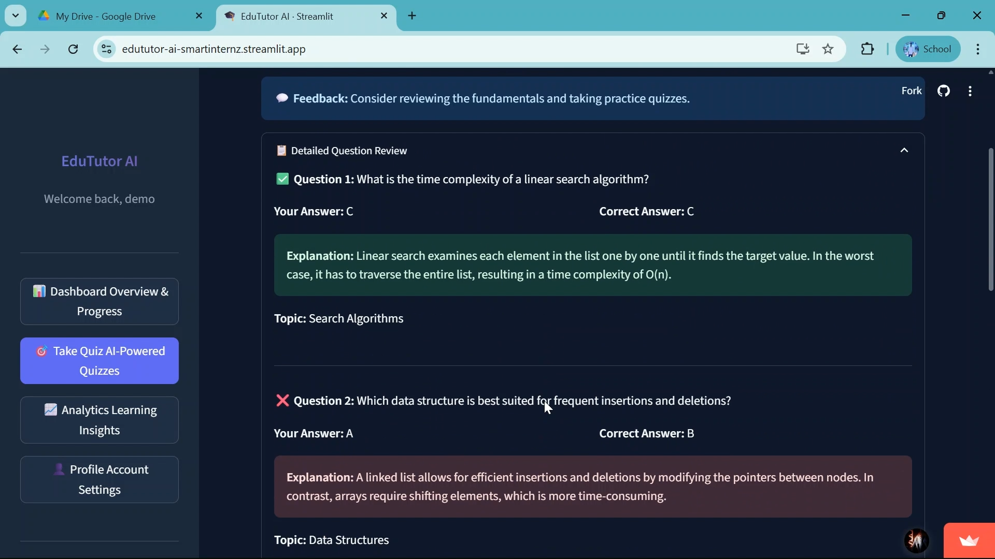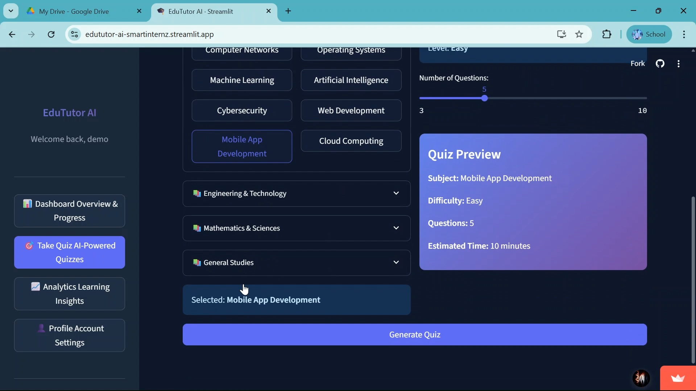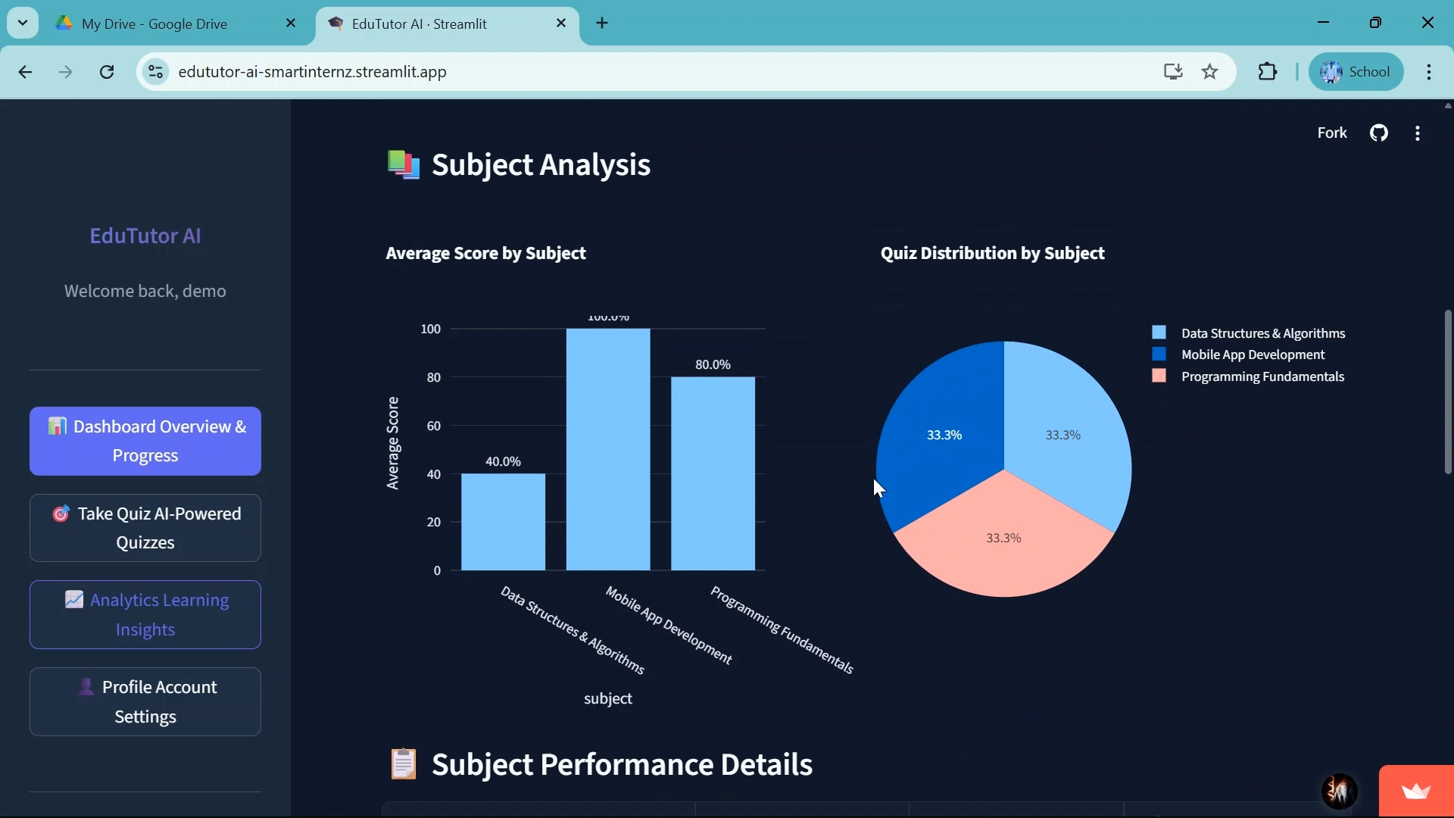

# 8. ADVANTAGES & DISADVANTAGES

**Advantages**

⮚ Fast, natural-language responses

⮚ Easy to use interface

⮚ Free and accessible via browser

**Disadvantages**

⮚ Depends on API availability

⮚ Limited by token usage and response length

⮚ No voice input or multilingual support (yet)

# 9. CONCLUSION

EduTutor AI serves as a practical, beginner-friendly AI tutoring app leveraging IBM Watsonx. It demonstrates the integration of cloud AI models with front-end frameworks like Streamlit.

# 10. FUTURE SCOPE

⮚ Add voice input

⮚ Expand to subject-specific modules

⮚ Add multi-language support

⮚ Use authentication for user tracking

**GitHub & Project Demo Link**

GitHub Repo: <https://github.com/naidu199/EduTutor-AI-Smartinternz>

Deployed Link :: <https://edututor-ai-smartinternz.streamlit.app/>