Created the Pub/Sub topic and subscription with pull delivery type  
  
Created the service account and assigned the required permissions.  
  
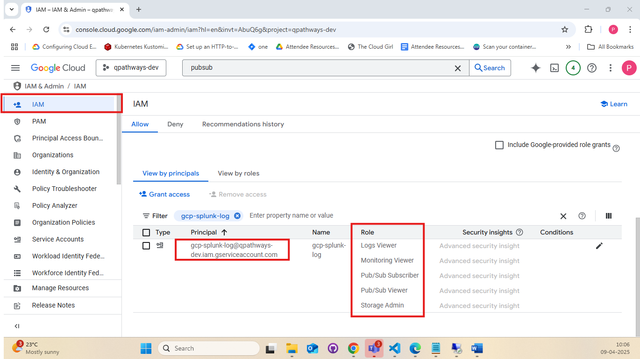

Created the sink using the Pub/Sub topic.  
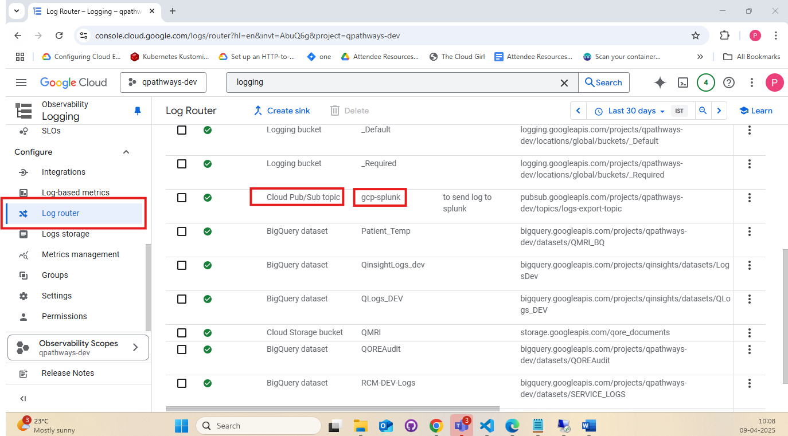  
  
  
  
  
  
In the current setup, we do not specify the particular logs to include.  
  
In the current setup, we do not specify the particular logs to exclude.  
