**MD. NAIEM SHEIKH**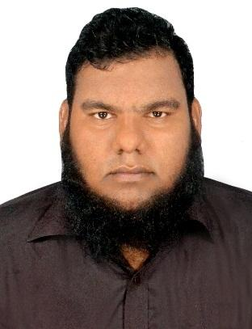

Address: Majukhan Bazar, Tongi, Gazipur

Contact: 01681733668, 01671601777  
E-mail: [naiem662@gmail.com](mailto:naiem662@gmail.com)

Linkedin:<https://www.linkedin.com/in/md-naiem-sheikh-58162a147/>

GitHub:<https://github.com/naiemsheikh>

Portfolio:<https://naiemsheikh.github.io/>

**Professional Profile:**

* **Created several website templates.**
* **Has strong knowledge in System Analysis, Data Mining and Pattern Recognition.**
* **Built numbers of software with OOP programming language C# in .Net platform.**

# Key Qualifications:

* Always try to show maximum willingness and creativity to work hard necessary to develop career, quick learner and ability to adapt from new environment.
* Excellent communication and interpersonal skill.
* Has Smart Negotiation Skill.

**Educational Qualifications:**

### B.Sc. (Hons) in Computer Science & Engineering

***Shanto-Mariam University of Creative Technology***

CGPA: 3.2 (Appeared)

* **Higher School Certificate (H.S.C )**

***Uttara Scholars City College, Uttara, Dhaka***

Major Concentration: Science

Passing year: 2013

Board: Dhaka

GPA: 3.34

**Secondary School Certificate (S.S.C)**

***Saleha Uchcha Madhyamik Bidyalaya, Dhaka***

Major Concentration: Science

Passing Year: 2011

Board: Dhaka

GPA: 4.00

**Language Skill:**

Considerably skilled and fluent in writing and speaking Bengali & English.

**Computer Skill:**

Well expert on Microsoft Office, MATLAB, Visual Studio, Hadoop.

**Computer Programming Skill:**

C, C#, C++, SQL, Java, HiveQL, Python.

**Web Programming Skill:**

HTML5, CSS, PHP, Javascript, Bootstrap, MySQL, PHP OOP, WordPress, Jquery.

**Professional Courses:**

Big Data Analytics by LICT (on going)

Data Science Foundation Course Level 1&2 By IBM

# Personal Information:

Father’s name : Md. Iman Ali Sheikh

Mother’s name : Most. Nazma Begum

Date of Birth : July 5

Sex : Male

Marital Status : Single

Religion : Islam

Nationality : Bangladeshi (By Birth)

**Md. Naiem Sheikh**



**Signature**