UNIVERSITY OF TEHRAN
Electrical and Computer Engineering Department
Computer Aided-Design
CA6

Name:
Mahdi Naieni 810101536
Amin Aghakasiri 810101381

Project Description:

This project is the continuation of CA4 and CA5. In this project, we are supposed to cascade a number of PE’s designed in the previous projects.

Datapath:
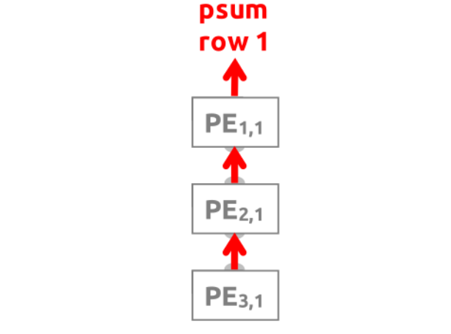
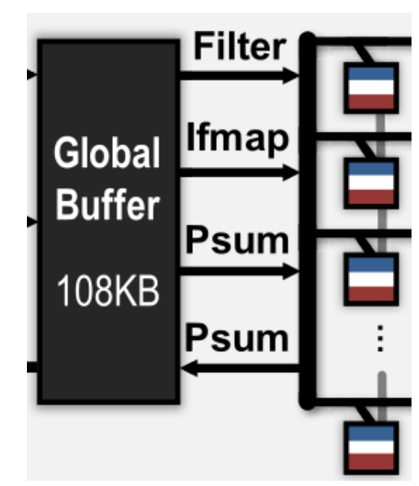

Datapath is the same as the project description.

Controller:

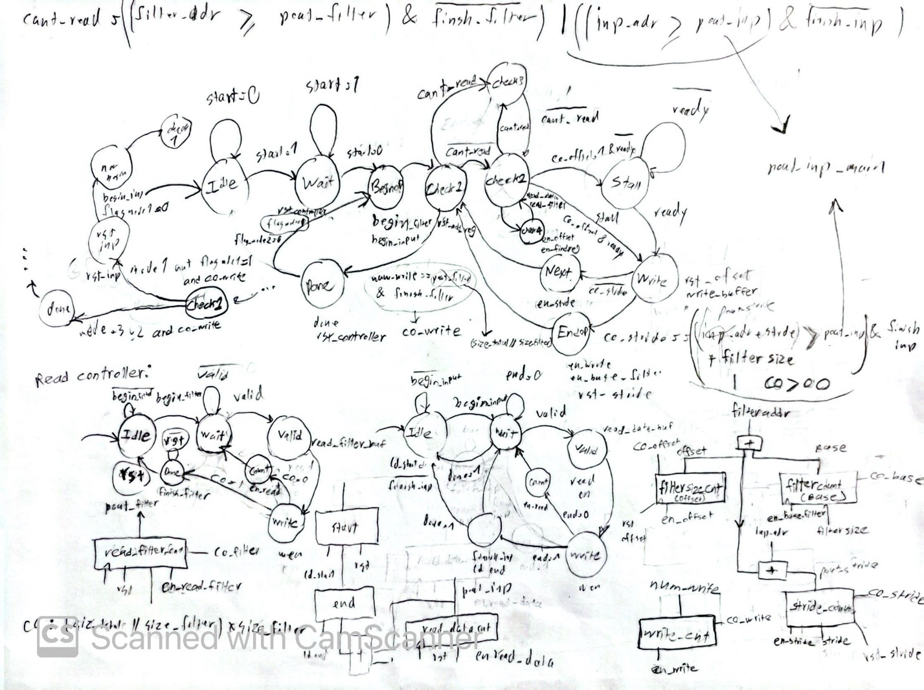
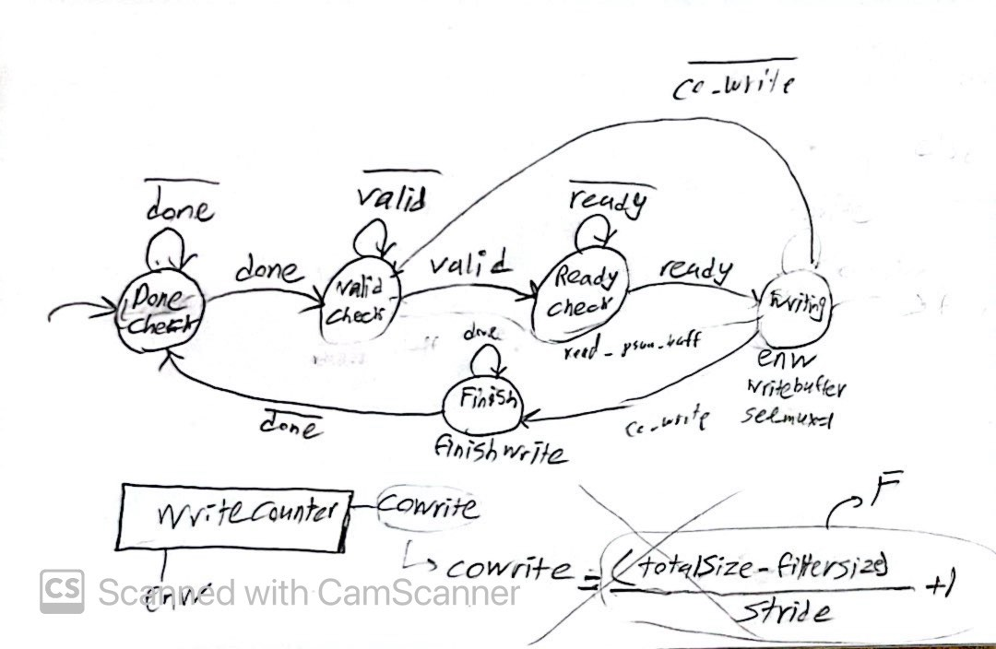
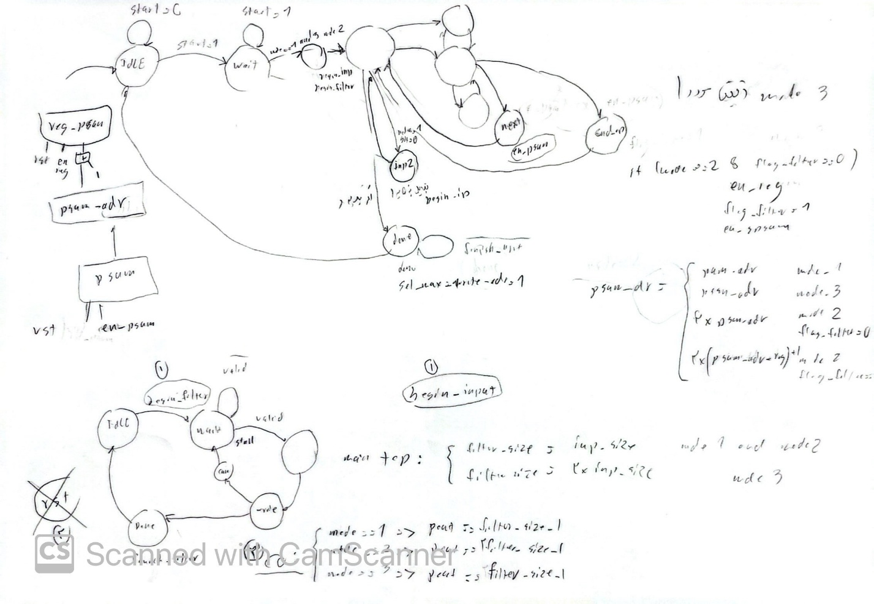

Final Top Code:
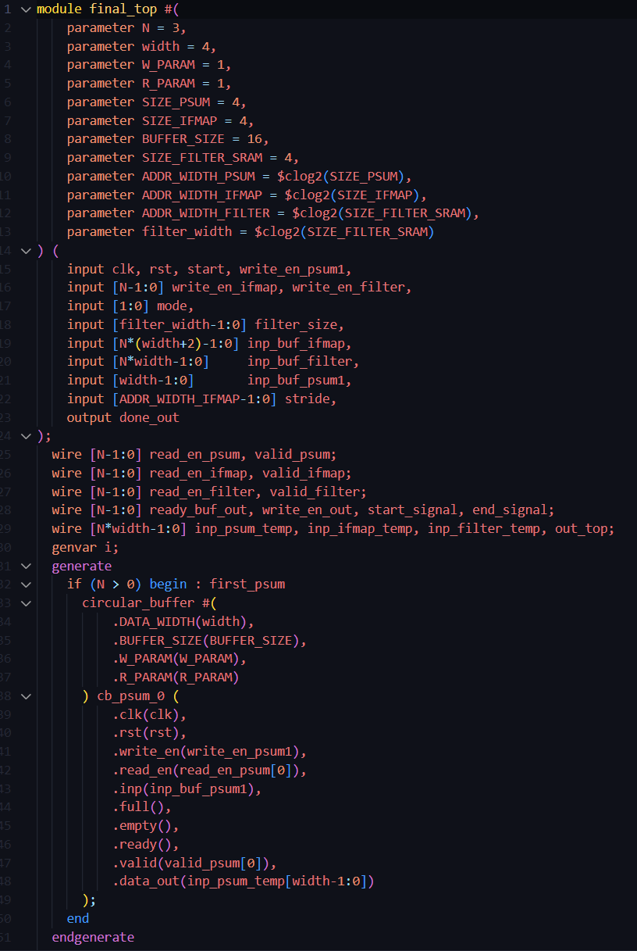

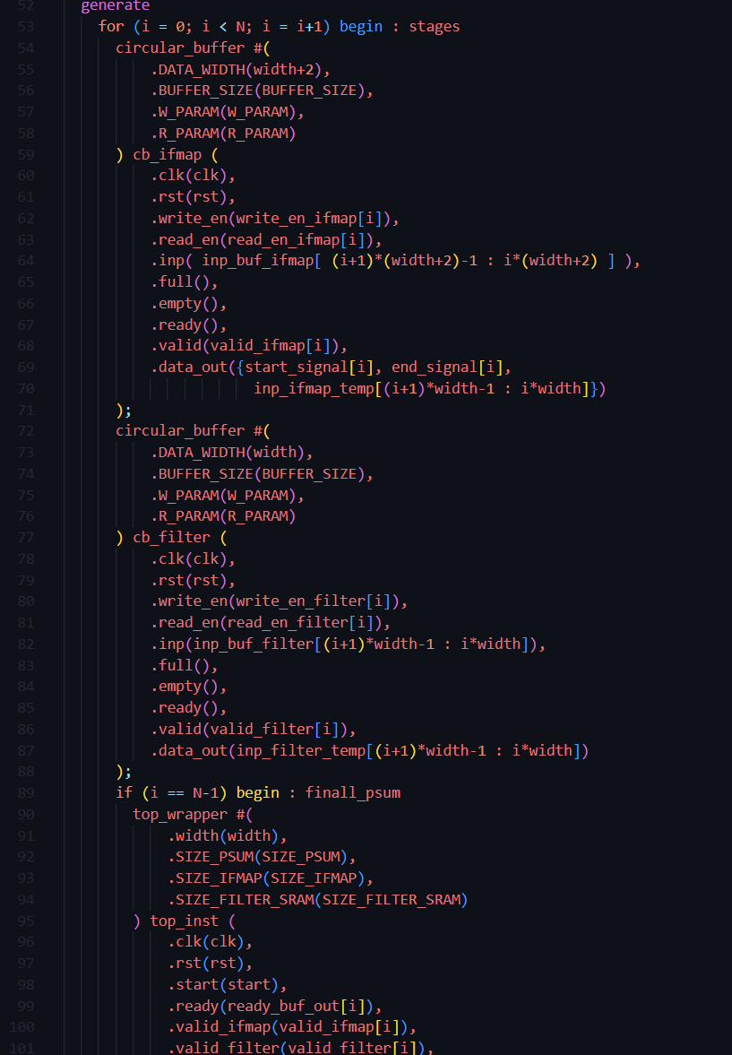
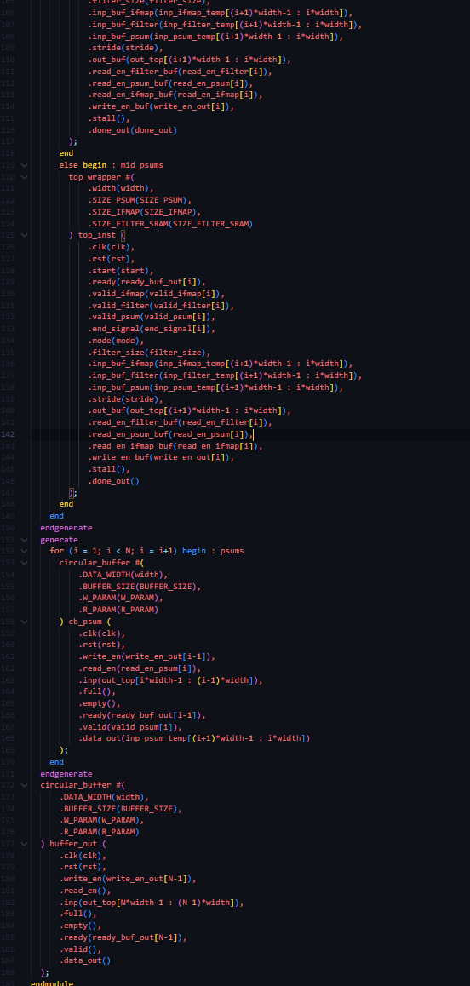
Global Buffer:
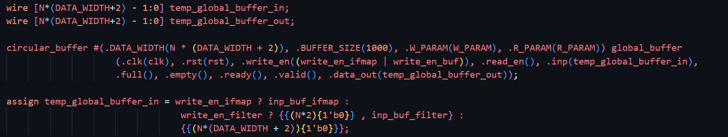

Mode 1 Part 1 Testcase with N = 4:

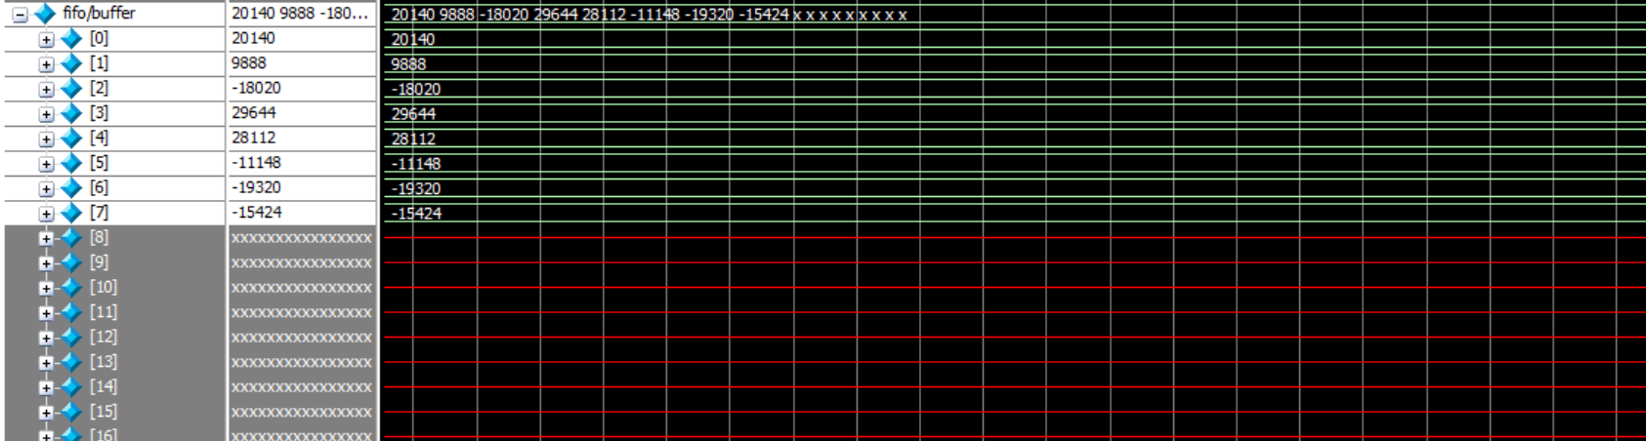

Global Buffer for Above Testcase:
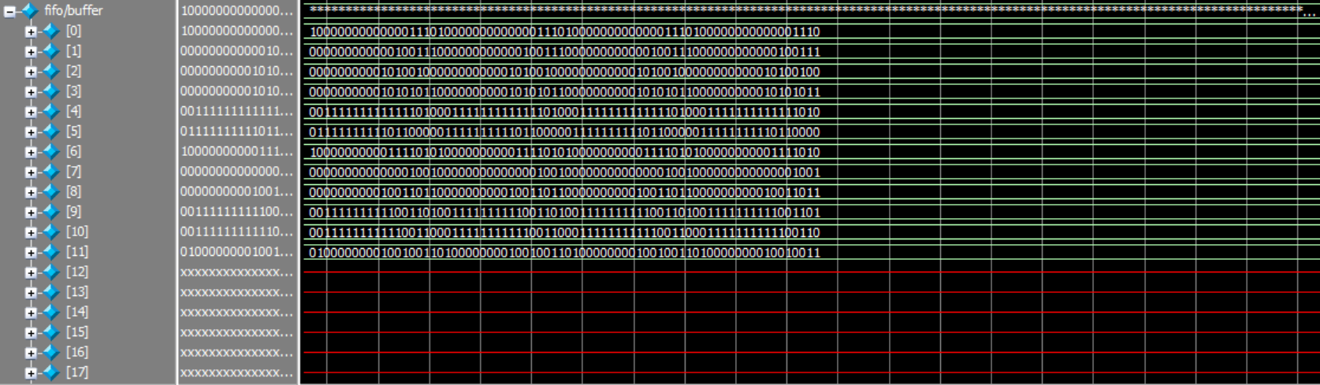

Mode 2:
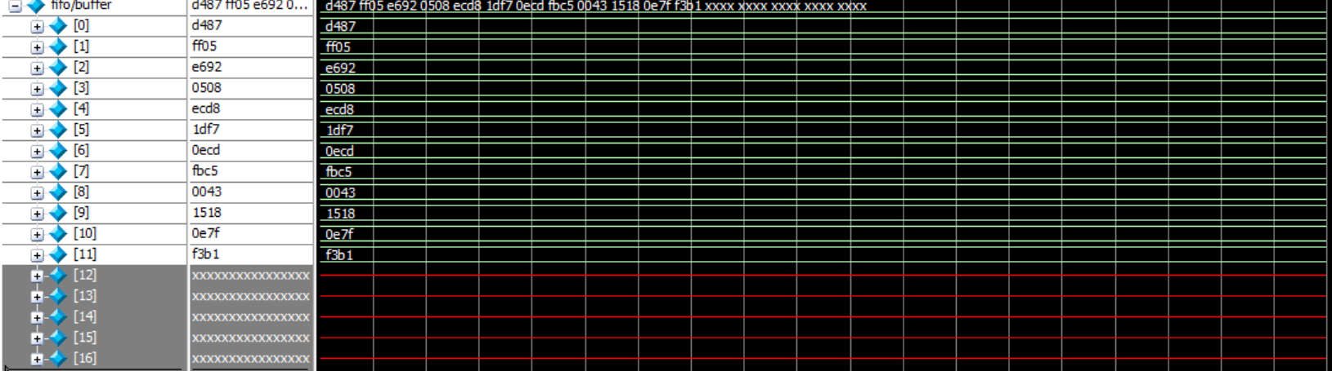

Mode 3:
