UNIVERSITY OF TEHRAN
Electrical and Computer Engineering Department
CAD
CA1

Name:
Mahdi Naieni 810101536
Amin Aghakasiri 810101381

Overview of project:
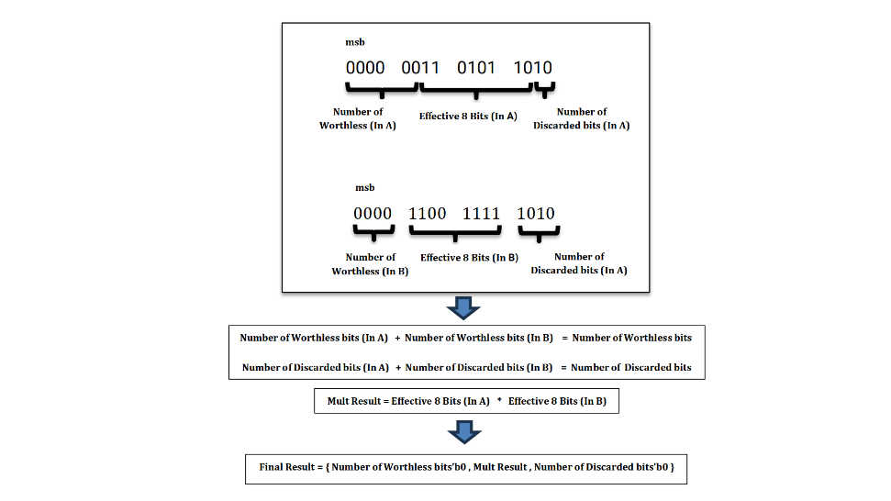

Data path:
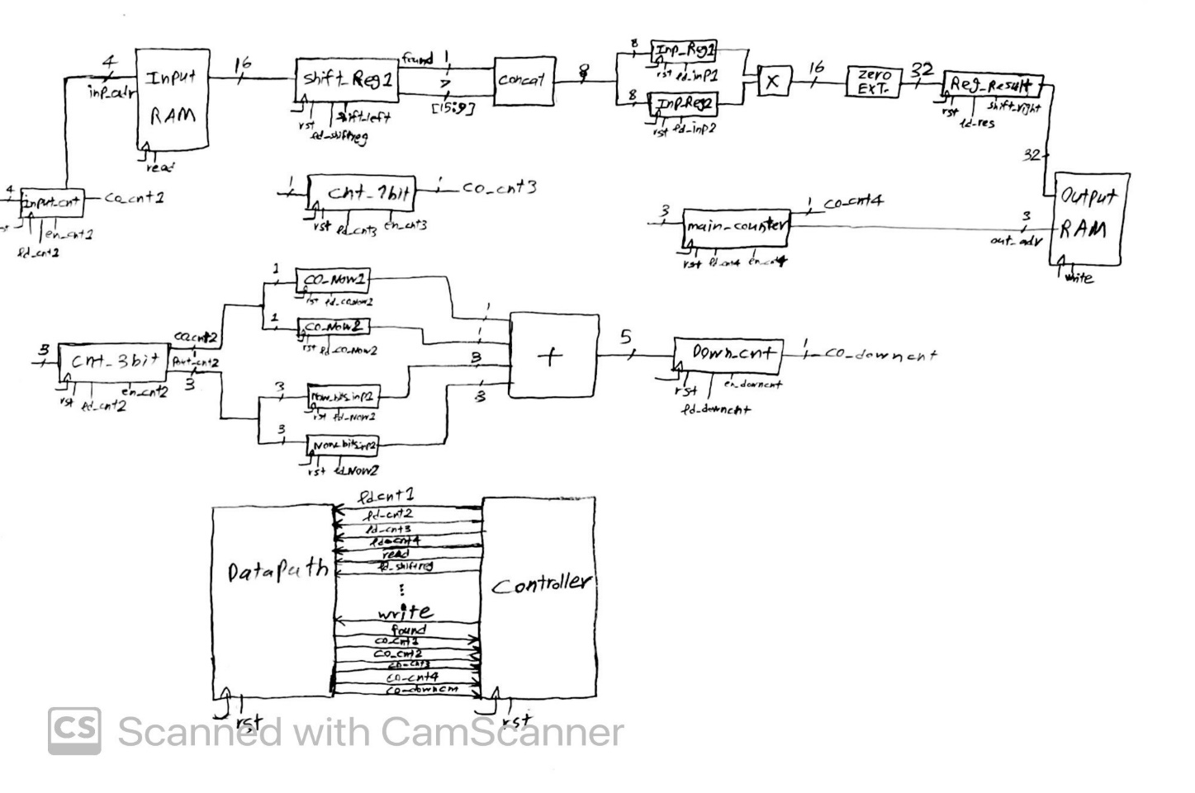

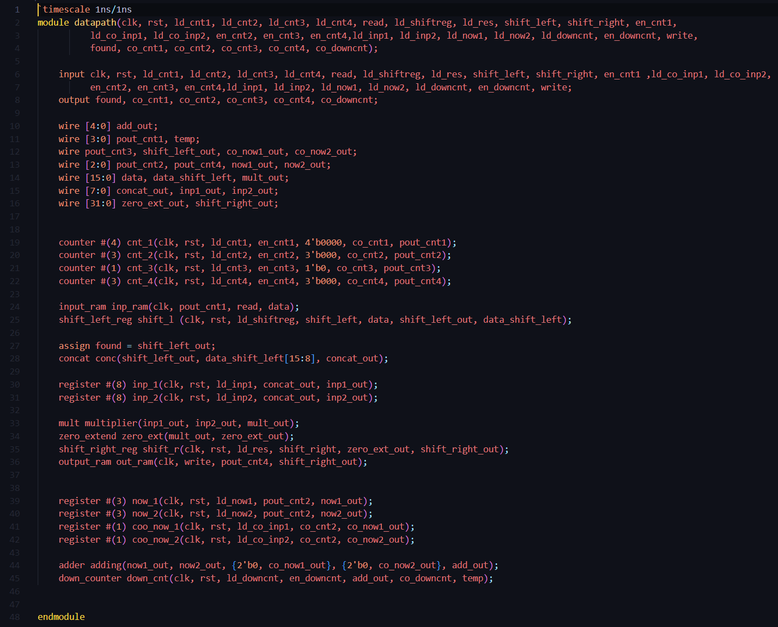

Controller:
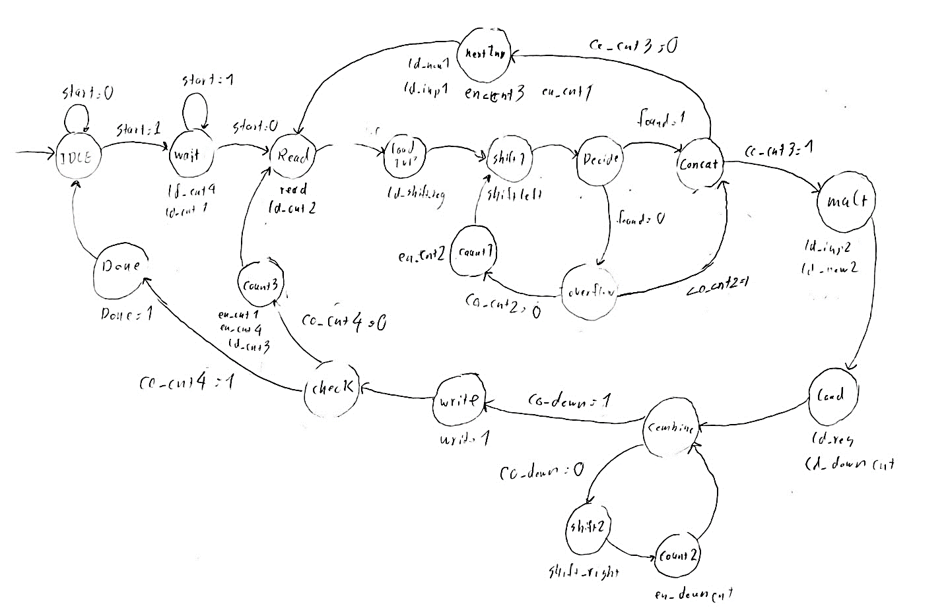

Controller Code:
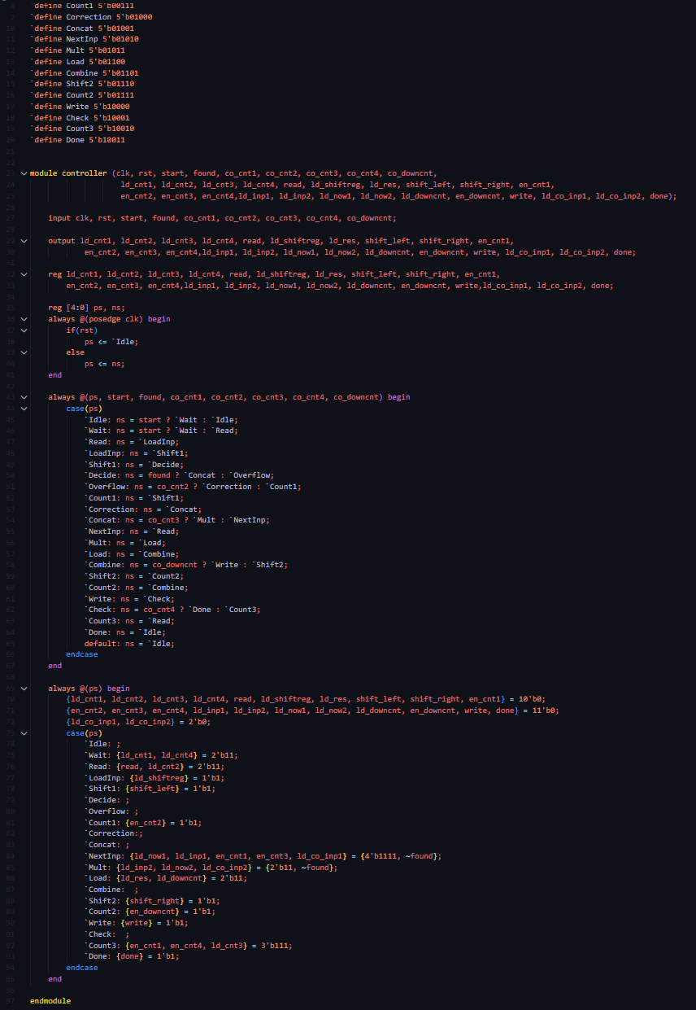

Sample Testbench:
