Unemployment in the regions
  - Synthetic data, for training only
Labour statistics team
2026-11-08
Table of contents

1 Summary
Rates are a share of the labour force, in %.
Unemployment fell in most regions between 2022 and 2025. Jazan is the exception. This note shows the national trend (Figure 1) and the latest rates (Table 1).
In Asir the rate was 7.9% in 2025 Q4, against 10.5% in 2022 Q1: a change of -2.6 points.
The data cover:
- 13 regions and the Kingdom as a whole
- 16 quarters, from 2022 Q1 to 2025 Q4
Section 2 defines the rate.
Official figures are on the GASTAT website.
Printed 08 November 2026. The latest version is online.
Reviewer: check the Jazan figures against the Q4 file.

2 Method
 How the rate is defined
The unemployment rate is
$$u=\frac{U}{U+E}×100$$
where $U$ is the number unemployed and $E$ the number employed.

3 Data
Rows: 224
Columns: 4
$ region <chr> "Kingdom", "Kingdom", "Kingdom", "Kingdom", "Kingdom", "Kingdo…
$ quarter <chr> "2022Q1", "2022Q2", "2022Q3", "2022Q4", "2023Q1", "2023Q2", "2…
$ date <date> 2022-01-01, 2022-04-01, 2022-07-01, 2022-10-01, 2023-01-01, 2…
$ rate <dbl> 8.8, 8.7, 8.6, 8.5, 8.2, 8.0, 7.8, 7.6, 7.4, 7.3, 7.3, 7.2, 6.…

4 Trend
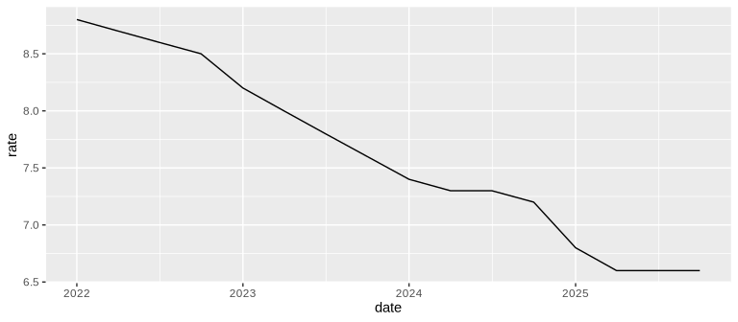
Figure 1: Unemployment rate, Kingdom, 2022 to 2025 (%)
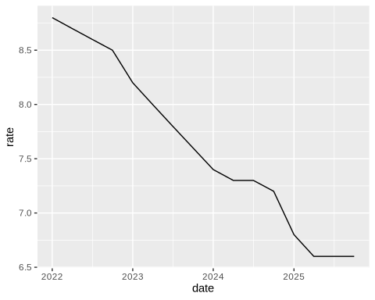  The Kingdom | 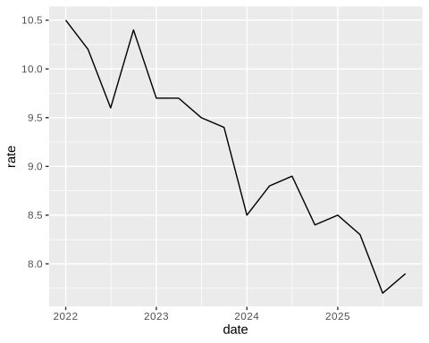  Asir

5 Latest rates

Table
Table 1: Unemployment rate by region, 2025 Q4 (%)
Region | Rate (%)
Eastern Province | 4.4
Riyadh | 5.7
Qassim | 5.9
Hail | 6.4
Kingdom | 6.6
Madinah | 6.8
Makkah | 7.1
Tabuk | 7.5
Asir | 7.9
Najran | 8.1
Northern Borders | 9.0
Al Bahah | 9.9
Al Jouf | 10.0
Jazan | 11.1

Chart
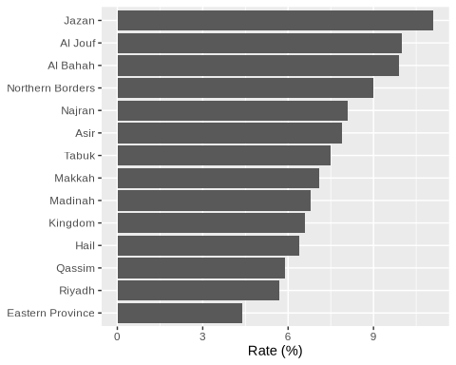

All figures in this note are synthetic, made for training.

