Unemployment in Riyadh
  - Synthetic data, for training only
2026-10-29

Summary
In Riyadh the rate was 5.7% in 2025 Q4, -2.2 points since 2022 Q1 and -0.9 points against the Kingdom (Figure 1, Figure 2, Table 1).

Trend
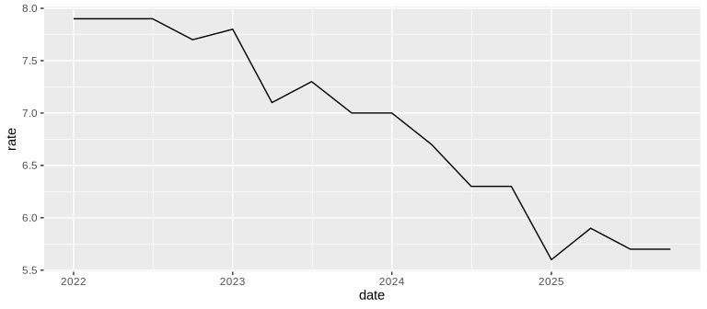
Figure 1: Unemployment rate, Riyadh (%)
  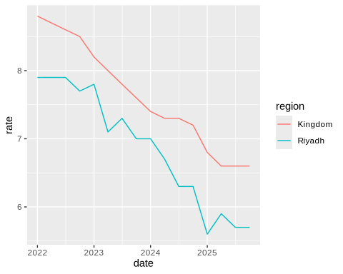
  (a) Both series
  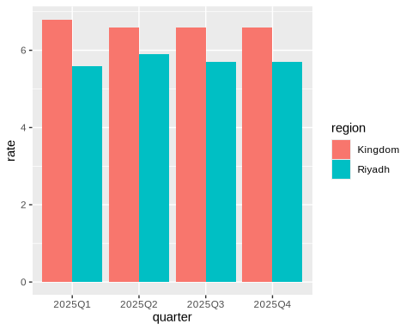
  (b) The last four quarters
Figure 2: Against the Kingdom

Latest quarters
Table 1: Unemployment rate, Riyadh (%)
quarter | rate
2025Q1 | 5.6
2025Q2 | 5.9
2025Q3 | 5.7
2025Q4 | 5.7

 Method
Rates are the unemployed as a share of the labour force. The data are synthetic, made for training.

