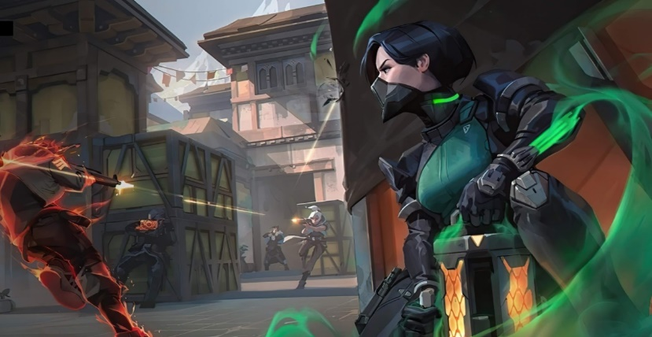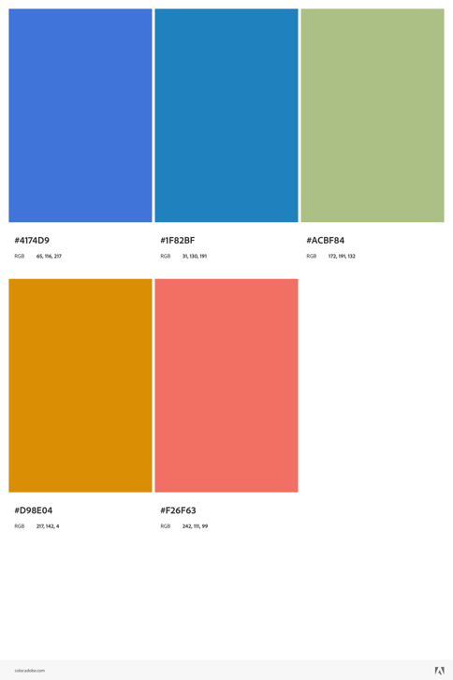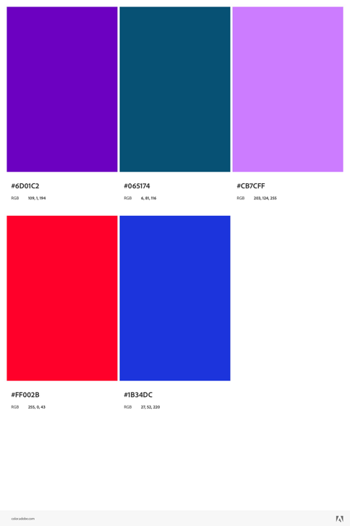the images will be all from games:

the font I will use is : Lora

<style>

@import url('https://fonts.googleapis.com/css2?family=Lora:ital,wght@0,400;0,500;1,500;1,700&display=swap');

</style>

font-family: 'Lora', serif;