Naomi Gutstein

nyg316

EECS351

Project B: Henry the Clown

**My Goal**

The goal of my project B was to create a fun character using the skills and knowledge that I have learned and gained so far in this graphics course.

**User’s Guide**

Welcome to the circus! In the circus you can find Henry the clown. Henry has two eyes, eyebrows, a nose, a mouth. Henry loves giving candy to kids at the circus so he always keeps some near by. Currently, Henry has some candy around him on the ground (two red fruit snacks and two tootsie rolls).

**Building the Garden**

*Ground-Planed Grid*: The circus exists on a horizontal ‘floor’ of lines that extend as far as Henry can see.

*Animated, adjustable 5-Jointed, 6-Segment Shape:* In the circus, Henry’s mouth contains 6 parts connected by 5 sequential joints. Henry’s mouth is animated to continuously move from a straight face to happy face. ☺ To adjust Henry's mouth press on keys 1, 2, 3, 4, 5, or 6. Depending on which key you press, a section of Henry's mouth with adjust. As you increase the key number pressed, the next right segment of Henry's mouth is adjusted. So, pressing key 1 will adjust the left-most segment of Henry's mouth, while pressing key 6 will adjust the right-most segment of Henry's mouth.

*4 or more Additional Multi-color 3D Shapes placed on ground plane*: All 4 3-D multi-colored pieces of Henry the clown’s candy are on the ground plane.

*Draw 3D Axes (r,g,b == x,y,z)*: There are 3D axes on Henry’s mouth, nose, and on one of his piece’s of candy on the ground.

*Simple Diffuse Overhead Shading:* The sun is shining bright at the circus. The sphere part of Henry’s nose is getting sunburnt! See the overhead light creating shading on his sphere nose.

**Life at the Circus**

*Smoothly adjustable 3D View Control:* Try moving to see a different view of Henry! You can move up by pressing the up-arrow key, down by pressing the down-arrow key, to the right by pressing the right-arrow key, and left by pressing the left-arrow key. To turn your direction of gaze to the right press the "d" key and to turn your direction of gaze to the left press the "a" key. To move forward press the "w" key and to move backward press the "s" key.

**The Garden of Eden Results**

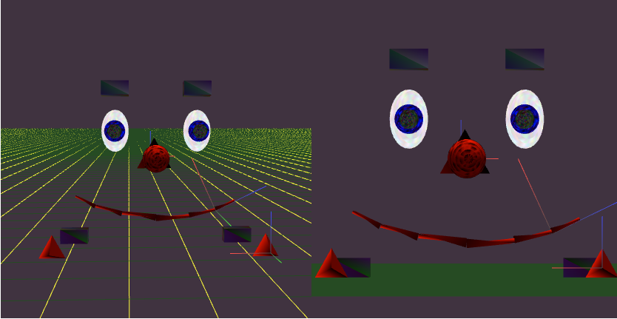

**Scene 1: The Circus**

Explanation of Scene 1: Henry the clown and his candies are all at the circus.

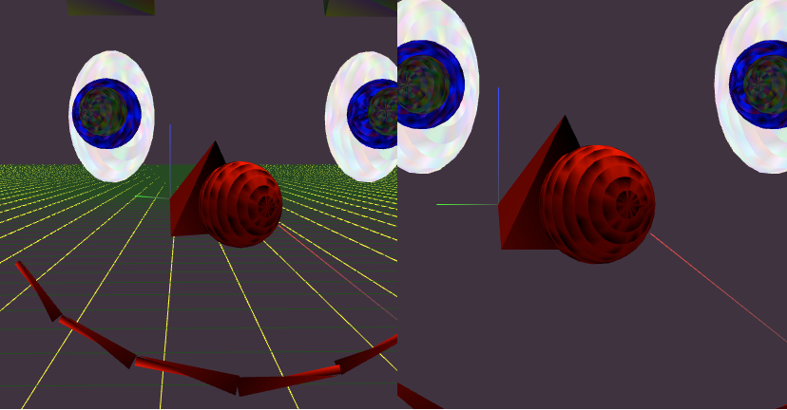

**Scene 2: Moving closer to Henry the Clown**

Explanation of Scene 2: Press the “w” key to move forward

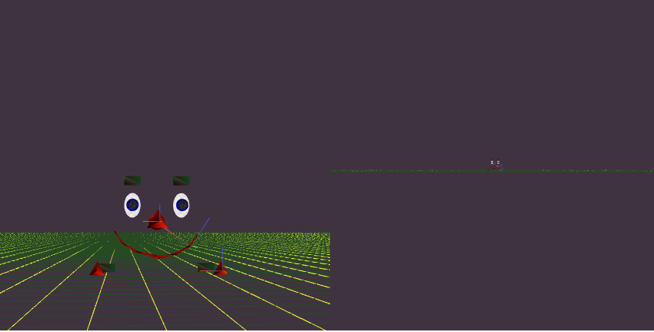

**Scene 3: Moving farther from Henry the Clown**

Explanation of Scene 3: Press the “s” key to move backwards

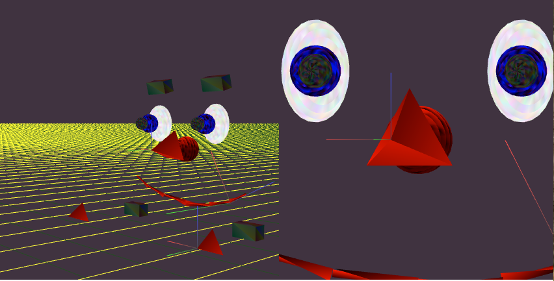

**Scene 4: Rotating around Henry the Clown**

Explanation of scene 4: Press the right and left arrow to rotate direction of gaze

*Scene Graph:*

