Naomi Gutstein

nyg316

EECS351

Project A: The Garden of Eden

**My Goal**

The goal of my project A was to tell a story using the skills and knowledge that I have learned and gained so far in this graphics course.

**User’s Guide**

Welcome to the Garden of Eden! In the garden you can find Adam, the Tree of Knowledge, the tree’s fruit, and the infamous evil snake. Adam’s lips are chomping down on the delicious and juicy fruit of the Tree of Knowledge. Beside Adam’s lips, the colorful and magical tree of knowledge places an apple of knowledge into Adam’s mouth. Next to the tree there is another one of it’s magic fruits, a special banana. Bellow Adam the evil snake is also there whispering evil thoughts and ready to slither around the garden.

**Building the Garden**

*3D parts and Per-vertex colors*: In the garden there are two different 3D parts: the apple and the banana. The apple consists of a sphere with a tetrahedron stem and the banana consists of a cube with two tetrahedrons. Both the 3D parts use the Math.random() function to have their colors differ at each vertex. Although both the fruits are one color, using Math.random(), the shades of the color vary depending on the vertex, which creates a really beautiful blend.

*Two or more movable sequential joints:* In the garden, both the tree and snake contain sequential joints.

**Life in the Garden**

*Animation, Distinct kinds of animated, jointed objects*: The Tree of Knowledge, Adam’s lips, the banana, and the apple all move continuously in the garden. Both the apple and the banana are made of 3D jointed objects both with distinct kinds of animation. The banana rotates while the apple rotates and moves continuously in and out of Adam’s mouth.

*Keyboard Interaction*: Slither the snake up the garden by clicking the up arrow on your key board, down the garden by clicking the down arrow on your key board, right in the garden clicking the right arrow on your key board, and left in the garden clicking the left arrow on your key board.

*Mouse-Click Interaction*: Rotate the evil snake by clicking on his green scales.

*Mouse-Drag Interaction:* Move the banana around the garden by clicking and dragging it.

**The Garden of Eden Results**

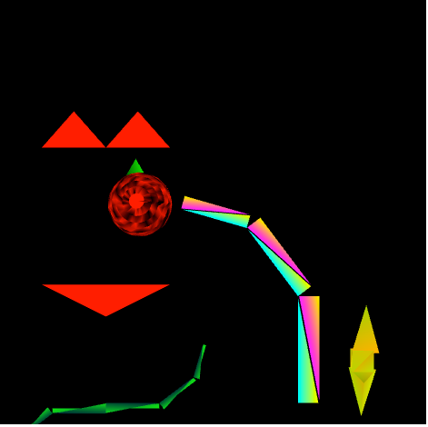

**Scene 1: Tree of Knowledge feeding Adam the apple**

Explanation of Scene 1: The Tree of Knowledge, apple, and Adam are all animated so when you open the screen, the tree will already be throwing the apple into Adam’s mouth.

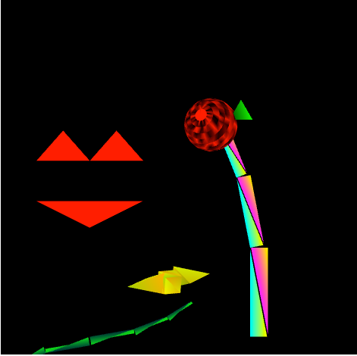

**Scene 2: Giving the banana to the snake to eat**

Explanation of Scene 2: Click and drag the rotating magic banana to the evil snake.

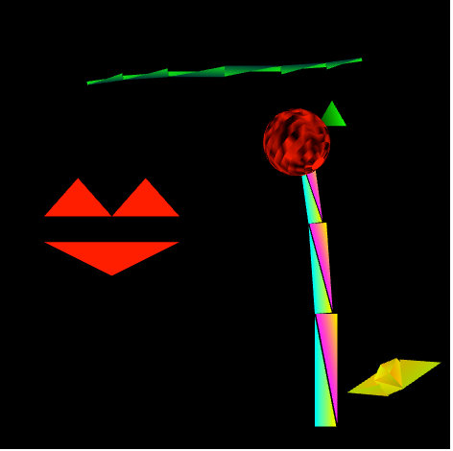

**Scene 3: Snake slithering around the garden**

Explanation of Scene 3: Move the snake using the arrow keys to the top of the garden.

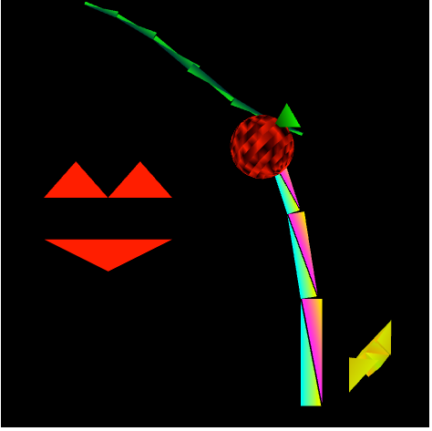

**Scene 4: Rotating snake to eat apple**

Explanation of Scene 4: Click on the evil snake to rotate it so the snake has a better angle to eat the fruit.

*Scene Graph:*

