Naomi Gutstein

nyg316

EECS351

Project C: Rafi the Bunny

**My Goal**

The goal of my project C was to create a fun character using the skills and knowledge that I have learned and gained so far in this graphics course.

**User’s Guide**

Welcome to the Zoo! In the Zoo you can find Rafi the Bunny. Rafi has a head, a tummy, two ears, hands, and feet. Henry loves carrots so he always keeps some near by. Currently, Henry has two carrots next to him.

**Building the Zoo**

*Ground-Planed Surface*: The Zoo exists on a plane of grass that spans as far as Rafi can see.

*> 3 Solid, Jointed, continually flexing shapes:* In the Zoo, Rafi and both of his carrots are 3D shapes at different ground-plane locations, with continually changing joint angles.

*Obviously different-looking Materials for each separate object:* In the Zoo, Rafi loves to disco! Not only are the carrots and Rafi made of different materials and so are the carrot’s stems, but try pressing the “m” key to enter the disco!

**Life at the Circus**

*5-DOF Camera Control:* Try moving to see a different view of Rafi!

* Up-arrow key = move upwards
* Down-arrow key = move downwards
* Right-arrow key = move to the right
* Left-arrow key = move to the left
* "w" key = move forwards
* "s" key = move backwards
* "d" key = rotate to the right
* "a" key = rotate to the left
* "+" key = rotate upwards
* "-" key = rotate downwards

*One ‘headlight’ light source attached to the camera that users can switch on/off:* To turn the headlight on and off press the “p” key

*One light source at user-adjustable 3D world-space position, that users can switch on/off, and separate, user-adjustable R, G, B values for ambient, diffuse, and specular light amounts:* To turn the overhead light on and off press the “o” key.

* "1" key = adjust red ambient
* "2" key = adjust green ambient
* "3" key = adjust blue ambient
* "4" key = adjust red diffuse
* "5" key = adjust green diffuse
* "6" key = adjust blue diffuse
* "7" key = adjust red specular
* "8" key = adjust green specular
* "9" key = adjust blue specular

In order to "shift" the way you are adjusting, just click the "shift" key!

*Switching between lighting/shading methods:* To switch between lighting methods press the “l” key. To switch between shading methods press the “k” key.

**The Zoo Results**

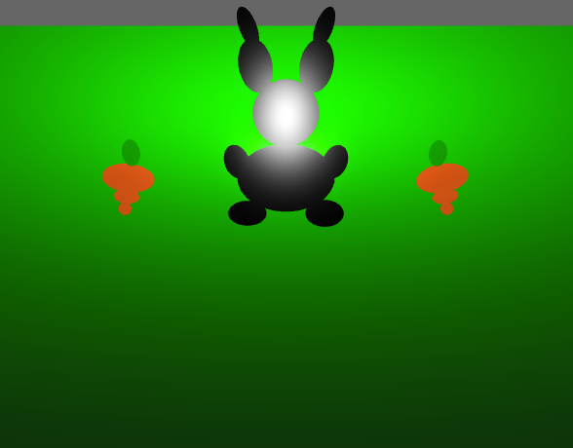

**Scene 1: The Zoo**

Explanation of Scene 1: Rafi the bunny and his carrots are all at the zoo.

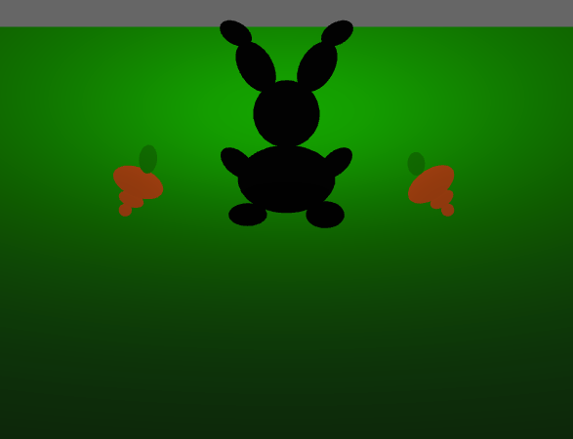

**Scene 2: Turning the headlight off**

Explanation of Scene 2: press the “p” key to turn the headlight on and off

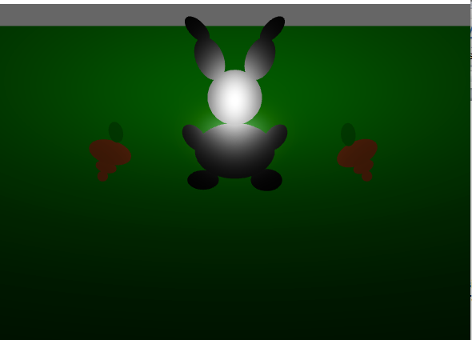

**Scene 3: Turning the overhead light off**

Explanation of Scene 3: press the “o” key to turn on and off the overhead light

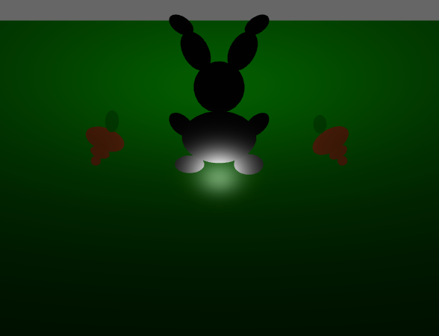

**Scene 4: Switching between lighting methods**

Explanation of Scene 4: press the “l” key to switch between different shading methods

*Scene Graph:*

