PITCH DECK • AFRICA’S BIGGEST OPPORTUNITY ENGINE
NaijaJobber 🦇
Building Africa’s Fast Growing Opportunity Engine
Where opportunity meets preparation
“From Telegram drops to a full-blown talent tech revolution.”
From Hustle to Hire
Confidential • July 2026 • Editable deck

01 • WHAT IS NAIJAJOBBER?
Africa’s fast-growing opportunity engine
A fast-growing, grassroots launchpad for early-stage Web3, tech, local, remote, white-collar, blue-collar, student, and freelance talent.
- Real builders matched with projects: moderators, ambassadors, beta testers, community managers, and creators.
- Career builders matched with employers: students, professionals, tradespeople, and first-time job seekers.
- A real-time talent-to-opportunity pipeline: Swipe-based talent matching, backed by verification and community.

02 • PROBLEM
Talent exists. Access and trust do not.
- Millions of African youth are skilled but unemployed or underemployed.
- Opportunities are scattered across chats, social networks, and global platforms not designed for African users.
- Existing platforms often exclude Web3, blue-collar, microjob, and early-career pathways.
- Unverified recruiters expose job seekers to scams and physical-safety risks.
- Employers need faster access to credible talent without building another HR department.

03 • SOLUTION
One bridge to real-time opportunity
- Web3 ambassador, moderator, beta tester, community, and quest roles.
- Local jobs, office roles, freelance assignments, microjobs, and remote employment.
- Government/NGO training, educational resources, career tools, events, and job fairs.
- Verified recruiters, moderated listings, optional local-gig safety support, and account integrity.
- Companies discover verified talent, and job seekers discover real opportunities, creating value for both employers and job seekers.
The difference between untapped potential and income is often information. NaijaJobber puts that information and the path to act on it in one place.

04 • PRODUCT
Community today. Building Tomorrow's TalentTech platform next.
Live community | Platform roadmap
Telegram and WhatsApp communities | Local / International-Web3 discovery
Daily curated job drops | Swipe-based job matching
Tech events and opportunity updates | Verified recruiter dashboard
Tech/crypto news and education | Talent-near-you and curated talent pools
Community success stories | Jobber XP, badges, referrals, courses, and rewards

05 • WHY THE BAT?
Built for the night builder
- A resting bat is not idle, it is prepared, conserving energy, ready to launch.
- The symbol mirrors African youth learning, applying, and building after hours.
- Minimal geometry communicates confidence, upward momentum, and digital recall.
- Brand energy: electric green, deep black, bold, street-smart, uplifting.
Opportunity Never Sleeps.
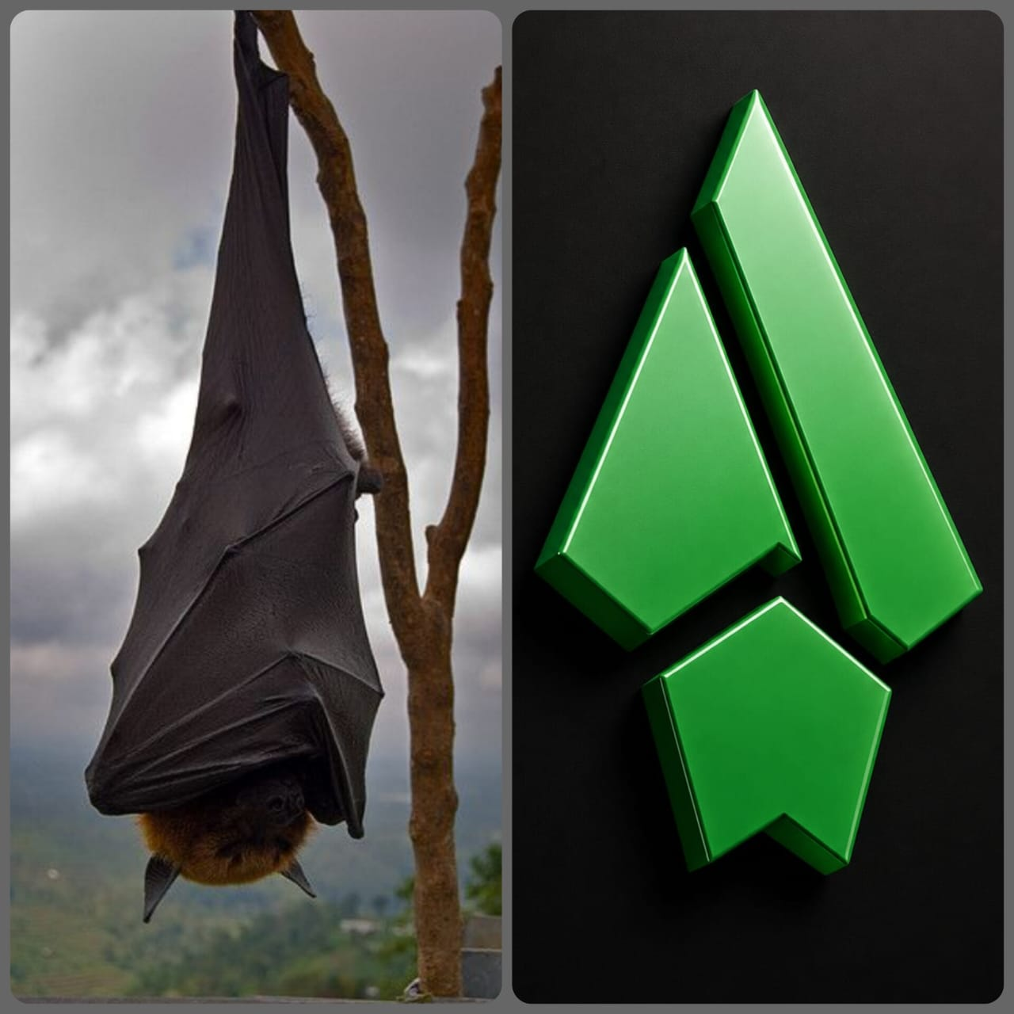

06 • MARKET
A massive underserved opportunity
Market Insight: Each year, between 10 and 12 million young Africans enter the labor market, but only around 3 million formal jobs are created, and there's growing demand for Web3 and digital skills (African Development Bank. Jobs for Youth in Africa Strategy 2016–2025)
- Beachhead: Nigeria’s community-driven local, remote, and Web3 opportunity market.
- Expansion: Lagos to Nairobi and other high-density African talent corridors.
- Demand: global startups, fintechs, Web3 ecosystems, SMEs, NGOs, governments, and training programs.
External market figures require independent citations before publication.

07 • TRACTION
Early Community Traction
NaijaJobber is pre-revenue. These figures are non-financial community traction, not paid-customer or income metrics.
As of October 2025 | Reported traction
Telegram | 950+ subscribers
WhatsApp | 825+ members
X / Twitter | 545+ followers
Engagement | Active daily community
Outcomes | Dozens of job/gig success stories
Opportunity cadence | Historically 3–5 daily curated drops

08 • PROPOSED BUSINESS MODEL
From pre-revenue to validated income
Revenue Today: Revenue Validation Begins Through Paid Pilot.
- 0–6 months: sponsored listings, Talent-as-a-Service, NaijaJobber Pro, digital products, and affiliates.
- 6–12 months: 2–5% transaction fees, $100–$300 corporate dashboards, and $1K–$10K sponsored campaigns.
- 12–24 months: $5K–$50K enterprise recruitment, hiring API, and responsible in-app advertising.
- Ongoing: Web3 ecosystem, African innovation, youth employment, and digital-skills grants.
Optional XP/token credentials come only after utility, compliance, and fraud controls are validated.

09 • DIFFERENTIATION
Speed, trust, culture, and breadth
Typical job board | NaijaJobber
Listings only | Community + learning + matching + outcomes
White-collar focus | Web3, local, remote, blue/white-collar, students
Slow search | Daily drops and swipe-based talent matching
Weak verification | Recruiter checks, moderation, and safety design
Static CV | Proof-of-work, XP, badges, talent spotlight
Global-first product language | African, builder-first culture

10 • USER STORY
Meet Chidera
22 • Lagos • NYSC • learning crypto from YouTube • I want to earn $100/month and support my family.
- Web3 route: discovers ambassador roles → joins a quest → earns first $50 → gets featured → builds confidence and portfolio.
- Local route: discovers nearby office roles → applies seamlessly → matches with a verified employer → gets hired → shares the success.
Multiply Chidera by 100,000—and ultimately 1 million.

11 • ROADMAP
Next six months: community to platform
- Finalize the platform MVP and verified recruiter workflows.
- Launch job dashboard, local/international discovery, and builder reputation.
- Grow toward 10,000 platform users while maintaining community quality.
- Secure strategic grants and run the first paid ecosystem and B2B hiring pilots.
- Establish measurable application, hiring, gig, safety, and learning outcomes.

12 • VISION
One million Africans connected to digital work by 2030
- Africa’s #1 opportunity engine—from Lagos to Nairobi.
- The go-to platform for global startups, local employers, fintechs, governments, NGOs, and ecosystems to find African talent.
- The launchpad for the next 1,000 Web3 stars and career leaders.
We’re not just building an app. We’re building Africa’s tech opportunity culture.

13 • FOUNDER
Built from the grassroots
ELLFEX — Founder
- Leading Web3 ambassador with experience across 35+ projects.
- Community growth and operations manager.
- Built and scaled the original Builders Hub community independently.
- Building a multidisciplinary team across development, operations, communications, verification, employer success, and finance.

14 • CALL TO ACTION
Help us put real opportunities in real hands.
Join us as an investor, strategic partner, employer, or ecosystem collaborator.
Founder: ELLFEX
X / Twitter: https://x.com/NaijaJobber
Telegram: https://t.me/EllfexNaijaJobber
Email: infoellfex@gmail.com

The hustle is African. The opportunity is NaijaJobber. 🦇

