ECA56 – ADVANCED WIRELESS COMMUNICATION SYSTEMS
EXPERIMENT 3
Analysis of Cellular Spectrum and Propagation Loss
Prepared by: Nilesh Naik
AIM
To compare propagation loss and received power at sub-1 GHz, mid-band and mmWave carrier frequencies, and illustrate the effect of frequency reuse on SIR.
APPARATUS / SOFTWARE REQUIRED
Computer with MATLAB Online/Desktop. No physical hardware is required; this is a software simulation.
MATLAB / ARDUINO CODE
clc;
clear;
close all;
% EXPERIMENT 3: Spectrum bands and propagation loss
frequencyGHz = [0.7 3.5 28];
distanceKm = 0.1:0.1:2;
Pt = 30; % Transmit power in dBm
figure(1);
hold on;
for k = 1:length(frequencyGHz)
fMHz = frequencyGHz(k)*1000;
FSPL = 32.44 + 20*log10(fMHz) + ...
20*log10(distanceKm*1000); % distance converted to metres for model
receivedPower = Pt - FSPL;
plot(distanceKm,receivedPower,'LineWidth',1.5);
end
grid on;
xlabel('Distance (km)');
ylabel('Received Power (dBm)');
title('Propagation Loss at Different Frequencies');
legend('0.7 GHz','3.5 GHz','28 GHz','Location','best');
% Free-space path loss comparison
figure(2);
hold on;
for k = 1:length(frequencyGHz)
fMHz = frequencyGHz(k)*1000;
FSPL = 32.44 + 20*log10(fMHz) + ...
20*log10(distanceKm*1000);
plot(distanceKm,FSPL,'o-','LineWidth',1.5);
end
grid on;
xlabel('Distance (km)');
ylabel('Free Space Path Loss (dB)');
title('Path Loss versus Distance');
legend('0.7 GHz','3.5 GHz','28 GHz','Location','best');
% Simplified SIR illustration for frequency reuse
clusterSize = [1 3 7 12];
sirDb = [0.5 8.9 15.3 19.4];
figure(3);
plot(clusterSize,sirDb,'o-','LineWidth',1.5);
grid on;
xlabel('Frequency Reuse Cluster Size');
ylabel('Estimated SIR (dB)');
title('SIR versus Frequency Reuse Cluster Size');
OUTPUT SCREENSHOTS
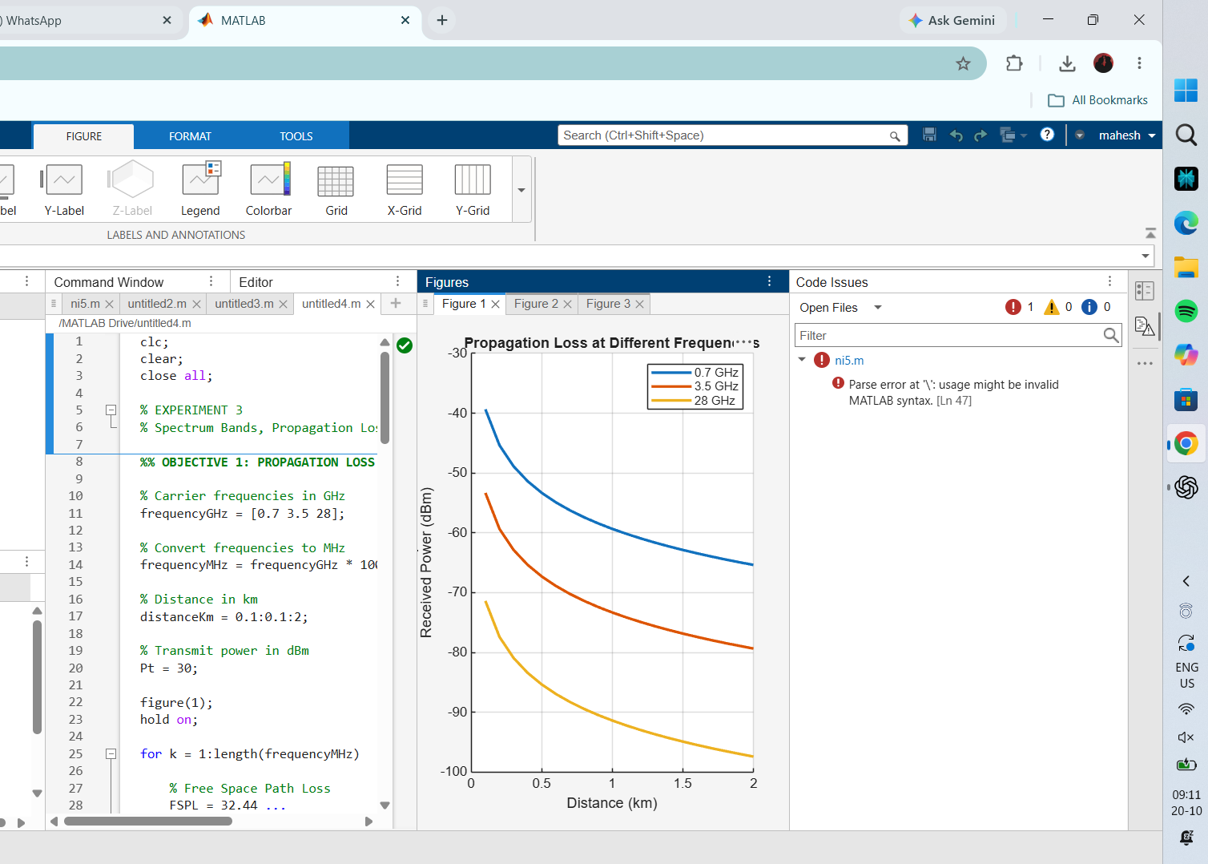
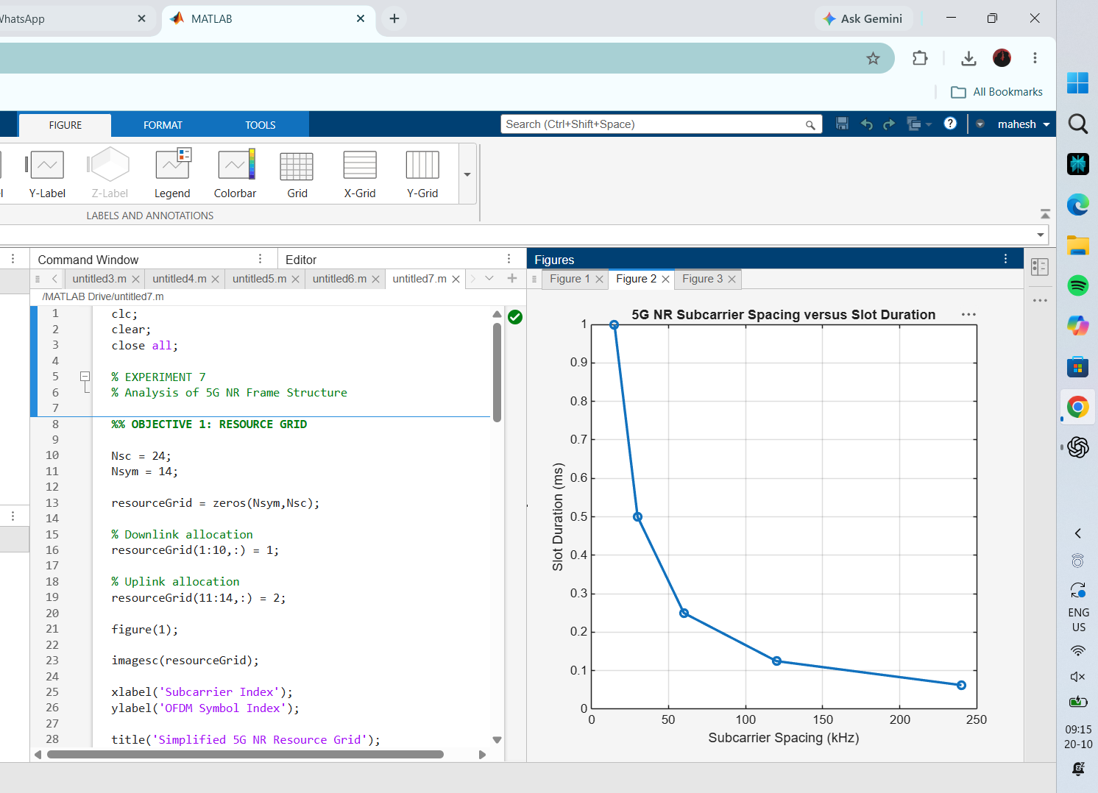
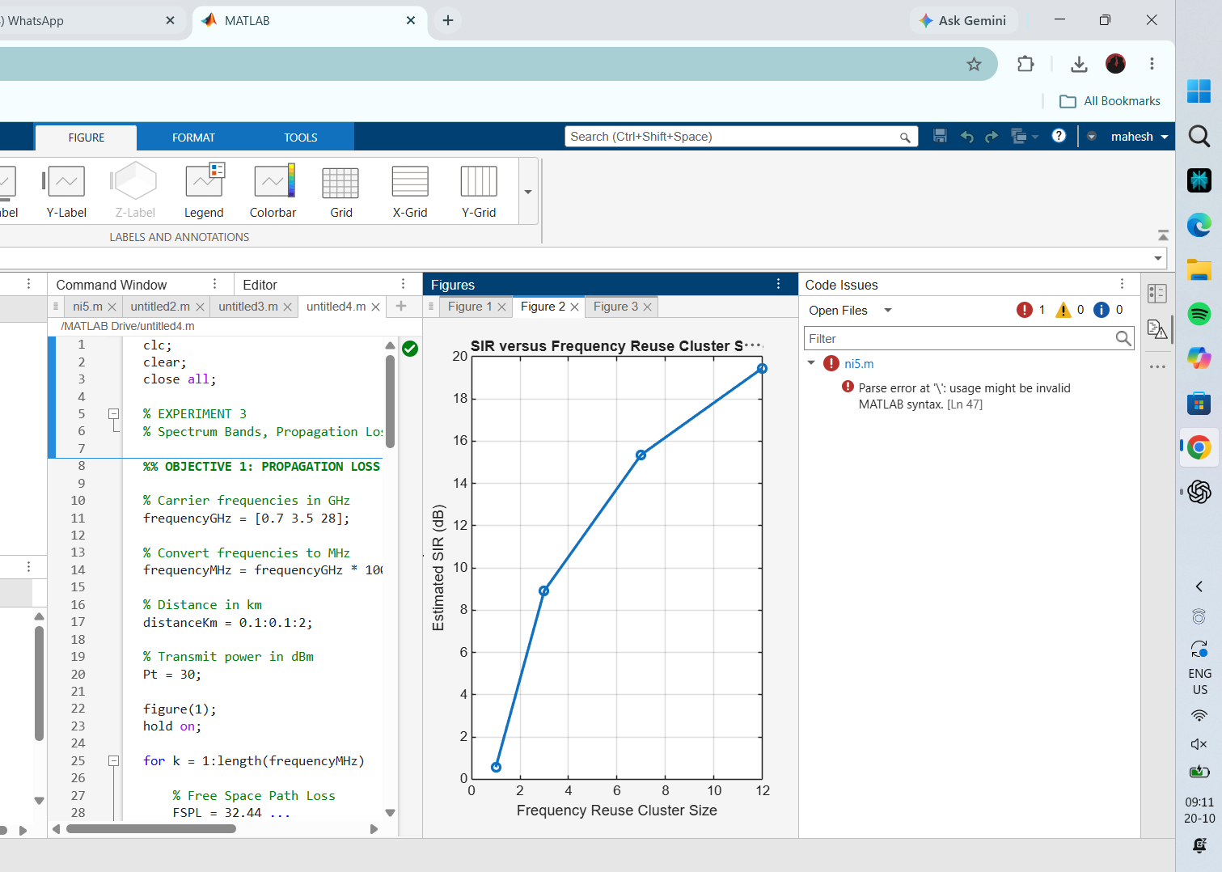
RESULT
The figures illustrate how received power and path loss vary with distance and carrier frequency, and how the simplified SIR estimate changes with frequency-reuse cluster size.

