ECA56 – ADVANCED WIRELESS COMMUNICATION SYSTEMS
EXPERIMENT 5
Simulation of LTE-Advanced Carrier Aggregation
Prepared by: Nilesh Naik
AIM
To simulate LTE-Advanced carrier aggregation and compare aggregated bandwidth and estimated throughput as the number of component carriers increases.
APPARATUS / SOFTWARE REQUIRED
Computer with MATLAB Online/Desktop. No physical hardware is required; this is a software simulation.
MATLAB / ARDUINO CODE
clc;
clear;
close all;
% EXPERIMENT 5: LTE-Advanced Carrier Aggregation
BWcc = 20; % Bandwidth per component carrier (MHz)
SE = 4; % Spectral efficiency (bits/s/Hz)
CC = [1 2 3 4 5]; % Number of component carriers
AggBW = BWcc .* CC;
Throughput = AggBW .* SE; % Simplified throughput estimate in Mbps
disp('LTE-ADVANCED CARRIER AGGREGATION RESULTS');
results = table(CC',AggBW',Throughput', ...
'VariableNames',{'ComponentCarriers','AggregatedBandwidth_MHz','Throughput_Mbps'});
disp(results);
figure(1);
bar(CC,AggBW);
grid on;
xlabel('Number of Component Carriers');
ylabel('Aggregated Bandwidth (MHz)');
title('LTE-Advanced Carrier Aggregation');
figure(2);
plot(CC,Throughput,'o-','LineWidth',1.5);
grid on;
xlabel('Number of Component Carriers');
ylabel('Theoretical Throughput (Mbps)');
title('Throughput versus Number of Component Carriers');
figure(3);
yyaxis left;
plot(CC,AggBW,'o-','LineWidth',1.5);
ylabel('Bandwidth (MHz)');
yyaxis right;
plot(CC,Throughput,'s-','LineWidth',1.5);
ylabel('Throughput (Mbps)');
grid on;
xlabel('Number of Component Carriers');
title('Bandwidth and Throughput Comparison');
OUTPUT SCREENSHOTS
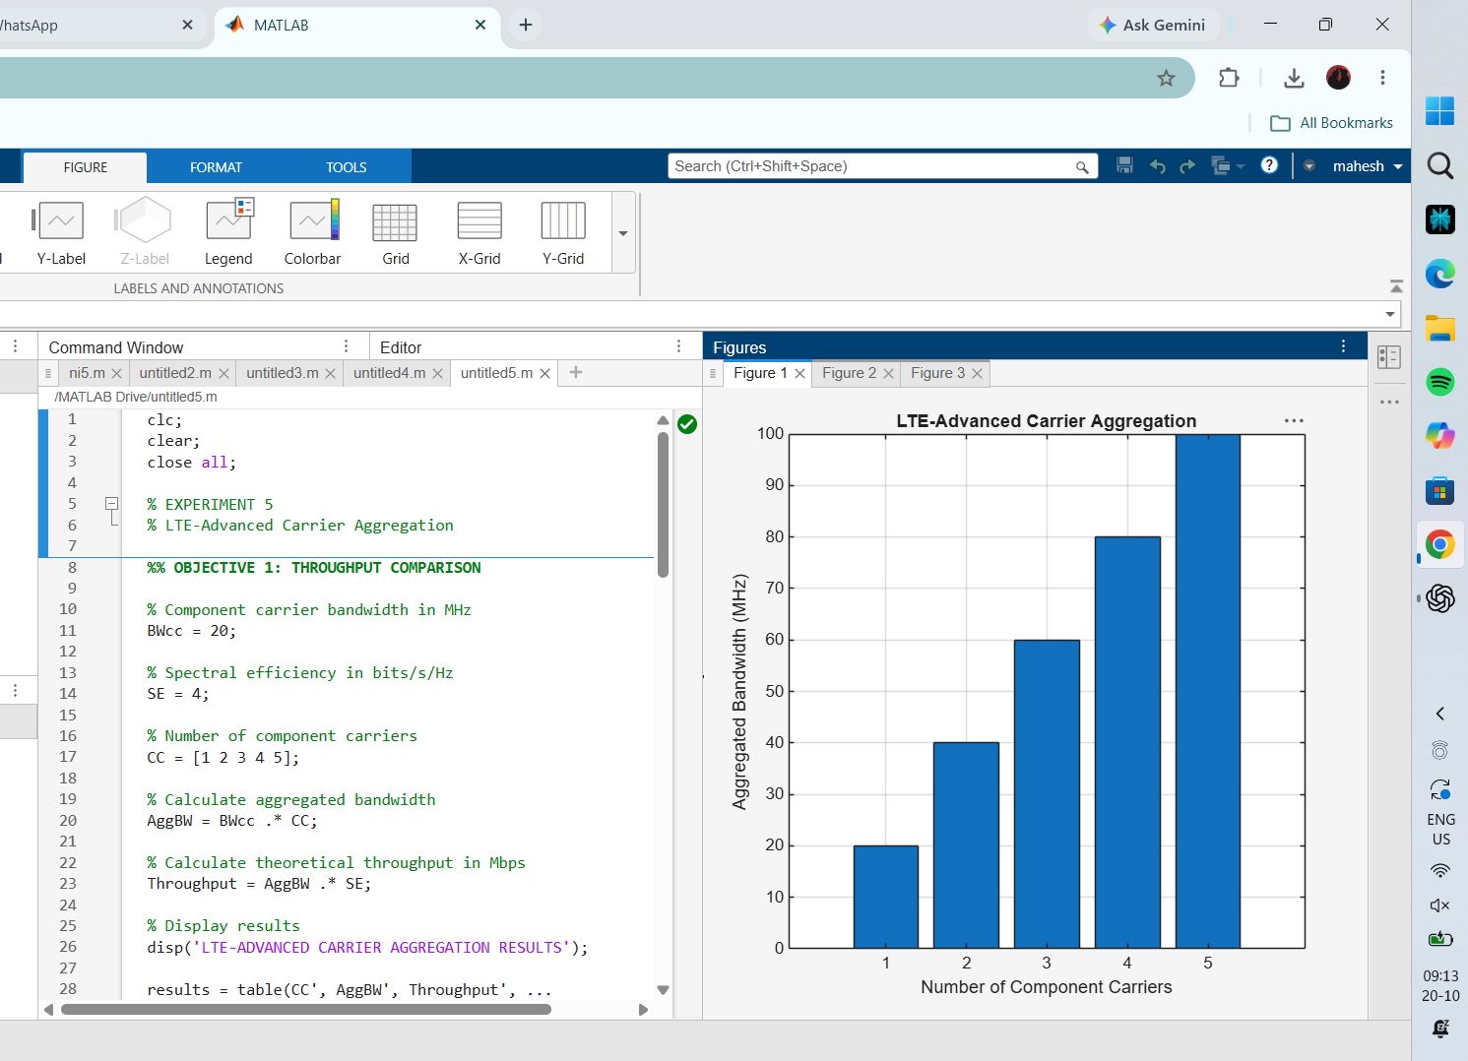
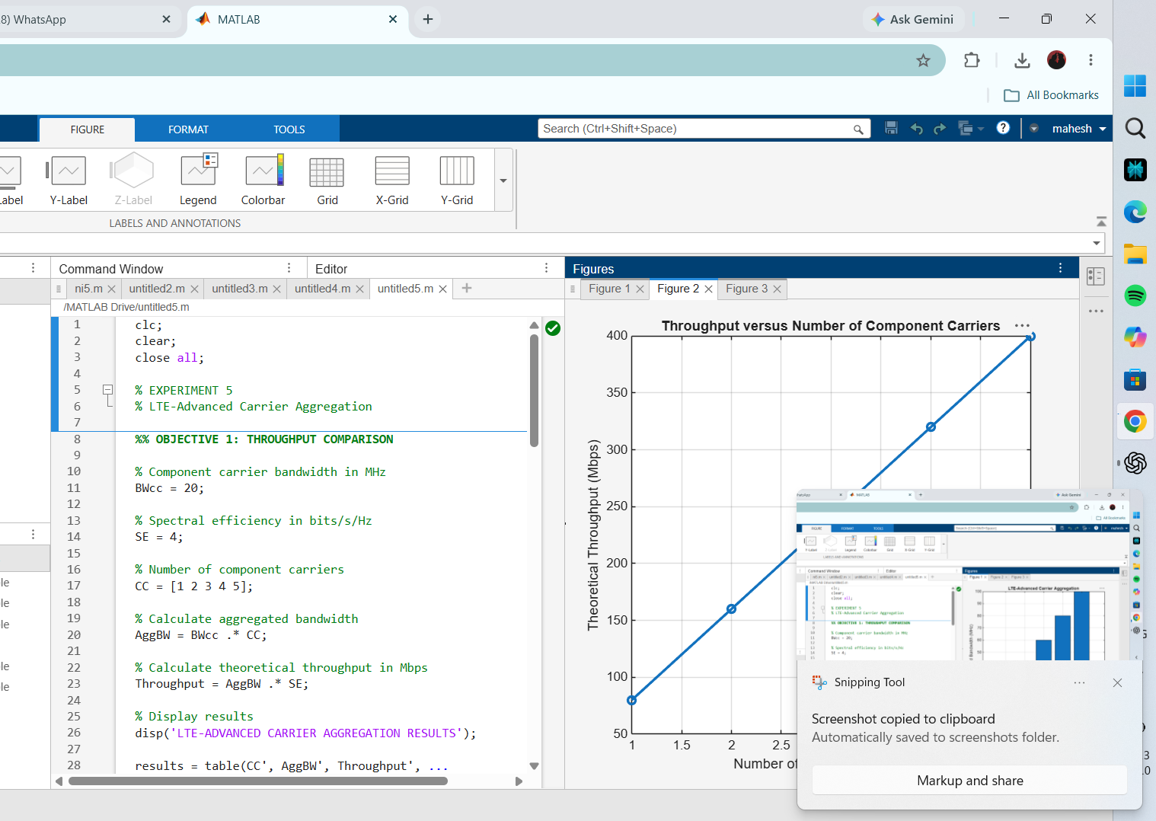
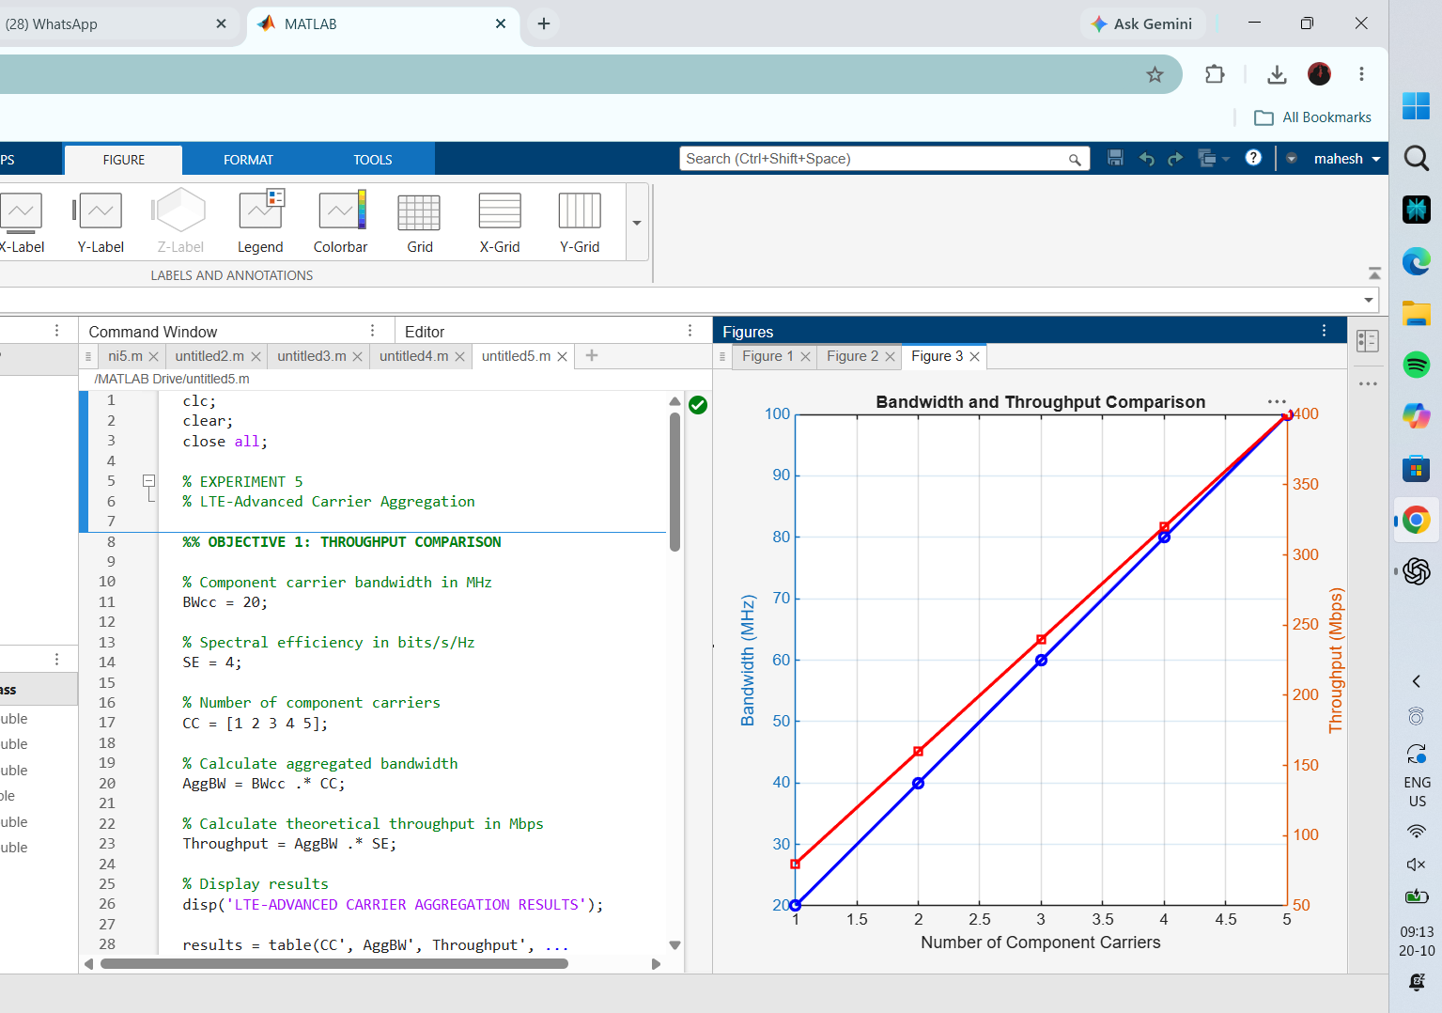
RESULT
With the simplified assumptions, aggregated bandwidth increases from 20 to 100 MHz and estimated throughput increases from 80 to 400 Mbps for one to five component carriers.

