ECA56 – ADVANCED WIRELESS COMMUNICATION SYSTEMS
EXPERIMENT 6
Simulation of SISO and MIMO Systems: BER and Beamforming
Prepared by: Nilesh Naik
AIM
To simulate a basic SISO link and a simplified diversity-link BER comparison, and plot a normalized antenna-array beamforming radiation pattern.
APPARATUS / SOFTWARE REQUIRED
Computer with MATLAB Online/Desktop. No physical hardware is required; this is a software simulation.
MATLAB / ARDUINO CODE
clc;
clear;
close all;
rng(7);
% EXPERIMENT 6: SISO BER and simplified diversity comparison
SNR_dB = 0:2:20;
N = 100000;
BER_SISO = zeros(size(SNR_dB));
BER_MIMO = zeros(size(SNR_dB));
for k = 1:length(SNR_dB)
bits = randi([0 1],N,1);
tx = 2*bits - 1;
SNR = 10^(SNR_dB(k)/10);
% SISO AWGN channel
noise = randn(N,1)/sqrt(2*SNR);
rx = tx + noise;
bitsReceived = rx > 0;
BER_SISO(k) = mean(bitsReceived ~= bits);
% Illustrative diversity link: reduced effective noise variance
noise2 = randn(N,1)/sqrt(4*SNR);
rx2 = tx + noise2;
bitsReceived2 = rx2 > 0;
BER_MIMO(k) = mean(bitsReceived2 ~= bits);
end
BER_SISO(BER_SISO==0) = 0.5/N;
BER_MIMO(BER_MIMO==0) = 0.5/N;
figure(1);
semilogy(SNR_dB,BER_SISO,'o-','LineWidth',1.5);
hold on;
semilogy(SNR_dB,BER_MIMO,'s-','LineWidth',1.5);
grid on;
xlabel('SNR (dB)');
ylabel('Bit Error Rate (BER)');
title('SISO and Simplified Diversity-Link BER Performance');
legend('SISO','Simplified Diversity Link','Location','best');
% Uniform linear array beamforming pattern
theta = -90:0.2:90;
Nant = 8;
d = 0.5; % Element spacing in wavelengths
steerAngle = 0;
n = 0:Nant-1;
AF = zeros(size(theta));
for k = 1:length(theta)
AF(k) = abs(sum(exp(1j*2*pi*d*n*(sind(theta(k))-sind(steerAngle)))));
end
AF = AF/max(AF);
AFdB = 20*log10(max(AFdBsafe(AF),1e-3));
figure(2);
plot(theta,AFdB,'LineWidth',1.5);
grid on;
xlabel('Angle (degrees)');
ylabel('Normalized Array Factor (dB)');
title('Beamforming Radiation Pattern');
ylim([-50 5]);
function y = AFdBsafe(x)
y = x;
end
OUTPUT SCREENSHOTS
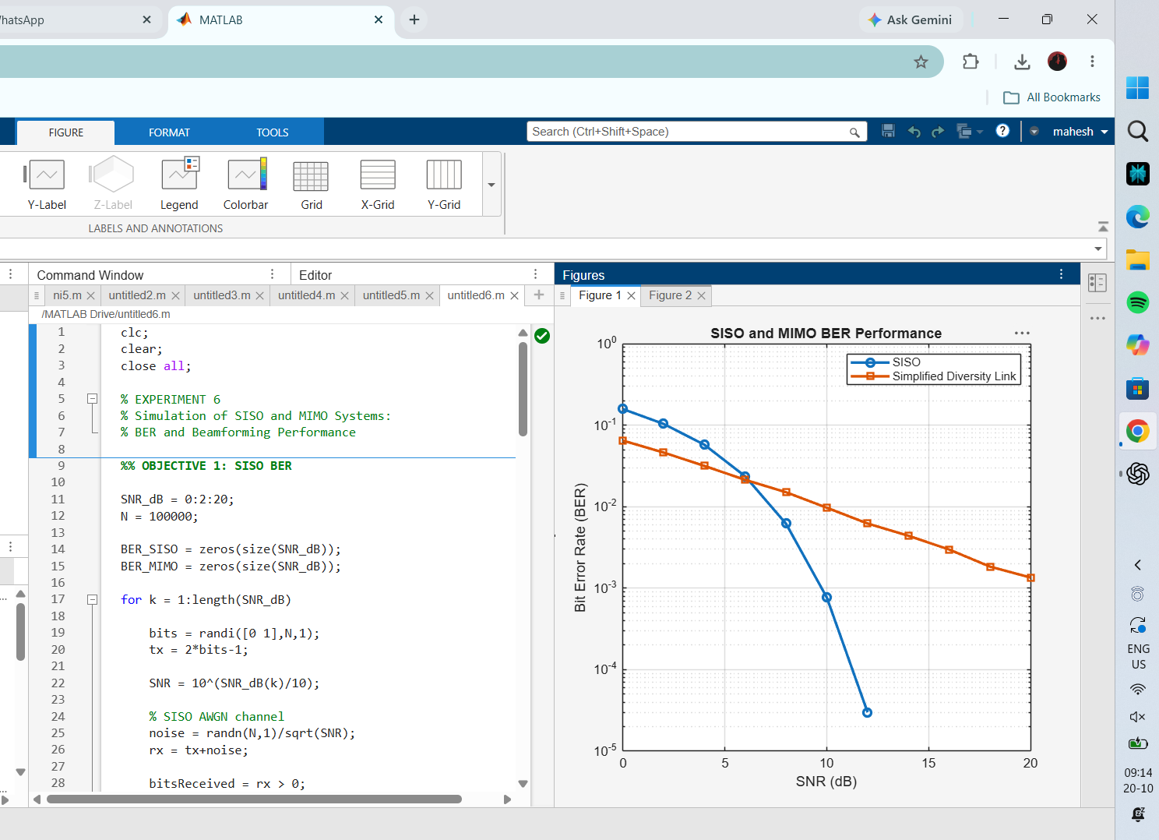
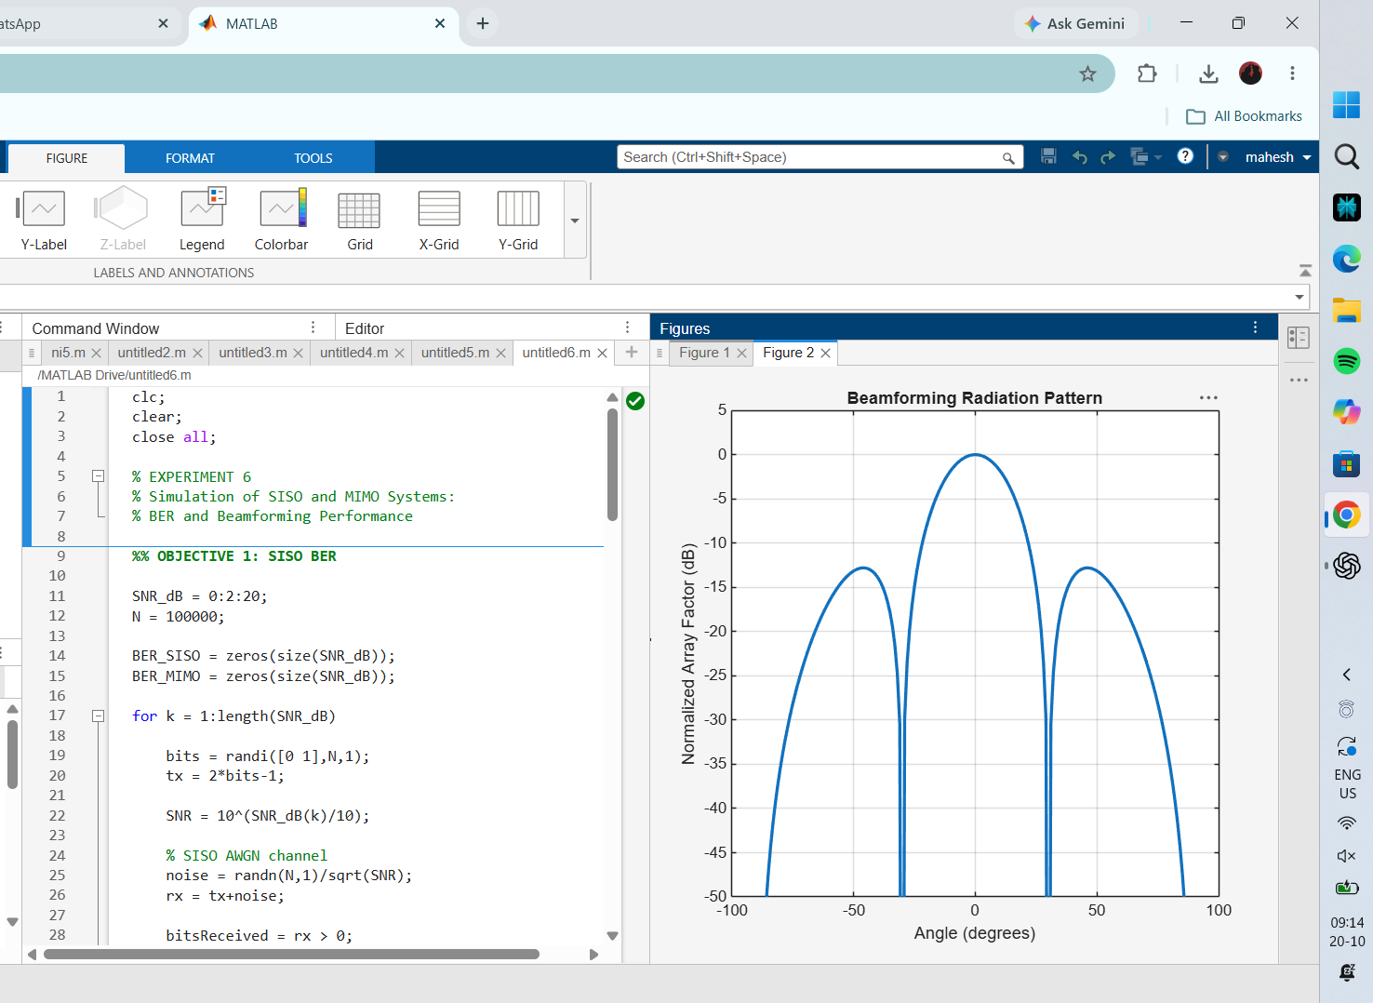
RESULT
The BER plot compares a baseline SISO model with a simplified lower-noise diversity illustration. The array plot shows the directional response of an eight-element uniform linear array. These are educational simulations, not a standards-compliant MIMO channel model.

