ECA56 – ADVANCED WIRELESS COMMUNICATION SYSTEMS
EXPERIMENT 7
Analysis of 5G NR Frame Structure
Prepared by: Nilesh Naik
AIM
To model a simplified 5G NR resource grid, show downlink/uplink symbol allocation, and compare subcarrier spacing with slot duration.
APPARATUS / SOFTWARE REQUIRED
Computer with MATLAB Online/Desktop. No physical hardware is required; this is a software simulation.
MATLAB / ARDUINO CODE
clc;
clear;
close all;
% EXPERIMENT 7: Simplified 5G NR frame structure
Nsc = 24;
Nsym = 14;
resourceGrid = zeros(Nsym,Nsc);
% Example allocation: first 10 symbols downlink, last 4 uplink
resourceGrid(1:10,:) = 1;
resourceGrid(11:14,:) = 2;
figure(1);
imagesc(resourceGrid);
set(gca,'YDir','normal');
xlabel('Subcarrier Index');
ylabel('OFDM Symbol Index');
title('Simplified 5G NR Resource Grid');
colorbar;
caxis([0 2]);
% Slot duration varies inversely with subcarrier spacing
SCS_kHz = [15 30 60 120 240];
slotDuration_ms = 1 ./ (SCS_kHz/15);
figure(2);
plot(SCS_kHz,slotDuration_ms,'o-','LineWidth',1.5);
grid on;
xlabel('Subcarrier Spacing (kHz)');
ylabel('Slot Duration (ms)');
title('5G NR Subcarrier Spacing versus Slot Duration');
% Plot downlink/uplink allocation across symbols
symbols = 1:Nsym;
downlink = double(symbols <= 10);
uplink = double(symbols >= 11);
figure(3);
plot(symbols,downlink,'bo-','LineWidth',1.5);
hold on;
plot(symbols,uplink,'rs-','LineWidth',1.5);
grid on;
xlabel('OFDM Symbol Index');
ylabel('Resource Allocation');
title('Downlink and Uplink Resource Allocation');
legend('Downlink','Uplink','Location','best');
OUTPUT SCREENSHOTS
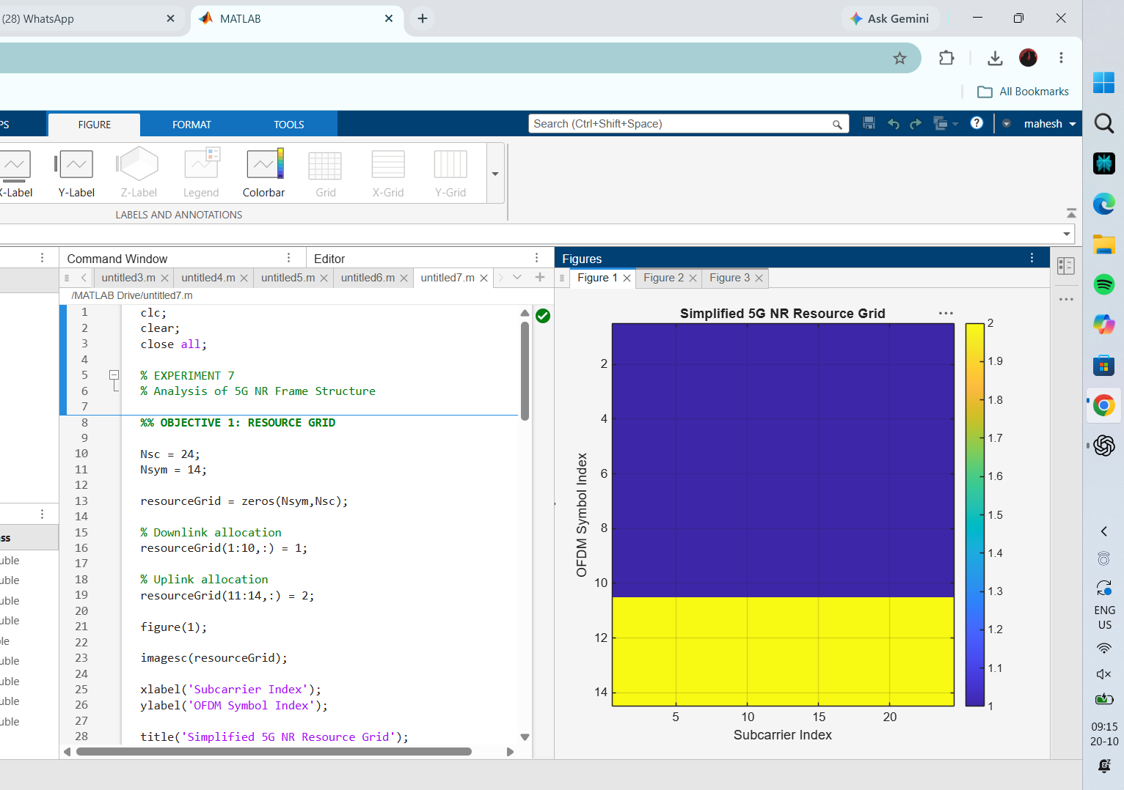
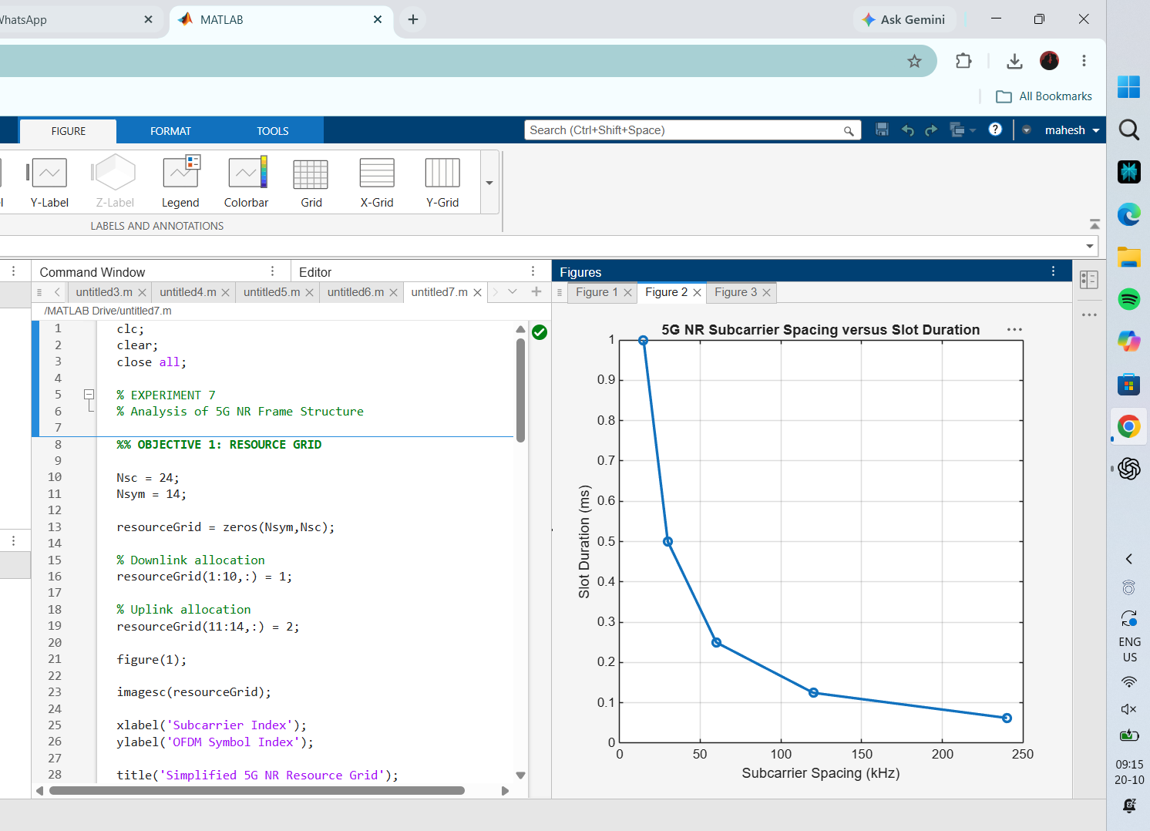
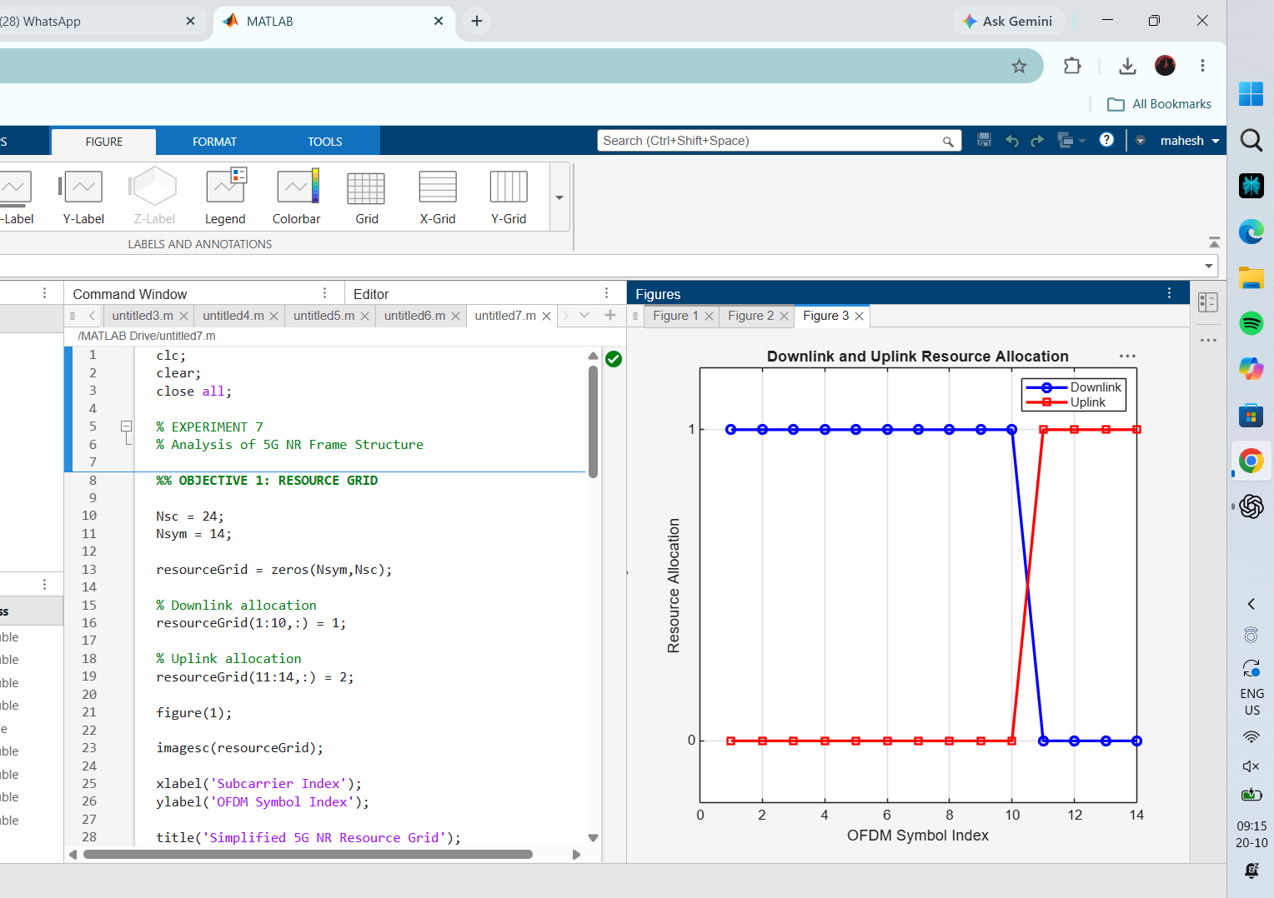
RESULT
The resource grid distinguishes the example downlink and uplink symbol regions. The slot-duration graph demonstrates that increasing subcarrier spacing reduces slot duration in this simplified numerology model.

