ECA56 – ADVANCED WIRELESS COMMUNICATION SYSTEMS
EXPERIMENT 8
OFDM Modulation and Demodulation
Prepared by: Nilesh Naik
AIM
To generate a BPSK-modulated OFDM signal, add a cyclic prefix, pass the signal through an AWGN channel, and evaluate BER versus SNR.
APPARATUS / SOFTWARE REQUIRED
Computer with MATLAB Online/Desktop. No physical hardware is required; this is a software simulation.
MATLAB / ARDUINO CODE
clc;
clear;
close all;
rng(7);
% EXPERIMENT 8: OFDM modulation and demodulation
N = 64; % Number of subcarriers
numSymbols = 100;
cpLength = 16;
SNR_dB = 0:2:20;
data = randi([0 1],N,numSymbols);
modulatedData = 2*data - 1; % BPSK symbols
% IFFT: frequency domain to time domain
ofdmSignal = ifft(modulatedData,N,1);
% Add cyclic prefix to each OFDM symbol
ofdmWithCP = [ofdmSignal(end-cpLength+1:end,:); ofdmSignal];
% Serial transmit signal and AWGN
tx = ofdmWithCP(:);
BER = zeros(size(SNR_dB));
figure(1);
plot(real(tx(1:80)),'LineWidth',1.2);
grid on;
xlabel('Sample Index');
ylabel('Amplitude');
title('Transmitted OFDM Signal');
for k = 1:length(SNR_dB)
signalPower = mean(abs(tx).^2);
noisePower = signalPower / 10^(SNR_dB(k)/10);
noise = sqrt(noisePower/2)*(randn(size(tx))+1j*randn(size(tx)));
rx = tx + noise;
rxMatrix = reshape(rx,N+cpLength,numSymbols);
rxNoCP = rxMatrix(cpLength+1:end,:);
receivedSymbols = fft(rxNoCP,N,1);
detectedBits = real(receivedSymbols) > 0;
BER(k) = mean(detectedBits(:) ~= data(:));
end
figure(2);
plot(real(rx(1:80)),'LineWidth',1.2);
grid on;
xlabel('Sample Index');
ylabel('Amplitude');
title('Received OFDM Signal with AWGN');
BER(BER==0) = 0.5/numel(data);
figure(3);
semilogy(SNR_dB,BER,'o-','LineWidth',1.5);
grid on;
xlabel('SNR (dB)');
ylabel('Bit Error Rate');
title('OFDM BER versus SNR');
OUTPUT SCREENSHOTS
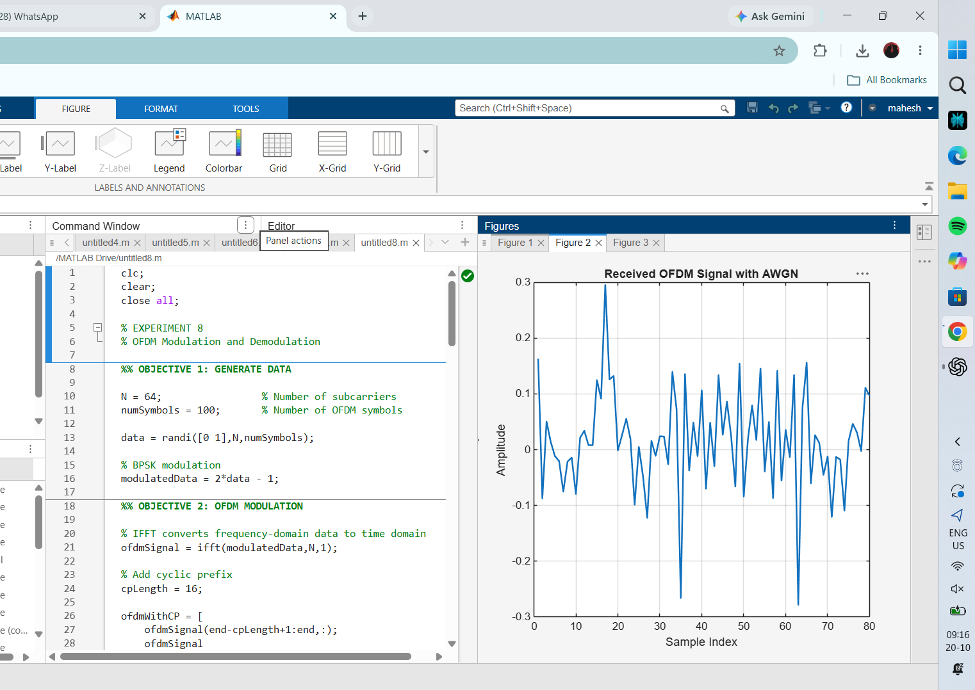
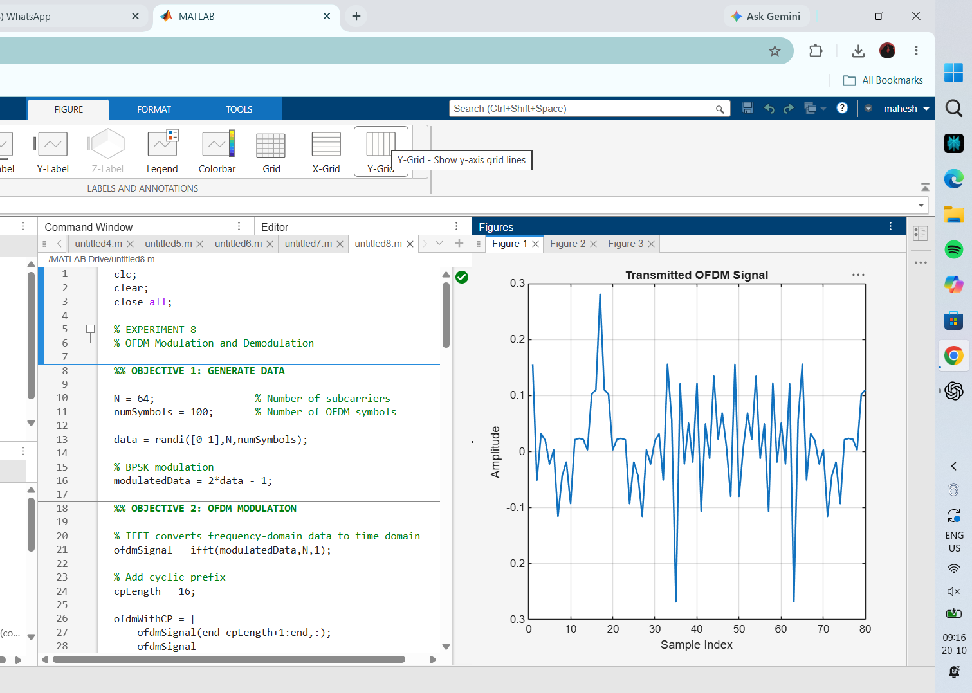
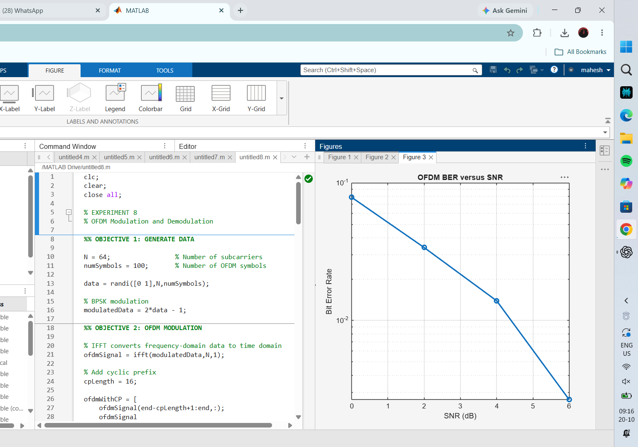
RESULT
The experiment plots transmitted and received OFDM waveform samples and the estimated BER versus SNR. The BER is expected to generally decrease as SNR increases.

