ECA56 – ADVANCED WIRELESS COMMUNICATION SYSTEMS
EXPERIMENT 9
Comparison of BPSK, QPSK and 16-QAM
Prepared by: Nilesh Naik
AIM
To compare the bit error rate (BER) of BPSK, QPSK and 16-QAM modulation schemes over an AWGN channel and display their constellation diagrams.
APPARATUS / SOFTWARE REQUIRED
Computer with MATLAB Online/Desktop. No physical hardware is required; this is a software simulation.
MATLAB / ARDUINO CODE
clc;
clear;
close all;
rng(7);
% EXPERIMENT 9: BPSK, QPSK and 16-QAM comparison
N = 100000;
SNR_dB = 0:2:20;
BER_BPSK = zeros(size(SNR_dB));
BER_QPSK = zeros(size(SNR_dB));
BER_16QAM = zeros(size(SNR_dB));
% BPSK data and symbols
bitsBPSK = randi([0 1],N,1);
txBPSK = 2*bitsBPSK - 1;
% QPSK data and symbols
bitsQPSK = randi([0 1],2*N,1);
b1 = bitsQPSK(1:2:end);
b2 = bitsQPSK(2:2:end);
txQPSK = ((1-2*b1) + 1j*(1-2*b2))/sqrt(2);
% 16-QAM Gray-like rectangular mapping, normalized average power
bits16 = randi([0 1],4*N,1);
B = reshape(bits16,4,[]).';
I = (1-2*B(:,1)).*(3-(1-2*B(:,2)));
Q = (1-2*B(:,3)).*(3-(1-2*B(:,4)));
tx16QAM = (I + 1j*Q)/sqrt(10);
for k = 1:length(SNR_dB)
snrLin = 10^(SNR_dB(k)/10);
% BPSK
noise = sqrt(1/(2*snrLin))*randn(size(txBPSK));
rx = txBPSK + noise;
BER_BPSK(k) = mean((rx>0) ~= bitsBPSK);
% QPSK
noise = sqrt(1/(2*snrLin))*(randn(size(txQPSK))+1j*randn(size(txQPSK)));
rx = txQPSK + noise;
d1 = real(rx)<0;
d2 = imag(rx)<0;
detected = zeros(2*N,1);
detected(1:2:end) = d1;
detected(2:2:end) = d2;
BER_QPSK(k) = mean(detected ~= bitsQPSK);
% 16-QAM: nearest levels on each axis
noise = sqrt(1/(2*snrLin))*(randn(size(tx16QAM))+1j*randn(size(tx16QAM)));
rx = tx16QAM + noise;
levels = [-3 -1 1 3]/sqrt(10);
[~,idxI] = min(abs(real(rx)-levels),[],2);
[~,idxQ] = min(abs(imag(rx)-levels),[],2);
recI = levels(idxI);
recQ = levels(idxQ);
% Reconstruct bits using the same axis mapping
recBits = zeros(N,4);
recBits(:,1) = recI < 0;
recBits(:,2) = abs(recI) < 2/sqrt(10);
recBits(:,3) = recQ < 0;
recBits(:,4) = abs(recQ) < 2/sqrt(10);
BER_16QAM(k) = mean(recBits(:) ~= bits16);
end
BER_BPSK(BER_BPSK==0) = 0.5/N;
BER_QPSK(BER_QPSK==0) = 0.5/(2*N);
BER_16QAM(BER_16QAM==0) = 0.5/(4*N);
figure(1);
semilogy(SNR_dB,BER_BPSK,'o-','LineWidth',1.5);
hold on;
semilogy(SNR_dB,BER_QPSK,'s-','LineWidth',1.5);
semilogy(SNR_dB,BER_16QAM,'^-','LineWidth',1.5);
grid on;
xlabel('SNR (dB)');
ylabel('Bit Error Rate');
title('BER Comparison of BPSK, QPSK and 16-QAM');
legend('BPSK','QPSK','16-QAM','Location','best');
figure(2);
subplot(1,3,1);
plot(real(txBPSK(1:2000)),imag(txBPSK(1:2000)),'o');
grid on; axis equal; title('BPSK Constellation');
xlabel('In-Phase'); ylabel('Quadrature');
subplot(1,3,2);
plot(real(txQPSK(1:2000)),imag(txQPSK(1:2000)),'o');
grid on; axis equal; title('QPSK Constellation');
xlabel('In-Phase'); ylabel('Quadrature');
subplot(1,3,3);
plot(real(tx16QAM(1:2000)),imag(tx16QAM(1:2000)),'o');
grid on; axis equal; title('16-QAM Constellation');
xlabel('In-Phase'); ylabel('Quadrature');
OUTPUT SCREENSHOTS
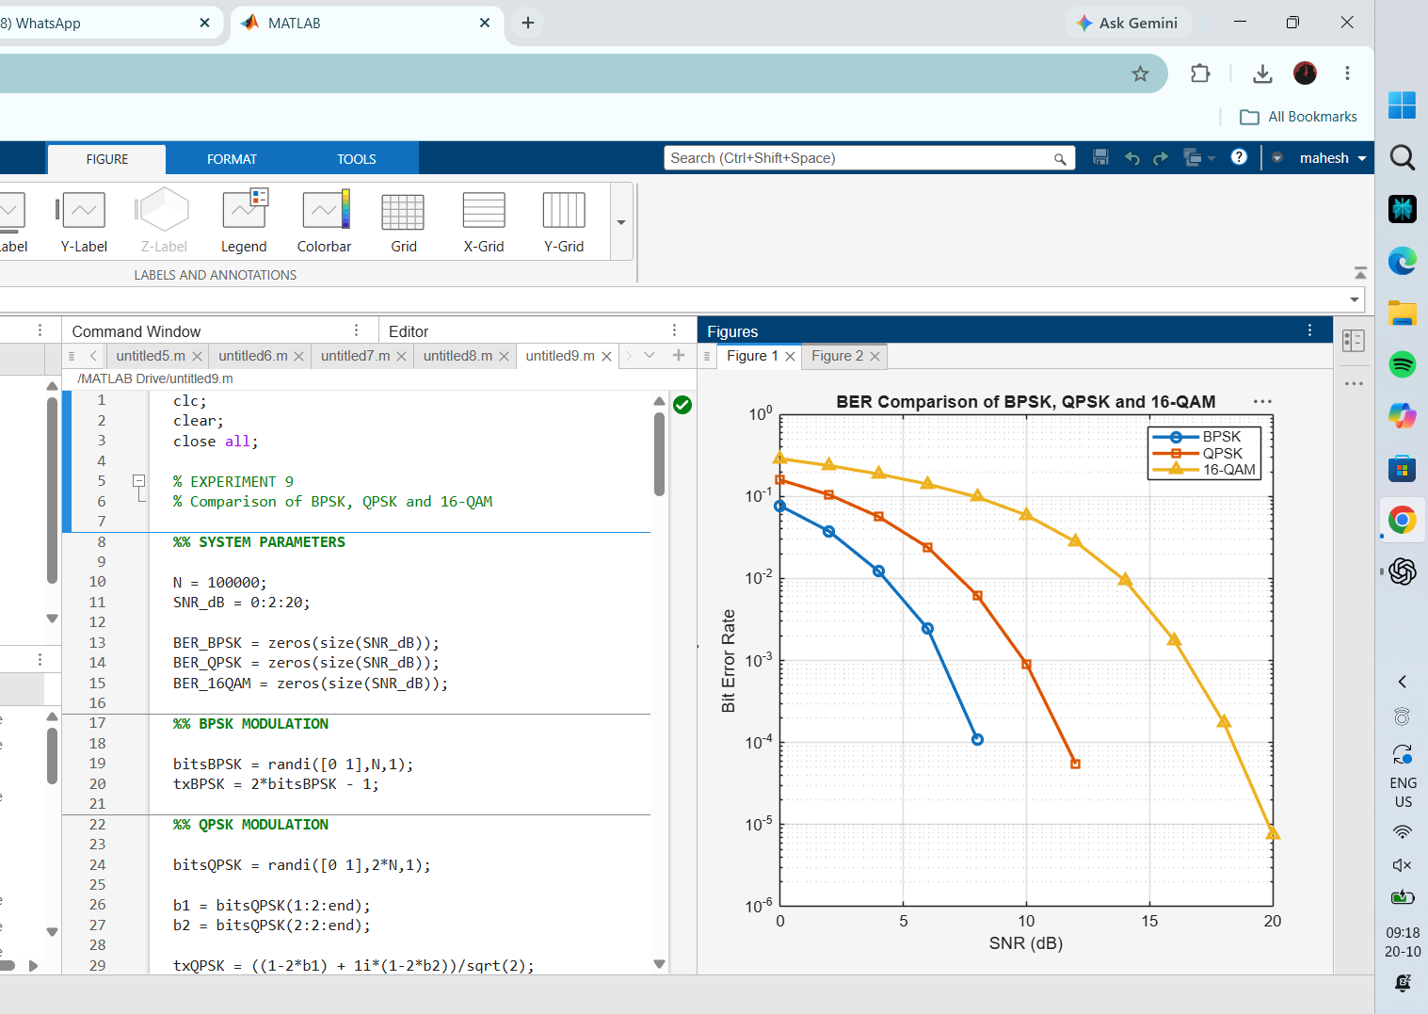
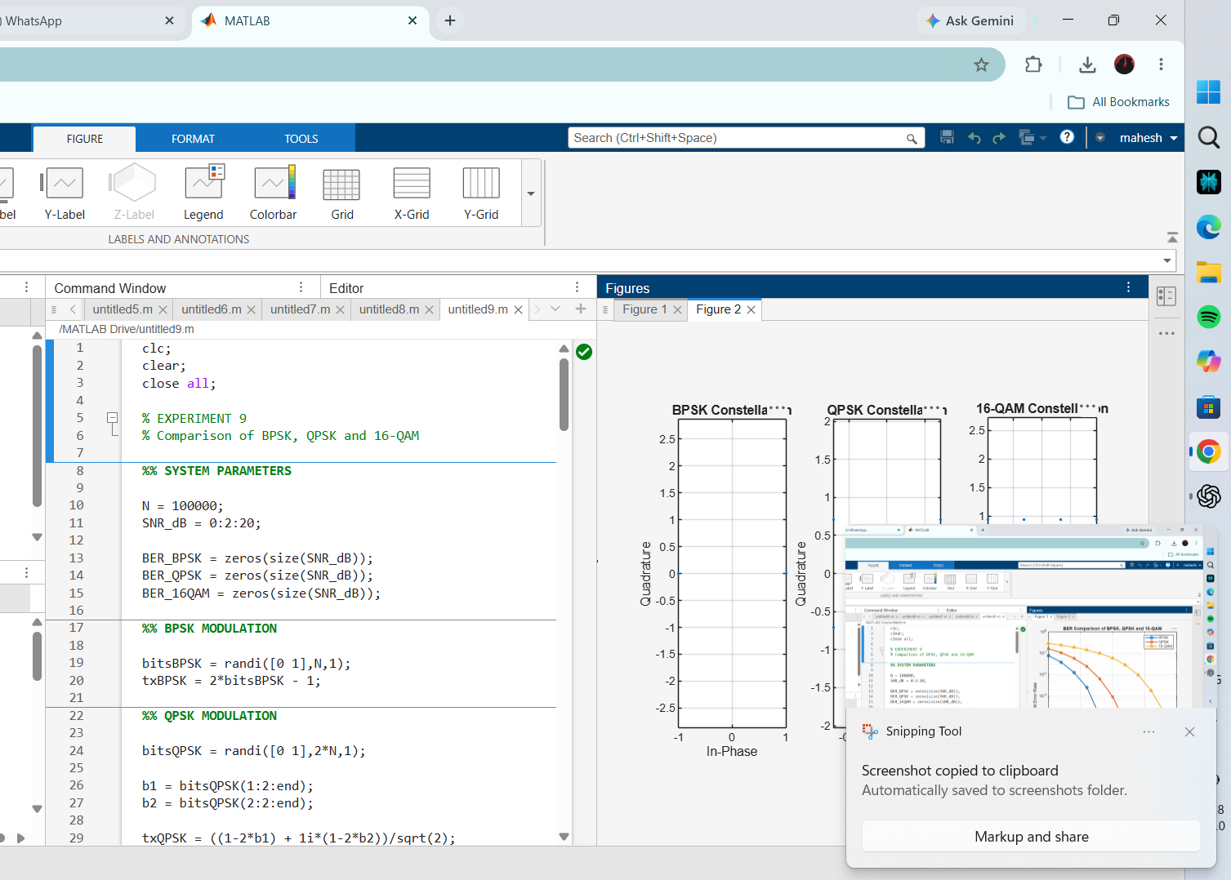
RESULT
The BER curves and constellation diagrams compare the three modulation schemes. BPSK generally offers better BER robustness at a given SNR, while higher-order modulation carries more bits per symbol at the cost of greater noise sensitivity.

